Synopsis of high-quality task:

This is a 3-Act Math Task that focuses on combining fractions with different denominators.

This could be used as an introduction to adding/subtracting fractions with different denominators. The task presents someone following a recipe; however, the amount of the last ingredient is not on the recipe. Students will need to determine how much of the last ingredient will be needed to make up the total amount that the recipe yields. In this situation, students can combine two fractions with different denominators to determine the missing amount.

Anticipated student time spent on task: 30-40 minutes

Student task structure(s): Suggest partners or individual

Math Content Standards and Practices:

5.NF.A.1. Add and subtract fractions with unlike denominators (including mixed numbers) by replacing given fractions with equivalent fractions in such a way as to produce an equivalent sum or difference of fractions with like denominators.
5.NF.A.2. Solve word problems involving addition and subtraction of fractions referring to the same whole (the whole can be a set of objects), including cases of unlike denominators, e.g., by using visual fraction models or equations to represent the problem. Use benchmark fractions and number sense of fractions to estimate mentally and assess the reasonableness of answers.

SMP 1 Make sense of problems and persevere in solving them.
SMP 2 Reason abstractly and quantitatively.
SMP 4 Model with mathematics.

Prior Knowledge:

4.NF.A.1. Explain why a fraction a ∕b is equivalent to a fraction (n $×$ a) ∕(n$×$ b) by using visual fraction models, with attention to how the numbers and sizes of the parts differ even though the two fractions themselves are the same size. Use this principle to recognize and generate equivalent fractions, including fractions greater than 1.
4.NF.B.3.d. Solve word problems involving addition and subtraction of fractions referring to the same whole and having like denominators, e.g., by using drawings or visual fraction models and equations to represent the problem.
Connections to the real-world:

This task presents a real-world situation: following a recipe. The recipe provides an opportunity to combine two fractions with different denominators. Following a simple recipe is something that many 10- or 11-year-olds have experienced, and this recipe is for a snack mix that would likely be appealing to many in this age group. Flexibility and deep understanding of fractions is frequently used when cooking.

Mastery Goals:

Learning Objective:
Students will use prior knowledge of equivalent fractions to combine two fractions with unlike denominators to solve a problem in a real-world situation.

Language Objective:
Students will use appropriate grade-level content vocabulary (halves, thirds, fourths, equivalent fractions, etc.) in whole class and partner discussions, building on others’ ideas and expressing their own clearly through oral and written communication.

Teacher instructions
Instructional Tips/Strategies/Suggestions:

Show Act 1 https://youtu.be/axjP9Eto_gU

Following video, ask students, “What do you notice, what do you wonder?” and record on chart paper. You may need to suggest/remind students to think about mathematical noticings or wonderings. Common noticings include, but are not limited to:
- I notice there were ¾ cup marshmallows used
- I notice there were ⅔ cup candy corn used
- I notice there was a white measuring cup not used
- I notice there was a bowl and spoon
- I notice there was a bag of chocolate chips not used
- I notice the recipe was ripped

Common wonderings include, but are not limited to:
- I wonder if they will melt it?
- I wonder how much chocolate chips they will use?
- I wonder if they will use the white measuring cup?
- I wonder how much the total recipe makes?
Once there is a list of noticings and wonderings, the question to focus on is, “How many/what measurement of chocolate chips are/is needed for the recipe?”

Students will estimate their answer and provide reasoning for that estimate. Students will then need to determine what information would help them solve this. When students determine that seeing the recipe would give them the information they need, show Act 2 (Act 2 is showing the recipe), then project the student handout of the recipe (below). You will likely need to have a quick discussion to make sure students understand how to read a recipe, particularly what “YIELD: four ½ cup servings” means. You may want to establish for the group that this information tells us how much the entire recipe will make.

Provide students with their own copy of the handout and allow partners or individuals to solve the task. Questions to ask to promote solving include:
- Could you draw a model to help?
- Where is the candy corn shown? Where are the marshmallows shown? Where is the whole recipe amount shown?
- Could you name these parts with a fraction?
- I notice the wholes are the same, but these parts are thirds and these are fourths. Is there a way to name these parts by the same units?
- Encourage students to use their model to answer this- which aligns with standard 4.NF.A.1
- Is 7/12 a common kitchen measurement? How would she measure this?
- Is your answer close to our estimates? Is it reasonable?

Give students approximately 15 minutes to work. By this point, most students should have at least determined that ¼ cup and ⅓ cup of chocolate chips would fill the remaining 2 cups of the recipe. It is likely that some students will be able to use their knowledge of equivalent fractions to combine ¼ and ⅓, but some may not. It is possible that some students may reason that ¼ and ⅓ are very close so the total of chocolate chips could be 2/4 or ⅔. Select and sequence a few examples to show.

Suggestions to look for in student work and possible sequence to show include:

- ¼ C AND ⅓ C chocolate chips (this solution can be found by drawing a representation of the situation).
- ¼ C AND ⅓ C chocolate chips, found numerically, without the drawing or model.
- Either ½ C or ⅔ C: found by reasoning that ⅓ and ¼ are close so we could estimate the answer as 2 of either unit fraction.

These examples offer an opportunity to talk about how in some situations these answers are totally acceptable but, in some cases, we may need to be more precise.

- 7/12 C chocolate chips; this solution may be found by drawing a representation and partitioning the thirds and fourths into twelfths, or by using fraction strips, tiles or other manipulatives. There may be some students who have learned to “multiply the numerator and denominator by the same thing,” but you’ll want to show a model or drawing to connect why that works.

Possible questions to ask to facilitate discussion as you sequence student work include:
- Where is the 2 cups in the picture? In the equation?
- Where is the candy corn in the picture? In the equation?
- Where are the marshmallows in the picture? In the equation?
- Where would the chocolate chips be in this picture? In the equation?
- What is the same/different between these examples?

If none of the students use equivalent fractions, this is a great springboard into a discussion about using equivalent fractions. You can show their models with ¼ and ⅓ missing from the two wholes and ask them to think about renaming them into the same unit. They may try using 6ths or 8ths. Honor these ideas and model them to show how the two units are still not the same. Students could also use 12ths or 24ths. Partition each model into what the class decides to use. Once they combine the renamed missing parts of the wholes to find either 7/12 or 14/24, ask them what they think the person in the video actually did.

Show Act 3 - https://youtu.be/ct1jfujRuj0

This will show that ½ c chocolate chips are used, so you’ll want to have a conversation about why this is different from the 7/12 or 14/24 that they calculated. You may want to ask:
Were we wrong?
Why is it ½ c?
What in the recipe allows us to know that ½ is okay? (“about” - not exactly - four servings)

Suggested supports:

Show a set of real measuring cups.
Encourage students to draw a model and recognize in the model the candy corn, the marshmallows, the total recipe amount and the chocolate chips.
Manipulatives: fraction tiles, fraction bars

Bonus questions could include:
Suggest students figure out how much of each ingredient they would need to serve their class.
What different quantities of these ingredients would also yield a total of approximately 2 cups?

If you only had a ¼ cup measuring cup, how could you make this recipe? If you only had a ⅓ cup measuring cup?

Instructional Materials/Resources/Tools:

Video links above to Act 1 and Act 3 (above)
Recipe to show for Act 2 (found below in student handout)
Student handout (below)
Fraction manipulatives

Accessibility and Supports:

Potential sentence starters:

I think we need ____________ cups of chocolate chips because_____________.
Four ½ cup servings is the same as _____________.
⅓ cup is close to _____________.
¼ cup is close to _____________.

Key academic vocabulary:
Halves, thirds, fourths, twelfths, equivalent fraction, improper fraction, mixed number, partition

Student Handout

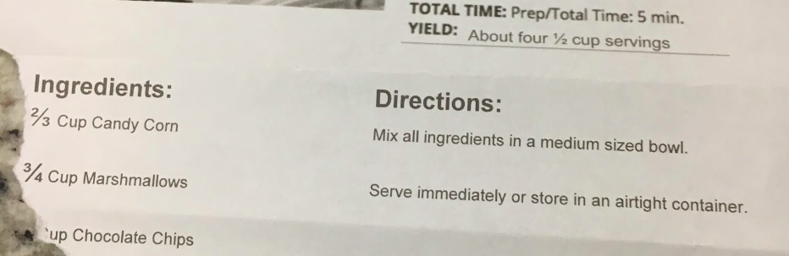

Sample Student Work:
This student work could be used as a springboard to a discussion about renaming the chocolate chips in each whole into the same size unit so they could be combined.

