Synopsis of high-quality task:

This task helps students make connections between the size of a unit and the number of units needed to measure a distance. Students use non-standard measuring tools and units before generalizing to standard measuring tools and units.

Anticipated student time spent on task: 100 minutes (two 50 minute sessions)

Student task structure(s): group work

Math Content Standards and Practices:

5.MD.A.1 Convert among different-sized standard measurement units within a given measurement system and use these conversions in solving multi-step, real-world problems.

SMP.2 Reason abstractly and quantitatively.
SMP.5 Use appropriate tools strategically.
SMP.8 Look for and express regularity in repeated reasoning.
Prior Knowledge:

4.MD.A.1 Know the relative sizes of measurement units within one system of units, including km, m, cm; kg, g, lb, oz,; L, mL, hr, min, sec. Within a single system of measurement, express measurements in a larger unit in terms of a smaller unit.

Connections to the real-world:

This activity utilizes non-standard measurements, which can support students to develop a conceptual understanding of the process for converting among units generally. Specifically, it will help them understand the reasoning for using multiplication to convert from a larger unit to a smaller unit (more of a smaller unit are needed to make the same amount) and division when converting from a smaller unit to a larger unit (less of a larger unit are needed to make the same amount). Converting among units and measuring precisely is a real world skill students will need.

Mastery Goals:

Learning Objectives:
Students will be able to convert among multiple units.
Students will be able to make sense of quantities and their relationships in problem situations.

Language Objectives:
Students will describe how to convert a distance measured in a smaller unit to a larger unit and vice versa.
Students will analyze relationships between important quantities to draw conclusions.

Teacher instructions
Instructional Tips/Strategies/Suggestions:

Set up:
- Gather the non-standard measurement tools (unsharpened pencils, toothpicks, small paper clips). There does not need to be enough materials for every group to cover their entire path. It will require students to get creative with strategies for precise measurement.
- If the relative sizes of the measurement tools you gather do not align with the intended sizes in this lesson (1 unsharpened pencil= 3 toothpicks; 1 toothpick= 2 small paper clips), you may choose different materials or paper strips.
- Masking tape seems to be the best tool for creating the paths. It does not leave a sticky residue behind and it is light in color which allows students to mark it up as they worked to make precise measurements.

Day 1 Instructions:
- Distribute masking tape to groups and give them several minutes to create their crooked paths. Remind them that the path should only extend from one end of the table to the other. It cannot be a straight line and there cannot be gaps or overlaps. (10 minutes)

Example:
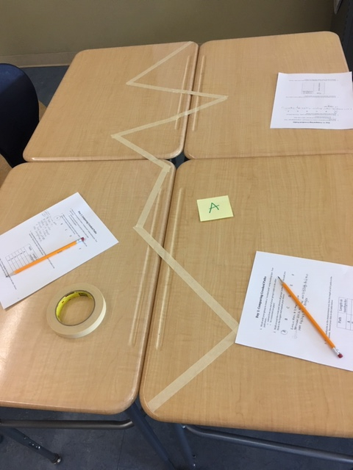

- Students should take a gallery walk around the room, observe all groups’ paths and mark/explain which path they predict will be the longest on the student handout. (5 minutes)
- Give groups a handful of toothpicks and ask them to measure the length of their path in toothpicks as precisely as possible. Some groups may cover the full distance in toothpicks. Others may repeat one toothpick, marking its end on the tape. Others may repeat a smaller set of toothpicks. Students may need to develop creative approaches to measure precisely when a full toothpick will not fit along a portion of the path. This provides a nice opportunity to connect to fractions. (10 minutes)

Examples:
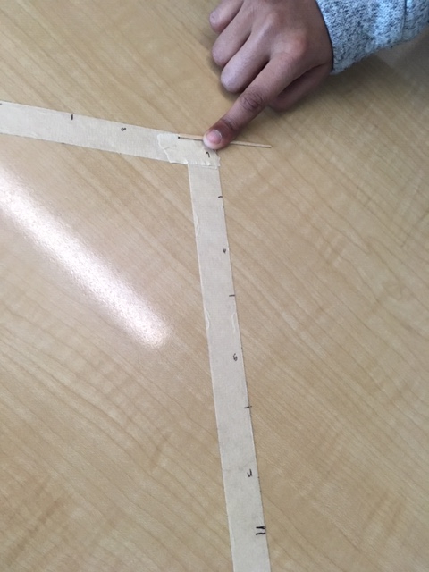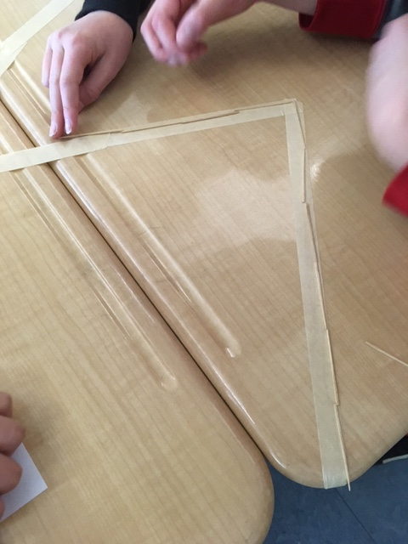

- Students should measure other groups’ paths and mark the lengths on their handout. If you prefer, each group can share their data with the class and the chart can be completed together to eliminate the additional measuring. Students should circle or highlight the longest path on their student handout. (25 minutes).

Day 2 Instructions:
- Groups should create a second path that is the same length as the longest crooked path in the class measured on day 1. If the paths that were created on day 1 are still available, students can just adjust their original path. (10 minutes)
- Students will find the length of their crooked path in unsharpened pencils. Some students will notice that 3 toothpicks are equivalent to one pencil. This may help them measure more efficiently. Others may cover the path in pencils. They will likely need to apply their understanding of fractions when only portion of a pencil, rather than the whole, fits along the path. (10 minutes)

Example:
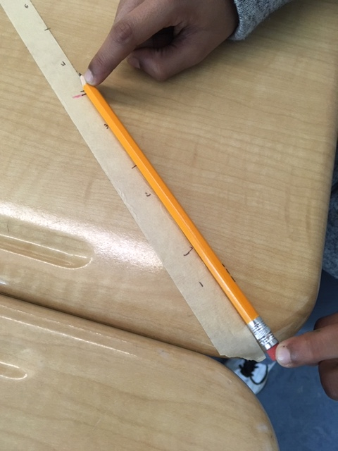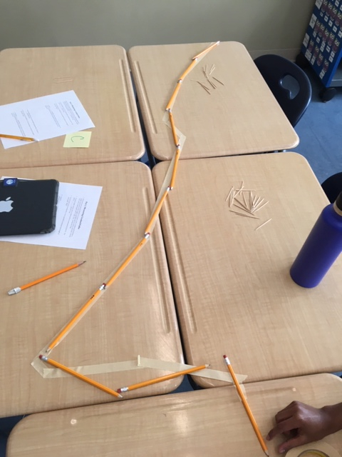

- Students will respond to the reflection questions in writing (questions 3-5). They should observe that 3 toothpicks are equivalent to one pencil. They should see that less pencils are needed since they take up more space than a toothpick. As a result, to convert from toothpicks to pencils, they could divide by 3 toothpicks per pencil. (5 minutes)
- Next, students will find the length of their path in small paper clips. At this point, push them toward efficiency. They should look for a way to measure the path without having to cover it in paper clips. (10 minutes)
- Students will respond to the reflection questions (questions 7-9). They should observe that 2 paper clips are equivalent to one toothpick. As a result, to convert from toothpicks to paper clips, they could multiply by 2 paper clips per toothpick. (5 minutes)
- Discuss questions 5 and 9 as a class. Consider creating a class anchor chart that shows how to convert among units generally. (10 minutes)

Instructional Materials:

- Student handout
- Masking tape
- Toothpicks
- Unsharpened pencils
- Small paper clips
- Pencils/ marker
- Scoring rubric
- Teacher note: 1 unsharpened pencil= 3 toothpicks; 1 toothpick= 2 small paper clips (do NOT include on student sheet!)
Accessibility and Supports:

Potential sentence starters:
- Day 1, Question 2: I think path ____ is the longest because…
- Day 2, Question 3: I need _____ toothpicks than pencils because…
- Day 2, Question 4: To convert a length from toothpicks to pencils, I need to…. because…
- Day 2, Question 5: To convert any length from a smaller unit to a larger unit…
- Day 2, Question 7: I need ____ toothpicks than paper clips because…
- Day 2, Question 8: To convert a length from toothpicks to paper clips, I need to...because…
- Day 2, Question 9: To convert any length from a larger unit to a smaller unit...

Key academic vocabulary:
Units
Equivalent
Factor
Product
Quotient

Student Worksheet
Name: ______________________________________
Day 1: Making and Comparing Crooked Paths

- Work with your group to create a “crooked path” using masking type. Your path must…
o extend from one end of your group’s table to the other.
o be connected (no gaps, no overlaps).

- Walk around the room and observe all groups’ paths. Circle the path you think is the longest and explain your choice.

A B C D E F

- Using toothpicks as the measurement tool, find the length of all 6 paths in the classroom.
Record your data in the table below:
Path | Length in toothpicks
A
B
C
D
E
F

- Observe your data. Circle or highlight the longest path in the table.
Discuss with your group: What makes this path the longest?

Name: ____________________________________________
Day 2: Measuring Crooked Paths with Different Units

- Work with your group members to create a new crooked path that has a length equivalent to the longest crooked path (circled on the day 1 sheet). Your new crooked path will be ____________ toothpicks long.

- Find the length of your new crooked path in unsharpened pencils. The path is ____________ pencils long.

- Do you need more toothpicks or more pencils to measure the length of your path? Why?

- 1 pencil = ____________toothpicks. How could you use this information to convert any distance measured in toothpicks to the distance measured in pencils?

- In general, how do you convert from a smaller unit (like an inch) to a larger unit (like a foot)?

- Find the length of your new crooked path using paper clips. The path is ____________paper clips long.

- Do you need more toothpicks or more paper clips to measure the length of your path? Why?

- 1 toothpick= ____________ paper clips. How could you use this information to convert any distance measured in toothpicks to the distance measured in paper clips?

- In general, how do you convert from a larger unit (like a foot) to a smaller unit (like an inch)?

Rubric
Extended Response  Scoring Rubric | On Target  Constructs and communicates a complete response | Almost There  Constructs and communicates a partial response | Not Yet  Does not construct  and communicate a relevant response
Accuracy  -Use math skills | The entire problem is solved accurately | Part of the problem is solved accurately | The problem is not solved accurately
Modeling/Representing  -Show your work/strategy (diagram, drawing, chart, table, graph, equation, etc.) | *Shows appropriate work/strategy clearly and completely | *Shows some appropriate work/strategy, but parts are missing or incorrect | *Does not show appropriate work/strategy
Reasoning  -Explain / justify your strategy  -Tell WHY, not how  -Put solution in context (use sentence frame) | *Explanation is complete and organized  → Uses math vocabulary correctly  → Puts answer in a sentence frame. | *Explanation is missing parts or is not organized | *Explanation is not included or is incorrect

Sample Student Work

