Task-level phenomenon:
In this lesson, the specific phenomenon is a picture of what Earth looked like in the past (Pangaea).

Synopsis of high-quality task:
This task has three parts and could be included in a unit on geologic time. The goal of this task is to analyze and interpret data in order to explain the phenomena of the existence of the supercontinent, Pangaea. Students will use data to create a puzzle using present day land masses that get configured into a supercontinent. They will also determine the pieces missing from the puzzle using evidence and eventually draw conclusions to explain what Earth looked like in the past and what it may look like in the future.

Anticipated student time spent on task: 2 sessions, 55 mins each

Type of Task (check one):
_____1. Investigation/experimentation/design challenge
_____2. Data representation, analysis, and interpretation
__x__ 3. Explanation

Student task structure(s): Partners

STE Standards and Science and Engineering Practices:

Standards:
6.MS-ESS2-3. Analyze and interpret maps showing the distribution of fossils and rocks, continental shapes, and seafloor structures to provide evidence that Earth’s plates have moved great distances, collided, and spread apart.
Clarification Statement:
- Maps may show similarities of rock and fossil types on different continents, the shapes of the continents (including continental shelves), and the locations of ocean structures (such as ridges, fracture zones, and trenches), similar to Wegener’s visuals.
State Assessment Boundary:
- Mechanisms for plate motion or paleomagnetic anomalies in oceanic and continental crust are not expected in state assessment.

Science and Engineering Practice(s):
- Developing and using models
- Constructing explanations

Prior Knowledge:
Previous Standard from Strand Map:
4-ESS1-1. Use evidence from a given landscape that includes simple landforms and rock layers to support a claim about the role of erosion or deposition in the formation of the landscape over long periods of time.
Clarification Statements:
- Examples of evidence and claims could include rock layers with shell fossils above rock layers with plant fossils and no shells, indicating a change from deposition on land to deposition in water over time; and a canyon with rock layers in the walls and a river in the bottom, indicating that a river eroded the rock over time.
- Examples of simple landforms can include valleys, hills, mountains, plains, and canyons.
- Focus should be on relative time.
State Assessment Boundary:
- Specific details of the mechanisms of rock formation or specific rock formations and layers are not expected in state assessment

4-ESS2-2. Analyze and interpret maps of Earth’s mountain ranges, deep ocean trenches, volcanoes, and earthquake epicenters to describe patterns of these features and their locations relative to boundaries between continents and oceans.

Previous Topics:
- Fossils are the remains/impressions of matter than have become petrified or cast in rock through applied pressure over time.
- Biological evolution describes any genetic change that happens over time and is ultimately inherited by several generations.
- The Law of Superposition states that in an undisturbed sample of rocks, layers that are near the surface are younger than those that are farther from the surface.

Connections to the real-world:
- In order for underwater vessels (e.g., submarines) to be safe, tectonic plate movement must be monitored and updated.
- Earthquakes and volcanic activity can also be explained by tectonic plate movement and thus, with close monitoring result in early detection systems.

Mastery Goals:
Learning Objective:
- Use a model to construct a supercontinent
- Construct an explanation of continental drift using evidence from tectonic plate movement

Performance Objectives:
- Use the shapes of continent pieces to construct a model of how land masses looked (PART I)
- Use continent pieces with fossil evidence to reconfigure how the land masses fit together in forming the supercontinent, Pangaea (Part II)
- Construct an explanation for the theory of continental drift (PART III)

Language Objective:
- Discuss orally, evidence of tectonic plate movement in small groups and whole class discussions.
- Construct a written explanation of continental drift and the existence of the supercontinent, Pangaea.

Teacher Instructions:

INTRODUCTION (~20 min)
- Show students a picture of Pangea and have then write down their notices and wonderings individually.
- Students share with a partner and then make a class list as a whole group. Please note that when discussing, all ideas are acceptable, including those that are incorrect.
- Students read a paragraph (individually or aloud) about plate tectonics. (Worksheet Part 1)
- Students compare notices and wonderings to the reading as a class discussion.
The Look For points below are what students are working towards in this task.
  - Do you think North America is moving? Do you think any of the continents are moving?
LOOK FOR:
    - Earth’s crust made of tectonic plates
    - There are slabs of the Earth’s crust
    - The slabs move at an average rate of several centimeters per year
  - Do continents alone make up these slabs? Are there areas where there are no slabs of crust?
LOOK FOR:
    - Oceans sit above these slabs too
    - The Earth’s crust is everywhere
    - There are cracks in the Earth’s crust

PART I (~30 min)
- Students observe a present day map (see student handout).
- Frame this next action by telling students, in small groups, they are to put together a complete puzzle using some continents as pieces and that all pieces must be used.
- As students finish their puzzles, ask students to complete a gallery walk.
- During their gallery walk, have students complete I Noticed/I Wondered sticky notes for each puzzle.
- As a large group, ask small groups to share the I Noticed/I Wondered sticky notes that were placed on their puzzles.
- As a whole class, identify patterns in this feedback. Compile a chart of this feedback on the front board.
- Give students the opportunity to rearrange puzzles based on new evidence gathered from the gallery walk/feedback.
- Ask students to put together a new puzzle using the same continents with pieces that show additional evidence of connections between continents.
- Ask students to explain how two puzzles they made look similar or different and to provide reasons why they are both similar and different.

PART II (~30 min)
- Frame the activity by telling students their completed puzzle represents a supercontinent.
- Ask students to use their puzzles to discuss their findings within their groups and to draft a definition of the term supercontinent.
- Provide globes to students or refer to the present day maps used in Part I. Ask students to compare continents on their globes with those that made up their supercontinent.
  - Ask students to discuss what is missing.
LOOK FOR
    - North America
    - Europe
    - Asia
  - Ask students discuss why these pieces may be missing.
LOOK FOR
    - Those continents did not have fossils to link them to Pangaea
    - There were no mountain chains that continued
    - Those continents had less evidence linking them to a supercontinent
- Have students construct a third puzzle using North America, Greenland, Asia, and Europe.
- Challenge students to make a third puzzle using missing continent pieces without evidence. Encourage small groups to discuss how their puzzle could be improved.
LOOK FOR: evidence, fossil records, mountain chains
- Provide students with missing continent pieces with evidence and have them improve upon their third puzzle.

PART III (~20 min)
- Remind students of the original questions.
  - Is North American moving? Are any continents moving?
  - What did Earth look like in the past?
  - Did a supercontinent ever exist? Might a supercontinent ever exist again?
- Students use the puzzles and present-day maps/globes to discuss their findings in their groups. Students should take notes on their discussion. For support, teachers could provide
  - Graphic organizers for writing
    - Possible example: CER - Claim would be that a supercontinent did exist and the evidence is the location of certain fossils, coal deposit locations, and major land formations across puzzle pieces (continents). The reasoning is showing that patterns match and explaining that the locations of these items have been found on different continents.
    - Sentence frames/starters
- Students write explanations about whether a supercontinent ever existed and whether another might ever exist again. Students can write more robust explanations by combining their explanations with supplemental resources.

Instructional Materials/Resources/Tools:

- Student handout introduction part A
- Student handout introduction part B
- Present-day map
- Pangaea puzzle pieces
- Fossil puzzle pieces and evidence
- Student handout part II
- Student handout part III

Task Sources:

The Dynamic Earth: the Story of Plate Tectonics, https://pubs.usgs.gov/gip/dynamic/dynamic.html
(online edition) from US Geological Survey, https://www.usgs.gov/

The Dynamic Planet: A Teaching Companion, https://volcanoes.usgs.gov/vsc/file_mngr/file-139/This_Dynamic_Planet-Teaching_Companion_Packet.pdf, from US Geological Survey

Supplemental Resources
Alfred Lothar Wegener: Moving continents by US Geological Survey, https://www.usgs.gov/
https://pubs.usgs.gov/gip/dynamic/wegener.html
- Continental Drift from Lumen Learning Candela Open Course Earth Science
https://courses.candelalearning.com/earthscienceck12/chapter/continental-drift/
- Plate Tectonics by Open Geography
http://www.opengeography.org/ch-5-plate-tectonics.html

The Ambassador would like to recognize Kris Grymonpre and Nicole Ruttan for their contributions to the development of this task.

Accessibility and Supports:

Key academic vocabulary (tier 2 and 3): continent, continental drift, convergent, drift, divergent, Earth, Pangaea, slab, supercontinent, tectonic plate

Students should be provided with claim, evidence, and reasoning graphic organizer (included below) for Part III.

Sample Student Work:

Student work not provided.

Continental Drift is Puzzling

Name:_____________________________________________________________

Introduction – Part A

Image from US Geological Survey

Notice | Wonderings

Continental Drift is Puzzling

Name:_____________________________________________________________

Introduction - Part B

Brief Overview of Plate Tectonics

Since ancient times, the name Terra Firma (meaning "solid ground" in Latin) sometimes has been and occasionally still is used for planet Earth. While our planet is for the most part "solid" and firm, its outermost layer is everywhere in ceaseless motion, shifting at measurable average rates of several centimeters per year. This ever–moving layer upon which we live is a thin skin of solid crust and the rigid uppermost mantle making up Earth's lithosphere. The lithosphere is broken up into slabs that geologists call lithospheric plates or tectonic plates. During the 20th century, a major scientific concept—Theory of Plate Tectonics— emerged to explain why and how these plates move about and interact. This theory has unified the study of the Earth and proven to be as relevant to the earth sciences as was the discovery of the structure of the atom to physics and chemistry, and as was the theory of evolution to the life sciences. Even though the plate tectonics theory is now widely accepted by the scientific community, some aspects of it are still being vigorously debated today.

NOTES

From This Dynamic Planet: A Teaching Companion by the US Geological Survey
PART I

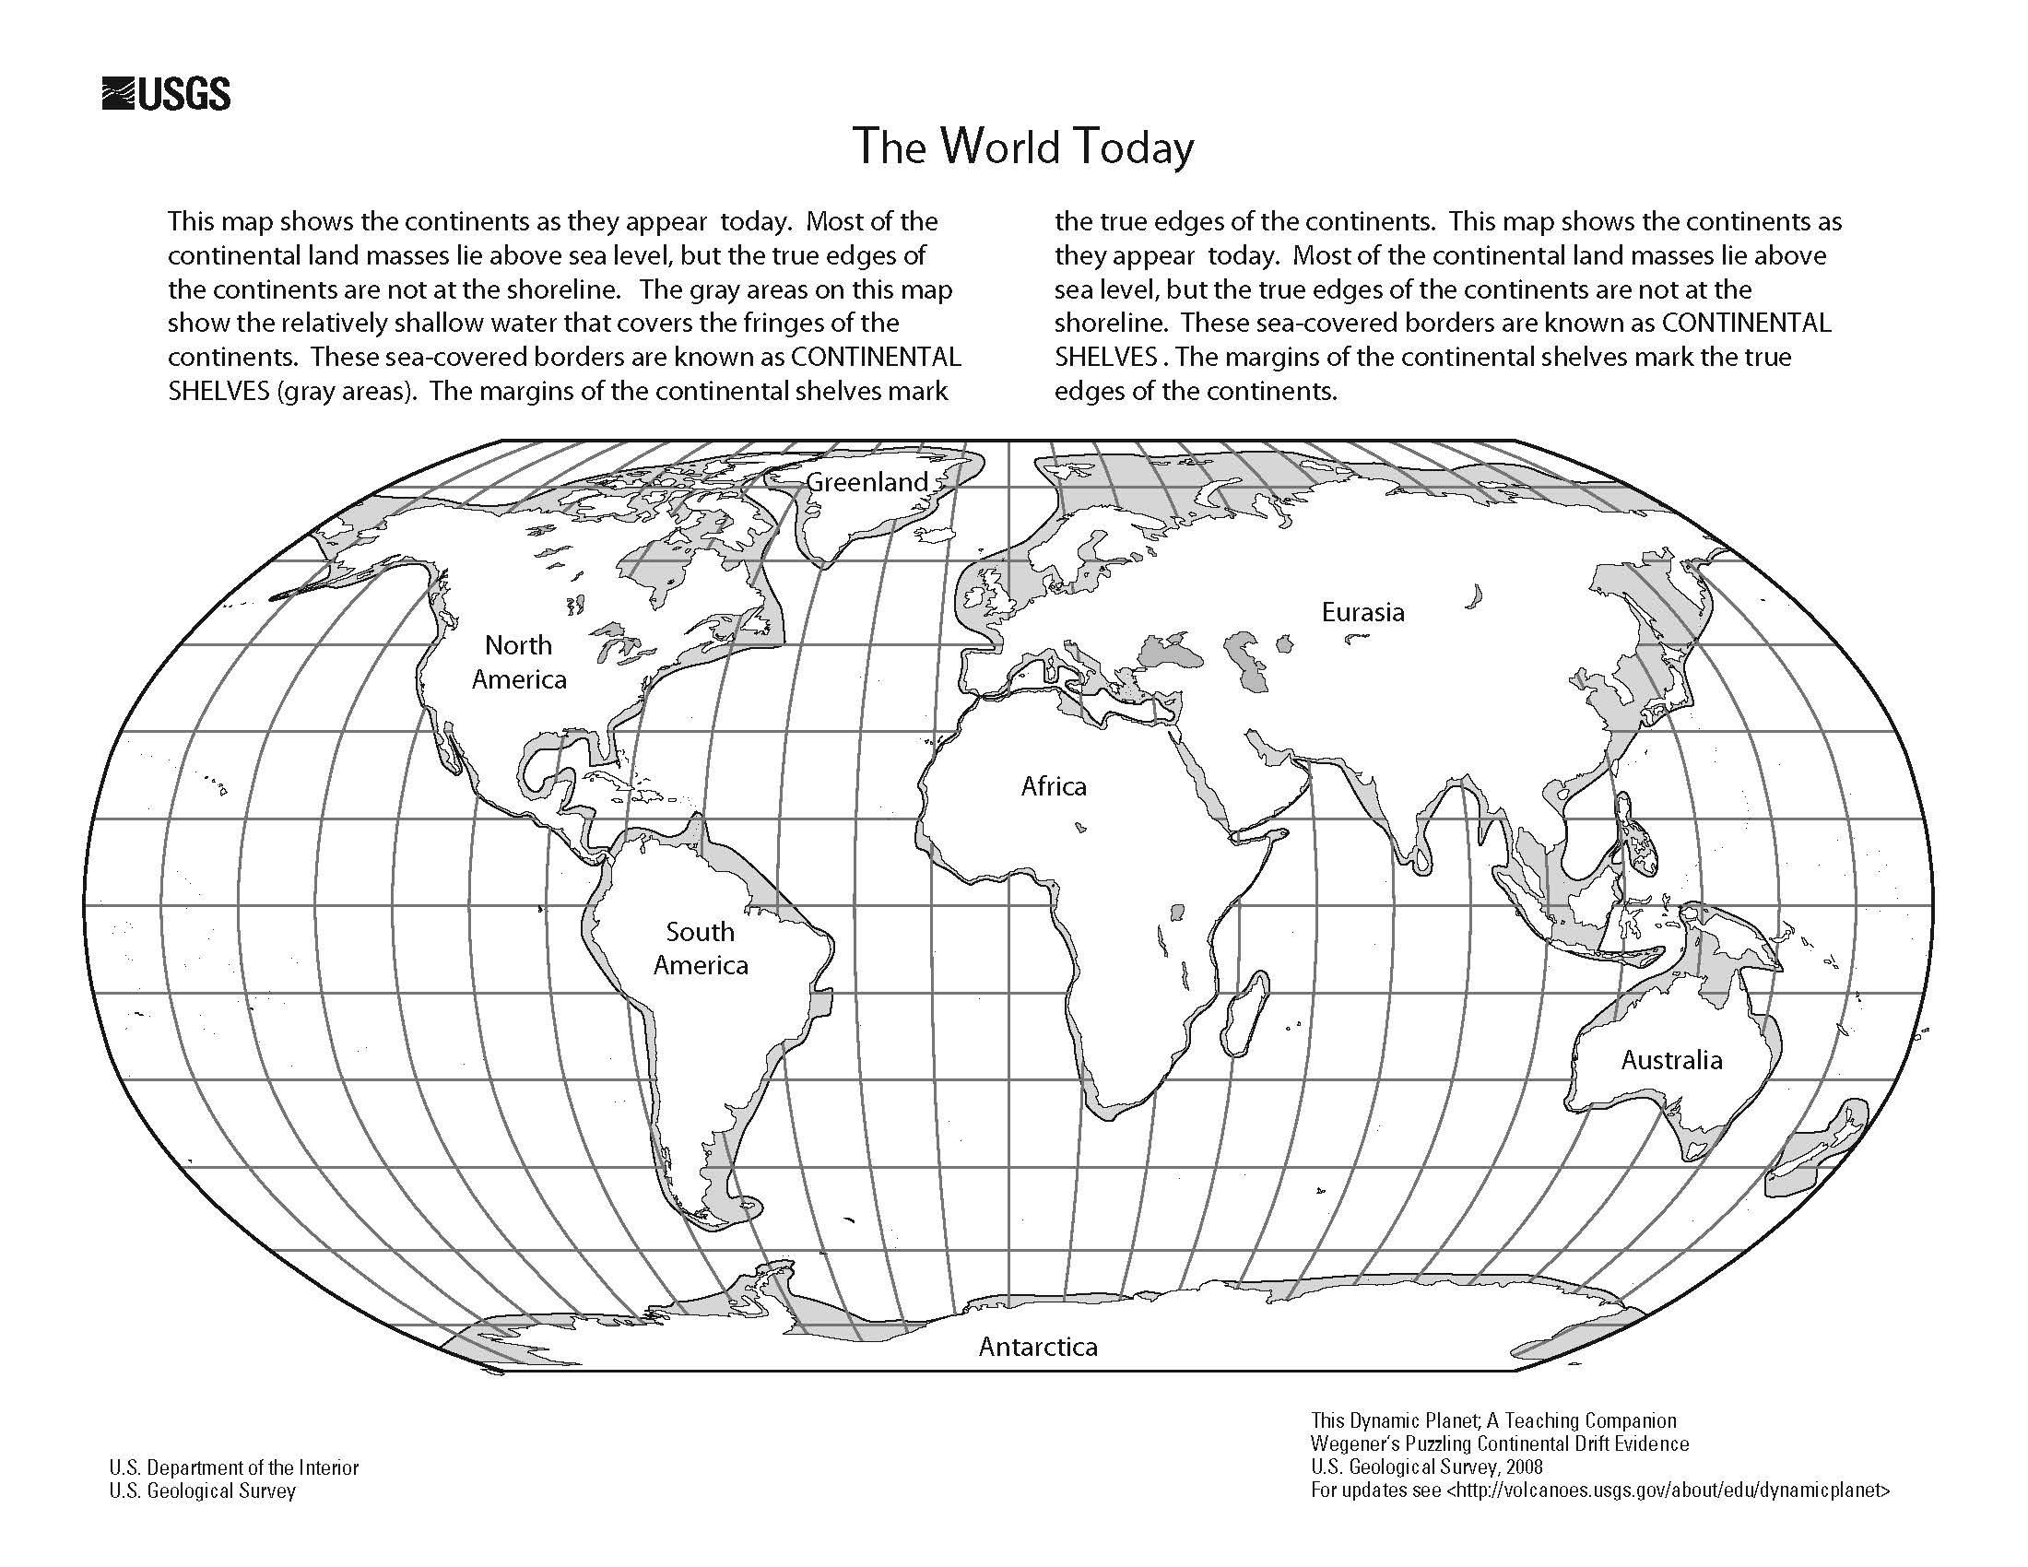

Present Day Map
Image from The Dynamic Planet: A Teaching Companion from US Geological Survey
Cut out these continents and put them together as one complete puzzle (Puzzle #1).
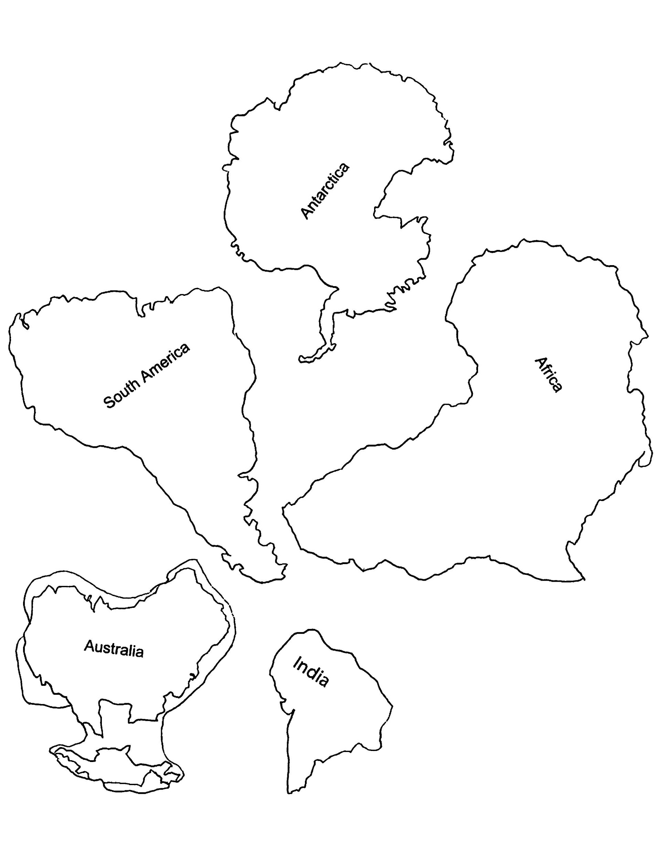

Image from The Dynamic Planet: A Teaching Companion from US Geological Survey

Cut out these continents and put them together using the evidence provided (Puzzle #2).
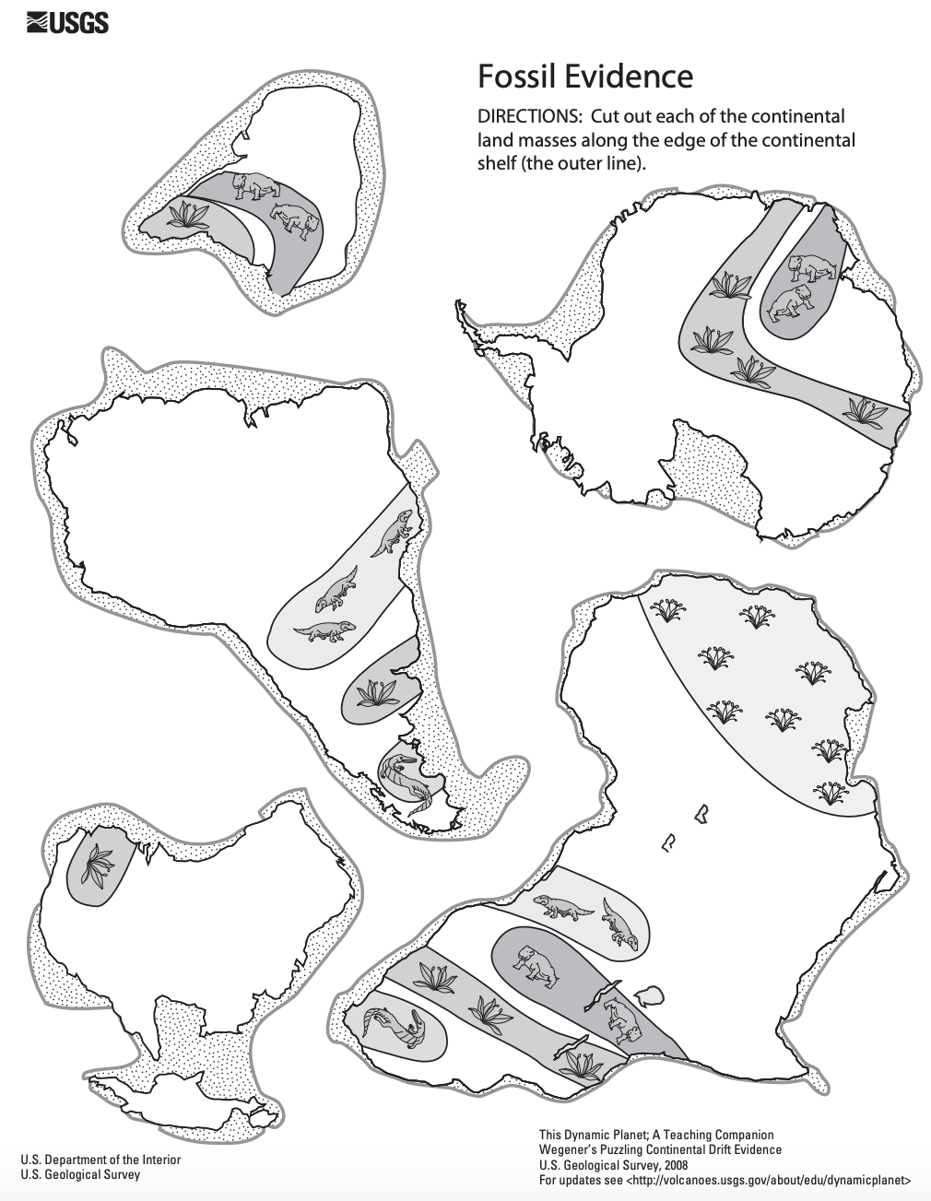

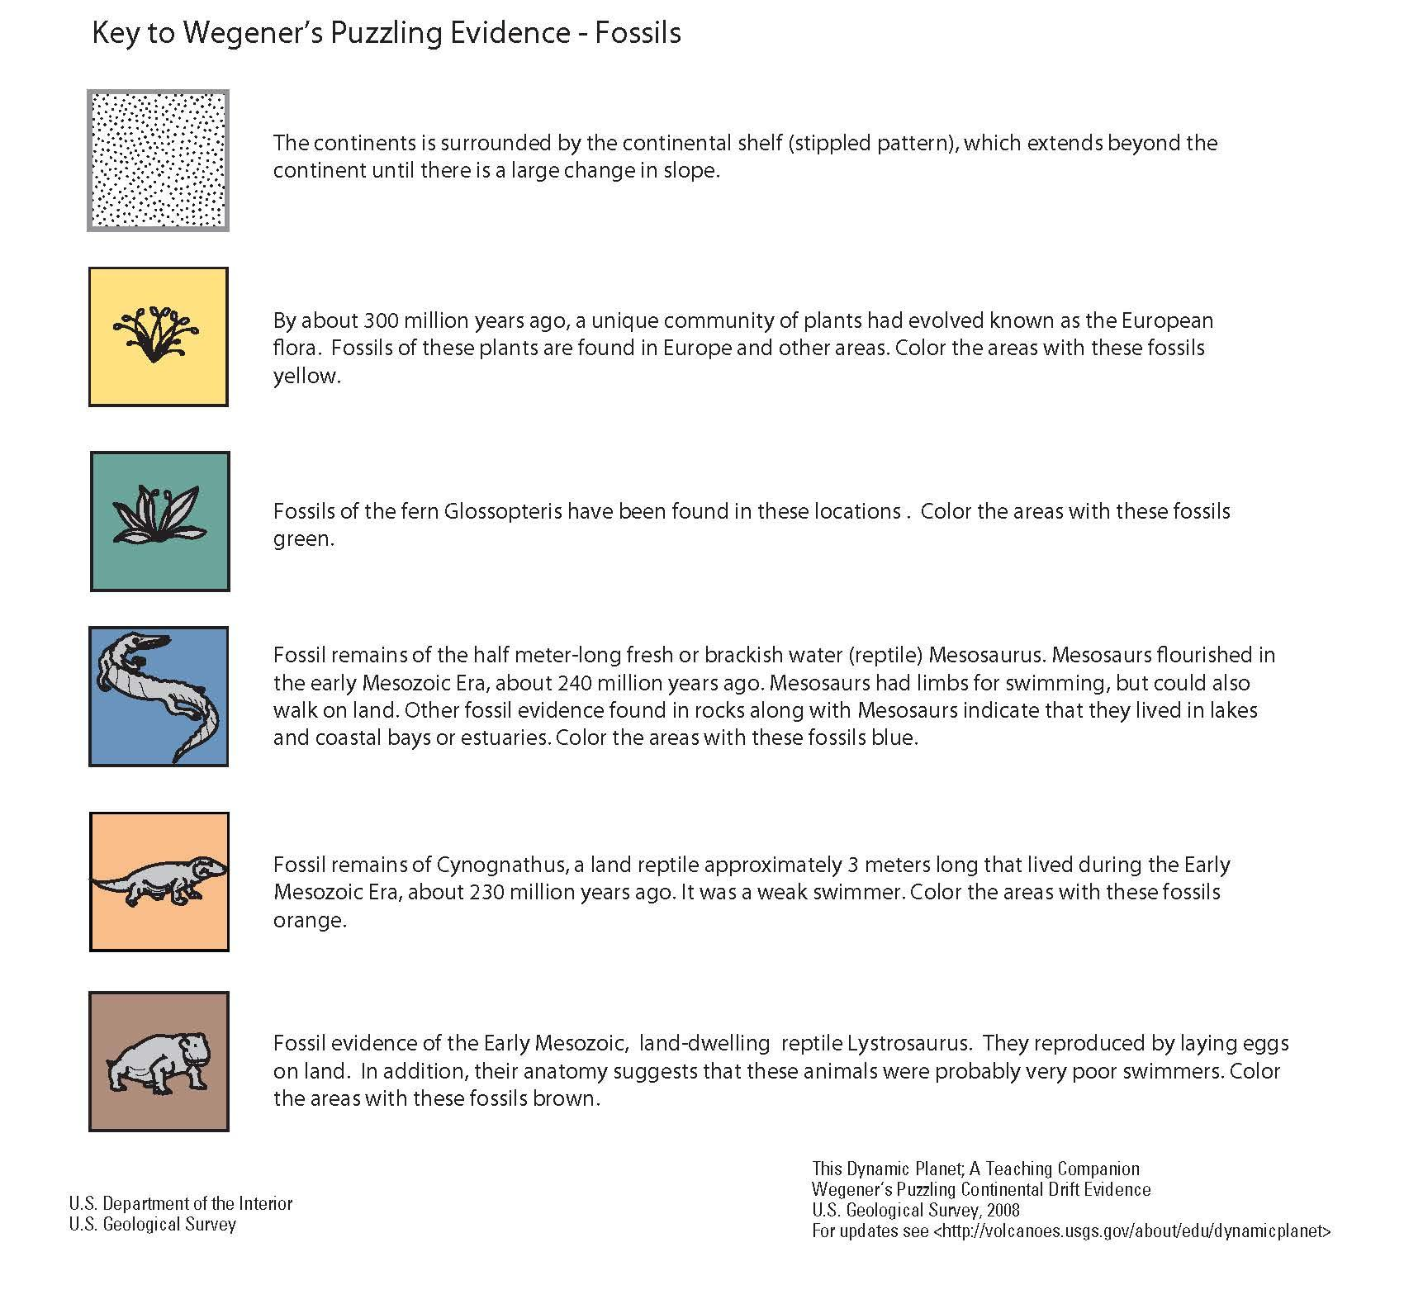

- Did the first puzzle you made look like the second puzzle you made? Provide reasons why or why not.

Part II

- What is a supercontinent? Use your puzzles to draft a definition.

- Comparing your supercontinent to the globe, are any continents missing? If so, which?

- If any continents are missing, why do you think they are missing from the supercontinent you constructed?

Cut out these continents and put them together as one complete puzzle (Puzzle #3).
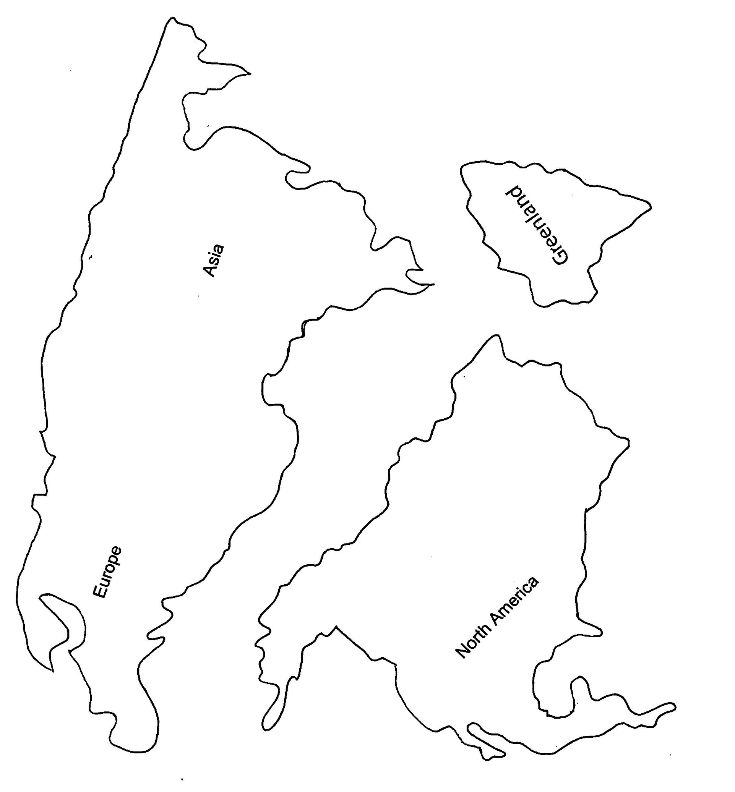

Image from The Dynamic Planet: A Teaching Companion from US Geological Survey

Cut out these continents and put them together as one complete puzzle (Puzzle #3 improved).

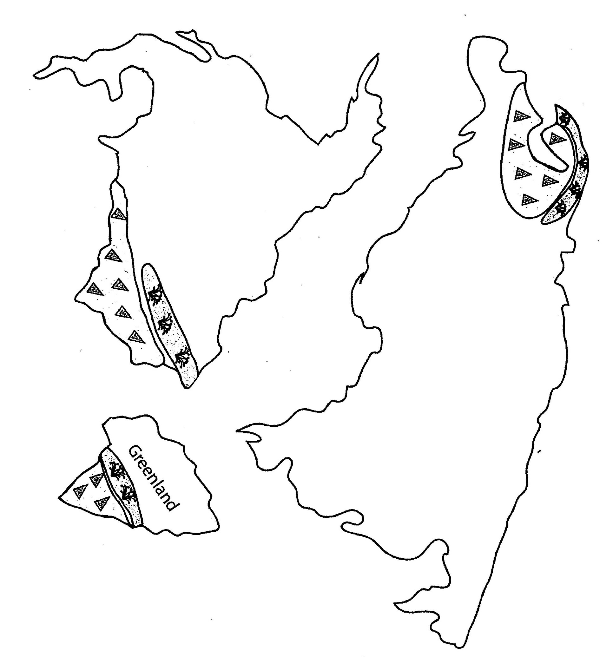

Image from The Dynamic Planet: A Teaching Companion from US Geological Survey via public domain

PART III

Name:_____________________________________________________________

Question: Did a supercontinent ever exist? Might a supercontinent ever exist again?

Claim:
Evidence:

Reasoning:

Supplemental Text:

