Synopsis of high-quality task:

Sophia is in 6th grade and she can buy a ticket for a 3-D movie for $11.50. When Sophia’s father was in 6th grade, in 1993, the cost of a movie ticket was $4.25.
- On his 12th birthday, Sophia's father was given $20.00 so he could take some friends to the movies. How many movie tickets could he buy with this money?

- How many movie tickets can Sophia buy for $20.00?

- On Sophia’s 12th birthday, her father said, “When I turned 12, my dad gave me $20 so I could go with three of my friends to the movies and buy a large popcorn. I'm going to give you some money so you can take three of your friends to the movies and buy a large popcorn.” How much money do you think her father should give her?

Anticipated student time spent on task: 30 minutes

Student task structure(s): Individual or partner work

Math Content Standards and Practices:

6.NS.B.3 Fluently add, subtract, multiply, and divide multi-digit decimals using the standard algorithm for each operation.

6.RP.A.1 Understand the concept of a ratio and use ratio language to describe a ratio relationship between two quantities.
SMP.1. Make sense of problems and persevere in solving them.
SMP.2. Reason abstractly and quantitatively.
SMP.4. Model with mathematics

Prior Knowledge:

5.NBT.B.5 Fluently multiply multi-digit whole numbers using the standard algorithm.
5.NBT.B.7 Add, subtract, multiply, and divide decimals to hundredths, using concrete models or drawings and strategies based on place value, properties of operations, and/or the relationship between addition and subtraction; relate the strategy to a written method and explain the reasoning used.

Connections to the real-world:

- Entertainment
- Money
- Social Relationships
- Family
- Financial Literacy - Inflation

Mastery Goals:

Learning Objective:
- Students will be able to interpret and compute products and quotients in real-life scenarios.
- Students will be able to describe a ratio relationship between two quantities.

Language Objective:
- Students will be able to describe and discuss with peers, a practical strategy for solving this real-world problem.

Teacher instructions
Instructional Tips/Strategies/Suggestions:

- Have students look at the movie tickets
- Ask students what they notice and wonder about the tickets. Write this information on the board. Shift the focus of the discussion to those that are relevant to the task (dates, cost of a movie ticket).
- Introduce the task to the students.
- Have students work in pairs to discuss which strategy and/or representation is best for solving the problem.
- Pull students back together to share their results and various methods used.
- Reveal the answer

- To find out how many tickets Sophia’s father could buy with $20, we divide 20 by the price of a single ticket: 20 ÷ 4.25 = 4.71
Since it's not possible to purchase a part of a ticket, this means that he could buy 4 tickets and will have some money left over.

Since 4 × 4.25 = 17.00 and 20 − 17.00 = $3.00
Sophia’s father could buy 4 movie tickets in 1993 with $20, and he would have $3.00 left over to purchase popcorn.

- To find out how many tickets Sophia can buy with $20, we divide 20 by the price of a single ticket:
20 ÷ 11.50 = 1.74
As before, it is impossible to buy part of a ticket. This means that Sophia can buy 1 ticket and will have some money left over.
1 × 11.50 = 11.50 and 20 − 11.50 = 8.50

Therefore, Sophia can buy 1 movie ticket if she has $20, and she will have $8.50 left over to purchase popcorn.

- Since 4 × $4.25 = $17.00, a large popcorn had to cost $3.00 or less if Sophia’s father bought it with the change from buying the tickets. Sophia’s movie ticket cost $11.50 ÷ $4.25 = 2.71 times as much as movie tickets cost in 1993. Assuming the price of popcorn increased at the same rate, and since 2.71 × $3.00 = $8.13, Sophia should be able to buy a large popcorn for $8.13. Four tickets will cost 4 × $11.50 = $46 dollars. With these assumptions, Sophia’s father should give her at least $54.13. Or, when rounding, $55.00.

Instructional Materials/Resources/Tools:

Include:
- Student directions for completing the task
- A materials list and/or materials management
- Safety information if applicable
- Any handouts, links, books, videos, materials, etc. that is needed for the student to complete the task
- Scoring rubric – Focus on including the standards-content and practices for performance criteria. Less focus should be on presentation style, design, etc. unless it is tied directly to an ELA standard.

Accessibility and Supports:

Key academic vocabulary:
Inflation

STUDENT SHEET

Name: ________________________________________

Sophia is in 6th grade and she can buy a ticket for a 3-D movie for $11.50. When Sophia’s father was in 6thgrade, in 1993, the cost of a movie ticket was $4.25.

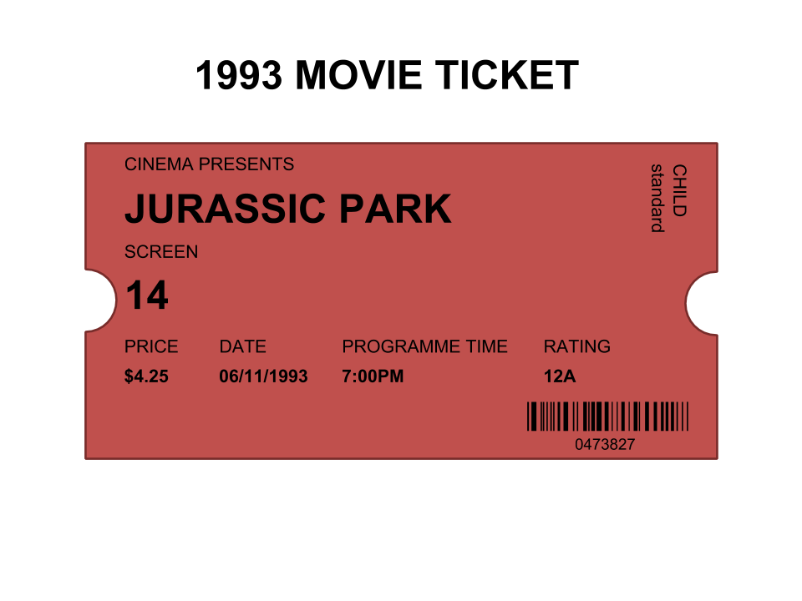
- On his 12th birthday, Sophia's father was given $20.00 so he could take some friends to the movies. How many movie tickets could he buy with this money?

- How many movie tickets can Sophia buy for $20.00?

- On Sophia’s 12th birthday, her father said, “When I turned 12, my dad gave me $20 so I could go with three of my friends to the movies and buy a large popcorn. I'm going to give you some money so you can take three of your friends to the movies and buy a large popcorn.” How much money do you think her father should give her?

Sample Student Work:

