Synopsis of high-quality task:

Through a 3-Act Task students experience videos of Usain Bolt and a cheetah running, and notice and wonder about the images. They determine how fast Usain Bolt was running in miles per hour, given his speed in meters per second. They also compare his speed to the average speed of five different land animals.

As an extension, small groups can determine how their own average speed compares to Usain Bolt’s, and to that of animals such as the cheetah.

This lesson is intended to take place at the beginning of a unit where students create ratios to calculate conversions.

Anticipated student time spent on task: 45 minutes

Student task structure(s): Individual work/ optional group work

Math Content Standards and Practices:

7.RP.A.2 Recognize and represent proportional relationships between quantities.
7.RP.A.3 Use proportional relationships to solve multi-step ratio, rate, and percent problems.

SMP1 Make sense of problems, and persevere in solving them.
SMP2 Reason abstractly and quantitatively.
SMP6 Attend to precision.

Prior Knowledge:

6.RP.A.3 Use ratio and rate reasoning to solve real-world and mathematical problems, e.g., by reasoning about tables of equivalent ratios, tape diagrams, double number line diagrams, or equations.

Connections to the real-world:

Usain Bolt is the current fastest runner in the world. Watching him run is truly impressive. The connection to a cheetah pushes the thinking of how fast a human can run. Students who have experience racing will hopefully find this to be an engaging activity, and may encourage more thinking about how fast a person or animal can travel by foot. Students learn that they can answer questions about speed, and make comparisons of the speeds of different moving objects, using math.

Mastery Goals:

Learning Objective:
Students will be able to use proportional relationships to convert kilometers per hour and meters per second to miles per hour.

Language Objective:
Students will be able to write and discuss what they notice and wonder about two videos regarding speed, calculate speed as distance divided by time, and compare the results of their calculations with each other.

Teacher instructions

Part I: Three Act Task
Act 1: Show the video clips of Usain Bolt running the 300m sprint, and a cheetah running at top speed. The cheetah video gives the cheetah’s speed in km/hr. The Bolt video gives his time at 100m, 200m, and 300m. In addition, it gives the World Record and the Meet Record.

(Independent think time while they write first, then turn and talk to a partner)
Turn and talk to a partner:
- What do you notice?
- What do you wonder?
I wonder how fast those runners were moving!
Act 2: What do we need to know in order to find out how fast they were going?
- Speed
- Distance traveled
- Time spent running

Cheetah | Usain Bolt
102 km/hr | 300 meters in 30.97 seconds

Who do you think was faster? What unit of speed can we calculate quickly for Usain Bolt? (meters per second) How can we compare his speed with that of the cheetah?

(Project for students to see) Here is a table comparing top speeds of animals in miles per hour. 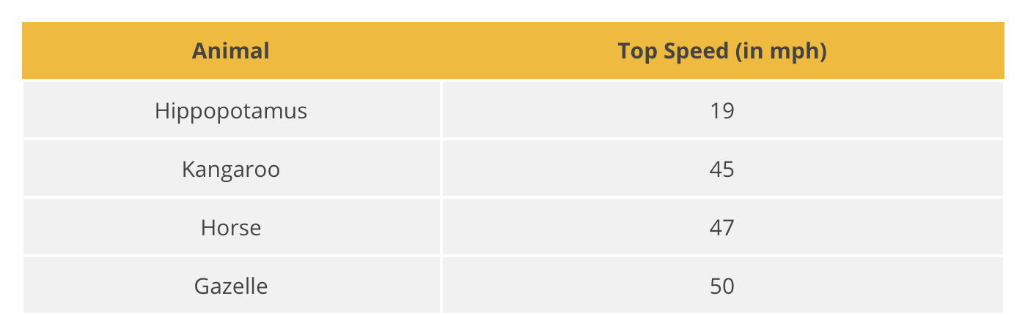
Where do you think the cheetah will fall on this table? Where do you think Usain Bolt will fall on this table? Do you think he can run as fast as a cheetah? As fast as a running hippopotamus?

Calculate it. How can we compare their speeds to those in the table? We will need to convert both speeds to miles per hour!
More useful information:
- 1.609 km in a mile (so how many meters in a mile?)
- 60 seconds in 1 minute
- 60 minutes in 1 hour

Act 3: cheetah: 102 km/hr => 63.39 mph, Bolt: 300m/30.97s => 21.67 mph
Show the Usain Bolt vs. Cheetah video. The cheetah is WAY faster than Usain Bolt!

Part II: Where do YOU fall on the table?
In groups of 4, measure out 10 meters. Time each other running 10 meters three times, and determine your Average Speed in m/s (average the three times). At your average speed, how long would it take you to run 100 meters? Then convert your speed to mph.

Instructional Materials/Resources/Tools:

Videos:
Cheetah video: https://www.youtube.com/watch?time_continue=1&v=zgQ0cyNJZV4 (40 sec)
Usain Bolt video: https://www.101qs.com/1973-bolt-conversion (47 sec)
Usain Bolt vs. Cheetah video: https://www.youtube.com/watch?v=yf2rf4R6ONM (2 min)

Table (from Illustrative Math): https://tasks.illustrativemathematics.org/content-standards/7/RP/A/3/tasks/1490

For part II:
- Meter sticks (1-2 per group of 4)
- Timers (1 per group)
- Space for 10 meters (hallway, gym, or outside)
- Tape for marking off start and finish line
- The Need for Speed Worksheet

Accessibility and Supports:

Potential sentence starters:
I notice that ____________.
I wonder about ____________.

Key academic vocabulary: Average speed versus “average”, Distance, Time, Meters per second, Miles per hour

Name: Date:

The Need for Speed
Act I: Watch the two videos.
 | What do you notice? | What do you wonder?
Cheetah
Usain Bolt

Act II: What question are we trying to answer?

Act III: Make your calculations in the space below. Use scrap paper if needed.

With your group, measure out 10 meters on the floor or ground. Time each other running 10 meters three times, and write your own times in the table below.

Distance | Time 1 | Time 2 | Time 3

What is your average time to run 10 meters?

What is your average speed, in meters per second (m/s)?

At your average speed, how long would it take you to run 100 meters?

Convert your speed to mph.

Sample Student Work