Synopsis of high-quality task:
Students interpret and analyze proportions in the context of a salt water mixture.
Anticipated student time spent on task: 55 minutes

Student task structure(s): Individual work, partner work, and group work

Task Source: https://www.illustrativemathematics.org/content-standards/tasks/180
Math Content Standards and Practices:
7.RP.A.1 Compute unit rates associated with ratios of fractions, including ratios of lengths, areas, and other quantities measured in like or different units.

7.RP.A.2 Recognize and represent proportional relationships between quantities.
a. Decide whether two quantities are in a proportional relationship, e.g., by testing for equivalent ratios in a table, or graphing on a coordinate plane and observing whether the graph is a straight line through the origin.
b. Identify the constant of proportionality (unit rate) in tables, graphs, equations, diagrams, and verbal descriptions of proportional relationships.
c. Represent proportional relationships by equations. For example, if total cost t is proportional to the number n of items purchased at a constant price p, the relationship between the total cost and the number of items can be expressed as t = pn.
d. Explain what a point (x, y) on the graph of a proportional relationship means in terms of the situation, with special attention to the points (0, 0) and (1, r) where r is the unit rate.

7.RP.A.3 Use proportional relationships to solve multi-step ratio, rate, and percent problems.

7.EE.B.4 Use variables to represent quantities in a real-world or mathematical problem, and construct simple equations and inequalities to solve problems by reasoning about the quantities.

SMP.1 Make sense of problems and persevere in solving them.
SMP.2 Reason abstractly and quantitatively.
SMP.7 Look for and make use of structure.
Prior Knowledge:
6.RP.A.1 Understand the concept of a ratio including the distinctions between part:part and part:whole and the value of a ratio; part/part and part/whole. Use ratio language to describe a ratio relationship between two quantities.

6.RP.A.2 Understand the concept of a unit rate a/b associated with a ratio a:b with b$≠$0, and use rate language in the context of a ratio relationship, including the use of units.

6.RP.A.3 Use ratio and rate reasoning to solve real-world and mathematical problems, e.g., by reasoning about tables of equivalent ratios, tape diagrams, double number line diagrams, or equations.
- Make tables of equivalent ratios relating quantities with whole-number measurements. Find missing values in the tables, and plot the pairs of values on the coordinate plane. Use tables to compare ratios.
- Solve unit rate problems including those involving unit pricing, and constant speed.
- Find a percent of a quantity as a rate per 100 (e.g., 30% of a quantity means 30∕100 times the quantity); solve problems involving finding the whole, given a part and the percent.
- Use ratio reasoning to convert measurement units within and between measurement systems; manipulate and transform units appropriately when multiplying or dividing quantities.

6.EE.B.6 Use variables to represent numbers and write expressions when solving a real-world or mathematical problem; understand that a variable can represent an unknown number, or, depending on the purpose at hand, any number in a specified set.

6.EE.C.9 Use variables to represent two quantities in a real-world problem that change in relationship to one another; write an equation to express one quantity, thought of as the dependent variable, in terms of the other quantity, thought of as the independent variable. Analyze the relationship between the dependent and independent variables using graphs and tables, and relate these to the equation.

Connections to the real-world:
- Sickness
- Remedies
- Teamwork
- Understanding interactions within mixtures
- Measuring
Mastery Goals:
Learning Objective:
- Students will be able to utilize multiple representations as they solve a real life problem incorporating a proportional relationship. Setups may include proportions (equivalent fractions), tables, graphs, and equations.
- Students will be able to adjust fractions and decimals to compare ratios in a real world situation.
- Students will show mastery of inverse operations within 1 step equations.

Language Objective:
- Students will be able to discuss, debate, and verbally explain strategies behind their choice of representation.
Teacher instructions

Whole Class Introduction of the task:
- Display the cartoon above (optional) and then the following scenario...

Liz and Brian both had a sore throat, so their mother told them to gargle with warm salt water.
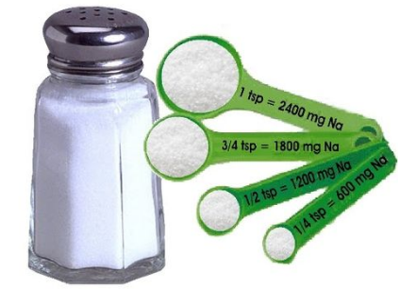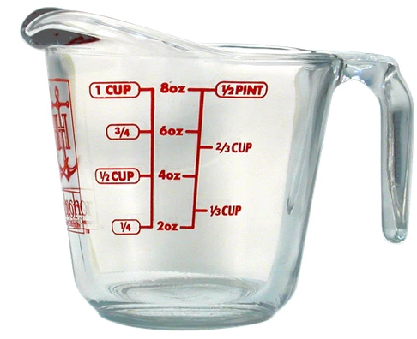
Brian mixed ⅔ of a teaspoon of salt with 1 ¾ cups of water.
Liz mixed 1 ½ teaspoons of salt with 4 ⅕ cups of water.
Liz told Brian, “I added more salt so mine must be more salty.”
- Without allowing any calculations, discuss as a class whether Liz’s claim must be true, could be true, or must be false.
Completion of the task: Students work independently or in pairs to complete parts a - c using the student handout at the end of this task.
- Is Liz’s claim that her warm salt water mixture is saltier correct? Justify your reasoning.
- At school the next day, Ryan overheard Liz talking about feeling much better and asked her for her warm salt water recipe because his throat had been sore for the past few days. However, when Ryan got home that afternoon he realized he only had ⅝ of a teaspoon of salt. How much warm water should Ryan mix the ⅝ of a teaspoon of salt with in order for the ratio of water to salt to be the same as in Liz’s recipe?
- Write three equations that show the relationship between s, the number of teaspoons of salt, and w, the number of cups of water, in Brian’s warm salt water mixture.

Wrap Up of the task:
Whole class discussion about mathematical approach to parts a & b and a list of various possible equations for part c.

Instructional Tips/Strategies/Suggestions:
- There is a non-mathematical fact that students must know about mixtures in order to answer this question. When salt is dissolved in water, the salt disperses evenly through the mixture, so any sample from the mixture that has the same volume will have the same amount of salt. This is not something that kids could know prior or by reasoning about it. For example, the same is not true when you mix sand and water. In general, it is important to know what facts about the world warrant applying a particular mathematical structure in a given context. In this particular case, teachers may need to provide some background knowledge or help students explain why a ratio is an appropriate mathematical tool in this context.
- Post or hand-out part 1 for students to view.
- Provide time for each individual student to reflect on what they view to be the most effective method for solving, without putting pen to paper.
- Check students’ solutions after part a.
- Encourage students to consider other fractions that would create proportional relationships to those given for Liz and Brian.
- To increase difficulty and promote flexibility, suggest students have equations in part c with s isolated and w isolated.
- As a possible extension, have students try part b over again, this time trying to match with Brian’s recipe.
Accessibility and Supports:

Potential sentence starters:

While students are discussing and sharing with their partners, invite them to use the sentence frame:
“For the mixtures to taste the same, _______________ has to be true/must be equal.”
“The best way to compare the rates is _______________________ because _______________.”

Key academic vocabulary:
- ratio
- rate
- unit rate
- complex fraction
- proportion/ proportional relationship
- inverse operations
- equation

Task Solution:
- The ratio of the number of teaspoons of salt to the number of cups of water in Brian’s mixture is ⅔: 1 ¾, so there are 2.625 cups of water for every teaspoon of salt or 8 teaspoons of salt for every 21 cups of water or 16 teaspoons of salt for every 42 cups of water.

The ratio of the number of teaspoons of salt to the number of cups of water in Liz’s mixture is 1 ½: 4 ⅕, so there are 2.8 cups of water for every teaspoon of salt or 5 teaspoons of salt for every 14 cups of water or 15 teaspoons of salt for every 42 cups of water.

Therefore, since Brian’s mixture has fewer cups of water per teaspoon of salt or more teaspoons of salt in 42 cups of water, his mixture is saltier.

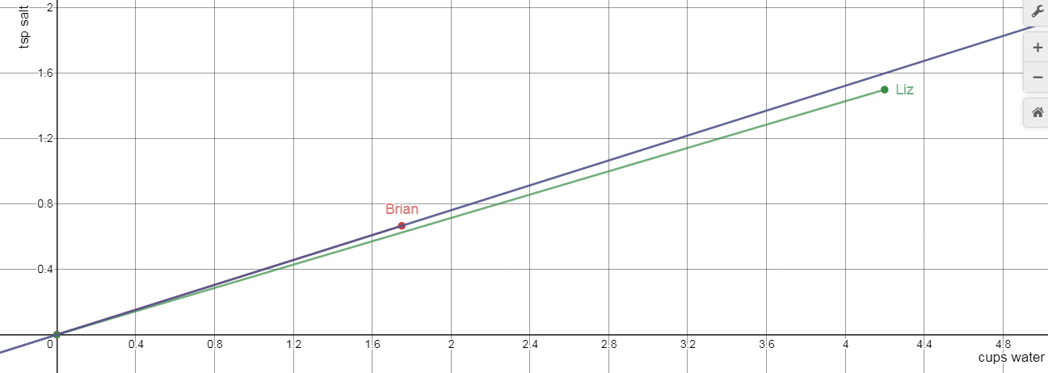
- Ryan will need 1 ¾ cups of water, so the ratio of the number of teaspoons of salt to the number of cups of water in his mixture will be ⅝ : 1 ¾, which means that there will be 2.8 cups of water for every teaspoon of salt or 5 teaspoons of salt for every 14 cups of water, just as in Liz’s recipe.

- Correct equations include...
⅔ s = 1 ¾ w
2.625s = w
(21/8)s = w
21s = 8w
s = (8/21)w
Sample Student Work:
- Is Liz’s claim that her warm salt water mixture is saltier correct? Justify your reasoning.

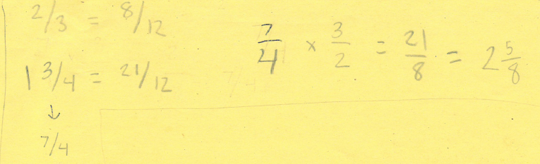

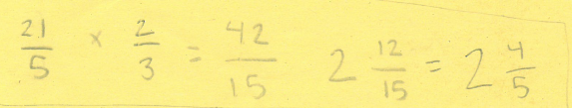

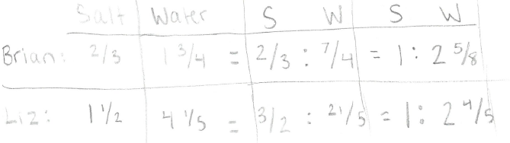
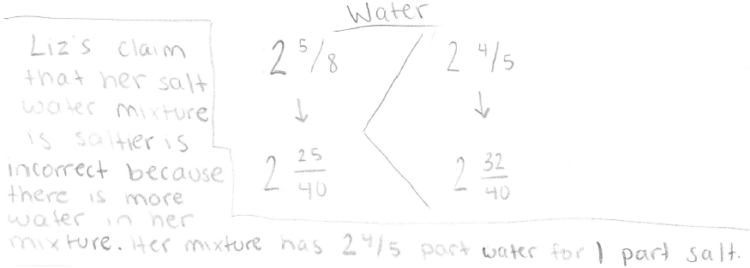
- At school the next day, Ryan overheard Liz talking about feeling much better and asked her for her warm salt water recipe because his throat had been sore for the past few days. However, when Ryan got home that afternoon he realized he only had ⅝ of a teaspoon of salt. How much warm water should Ryan mix the ⅝ of a teaspoon of salt with in order for the ratio of water to salt to be as the same as in Liz’s recipe?
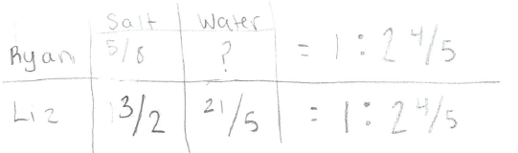
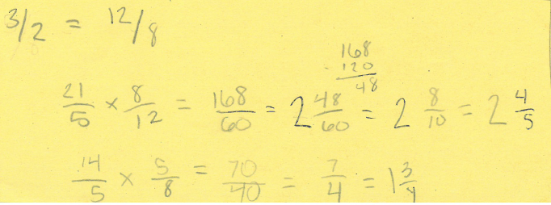

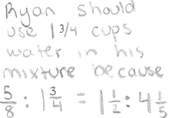
- Write three equations that show the relationship between s, the number of teaspoons of salt, and w, the number of cups of water, in Brian’s warm salt water mixture.

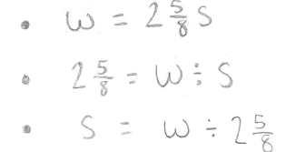

Student Handout:

Name __________________________

7th Grade Salty Proportions

Liz and Brian both had a sore throat, so their mother told them to gargle with warm salt water.

Brian mixed ⅔ of a teaspoon of salt with 1 ¾ cups of water.
Liz mixed 1 ½ teaspoons of salt with 4 ⅕ cups of water.
Liz told Brian, “I added more salt so mine must be more salty.”

- Is Liz’s claim that her warm salt water mixture is saltier correct? Justify your reasoning.

- At school the next day, Ryan overheard Liz talking about feeling much better and asked her for her warm salt water recipe because his throat had been sore for the past few days. However, when Ryan got home that afternoon he realized he only had ⅝ of a teaspoon of salt. How much warm water should Ryan mix the ⅝ of a teaspoon of salt with in order for the ratio of water to salt to be as the same as in Liz’s recipe?

- Write three equations that show the relationship between s, the number of teaspoons of salt, and w, the number of cups of water, in Brian’s warm salt water mixture.

