Synopsis of high-quality task:

Students discuss and determine if a student has enough money to pay and provide adequate tip for an Uber ride to his friend’s house.

Anticipated student time spent on task: 40 minutes

Student task structure(s): Individual work and Partner work

Math Content Standards and Practices:

7.RP.A.3 Use proportional relationships to solve multi-step ratio, rate, and percent problems.
7.EE.A.2 Understand that rewriting an expression in different forms in a problem context can shed light on the problem and how the quantities in it are related.
7.EE.B.3 Solve multi-step real-life and mathematical problems posed with positive and negative rational numbers in any form (whole numbers, fractions, and decimals), using tools strategically. Apply properties of operations to calculate with numbers in any form; convert between forms as appropriate; and assess the reasonableness of answers using mental computation and estimation strategies.
7.EE.B.4 Use variables to represent quantities in a real-world or mathematical problem, and construct simple equations and inequalities to solve problems by reasoning about the quantities.
- Solve word problems leading to equations of the form px + q = r and p(x ÷ q) = r, where p, q, and r are specific rational numbers. Solve equations of these forms fluently. Compare an algebraic solution to an arithmetic solution, identifying the sequence of the operations used in each approach.
- Solve word problems leading to inequalities of the form px + q > r or px + q < r, where p, q, and r are specific rational numbers. Graph the solution set of the inequality and interpret it in the context of the problem.
- Extend analysis of patterns to include analyzing, extending, and determining an expression for simple arithmetic and geometric sequences (e.g., compounding, increasing area), using tables, graphs, words, and expressions.

SMP.1 Make sense of problems and persevere in solving them.
SMP.2 Reason abstractly and quantitatively.
SMP.6 Attend to precision.

Prior Knowledge:
6.RP.A.2 Understand the concept of a unit rate a/b associated with a ratio a:b with b $≠$0, and use rate language in the context of a ratio relationship, including the use of units.

6.RP.A.3 Use ratio and rate reasoning to solve real-world and mathematical problems, e.g., by reasoning about tables of equivalent ratios, tape diagrams, double number line diagrams, or equations.
- Make tables of equivalent ratios relating quantities with whole-number measurements. Find missing values in the tables, and plot the pairs of values on the coordinate plane. Use tables to compare ratios.
- Solve unit rate problems including those involving unit pricing, and constant speed.
- Find a percent of a quantity as a rate per 100 (e.g., 30% of a quantity means 30∕100 times the quantity); solve problems involving finding the whole, given a part and the percent.

6.EE.B.5 Understand solving an equation or inequality as a process of answering a question: Which values from a specified set, if any, make the equation or inequality true? Use substitution to determine whether a given number in a specified set makes an equation or inequality true.
6.EE.B.6 Use variables to represent numbers and write expressions when solving a real-world or mathematical problem; understand that a variable can represent an unknown number, or, depending on the purpose at hand, any number in a specified set.
6.EE.B.7 Solve real-world and mathematical problems by writing and solving equations of the form x + p = q and px = q for cases in which p, q, and x are all nonnegative rational numbers.
6.EE.C.9 Use variables to represent two quantities in a real-world problem that change in relationship to one another; write an equation to express one quantity, thought of as the dependent variable, in terms of the other quantity, thought of as the independent variable. Analyze the relationship between the dependent and independent variables using graphs and tables, and relate these to the equation.
7.NS.A.3 Solve real-world and mathematical problems involving the four operations with integers and other rational numbers.
Connections to the real-world:
- Texting with friends
- Tipping
- Transportation - ride share
- Technology - video games
Mastery Goals:
Learning Objective:
- Students will be able to utilize multiple representations as they solve a real-life percent problem. Setups may include proportions, tables, and inequalities.
- Students will be able to manipulate a fraction into decimals and percentages in a real world situation.

Language Objective:
- Students will be able to discuss, debate, and verbally explain strategies behind their choice of representation.

Teacher instructions
Instructional Tips/Strategies/Suggestions:

- Present text exchange to class.

Yeah, what time?

Jack
My house? I have to stay home with my sister
What about Uber?
Fortnite later?
10:30 work?
I don’t have a ride
Good idea!
Details
Messages

- Provide time for each individual student to reflect on what they view to be the most effective method for solving, without putting pen to paper.
- Discuss the factors that would impact whether this person is able to take an Uber to Jack’s house. (Note: For this task to work, students will need to suspend knowledge of the fact that payment for Uber is done through a credit card on file and pretend instead that cash is exchanged during transit.)
- Discuss the different strategies students would like to implement. For example, bar diagrams and tables can be used to represent the relationship between fractions and parts of a whole. Record student responses on board for all to view.
- Consider pairing students based on common approach/strategies. (Hint: make sure students understand the pricing breakdown between the first mile and each subsequent mile)
- The task concludes with a synthesizing discussion of mathematical thinking.

Instructional Materials:
Include:
- Student Handout with student directions
- Scoring rubric – Focus on including the standards-content and practices for performance criteria. Less focus should be on presentation style, design, etc. unless it is tied directly to an ELA standard.
Accessibility and Supports:

Potential sentence starters:
While students are discussing and sharing with their partners, invite them to use the sentence frame:
“The best way to represent the rate structure is _______________________ because _______________.”
“To show the Uber rates, we decided to use a _____________________ because __________________.”

Key academic vocabulary:
- percent
- tip
- rate
- algebraic equation/inequality
Sample Student Work:

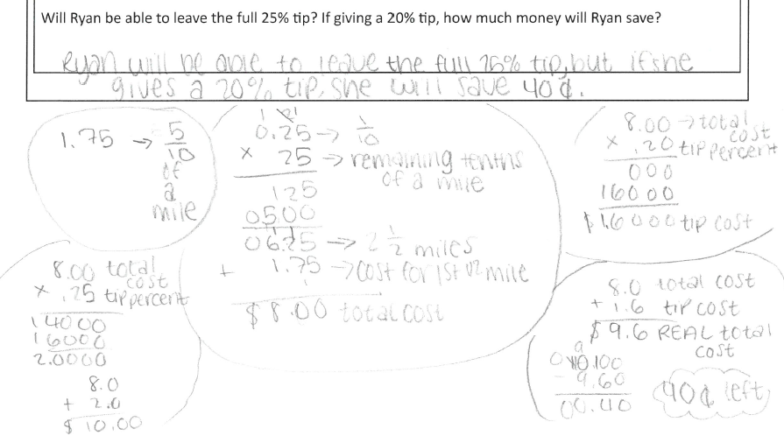

Student Handout:
Name __________________________

7th Grade Uber Ride (Percents/Parts of a Whole)

Ryan wishes to take an Uber to a friend’s house, which is 3 miles away. Ryan has $10 and wishes to leave a 25% tip (Ryan’s a good tipper) but may have to leave a tip that’s less than 25%. When opening the Uber app, Ryan sees the following pricing breakdown:

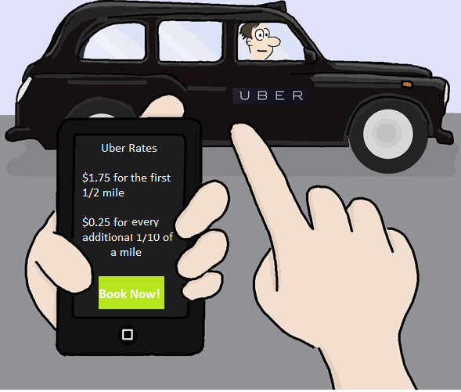
Will Ryan be able to leave the full 25% tip? If giving a 20% tip, how much money will Ryan save?

