Synopsis of high-quality task:

Students will complete this task after building background knowledge about linear relationships and how to represent them using a table and a graph. Students will use their prior knowledge of unit rates and proportions to complete this task.

Anticipated student time spent on task: 90 minutes (two 45-minute class periods)

Student task structure(s): partner work

Math Content and Practice Standards:

7.RP.A1 Compute unit rates associated with ratios of fractions, including ratios of lengths, areas, and other quantities measured in like or different units.
7.RP.A2b Identify the constant of proportionality (unit rate) in tables, graphs, equations, diagrams, and verbal descriptions of proportional relationships.

SMP1 Make sense of problems and persevere in solving them.
SMP4 Model with mathematics.
SMP7 Attend to precision.
Prior Knowledge:
6.RP.A Understand ratio and rate concepts and use ratio and rate reasoning to solve problems.
Connections to the real-world:

Many students have a routine of meeting friends someplace after school on Fridays or other special days. In this case, on Fridays and early release days many students walk from school to the center of the town (particularly Dunkin’ Donuts) with their friends. The problem in this scenario relates to students’ experiences.

Mastery Goals:

Learning Objective:
Students will be able to use unit rates to determine how long it will take them to catch up with a friend and how far away they are from a destination.

Language Objective:
Students will be able to explain the meaning of a graphical representation in the context of a scenario.

Teacher instructions
Instructional Tips/Strategies/Suggestions:

Students should work in pairs on this task so they may discuss different ways to approach this problem. Introduce the task by projecting it to the full class. Discuss the rubric as well.
On the second day, students will work on completing this task. If they finish early, they may work on the extensions provided.

Instructional Materials:
- Student handout
- Graph paper
- Ruler
- Lined paper

Accessibility and Supports:

Potential prompts for students:
- How far along will your friend be when you begin walking?
- How much of a head start does your friend have?

Key academic vocabulary:
- Table
- Graph
- Unit Rates
- Rates
- Constant of Proportionality
- Proportions

Student Worksheet

Name: __________________________________

Walking Rates
Work with a partner to solve the following problem. Be sure to show all your work.

You and your friend are planning to meet after school at Dunkin Donuts in the center of the town. You had to talk to your teacher after school, so your friend left with some other friends. You started 5 minutes later than them. When you leave from the school, you start walking fast as you want to catch up with your friends. You notice on your Fitbit that you are walking at the rate of 0.07 miles per minute. When you call your friend, she tells you that she is walking at the rate of 0.04 miles per minute.

Here is a snapshot from Google Maps showing the distance from Oak to Dunkin Donuts:

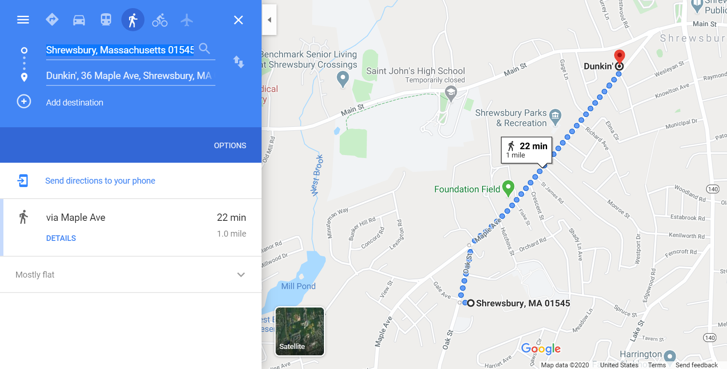

- How much time will it take you to catch up with your friends?
(Hint: A table would be helpful here!)
- How far away from Dunkin Donuts will you be once you meet up?
- Suppose you and your friends choose to continue at your walking rate. How much longer will it take you to reach Dunkin Donuts?
Your solution should include a graph.

**All work should be organized by problem on a separate sheet of plain paper.
Use graph paper for your graph.**
Extensions:

- If you left school at 2:35, what time would you and your friends arrive at Dunkin?

- What rate does Google predict you will walk? How do you think they make this prediction?

- Create a scale for this Google map to the center of the town.

Rubric
 | 4 | 3 | 2
Analysis/Interpretation | Accurate and complete interpretation of solutions as relating to the problem’s real world relevance. | Accurate OR complete interpretation of solutions as relating to the problem’s real world relevance. | Interpretation of solutions as relating to the problem’s real world relevance is neither accurate nor complete.
Mathematical Concepts | Work shows a full and in- depth understanding of proportional reasoning using rates. | Work shows proficient understanding of proportional reasoning using rates. | Work shows a limited understanding of proportional reasoning using rates..
Accuracy | Work is thorough and there are little to no errors. | Most work is shown. There may be a few errors. | Little work is shown and/or contains several inaccuracies.

Sample Student Work

