Synopsis of high-quality task:

Students are presented with an image and a prompt as a hook. The image shows two fish tanks: one empty and one full. Students describe what the image and table of information are showing and then write equations to represent the changing situation. Students use the equations to determine if there is a time when both tanks will have the same amount of water. This activity falls in the middle of the equations unit after students have learned how to solve equations with one variable where the variable occurs on both sides of the equal sign and before they begin solving equations in two variables.

Anticipated student time spent on task: 50 minutes

Student task structure(s): Partners or small groups

Math Content Standards and Practices:

8.EE.C.7. Solve linear equations in one variable.

8.EE.C.8. Analyze and solve pairs of simultaneous linear equations.

SMP 1. Make sense of problems and persevere in solving them.
SMP 2. Reason abstractly and quantitatively.
SMP 3. Construct viable arguments and critique the reasoning of others.

Prior Knowledge:

6.NS.B.3. Fluently add, subtract, multiply, and divide multi-digit decimals using the standard algorithm for each operation.

7.EE.B.4. Use variables to represent quantities in a real-world or mathematical problem, and construct simple equations and inequalities to solve problems by reasoning about the quantities.

7.RP.A.3. Use proportional relationships to solve multi-step ratio, rate, and percent problems.

Connections to the real-world:

Students can use this experience to recognize that a wide variety of real-life situations can be represented by algebraic equations.

Mastery Goals:

Learning Objective:
Students will be able to write two expressions to represent two situations. They will also solve each expression and/or set the two expressions equal to one another to find a solution.

Language Objective:
Students will be able to orally share ideas for problem solving with a partner or small group, building on others’ ideas and clarifying their own.

Teacher instructions:

- Project image and table and engage in a notice and wonder. Facilitate discussion so that students understand the situation, drawing attention to similarities and differences in the table.
- If preferred, have students work with partners or small groups of 3-4 to complete worksheet 1 and then have discussion.
- At the end of the discussion, if students have not developed the question, the teacher should guide students toward, “How long it will take for the water in both tanks to reach the same level?” Discussion may include what information is needed to solve. To ground their work in reasonableness, you will likely want to establish an estimate for the time when the two tanks will have the same amount of water prior to students solving.
- Students should work together (either in partners or small groups) to solve.
Possible Questions to guide students toward equations:
What is happening to the water in each tank? Can you use the table to help you figure out specific details?
Where does the water level start in each tank? How can you use this information to help write your equation?
What is the amount of change in water in tank one after 5 minutes?
Is it the same amount of change every 5 minutes? What is the amount of change in 1 minute? Is there a constant of proportionality? How can you use this to help write your equation?
- Encourage use of multiple models to solve the problem. (example: double number line, equation, table, graphing)
- Whole group share of solution and processes used to solve the problem.

Instructional Materials/Resources/Tools:

Materials:
Student handouts (below)
Calculators (optional)

Answer Key:
Expressions: The amount of water (in liters) in:
tank 1 after t minutes is 30t + 25.
tank 2 after t minutes is -20t + 1000.

Time when both tanks will have the same amount of water:
30t + 25 = 1000 - 20t
T = 19.5 minutes

Accessibility and Supports:
            - Teacher may choose to share expressions with all students or use this opportunity to differentiate and only give the expressions to select groups
            - Prior to starting the problem, provide the fish tanks image to students who benefit from extra processing time
            - Pre-drawn double number-line or graph or table (in the range of the students’ estimates)
            - Allow students to describe what is happening to the tanks orally rather than in writing

Potential sentence starters:
I estimate the tanks will be at the same water level at _______ minutes because…..
The water in the tank is changing by _________liters every 5 minutes.

Key academic vocabulary: equal, equation, variable, justify, expression

Student worksheet #1

Tank 1 Tank 2
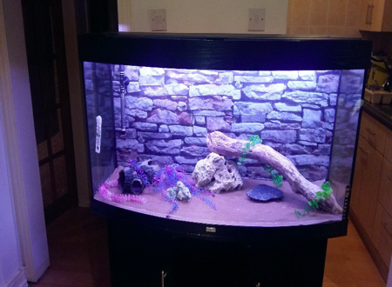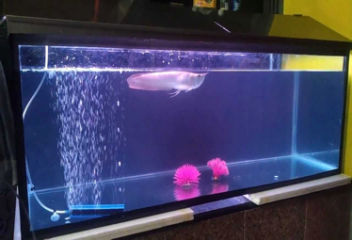

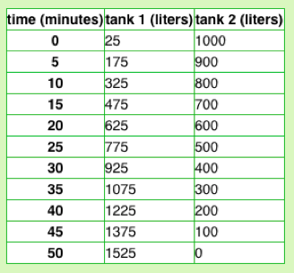

What do you notice? What do you wonder?

Describe what is happening in each tank.

What might the question be?

Student worksheet #2

Write an expression to represent the amount of water in tank 1 after t minutes.

Write an expression to represent the amount of water in tank 2 after t minutes.

Solve to find how long it will take for the water in both tanks to reach the same level. Show all work and justify your reasoning.

Sample Student Work:
