Task-Level Phenomena: Students observe object A and B.
Synopsis of high-quality task:
This task asks students to bridge the divide between colloquial descriptions of traits, characteristics or attributes, and the formal language and concepts of characteristic physical properties. The students are tasked with moving beyond the typical qualitative descriptors of matter (big, heavy, hard, etc.). They are required to successfully negotiate these challenges by acquiring and employing more precise, quantitative descriptors associated with the fundamental quantities (volume, mass, density, etc.). This task can be used as an introductory activity to a physical science unit.

Anticipated student time spent on task: 45 min block

Type of Task (check one):
_____ 1. Investigation/experimentation/design challenge
_____ 2. Data representation, analysis, and interpretation
__x__ 3. Explanation

Student task structure(s): Partner work

STE Standards and Science and Engineering Practices:

STE Standard:
8.MS-PS1-2. Analyze and interpret data on the properties of substances before and after the substances interact to determine if a chemical reaction has occurred.
Clarification Statements:
- Examples of reactions could include burning sugar or steel wool, fat reacting with sodium hydroxide, and mixing zinc with HCl.
- Properties of substances include density, melting point, boiling point, solubility, flammability, and odor.

Science and Engineering Practice:
- Obtaining, evaluating, and communicating information

Prior Knowledge:

Previous Standard from Strand Map:

6.MS-PS1-7. Use a particulate model of matter to explain that density is the amount of matter (mass) in a given volume. Apply proportional reasoning to describe, calculate, and compare relative densities of different materials.

6.MS-PS1-6. Plan and conduct and experiment involving exothermic and endothermic chemical reactions to measure and describe the release of thermal energy.
Clarification Statements:
- Emphasis is on describing transfer of energy to and from the environment.
- Examples of chemical reactions could include dissolving ammonium chloride or calcium chloride.

6.MS-PS1-8(MA). Conduct an experiment to show that many materials are mixtures of pure substances that can be separated by physical means into their component of pure substances.
Clarification Statement:
- Examples of common mixtures include salt water, oil and vinegar, milk, and air.

8.MS-PS1-1. Develop a model to describe that: (a) atoms combine in a multitude of ways to produce pure substances which make up all of the living and nonliving things that we encounter; (b) atoms form molecules and compounds that range in size from two to thousands of atoms; and (c) mixtures are composed of different proportions of pure substances.

Clarification Statements:
- Examples of molecular-level models could include drawings, three dimensional ball and stick structures, or computer representations showing different molecules with different types of atoms. Reactions could include burning sugar or steel wool, fat reacting with sodium hydroxide, and mixing zinc with HCl.
- Properties of substances include density, melting point, boiling point, solubility, flammability, and odor.

Connections to the real-world:
- Students interact with a variety of physical substances daily. This activity will create a greater awareness of the properties that exist within all matter.

Mastery Goals:

Learning Objective:
- Use observations to identify that all matter has physical properties.

Performance Objective:
- Through observations and discussions, describe specific physical properties of all matter (mass, volume, density, shape, and composition) They will be able to compare these physical properties for a variety of objects.

Language Objective:
- Students orally ask clarification questions through peer-to-peer or teacher-student interaction.
- Students use vocabulary terms volume, density, mass, and geometric shapes in writing.
Teacher instructions
Instructional Tips/Strategies/Suggestions:
This task has 5 parts.

Part: 1 Whole Class Observations:
- Students are presented with object (A) and make a list of one-word observations. Students share out with class and the teacher records unique observations on board.
- Repeat the process with object (B).
- Guide the class in separating observations of form vs. function, reducing the list to form terminology only (generic categories to steer toward or compile towards: size, weight, shape, composition).

Part 2: Small Group Station Observations:
- Groups of students move from station to station making observations about the additional objects (C-H). Handout the student observation form to each student.

Part: 3: Individual/Pairs Obtaining Information:
- Introduce the vocabulary boards (these should be made ahead of time by the teacher, see the images below for suggested terminology). The goal is for students to see how scientific terminology is essential, especially when describing the physical properties of objects. Vocabulary Boards should include terms with definitions underneath the index card. See images below
- Students use the vocabulary boards to try and identify a new term for their objects C-H and discuss with their partners on improved descriptions of objects C-H.
- Students rank them by categories of size, weight, shape, or composition and identify a way to synthesize two of these.

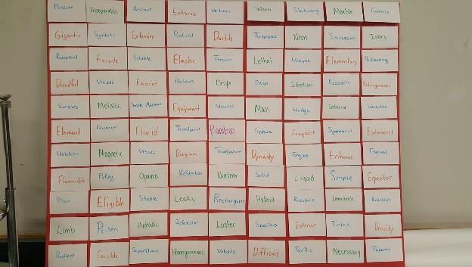
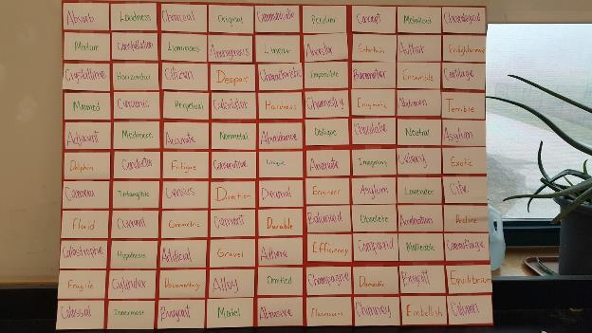

Part: 4 Whole Class:
- An exit ticket should be given to students asking them to identify new terminology for objects A and B from the start of class. Students may get up to review the vocabulary boards if that is helpful.
Instructional Materials/Resources/Tools:
Include:
- Teacher will provide objects, A and B. It is recommended to use various objects from around the classroom. For example, blocks, marbles, metal wire, plastic tube, cork, etc.
- Teacher will provide a randomized list of appropriate vocabulary terms (see images above for terms) with definitions on a wall or board.
- Teacher will establish stations for object C comparisons
  - Identify 6 objects to place around the room. It is recommended to use various objects from around the classroom. For example, blocks, marbles, metal wire, plastic tube, cork, etc.
  - Label each object with a letter (C-H)

Task Source:
- The Ambassador would like to recognize science teachers from North Brookfield Public Schools for their contributions to the development of this task.

Accessibility and Supports:
- Provide dictionaries for students to look up Tier 1 and 2 vocabulary words.

Student Work Samples:
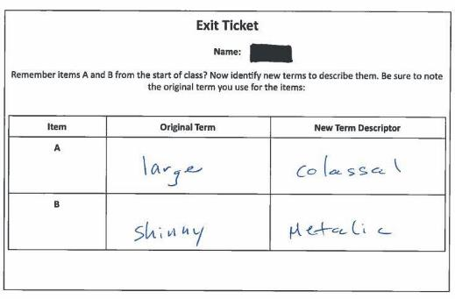

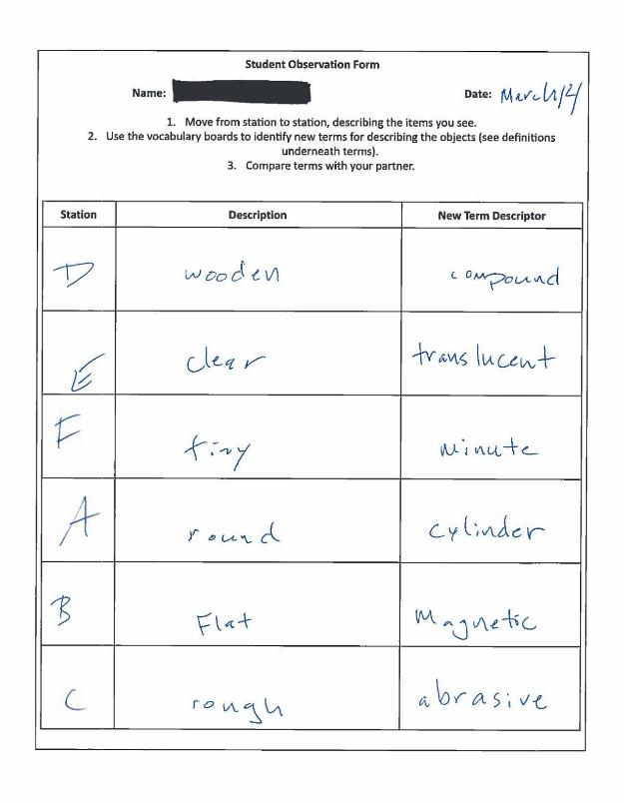
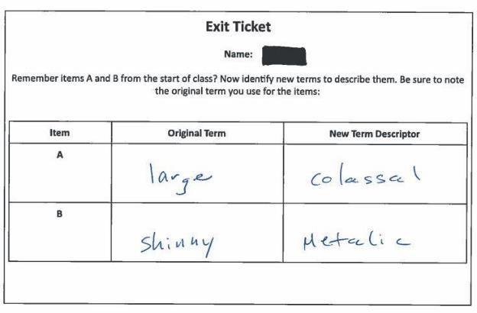

Student Observation Form

Name: Date:

Directions:
- Move from station to station, describing the items you see.
- Use the vocabulary boards to identify new terms for describing the objects (see definitions underneath terms).
- Compare terms with your partner.

Station | Description | New Term Descriptor

Exit Ticket

Name:

Remember items A and B from the start of class? Now identify new terms to describe them. Be sure to note the original term you use for the items:

Item | Original Term | New Term Descriptor
A
B

Exit Ticket

Name:

Remember items A and B from the start of class? Now identify new terms to describe them. Be sure to note the original term you use for the items:

Item | Original Term | New Term Descriptor
A
B

