Task-level phenomenon:
In this lesson, the specific phenomenon a video with liquid nitrogen shrinking an inflated balloon and then see it return to its normal size when it is at room temperature.

Synopsis of high-quality task:
Through this series of lessons students engage in investigations and discussions to use as evidence to develop an explanation for particle movement. Students create a model to show the particle movement of ice, water vapor, and liquid water when heat energy is added and taken away. Models will be presented in the form of drawings and depict differences in speed and spatial arrangement of observed particles.

This task has five parts. Students are first introduced to the concept using the phenomena of inflated latex balloons exposed to liquid nitrogen. Students are asked to explain why the balloons so drastically change when placed in and taken out of the liquid nitrogen and back up their explanation using in-person and virtual investigation. By the end of the unit, students should understand that more heat energy increases kinetic energy of particles of a pure substance, creating a state change (i.e. liquid to gas) and vice versa. Students should also understand that while both physical and chemical changes are observable changes, chemical changes are irreversible and results when two or more substances combine to create an entirely new substance.

Anticipated student time spent on task: 5 class sessions, 55 minutes each

Type of Task (check one):
_x__ 1. Investigation/experimentation/design challenge
____ 2. Data representation, analysis, and interpretation
____ 3. Explanation

Student task structure(s): individual and group work
STE Standards and Science and Engineering Practices:
8.MS-PS1-4. Develop a model that describes and predicts changes in particle motion, relative spatial arrangement, temperature, and state of a pure substance when thermal energy is added or removed.
Clarification Statements:
• Emphasis is on qualitative molecular-level models of solids, liquids, and gases to show that adding or removing thermal energy increases or decreases kinetic energy of the particles until a change of state occurs.
• Examples of models could include drawings and diagrams.
• Examples of pure substances could include water, carbon dioxide, and helium.
Science and Engineering Practices:
- Developing and Using Models
- Planning and Carrying Out Investigations
- Constructing Explanations

Prior Knowledge:
Previous Standard from Strand Map
6.MS-PS1-7(MA). Use a particulate model of matter to explain that density is the amount of matter (mass) in a given volume. Apply proportional reasoning to describe, calculate, and compare relative densities of different materials.

Previous Topics:
- Matter is made of unseen particles
- Particles are in constant motion
- Air is made of particles
- Knowledge of the states of matter

Connections to the real-world:
Energy transfer is happening all around us, all the time! When we hug, rub our hands together, hold a cup of hot chocolate, and roast a marshmallow over the fire! Our environment, in its simplest form, is composed of materials in different states of matter, making up different shapes, occupying spaces, and coming within close physical proximity to one another. These different types and states of matter also interact with each other and create changes in properties. An unseen phenomenon we usually overlook is the release or absorption of thermal energy between matter, also called heat transfer. Why do our hands warm up when we hold a hot mug of hot chocolate? When we cook marshmallows over a fire, what is happening when the marshmallow turns black and melts? These are the types of questions we will investigate and explain using science!
Mastery Goals:
Learning Objective:
- Construct evidence-based explanations of how particle movement is affected by adding and removing thermal energy

Performance Objective:
- Generate questions about observed phenomena of balloons placed in liquid nitrogen
- Carry out investigations to demonstrate what happens when thermal energy is added and removed
- Develop models and construct explanation of what happens to particles when energy is added or removed

Language Objective:
- Construct an explanation in writing that summarizes how particle movement is affected by adding and removing thermal energy

Teacher Instructions: Instructional Tips/Strategies/Suggestions:
Day 1
-Make observations about what is happening in the video and apply it to their prior knowledge of particle motion
-Ask questions about presented scientific phenomena and develop strategies for investigation

Do Now:
Students watch YouTube video (see link below) of what happens when balloon animals are placed into a container filled with liquid nitrogen, then observe what happens to them once they are removed from the container. https://www.youtube.com/watch?v=ZvrJgGhnmJo

- What is happening to the balloon?
- Why do you think this is happening to the balloon?
- What questions can we ask in order to explain what we see?

Mini-Lesson:
- Introduce lesson objectives. Tell students that they will watch a video of a “scientific phenomenon” (Explain that a “phenomenon” is a happening that is observable and has a scientific explanation but is also kind of weird and abnormal to see)
- Show the video: Liquid nitrogen and balloon animals. At this time students are not writing anything (Additional video if necessary: Liquid nitrogen balloon babies)
- After the video finishes, ask students to do a silent quick write or draw a model to explain what they think is happening to the balloon and why.

Quick Write:
“What is happening to the balloon? Why?”
- Have students share what they wrote with a group or partner.
- Show video again.
- Have each group decide on one question that can be ‘tested’ and one question that is a ‘research’ question and display them on their table.
- Students will then do a gallery walk through the class and write down two investigatory and two research questions. (This will allow students to practice identifying question types and understanding their use. Discuss criteria for each as a class. Investigatory questions have variables that can be measured, observed, and tested. Research questions require students to review outside sources to find answers.)

**Extension Opportunity:
Group the remaining questions and ask students to identify if they are research questions or investigative questions.
Sort questions into research-based and investigative categories.
- Ask, “Which questions can we find the answers to by researching? Which questions can we find the answers to by doing investigations in class?”
- Explain to the class that the phenomenon they watched must be investigated so they can obtain more information. Ask the class which of the investigations appeal to them most and how they can plan to investigate the matter further. Make a rough list of proposed ideas.
- Ask, “What will we do as a class to investigate this further?”
- Allow students to design their own experiment with a measurable outcome.

Day 2
-Carry out an investigation and identify factors that can cause changes in a balloon during a lab investigation
-Develop a model to illustrate observed changes of the balloon under different conditions

Do Now:
- Hypothesize what you or your group think might happen to your balloon when the temperature of water changes?
- Is this question investigatory or research: What will happen to the balloon when the temperature of water changes?
Sentence stems:
- When/If…
- I think… because…
- I wonder if…

Mini-lab:
If you have the supplies and prefer to have students carry out the experiments they designed on the previous day, this is a perfect time to do so.

LAB: Heating and Cooling Air
This Hot Air, Cold Air Science Activity is an experiment to watch the effects of hot air and cold air using a balloon. This activity is an opportunity for students to talk about what they can see and why it is happening. Students will see first-hand what effects hot and cold air has on a balloon.

- Introduce the materials:
balloons, bottles, hot water, ice water, room temperature water
- Designate lab team roles in arranged groups.
- Students experiment with three distinct water temperatures: cold, hot, room.

  - Procedure:
  - Blow the balloon up to stretch it and help make it more flexible and let the air out.
  - Place the balloon over the mouth of the empty plastic bottle.
  - Stand the bottle in the center of the container filled with room temperature water. Wait a few minutes and record your observations
  - Remove the bottle from the room temperature water and place it in the container filled with hot water. Wait a few minutes and record your observations
  - Remove the bottle from the hot water and place it in the container with cold water and ice. Wait a few moments and record observations
  - Repeat step 3 and 5 again

- Ask students to write and illustrate observed changes of the balloon under manipulated conditions.
(If you students are accustomed to using a lab report format feel free to use that in order to facilitate this data collection.)
- Have students clean up and be prepared to share their findings.
- Share out as a group.

Day 3
-Use a simulation to make observations and identify characteristics of particle movement under different temperatures in various states of matter.
-Develop a model to illustrate particle arrangement in solids, liquids, and gases at various temperatures.

Simulation: States of Matter Simulation and Compressing Gas in a Syringe
Other simulation: Particulate Simulation Solid, Liquid, Gas, & Phase Change

Do Now:
- Based on yesterday’s experiment, what happened to the balloon in the cold water?
- Based on yesterday’s experiment, what happened to the balloon in the hot water?
- What is inside the balloon that might be causing these changes?

Mini-Lesson:
- Have students get or share a computer
- Have students write the following three questions in their notebook:
  - 1. How do scientists show what air looks like?
  - 2. What changes do you notice about the air when temperature is decreased or increased?
  - 3. Illustrate your observations
- Direct students to the following link: States of Matter Simulation
- Have students investigate and analyze the states of matter in the simulation through the following steps
- Have students click on “Solid Water”
  - Illustrate in notebook the particles shown at -10°C (260 K), -5°C (270 K)
- Have students click on “Liquid Water”
  - Illustrate in notebook the particles shown at 20°C (290 K), 70°C (340 K)
- Have students click on “Water Vapor”
  - Illustrate in notebook the particles shown at 110°C (380 K), 150°C (420 K)
Exit Ticket:
Describe how the particles moved based on temperature in the solid, liquid, and gas.

Day 4
-Use a simulation to make observations and identify characteristics of particle movement under different temperatures in various states of matter
-Develop a model to illustrate particle arrangement in solids, liquids, and gases at various temperatures

Do Now:
- What causes the particles to speed up?
- What causes the particles to slow down?
(Answer: Heat causes particles to speed up. Removing heat causes particles to slow down. A common misconception is that cold is added and causes the particles to slow down. Remind students that a lower temperature is the result of a lack of heat or the removal of heat.)

Mini-lesson:
Jigsaw- Students will be creating posters to illustrate each state of matter at various temperatures as shown in the simulation:

States of Matter Simulation and Particulate Simulation
- Split students into 6 groups
- Assign each group one of the following:
  - Group 1--Solid -10°C (260 K)
  - Group 2--Solid -5°C (270 K)
  - Group 3--Liquid 20°C (290 K)
  - Group 4--Liquid 70°C (340 K)
  - Group 5--Gas 110°C (380 K)
  - Group 6--Gas 150°C (420 K)
- Have groups create a poster illustrating their assigned state of matter with a brief description of particle movement and arrangement
- Have students arrange posters in order around the room.

Exit Ticket:
Students will do a gallery walk around the room and list the patterns they see.

Day 5
-Analyze scientific text on particle movement
-Construct an explanation using informational text and lab observations for balloon phenomena

Do Now: What is happening to the particles in the balloon as the balloon heats up? Give examples.

Mini-lesson:
- Have students read the article on particle motion.
- Teaching note: support ELLs using jigsaw style reading and discussion
Reading: Particles in Motion! p. 23 - p. 27
- Have students use the CER template to begin gathering information to write their CER response
CER Template: CER writing template
Sentence Stems: Science Talk Stems

Exit Ticket: Students use the CER rubric to rate their partner’s argument. Students make revisions to their own CER.

CER Question: Does the temperature of the bottle affect movement of air?

Sample CER Response:
Claim: Yes, the temperature of the bottle affects the movement of air.
Evidence: When we placed the bottle in the hot water the balloon inflated! When we placed the bottle in the cold water the balloon deflated!
Reasoning: When the bottle was placed in the hot water, the particles increased their speed. The particles had more kinetic energy and moved away from each other while taking up more space. This caused them to push against the side of the balloon and inflate it. The opposite happened when the bottle was in the cold water. The kinetic energy decreased, and the particles came together causing them to deflate the balloon!

Instructional Materials/Resources/Tools:
- Student directions for completing the task
- Internet access
- A materials list and/or materials management
- Safety information if applicable
- Any handouts, links, books, videos, materials, etc. that is needed for the student to complete the task
- Scoring rubric – Focus on including the standards-content and practices for performance criteria. Less focus should be on presentation style, design, etc. unless it is tied directly to an ELA standard.

Resources:
Nitrogen Balloon Animals Video
- https://www.youtube.com/watch?v=qWc6Z-NEjR0
Heating and Cooling Air Instructions

Heating and Cooling Air Demo
- https://www.youtube.com/watch?v=I_yzhXjTfUE
- https://www.youtube.com/watch?v=qWc6Z-NEjR0
States of Matter simulation:
- http://authoring.concord.org/activities/11/pages/72/4fe074f1-a7e5-459c-888a-ffa1a2b6f83c
Gas Pressure in a Syringe simulation:
- http://lab.concord.org/embeddable.html#interactives/interactions/syringe.json
PhET States of Matter simulation:
- http://phet.colorado.edu/sims/html/states-of-matter/latest/states-of-matter_en.html
Water Molecules at Different Temperature teaching slides:
- https://www.middleschoolchemistry.com/multimedia/chapter1/lesson2
Reading: Particles in Motion! p. 23-27
- https://documentcloud.adobe.com/link/track?uri=urn%3Aaaid%3Ascds%3AUS%3Ad7ec79f6-d66a-4a1e-ae60-40bd4189420b
CER Writing Template:
- https://documentcloud.adobe.com/link/track?uri=urn%3Aaaid%3Ascds%3AUS%3Aed429125-73b3-4675-90f3-973ada671424
Science Stems/Science Talk Stems:

Accessibility and Supports:
Science Stem Talks handout
CER Graphic Organizer

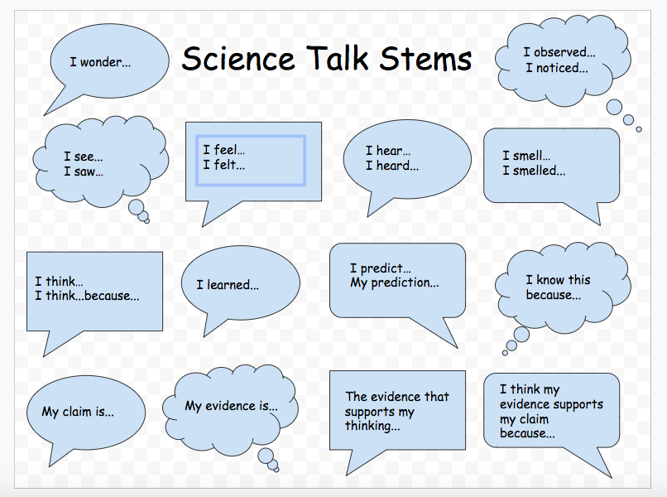
Additional resources on argumentation can be found:
https://www.sciencepracticesleadership.com/instruction-tools.html

Grading Rubric
 | 4 Points | 3 Points | 2 Points | 1 Points | 0 Points
CLAIM  The writer makes a statement or conclusion that answers the original question. | Compelling Claim  - Claim is clear and scientifically accurate  - Claim is well stated | Credible Claim  - Claim is clear | Partial Claim  - Claim is implied but not clearly stated  - Claim reveals partial understanding | Weak Claim  - An attempt at a claim is made but is minimally accurate | Invalid Claim  - No identifiable statement of claim.
EVIDENCE  The writer supports the claim with relevant evidence using the sources provided. | Ample Evidence  - Evidence is ample and incorporates both sources in order to present a well-rounded amount of data | Sufficient Evidence  - Evidence is sufficient but only from 1 source (article or lab) | Partial Evidence  - Evidence is basic | Weak Evidence  - Evidence is minimal  - (1 piece from 1 source) | Invalid Evidence  - Evidence is unclear  - Evidence is not present
REASONING  The writer explains why the data/evidence supports the answer to the question. | Convincing Reasoning  - Explicit reasoning is provided that links all evidence to the claim to show support for the answer | Well-developed Reasoning  - Explicit reasoning is provided that links most evidence to the claim  - Reasoning is mostly accurate | Partial Reasoning  - Explicit reasoning is provided that links some evidence to the claim  - Reasoning reveals partial understanding | Weak Reasoning  - Minimal reasoning is provided to link evidence to the claim  - Reasoning is minimally accurate | Invalid Reasoning  - Reasoning is provided but does not link evidence to the claim.  - Reasoning is inaccurate or incomplete

Sample Student Work:
In the pilot phase of this task, the work below is an example of what was produced at the 6th grade level and at the 8th grade level. Neither of these samples is an exemplar, but they are demonstrations of student thinking at various levels.
Grade 6:

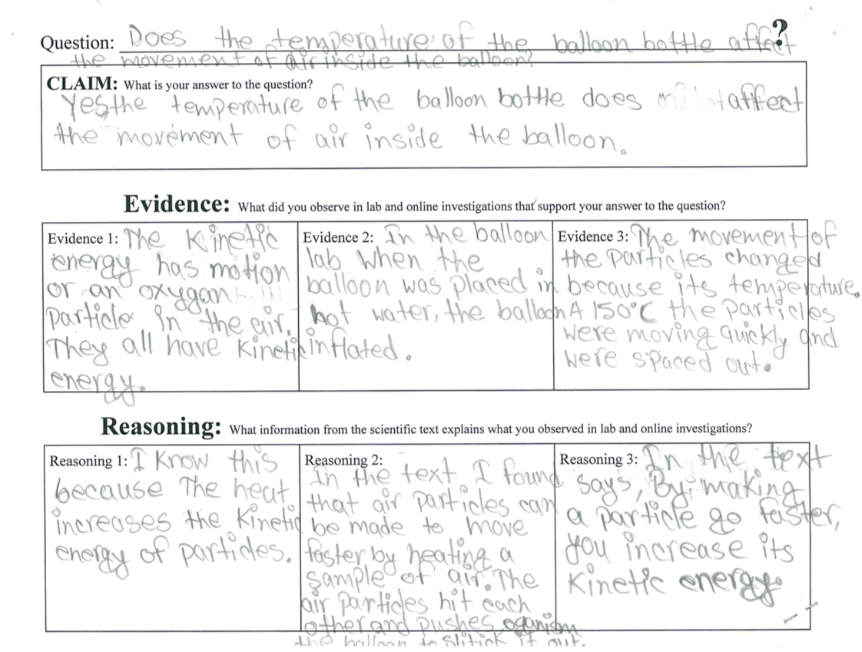

Grade 8:

