Synopsis of high-quality task:
Students will read and interpret a table and a graph created by two friends, Alex and Johnny, during their families’ road trips. They will then determine whose data is a function and why. After determining if the relations are functions, the students will look at a graph of data and determine the mistakes that have been made.

Anticipated student time spent on task: 55 minutes

Student task structure(s): Partner work and group work

Math Content Standards and Practices:
8.F.A.1 Understand that a function is a rule that assigns to each input exactly one output. The graph of a function is the set of ordered pairs consisting of an input and the corresponding output.

8.F.A.2 Compare properties of two functions each represented in a different way (algebraically, graphically, numerically in tables, or by verbal descriptions).

8.F.B.4 Construct a function to model a linear relationship between two quantities. Determine the rate of change and initial value of the function from a description of a relationship or from two (x, y) values, including reading these from a table or from a graph. Interpret the rate of change and initial value of a linear function in terms of the situation it models, and in terms of its graph or a table of values.

SMP.1 Make sense of problems and persevere in solving them.
SMP.3 Construct viable arguments and critique the reasoning of others.
SMP.6 Attend to precision.

Prior Knowledge:
7.RP.A.1 Compute unit rates associated with ratios of fractions, including ratios of lengths, areas, and other quantities measured in like or different units.

7.RP.A.2 Recognize and represent proportional relationships between quantities.
a. Decide whether two quantities are in a proportional relationship, e.g., by testing for equivalent ratios in a table, or graphing on a coordinate plane and observing whether the graph is a straight line through the origin.
b. Identify the constant of proportionality (unit rate) in tables, graphs, equations, diagrams, and verbal descriptions of proportional relationships.
c. Represent proportional relationships by equations. For example, if total cost t is proportional to the number n of items purchased at a constant price p, the relationship between the total cost and the number of items can be expressed as t = pn.
d. Explain what a point (x, y) on the graph of a proportional relationship means in terms of the situation, with special attention to the points (0, 0) and (1, r) where r is the unit rate.

7.RP.A.3 Use proportional relationships to solve multi-step ratio, rate, and percent problems.

7.EE.B.4 Use variables to represent quantities in a real-world or mathematical problem, and construct simple equations and inequalities to solve problems by reasoning about the quantities.
Connections to the real-world:
-road trips/travel
-miles per hour

Mastery Goals:
Learning Objective:
- Students will be able to recognize a function from a given table of data and from a given graph
- Students will be able to find a function rule to describe the relationship between the input and output values
- Students will be able to understand how to correctly graph a function, given a table of data.

Language Objective:
- Students will be able to discuss, debate, and verbally explain strategies behind their choice of representation.

Teacher instructions
Instructional Tips/Strategies/Suggestions:
- Make sure students realize that there are multiple errors to fix in the graph in part c
- Students do not need to understand the definition of a function addressed in part a and b in order to attempt part c and d
- Start with asking students what they notice and wonder about the data table and the graph.
- Students then complete the next sections with a partner or on their own.

Instructional:
Include:
- Student handout with directions for completing the task

Accessibility and Supports:

Potential sentence starters:
-What do you wonder?
-What do you notice?

Key academic vocabulary:
-Function
-Rate of Change
-Slope
-Linear Functions
-Coordinate Grid

Sample Student Work:
- Is Johnny´s data a function? Please defend your answer.

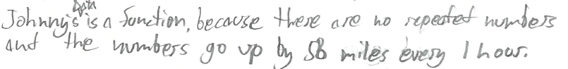
Is Alex´s data a function? Please defend your answer.

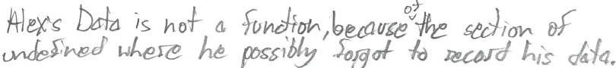

- Write an equation that represents the relationship between the hours (h) and miles (m) of Johnny’s road trip?

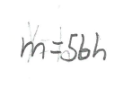
- Johnny’s data has been graphed with multiple errors. List below the errors you have found.

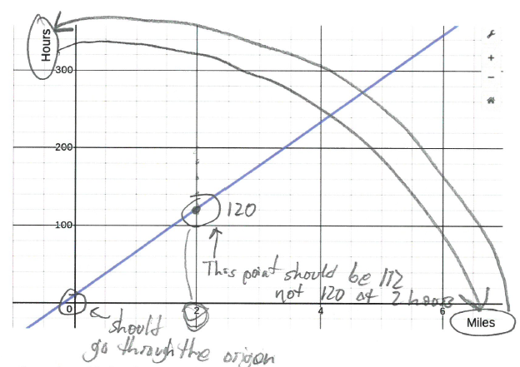
- How you would fix his graph to correctly represent a function?

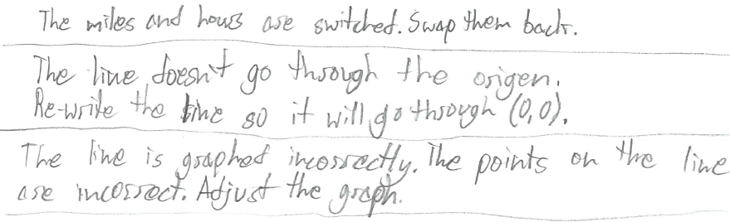

Student Handout:

Name __________________________

Road Trip (8th Grade Functions)

Alex and Johnny are going on road trips with their families during April Vacation. They both left their houses at 10 am and arrived at their destination at 3pm. The graphics below shows the data of their mileage and time.

Johnny’ Data Alex’s Data
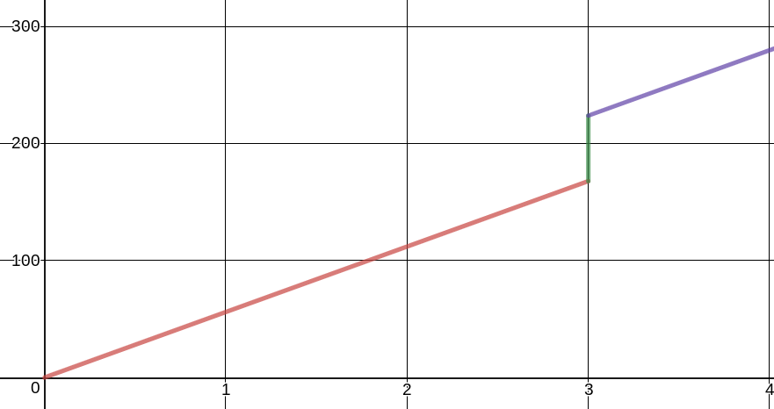
Hours | Miles
1 | 56
2 | 112
3 | 168
4 | 224
5 | 280

- Is Johnny´s data a function? Please defend your answer.

Is Alex´s data a function? Please defend your answer.

- Write an equation that represents the relationship between the hours (h) and miles (m) of Johnny’s road trip?

- Johnny’s data has been graphed with multiple errors. List below the errors you have found.

Johnny’s Road Trip Data

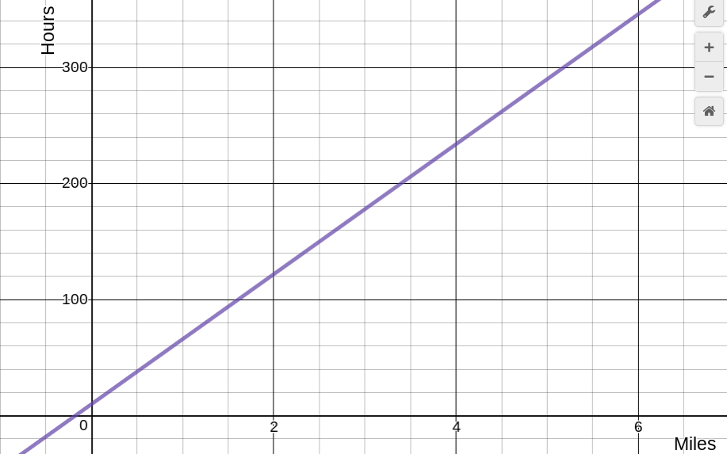

Hours | Miles
1 | 56
2 | 112
3 | 168
4 | 224
5 | 280

- How you would fix his graph to correctly represent a function?

