Task-level phenomenon:
Students build proteins using mutated and unmutated DNA strands and observe that substrates do not fit in a misshapen protein.

Synopsis of high-quality task:
The key concept in this lesson is that mutations in DNA can code for faulty proteins; one example of this phenomenon is in sickle cell disease, where a hemoglobin proteins are misshapen and can’t transport oxygen to the body, which causes the symptoms experienced with sickle cell disease. Students create a model protein of a hemoglobin molecule based on a sequence of DNA. Students will be given four different coding sequences of DNA to create one hemoglobin molecule; strands of DNA will either code for a normal hemoglobin molecule or a mutated hemoglobin molecule seen in sickle cell. Students build a template strand, transcribe mRNA, and translate to the amino acid sequence, then put molecules together to build a full protein and compare the shapes between the normal and sickled hemoglobin. Students will use their model protein to see if the substrate (oxygen) fits into the different hemoglobin molecules, in order to construct an explanation for why a mutation in DNA could result in a faulty protein. This task is best positioned towards the completion of a unit about the structure of DNA and RNA, including protein synthesis.

Anticipated student time spent on task: 1-3 sessions, 55 min each

Type of Task (check one):
____ 1. Investigation/experimentation/design challenge
____ 2. Data representation, analysis, and interpretation
__X_ 3. Explanation

Student task structure(s): group work (2-4 students)

STE Standards and Science and Engineering Practices:

HS-LS1-1. Construct a model of transcription and translation to explain the roles of DNA and RNA that code for proteins that regulate and carry out essential functions of life.
Clarification Statements:
- Proteins that regulate and carry out essential functions of life include enzymes (which speed up chemical reactions), structural proteins (which provide structure and enable movement), and hormones and receptors (which send and receive signals).
- The model should show the double-stranded structure of DNA, including genes as part of DNA’s transcribed strand, with complementary bases on the nontranscribed strand.
State Assessment Boundaries:
- Specific names of proteins or specific steps of transcription and translation are not expected in state assessment.
- Cell structures included in transcription and translation will be limited to nucleus, nuclear membrane, and ribosomes for state assessment.

Science and Engineering Practices:
- Developing and using models
- Constructing explanations
Prior Knowledge:
Previous Standards from Strand Map:

8.MS-LS3-1. Develop and use a model to describe that structural changes to genes (mutations) may or may not result in changes to proteins, and if there are changes to proteins there may be harmful, beneficial, or neutral changes to traits.
Clarification Statements:
- An example of a beneficial change to the organism may be a strain of bacteria becoming resistant to an antibiotic.
- A harmful change could be the development of cancer; a neutral change may change the hair color of an organism with no direct consequence.
State Assessment Boundary:
- Specific changes at the molecular level (e.g., amino acid sequence change), mechanisms for protein synthesis, or specific types of mutations are not expected in state assessment

HS-LS1-6. Construct an explanation based on evidence that organic molecules are primarily composed of six elements, where carbon, hydrogen, and oxygen atoms may combine with nitrogen, sulfur, and phosphorus to form monomers that can further combine to form large carbon-based macromolecules.
Clarification Statements:
- Monomers include amino acids, mono- and disaccharides, nucleotides, and fatty acids.
- Organic macromolecules include proteins, carbohydrates (polysaccharides), nucleic acids, and lipids.
State Assessment Boundary:
- Details of specific chemical reactions or identification of specific macromolecule structures are not expected in state assessment.

Previous Topics:
- DNA replication, transcription, translation, mutations
- Building blocks of macromolecules
- DNA and RNA structure
- Roles and types of RNA
Connections to the real-world:
- Many genetic diseases, such as sickle cell, PKU, cystic fibrosis, Huntington’s, and others, have symptoms that result from the transcription and translation of a faulty DNA code for an essential protein.
- Some diseases, such as cancer, result from DNA mutations acquired during a lifetime, which can result in a faulty DNA code, which is transcribed and translated into a faulty essential protein.
Mastery and Language Goals:

Learning Objective:
- Students will be able to use a model to explain the process of transcription and translation.
- Students will be able to explain that proteins are responsible for major biological functions, DNA contains genes that result in proteins through transcription and translation, and mutations in genes can cause proteins to be nonfunctional (or less functional).

Performance Objective:
- Students will create a model using building blocks and using the model to explain how a mutation in a DNA strand can lead to a non-functional (or less functional) protein, such as the one that results in sickle-cell anemia, in order to evaluate and interpret different protein models to predict the location of mutations.

Language Objective:
- Students will be able to explain, in writing, the process used to construct their model hemoglobin and to test its effectiveness.
- Students will be able to construct a written explanation of how mutations in DNA are manifested in protein synthesis.
Instructional Materials/Resources/Tools:
Instructional Resources:
- Teacher instructional sheet
- Student worksheet (A = normal protein, B = mutated/sickled protein)
- Genetic code table
- Scoring rubric
- Teacher key responses
Materials:
- 5-inch rubber balls (to act as substrate)
- Building blocks (Snowflake or STEM building blocks):
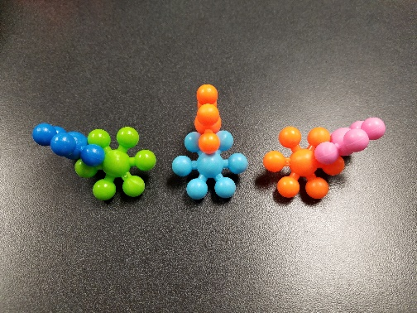

Teacher Instructions:

Preparation:
- Because the genetic diseases and their consequences are a phenomenon for this task, be attentive and sensitive to the needs of your student population. For example, consider creating some norms with your students before watching the video and engaging in the discussion and ensure videos that show the consequences of these diseases take an approach of empathy and understanding.
- Throughout this lesson, it is important for students to collaborate and for teachers to facilitate collaboration and discussion.
- Timing is based on the needs of the students and should be adjusted by the teacher. Time frames are given as guides.
- Content Note: Although students conduct DNA replication prior to transcription, DNA replication is not part of the transcription and translation process.

Day 1
Start by showing a short film clip describing a genetic disease resulting in a faulty protein. “Living with Sickle Cell Disease” by Boston Children’s Hospital (https://youtu.be/5s3s1oMsg74) is one example. Have students answer the following questions as they watch. (10-15 minutes)
- What do you notice and wonder about this disease (e.g., some of the symptoms)?
- Why do you think these symptoms happen?
- What do we need to figure out in order to help us understand what causes this disease?

Break the class into groups of 2-4 and distribute the student worksheets. Students first produce the coding strand of the DNA and then transcribe and then translate the strands. (15-30 minutes)

Break the coding, DNA replication, transcription, and translation sections of the activity into 4 discrete sections of the lesson to provide more frequent check-ins. For example, checks could be made after completing the coding strand of DNA or the strand of mRNA. Consider having a checkpoint where students must have their mRNA checked in order for them to get through the “nuclear pores” into the cytoplasm to build the proteins. Having frequent check-ins can help students revise their models earlier on. In these instructions, the translation section of the activity is separated into Day 2, below.

Day 2
Part I (20-30 minutes): Students use their amino acid sequences and charts to build the proteins. This will be done at lab benches or a different section of the classroom than Day 1 activities to emphasize that translation occurs outside of the nucleus at the ribosome. Large pieces of cardboard paper labeled “ribosomes” for them to work on emphasizes this even further. Look out for:
- Students making the connection between the correct amino acids and (with the building blocks) right clicks or left clicks.
- The basic structure of the four strands as in the picture below. If they don’t match, guide students to check their transcription or translation sequences.
- Models of the normal protein will be able to fit the substrate (rubber ball) into the protein. Models with the mutated protein should have the same shaped base but not be able to fit in the substrate to the active site.

Part II (20-30 minutes): After completing the building, students should write their explanations.
There are two different worksheets provided for the written explanation. The first is for students who require more of a challenge (e.g., AP Biology students) and some of the vocabulary terms are not included in STE Frameworks. The second sheet is for most Biology students.
Task Source:
The Ambassador would like to recognize Jeff Farrington and Aimee Jarominski for their contributions to the development of this task.

Resources:
https://www.yourgenome.org/facts/what-is-sickle-cell-anaemia (CC-BY4.0)
https://www.yourgenome.org/facts/what-is-sickle-cell-anaemia
https://www.yourgenome.org/copyright

Building a Protein: Hemoglobin
Student Direction Sheet

Standards:
HS-LS1-1. Construct a model of transcription and translation to explain the roles of DNA and RNA that code for proteins that regulate and carry out essential functions of life.
Science Practice: Constructing explanations, Developing and using models

Learning Objectives:
- Proteins are responsible for major biological functions
- DNA contains genes which result in proteins being made
- A change in one or more of the DNA bases can result in a protein that does not work correctly (a mutation)

Diseases are caused by various factors like a virus, bacteria, environmental factors (sun radiation), and genetic mutations. Genetic mutational diseases like diabetes, lactose intolerance, and sickle cell anemia are caused by a change in the nucleotide sequence of a gene. In this modeling exercise we will be building hemoglobin molecules based on a given gene sequence to show how proteins might be changed by a change in the genetic sequence. Hemoglobin is a protein found in the red blood cells of vertebrates although some oxygen can travel in the blood by itself, hemoglobin binds easily to oxygen and allows a much larger amount of oxygen to quickly move into the blood, and get carried to the cells of the body. The hemoglobin protein is composed of four subunits bound together. All four subunits are individually transcribed and translated and then join together to produce a functional protein with a binding site for oxygen. People with sickle cell experience fatigue, pain, and jaundice. Later in life, their organs and bones and joints can be adversely affected.

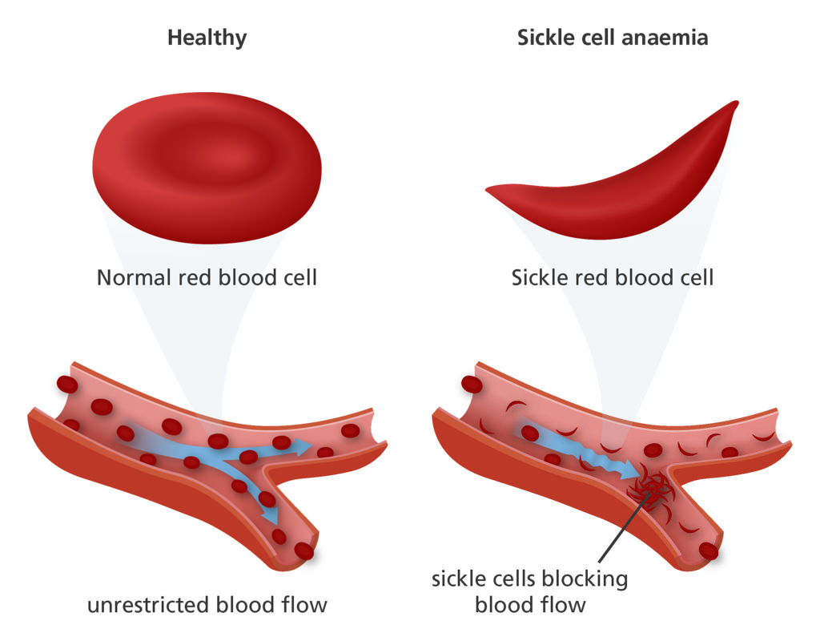
Image credit: Genome Research Limited CC BY_NC_SA 220

Each group of students will be given a strand of DNA that is the non-template (non-transcribing or the coding strand). Your job is to produce the template strand of DNA, transcribe it into RNA and then translate it into a protein strand using the amino acid building blocks. Your strand will then be added to 3 other strands from 3 other groups to form a full protein . You will be assessed on your model and the explanation at the end of your activity.

Procedure:
- Each group of students will be provided a strand of “DNA” that represents the non transcribed or coding strand. At your desks, which will represent the nucleus, you must first produce the template strand of DNA by replication. Complete this on Student Sheet.

- The template strand must now be transcribed into the mRNA strand using the correct bases. This is the process of transcription. This should be recorded on your student sheet.

- Take your Student Sheets to the area where the amino acid building blocks are located. This is the ribosome area. Using your knowledge of the triplet code and your universal codon sheet, you are to build a protein model. Start by writing down the amino acids in the correct sequence on your paper. This is translation. Once you are done writing them on paper, use the key to connect the correct building block pieces. Each “amino acid” has a particular way of attaching. A left click refers to moving the attachment one attachment piece to the left or (and vice versa for the right click). Hold the piece flat to add the next piece. Each amino acid also has a specific color assigned to it.

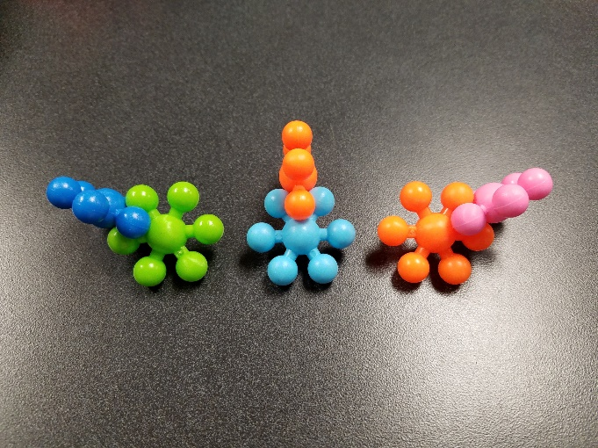

Left click Center Right click

KEY TO AMINO ACID TRANSLATION TO BUILDING BLOCKS:

Left Click Straight: Right Click
Glutamine = Orange Methonine = Purple Proline = Dark Green
Serine = Red Valanine = Dark Blue Alanine = Light Green
Arganine = Light Blue Leucine = Yellow
Histodine = Pink

4. Join with the other three groups that have been assigned to make the other subunits to your protein. The two base strands should join to form an oval shape that will be the base of your hemoglobin. The top parts should join to the base at the second amino acid of each strand and the eighth amino acid of the other strand to form a basket like shape. The “substrate”, in this case a 5 inch rubber ball, should fit into the protein. If the “substrate” does not fit, then you may have a mutated (sickled) hemoglobin protein.

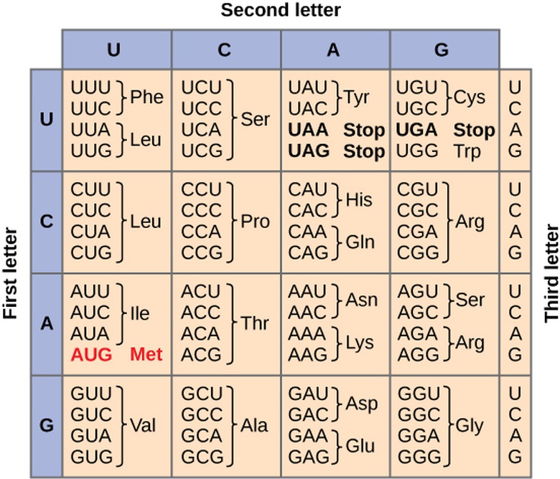

Building Hemoglobin
Student Worksheet A
Name:

Directions: Using the given DNA coding strand, build the nucleotide sequence of the DNA template strand. Then use the DNA template strand to determine the nucleotide sequence of the RNA strand and, consequently, the amino acid sequence of the polypeptide using the codon chart provided on the last page. Be sure to label all 5’ and 3’ ends. Once the amino acid sequence chain has been determined, use the building blocks provided to build a physical representation of your polypeptide.

BASE 1:

DNA coding strand:
5’ ATG-----GTC-----CGC-----GAA-----AGG-----TCC-----CAC-----AGT-----ATG-----GTG-----TAA 3’

DNA template strand:
_____----_____----_____----_____----_____----_____----_____----_____----_____----_____----____

RNA strand:
_____----_____----_____----_____----_____----_____----_____----_____----_____----_____----____

Amino acids:
_____----_____-----_____----_____-----_____----_____----_____-----_____----_____----_____

BASE 2:

DNA coding strand:
5’ ATG-----ATG-----CAC-----TCT-----AGG-----GAA-----ATG-----TCA-----GTC-----AGA-----TGA 3’

DNA template strand:
_____----_____----_____----_____----_____----_____----_____----_____----_____----_____----____

RNA strand:
_____----_____----_____----_____----_____----_____----_____----_____----_____----_____----____

Amino acids:
_____----_____-----_____----_____-----_____----_____----_____-----_____----_____----_____

Top 1:
DNA coding strand:
5’ ATG-----AGG-----CAT-----GCA-----ATG-----CTT-----AGA-----CCC-----GTC-----TAA 3’

DNA template Strand:
_____-----_____----_____-----_____-----_____-----_____----_____-----_____-----_____-----_____

RNA strand:
_____-----_____-----_____-----_____-----_____-----_____-----_____-----_____-----_____-----_____

Amino acids:
_____-----_____-----_____-----_____-----_____-----_____-----_____-----_____-----_____

Top 2:

DNA coding strand:
5’ ATG-----GTA-----GTG-----CTA-----AGA-----CCG-----CAC-----GCA-----AGG-----TAA 3’

DNA template strand:
_____-----_____----_____----_____----_____-----_____----_____-----_____----_____-----_____

RNA strand:
_____-----_____-----_____-----_____-----_____-----_____-----_____-----_____-----_____-----_____

Amino acids:
_____-----_____-----_____-----_____-----_____-----_____-----_____-----_____-----_____

KEY TO AMINO ACID TRANSLATION TO BUILDING BLOCKS:

Straight: Right Turn Left Turn
Methonine = Purple Proline = Dark Green Glutamine = Orange
Valanine = Dark Blue Alanine = Light Green Serine = Red
Arganine = Light Blue Leucine = Yellow
Histodine = Pink

Building Hemoglobin
Student Worksheet B

Name:

Directions: Using the given DNA coding strand, build the nucleotide sequence of the DNA template strand. Then use the DNA template strand to determine the nucleotide sequence of the RNA strand and, consequently, the amino acid sequence of the polypeptide using the codon chart provided on the last page. Once the amino acid sequence chain has been determined, use the building blocks provided to build a physical representation of your polypeptide.

BASE 1:

DNA coding strand:
5’ ATG-----GTC-----CGC-----GAA-----AGG-----TCC-----CAC-----AGT-----ATG-----GTG-----TAA 3’

DNA template strand:
_____----_____----_____----_____----_____----_____----_____----_____----_____----_____----____

RNA strand:
_____----_____----_____----_____----_____----_____----_____----_____----_____----_____----____

Amino acids:
_____----_____-----_____----_____-----_____----_____----_____-----_____----_____----_____

BASE 2:

DNA coding strand:
5’ ATG-----ATG-----CAC-----TCT-----AGG-----GAA-----ATG-----TCA-----GTC-----AGA-----TGA 3’

DNA template strand:
_____----_____----_____----_____----_____----_____----_____----_____----_____----_____----____

RNA strand:
_____----_____----_____----_____----_____----_____----_____----_____----_____----_____----____

Amino acids:
_____----_____-----_____----_____-----_____----_____----_____-----_____----_____----_____

Top 1:
DNA coding strand:
5’ ATG-----AGG-----CAT-----GCA-----ATG-----CTT-----AGA-----CCC-----GTC-----TAA 3’

DNA template Strand:
_____-----_____----_____-----_____-----_____-----_____----_____-----_____-----_____-----_____

RNA strand:
_____-----_____-----_____-----_____-----_____-----_____-----_____-----_____-----_____-----_____

Amino acids:
_____-----_____-----_____-----_____-----_____-----_____-----_____-----_____-----_____

Top 2:

DNA coding strand:
5’ ATG-----GTG-----CCA-----CGG-----CTA-----TCG-----GAG-----GTC-----AGG-----TAG 3’

DNA template strand:
_____-----_____-----_____-----_____-----_____----_____-----_____----_____-----_____-----_____

RNA strand:
_____-----_____-----_____-----_____-----_____----_____-----_____-----_____-----_____-----_____

Amino acids:
_____-----_____----_____----_____-----_____----_____----_____----_____-----_____

KEY TO AMINO ACID TRANSLATION TO BUILDING BLOCKS:

Straight: Right Turn Left Turn
Methonine = Purple Proline = Dark Green Glutamine = Orange
Valanine = Dark Blue Alanine = Light Green Serine = Red
Arganine = Light Blue Leucine = Yellow
Histodine = Pink

Assessment A:
Part 1
Using your constructed hemoglobin model, explain the role of DNA and RNA in protein synthesis. Also, compare the normal top 2 protein to the mutated top 2 protein sequence - what is the difference? What is the effect of this difference on the function of hemoglobin?

Please use the following terms in your explanation:

DNA
Nucleus
Double-stranded
RNA
Gene
Transcription
Translation
Amino acids
Protein
Polypeptide
Hemoglobin
Normal protein
Sickled protein
Ribosome
Nucleotides
Base-pairing
tRNA
Single-stranded
Template strand
Coding strand
Transcription factors
5’ and 3’ ends
RNA Polymerase
Start codon
Stop codon
Promoter

Part 2.
Pose an explanation for natural events such as a white tiger or a leaf that is misshapen. Use your knowledge of the process of genetic expression to explain why mutations are most likely located on the DNA instead of the during the process of transcription or translation.

Assessment B:

Part 1.
Compare the normal top 2 protein to the mutated top 2 protein sequence - what is the difference? What is the effect of this difference on the function of hemoglobin? Using your constructed hemoglobin model, explain the role of DNA and RNA in producing a functional protein. Please use the following terms in your explanation:
DNA
Nucleus
Double-stranded
mRNA
Gene
Transcription
Translation

Amino acids
Polypeptide
Hemoglobin
Normal protein
Sickled protein
Ribosome
Nucleotides
Base-pairing

Codon
Single-stranded
Template strand
Coding strand

Starter Sentence:
The purpose of DNA is……

Part 2.
Pose an explanation for natural events such as a white tiger or a leaf that is misshapen.

Assessment C:

Use the following vocabulary terms to complete the sentences below.

DNA
Nucleus
Double-stranded
mRNA
Gene
Transcription
Translation

Amino acids
Polypeptide
Hemoglobin
Normal protein
Sickled protein
Nucleotides
Base-pairing

Amino Acids
Codon
Single-stranded

- The process of replication takes place in the ____________ and it means making a copy of ________. It does this by DNA polymerase bringing in new _______________.
- When A pairs with T and G pairs with C it is called ____________________.
- The template strand of the DNA is used to make ____________ in the nucleus, a process called ________________.
- DNA is _________________ while RNA is _________________.
- A section on the DNA which codes for a specific trait or protein is called a ___________.
- Once the _________strand is made, it goe to the cytoplasm where ______________ occurs at the ribosomes.
- The protein is made by ____________________joining together. The the subunits combine together to make a _____________, a long chain of subunits.
- Each set of three nucleotides is called a _____________ and codes for a specific amino acids.
- _______________ is the protein found in your red blood cells.
- When the DNA is correct, after transcription and translation a ________________ is made.
- If there is a mistake or a mutation, then a ________________ could be made.

Hemoglobin Model Rubric
Category | 5 | 4 | 3 | 2 | 1
Written Assessment | The written assessment provides a detailed and accurate explanation of the role of DNA and RNA in protein synthesis. All terms on assignment are used appropriately. A specific example is well-constructed to describe how a mutation can lead to a nonfunctional protein. | The written assessment provides a detailed explanation of the role of DNA and RNA in protein synthesis. All terms on assignment are used appropriately. An example is described to show how a mutation can lead to a nonfunctional protein. | The written assessment provides an explanation of the role of DNA and RNA in protein synthesis, but more detail could have been included. Most terms on assignment are used appropriately. An example is not described to show how a mutation can lead to a nonfunctional protein. | The written assessment shows little to no effort and does not clearly explain the role of DNA and RNA in protein synthesis. An example of a mutation that can lead to a nonfunctional protein is not provided. | No written assessment was turned in.
Technically Appropriate Language | Word choice enhances and clarifies meaning. Transitions connect ideas and sequencing is logical and effective. The report is written in an appropriate third person, objective voice. | Word choices are functional, adequate and correct. Transitions are evident and sequencing shows some logic. The report is written in an appropriate third person, objective voice. | Sentence structure and word choice are simplistic and repetitive. Transitions and sequencing leads to some confusing. The report is written in an appropriate third person, objective voice. | Sentence structure and word choice are often incorrect. Transitions and sequencing is not always logical. The report is not written in an appropriate third person, objective voice. | Sentence structure interefers with communicating knowledge. Transitions and sequencing are confusing. The report is not written in an appropriate third person, objective voice.
Hemoglobin Model Rubric
Category | 5 | 4 | 3 | 2 | 1
Written Assessment | The written assessment provides a detailed and accurate explanation of the role of DNA and RNA in protein synthesis. All terms on assignment are used appropriately. A specific example is well-constructed to describe how a mutation can lead to a nonfunctional protein. | The written assessment provides a detailed explanation of the role of DNA and RNA in protein synthesis. All terms on assignment are used appropriately. An example is described to show how a mutation can lead to a nonfunctional protein. | The written assessment provides an explanation of the role of DNA and RNA in protein synthesis, but more detail could have been included. Most terms on assignment are used appropriately. An example is not described to show how a mutation can lead to a nonfunctional protein. | The written assessment shows little to no effort and does not clearly explain the role of DNA and RNA in protein synthesis. An example of a mutation that can lead to a nonfunctional protein is not provided. | No written assessment was turned in.
Technically Appropriate Language | Word choice enhances and clarifies meaning. Transitions connect ideas and sequencing is logical and effective. The report is written in an appropriate third person, objective voice. | Word choices are functional, adequate and correct. Transitions are evident and sequencing shows some logic. The report is written in an appropriate third person, objective voice. | Sentence structure and word choice are simplistic and repetitive. Transitions and sequencing leads to some confusing. The report is written in an appropriate third person, objective voice. | Sentence structure and word choice are often incorrect. Transitions and sequencing is not always logical. The report is not written in an appropriate third person, objective voice. | Sentence structure interefers with communicating knowledge. Transitions and sequencing are confusing. The report is not written in an appropriate third person, objective voice.

Teacher Guide: Sequences of DNA, RNA, and Amino Acids

BASE 1:
Amino Acids:
Met-----Val-----Arg-----Glu-----Arg-----Ser----His---Ser----Met-----Val-----Stop

RNA strand:
AUG-----GUC-----CGC-----GAA-----AGG-----UCC-----CAC-----AGU-----AUG-----GUG-----UAA

DNA Template strand:
TAC-----CAG-----GCG-----CTT-----TCC-----AGG-----GTG-----TCA-----TAC-----CAC-----ATT

DNA Coding Strand:
ATG-----GTC-----CGC-----GAA-----AGG-----TCC-----CAC-----AGT-----ATG-----GTG-----TAA

BASE 2:
Amino Acid:
Met-----Met-----His-----Ser-----Arg-----Glut-----Met-----Ser-----Val-----Arg-----Stop

RNA Strand:
AUG-----AUG-----CAC-----UCU-----AGG-----GAA-----AUG-----UCA-----GUC-----AGA-----UGA

DNA Template Strand:
TAC------TAC------GTG------AGA-----TCC-----CTT------TAC-----AGT------CAG-----TCT-----ACT

DNA Coding Strand:
ATG------ATG------CAC-----TCT------AGG------GAA------ATG------TCA-----GTC-----AGA-----TGA

Top 1:
Amino Acids:
Met-----Arg-----His-----Ala-----Met-----Leu-----Arg-----Pro-----Val-----Stop

RNA Strand:
AUG-----AGG-----CAU-----GCA-----AUG-----CUU-----AGA-----CCC-----GUC-----UAA

DNA Template Strand:
TAC-----TCC-----GTA-----CGT-----TAC-----GAA-----TCT-----GGG-----CAG-----ATT

DNA Coding Strand:
ATG-----AGG-----CAT-----GCA-----ATG-----CTT-----AGA-----CCC-----GTC-----TAA

Top 2:
Amino Acids:
Met-----Val-----Val-----Leu-----Arg-----Pro-----His-----Ala-----Arg-----Stop

RNA Strand:
AUG-----GUA-----GUG-----CUA-----AGA-----CCG-----CAC-----GCA-----AGG-----UAA

DNA Template Strand:
TAC-----CAT-----CAC-----GAT-----TCT-----GGC-----GTG-----CGT-----TCC-----ATT

DNA Coding Strand:
ATG-----GTA-----GTG-----CTA-----AGA-----CCG-----CAC-----GCA-----AGG-----TAA

Mutant: B top 2
Amino Acids:
Met-----Val-----Pro-----Arg-----Leu-----Ser-----Glu-----Val-----Arg-----Stop

RNA Strand:
AUG-----GUG-----CCA-----CGG-----CUA-----UCG-----GAG-----GUC-----AGG-----UAG

DNA Template Strand:
TAC-----CAC-----GGT-----GCC-----GAT-----AGC-----CTC-----CAG-----TCC-----ATC

DNA Coding Strand:
ATG-----GTG-----CCA-----CGG-----CTA-----TCG-----GAG-----GTC-----AGG-----TAG

Teacher Key for Models:

Normal hemoglobin

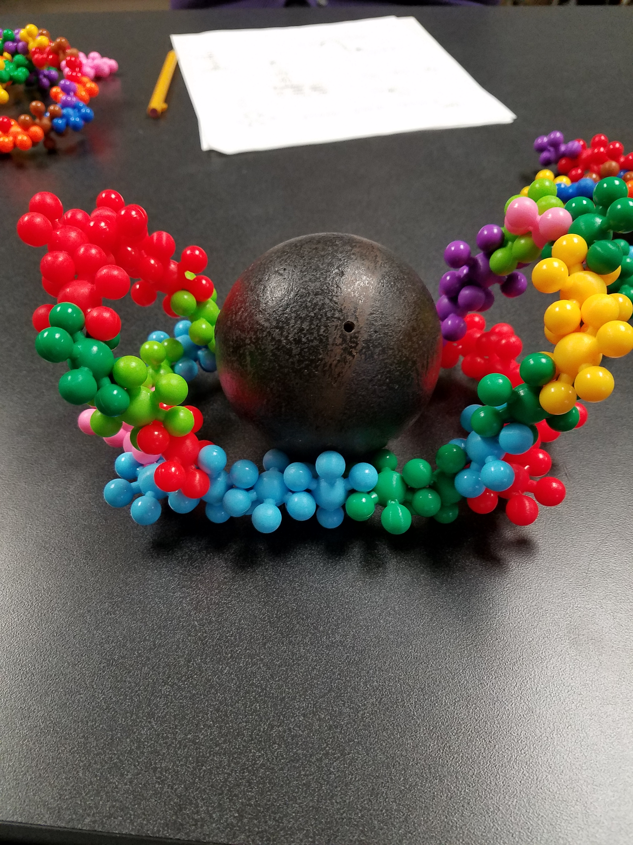

Mutant hemoglobin

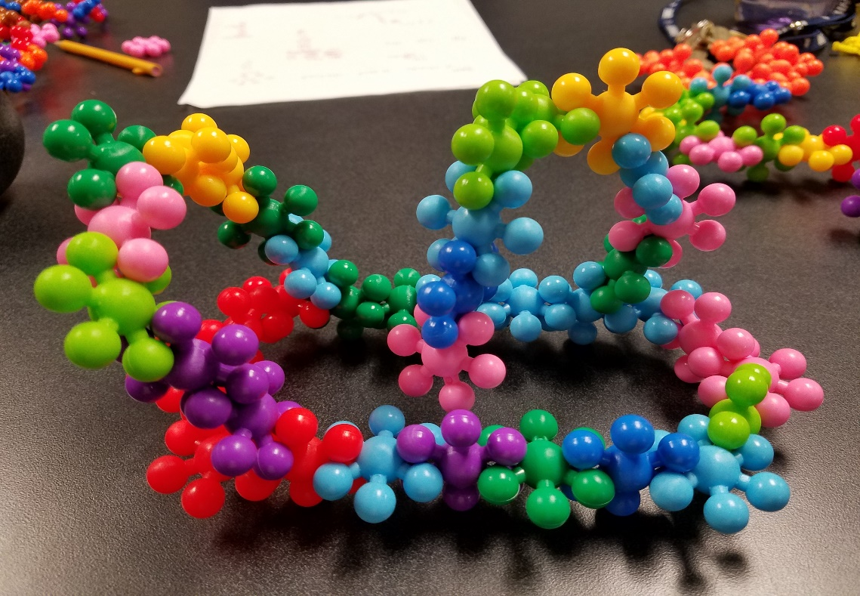

Student Work Samples:

Example 1, worksheet version 1 (scored 2.5/5)

DNA is inside the nucleus of the cell, and it is a double stranded structure holding genetic information. All genes are made of DNA. Cell signaling sends a signal to the nucleus to being replication. The cellular response is transcription factors binding to the Promoter, which starts the genetic code, and allows the RNA polymerase to bind to the Promoter and read the template strand of DNA. The other strand in the double stranded structure DNA is called the coding strand, witch is opposite of the template strand and has the same nucleotides as the mRNA strand. If the DNA strand is built from 3’ to 5’, then the mRNA strand will be built from 5’ to 3’. The base pairings begin, binding the nucleotides A to U and C to G. At the end of the DNA strand is the terminator, ending the genetic coding. The MRNA that is built leaves the nucleus as a single strand and is then translated. The start codon of mRNA enters the ribosome at the A site. This is where the tRNA carries the next amino acid to be added to the polypeptide chain. The Psite then holds the tRNA that carries the growing polypeptide chain. The E site then discharges the tRNA and it exits the ribosome, leaving the amino acid behind to create a protein. The stop codon at the end of the mRNA strand marks the end of the translation. The hemoglobin is a protein that is in red blood cells. A hemoglobin with normal protein is able to bind correctly to oxygen in the blood, but a sickled protein cannot bind to the oxygen, this being a mutation.

Example 2, worksheet version 1 (scored 5/5)

Our world is inhibited by thousands of organism, all of which have DNA, a molecule composed of nucleotides, that carrie the genetic instructions used in the growth, development, functioning, and reproduction. In all organisms the DNA is packed tightly as chromosomes and in Eukaryotes, the chromosomes are found in the nucleus, the control center of a cell or the “main brain” of the cell. This DNA packaged as chromosomes codes for genes, which are units of heredity between a parent and offspring, that code for characteristics of the offspring. A chromosome contains hundreds to thousands of genes. These genes code for different proteins, whether it be blue eye proteins, or skin proteins. These proteins are made out of polypeptides, a linear organic polymer consisting of bound amino-acids, which are organic compounds containing amine and carboxyl functional groups, along with a side chain specific to each amino acid. The key elements of an amino acid are carbon, hydrogen, oxygen, and nitrogen, although other elements are found in the side chains of certain amino acids. When a cell needs specific proteins, whether it be for growth or repairments, it uses cell signaling, to send a message to create more proteins.
Now that we have acknowledged the basics of DNA and the creation of proteins, let's get into the process of transcription. Transcription begins with transcription factors, which are proteins that control the rate of transcription. Transcription factors will signal for the creation of a protein when a protein is needed and they receive the message when there is a need for proteins, from cell signaling. When a protein is being synthesized the first step of doing so is transcription, in which information in DNA is copied into a new format. This new format is RNA,which carries the instructions of DNA. In the process of transcription the DNA starts as a double helix, which means it is double-stranded, with one strand, the template strand, having a certain order of nucleotides, and the other, the coding strand, having the base pair for the nucleotides. The base pairs for nucleotides are A-T and G-C. The enzyme, helicase then unzips the DNA by breaking hydrogen bonds, making it two single-stranded chains. Then the promoter, a region of DNA, located near transcription start site of a gene of a template strand, initiates transcription. The promoter prompts RNA Polymerase, an enzyme to transcribed DNA into mRNA, through matching up the base pairs, expect instead of A-T, it is A-U. RNA Polymerase, then stops transcribing the DNA, into mRNA, when it transcribes a sequence of DNA, known as the terminator. Throughout transcription, the RNA polymerase read the template DNA strand in the 3' to 5' direction, but the mRNA is formed in the 5' to 3' direction
Once transcription is completed, protein synthesis continues with translation. Now that mRNA has been transcribed successfully, it holds the instructions required for building polypeptides, which comes in groups of three nucleotides called codons. Codons code for the amino acids and send signals. There are two different types of codons in the mRNA, besides the regular amino acids. The start codon, AUG, which signals the start of translation and the stop codons, UAG, UAA and UGA, which signals the stop of translation. Translation begins when mRNA travels through the cell’s cytoplasm to ribosomes, were the polypeptides are built. Then tRNA connect mRNA codons to the amino acids they encode, building the polypeptides, made out of amino acid chains. They can do this by having a sequence of three nucleotides called an anticodon at one end of the tRNA, which binds to specific mRNA codons, while the other end carries the amino acid specified by the codons. Proteins are then created once the required polypeptide chain(s) are completed.
Proteins aren't always synthesized correctly and when that occurs a mutation is the result, creating a genetic disorder. An example of genetic disorder is Sickle Cell Anemia. This disorder is caused when the protein hemoglobin, responsible for binding and transporting oxygen to blood, is coded for incorrectly. This incorrect coding, effects sequences of DNA, in which one could be deleted, replaced or moved in the chain. A single mutation can cause Sickle Cell Anemia, changing a normal protein to a sickled protein, which restricts oxygen flow to the blood, resulting in damaging effects. There is a possibility of thousands of mutations in coding, that could cause genetic disorders, like Sickle Cell Anemia.

