Task-level phenomenon: Students watch a video showing the breaking-off of a chunk of glacier that is bigger than lower Manhattan.

Synopsis of high-quality task:
In this investigation, students are designing and carrying out an investigation, engaging in discussion, and using models to show their understanding over the course of 4-5 class periods.

After watching the phenomenon, students will then respond to a probe about the fastest way to get an ice cube to melt without adding extra thermal energy. A science discussion will gather ideas and result in several testable questions. In small groups students will design and carry out investigations, gathering quantitative data about melt rate and how the rate is impacted by various actions. Each group will graph their data, and present that evidence and their conclusions orally to the class. Students will then carry out a second science discussion, making meaning of the results, and, again in small groups, make mental models (diagrams w/annotations) that explain the energy transfer and phase change as changes in the motion of particles. After viewing simulations of heat transfer and phase changes at the particle level, students will refine their models, and the class will construct a consensus model and an anchor chart for mental models.

Anticipated student time spent on task: 4-5 class sessions, 55 minutes each

Type of Task (check one):
__x_ 1. Investigation/experimentation/design challenge
____ 2. Data representation, analysis, and interpretation
____ 3. Explanation

Student task structure(s): Group work
STE Standards and Science and Engineering Practices:

Standards:
HS-PS3-2. Develop and use a model to illustrate that energy at the macroscopic scale can be accounted for
as either motions of particles and objects or energy stored in fields.
Clarification Statements:
- Examples of phenomena at the macroscopic scale could include evaporation and condensation, the conversion of kinetic energy to thermal energy, the gravitational potential energy stored due to position of an object above the earth, and the stored energy (electrical potential) of a charged object’s position within an electrical field.
- Examples of models could include diagrams, drawings, descriptions, and computer simulations.

HS-ESS2-5. Describe how the chemical and physical properties of water are important in mechanical and chemical mechanisms that affect Earth materials and surface processes.
Clarification Statements:
- Examples of mechanical mechanisms involving water include stream transportation and deposition, erosion using variations in soil moisture content, and frost wedging by the expansion of water as it freezes.
- Examples of chemical mechanisms involving water include chemical weathering and recrystallization (based on solubility of different materials) and melt generation (based on water lowering the melting temperature of most solids).

Note: In this task, limited to the property of rate of melting

Science and Engineering Practices:
- Planning and carrying out investigations
- Developing and using models

Prior Knowledge:
Previous Standard from Strand Map:
7.MS-PS3-5 Present evidence to support the claim that when the kinetic energy of an object changes, energy is transferred to or from the object.
Clarification Statement:
- Examples of empirical evidence could include an inventory or other representation of the energy before and after the transfer in the form of temperature changes or motion of an object.
State Assessment Boundary:
- Calculations of energy are not expected in state assessment.

7.MS-ESS2-4 Develop a model to explain how the energy of the Sun and Earth’s gravity drive the cycling of water, including changes of state, as it moves through multiple pathways in Earth’s hydrosphere.
Clarification Statement:
- Examples of models can be conceptual or physical.
State Assessment Boundary:
- A quantitative understanding of the latent heats of vaporization and fusion is not expected in state assessment.

Previous Topics:
- Matter is composed of particles (atoms, molecules, ions).
- All substances can exist in three different phases.
- Energy is the capacity to do work or cause a transformation; energy can be mechanical (potential or kinetic) or electromagnetic.

Connections to the real-world:
Students experience energy transfers every day, in all sorts of common situations. Classrooms (and other spaces) are often over-heated or under-heated (or over/under air-conditioned) and students adopt different strategies to keep themselves at a more comfortable temperature. In addition, water is the one substance that most students have experienced in all three of its phases. This phenomenon and the learning activities it anchors allow the students to think about some of these basic energy and matter concepts in the compelling context of Climate Change
Mastery Goals:

Learning Objective:
- Plan and carry out an experiment investigating the melting rate of ice cubes
- Create a model to demonstrate the interaction of energy and matter at the particle level, during a melting phase
- Construct an explanation of what factors affect the melting rate of ice

Performance Objective:
- Design and carry out an experiment that explores the impact of one or more factors on the melt-rate of an ice cube.
- Create a model that explains what happens at the particle level, to matter and energy as ice melts
- Construct an explanation of what factors affect the melting rate of ice

Language Objective:
- Discuss orally and explain in writing what factors affect the melting rate of ice

Teacher instructions
Instructional Tips/Strategies/Suggestions:

Note: This task was developed in a high school course on Climate Change and builds/reactivates background knowledge for a unit on Earth’s Energy Balance. This task is designed both to provide students with practice/scaffolding in designing investigations and creating models, and to re-activate (elicit) and clarify students’ prior knowledge about the particulate nature of matter and how these particles behave as they gain or lose energy.

Day 1: Students watch this video: “Largest Calving Event Ever Filmed” https://www.youtube.com/watch?time_continue=45&v=hC3VTgIPoGU&feature=emb_logo and record at least 5 observations and 2 questions.

Students then respond to a formative assessment probe, “Melting Ice” that asks which of five options will be the fastest way to melt an ice cube. Divide students into small groups for science discussion circles about which answer they selected and why. Note: This discussion is for the purpose of gathering ideas and noting questions (teacher will not do any teaching/explaining of science concepts during this conversation). The discussion objective (which may be explicitly shared with students) is for students to ask each other clarifying questions. Teacher can also share sentence starters with students if needed. Possible probing questions the teacher can ask, if necessary, include:
- What were they seeing? Where were they?
- What is going on in the video?
- Is more of this going to happen?
- How does this “calving” affect sea level?
- Are there basic laws of nature that we have studied in Physics and Chemistry that we can see in action here?

If there is more than one discussion circle, a student volunteer in each small group can take notes on the conversation virtually or in a notebook to share with rest of class.
Optional: Teacher can assign a reflection as homework.

Have students use their notes from the video and discussions to write down questions they have about ice melting on slips of paper. Tape them onto the board/around room and use a quick gallery walk to review the questions. Then, as a whole class, students sort the questions into ones that are testable (able to investigate) and ones that are not. Students may be prompted to rewrite some of the non-testable questions as testable questions, and to make sure that all the questions ask about the rate of melting. An example of a testable question that may result from this discussion is, “How does smashing an ice cube into smaller pieces affect the melt rate of the ice cube?” An example of a question that is not easily testable is, “Why does smashed ice melt faster?”

Day 2-3: At the end of Day 1, there will be at least 6 categories of testable questions, each corresponding to one of the ideas suggested on the probe. These categories are groups of questions about how melting rate is affected by the following:
- Breaking ice into smaller pieces
- Putting ice in water
- Running w/ice (or moving air over the surface of the ice)
- Putting salt (NaCl) on the ice
- Squeezing the ice
- Wrapping the ice in Aluminum foil
Using these categories, divide students up into at least 6 different small work groups of 2-4 students. More than one group can have the same category of question, but all 6 categories should be assigned if class size permits.

Each group is tasked with designing and carrying out an investigation that can answer the questions by producing data with quantifiable results (may take a day to design the experiment and the following day to conduct the experiment). Products for the investigation will be a large format graph of each group’s results, and an oral presentation about the group’s interpretation of the results and how they do or do not answer the question. Students are given Criteria for Science Data Tables & Graphs. Note: If you are unsure of your students’ graphing abilities, you may want to do a pre-assessment and very targeted differentiation of the graphing based on the results of the pre-assessment.

Day 4-5: In the second science discussion circle, the purpose is making meaning, in which students attempt to explain, on a particle level:
- Why they saw the results they did, and
- Where energy was transferred/stored, and
- How energy was transferred/stored
Note: If students tend to talk only about the macro-level, remind them to think/talk about what’s happening at the particle level, e.g., “That’s an interesting idea. Can you say what you think would be happening to the individual water molecules in the ice?”

Present some examples of science models, have the class develop a list of criteria for an effective model, and post criteria on an Anchor Chart in the classroom. The students create the first draft of their final products, a model (combination of text and diagrams) that explains the energy transfer and phase change that occurred as changes in the motion of particles.

The investigation and the students’ attempts to explain the results have now created a “need to read.” Remaining in their lab groups, students read one of six short science texts (each text corresponding to the category of investigation carried out) and present summaries of the texts back to the whole class, jigsaw style. A gallery walk can be used during the refining of the models. Have students use sticky-notes to give each group feedback, using these sentence frames: “Something I notice is….” “A question I have is…”

The students refine their final products, their models (combinations of text and diagrams) that explain the energy transfer and phase change that occurred as their ice cubes melted as changes in the motion of particles.
Instructional Materials/Resources/Tools:

Materials: list and/or materials management
- Copies of student handouts printed out computers and internet access (to access and read the articles for the Jigsaw, 1 per student)
- Large format graph paper (chart paper size, 1 per lab group), tape, markers
- Scissors and/or pre-cut up sheets approx. ⅓ of a letter size page (for students to write questions on, approx. 3 per student)
- Ice cubes, cooler
- Lab equipment (not all groups will choose/need to use all of these):
  - Scales (triple beam or electronic)
  - Graduated cylinders, 10 mL, 50 mL
  - Funnels
  - Tweezers/forceps/tongs/test tube clamps (to hold ice cubes)
  - Aluminum foil
  - Scissors
  - Hammers (to break up ice cubes)
  - Paper towels, paper plates, other dishes to contain/clean up ice & water
  - Beakers, various sizes
  - Thermometers
  - String/wire
  - Salt
  - Books or other dense objects (to be used to apply pressure to ice cubes)
  - Tongs
  - Water, at room temperature
  - Stop watches (or student phones)
  - Goggles

Safety information: Think ahead of time how students may use the hammers to crush ice, and go over these guidelines with the appropriate groups, or with the whole class. Have students wear goggles, just in case of a flying ice chip. If the tweezers have sharp points consider if they should be used, and, if so, what level of safety guidance is necessary. Remind students of procedures to deal with any broken glassware. Pre-plan clean up instructions to avoid wet floors.

Handouts, links, videos, materials, etc. needed for the student to complete the task.
- Criteria for Science Data Tables and Graphs
- Melting Ice Formative Assessment Probe
- Melting Ice Formative Assessment Probe with Sentence Stems
- Investigation Planning Worksheet
- Ice Investigation Articles for the Jigsaw Reading. They are:
  - How Insulation Works (https://www.explainthatstuff.com/heatinsulation.html)
  - Why Does Salt Melt Ice? (http://antoine.frostburg.edu/chem/senese/101/solutions/faq/why-salt-melts-ice.shtml)
  - Why Does Salt Melt Ice? (with illustrations)
  - Do Large Ice Cubes Yield a Less Watery Drink? (https://www.theglobeandmail.com/life/food-and-wine/wine/do-large-ice-cubes-yield-a-less-watery-cocktail/article578135/)
  - Conduction, Density and Heat Capacity (http://climate.ncsu.edu/edu/Conduction https://www.e-education.psu.edu/earth103/node/1005)
  - Heat Transfer by Convection (http://www.physicsclassroom.com/class/thermalP/Lesson-1/Methods-of-Heat-Transfer)
  - Theory Under Pressure Skates on Thin Ice (https://www.huffingtonpost.co.uk/david-bradley/theory-under-pressure-ska_b_2175389.html?guccounter=1)
- Scaffolding for a Mental Model handout
- Scoring rubric.
- Model Scoring Rubric
Task Sources:
The Ambassador would like to recognize Mira Brown for their contributions to the development of this task.
Accessibility and Supports:
The jigsaw reading provides an opportunity for differentiation, both through selection of the articles, homogeneous or heterogeneous groupings, and varied level of teacher support to the groups. The Mental Model form of explanatory writing allows students to use more writing or more drawing to express their ideas, depending on their personal strengths and preferences.

Sample Student Work:
High level work, student group is all ELLs, levels 3-5
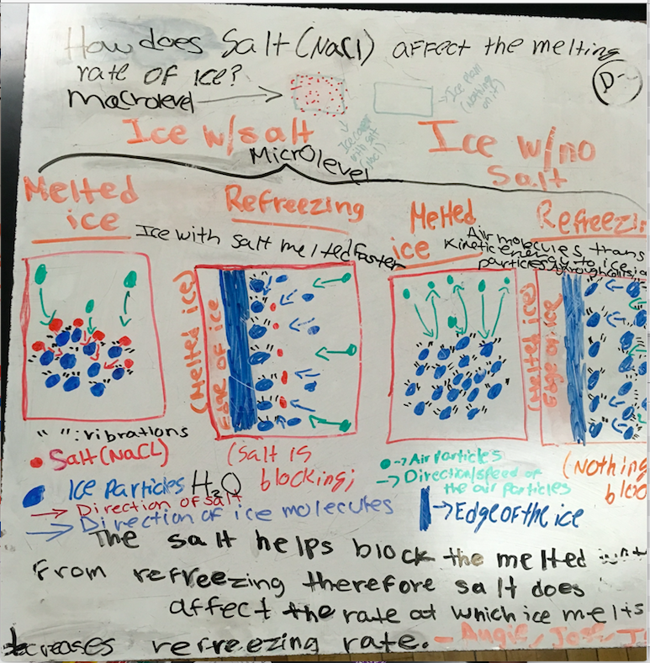

Medium level student work, group includes one student with an IEP, and one student who is an ELL.
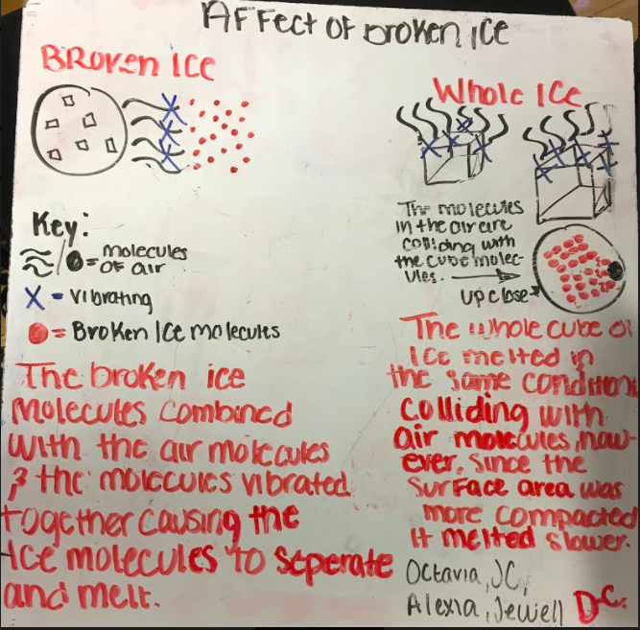

Low level work, all three students in this group are general ed. (The piece of paper at the top of the photo is a print-out of their 1st draft.)
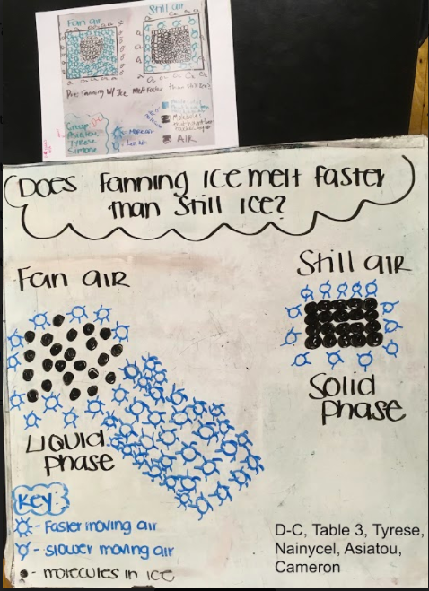

Criteria for Science Data Tables and Graphs

These criteria can be developed with the students, or just given out to them.

Criteria for a Science Data Table
- Has a title, which is the Question your experiment is set up to answer
- Has column and row headings, w/units (if appropriate)
- Has the Manipulated variable (or time) in the first column, and the Responding Variable(s) in the following columns.
- Has the correct # of significant figures for each data point recorded.
- Is neat enough to read!

Criteria for a Science Graph
- Has a title, which is the Question your experiment is set up to answer
- Has labels on X & Y axes, w/units (if appropriate)
- Has the Manipulated variable (or time) on the X-axis, and the Responding Variable(s) on the Y-axis.
- Is scaled to make the data use the entire page of graph paper & to reflect the precision of the data.
- If graph shows more than one set of data, each set is clearly labeled or identified with a key.
- Is accurate.
- Is neat.

Formative Assessment Probe 1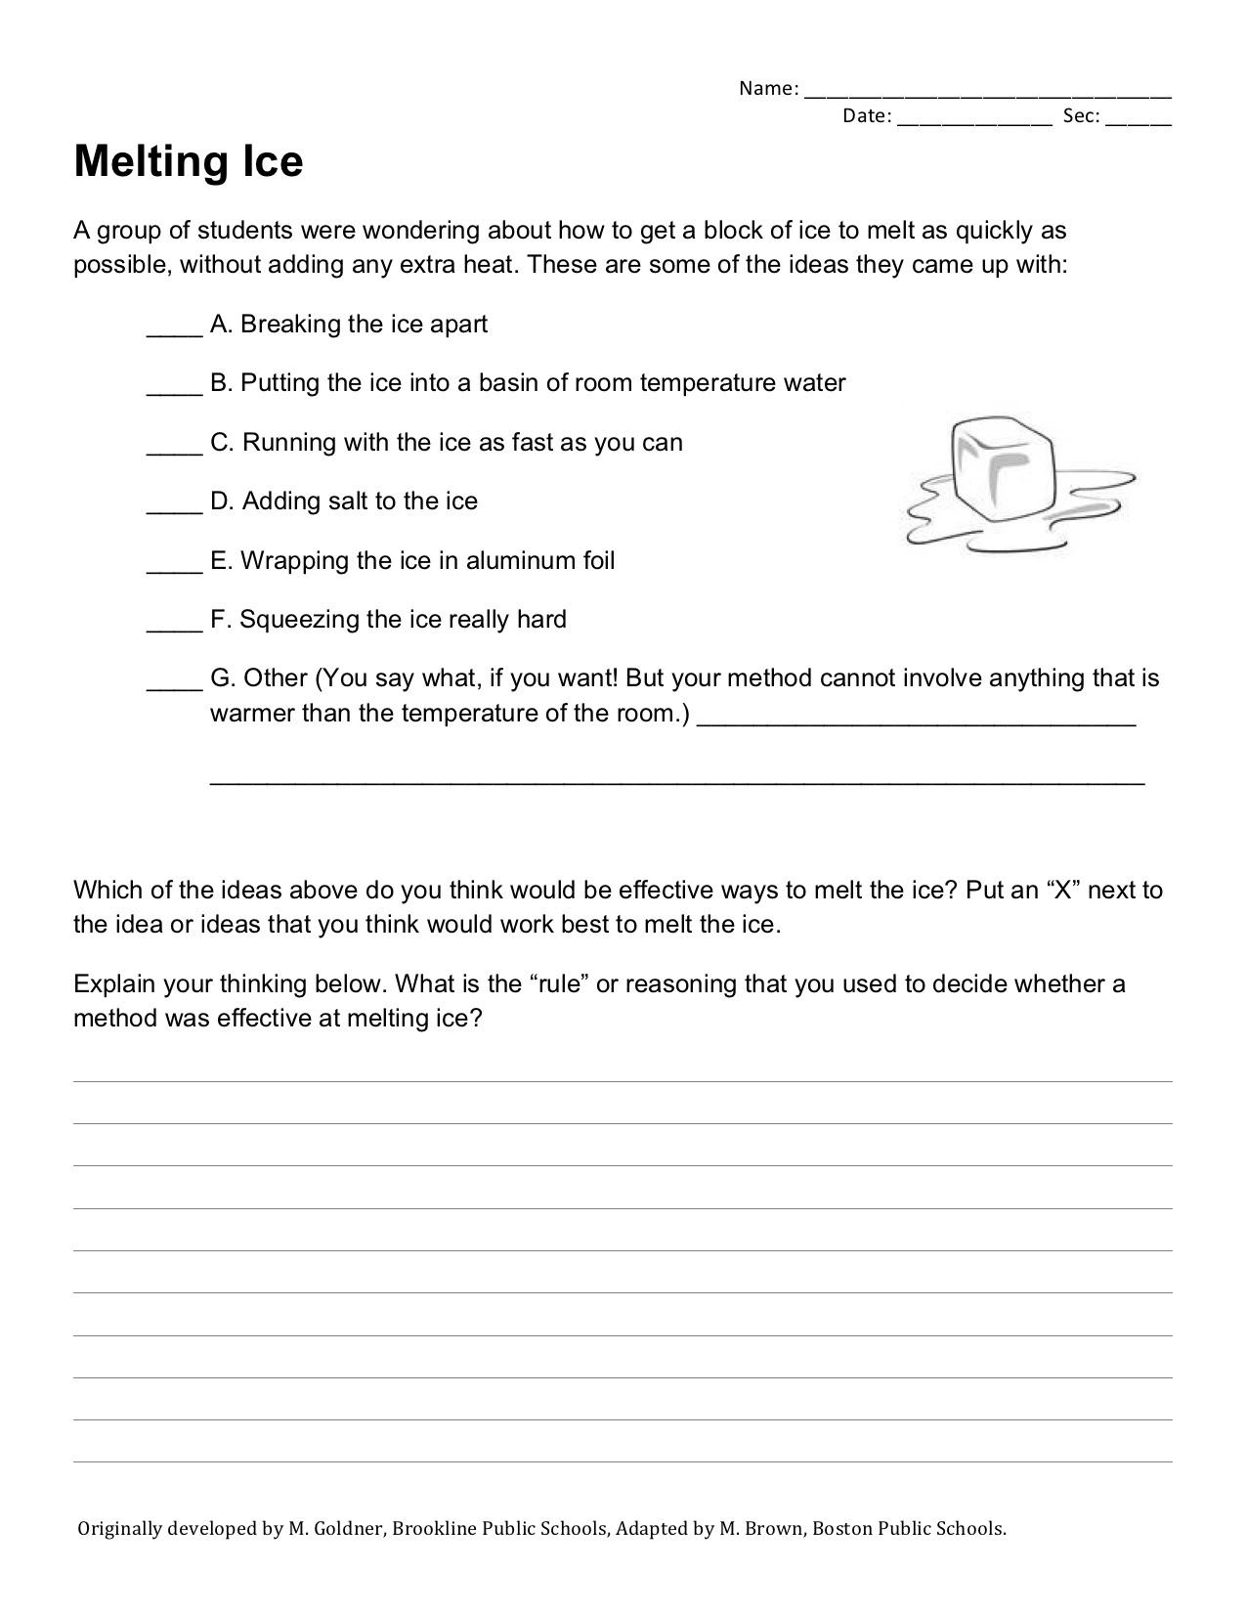
Formative Assessment Probe 2
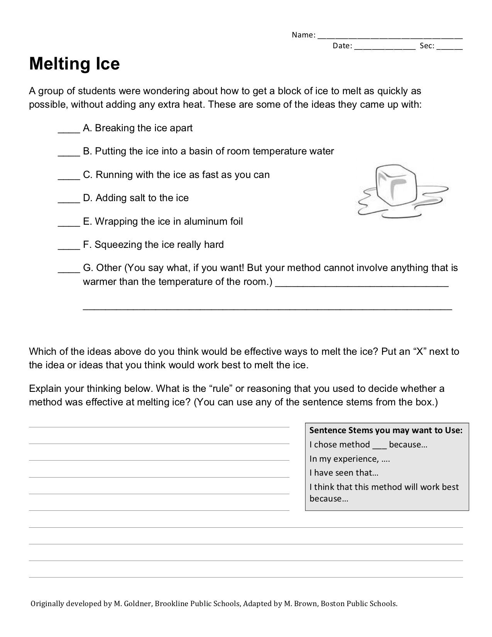
Name: _________________________
Date: ____________ Sec: _____
Experiment Planning Worksheet for _________________________

What is your Testable (“Investigable”) Question?
Give a quick summary of what you will do to try to answer your question (this is not asking for step by step instructions).
What is your prediction for what you think will happen in this experiment?
Give a solid reason for your prediction that uses relevant background information.
What is your manipulated (independent) variable?
What is your responding (dependent) variable(s)?
Explain what will your control be (in other words, when you manipulate one variable, and record the resulting melt-rate data, what will you compare this melt rate to?)
How will you make sure that you are only changing one variable?

Make a list of observations or measurements you will need to make while the experiment proceeds
How you will record data and observations? Create a rough draft data table or other form here, where you can keep track of your data and observations as the experiment proceeds. Once the teacher has approved your data table, make a clean copy of it in your notebook on pg. ___.

Imagine you were giving specific instructions to someone else to set up your experiment for you. Below, create a step-by-step list of instructions for carrying out this experiment.
Make a list of materials you will need

How Insulation Works
If you're out and about in winter and you're feeling cold, chances are you'll put on a hat or another layer of clothing. If you're sitting at home watching television and the same thought strikes you, you're more likely to turn on your heating. Now what if we switched the logic around? What if you ate more food whenever you felt cold and stuck a woolly hat on top of your house each winter? The first wouldn't make much difference: food supplies the energy your body needs, but it doesn't necessarily make you any warmer right there and then. But putting "clothes" on your house—by insulating it—is actually a very good idea: the more thermal insulation you have, the less energy escapes, the lower your fuel bills, and the more you help the planet in the fight against global warming. Let's take a closer look!
Vocabulary You Need

Insulate - (v) to keep one thing away from another thing; to isolate something from its surroundings.
Efficient - (adj) preventing the wasteful use of a particular resource.
Buffer - (v) to lessen or moderate the impact of (something).
Thermal energy - (n) the internal energy of an object due to the kinetic energy of its atoms and/or molecules. The atoms and/or molecules of a hotter object have greater kinetic energy than those of a colder one, in the form of vibrational, rotational, or, in the case of a gas, translational motion.
Vacuum - a space without any matter in it.

Holding onto your heat

The real problem with home heating is retaining the heat you produce: in winter, the air surrounding your home and the soil or rock on which it stands are always at a much lower temperature than the building. So, no matter how efficient your heating is, your home will still lose heat sooner or later. The answer is, of course, to create a kind of buffer zone in between your warm house and the cold outdoors. This is the basic idea behind thermal insulation, which is something most of us think about far too little.

How does heat escape from your home?

Why does heat escape from your home in the first place? To understand that, it helps to know a little bit about the science of heat. “Heat” is what scientists call thermal energy when that energy is in the process of being transferred (moved from one place to another and/or from one substance to another). As you probably know, heat can travel in three different ways by processes called conduction, convection, and radiation. Knowing about these three types of heat flow, it's easy to see lots of ways in which your cozy warm home is leaking heat to the freezing cold world all around it:
- Your house is standing on cold soil or rock, so heat flows down directly into the Earth by conduction.
- Heat also travels by conduction through the solid walls and roof of your home. On the outside, the outer walls and the roof tiles are hotter than the atmosphere around them, so the cold air near to them heats up and flows away, carrying away heat by convection.
- Your house may seem like a big complex space with lots going on inside in but, from the point of view of physics, it's also like a campfire in the middle of vast, cold surroundings: it constantly radiates heat into the atmosphere.
The more heat escapes from your home, the colder it gets inside, so the more you have to use your heating and the more it costs you. The more you use your heating, the more fuel has to be burned somewhere (either in your own home or in a power plant generating electricity somewhere else), the more carbon dioxide gas is produced, and the worse global warming becomes. It's far better to insulate your home and reduce the heat losses. That way, you'll need to use your heating much less. The great thing about home insulation is that it usually pays for itself quite quickly in lower fuel bills. Before long, it's even making you money! And it's helping the planet too.

How thermal insulation works
Suppose you've just poured yourself a hot cup of coffee. Pretty soon, it's going to be a cold cup of coffee instead. What can you do to postpone the inevitable? Somehow you need to stop heat escaping by conduction, convection, and radiation.

The first thing you could do is put a lid on. By stopping hot air rising away above the cup, you'll be cutting down heat losses by convection. Some heat is also going to be disappearing (conducted away) through the bottom of the hot cup into the cold table it's standing on. What if you could surround the cup with a layer of air? Then very little conduction could take place. So maybe have a second cup outside the first one with an air gap in between. Because air is so much less dense than the solid counter there is so much less matter to bump up against the cup and “steal” its heat – a vacuum in between the two cups would be even better insulation! So, that's convection and conduction just about licked, but what about radiation? If you were to wrap aluminum foil around the outer cup, most of the radiation the hot coffee gives off will be reflected back in towards the cup, so aluminum foil should solve the radiative heat loss problem, too. Apply all three of those solutions—a lid, an air gap, and a metallic coating—and what you have is effectively a vacuum flask or “thermos”–a really effective way of keeping hot drinks hot. (It's also good at keeping cold drinks cold, because it stops heat flowing in just as effectively as it stops heat flowing out.)

It's worth noting, just in passing, that sometimes restaurants give you hot drinks or food to go in styrofoam containers. Ever wondered why? The answer is simply that styrofoam is a superb thermal insulator, because styrofoam is just plastic with lots of air pumped into it. With stryofoam you get a lot of the insulating properties of a vacuum flask. (Too bad styrofoam is such a horrible thing for the environment!)

Adapted from https://www.explainthatstuff.com/heatinsulation.html

Why Does Salt Melt Ice?
Vocabulary You Need

Equilibrium – Balance
Melting Point / Freezing Point – the temperature at which a substance freezes and melts
Dissolve – when a substance is mixed entirely in another substance to the point where the 1st substance is not visible at all.
Array – a orderly arrangement of something

In order to understand why salt melts ice, we first need to look very closely at what happens to liquid water molecules and frozen water molecules (ice) when they come in contact.

When ice and water are in contact, two things happen at the molecular level:

- some molecules on the surface of the ice escape into the liquid water (melting), and
- some molecules of water are trapped on the surface of the solid
ice (freezing).

If the amount of ice melting is the same as the amount of water freezing, then there is a balance. We say that the ice and water are in equilibrium with each other. This is what happens at 0°C (32°F), the melting point of water. At this temperature, you wouldn’t notice any change. An ice cube, for example wouldn’t get bigger or smaller. That is, unless conditions change in a way that favors one of the processes over the other.
The balance between freezing and melting processes can easily be upset. One easy thing you can do is to change the temperature (by adding or taking away heat from the system).

If the ice/water mixture is cooled below 0°C, the molecules move slower. The slower-moving molecules are more easily captured by the ice and freezing occurs at a greater rate than melting. Eventually all the liquid water will be captured by the ice and all the water will be in the solid state.

On the other hand, heating the mixture makes the molecules move faster on average, and melting would be more likely. Eventually all the frozen water will escape into the liquid water and there will be no more ice.

Adding salt (sodium chloride, NaCl) to the system will also disrupt the equilibrium. This happens because you are replacing some of the water molecules with NaCl “particles”. Since NaCl is an ionic compound, the salt “particles” are actually ions, because NaCl separates into ions (Na⁺ and Cl⁻, individual atoms with positive or negative charges) as the salt dissolves in the water. These ions take up the space that some water molecules would have occupied in the liquid water, but the ions do not pack easily into the array of water molecules in the solid ice. The solid molecules have a harder time capturing the liquid water molecules because there is another substance in the way. In addition, there are fewer molecules on the liquid side because some of the water has been replaced by salt. Now the total number of water molecules captured by the ice per second decreases, so the rate of freezing decreases. The rate of melting is unchanged by the presence of the salt, so melting is still happening at the same rate. But the freezing process is slower, so melting occurs faster than freezing. We have disrupted the equilibrium between melting and freezing that normally occurs at 0°C.

That's why salt melts ice, even at 0°C.

Source: Adapted from http://antoine.frostburg.edu/chem/senese/101/solutions/faq/why-salt-melts-ice.shtml
Images: http://kaffee.50webs.com/Science/labs/Chem/Lab-Salt.Ice--Check-in.html

Why Does Salt Melt Ice?
Vocabulary You Need

Equilibrium – Balance
Melting Point / Freezing Point – the temperature at which a substance freezes and melts
Dissolve – when a substance is mixed entirely in another substance to the point where the 1st substance is not visible at all.
Array – a orderly arrangement of something

In order to understand why salt melts ice, we first need to look very closely at what happens to liquid water molecules and frozen water molecules (ice) when they come in contact.

When ice and water are in contact, two things happen at the molecular level:

- some molecules on the surface of the ice escape into the liquid water (melting), and
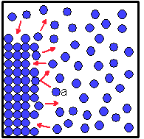
- some molecules of water are trapped on the surface of the solid
ice (freezing).

If the amount of ice melting is the same as the amount of water freezing, then there is a balance. We say that the ice and water are in equilibrium with each other. This is what happens at 0°C (32°F), the melting point of water. At this temperature, you wouldn’t notice any change. An ice cube, for example wouldn’t get bigger or smaller. That is, unless conditions change in a way that favors one of the processes over the other. See the image on the right →
The balance between freezing and melting processes can easily be upset. One easy thing you can do is to change the temperature (by adding or taking away heat from the system).

If the ice/water mixture is cooled below 0°C, the molecules move slower. The slower-moving molecules are more easily captured by the ice and freezing occurs at a greater rate than melting. Eventually all the liquid water will be captured by the ice and all the water will be in the solid state.

On the other hand, heating the mixture makes the molecules move faster on average, and melting would be more likely. Eventually all the frozen water will escape into the liquid and there will be no more ice.

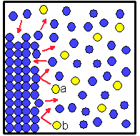
Adding salt (sodium chloride, NaCl) to the system will also disrupt the equilibrium. This happens because you are replacing some of the water molecules with NaCl “particles”. Since NaCl is an ionic compound, the salt “particles” are actually ions, because NaCl separates into ions (Na⁺ and Cl⁻, individual atoms with positive or negative charges) as the salt dissolves in the water. These ions take up the space that some water molecules would have occupied in the liquid water, but the ions do not pack easily into the array of water molecules in the solid ice. The solid molecules have a harder time capturing the liquid water molecules because there is another substance in the way. In addition, there are fewer molecules on the liquid side because some of the water has been replaced by salt. Now the total number of water molecules captured by the ice per second decreases, so the rate of freezing decreases. The rate of melting is unchanged by the presence of the salt, so melting is still happening at the same rate. But the freezing process is slower, so melting occurs faster than freezing. We have disrupted the equilibrium between melting and freezing that normally occurs at 0°C. That's why salt melts ice, even at 0°C. See the image on the right →

Source: Adapted from http://antoine.frostburg.edu/chem/senese/101/solutions/faq/why-salt-melts-ice.shtml
Images: http://kaffee.50webs.com/Science/labs/Chem/Lab-Salt.Ice--Check-in.html

Do large ice cubes yield a less-watery drink?
Vocabulary you need:

Beverage - (n) a drink
Surface Area - (n) the total area on the outside of an object
Surface area to volume ratio - (n) the number you get when you divide an object’s total surface area by its total volume.
Arbitrary - (adj) chosen for no reason
Shed - (v) to lose; to let fall off
Consistent - (adj) the same throughout
Waterier - (adj) more watery

Have you encountered the Colossal Ice Cube? Typically served in fancy beverages, the cubes often measure about five centimeters (about 2 inches) on each side, barely fitting into the glass. The theory is simple. Big cubes melt more slowly, resulting in a less-watery drink.
Or do they?

When I first read about this, I was skeptical. Warmth flowing into the drink from the room is the same in both cases. That should produce equal melting. Heat in equals water out.

It seemed to me that those who serve fancy drinks have been guilty of bogus science. Just because large cubes stay larger for a longer period of time, like a glacier versus icicles in the sun, if there is the same amount of ice, just in smaller or larger cubes, isn’t there the same amount of melted water in the end?

A fan of the seductive clink of multiple small cubes, I had to find out. That's where Dr. Doug Bonn came in. He's a professor in the Physics and Astronomy department at the University of British Columbia and a specialist in low-temperature physics. I liked him immediately because he led me to believe that I wasn't entirely stupid.

"The first thing that you would think is, okay, in that situation, it's the amount of heat coming in from the environment that's going to affect how fast the ice cube melts," he told me over the phone. "The glasses are in the same environment."

He kindly agreed to do an experiment to find out. Using beakers, a scale and a fancy thermometer, he set to work with ice and water. To exaggerate the potential difference in melting rates, he used a 7-to-1 ice-size ratio - one 35-gram cube, which is slightly larger than those of your freezer ice trays, versus seven five-gram cubes. That's an equal volume of ice in both drinks but a greater-than-normal number of smaller cubes in the second.

Assisted by PhD student Brad Ramshaw, he placed the cubes in 125 grams, or about 4½ ounces, of water each for an arbitrary 17 minutes. "It was limited by our patience, not a statement about how quickly you should drink a drink," he said. They measured the temperature in the air above both drinks. It was 7 to 8° C. Nothing was left to chance.

The verdict? Ouch. The large cube shed 4.7 grams of water while the smaller ones shed a total of 7.7 grams, a 61% difference. A second trial using two large cubes and 14 smaller ones yielded a similar result. Big cubes do make less watery drinks.

So, I bow my head in shame, but not completely. Dr. Bonn says the physics is more involved than most people probably realize. He points out that while the larger ice cube melts more slowly, giving you a less watery drink, the small cubes, thanks to more surface area, yield a more consistently colder beverage. This is because the small cubes have a greater surface area to volume ratio, they melt more quickly, taking heat away from the drink more effectively – small cubes give you a more consistently cold, but waterier drink.

The ratio of surface area to volume is an important factor in how quickly things heat up or cool down, and there are many examples of this in nature. Small animals like mice have a large surface area compared to their volume. They lose heat to their surroundings very quickly and must eat a lot of food to replace the energy lost. Large animals like elephants have a different problem. They have a small surface area compared to their volume. They lose heat to their surroundings more slowly and may even have difficulty avoiding overheating.

Elephants get around this partly by the fact that they have large ears with a large surface area compared to their volume. These allow heat to be transferred from the elephant to its surroundings, helping to keep the animal cool.

Engineers design heat transfer devices so that they gain or lose heat energy efficiently. For example,
car radiators are flat, with many small fins to provide a large surface area. Similarly, household radiators are thin and flat, and may have fins so that heat energy is transferred to the room quickly.

A Car Radiator A Household Radiator

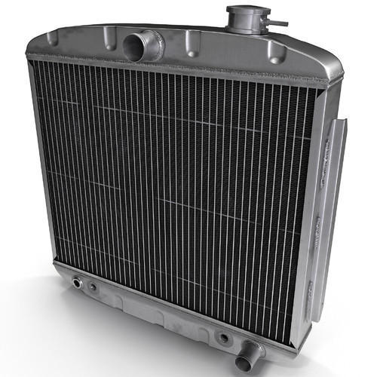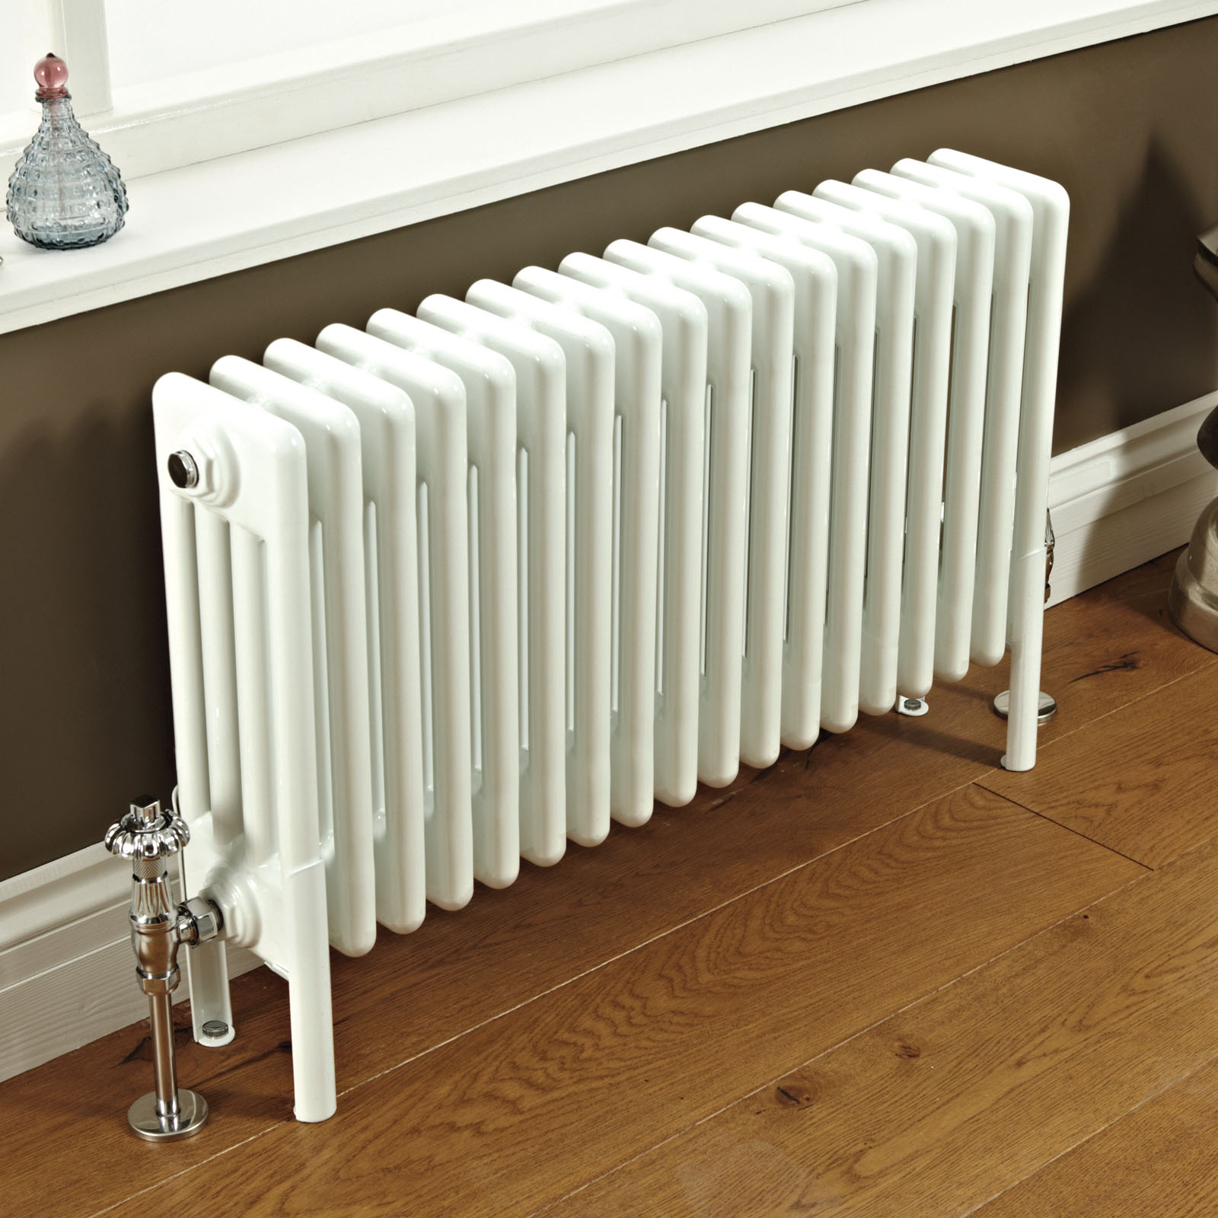

Sources: adapted from https://www.theglobeandmail.com/life/food-and-wine/wine/do-large-ice-cubes-yield-a-less-watery-cocktail/article578135/
http://www.bbc.co.uk/schools/gcsebitesize/science/aqa/heatingandcooling/heatingrev6.shtml)

Heat Transfer by Conduction

Conduction occurs when two objects at different temperatures touch each other and energy directly transfers from the material in the hotter object to the material in the colder object at the point of contact. During conduction, heat is transferred through the vibration of molecules in one or more substances. When something gets warmer, this means that there is an increase in the vibration and movement of the molecules or atoms that make up the item that is getting warmer. In solids, particles (atoms or molecules or ions) are closely packed together and are in direct contact. Since they are close to each other, particles that vibrate more in one spot will basically “bump into” to other particles nearby and pass on the vibrations. The vibrations then spread throughout the object. Conduction works similarly with liquids and gases, but since the density of matter is less in liquids and much less in gases (where there is lots of empty space between molecules), there will be less efficient energy transfer between the molecules because there is not as much bumping of molecules.

A metal pot used to boil water on a stove top is an example of how heat is transferred through conduction. At first the water in the pot is at room temperature and does not feel hot at all before the pot is placed on the stove. After the pot sits on the stove, the pot and its handles begin to get warmer and warmer. After a while, the pot may become too hot to touch with bare hands. In this case, the heat from the stove burner was applied to the bottom of the pot. Due to conduction, the atoms that made up the pot increased their vibration, and the vibrations eventually carried on through the entire pot. The heat we feel when we touch it is actually the vibrations. The heat from the pot is also conducted to the water touching the pot (another example of conduction).

When bare skin is in direct contact with frigid air or with a cold solid such as ice or metal that has been out in the cold, heat is transferred out of the skin into the colder object. This chills the skin, and can lead to cell stress and eventually damage like frostbite. This conduction of heat away from the skin is enhanced if the skin is wet, since water is a better conductor of heat and cold than air is (liquid water is more dense than air, and so there are more molecules to bump up against the skin and “steal” the vibrations of the skin’s molecules). Cold winds blowing across skin enhance the chilling effect by convection, which removes the heat by the movement of air away from the body (convection works by moving away the air that has warmed up, providing a new supply of cold air to take away more vibrational energy).

Heat Capacity and Conduction

Different materials conduct heat differently. One of the properties of a material that affects how fast it can conduct heat is a concept called heat capacity, sometimes called specific heat. Simply put, the heat capacity expresses how much energy you need to change the temperature of a given mass. Let’s say we have a chunk of rock that weighs one kilogram, and the rock has a heat capacity of 2000 Joules per kilogram per °C — this means that we would have to add 2000 Joules of energy to increase the temperature of the rock by 1 °C. If our rock had a mass of 10 kg, we’d need 20,000 Joules to get the same temperature increase. However, water has a heat capacity of 4184 Joules per kg per °K, so you’d need twice as much energy to change its temperature by the same amount as the rock. If you were to put the rock and the water in beakers on a stove and arrange them so that they had the same amount of surface area touching the stove, both the rock and the water would be absorbing heat at about the same rate – however the temperature of the rock would increase much more rapidly than the temperature of the water., both would the water would

The heat capacity of a material, along with its total mass and its temperature, tell us how much thermal energy is stored in a material. Imagine we have a square tub full of water one meter deep and one meter on the sides, then we have one cubic meter of water. Next to that imagine an equal size tub filled just with air. We’ll also imagine that the two tubs are at the same temperature. The density of the water is about a thousand times greater than the density of air. And, the heat capacity of water is about six times greater than the heat capacity of air. These two things together mean that the air will cool down much much faster than the water. The water is simply holding much more thermal energy, so it takes a lot longer to lose the amount of energy necessary to bring down the temperature. One way to summarize this is to say that the higher the heat capacity of a substance, the harder it is to change the temperature of that substance.

Sources: adapted from http://climate.ncsu.edu/edu/Conduction
https://www.e-education.psu.edu/earth103/node/1005

Heat Transfer by Convection
Liquids and gases are fluids; their particles are not fixed in place, so they move freely within a sample of fluid. Convection is the process of heat transfer from one location to another by the movement of fluids. The moving fluid carries thermal energy with it, in the form of molecules or atoms that are vibrating/traveling faster. The fluid flows from a high temperature location to a low temperature location, transferring heat.

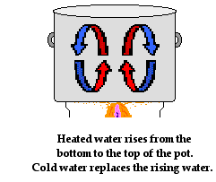
To understand convection in fluids, let's consider the heat transfer through the water that is being heated in a pot on a stove. Of course the source of the heat is the stove burner. The metal pot that holds the water is heated by the stove burner. As the metal becomes hot, it begins to conduct heat to the water. The water at the boundary with the metal pan becomes hot. Fluids expand when heated and become less dense, because the faster moving particles hit each other harder, and bounce further apart from each other. This pushing away from each other is what causes the fluid to expand (take up more space). So as the water at the bottom of the pot becomes hot, its density decreases (remember, density = mass/volume, so if you have the same mass taking up more space, density has decreased). Differences in water density between the bottom of the pot and the top of the pot results in the formation of convection currents. Hot, less dense water begins to rise to the top of the pot displacing the colder, more dense water that was originally there. And the colder water that was present at the top of the pot moves towards the bottom of the pot where it is heated and begins to rise. These currents slowly develop over time, providing the pathway for heated water to transfer energy from the bottom of the pot to the upper surface of the water.
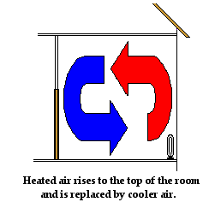
Convection also explains how an electric heater placed on the floor of a cold room warms up the air in the room. Air touching the coils of the heater warm up. As the air warms up, it expands, becomes less dense and begins to rise up through the denser, colder air. As the hot air rises, it pushes some of the cold air near the top of the room out of the way. The cold air moves towards the bottom of the room to replace the hot air that has risen. As the colder air approaches the heater at the bottom of the room, it becomes warmed by the heater and begins to rise. Once more, convection currents are slowly formed. Air travels along these pathways, carrying energy with it from the heater throughout the room.

Convection is the main method of heat transfer in fluids such as water and air. It is often said that heat rises in these situations. The more appropriate explanation is to say that heated fluid rises. For instance, as the heated air rises from the heater on a floor, it carries more energetic particles with it. As the more energetic particles of the heated air mix with the cooler air near the ceiling, the average kinetic energy of the air near the top of the room increases. This increase in the average kinetic energy corresponds to an increase in temperature. The net result of the rising hot fluid is the transfer of heat from one location to another location.
The two examples of convection discussed here - heating water in a pot and heating air in a room - are examples of natural convection. The driving force of the circulation of fluid is natural - differences in density between two locations as the result of fluid being heated at some source. Natural convection is common in nature. The earth's oceans and atmosphere are heated by natural convection.

In contrast to natural convection, forced convection involves fluid being forced from one location to another by fans, pumps and other devices. Many home heating systems involve forced air heating. Air is heated at a furnace and blown by fans through ductwork and released into rooms at vent locations. This is an example of forced convection. The movement of the fluid from the hot location (near the furnace) to the cool location (the rooms throughout the house) is driven or forced by a fan. Some ovens are forced convection ovens; they have fans that blow heated air from a heat source into the oven. Some fireplaces enhance the heating ability of the fire by blowing heated air from the fireplace unit into the adjacent room. This is another example of forced convection.

Source: Adapted from http://www.physicsclassroom.com/class/thermalP/Lesson-1/Methods-of-Heat-Transfer

Theory Under Pressure Skates on Thin Ice
By David Bradley

Countless science teachers, textbooks and fans of ice skating will tell you that ice melts under pressure. They explain how applying pressure lowers the freezing point of water so that it has to be much colder before it will freeze into solid ice, and how, conversely, ice under pressure will melt.

The classic example of this phenomenon in action can be seen every time a skater's blades swish across the surface of an ice rink. The relatively sharp edge of the blade and the weight of the skater pressing down on the ice lower its freezing point so that the ice beneath melts, forming a thin film of liquid water on the surface of the rink - across which the skate can then glide with almost no friction.

Unfortunately it is simply not true.

Scientists have calculated the change in the freezing point of water at different pressures and backed it up with experiments. To lower the freezing point of water from 0°C to -1°C, you must apply a pressure more than 121 times the pressure of the atmosphere bearing down on your head right now.

One of the scientists who has done the watery sums, chemist Kevin Lehmann of the University of Virginia, has a solid answer. He started by assuming that an ice skater has a mass of about 75 kilograms (165 pounds). The blade of each skate in contact with the surface is about 3 millimetres wide and 200 millimetres long. Pressure is defined as the force applied to a specific area. The newtons of force pressing down on the ice is 75 kilograms multiplied by the acceleration due to gravity, which has a value of 9.8 m/s² or newtons per kilogram (remember, force = mass x acceleration).

So, a force of 735 newtons (75 multiplied by 9.8) is pressing down on the blade of that skate. To calculate the pressure we need to know the area of the blade in metres. 3 millimetres by 200 millimetres is 0.003 by 0.2 metres, an area of 0.0006 square metres. The pressure is the force, 735 newtons, divided by this area, which is 1,225,000 newtons per metre squared, or 1,225,000 pascals (a pascal is the SI unit issued for pressure, 1 pascal = 1 newton/m²).

That value for the pressure being applied through the skate to the ice sounds enormous. And in some senses it is: it is about 12 times the value of atmospheric pressure, and it's the pressure you experience if you dive underwater to a depth of about 120 metres. But this pressure is about ten times too small to melt ice. The skater would have to apply a pressure of 120 times atmospheric pressure to do that, and to exert that amount of pressure they would have to weigh ten times as much as a normal ice skater, and so be about 750 kilograms.

You might be wondering whether the pressure could be increased by sharpening the blades. After all, dividing the force of a 75-kilogram skater by a pointy and therefore smaller surface area would equate to a higher pressure. But the effect would be to lower the freezing point of the ice only by a few tenths of a degree. Given that most ice rinks freeze their ice to well below 0°C, this would have little impact. The ice would stay solid.

So how do skaters skate over the solid and rough surface of ice if there is no liquid lubricant in the form of water to allow them to do so?

Lehmann concedes that, as with many other properties of water, scientists simply don't know. There are theories about the water molecules at the surface and how they are not being held as tightly in the ice as those within the frozen solid. There are also ideas about defects in the structure of ice that might allow some water molecules to become loose and so enter the liquid state.

It might be that the steel of the blade somehow grabs these loose water molecules and promotes melting as more and more water molecules loosen their grip on the ice to form that thin slippery layer of water below the skate.

Either way, this melting has nothing to do with the pressure applied.

One property that quickly becomes apparent to anyone new to ice skating, however, is that when you land on the ice with a bump and struggle back to your feet, your body heat allows the frozen particles of ice to quickly revert to the liquid state ... leaving you with a soggy behind.

The Science: Applying pressure to ice has the effect of lowering its freezing point, which means it will melt to form liquid water above a certain temperature. However, the pressure exerted on the ice by even the bulkiest of skaters will be a fraction of that needed to melt ice at the frozen temperature of an ice rink.

Source: Adapted from: https://www.huffingtonpost.co.uk/david-bradley/theory-under-pressure-ska_b_2175389.html?guccounter=1

Group Members_______________________
Sec _____
Group Work – Make your Mental Models
Make a Mental Model that explains the results of your Melting Ice Experiment.

Your Model must answer the question, “In our experiment, how did the particles of matter interact to transfer energy, and how did these interactions result in a phase change?” You should also show why one ice sample melted faster than the other.
Here are some questions to discuss and answer together to help you create your mental model.

1. What do you each think was happening? You don’t have to write this all down, but each of you should say out loud 1 or more sentences such as:
I think energy from the ___________ transferred to the ice by…
I think that the particles of the _____________ ice sped up more slowly because….
The particles of the meltwater are arranged like….
The particles of the ice are arranged like _____________ at first, but as energy is transferred to them, they…
When the _____________ molecules hit the _____________ molecules…

2. List all the substances involved (everyone had ice, air, and melt-water involved, and some kind of surface the ice was sitting on/touching – did your group have any other substances?):

3. How you will represent the particles of each type of substance involved? (draw the symbols here)

4. Now think about how you will represent each type of motion. And how will you represent energy and/or temperature?

5. Now create the model, using whiteboard and dry erase markers.

Science Models Scoring Criteria – Heat Transfer and Phase Change
Your Mental Model should answer the question, “How do the particles of matter interact to transfer energy, and how can these interactions result in a phase change?”

 | Exemplary (4) | Proficient (3) | Developing (2) | Not Yet (1)
Scientifically Accurate Depiction of Concepts (illustrations)  40 points | - Drawings accurately reflect all the components necessary to explain the scientific concept.  - Drawings clearly distinguish between what is happening at the macro level (we can see it) and at the particle (atoms/molecules) level  - Motion is clearly represented, and the relative motion of different components is clear. | - Drawings accurately reflect most of the components necessary to explain the scientific concept.  - Drawings distinguish between what is happening at the macro level (we can see it) and at the particle (atoms/molecule) level, but some clarity is lacking  - Motion is represented, but the relative motion of different components is not entirely clear. | - Drawings reflect some of the components necessary.  - Drawings do not clearly distinguish between what is happening at the macro level (we can see it) and at the particle (atoms/ molecules) level.  - Motion is represented, but relative motion of different components is not clear. | - Drawings lack most of the components necessary to explain the scientific concept.  - Drawings only depict what is happening at the macro level.  - Motion is not represented, or is unclear, or misrepresented.
Scientifically Accurate Description of Concepts (text)  40 Points | - Text (labels/text blocks/titles) is accurate  - Text includes all the components necessary to explain the scientific concept.  - Science vocabulary is used correctly and explained. | - Text (labels/text blocks/titles) is mostly accurate  - Text includes most of the components necessary to explain the scientific concept.  - Science vocabulary is used correctly. | - Text (labels/text blocks/titles) is only partially accurate  - Text includes only some of the components necessary.  - Not enough science vocabulary is used, or it is used, but not entirely correctly. | - Text (labels/text blocks/titles) is inaccurate and/or missing.  - Science vocabulary is not used, or it is used, but not correctly.
Form, Creativity  10 points | - A key or clear labels explains what each symbol represents.  - The Model is neat.  - The Model is arranged so that the reader knows where to start, and the information flow is coherent and obvious.  - Color is used to improve the clarity of the Model. | - Most but not all of the criteria for Exemplary are met. | - Some of the criteria for Exemplary are met. | - Key/labels are missing/inaccurate/ unclear.  - Model is messy.  - The Model has confusing flow.  - Little or no color is used.
Presentation  10 points | - All members of the group respond to questions and are able to explain the concepts. | - All members of the group respond to questions, and most are able to explain most concepts. | - Only some members of the group respond to questions and are able to explain the concepts. | - No member of the group can respond to questions, or able to explain the concepts.
Comments:

