Task-level phenomenon:
Motion data pulled from vehicles as well as accelerometers from phones allow for police investigators to use corroborative evidence when handling crimes.
Synopsis of high-quality task:
In this task, students will analyze data and form an argument to determine who robbed A&D Pizza. Students analyze maps and motion graphs of three vehicles to identify evidence to make their case. Students present their findings at the end of the task.

Anticipated student time spent on task: 1 session, 45-60 minutes

Type of Task:
 | 1. Investigation/experimentation/design challenge
✔ | 2. Data representation, analysis, and interpretation
 | 3. Explanation

Student task structure(s): Partner work
STE Standards and Science and Engineering Practices:
HS-PS2-1. Analyze data to support the claim that Newton’s second law of motion is a mathematical model describing change in motion (the acceleration) of objects when acted on by a net force.
Clarification Statements:
- Examples of data could include tables or graphs of position or velocity as a function of time for objects subject to a net unbalanced force, such as a falling object, an object rolling down a ramp, and a moving object being pulled by a constant force.
- Forces can include contact forces, including friction, and forces acting at a distance, such as gravity and magnetic forces.
State Assessment Boundary:
- Variable forces are not expected in state assessment.

HS-PS2-10(MA). Use free-body force diagrams, algebraic expressions, and Newton’s laws of motion to predict changes to velocity and acceleration for an object moving in one dimension in various situations.
Clarification Statements:
- Predictions of changes in motion can be made numerically, graphically, and algebraically using basic equations for velocity, constant acceleration, and Newton’s first and second laws.
- Forces can include contact forces, including friction, and forces acting at a distance, such as gravity and magnetic forces.

Science and Engineering Practice(s):
- Engaging in argument from evidence

Prior Knowledge:
Previous Standards from Strand Map:
8.MS-PS2-2. Provide evidence that the change in an object’s speed depends on the sum of the forces on the object (the net force) and the mass of the object.
Clarification Statement:
- Emphasis is on balanced (Newton’s first law) and unbalanced forces in a system, qualitative comparisons of forces, mass, and changes in speed (Newton’s second law) in one dimension.
State Assessment Boundaries:
- State assessment will be limited to forces and changes in motion in one dimension in an inertial reference frame and to change in one variable at a time. The use of trigonometry is not expected in state assessment.

HS-PS2-2. Use mathematical representations to show that the total momentum of a system of interacting objects is conserved when there is no net force on the system.
Clarification Statement:
Emphasis is on the qualitative meaning of the conservation of momentum and the quantitative understanding of the conservation of linear momentum in interactions involving elastic and inelastic collisions between two objects in one dimension
Connections to the real-world:
- The task is presented as a real-life case in which students take the role of forensic scientist
- The task is situated in students’ town – guidance is included in the task for adapting to any locality
Mastery Goals:

Learning Objective:
- Evaluate graph data in order to construct an argument using evidence.

Performance Objective:
- Construct an evidence-based argument for which vehicle was involved in the scenario, including an analysis of the available data, and why selected data was chosen for the argument.

Language Objective:
- Orally debate on the selection of evidence, and write an argument based on evidence.

Teacher instructions

Before giving this task:
This is more relevant when customized to local streets for your students:
- Choose a location in the area that the students would know.
  - It’s helpful to gather the information in classes leading up to this task by asking what are some good places to eat/shop/visit in town.
  - Good locations have multiple roads that head nearly directly away from it.
- Use Google Maps or other online mapping tool to get a map and scale of the location.
  - Change the scale in the lower right portion of the screen to metric, then zoom until the 100m is a little under an inch.
  - Using the snipping tool application
Or the ‘print screen’ option to grab a screenshot of the area you will be using.
  - Also grab a picture of the scale to include with your map.
  - Change the location names in the student materials to the customized location.

Introduction of task:
- Give students the written introduction and instructions on creating an argument based on the evidence provided.
- Allow students ~5 mins to read the assignment. Then, as a class, answer any questions the students have, and briefly show them the different information that is available (maps, graphs, etc) to construct their arguments.
- After the briefing, students are paired up and may begin.

Tips:
- The task itself is open-ended. Students have to decide what is important to their argument and what is not.
- The task takes roughly 45 mins, after which there is a debrief on what the students looked at and used for their arguments as well as what they compared and discovered. Plan when the debrief will take place.
- This serves as an assessment task for students after they have had some experience with motion graphs.

General Hints:
- Acceleration graphs can be used to determine when the vehicle sped up or slowed down
- Acceleration graphs should be used as constant acceleration for the amount of time on the bar graph (e.g., one bar at 10m/s² is an acceleration of 10m/s² for one second). This information can be used to construct the velocity v time graph, and then the position v. time graph.
- Using the scale on the map, distance can be mapped out to see possible end points for the chase.
- Emphasize that the strength of the argument depends on the strength of the evidence.
Instructional Materials/Resources/Tools:
Materials:
- Map for each group or student
- Student directions for each student
- Graphs for each group or student
- Ruler for each group or student

Accessibility and Supports:
Vocabulary:
- displacement - the change of position
- velocity - rate of change of position in time
- acceleration - rate of change of the velocity per unit time
- time - measurement of interval between events
- force - a push or pull causing an acceleration on an object
- scale - ratio of distance into and out of a map
- slope - rise over run of a graph
Scaffolding:
- Hint 1: Recommend students use the acceleration graph to determine the velocity of the vehicle, and from there, determine the position of the vehicle. Students can use these principles to construct a rough velocity v time and position v time graph.
- Hint 2: Recommend students measure out distance from the location using the scale of the map
Extending:
- Students can create a report in the form of a presentation or other modality
Task Source:
The Ambassador would like to recognize Millbury Public Schools teachers for their contributions to the development of this task.

Student Handout
Who Robbed A&D Pizza!?
It’s a regular who-dunnit! You are a group of forensic analysts that are given a limited amount of information. You will have a map of the crime scene as well as the surrounding area. With your knowledge of displacement, velocity, acceleration, and time, you must solve the case!

The suspect is known to have left the scene in a vehicle. The suspect then travelled between 100m to 200m from the location before being spotted by the police. A chase ensued and the suspect was apprehended (caught by the police) 30 seconds after the suspect rammed their vehicle into another car and got out on foot. An estimated 29000 N of force was used to stop the vehicle.

The suspect’s vehicle as well as two other vehicles have had their accelerometer data pulled from their computers, however, due to a clerical error, the information has been mislabeled. Using your knowledge of motion, you must determine which data is the correct data that matches the description of incident.

Assignment:
Use the acceleration graphs, the map, and your knowledge of Millbury to determine which vehicle belonged to the suspect. Your response should include:
- Which vehicle you identified as the suspect’s (1 pt).
- What steps you took to determine the vehicle chosen (1 pt).
- What data you used to backup your choice (1 pt per evidence).
- Why you eliminated the other vehicles as choices (1 pt per reason).
- What steps you took in investigating this information (1 pt per evidence).

The Map
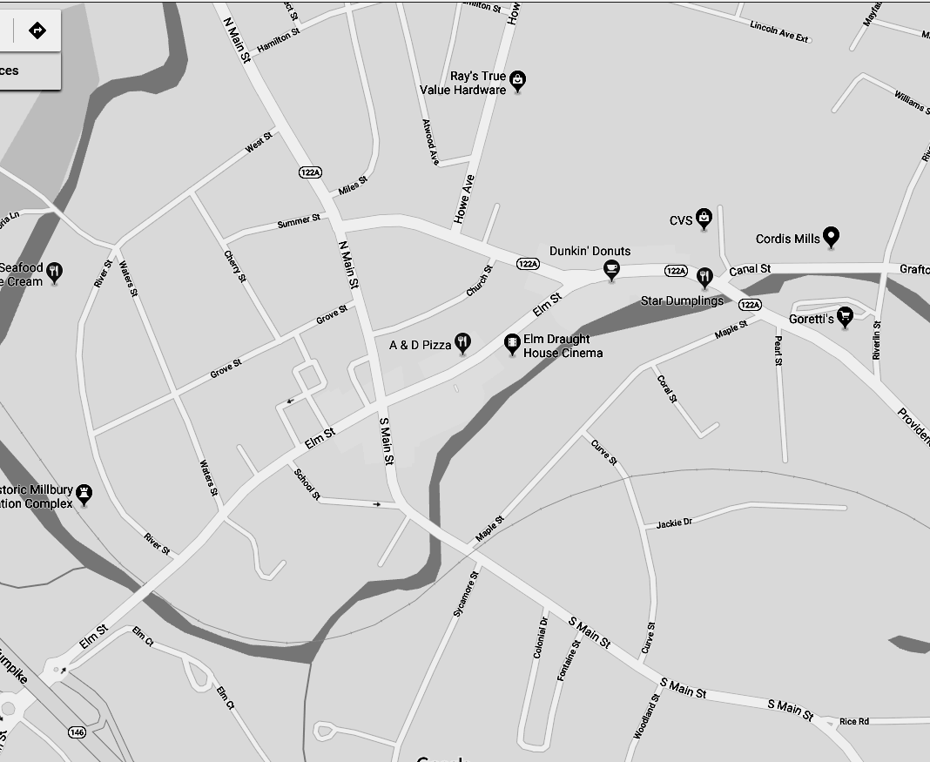

Vehicle 1
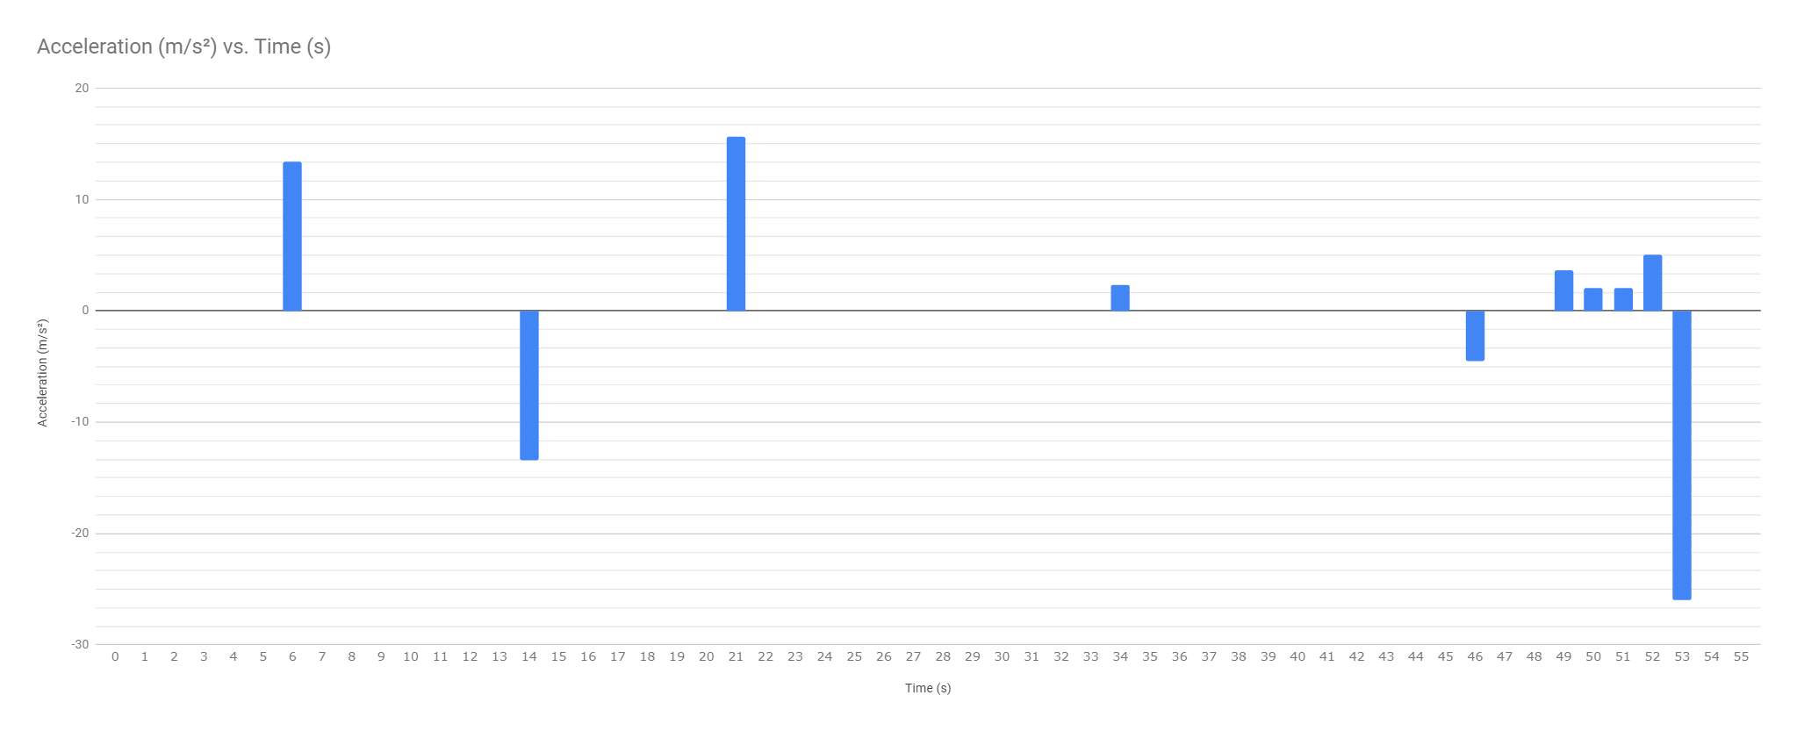

Vehicle 2
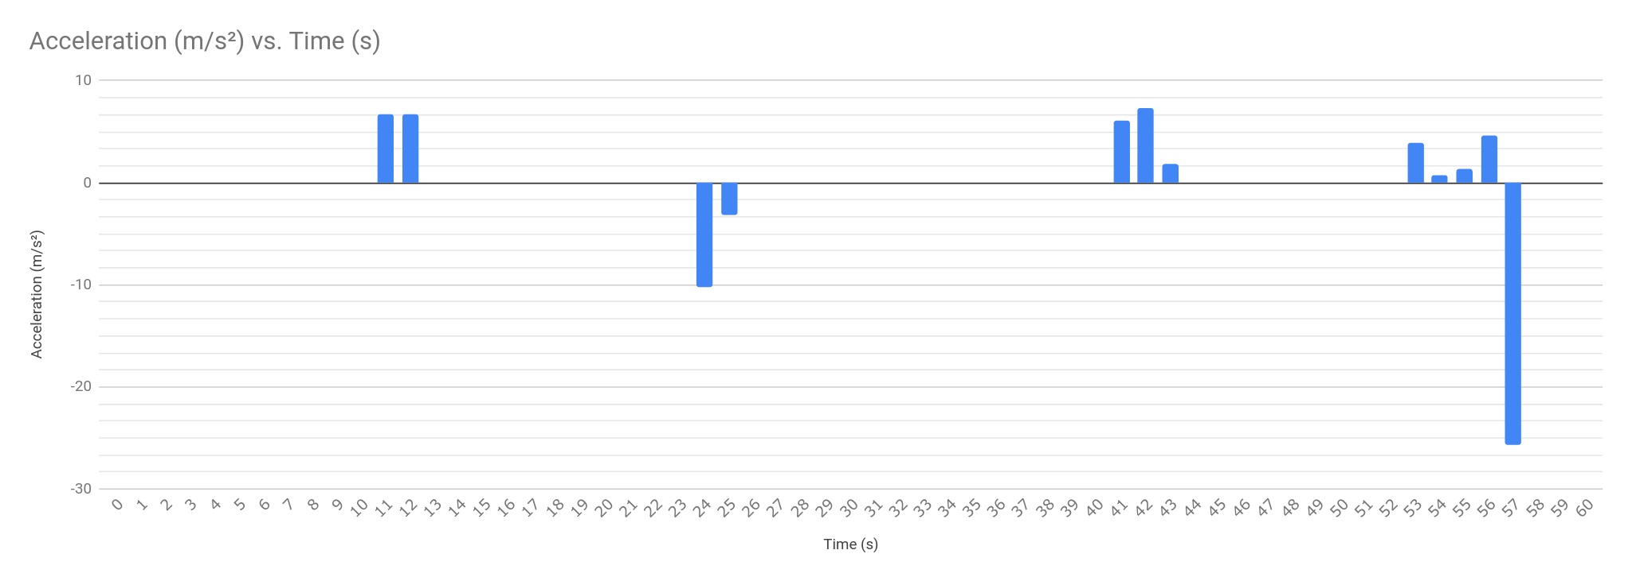

Vehicle 3
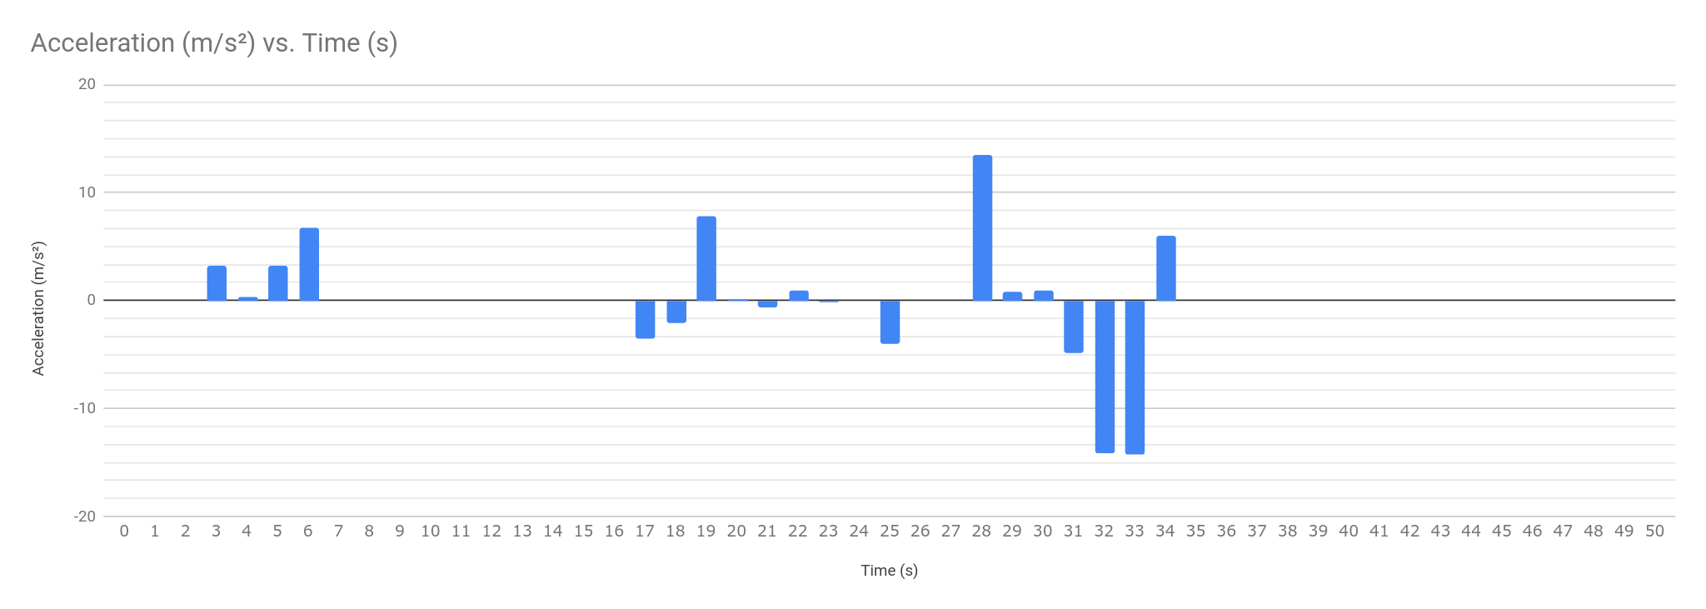

Sample Student Work:
