Task-Level Phenomenon:
Students engage in an engineering design problem about how passengers in vehicles do not wear seatbelts, and when they do wear seatbelts, still incur bodily injury from the force of the seatbelt on the passenger during the crash.

Synopsis of high-quality task:
This task is part of a three-lesson sequence. This is the final part in the sequence, preceded by Seatbelt Data Analysis and Crash Test Investigation, which are posted on the STEM Ambassador website. This task expands upon the Crash Test Investigation task. This task takes an engineering approach, in that student groups are given the mission to design, create, and collect data on a better seatbelt design; one which not only prevents fatality, but also reduces the amount of bodily injury incurred by the force of the seatbelt on the person during a crash. Groups must design, create, and carry out an experiment that will provide data to support their proposed design. They present their findings, discussing each step of their design process, the data they choose to collect and why, and relate the results to the science of Newton’s Laws of Motion.

Anticipated student time spent on task: 2 sessions (1 session for design and data collection; 1 session for creating presentation), 55 minutes each

Type of Task (check one):
__x_ 1. Investigation/experimentation/design challenge
____ 2. Data representation, analysis, and interpretation
____ 3. Explanation

Student task structure(s): group work
STE Standards and Science and Engineering Practices:

Standards:
HS-PS2-1 Analyze data to support the claim that Newton’s second law of motion is a mathematical model describing change in motion (the acceleration) of objects when acted on by a net force.
Clarification Statements:
- Examples of data could include tables or graphs of position or velocity as a function of time for objects subject to a net unbalanced force, such as a falling object, an object rolling down a ramp, and a moving object being pulled by a constant force.
- Forces can include contact forces, including friction, and forces acting at a distance, such as gravity and magnetic forces.
State Assessment Boundary:
- Variable forces are not expected in state assessment.

HS-PS2-10(MA) Use free-body force diagrams, algebraic expressions, and Newton’s laws of motion to predict changes to velocity and acceleration for an object moving in one dimension in various situations.
Clarification Statements:
- Predictions of changes in motion can be made numerically, graphically, and algebraically using basic equations for velocity, constant acceleration, and Newton’s first and second laws.
- Forces can include contact forces, including friction, and forces acting at a distance, such as gravity and magnetic forces.

Practices:
- Planning and Carrying Out Investigations
- Construction Explanations and Designing Solutions
- Engaging in Arguments from Evidence

Prior Knowledge:
Previous Standards from Strand Map:

7.MS-PS3-1. Construct and interpret data and graphs to describe the relationships among kinetic energy, mass, and speed of an object.
Clarification Statements:
- Examples could include riding a bicycle at different speeds and rolling different sized rocks downhill.
- Consider relationships between kinetic energy vs. mass and kinetic energy vs. speed separate from each other; emphasis is on the difference between the linear and exponential relationships.
State Assessment Boundary:
- Calculation or manipulation of the formula for kinetic energy is not expected in state assessment.

8MS-PS2-2 Provide evidence that the change in an object’s speed depends on the sum of the forces on the
object (the net force) and the mass of the object.
Clarification Statement:
- Emphasis is on balanced (Newton’s first law) and unbalanced forces in a system, qualitative comparisons of forces, mass, and changes in speed (Newton’s second law) in one dimension.
State Assessment Boundaries:
- State assessment will be limited to forces and changes in motion in one dimension in an inertial reference frame and to change in one variable at a time.
- The use of trigonometry is not expected in state assessment.

Considerations for the teacher concerning prior knowledge:
- Familiarity with the engineering and design process
- Assuming the Seatbelt Data Analysis task and the Crash Test Investigation task have been completed, students will have a solid base of knowledge of evidence of seat belt benefits, as well as designing and carrying out an investigation. However, the following concerns from these two tasks may still be relevant:
  - It cannot be assumed that all students have had experience driving in cars or wearing seatbelts. Especially in the urban environment where travel by subway and buses (which don’t use seatbelts) is common, some students may not be as familiar with seat belt use. Some discussion about seat belts and showing of seatbelts in cars (pictures) may be required.
  - Groups are encouraged to use the Claim, Evidence, Reasoning format for their interpretations of data and explanation of results. Some students may not be familiar with this format of argumentative reasoning and may need some scaffolding.
  - Understanding of qualitative and quantitative data.

Connections to the real-world:
- Driver safety and fatalities from car crashes are a reality.
- Seat belts are a real-world device that save lives, yet many students probably have someone they know that refuses to “buckle-up.”
- Engineering and design are booming industries and promising career options for our students. These tasks can be used to begin to get students thinking about how the skills they practiced in the classroom can be applied in industry.
Mastery Goals:

Learning Objective:
- Apply Newton’s first law to the design elements for a better seatbelt.

Performance Objective:
- Design, carry out, and present an investigation that provides relevant qualitative and quantitative data on how seat belts increase driver safety during a crash, applying Newton’s Laws of Motion to explain the results.

Language Objective:
- Read and interpret data sets, pictures, and diagrams, and create meaningful visual representations of experimental data, working collaboratively to present relevant findings and conclusions obtained from their investigation.

Teacher instructions/Tips/Strategies/Suggestions:

ENGAGE:
Students are given a prompt in which they are to use knowledge gained from previous lessons (Seatbelt Data Analysis and Crash Test Investigation) to form a counterclaim against the argument proposed that seat belts do more harm than good.

- Seatbelt Injury CER Seatbelt Injury CER

Encourage students to refer back to the data from Seatbelt Data Analysis (you may wish to hand out the data graphs again for reference, included in resource section of this lesson plan).

EXPLORE
Students expand on their crash test investigation they did during the previous task. The instructor should emphasize to students that this is not merely a repeat of the first part, and they are expected to engage in the engineering and design process. Note: You may need to introduce the engineering design process and explain how groups will incorporate it for this task

In this task, groups are given the objective of creating a better seatbelt design, one that not only saves lives, but also will minimize injury sustained during the application of the force of the seatbelt on the human body to stops its inertial motion. Similar to the crash test investigation task, the instructor should emphasis with groups that they need to focus on what type of data they should collect, is it measurable and quantifiable, and how does it relate back to what we know from Newton’s Laws of Motion. The instructor should ensure that during groups’ work on this phase, the groups are taking notes on the process they used and writing down observations of what occurred.
- Seatbelt Safety Design Sheet

As students may not be familiar with the process of engineering, the teacher may need to provide some instruction and guidance in that often the first engineered design may not yield the optimal result, or fail completely! It should be explained to groups that they most likely will have many designs, many of the initial ones which will not perform that well. The instructor should explain that groups must document and provide evidence of a progression in their designs, using tests and data collection of the results as evidence of this.

Encourage students to try, try, and try again, to design and redesign, and provide data/results as evidence of this. In fact, this is a requirement of the grading rubric for this project (see Evaluate section of LP for the rubric). To aid students new to this, the instructor may wish to handout a graphic organizer, such as the Seatbelt Test Graphic Organizer included below, to help ensure student groups understand that they should test at least 3 design modifications.
- Seatbelt Test Graphic Organizer

EXPLAIN:
Just like in Crash Test Investigation, students are required to relate what they observed, and the data collected to Newton’s Laws of Motion. Assuming Crash Test Investigation was completed, students should already have notes and understandings of Newton’s Laws of Motion and how these concepts apply to car crash phenomenon. However, if after Crash Test Investigation presentations, the instructor has assessed students still need deeper understandings of Newton’s Laws and it application, supplementary links are provided below for students to explore to gain further knowledge that they can incorporate into their presentation (students can draw upon their textbooks and course work for a resource as well).
- Newton’s 1st Law Notes Sheet/Instructions
- Links:
  - https://www.texasgateway.org/resource/newtons-law-inertia
  - https://www.physicsclassroom.com/Physics-Tutorial/Newton-s-Laws
  - https://www.youtube.com/watch?v=PNTLDNxTMdg

EVALUATE:
As in Crash Test Investigation, student groups will once again present their results to the class. For this presentation, the peers of the class will make up the board that assess the design of other groups’ projects. As a group presents, the other groups are given the rubric to assess the project (see rubric in evaluate section). The rubric used is nearly the same as in Crash Test Investigation, as it emphasizes the quantity and quality of the data collected, the application of Newton’s Laws for an explanation. However, the rubric for this task has an added category that evaluates the implementation of the engineering design process (multiple revisions, tests, and redesigns based on the results). See end of this lesson plan for the student handout and rubric.
- Presentation Notes
- Presentation Evaluation Rubric

Instructional Materials/Resources/Tools:

- Student handouts
  - Seatbelt Injury CER
  - Seatbelt Safety Design Sheet
  - Seatbelt Test Graphic Organizer
  - Newton’s 1st Law Notes Sheet/Instructions
  - Presentation Notes
  - Presentation Evaluation Rubric

- Links to Newton’s Laws content:
  - https://www.texasgateway.org/resource/newtons-law-inertia
  - https://www.physicsclassroom.com/Physics-Tutorial/Newton-s-Laws
  - https://www.youtube.com/watch?v=PNTLDNxTMdg

- Materials list (per group): car or cart with wheels, a piece of cardboard for a ramp, clay to make a model person, and various materials that can be used for seatbelt construction (copper wire, paper clip, string, rubber band, tape, etc.). Note: If the instructor does not have a small car or cart for each group to use, some instructors have made cars out of paper (just google paper cars). This will add another level to the task (as well as time involved) but can be a part of the task where students must design their own car to use for the investigation.

- Scoring rubric

Task Sources:
Fatalities vs Seat Belt Use graph - https://one.nhtsa.gov/people/injury/research/buckleup/ii__trends.html

The Ambassador would like to recognize Stacy-Michelle Reid and Scott Hubeny for their contributions to the development of this task.
Accessibility and Supports:
Students should be reminded there is no one “right answer” with such a task and encouraged to explore and try various avenues in pursuit of their goal, knowing it may take a few tries to get a desired outcome.

Some students may need support with deciding what is relevant data to measure and collect, as well as the best way to organize this data for analysis and presenting. Examples of data tables and graphs can be provided as inspiration and guidance for students.

Also, students may need help in understanding that the engineering and design process involves several steps and constant evolution along the way. Remind students that the first way to approach an investigation is not always the optimum way, and constant refinement through assessing results from multiple experiments will be in order.

Word walls and/or glossary for reference can be incorporated to help students remember these key terms.

key academic vocabulary
- Inertia
- Acceleration
- Force
- Unbalanced
- Quantitative
- Qualitative
- Newton’s Laws

Sample Student Work:

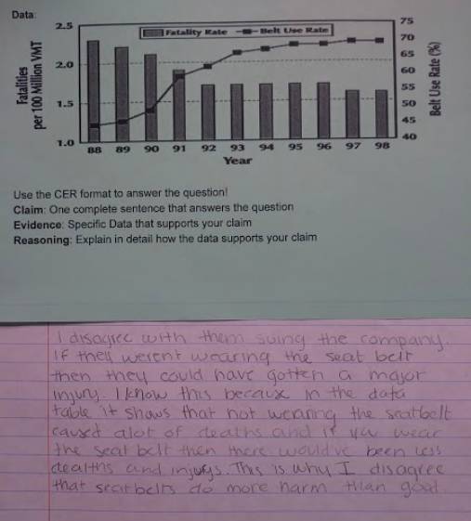
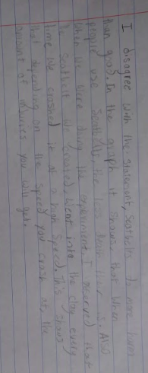

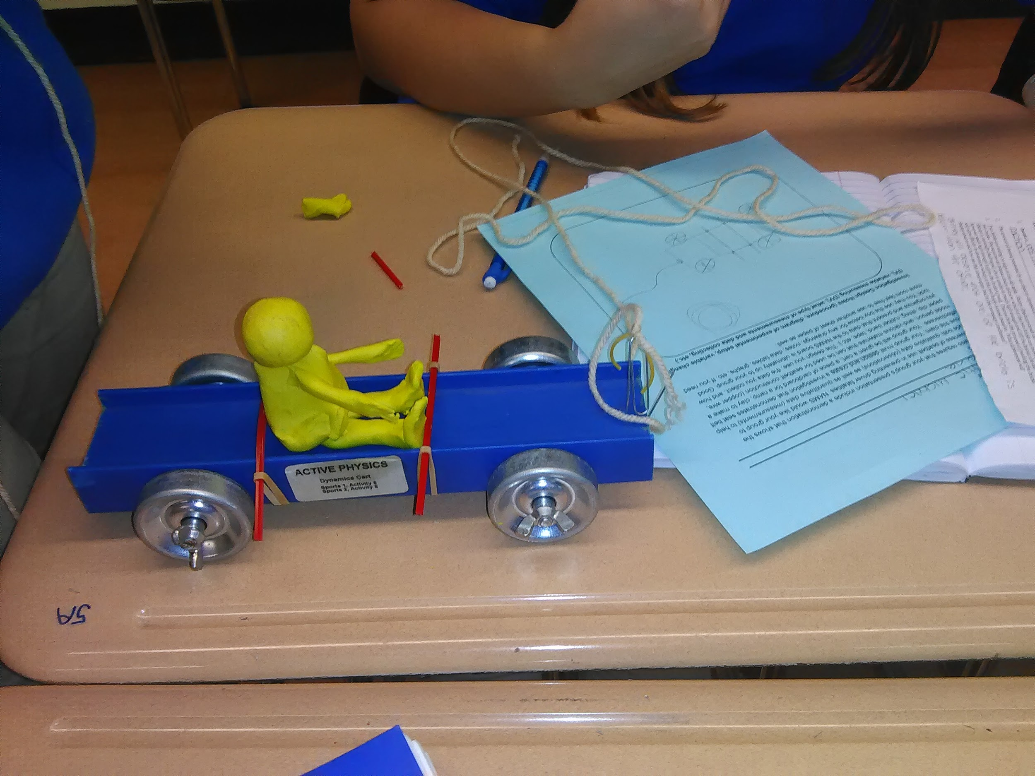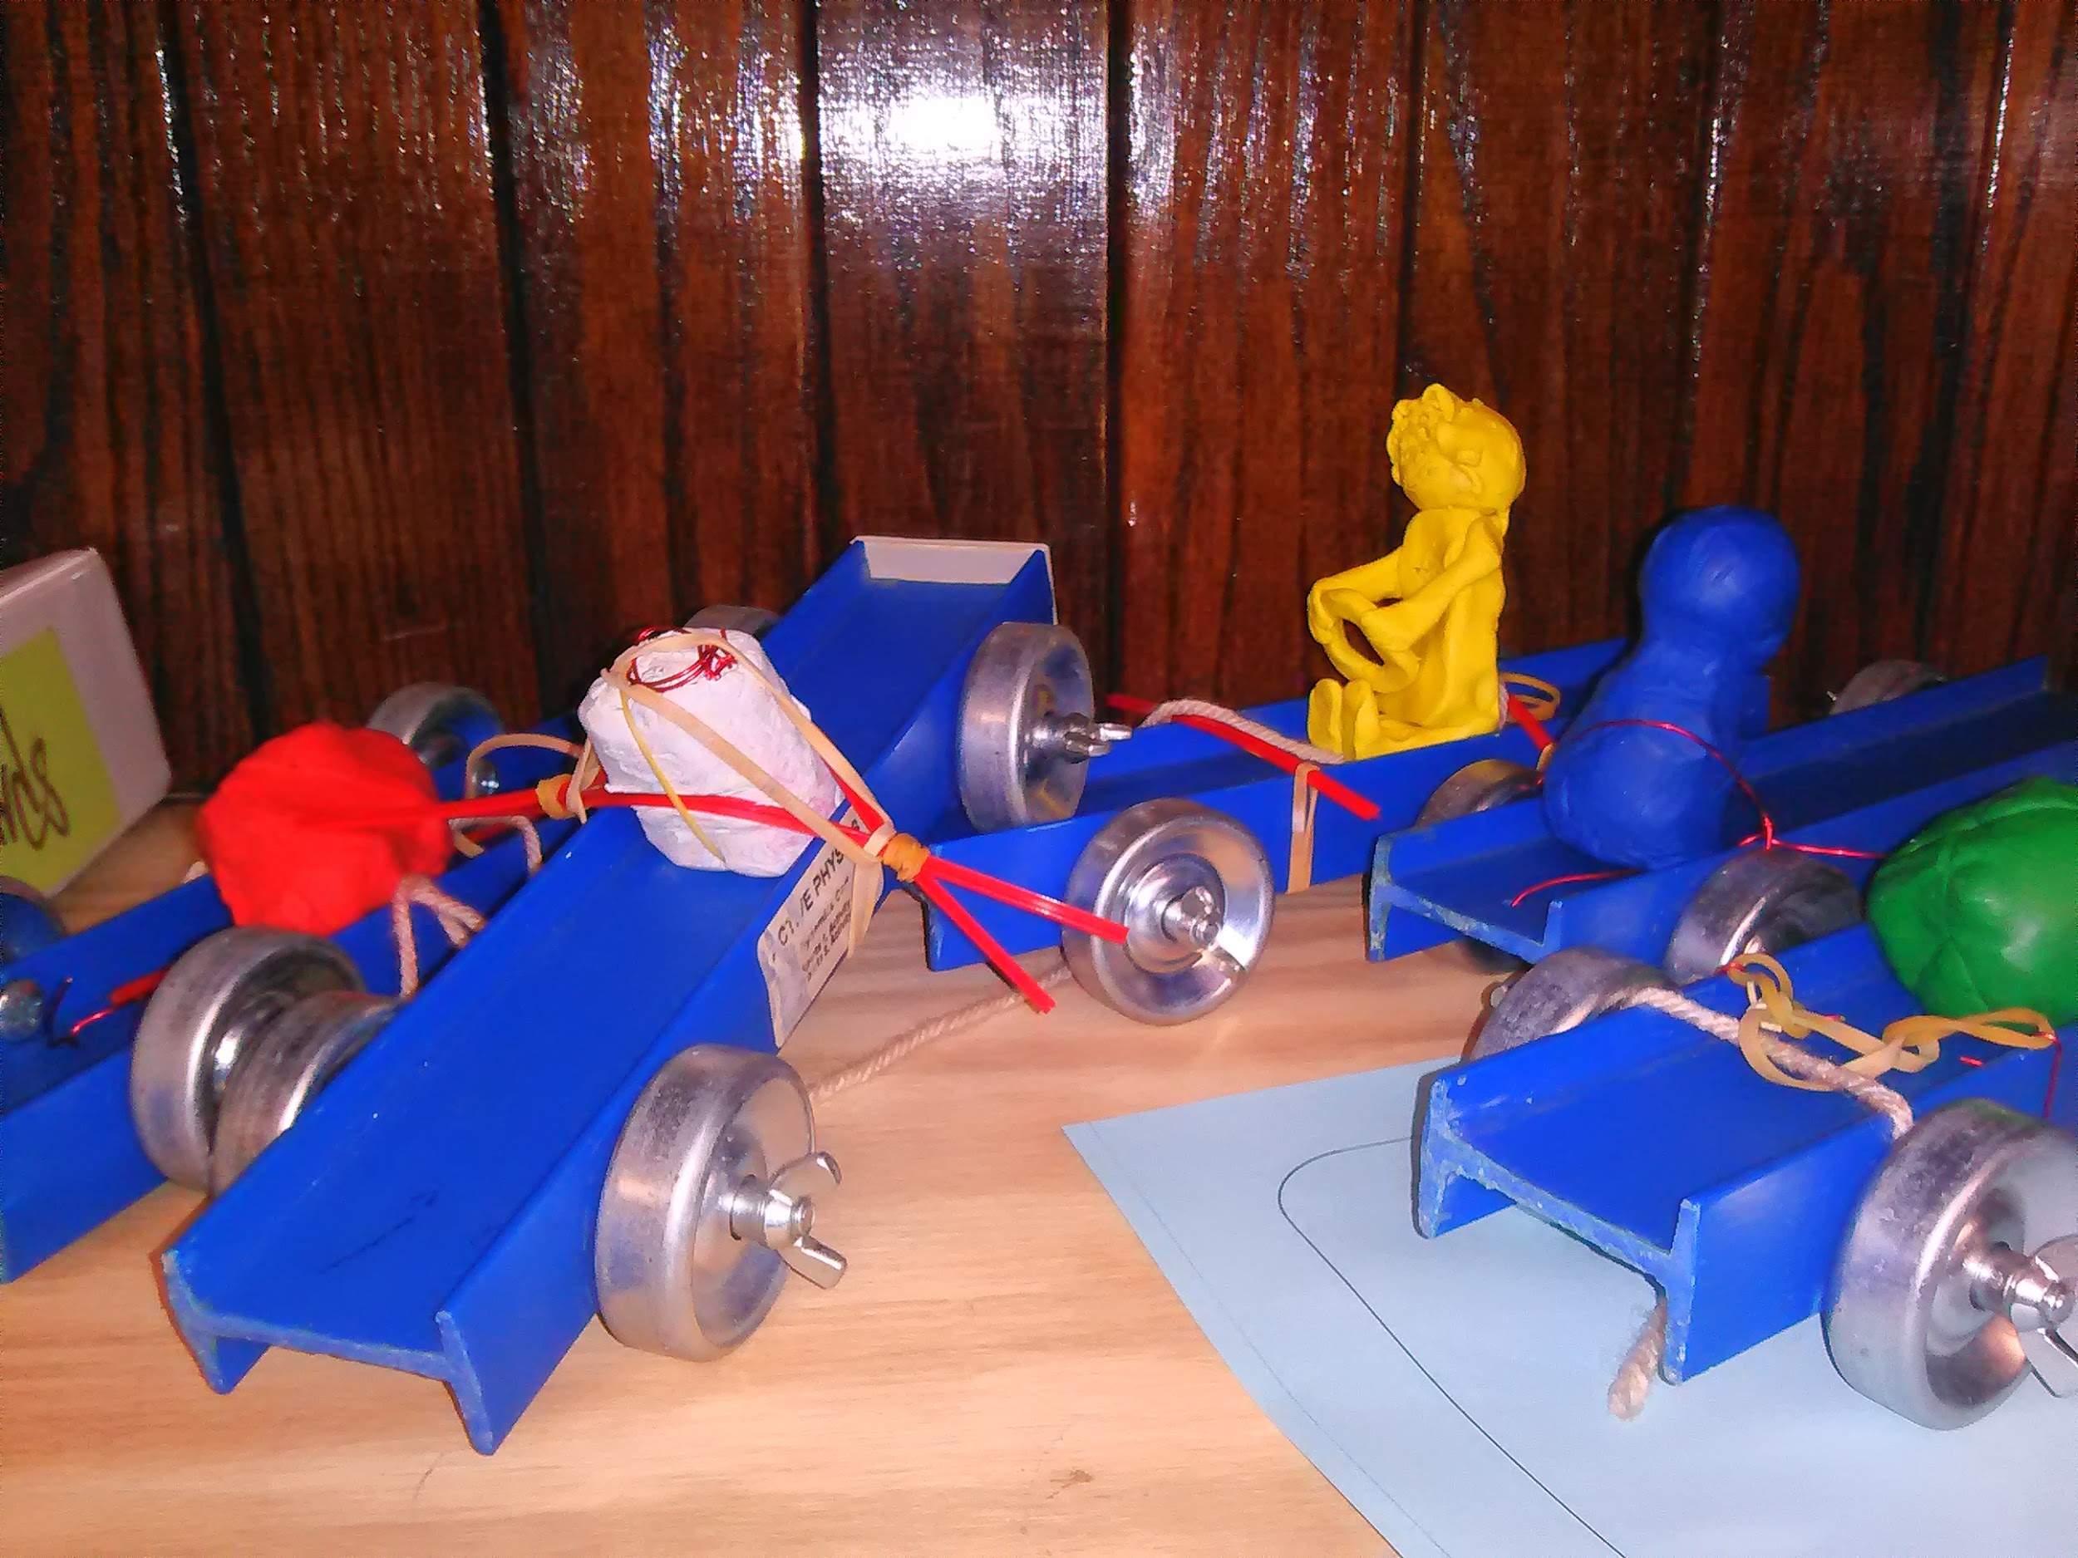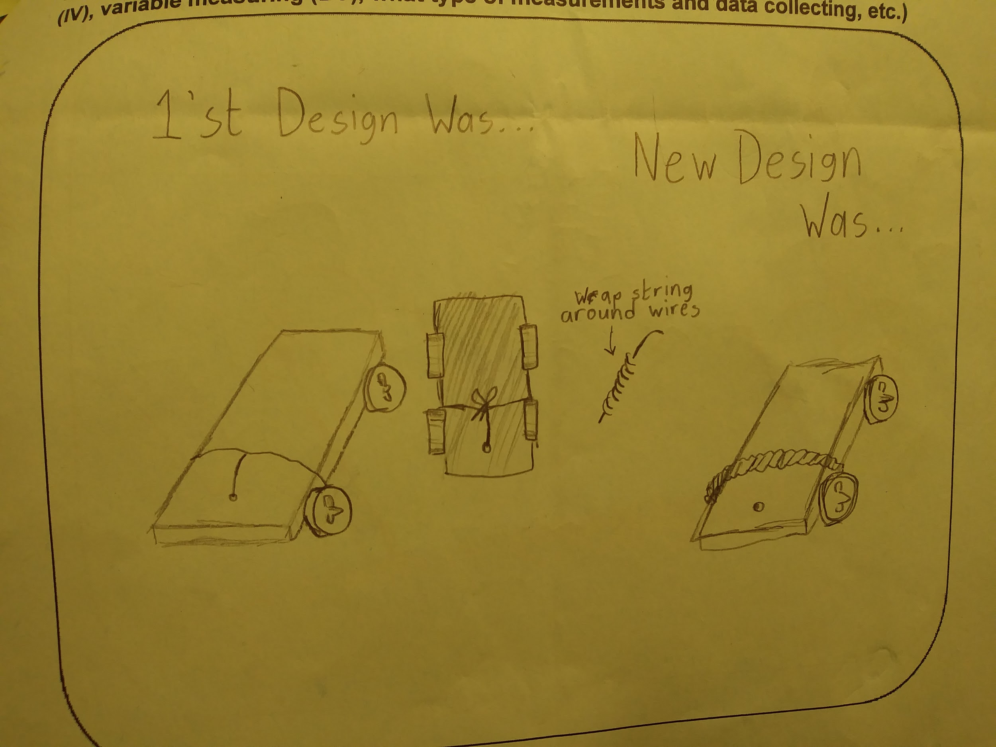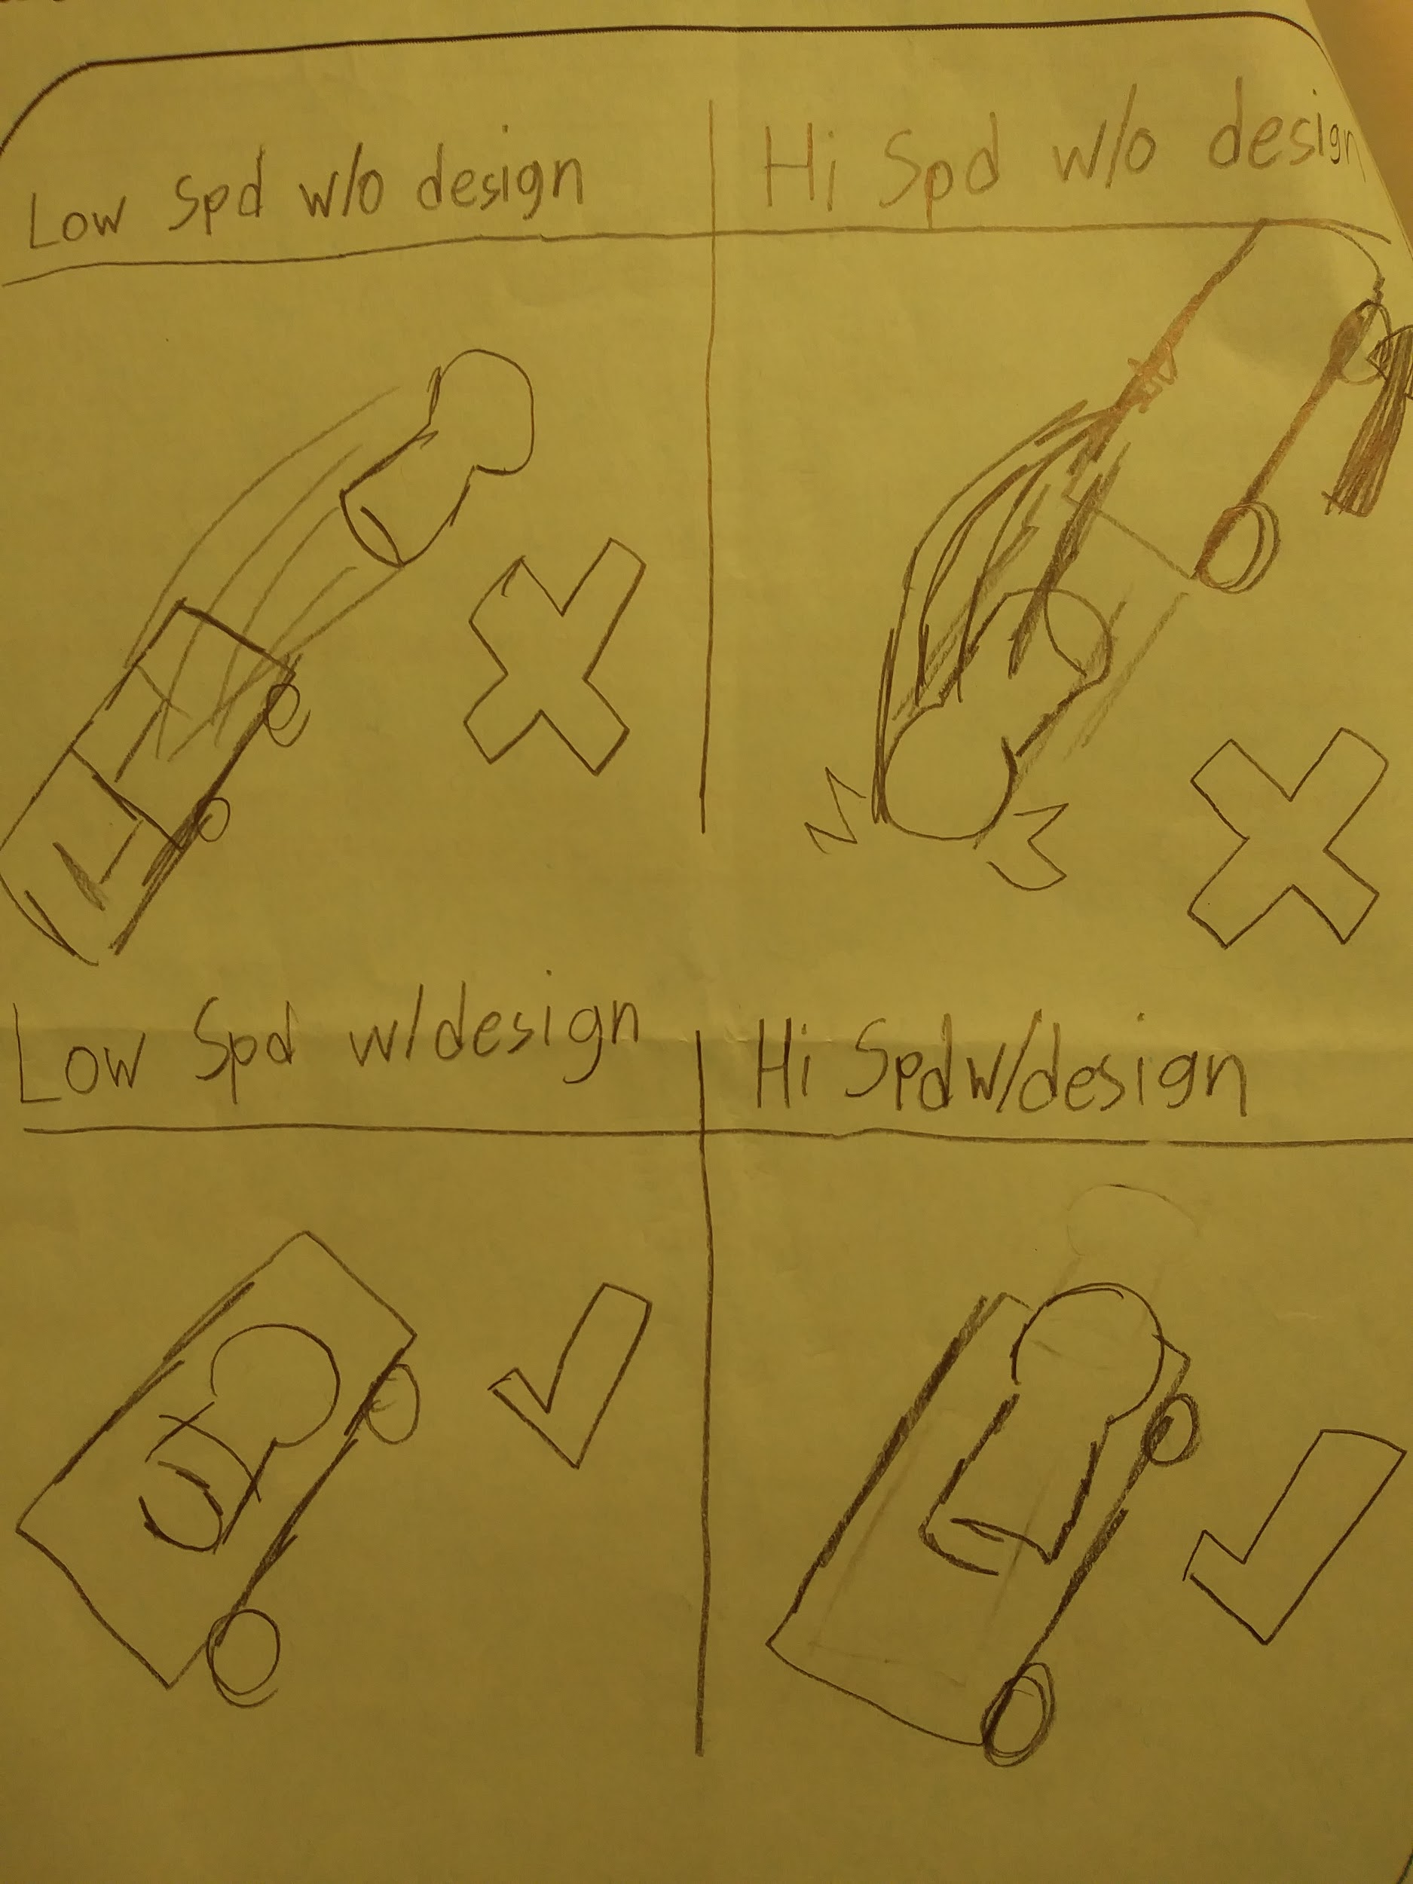
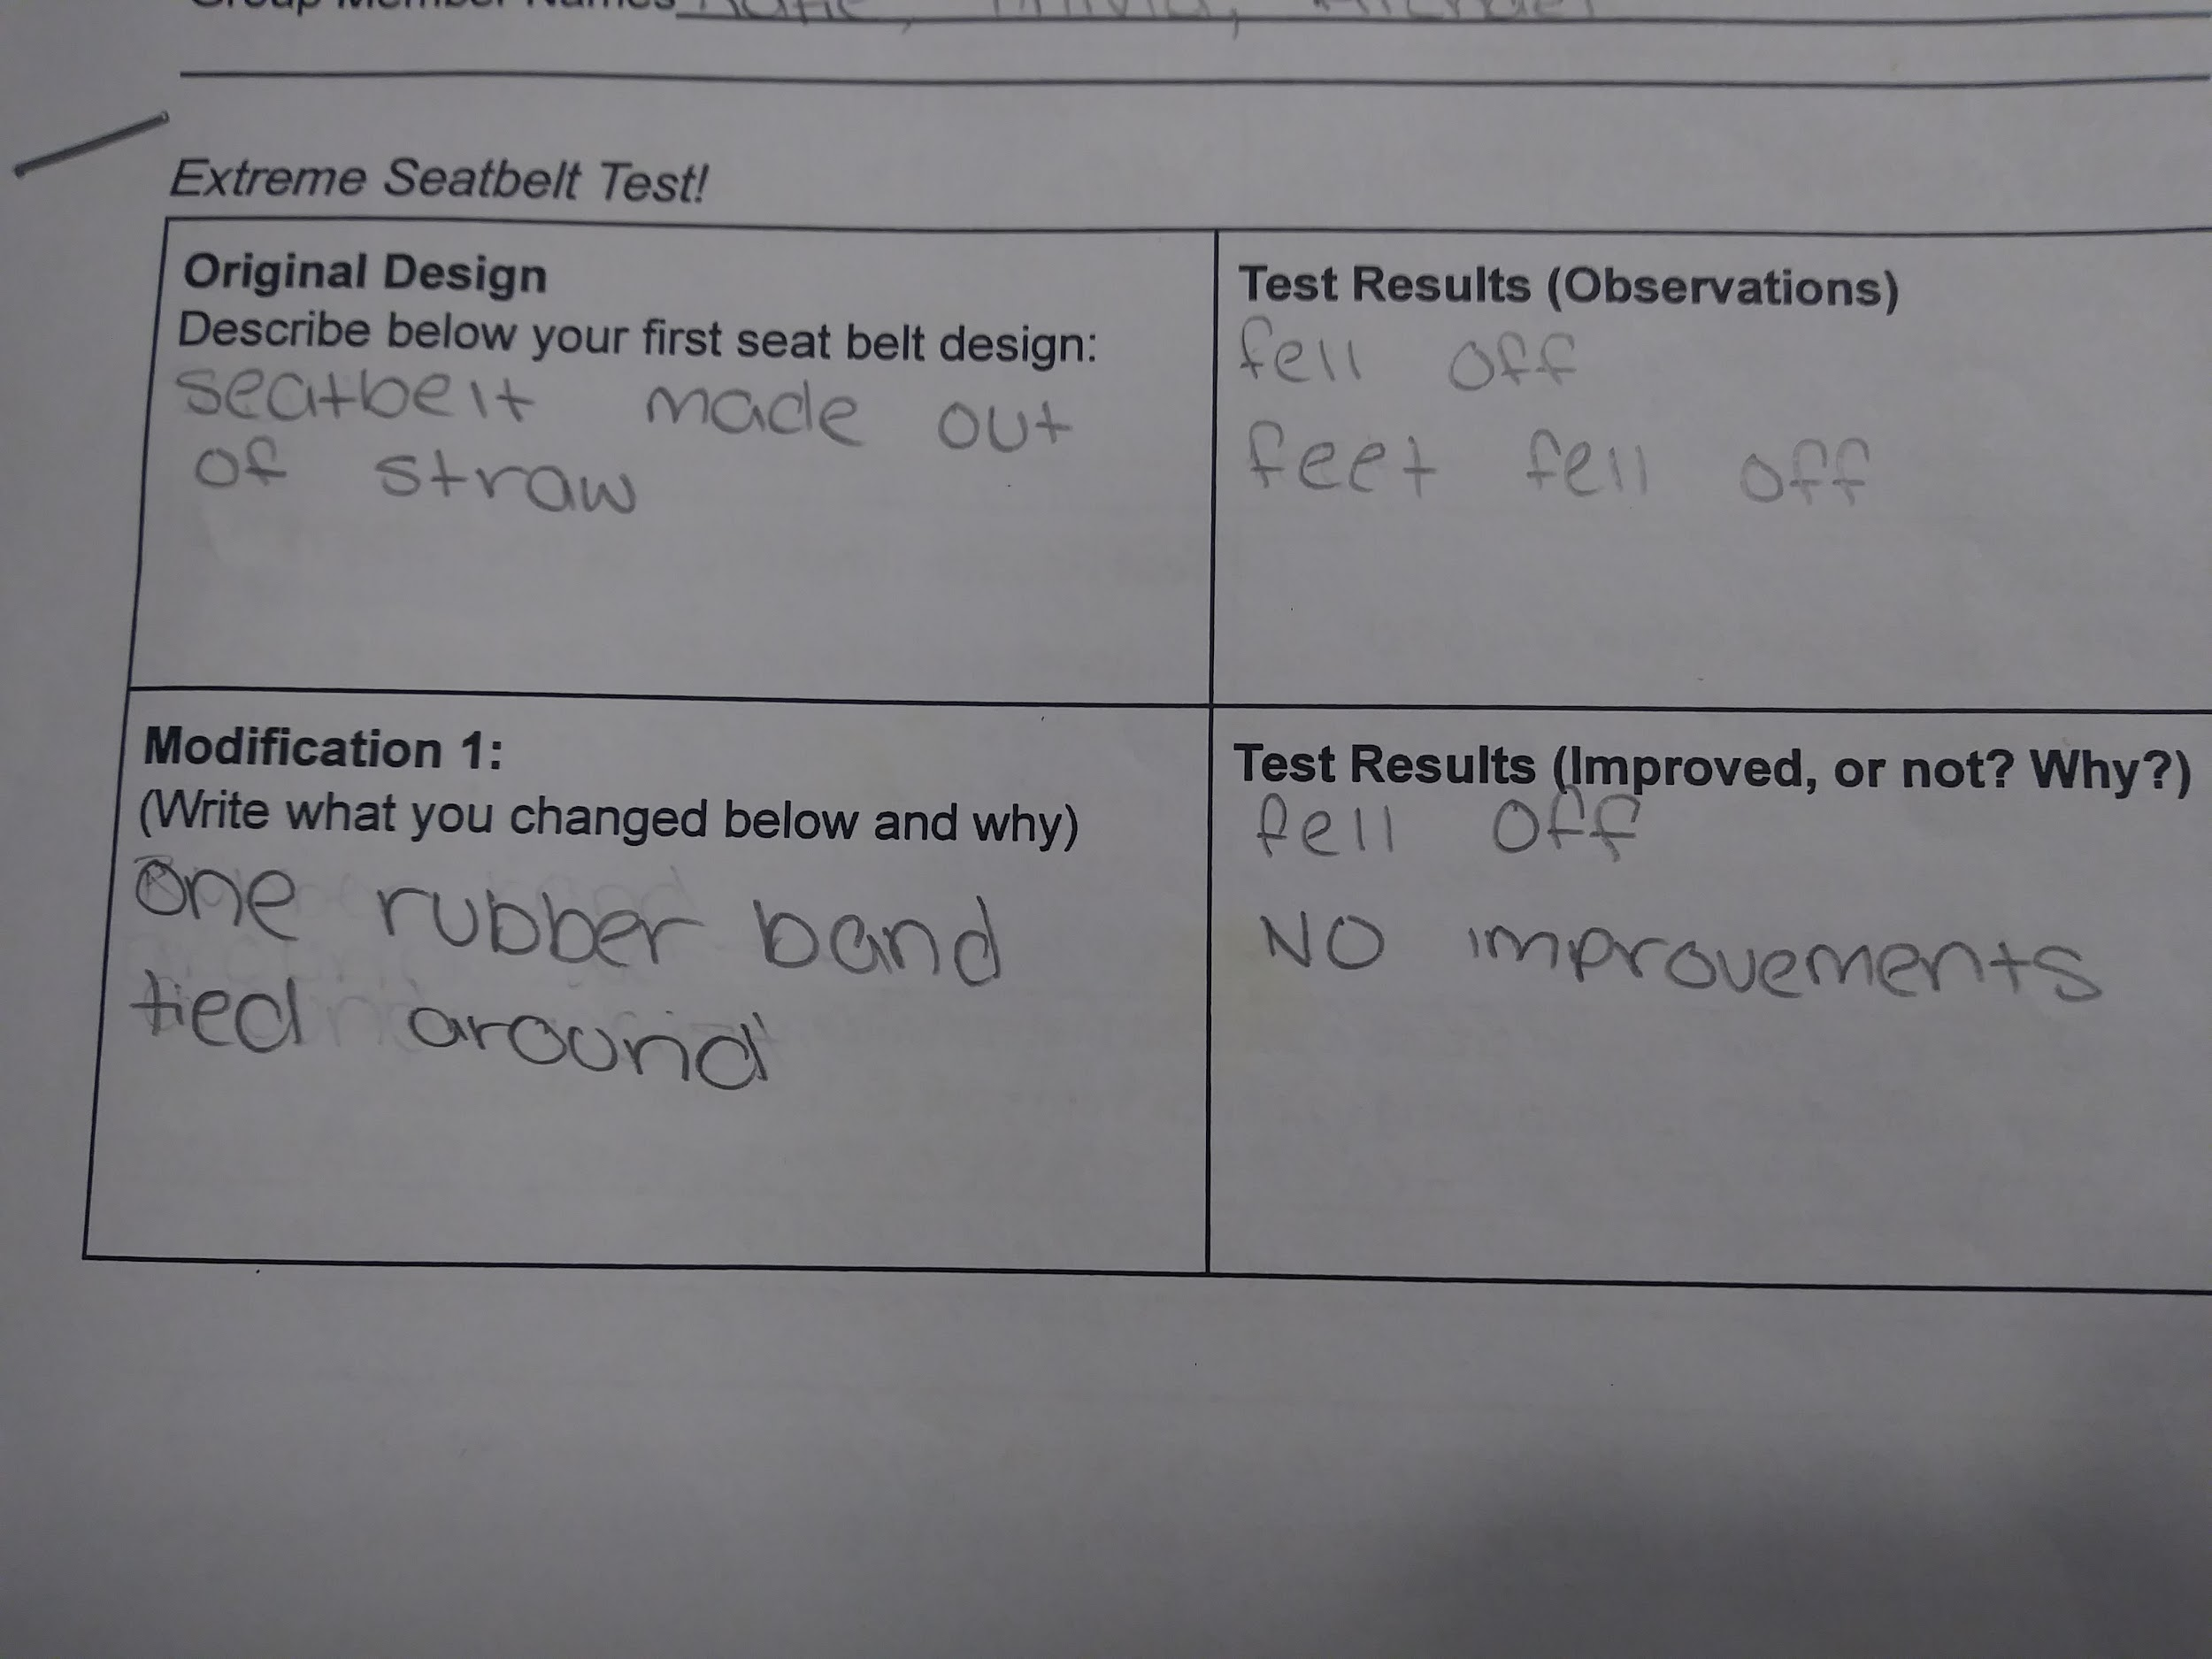
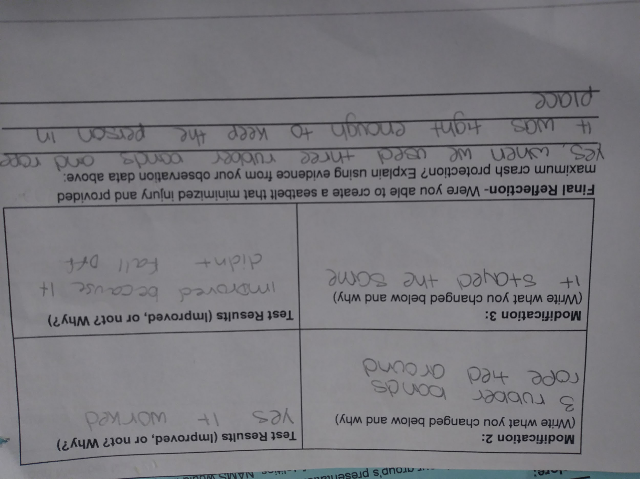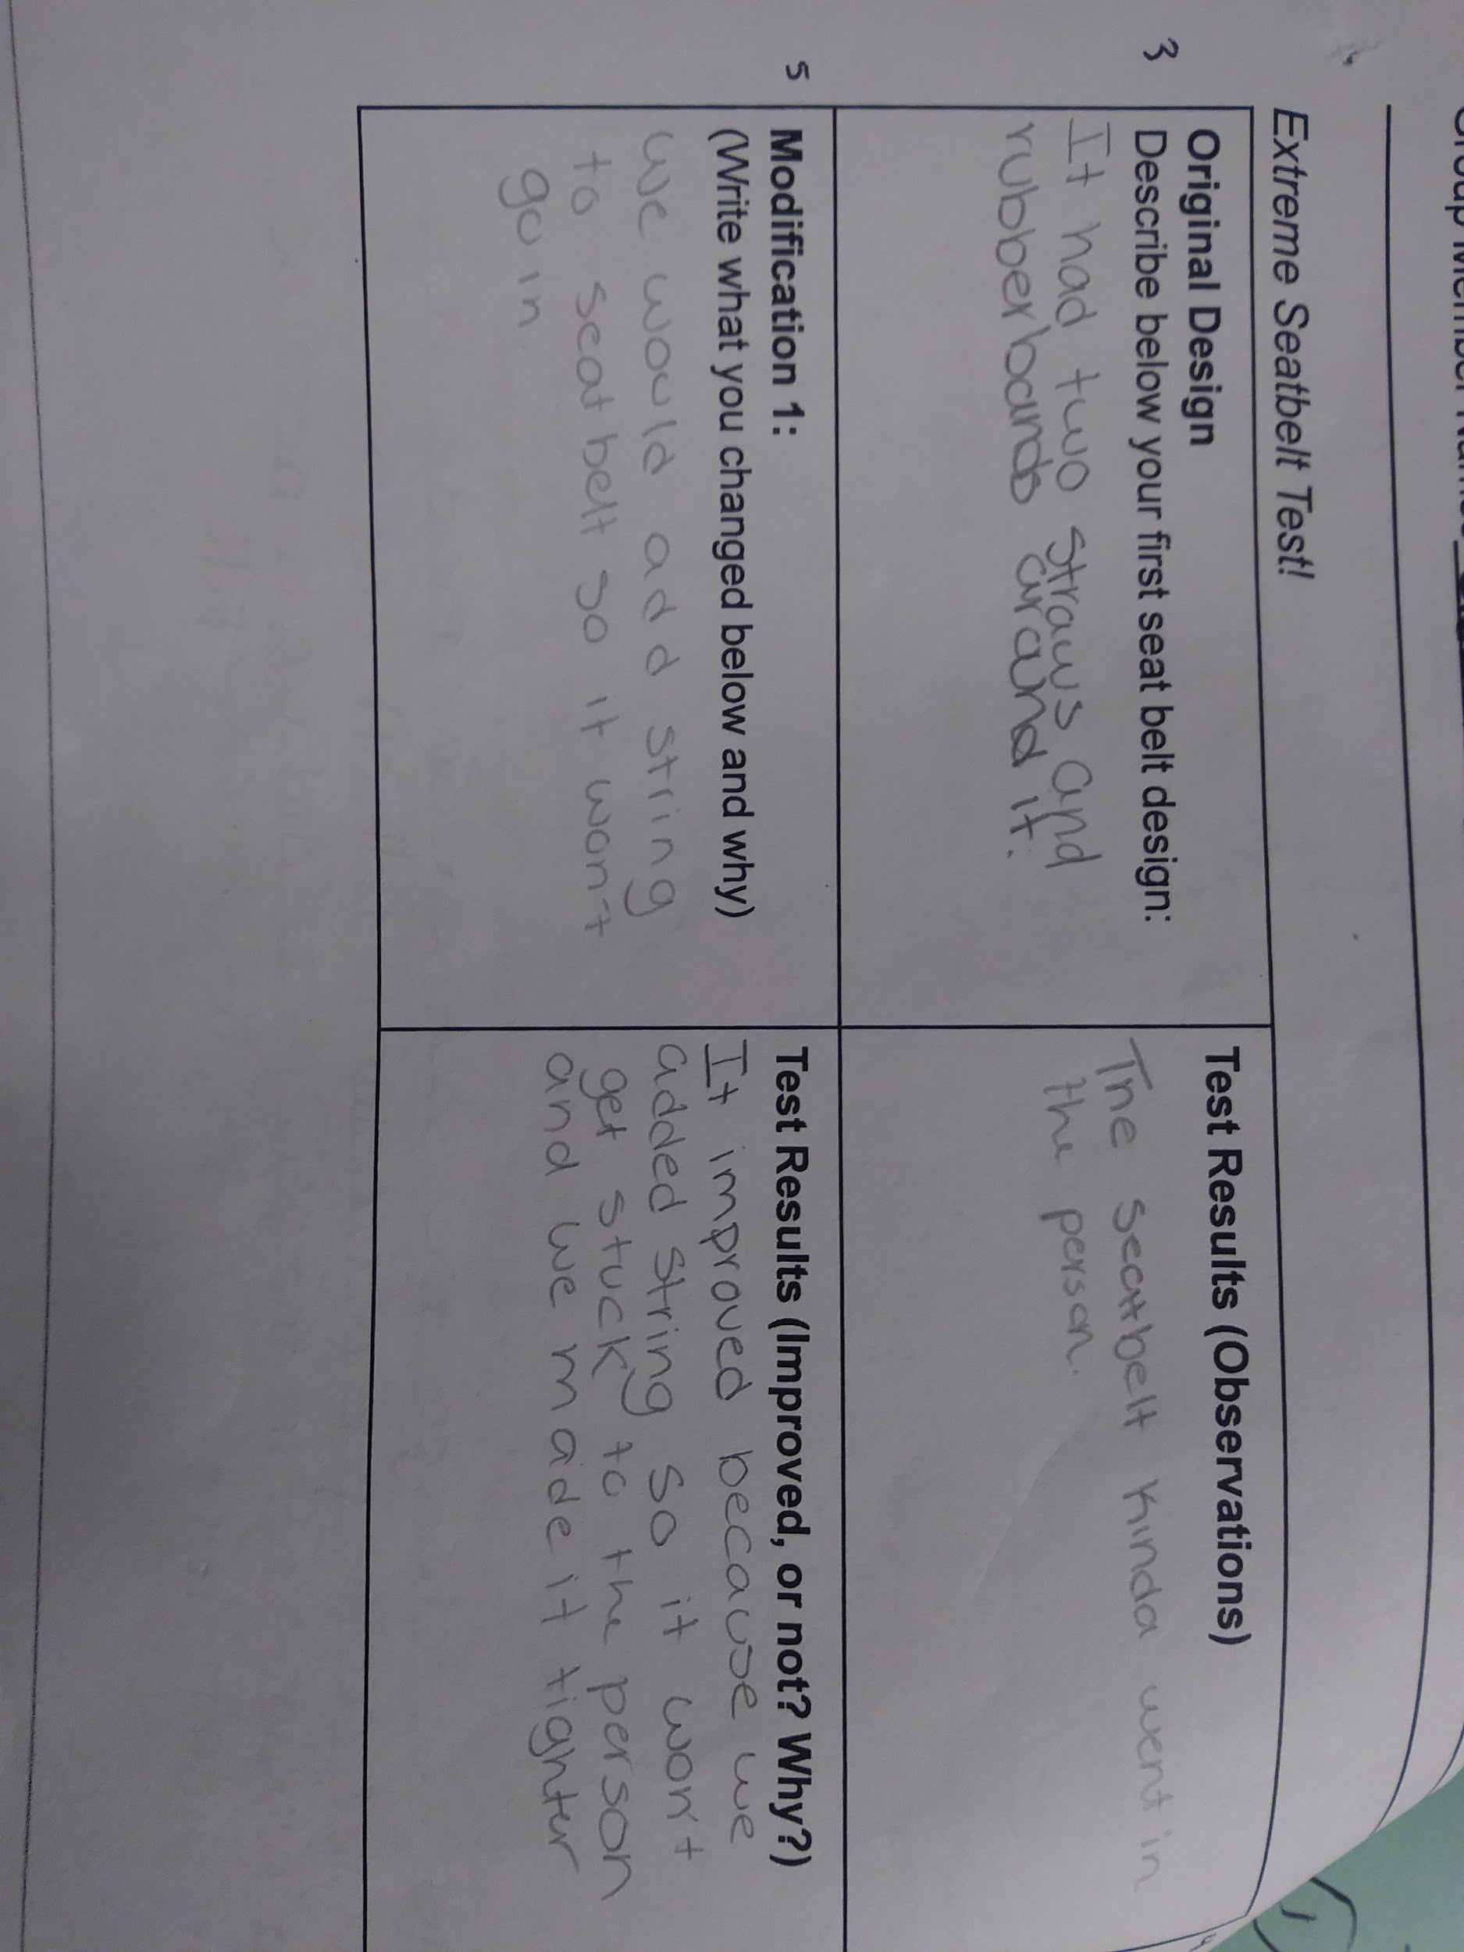

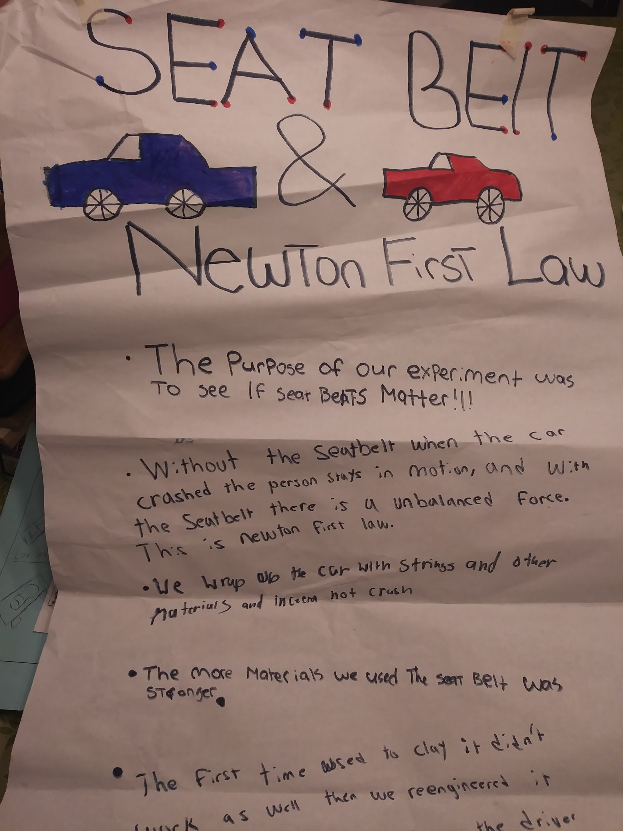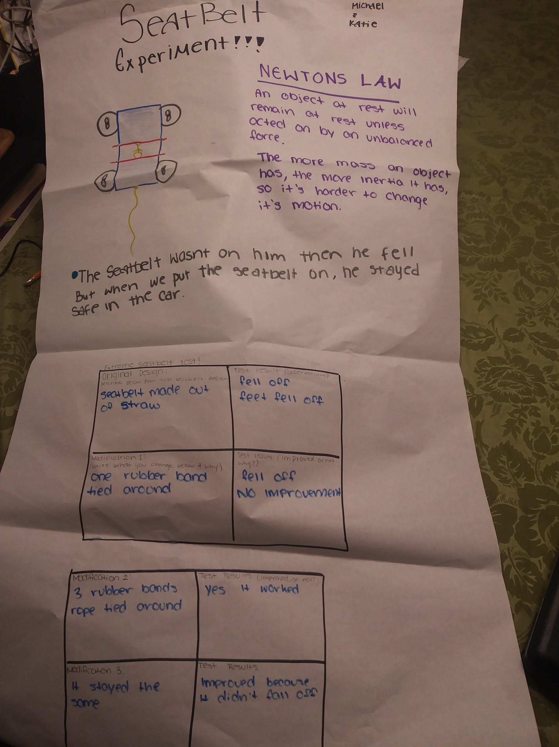

Name _______________________________________________________________ Date ______________
ENGAGE - Seatbelt Injury C - E - R
The NAMS board was very pleased with the presentations the other day. They feel that your work has greatly supported their mission in making sure all drivers will use seatbelts. However, further research done by NAMS has found that some people are still convinced that seat belts do more harm than good. One such person, a Mr. Smith, even sent the following image to NAMS. These pictures were taken by the individual of himself and his wife after they were in a car crash that involved their car traveling at 50mph and slamming into a guardrail. They are currently suing the car manufacturer for the injuries sustained by the seatbelts, and claim that seatbelts do more harm than good.
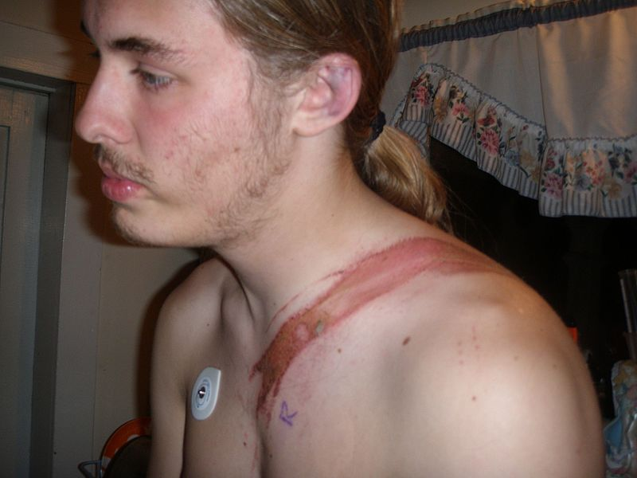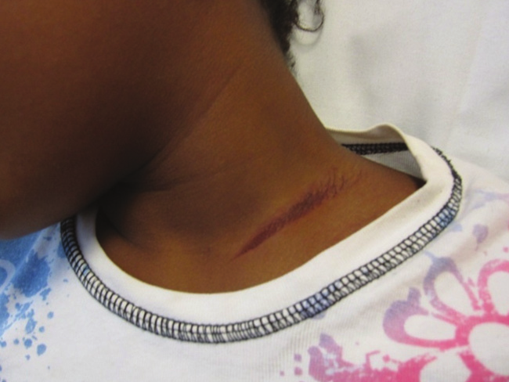
Photo 1: https://commons.wikimedia.org/wiki/File:Vehicle_accident_injury_depression.JPG Photo 2: Courtesy of Matthew Clifton, MD, Children's Healthcare of Atlanta, Atlanta, Georgia.

With your group, examine the images above and state whether you support or refute the claim proposed by Mr. Smith. Be sure to include evidence and reasoning to support your claim and be ready to share your conclusion with the class. Use the box below for notes:

Name _______________________________________________________________ Date ______________

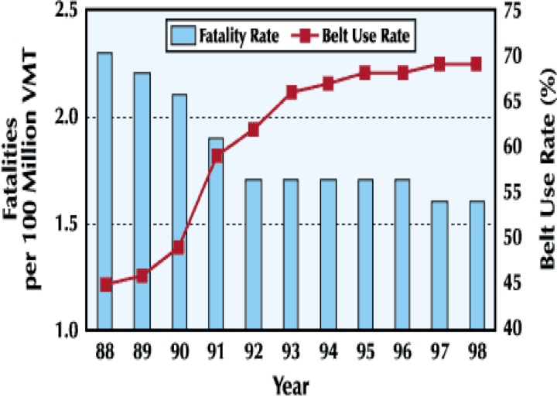
Seatbelt Safety Design

Though NAMS believes without a doubt that seat belts save lives, they also believe that the seat belt design can be improved. They especially believe this after seeing the various groups’ presentations and the different seat belt designs created. The NAMS commission would like to extend this work, and have commissioned a new challenge to the groups- to design the most effective, safest, and also most comfortable seat belt.

Each group will have access to the same materials as before. Using the knowledge you gained from observing various groups’ presentations, as well as what you learned of Newton’s Laws of Motions, your group must design and test the ultimate seat belt. This may take you many trials, and you may have to try many designs before you are satisfied. Be sure to collect ample data and observations of every step of the process!

As before, NAMS requires that you have both qualitative and quantitative data in your presentation. Your group’s design, as well as the data you collect and present, and how you organize that data, is up to your group.

Observation Notes, Diagrams, Drawings, Data Tables, Graphs, Etc. (use more paper as needed)

Name _______________________________________________________________ Date ______________
Extreme Seatbelt Test!
Original Design  Describe below your first seat belt design: | Test Results (Observations)
Modification 1:  (Write what you changed below and why) | Test Results (Improved, or not? Why?)

Modification 2:  (Write what you changed below and why) | Test Results (Improved, or not? Why?)
Modification 3:  (Write what you changed below and why) | Test Results (Improved, or not? Why?)

Final Reflection- Were you able to create a seatbelt that minimized injury and provided maximum crash protection? Explain using evidence from your observation data above:
_____________________________________________________________________________
_____________________________________________________________________________
_____________________________________________________________________________
_____________________________________________________________________________

Name _______________________________________________________________ Date ______________
Newton’s 1st Law Research/Notes
It is no accident (no pun intended) that NAMS choose your classroom for this task. NAMS is also requiring that the presentations include an explanation of the physics involved. They are particularly interested in how forces and Newton’s Laws of Motion apply to the situation. Your group must gather knowledge about Newton’s Laws of Motion and forces, and detail how they apply in the particular situation of a car crash/seatbelt senario and your group’s demonstration. You may use your textbook, and also consult some of these online resources listed below to gather knowledge about Newton’s Laws.
- https://www.texasgateway.org/resource/newtons-law-inertia
- https://www.physicsclassroom.com/Physics-Tutorial/Newton-s-Laws
- https://www.brainpop.com/science/motionsforcesandtime/newtonslawsofmotion/
- https://www.youtube.com/watch?v=PNTLDNxTMdg

Notes on Newton’s Laws of Motion

Name _______________________________________________________________ Date ______________
Seatbelt Design Presentation Notes
For your presentation, NAMS would like you to apply the science you learned about involving Newton’s Laws of Motion to help explain the observations and the results obtained. The goal for your presentation is to prove beyond doubt that your seat belt design is the absolute best at preventing injury, and to clearly explain the science involved.

Explanation and Application of Newton’s Laws of Motion to Design Results

Name _______________________________________________________________ Date ______________
Rubric:
It’s now time for the presentations! As part of the NAMS board, you will watch and listen closely to each group’s presentation, using the rubric below to see if they meet the project requirements.
