Task-level phenomenon:
In this task, the specific phenomenon is exploring why red-green color blindness occurs more often in males than in females.

Synopsis of high-quality task:
This task has three parts and could be included in a unit on Mendelian genetics. The goal of this task is to analyze and interpret data in order to explain the phenomena of why males have red-green color blindness more often than females. Students will use the story of a family with red-green color blindness to create a pedigree and use this pedigree to explain the sex-linked inheritance pattern. Students will also determine a diagnosis based on a pattern of sex-linked inheritance. Keep in mind that explaining the phenomena of the greater frequency of red-green color blindness in males than in females is the ultimate goal and should always be a part of the assessment of this lesson, as it is most applicable to the standard.

Anticipated student time spent on task: 2 class sessions, 55 mins each

Type of Task (check one):
____ 1. Investigation/experimentation/design challenge
_X__ 2. Data representation, analysis, and interpretation
____ 3. Explanation

Student task structure(s): Small group

STE Standards and Science and Engineering Practices:
HS-LS3-3. Apply concepts of probability to represent possible genotype and phenotype combinations in offspring caused by different types of Mendelian inheritance patterns.
Clarification Statements:
- Representations can include Punnett squares, diagrams, pedigree charts, and simulations.
- Inheritance patterns include dominant-recessive, codominance, incomplete dominance, and sex-linked.

Science and Engineering Practices:
- Analyzing and interpreting data
- Constructing explanations
Prior Knowledge:
Previous Standard from Strand Map:
8.MS-LS3-3(MA). Communicate through writing and in diagrams that chromosomes contain many distinct genes and that each gene holds the instructions for the production of specific proteins, which in turn affects the traits of an individual.
State Assessment Boundary:
- Specific changes at the molecular level or mechanisms for protein synthesis are not expected in state assessment.
Previous Topics:
- Genotype and phenotype describe what genes are included (genotype) and what the observable properties are (phenotype).
- Dominant and recessive describe inheritance patterns of traits.
- Heterozygous and homozygous indicate the types of alleles included in a gene.
- Complete dominance occurs when one allele (dominant) masks the effect of a different allele (recessive).
- Punnett squares are used to predict genotypes when two genes are crossed.
- Autosomal dominant and autosomal recessive describe inheritance patterns that exist on non-sex chromosomes.
- Sex chromosomes determine if an organism is male or female.
Red-green color blindness is a sex-linked recessive disorder carried on the X chromosome. As a result, red-green color blindness occurs more often in males than in females. Females have two X chromosomes and because red-green color blindness is recessive, a female may be a carrier for red-green colorblindness and not actually have the disorder (heterozygous). However, a male that has the gene for red-green color blindness will have the disorder because he has one X chromosome only.

Connections to the real-world:
- There are several sex-linked traits other than red-green color blindness (e.g., hemophilia, male pattern baldness, Duchenne Muscular Dystrophy).
- Males are affected more than females when sex-linked inheritance pattern is X-linked
- Approximately 8% of men versus 0.5% of women with Northern European ancestry are affected by red-green color blindness.

Mastery and Language Goals:

Learning Objective:
- Analyzing and interpreting genetic information in pedigree charts to determine a trait’s inheritance pattern
- Construct an explanation for why X-linked traits happen with greater frequency in males than in females.

Performance Objective:
- Create a model of a pedigree representing how red-green color blindness is expressed in a family (PART 1).
- Analyze and interpret the pedigree to determine how red-green color blindness is inherited (PART II).
- Construct and explanation for why its frequency is greater in males than in females (PART II).
- Analyze and interpret data about sex-linked diseases to make a specific diagnosis (PART III)

Language Objective:
- Orally discuss genetic information of families in small groups.
- Construct a written explanation for why X-linked traits happen with greater frequency in males than in females.

Teacher Instructions:

INTRODUCTION: (~5 min)
- Students read about the frequency of red-green color blindness in males versus females (individually or aloud) from the introduction.
- Discuss - Please note that when discussing, all ideas are acceptable, including those that are incorrect. The Look For points below are what students are working towards in this task. However, be prepared if students come with this prior knowledge.
  - Why do you think this disorder happens more in males than females?
LOOK FOR: In this section you are eliciting student ideas and can collect them on the board.
    - Allele for disorder is attached to a sex chromosome
    - Sex chromosomes are different for males than females
  - Why is it important to track genetic disorders through generations, even those such as red-green color blindness that are not life-threatening?
    - Parents who carry alleles for disorders that may be life threatening may want to know this information prior to becoming pregnant.
    - Perhaps once conceived and before birth, procedures can be done while in the womb to help curtail symptoms of life threatening genetic disorders that may be carried through generations.

PART I: (~30 min)
- Students read about the family with red-green color blindness (individually or aloud).
- Frame the activity by telling students they are to create a family tree that represents the data given in the description. This is up to the student to decide how to display this information. There is no specific expectation here. Students are doing this for the first time and thus, there will be great variation.
- Emphasize the importance of representing the data in ways that make sense to another student.
- LOOK FOR: representations that delineate males from females, offspring from parents, older generations from younger generations, and those affected by red-green colorblindness from those that are not.
- As students finish, complete a gallery walk. Ask students to make improvements to their trees as they deem necessary based on what they observed during their walk.
- As a large group, create a pedigree based on student directions/feedback. Be sure to include a legend of symbols.
- Double check the accuracy of the pedigree by re-reading the story aloud and highlighting in the pedigree each piece of data provided from the original story.
PART II: (~30 min)
- Remind students of the original question - why does red-green color blindness happen more in males than females?
- Students use the class pedigree to discuss their findings in their groups. Students should take notes on their discussion. For support, teachers could provide
  - Graphic organizers for writing
    - Possible example: CER - Claim would be the pattern of inheritance and the evidence is the Punnett squares with genotypes of parents showing offspring. The reasoning is showing the pattern of inheritance that matches the Punnett squares pulled from the pedigree for evidence.
    - Sentence frames/starters
- Students write explanations about how the frequency of red-green color blindness is greater in males than in females using supporting evidence from the class pedigree. Students can write more robust explanations by combining their explanations with supplemental text, about various patterns of inheritance (e.g., supporting what it is and pointing out what it cannot be)
- Supplemental Text: 8.3 Laws of Inheritance from Concepts of Biology by OpenStax CC BY 4.0 https://cnx.org/contents/s8Hh0oOc@14.1:zLLYW2hj@9/8-3-Extensions-of-the-Laws-of-Inheritance?minimal=true

PART III: (~30 min)
- Before starting this section, arrange students into small groups. Assign each group a mystery pedigree.
- Go over expectations with students - graphic organizer must include claim, evidence, and reasoning to substantiate diagnosis.
- This part is meant to serve as an application of various patterns of inheritance, of which sex-linked is one type. Students should already be familiar with autosomal dominant and autosomal recessive inheritance patterns (see previous topics), in addition to the sex-linked patterns they’ve just worked with.
LOOK FORS
  - Autosomal dominant (Huntington Disease)
    - Mystery Pedigree 4
    - Affects nearly every generation
    - Traits do not affect one sex more than the other
  - Autosomal recessive (Phenylketonuria)
    - Mystery Pedigree 3
    - Unaffected parents have affected offspring indicates trait is recessive
    - Traits do not affect one sex more than the other
  - Sex-linked dominant (Incontinentia Pigmenti)
    - Mystery Pedigree 1
    - Affects nearly every generation
    - Trait affects females more than males indicates trait may be sex-linked
  - Sex-linked recessive (Granulomatous Disease)
    - Mystery Pedigree 2
    - Unaffected parents have affected offspring indicates trait is recessive
    - Trait affects males more than females indicates trait may be sex-linked
- At the end of this part, have students present their data, focusing on why they chose the diagnosis they did and if they were wrong why did that happen?

Instructional Materials/Resources/Tools:
- Student handouts (included below)

Task Source:
Supplemental Resources
- Concepts of Biology by OpenStax CC BY 4.0
https://cnx.org/contents/s8Hh0oOc@14.1:zLLYW2hj@9/8-3-Extensions-of-the-Laws-of-Inheritance?minimal=true
- Genetics Home Reference by National Library of Medicine
https://ghr.nlm.nih.gov/
Image from Wikimedia Commons user Dan-yell without changes; license CC BY-SA 3.0.
Accessibility and Supports:
Claim, evidence, and reasoning graphic organizer for Part III (included below)

Sample Student Work:
Sample #1

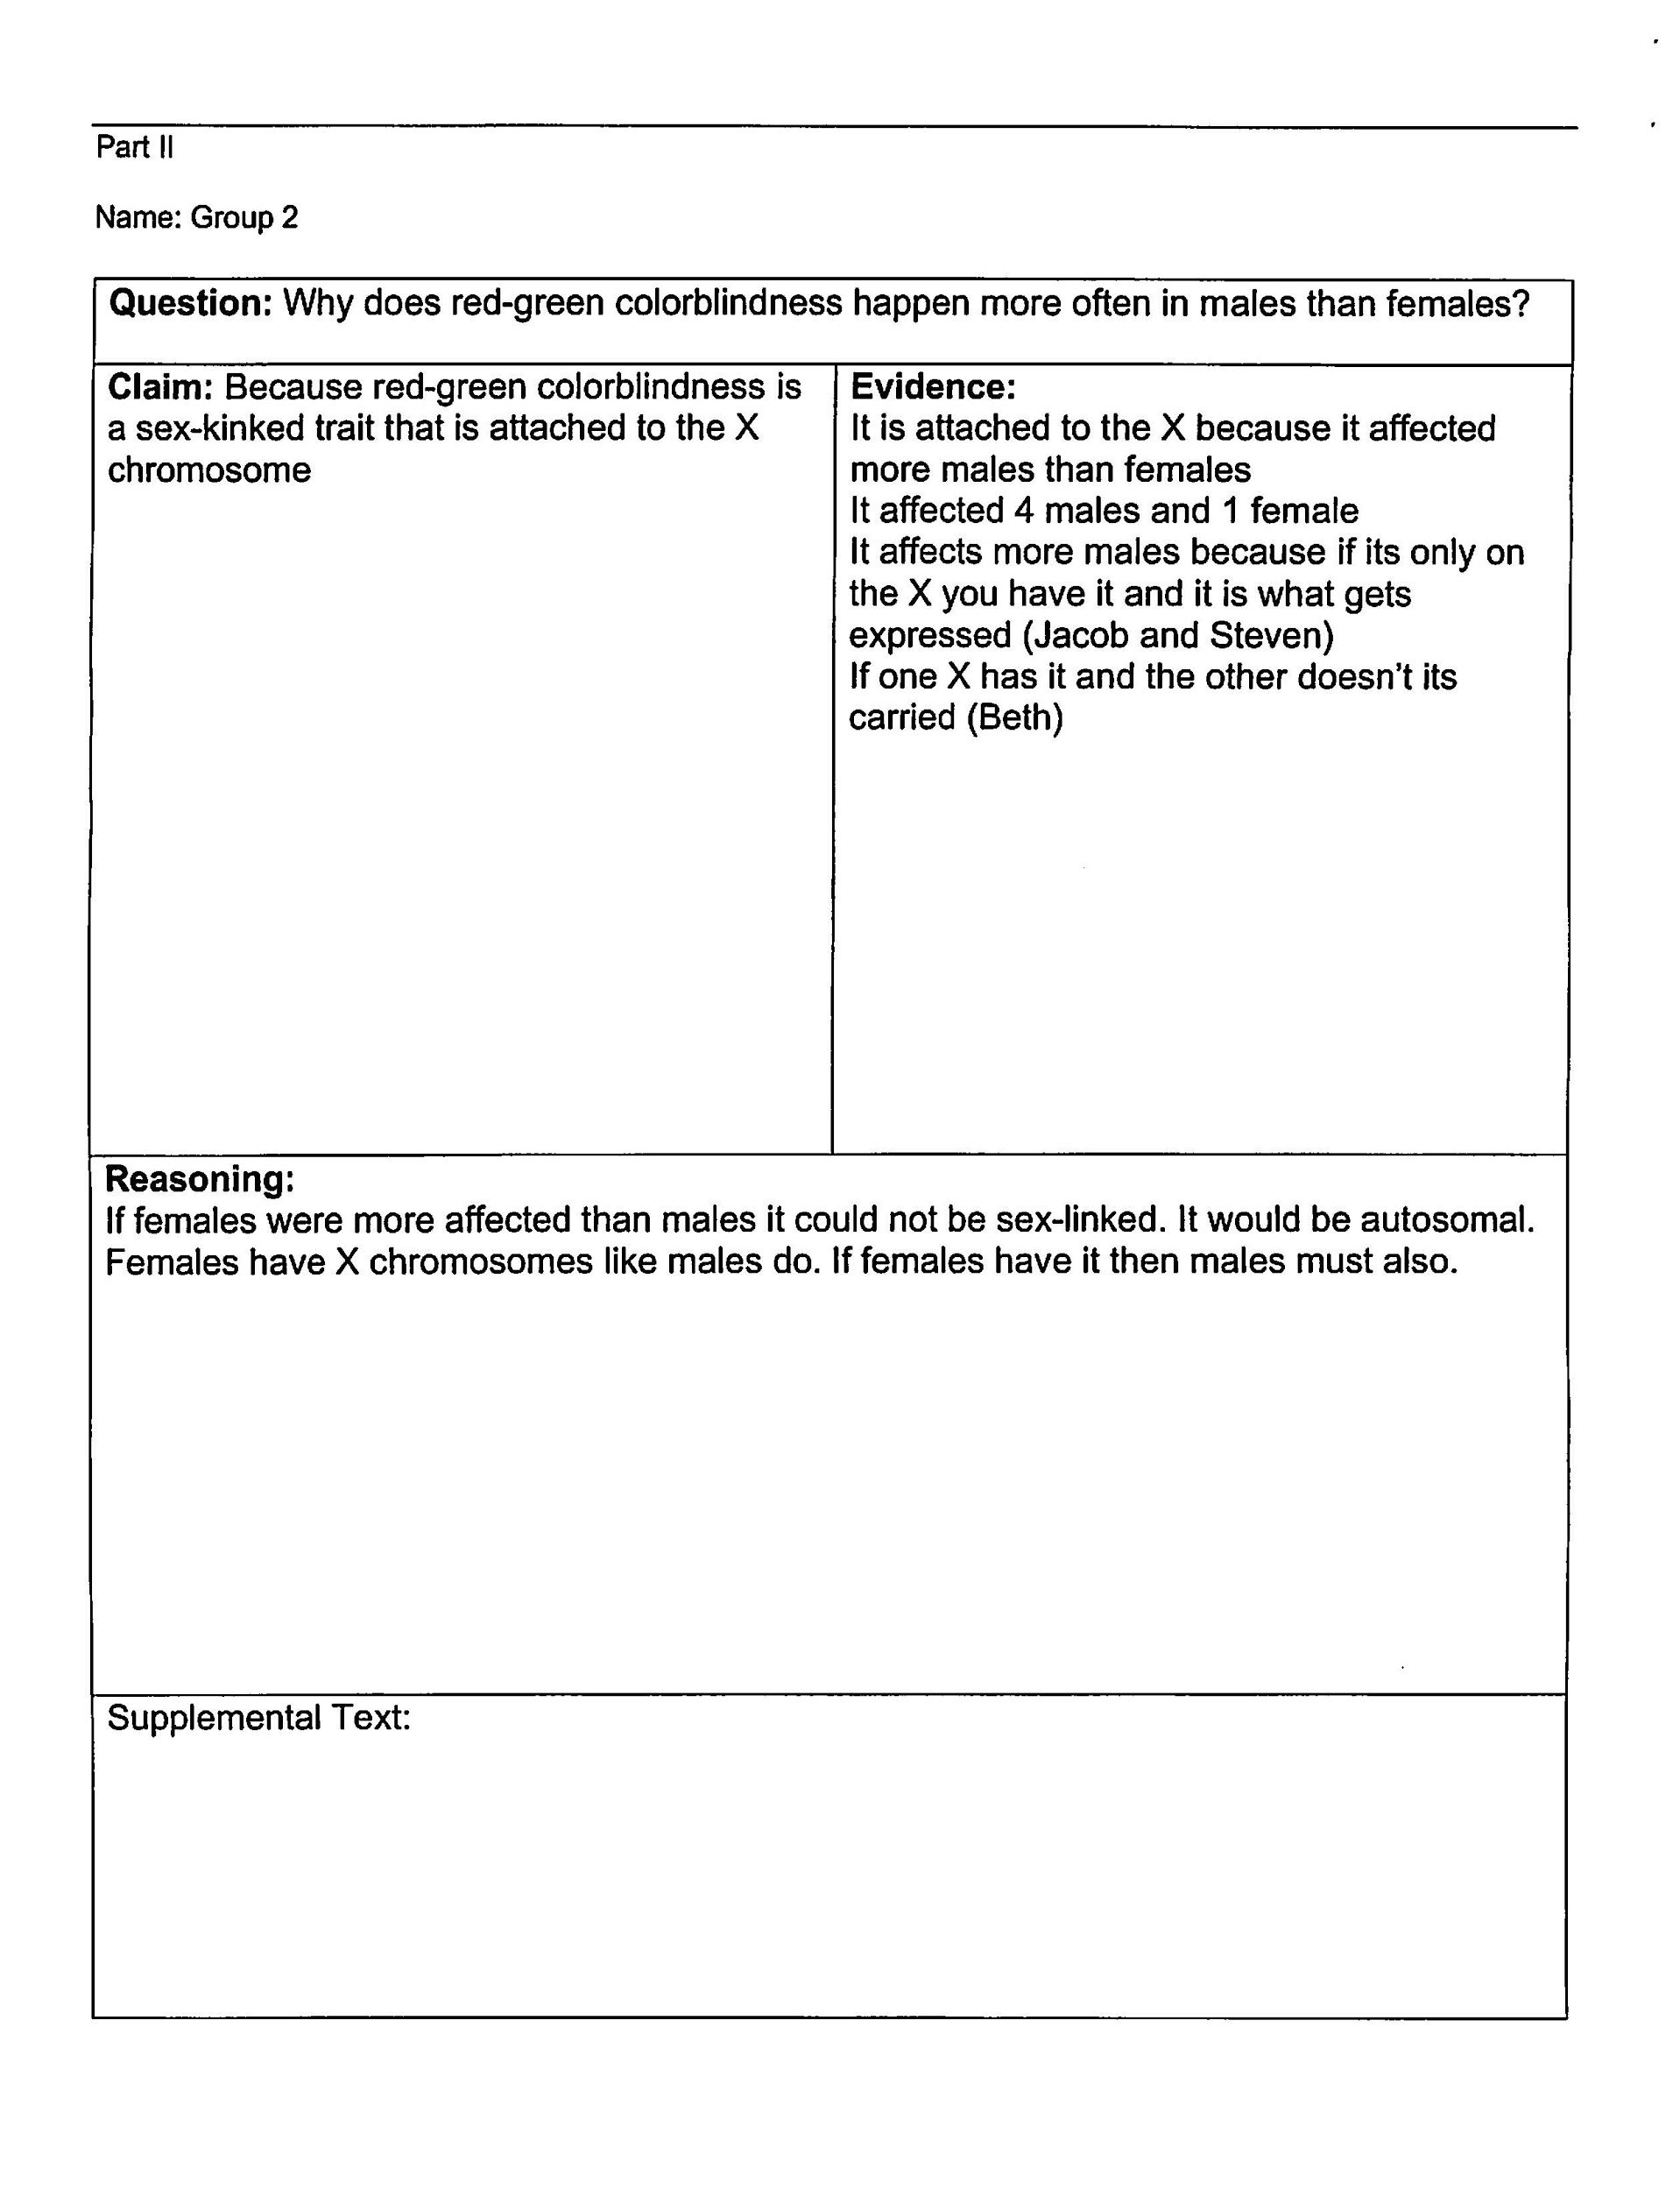
Sample 2
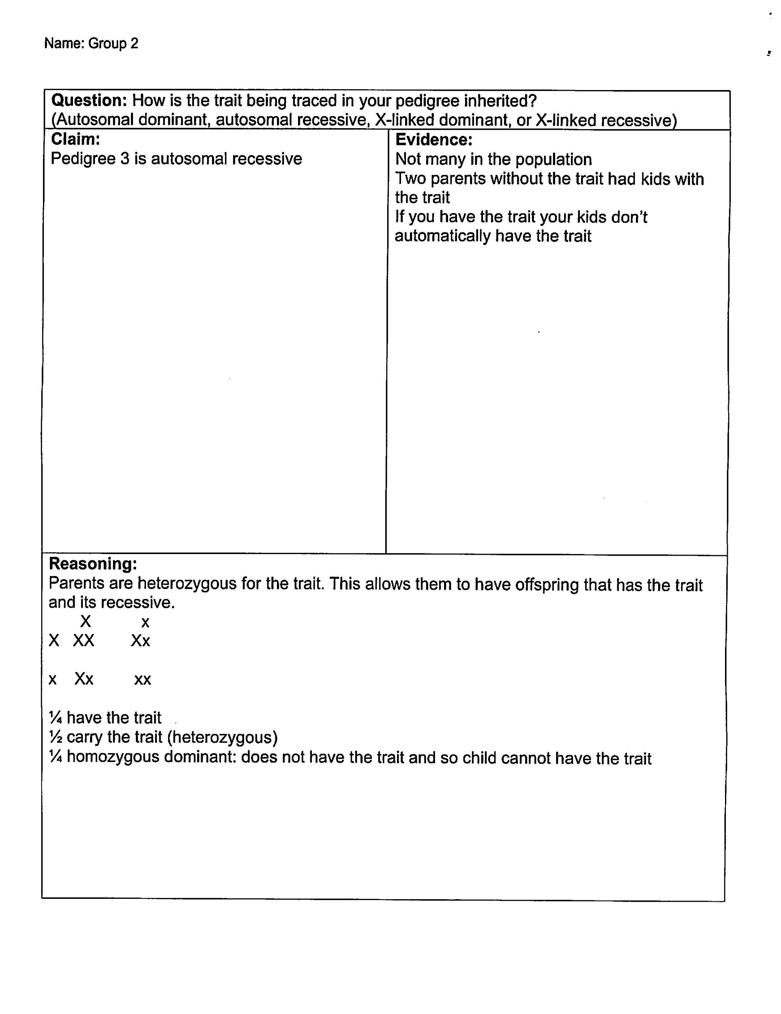
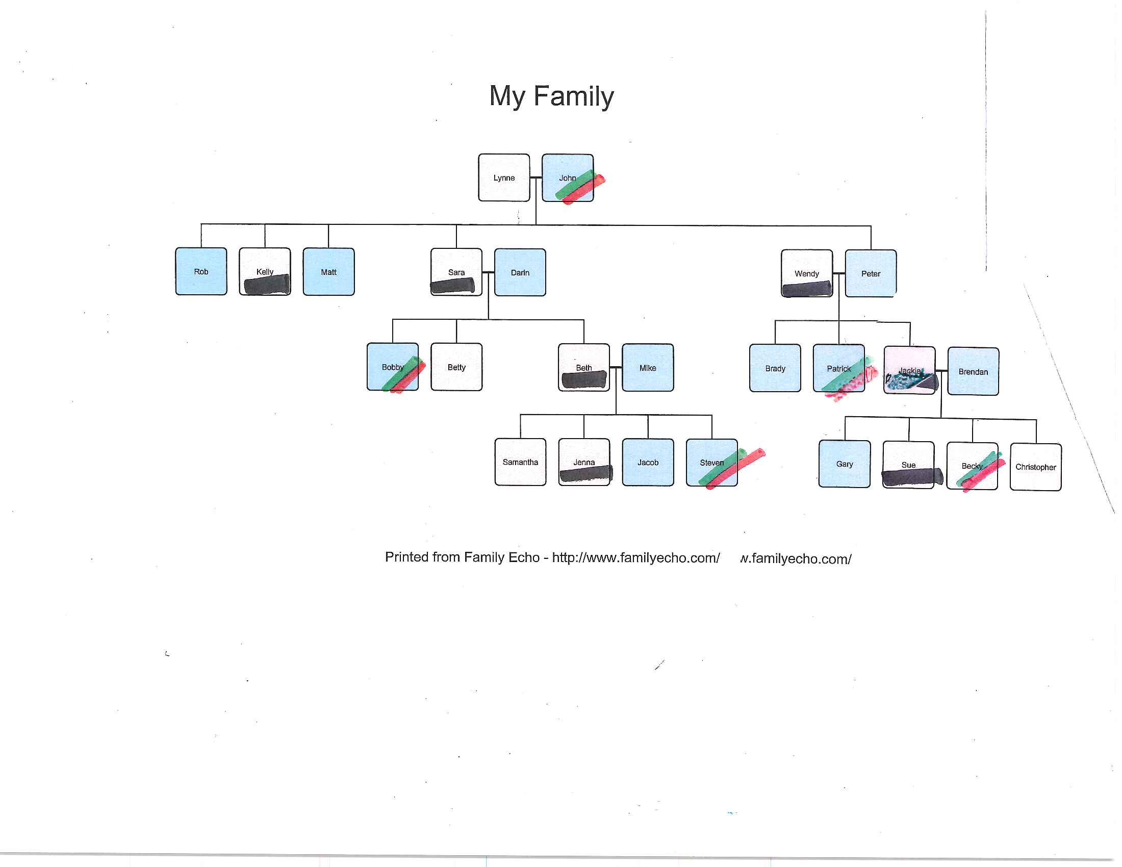

Sample #3
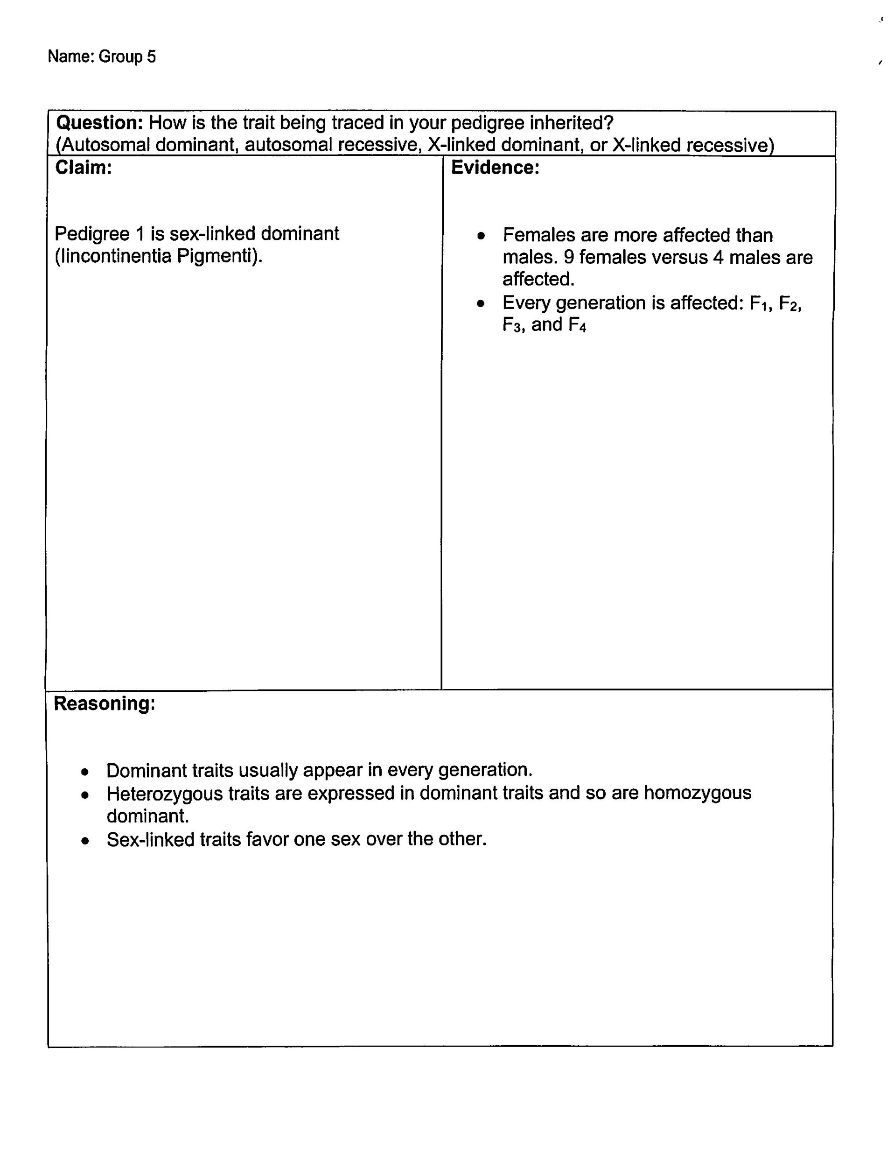

Why Does Red-Green Colorblindness Happen More Often in Males Than Females?

Name:____________________________________________________________________________________

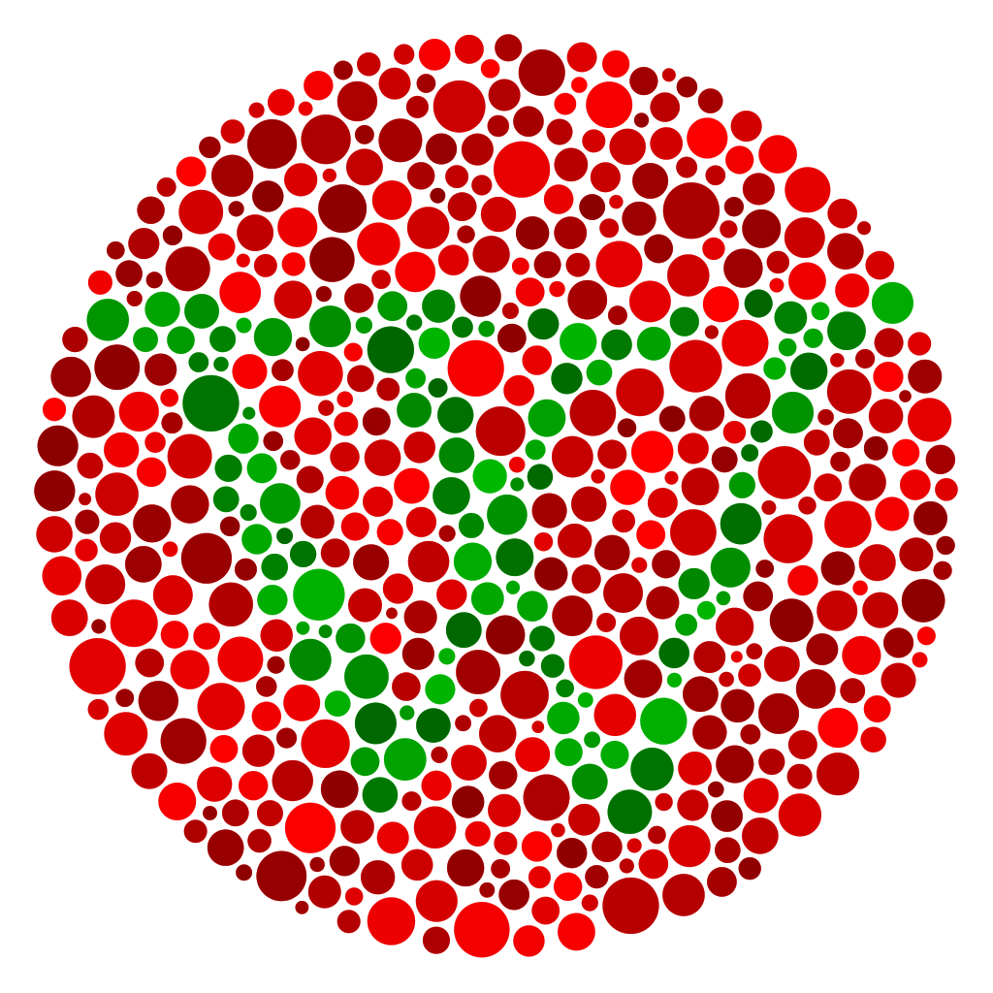
Introduction
According to Genetics Home Reference, “Red-green color vision defects are the most common form of color vision deficiency. This condition affects males much more often than females. Among populations with Northern European ancestry, it occurs in about 1 in 12 males and 1 in 200 females. Red-green color vision defects have a lower incidence in almost all other populations studied.”

The image at left is one of the many used by professionals to help diagnose red-green colorblindness.

Image from Wikimedia Commons user Dan-yell without changes; license CC BY-SA 3.0.

Objectives:
- Create a pedigree that shows which members of a family have red-green color blindness
- Analyze the pedigree to determine how red-green color blindness is inherited
- Construct an explanation for why red-green color blindness is greater in males than in females
- Analyze and interpret data from a pedigree to determine a diagnosis

Part I

The Story of Red-Green Colorblindness in the Smith Family
John has red-green colorblindness. John and Lynne are married and have five children. Rob is the oldest, Kelly, who is a carrier of the trait, is next, and then comes Matt. Peter is the youngest and came in line after Sara, who is also a carrier. Sara married Darin and Peter married Wendy, another carrier of the red-green colorblindness trait.

Darin and Sara have three children. The names of their children, youngest to oldest, are Beth, Betty, and Bobby. Beth is carrier of red-green colorblindness and Bobby is affected by red-green colorblindness. Beth married Mike and have four children. The names of their children, youngest to oldest, are Steven, Jacob, Jenna, and Samantha. Steven is also affected by red-green colorblindness, while Jenna is a carrier.

Peter and Wendy also have three children. Youngest to oldest, they are Patrick, Brady, and Jackie. Patrick is affected by red-green colorblindness and Jackie is a carrier. Jackie is married to Brendan, who is red-green colorblind. They have four children. Gary is the oldest and is affected by red-green colorblindness. Sue is the second oldest and is a carrier, unlike her younger sister Becky, who is affected by red-green colorblindness. The baby of the family is Christopher.

Part II

Name:____________________________________________________________________________________

Question: Why does red-green colorblindness happen more often in males than females?

Claim:
Evidence:

Reasoning:

Supplemental Text:

Part III

- Analyze the mystery pedigree.

- Complete a Claim, Evidence, and Reasoning graphic organizer to determine a genetic disease diagnosis for the assigned pedigree.

Possible Genetic Disease Diagnoses, excerpts from Genetics Home Reference by the National Library of Medicine (https://ghr.nlm.nih.gov/)
- Incontinentia Pigmenti (sex-linked dominant)
Incontinentia pigmenti is characterized by skin abnormalities that evolve throughout childhood and young adulthood. Many affected infants have a blistering rash at birth and in early infancy, which heals and is followed by the development of wart-like skin growths. In early childhood, the skin develops grey or brown patches (hyperpigmentation) that occur in a swirled pattern. These patches fade with time, and adults with incontinentia pigmenti usually have lines of unusually light-colored skin (hypopigmentation) on their arms and legs.

- Granulomatous Disease (sex-linked recessive)
Chronic granulomatous disease is a disorder that causes the immune system to malfunction, resulting in a form of immunodeficiency. Immunodeficiencies are conditions in which the immune system is not able to protect the body from foreign invaders such as bacteria and fungi. Individuals with chronic granulomatous disease may have recurrent bacterial and fungal infections. People with this condition may also have areas of inflammation (granulomas) in various tissues that can result in damage to those tissues. The features of chronic granulomatous disease usually first appear in childhood, although some individuals do not show symptoms until later in life.

- Phenylketonuria (autosomal recessive)
Phenylketonuria (commonly known as PKU) is an inherited disorder that increases the levels of a substance called phenylalanine in the blood. Phenylalanine is a building block of proteins (an amino acid) that is obtained through the diet. It is found in all proteins and in some artificial sweeteners. If PKU is not treated, phenylalanine can build up to harmful levels in the body, causing intellectual disability and other serious health problems.

- Huntington Disease (autosomal dominant)
Huntington disease is a progressive brain disorder that causes uncontrolled movements, emotional problems, and loss of thinking ability (cognition).

Adult-onset Huntington disease, the most common form of this disorder, usually appears in a person's thirties or forties. Early signs and symptoms can include irritability, depression, small involuntary movements, poor coordination, and trouble learning new information or making decisions. Many people with Huntington disease develop involuntary jerking or twitching movements known as chorea. As the disease progresses, these movements become more pronounced. Affected individuals may have trouble walking, speaking, and swallowing. People with this disorder also experience changes in personality and a decline in thinking and reasoning abilities. Individuals with the adult-onset form of Huntington disease usually live about 15 to 20 years after signs and symptoms begin.

A less common form of Huntington disease known as the juvenile form begins in childhood or adolescence. It also involves movement problems and mental and emotional changes. Additional signs of the juvenile form include slow movements, clumsiness, frequent falling, rigidity, slurred speech, and drooling. School performance declines as thinking and reasoning abilities become impaired. Seizures occur in 30 percent to 50 percent of children with this condition. Juvenile Huntington disease tends to progress more quickly than the adult-onset form; affected individuals usually live 10 to 15 years after signs and symptoms appear.

Mystery Pedigree 1

Mystery Pedigree 2

Mystery Pedigree 3

Mystery Pedigree 4

Name:____________________________________________________________________________________

Question: How is the trait being traced in your pedigree inherited?
(Autosomal dominant, autosomal recessive, X-linked dominant, or X-linked recessive)
Claim:

Evidence:

Reasoning:

