Classroom Connections
Examining the Intersection of the Standards for Mathematical Content
and the Standards for Mathematical Practice

Title: Modeling & Problem Solving with Fractions

Common Core State Standard Addressed in the Student Work Task:
5.NF.2 | Solve word problems involving addition and subtraction of fractions referring to the same whole, including cases of unlike denominators, e.g., by using visual fraction models or equations to represent the problem. Use benchmark fractions and number sense of fractions to estimate mentally and assess the reasonableness of answers.

Evidence of Standards for Mathematical Practice in the Student Work:
1: Make sense of problems and persevere in solving them.
2: Reason abstractly and quantitatively.
3: Construct viable arguments and critique the reasoning of others.
4: Model with mathematics.
6: Attend to precision.
7: Look for and make use of structure.

Task Components:
Part I: Mathematical Background (Page 2)
- Today’s Content

Part II: Math Metacognition (Pages 3 – 4)

Part III: Unpacking the Rigor of the Mathematical Task (Pages 5 – 6)

Part IV: Looking at Student Work (Pages 7 – 8)
- Bows Task (Grade 5)
- Protocol for LASW

Part V: Vertical Content Alignment (Page 9)
- Charting Coherence through Mathematical Progressions
- Writing a Grade – Level Problem or Task

Part VI: Wrap – up (Page 10)

Handouts Included:
- Math Metacognition: Page 11
- Protocol for LASW: Page 12
- Mathematical Task - Bows: Page 13
- Student Work Samples: Pages 14 – 19
- Student Work Analysis Grid: Page 20
- Unpacking the Rigor: Page 21

Part I: Mathematical Background
Approximate Time: 10 minutes
Grouping Structure: Whole Group

- Today’s Content:
  - The mathematics during this session focuses on making connections among the varied content standards found at Grade 5. In the student work task, many adults will immediately jump to using division to solve the problem. However, it is interesting to consider how to solve this using addition and subtraction, as the students do, since they have yet to work with division involving fractions. Both the metacognition and student work tasks involve situations that ask us to consider how we are able to connect what we (and students) know about whole number operations to fractions. In addition, the students are asked about a remainder but not required to interpret it, only to state whether or not leftover material is involved.

  - What do we need to know about:
    - Visual fraction models
    - Equivalent fractions
    - Measurement and length
    - Addition and subtraction
    - Multiplication and division
    - Relationship between operations on whole numbers and on fractions
    - Interpreting remainders in division contexts
before we can operate and problem solve with fractions accurately and efficiently?

  - Chart ideas to refer to during the Protocol for LASW.

Part II: Math Metacognition
Approximate Time: 30 minutes
Grouping: Whole Group

- Problems: These two problems get us thinking about real-life situations that involve any of the four operations with both whole number and fractional quantities, whether in the given information in the problem or in the solution itself. Teachers can have the option of selecting an option for #1 and then comparing/contrasting their thinking to someone choosing the other option. The second problem involves analyzing the same situation – both with fractional amounts with no remainder and whole number amounts with a remainder – to bring up discussion around the connectedness of whole number and fractional operations.
- Write a sentence that uses the numbers or words in one of the sets below. Other words and numbers can also be used.

OPTION A: exactly, fabric, feet, 4 ½, 5/8
OPTION B: yards, rope, leftover, 4, 5

- Sam is building some shoe bins near his front door. He has a length of wood that is _________. He wants to cut the wood into ________ -sized pieces to use to build the bins.
  - Fill in the blanks above with whole number amounts (include units) so that Sam will have some leftover wood after he cuts his pieces.
  - Fill in the blanks above with fractional amounts (include units) so that Sam will have no leftover wood after he cuts his pieces.

- Solutions: 1) Answers will vary, but a possibility for Option A: If I need to make 2 curtains that are exactly 4 ½ feet long from a piece of fabric that is 5 1/8 feet long, I will have a piece of fabric that is 5/8 foot leftover. Option B: If I have 5 yards of string to make a few knots and need 4 yards leftover for another project, then I can use 1 yard for the knots. 2) Answers will vary, but a possibility would be: a) 24” long; 5” and b) 2 2/3 yds; 2/3 yd

- Problem Intent:
  - Math metacognition allows teachers the opportunity to think about their own mathematical thinking in a more natural way that often makes use of more reasoning and helps to develop a better sense of number.

  - This particular exercise is designed to get teachers thinking about the similarities and differences that exist between reasoning and problem solving with whole numbers and with fractions. Problem 1 above can involve any operation and similar thinking can be used regardless of the quantity (i.e., in addition problems) or can vary based on the quantities used (i.e., some subtraction or division contexts).
Part II: Math Metacognition, cont

  - We also want to think about a “division” context that can be approached in other ways, including addition and subtraction. This comes up in the student work task, so it’s helpful to consider this idea ahead of time. In addition, the task asks students to consider a measurement context that involves having material leftover, which occurs here as well.

- Bring discussion back to the topics at hand.
  - Compare and contrast possible solutions for Option A and Option B from Problem 1. What was the same? What was different? Why?
  - Compare and contrast the thought process used for 2a) and 2b). What was the same? What was different? Why?
  - What models and/or contexts helped you to reason through these problems?
  - Did your strategy or method change as the numbers were changed?
  - How are these problem sets related? How are addition/subtraction and division related?
  - What implications does this have on our work with operations with fractions?
  - How can metacognition help promote successful problem solving with your own students?

Part III: Unpacking the Rigor of the Mathematical Task
Approximate Time: 30 minutes
Grouping: Whole Group

- Comparing Different Versions of the Mathematical Task: Let’s compare the rigor of two related problems to the Bows task. The level of rigor is based on which of the Standards for Mathematical Practice we could expect to see when examining the student solutions. Pass out the “Unpacking the Rigor” handout (see Page 21). See completed chart on the next page for more details of what this would look like.

- In addition to the Mathematical Practices, consider discussing the following with your group as you compare the variations above:
  - Cognitive demand
  - Task accessibility to a variety of learners
  - Real-life applications and math connections
  - Assessment of student learning

- If time allows, you can use a Venn Diagram to compare and contrast the elements of each version of the task.

Unpacking the Rigor
Comparing Different Versions of the Bows Mathematical Task

Task | Level of Rigor
A traditional problem involving operations with fractions would look something like this:  Fill in the blank with <, >, or =.  $\frac{3}{5}$ ____ $\frac{7}{10}$ | MP6: When students are comparing two fractions with unlike denominators that are close to one another, they are attending to precision.
Adding a context to the problem above and following it up with a thought question, we now have a more rigorous task:  Jessica and Lisa want to make bows. Jessica makes a bow that is 3/5 yard long, and Lisa makes a bow that is 7/10 yard long. Whose bow is longer? How do you know? | MP2: When students are able to accurately reason about the relative size of two quantities and justify how they know which is greater, they are exhibiting use of this practice.  MP6: When students are comparing two fractions with unlike denominators that are close to one another, they are attending to precision.
Now, additional components are included in the previous task to raise it to a much higher level of cognitive demand: 1) A total amount of ribbon for each girl (not evenly divisible by both lengths) is included, and the context changes to have them consider making as many bows as possible, 2) justification of which girl makes the most bows, and 3) asking for a visual model to be included to represent the measurements.  Jessica and Lisa want to make bows. Each girl has 3 ½ yards of ribbon. Jessica wants to use exactly 3/5 yard of ribbon in each of her bows. Lisa wants to use exactly 7/10 yard of ribbon in each of her bows.  - How many bows can each girl make if she uses as much of the ribbon as possible?  - Jessica says that she can make the best use of the ribbon because she will have the least ribbon leftover. Lisa says that she can make the best use of the ribbon because she will have the least ribbon leftover. Which girl is correct?  Draw a model to represent each girl’s measurements and explain how you arrived at you answers to the questions above. | MP1: When students are reading a word problem and deciding what operation should be used to solve the problem, they are making sense of the problem.  MP2: When students are able to accurately reason about the relative size of two quantities and justify how they know which is greater, they are exhibiting use of this practice.  MP3: When students can explain their argument about which student made the best use of the ribbon by considering both girls’ thinking, they are constructing viable arguments and critiquing the reasoning of others.  MP4: When students draw a picture to represent the problem and use it to justify their calculations, they are exhibiting use of models.  MP6: When students are analyzing fractions with unlike denominators and considering leftover amounts, they are attending to precision as they correctly express the appropriate solution.  MP7: When students are able to make use of numerical calculations or quantities involved in one girl’s bows and apply it to the other girl’s or if they are able to observe a pattern from their visual model and can extend that pattern over the scope of an entire problem, they are exhibiting use of this practice.
Part IV: Looking at Student Work (LASW)
Approximate Time: 50 minutes
Grouping: Refer to protocol

- Mathematical Task Introduction: The problem and student work used for this session are from Grade 5. Complete the Protocol for LASW (see Page 12) with the group.

- Bows Task:
Jessica and Lisa want to make bows. Each girl has 3 ½ yards of ribbon. Jessica wants to use exactly 3/5 yard of ribbon in each of her bows. Lisa wants to use exactly 7/10 yard of ribbon in each of her bows.
- How many bows can each girl make if she uses as much of the ribbon as possible?
- Jessica says that she can make the best use of the ribbon because she will have the least ribbon leftover. Lisa says that she can make the best use of the ribbon because she will have the least ribbon leftover. Which girl is correct?
Draw a model to represent each girl’s measurements and explain how you arrived at you answers to the questions above.

- Solution:
  - Students can use repeated addition to know that 3½ yds = $\frac{35}{10}$. $\frac{7}{10}$ counted 5 times (like jumps on a number line in whole number multiplication) will use the entire 3½ yds of ribbon. There is one $\frac{7}{10}$ in each yard, with $\frac{3}{10}$ left over for each of the 3 yards. 3 x $\frac{3}{10}$ = $\frac{9}{10}$. The remaining ½ yard can be thought of as $\frac{5}{10}$. $\frac{9}{10}$ + $\frac{5}{10}$ = $\frac{14}{10}$. There are two $\frac{7}{10}$’s in $\frac{14}{10}$. Therefore, there are 5 bows made with no ribbon leftover.
  - Students could also solve the problem by changing $\frac{3}{5}$ to $\frac{6}{10}$ and using this method to figure out that there will be ribbon left over.

- Task Intent and Instructional Purpose:
  - The intent of this task is three-fold: 1) to engage students in the Mathematical Practices, 2) to explore equivalent fractions, and 3) to connect and extend whole number strategies to fractions. This is a task that can be used as a formative assessment for later work with fraction operations. The teacher can assess how students solve this problem and whether or not they rely on their prior knowledge of operations with whole numbers.

Part IV: Looking at Student Work (LASW), cont.

  - Students should know that fractions are composed of unit fractions and be able to understand cardinality (i.e.,$\frac{3}{5}= \frac{1}{5}+ \frac{1}{5}+ \frac{1}{5}$ ). This idea could help them to solve this problem using prior knowledge (i.e., repeated addition or by skip counting as in early multiplication with whole numbers).

  - Fifths and tenths were used intentionally because they are easily compared. In fact, students are actually comparing increments of $\frac{6}{10}$ and $\frac{7}{10}$.

  - This task did not ask for interpretation of the remainder but instead to consider the girl with the least ribbon leftover. It also gets students to think about using repeated addition or subtraction as a way to compare these fractions.

- Questions for Evidence-based, Whole Group Discussion:
  - Does the student work exhibit proficiency of the Standards for Mathematical Content?
  - Consider the Standards for Mathematical Practice that are embedded in the task design. Which of these Practices do you see exhibited in the student work?
  - What is the evidence in the student work that the student is moving towards the intentions of the task design? (i.e., understanding and demonstrating mastery of the content as well as engaging in math practices)
  - How far removed from the intent of the task is the student’s thinking? Which pieces of understanding are present? Which are not? Is there evidence that they are close? Is there a misconception present?

Part V: Vertical Content Alignment
Approximate Time: 25 Minutes
Grouping: Partners or Small Groups

- Charting Coherence through Mathematical Progressions in the Standards for Mathematical Content

  - The content standard for this task is 5.NF.2. It is important that the group analyzes this standard with respect to standards in K – 4 and beyond Grade 5 in order to identify where along the continuum of learning it falls.

  - Beginning, Middle, End: Using the Standards for Mathematical Content, trace the progression of the concepts involved in this task from K – 8. See separate handout for an example of this progression.

- Writing a Problem or a Task: As a way to synthesize learning from today’s discussion, ask teachers to come up with a math problem or task that would embody the ideas discussed today. The problem should be appropriate to use at a particular grade level. Writing these problems will help both you as the facilitator and the other group members develop a stronger sense of how these mathematical ideas show up in classrooms from grades K – 8.
  - Consider having teachers work in pairs to write these problems. Be sure to have a wide variety of grade levels represented in the problems. This practice is an especially powerful means to identify vertical connections in content. Use the standards identified in Part A: Charting Coherence. Each pair of teachers should select a standard from this progression to be used as a basis for their written task.
  - Have teachers write their problem to share with the whole group. Be sure to ask them to include the appropriate learning standard(s) and Standard(s) for Mathematical Practice to which the problem is written. In this way, teachers are asked to articulate the types of content and practices with which students would be involved as a way to truly see how the work done here can have an impact on classroom practice, regardless of grade level.
  - What do you notice about the problems presented?

Part VI: Feedback & Wrap-up
Approximate Time: 5 Minutes
Grouping: Individual

- Closing: Close your time together by facilitating a discussion around how the LASW process will impact what teachers do within their own classrooms. Some questions to help guide discussion include:
  - What do we take away after LASW?
  - What did we learn? About student thinking? About our own knowledge?
    - Refer back to chart made at the beginning of the discussion during Part I: Mathematical Background.
  - How does it impact your practice at your grade level?

- Exit Cards: Pass out exit cards for the group and ask them to provide some feedback to you as the facilitator. Select one or two questions from the list below to help them summarize their thinking about the mathematics from today’s session. Collect exit cards so that a summary can be shared the next time you meet.

Exit Card Questions

- How does the mathematics that we explored connect to your own teaching?

- How do the mathematical practices that we explored connect to your own teaching?

- What idea or topic did you find most interesting from today’s discussion? Why?

- How was this discussion for you as a learner?

- What ideas were highlighted for you in today’s discussion that you had not previously considered?

- What are you taking away from today’s work?

Math Metacognition

- Write a sentence that uses the numbers or words in one of the sets below. Other words and numbers can also be used.

OPTION A: exactly, fabric, feet, 4 ½, $\frac{5}{8}$

OPTION B: yards, rope, leftover, 4, 5

- Sam is building some shoe bins near his front door. He has a length of wood that is _________. He wants to cut the wood into ________ -sized pieces to use to build the bins.
  - Fill in the blanks above with whole number amounts (include units) so that Sam will have some leftover wood after he cuts his pieces.
  - Fill in the blanks above with fractional amounts (include units) so that Sam will have no leftover wood after he cuts his pieces.

Protocol for
Looking at Student Work

- Read the task and discuss what it is assessing.

- Solve the problem individually

- Share your thinking with a partner

- Discuss the mathematics of the task as a whole
group

- Look at how students solved the same task

- Identify evidence of the Standards of
Mathematical Practice exhibited in the student
work

- Discuss evidence of the Standards of
Mathematical Practice exhibited in the student
work as a whole group

Based on the Mathematics Learning Community (MLC) Protocol for LASW,
© 2011 Commonwealth of Massachusetts [Department of Elementary and Secondary Education]

Mathematical Task
Bows

Jessica and Lisa want to make bows. Each girl has 3 ½ yards of ribbon. Jessica wants to use exactly 3/5 yard of ribbon in each of her bows. Lisa wants to use exactly 7/10 yard of ribbon in each of her bows.
- How many bows can each girl make if she uses as much of the ribbon as possible?
- Jessica says that she can make the best use of the ribbon because she will have the least ribbon leftover. Lisa says that she can make the best use of the ribbon because she will have the least ribbon leftover. Which girl is correct?

Draw a model to represent each girl’s measurements and explain how you arrived at you answers to the questions above.
Student Work Analysis
Problem: Bows Grade Level: 5
Student A
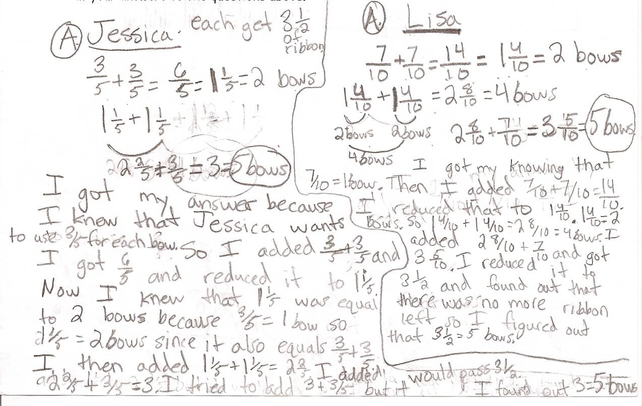
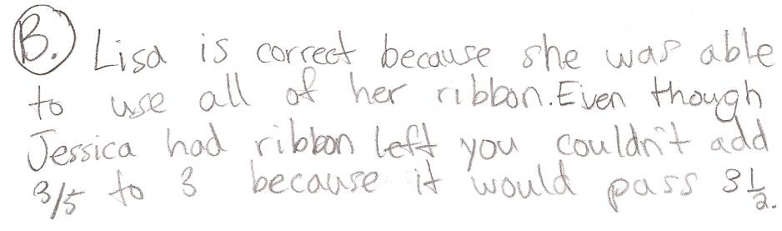
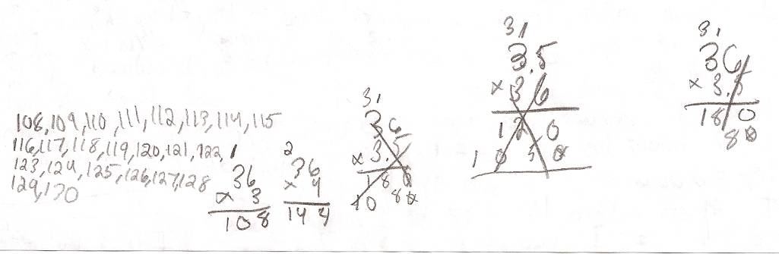

Student Work Analysis
Problem: Bows Grade Level: 5
Student B
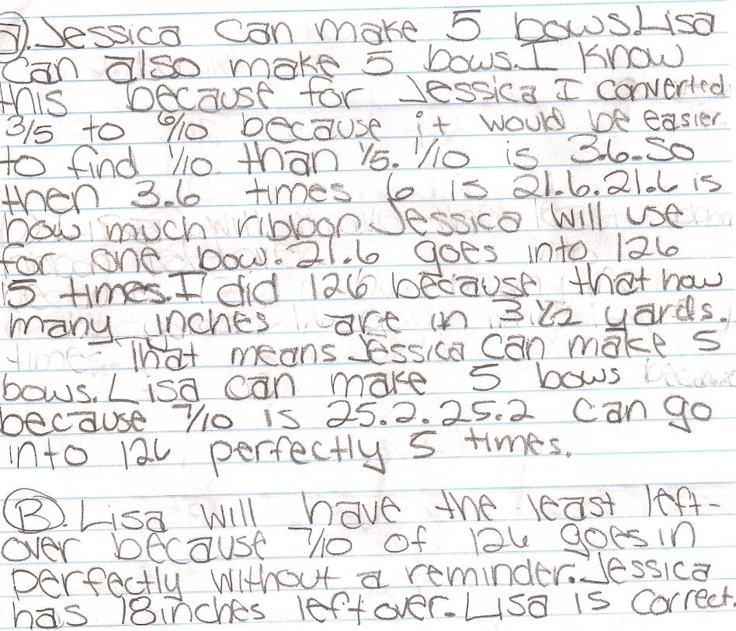
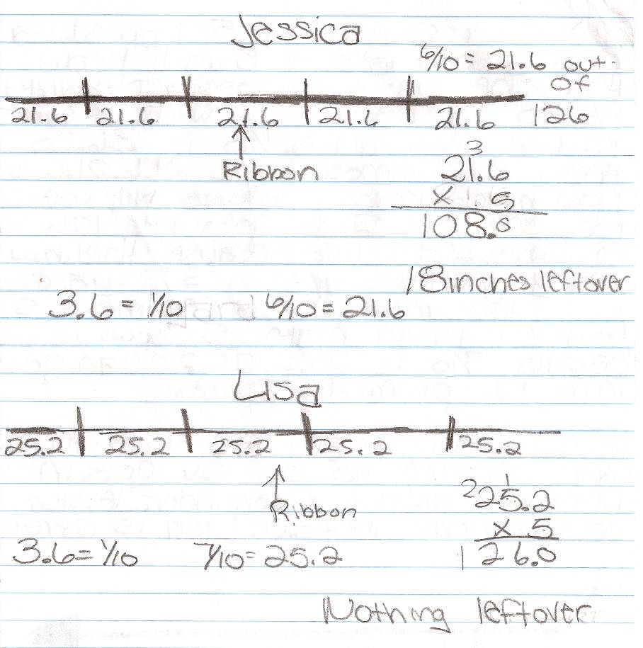
Student Work Analysis
Problem: Bows Grade Level: 5

Student C
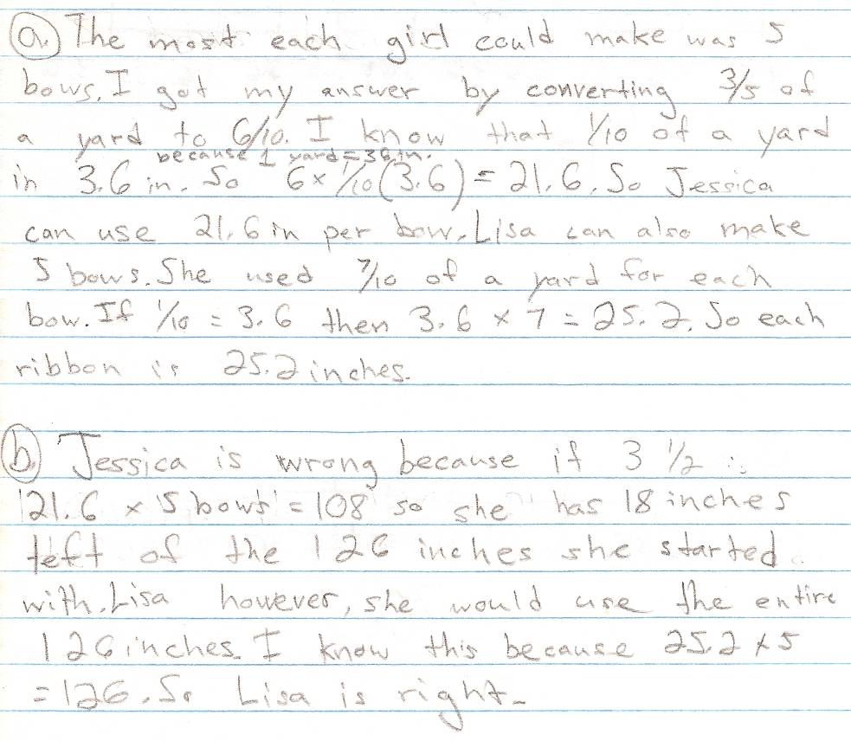
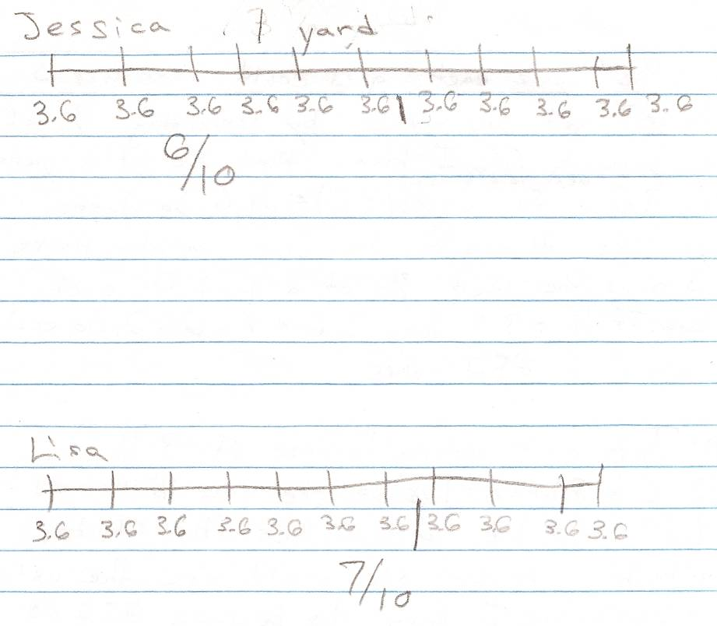
Student Work Analysis
Problem: Bows Grade Level: 5

Student D – Page 1
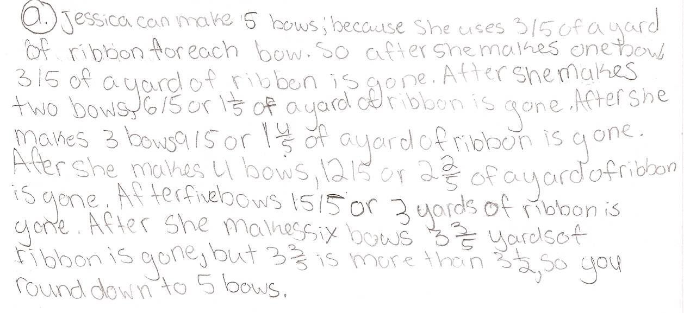
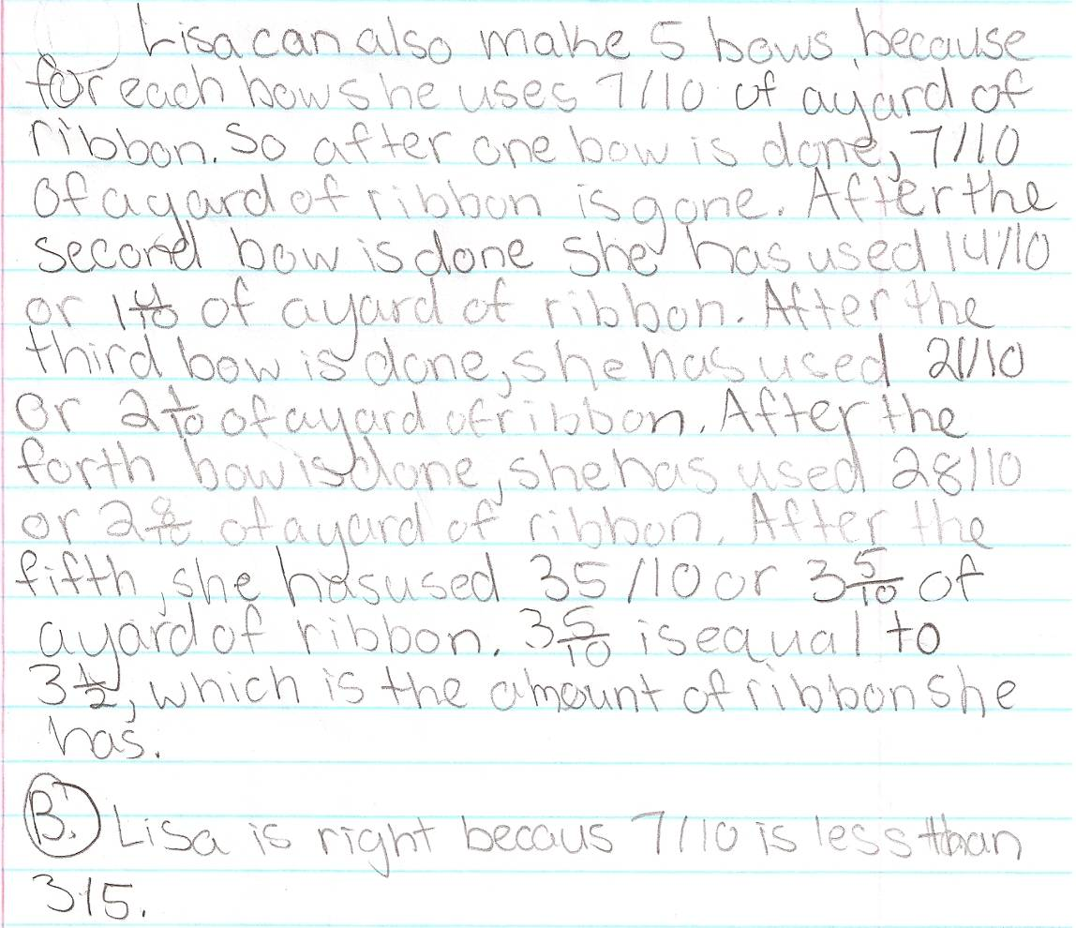

Student Work Analysis
Problem: Bows Grade Level: 5

Student D – Page 2
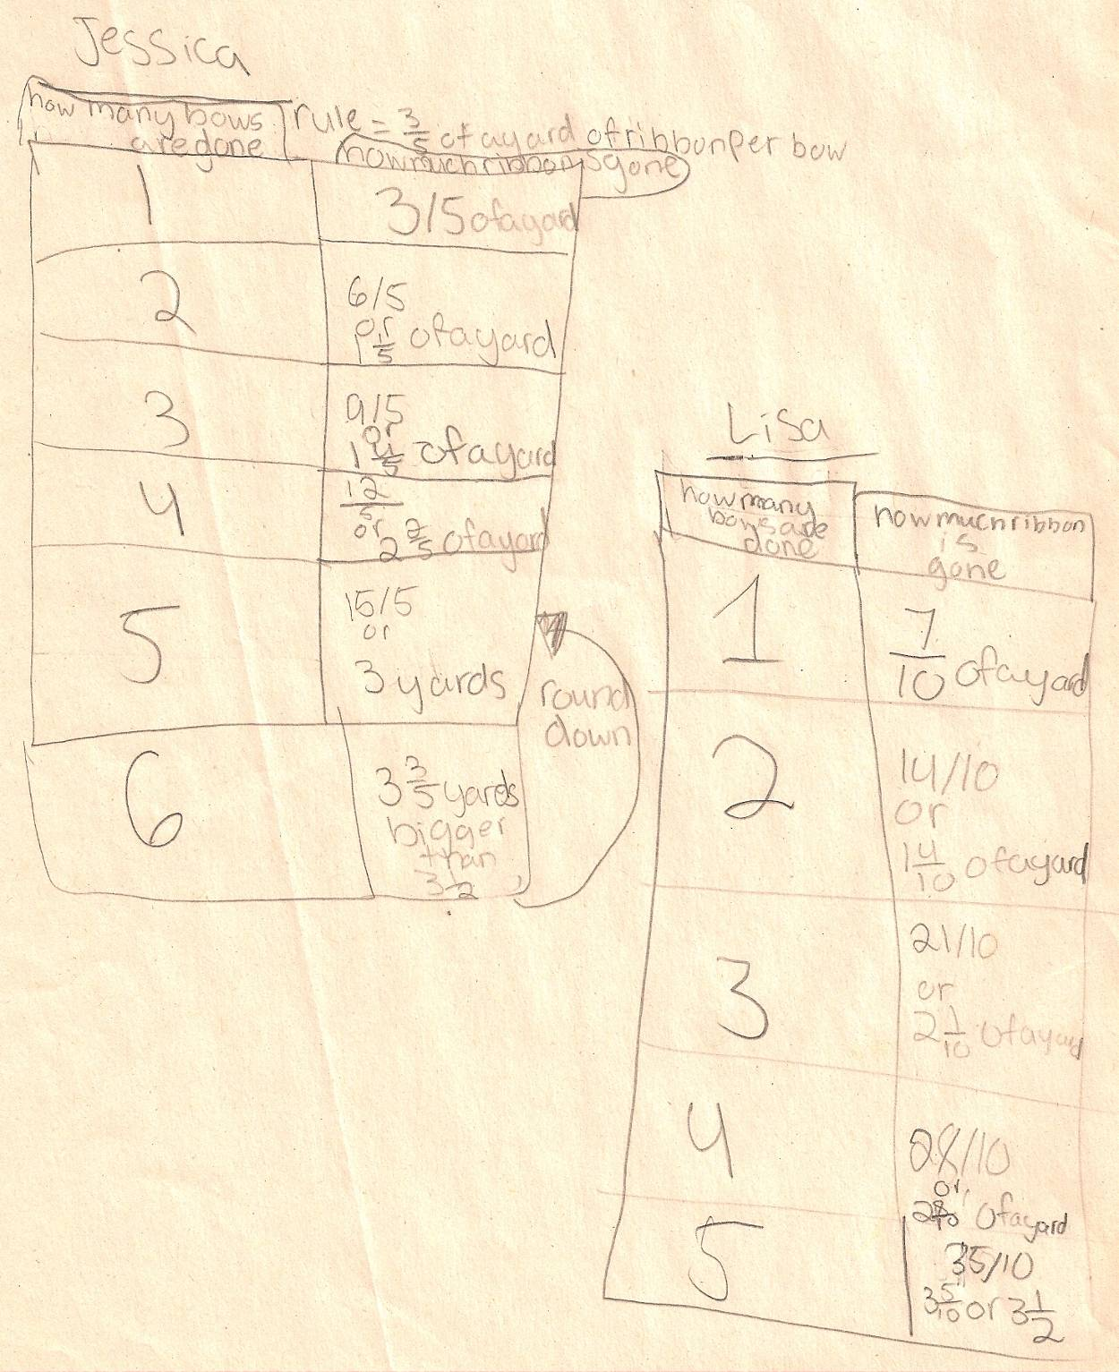
Student Work Analysis for: Bows

Student | MP 1:Problem Solving  MP 6: Precision | MP 2: Reason Abstractly  MP 3: Critique Reasoning | MP 4: Model with math  MP 7: Look for /make use of structure | What comes next in instruction for this student?
A
B

C

D

Unpacking the Rigor
Comparing Different Versions of the Bows Mathematical Task
Task | Level of Rigor
Fill in the blank with <, >, or =.

$\frac{3}{5}$ ____ $\frac{7}{10}$

Jessica and Lisa want to make bows. Jessica makes a bow that is 3/5 yard long, and Lisa makes a bow that is 7/10 yard long. Whose bow is longer? How do you know?

Jessica and Lisa want to make bows. Each girl has 3 ½ yards of ribbon. Jessica wants to use exactly 3/5 yard of ribbon in each of her bows. Lisa wants to use exactly 7/10 yard of ribbon in each of her bows.
- How many bows can each girl make if she uses as much of the ribbon as possible?
- Jessica says that she can make the best use of the ribbon because she will have the least ribbon leftover. Lisa says that she can make the best use of the ribbon because she will have the least ribbon leftover. Which girl is correct?
Draw a model to represent each girl’s measurements and explain how you arrived at you answers to the questions above.

