Classroom Connections
Examining the Intersection of the Standards for Mathematical Content
and the Standards for Mathematical Practice

Title: Considering Coordinate Geometry

Common Core State Standards Addressed in the Student Work Task:
G.GPE.1 Derive the equation of a circle of given center and radius using the Pythagorean Theorem;
complete the square to find the center and radius of a circle given by an equation.
G.GPE.4 Use coordinates to prove simple geometric theorems algebraically.

Evidence of Standards for Mathematical Practice in the Student Work:
2: Reason abstractly and quantitatively.
3: Construct viable arguments and critique the reasoning of others.
5: Use appropriate tools strategically.
6: Attend to precision.
7: Look for and make use of structure.
8: Look for and express regularity in repeated reasoning.

Task Components:
Part I: Mathematical Background (Page 2)
- Today’s Content

Part II: Math Metacognition (Page 3)

Part III: Unpacking the Rigor of the Mathematical Task (Pages 4 –5)

Part IV: Looking at Student Work (Page 6 – 7)
- Triangle ABC Task (HS Geometry)
- Protocol for LASW

Part V: Vertical Content Alignment (Page 8)
- Charting Coherence through Mathematical Progressions
- Writing a Grade – Level Problem or Task

Part VI: Wrap – up (Page 9)

Handouts Included:
- Math Metacognition: Page 10
- Protocol for LASW: Page 11
- Mathematical Task – Triangle ABC: Page 12
- Student Work Samples: Pages 13 – 17
- Student Work Analysis Grid: Page 18
- Unpacking the Rigor: Page 19

Materials Needed:
- Grid paper or graph boards
- Ruler or straight-edge

Part I: Mathematical Background
Approximate Time: 10 minutes
Grouping Structure: Whole Group

- Today’s Content:
  - The mathematics during this session focuses on coordinate geometry, and the student work task itself includes several different elements and skills. For example, students must prove whether or not a figure is a right triangle, determine a midpoint, and find an equation of a circle. Coordinate geometry provides a nice opportunity to blend students’ prior knowledge of algebra with new concepts and skills learned in geometry.

  - What do we need to know about:
    - Locating ordered pairs
    - Properties of shapes, in particular of triangles
    - Distance
    - Slope
    - Midpoint
    - Pythagorean Theorem
    - Circles and equations of circles
before we can solve real-life problems using the coordinate plane accurately and efficiently?

  - Chart ideas to refer to during the Protocol for LASW.

Part II: Math Metacognition
Approximate Time: 30 minutes
Grouping: Whole Group

- Problem: This problem set is designed to encourage discussion amongst teachers around various aspects of coordinate geometry. This is especially helpful due to the wide scope of the student work task. By removing one of the vertices, discussion can be had around what type of figure is formed when the location of vertex D is changed. In addition, the nature of questions #3 and #5 – asking for questions rather than answers – allows you to assess what teachers are currently thinking (and in turn, can model a process that they can use themselves with their own students).
Three of the vertices of figure ABCD have been drawn on the coordinate plane below.
A(-3, 4) B(2, 4) C(4, 1) D( , )
- Decide on a location for vertex D.
- What type of figure is ABCD? How do you know?
- Come up with 3 questions you could ask about Figure ABCD.
- Decide on a new location for vertex D so that a different geometric figure is formed. What type of figure is ABCD now? How do you know?
- Can you ask the same questions as in Question 3 above? If so, why? If not, why not?
- Come up with at least 1 question you could now ask about your new Figure ABCD.

- Solutions: Answers will vary for all problems, but here is a possible set of solutions.1) D could be placed at (-1,1). 2) Figure ABCD is now a parallelogram. I know because it is a quadrilateral with two pairs of parallel sides (AB and DC are parallel (both have a slope of 0/5) and are congruent (5 units) and AD and BC are parallel (both have a slope of -3/2) and are congruent (√13). Opposite angles are congruent. 3) Three questions I could ask about this figure: a) What is the area of Figure ABCD? b) If I reflect Figure ABCD about y = 0, what are the coordinates of the image? and c) What is a real-life situation that would involve considering Figure ABCD on a coordinate plane?. 4) D could be placed at (-3,1) to create a trapezoid. I know because a trapezoid is a quadrilateral with exactly 1 pair of parallel sides, and here, only AB and DC would be parallel (see above). 5) Yes all 3 questions could still pertain to this new figure. 6) Determine the perimeter of Figure ABCD.

- Problem Intent: This particular exercise is designed to get teachers thinking about different aspects of coordinate geometry, including locating ordered pairs and properties of shape, as well as area, perimeter, distance, Pythagorean Theorem, slope, transformations, etc. (based on the nature of the questions posed). Setting up questions in a non-traditional format, such as in this problem set, could also be a source of discussion for your group.

- Have teachers share and compare their answers. Then, bring discussion back to the topics at hand:
  - What are all the possible shapes that Figure ABCD could be?
  - Compare and contrast the types of questions asked – would you consider them to be basic questions (i.e., think “low” on Bloom’s Taxonomy) or rich questions?
  - What implications does this have on our work with students?
  - How can metacognition such as this task help to promote student discourse in your own classroom?
Part III: Unpacking the Rigor of the Mathematical Task
Approximate Time: 30 minutes
Grouping: Whole Group

- Comparing Different Versions of the Mathematical Task: Let’s compare the rigor of two related problems to the Triangle ABC task. The level of rigor is based on which of the Standards for Mathematical Practice we could expect to see when examining the student solutions. Pass out the “Unpacking the Rigor” handout (see Page 19). See completed chart on the next page for more details of what this would look like.

- In addition to the Mathematical Practices, consider discussing the following with your group as you compare the variations above:
  - Cognitive demand
  - Task accessibility to a variety of learners
  - Real-life applications and math connections
  - Assessment of student learning

- If time allows, you can use a Venn Diagram to compare and contrast the elements of each version of the task.

Unpacking the Rigor
Comparing Different Versions of the Triangle ABC Mathematical Task
Task | Level of Rigor
A traditional problem involving the Pythagorean Theorem would look something like this:  On the coordinate grid, sketch the triangle with these three vertices:  A(-2, -5), B(2,3), and C(4, -3)  Using the Pythagorean Theorem to show that ABC is a right triangle. | MP2: When students make sense of quantities and their relationships in problems, they are exhibiting use of this practice.  MP5: When students are using appropriate tools (i.e., the coordinate grid) to work on mathematics, they are exhibiting use of this practice.
Now, the students are asked to explain how ABC is a right triangle, rather than simply showing it using the Pythagorean Theorem. In addition, the task now involves two extra concepts, midpoint and distance. With these two additional elements, the scope of the task has widened, yet the level of questioning involving these two concepts remains at a low level.  On the coordinate grid, sketch the triangle with these three vertices:  A(-2, -5), B(2,3), and C(4, -3)  - Using the Pythagorean Theorem, explain how ABC is a right triangle.  - Using the midpoint formula, identify the midpoint of AB.  - Using the distance formula, show that this midpoint is equidistant from points A, B, and C. | MP 3: When students are asked to explain in words how a figure fits a given definition or description, they are constructing a viable argument.  MP5: When students are using appropriate tools (i.e., the coordinate grid) to work on mathematics, they are exhibiting use of this practice.  MP6: When students are ensuring that their mathematical justification does indeed show that a given figure matches a definition and when students evaluate expressions accurately and pay attention to all aspects of a given situation (i.e., midpoint is equidistant from all 3 vertices), they are attending to precision.
In this final version, students are now asked to consider whether or not the figure is a right triangle and must explain this answer mathematically. This question contrasts with the two previous versions in that it no longer specifies a property or theorem students must use, making it a more challenging task to complete. Question 2 asks students to prove a given statement about a midpoint and Question 3 seeks to extend the scope of the problem by incorporating circles. This resulting task is a much richer form of assessment than the other two.  Solve this problem in the space provided below. Show and explain all of your work.  On the coordinate grid, sketch the triangle with these three vertices: A(-2, -5), B(2,3), and C(4, -3)  Use your sketch to answer the following questions:  - Is this a right triangle? Explain mathematically how you know the answer to this question.  - Find the coordinates of the midpoint of the longest side of this triangle and prove that it is equidistant from each of the triangle’s vertices.  - Write the equation for a circle that will go through all three vertices of the triangle and verify that the coordinates of the vertices satisfy this equation. | MP2: When students are asked to apply mathematical concepts, properties, or theorems to a given situation, without guidance as which particular ideas to apply, they are exhibiting use of this practice.  MP 3: When students are asked to explain in words how a figure fits a given definition or description and to prove how a given property holds true, they are constructing viable arguments.  MP5: When students are using appropriate tools (i.e., the coordinate grid) to work on mathematics, they are exhibiting use of this practice.  MP6: When students are ensuring that their mathematical justification does indeed show that a given figure matches a definition and when students evaluate expressions accurately and pay attention to all aspects of a given situation (i.e., verifying that the coordinates of all 3 vertices satisfy the equation), they are attending to precision.  MP7: When students see a numerical situation (i.e., line segments whose slopes are negative reciprocals or the sum of the squares of two side lengths equal to the square of a third, longer length), they are looking for and making use of structure.  MP8: When students are able to generalize a given situation (i.e., midpoint and equidistance) and extend it to another situation or another aspect of a geometric figure, they are expressing regularity in this repeated reasoning.

Part IV: Looking at Student Work (LASW)
Approximate Time: 50 minutes
Grouping: Refer to protocol

- Mathematical Task Introduction: The problem and student work used for this session are from high school Geometry. Complete the Protocol for LASW (see Page 11) with the group.

- Triangle ABC Task:

Solve this problem in the space provided below. Show and explain all of your work.
On the coordinate grid, sketch the triangle with these three vertices:

A(-2, -5), B(2,3), and C(4, -3)

Use your sketch to answer the following questions:

- Is this a right triangle? Explain mathematically how you know the answer to this question.
- Find the coordinates of the midpoint of the longest side of this triangle and prove that it is equidistant from each of the triangle’s vertices.
- Write the equation for a circle that will go through all three vertices of the triangle and verify that the coordinates of the vertices satisfy this equation.

- Solution: (1) Yes, it is a right triangle. The most common way to explain this mathematically is to use the Pythagorean Theorem. Length of AC is √40 units, and the length of BC is also √40 units. Length of AB is √80 units. Therefore a² + b² = c² holds true and ABC is a right triangle. Other possible ways include showing that triangle ABC could be seen as ½ of a square with vertex D at (-4,1) or that legs AC and BC are perpendicular since their slopes are negative reciprocals of one another. (2) Midpoint of longest side (AB) is located at (0, - 1). Midpoint separates AB in two congruent pieces, therefore it is equidistant from vertices A and B. Use the distance formula to show that the distance from (0, -1) to point C is equidistant (√20 units). (3)The equation of the circle that will pass through vertices A, B, and C is: 20 = x² + (y +1)²

- Task Intent and Instructional Purpose:
  - It is important to have a discussion about the types of questions present in this task. Refer back to the discussion you had as a group during Math Metacognition. Which questions are basic? Which are rich? What distinguishes them in your mind?
  - Questions 1 and 2 provide students with an opportunity to use their knowledge of geometry to prove two different things: 1) that the triangle is indeed a right triangle as it so appears and 2) that the midpoint of the hypotenuse is equidistant from all three vertices of

Part IV: Looking at Student Work (LASW), cont.

the triangle. This type of question gives so much more information about what the student knows and does not understand.
  - The content of Question 3 could serve as an extension, however the question format is more basic than the first two. In student work samples collected, we saw that many students showed little justification for their proofs yet were still able to identify the correct equation of the circle. What implications might this have? What might you do differently?

- Questions for Evidence-based, Whole Group Discussion:
  - Does the student work exhibit proficiency of the Standards for Mathematical Content?
  - Consider the Standards for Mathematical Practice that are embedded in the task design. Which of these Practices do you see exhibited in the student work?
  - What is the evidence in the student work that the student is moving towards the intentions of the task design? (i.e., understanding and demonstrating mastery of the content as well as engaging in math practices)
  - How far removed from the intent of the task is the student’s thinking? Which pieces of understanding are present? Which are not? Is there evidence that they are close? Is there a misconception present?

Part V: Vertical Content Alignment
Approximate Time: 25 Minutes
Grouping: Partners or Small Groups

- Charting Coherence through Mathematical Progressions in the Standards for Mathematical Content
  - The content standards for this task are G.GPE.1 and G.GPE.4. It is important that the group analyzes these standards with respect to standards in K through HS Geometry in order to identify where along the continuum of learning it falls.
  - Beginning, Middle, End: Using the Standards for Mathematical Content, trace the progression of the concepts involved in this task from K through HS Geometry. See separate handout for an example of this progression.

- Writing a Problem or a Task: As a way to synthesize learning from today’s discussion, ask teachers to come up with a math problem or task that would embody the ideas discussed today. The problem should be appropriate to use at a particular grade level. Writing these problems will help both you as the facilitator and the other group members develop a stronger sense of how these mathematical ideas show up in classrooms from grades K – 12.
  - Consider having teachers work in pairs to write these problems. Be sure to have a wide variety of grade levels represented in the problems. This practice is an especially powerful means to identify vertical connections in content. Use the standards identified in Part A: Charting Coherence. Each pair of teachers should select a standard from this progression to be used as a basis for their written task.
  - Have teachers write their problem to share with the whole group. Be sure to ask them to include the appropriate learning standard(s) and Standard(s) for Mathematical Practice to which the problem is written. In this way, teachers are asked to articulate the types of content and practices with which students would be involved as a way to truly see how the work done here can have an impact on classroom practice, regardless of grade level.
  - What do you notice about the problems presented?

Part VI: Feedback & Wrap-up
Approximate Time: 5 Minutes
Grouping: Individual

- Closing: Close your time together by facilitating a discussion around how the LASW process will impact what teachers do within their own classrooms. Some questions to help guide discussion include:
  - What do we take away after LASW?
  - What did we learn? About student thinking? About our own knowledge?
    - Refer back to chart made at the beginning of the discussion during Part I: Mathematical Background.
  - How does it impact your practice at your grade level?

- Exit Cards: Pass out exit cards for the group and ask them to provide some feedback to you as the facilitator. Select one or two questions from the list below to help them summarize their thinking about the mathematics from today’s session. Collect exit cards so that a summary can be shared the next time you meet.

Exit Card Questions

- How does the mathematics that we explored connect to your own teaching?

- How do the mathematical practices that we explored connect to your own teaching?

- What idea or topic did you find most interesting from today’s discussion? Why?

- How was this discussion for you as a learner?

- What ideas were highlighted for you in today’s discussion that you had not previously considered?

- What are you taking away from today’s work?

Math Metacognition

Three of the vertices of figure ABCD have been drawn on the coordinate plane below.

A(-3, 4) B(2, 4) C(4, 1) D( , )

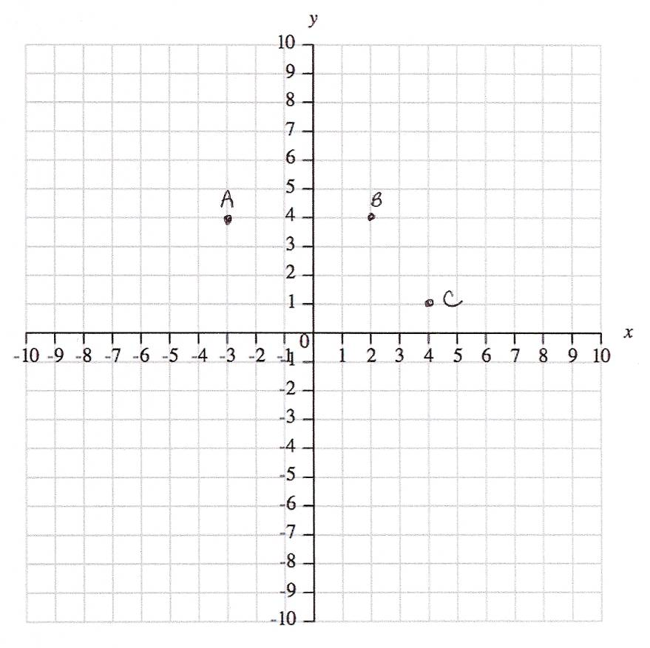

- Decide on a location for vertex D.

- What type of figure is ABCD? How do you know?

- Come up with 3 questions you could ask about Figure ABCD.

- Decide on a new location for vertex D so that a different geometric figure is formed. What type of figure is ABCD now? How do you know?

- Can you ask the same questions as in Question 3 above? If so, why? If not, why not?

- Come up with at least 1 question you could now ask about your new Figure ABCD.

Protocol for
Looking at Student Work

- Read the task and discuss what it is assessing.

- Solve the problem individually

- Share your thinking with a partner

- Discuss the mathematics of the task as a whole
group

- Look at how students solved the same task

- Identify evidence of the Standards of
Mathematical Practice exhibited in the student
work

- Discuss evidence of the Standards of
Mathematical Practice exhibited in the student
work as a whole group

Based on the Mathematics Learning Community (MLC) Protocol for LASW,
© 2011 Commonwealth of Massachusetts [Department of Elementary and Secondary Education

Mathematical Task
Triangle ABC

Solve this problem in the space provided below. Show and explain all of your work.

On the coordinate grid, sketch the triangle with these three vertices:

A(-2, -5), B(2,3), and C(4, -3)

Use your sketch to answer the following questions:

- Is this a right triangle? Explain mathematically how you know the answer to this question.
- Find the coordinates of the midpoint of the longest side of this triangle and prove that it is equidistant from each of the triangle’s vertices.
- Write the equation for a circle that will go through all three vertices of the triangle and verify that the coordinates of the vertices satisfy this equation.
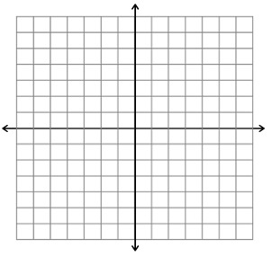
Student Work Analysis
Problem: Triangle ABC Grade Level: HS Geometry

Student A
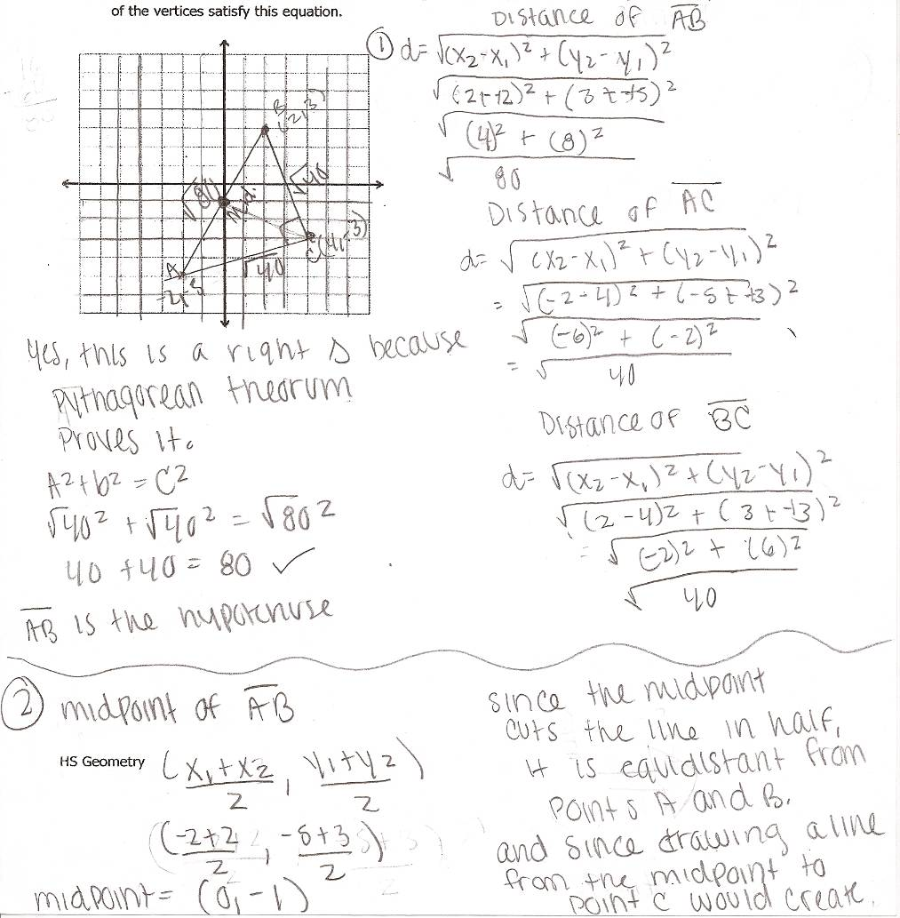
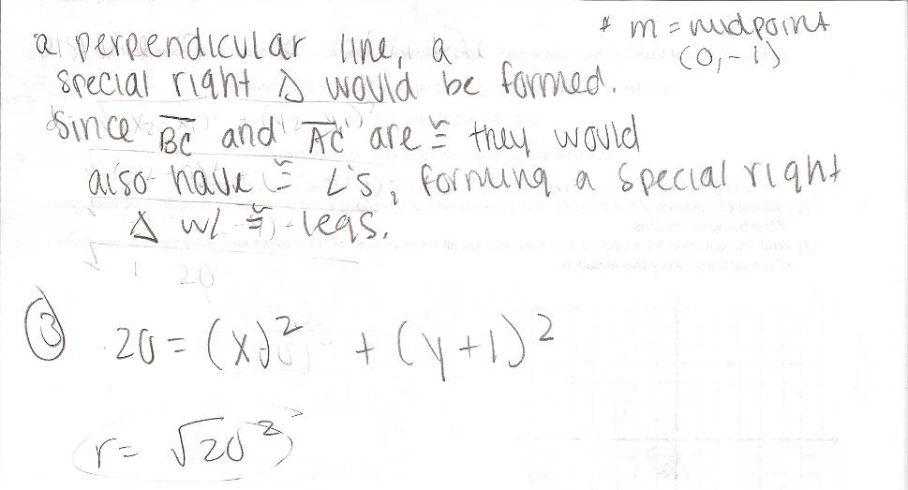

Student Work Analysis
Problem: Triangle ABC Grade Level: HS Geometry
Student B
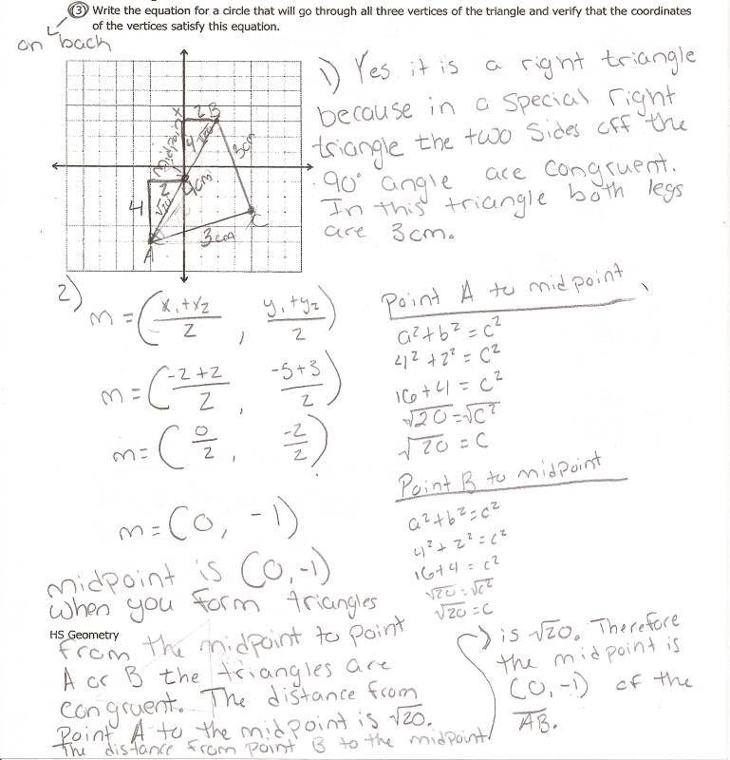
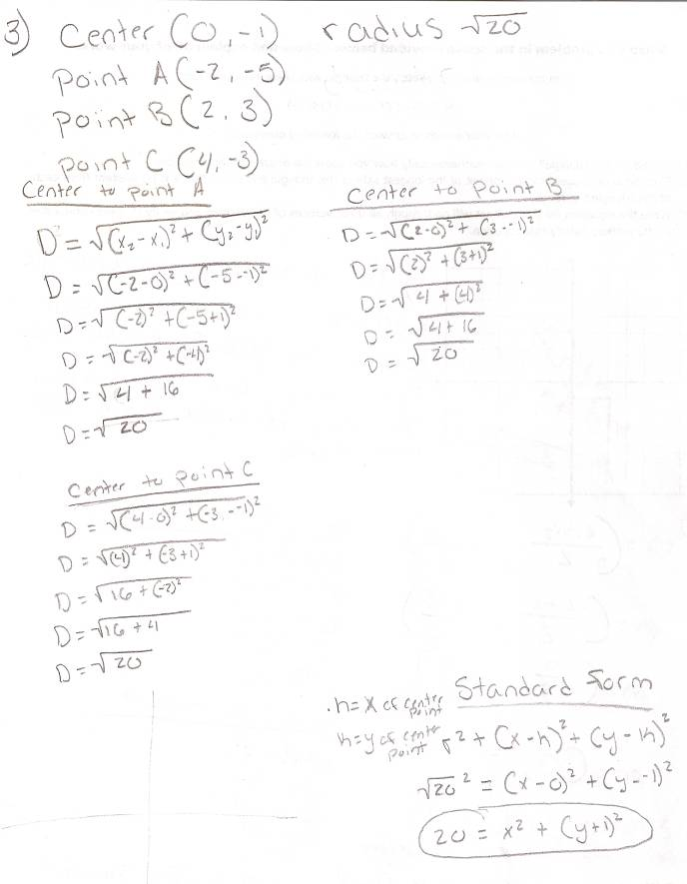
Student Work Analysis
Problem: Triangle ABC Grade Level: HS Geometry

Student C
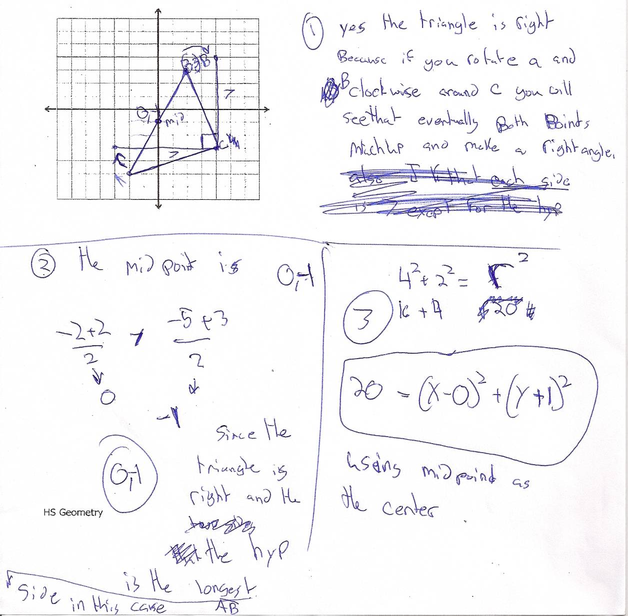

Student Work Analysis
Problem: Triangle ABC Grade Level: HS Geometry

Student D
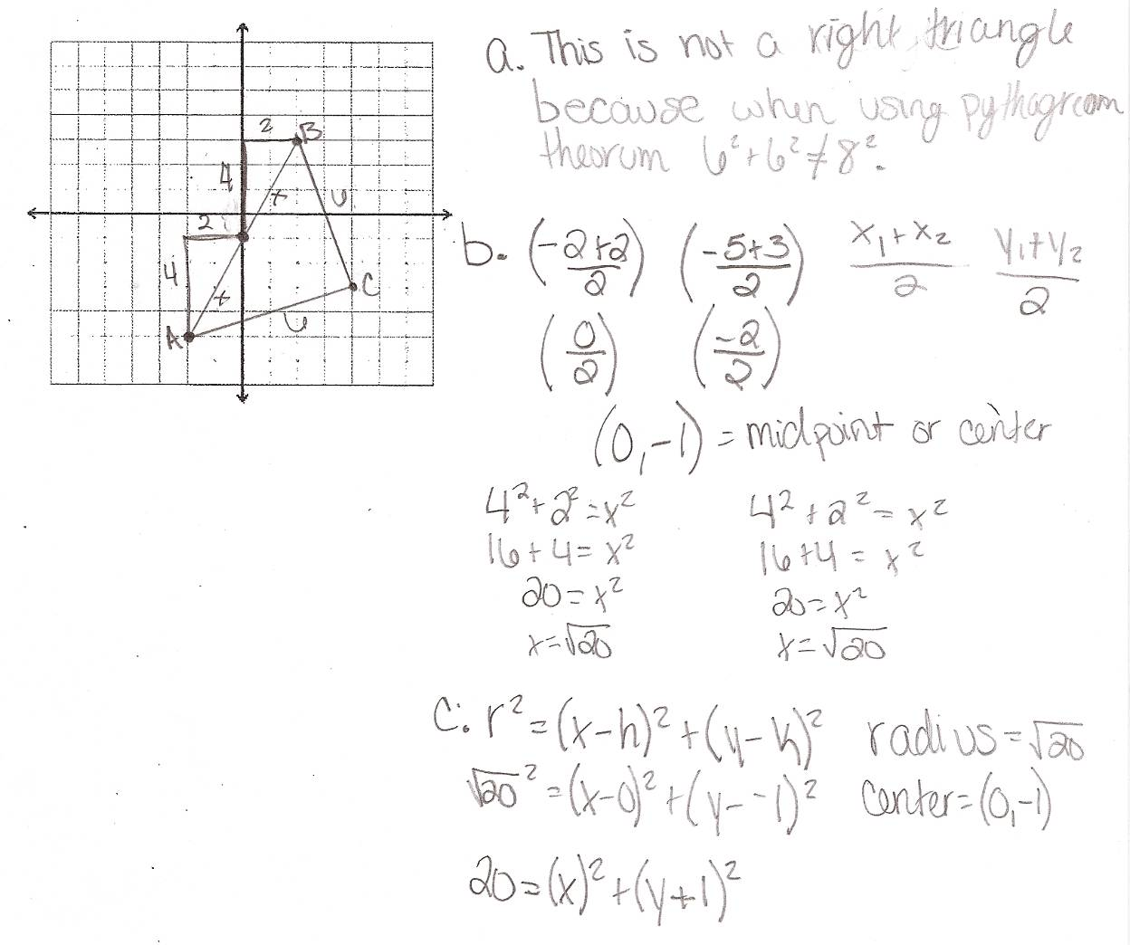

Student Work Analysis
Problem: Triangle ABC Grade Level: HS Geometry

Student E
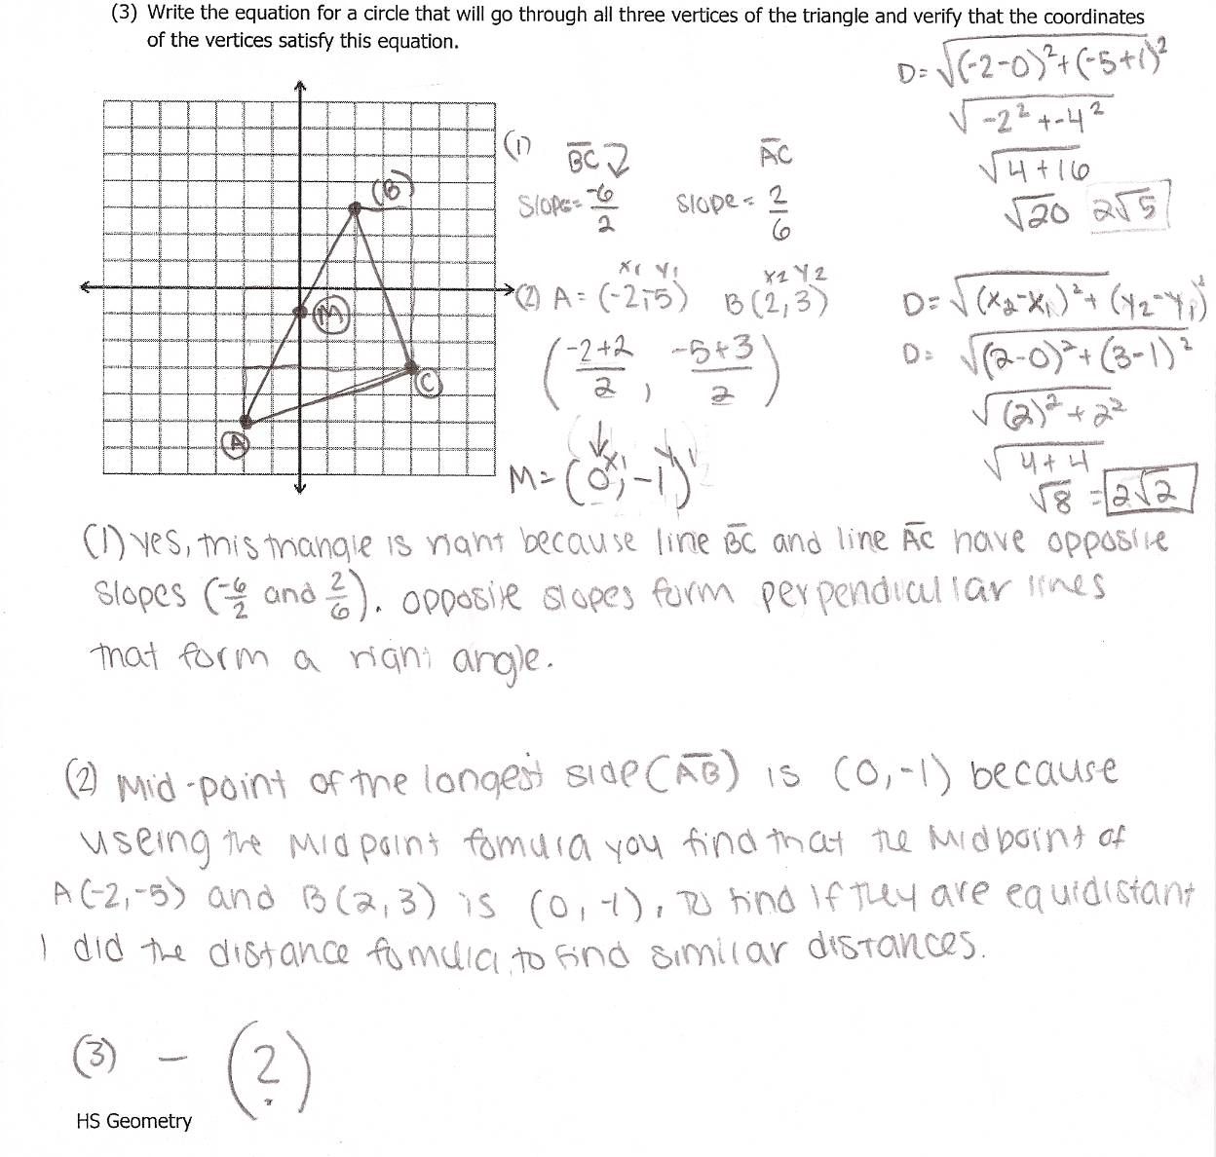

Student Work Analysis for: Triangle ABC

Student | MP 2: Reason abstract.  MP 3: Critique Reason. | MP 5: Use tools  MP 6: Precision | MP 7: Structure  MP 8: Repeated Reason. | What comes next in instruction for this student?
A
B

C

D

E

Unpacking the Rigor
Comparing Different Versions of the Triangle ABC Mathematical Task
Task | Level of Rigor
On the coordinate grid, sketch the triangle with these three vertices:

A(-2, -5), B(2,3), and C(4, -3)

Using the Pythagorean Theorem, explain how ABC is a right triangle.

On the coordinate grid, sketch the triangle with these three vertices:

A(-2, -5), B(2,3), and C(4, -3)

- Using the Pythagorean Theorem, explain how ABC is a right triangle.
- Using the midpoint formula, identify the midpoint of AB.
- Using the distance formula, show that this midpoint is equidistant from points A, B, and C.

Solve this problem in the space provided below. Show and explain all of your work.
On the coordinate grid, sketch the triangle with these three vertices:
A(-2, -5), B(2,3), and C(4, -3)

Use your sketch to answer the following questions:

- Is this a right triangle? Explain mathematically how you know the answer to this question.
- Find the coordinates of the midpoint of the longest side of this triangle and prove that it is equidistant from each of the triangle’s vertices.
- Write the equation for a circle that will go through all three vertices of the triangle and verify that the coordinates of the vertices satisfy this equation.

