Classroom Connections
Examining the Intersection of the Standards for Mathematical Content
and the Standards for Mathematical Practice

Title: Making Sense of “Invert and Multiply”

Common Core State Standard Addressed in the Student Work Task:
6.NS.1 | Interpret and compute quotients of fractions, and solve word problems involving division of fractions by fractions, e.g., by using visual fraction models and equations to represent the problem.

Evidence of Standards for Mathematical Practice in the Student Work:
1: Make sense of problems and persevere in solving them.
2: Reason abstractly and quantitatively.
3: Construct viable arguments and critique the reasoning of others.
5: Use appropriate tools strategically.
6: Attend to precision.
7: Look for and make use of structure.

Task Components:
Part I: Mathematical Background (Page 2)
- Today’s Content

Part II: Math Metacognition (Page 3)

Part III: Unpacking the Rigor of the Mathematical Task (Pages 4)

Part IV: Looking at Student Work (Page 5)
- Paint Containers Task (Grade 6)
- Protocol for LASW

Part V: Vertical Content Alignment (Page 6)
- Charting Coherence through Mathematical Progressions
- Writing a Grade – Level Problem or Task

Part VI: Wrap – up (Page 7)

Handouts Included:
- Math Metacognition [Set 1]:Page 8
- Math Metacognition [Set 2]:Page 9
- Protocol for LASW: Page 10
- Mathematical Task - Paint containers: Page 11
- Student Work Samples: Pages 12 – 15
- Student Work Analysis Grid: Page 16
- Unpacking the Rigor: Page 17

Part I: Mathematical Background
Approximate Time: 10 minutes
Grouping Structure: Whole Group

- Today’s Content:
  - The mathematics during this session focuses on division of fractions. In particular, we consider how the quotient of a whole number and a non-unit fraction can be the same as the product of the same whole number and the fraction’s reciprocal. The student work task involves interpreting a student’s visual model of this process.

  - What do we need to know about:
    - the relationship between multiplication and division of whole numbers
    - the area model for multiplication
    - Reciprocals of fractions
    - Multiplication of a whole number by a mixed number
    - Interpreting remainders in division contexts, including fractional remainders (portions of portions)
before we can truly understand and perform division of fractions accurately and efficiently?

  - Chart ideas to refer to during the Protocol for LASW.

Part II: Math Metacognition
Approximate Time: 30 minutes
Grouping: Whole Group

- Problem: This problem is a way to get us thinking about the mathematics that we will be examining later on in the session during the LASW section. Give half of the group Problem Set 1 to solve and the other half, Set 2. They should solve the problems MENTALLY – no paper or pencil. Once they think about each problem mentally, they can record their thought process on paper. If time allows, have them do a visual for each problem to represent their thinking in another way.
Set 1  Page 9 | Set 2  Page 10
3 ÷ 3 = ? | 3 x $\frac{1}{3}$ = ?
3 ÷ 2 = ? | 3 x $\frac{1}{2}$ = ?
3 ÷ 1 = ? | 3 x 1 = ?
3 ÷ $\frac{2}{3}$ = ? | 3 x 1 ½ = ?
3 ÷ $\frac{1}{3}$ = ? | 3 x 3 = ?

- Solutions: 1, 1 ½ or $\frac{3}{2}$, 3, 4 ½ or $\frac{9}{2}$, 9

- Problem Intent:
  - Math metacognition allows teachers the opportunity to think about their own mathematical thinking in a more natural way that often makes use of more reasoning and helps to develop a better sense of number.
  - This particular exercise is designed to get teachers thinking about the relationship between dividend and divisor in a division problem and between two factors in a multiplication problem.
  - In addition, we also want teachers to consider how a division and multiplication problem can be related to one another and how we can use the inverse nature of the two operations to help us problem solve and make sense of real-life problems.

- Bring discussion back to the topics at hand.
  - In what order did you work through these problems?
  - What thought process did you use? What models and/or contexts helped you to reason through these problems?
  - Would your strategy or method change if the numbers were different? (i.e., to 7 ÷ $\frac{4}{9}$ )
  - How are these problem sets related? How are division and multiplication related?
  - What implications does this have on our work with division of fractions?
  - How can metacognition help promote successful problem solving with your own students?
Part III: Unpacking the Rigor of the Mathematical Task
Approximate Time: 30 minutes
Grouping: Whole Group

- Comparing Different Versions of the Mathematical Task: Let’s compare the rigor of two related problems to the Paint Containers task. The level of rigor is based on which of the Standards for Mathematical Practice we could expect to see when examining the student solutions. Pass out the “Unpacking the Rigor” handout (see Page 18).

- In addition to the Mathematical Practices, consider discussing the following with your group as you compare the variations above:
  - Cognitive demand
  - Task accessibility to a variety of learners
  - Real-life applications and math connections
  - Assessment of student learning

- If time allows, you can use a Venn Diagram to compare and contrast the elements of each version of the task.

Part IV: Looking at Student Work (LASW)
Approximate Time: 50 minutes
Grouping: Refer to protocol

- Mathematical Task Introduction: The problem and student work used for this session are from Grade 6. Complete the Protocol for LASW (see Page 11) with the group.

- Paint Containers Task:

John is painting trim on houses this summer and purchased a large 4 gallon drum of paint. To make his job easier, John purchased special containers that hold $\frac{3}{7}$ gallon of paint. John is trying to figure out how many containers he will need if he uses all of his paint. John drew the following model to figure out his problem.
Explain John’s model and why it will work to figure out his problem.

- Solution: John’s model shows 1gallon of paint (large rectangle) that he then subdivided into sevenths. He then grouped 3 of these sevenths to count how many $\frac{3}{7}$ gallon-containers could be filled in one gallon. He noted that there are 2 $\frac{1}{3}$ of the $\frac{3}{7}$ gallon-containers in 1 gallon, so he would need to multiply 2 $\frac{1}{3}$ by 4 to determine how many could be filled by the entire 4 gallon drum. This would result in the solution of 9 $\frac{1}{3}$ containers. He would therefore need 10 containers, 9 of which would be full and 1 of which would be $\frac{1}{3}$ full.

- Task Intent and Instructional Purpose:
  - The intent of this task is for students to reason through a real-life context in which it makes sense to consider the relationship between multiplication and division in order to solve a problem. A visual model can be used to help recognize that two different, yet connected numerical expressions lead to the same result: 4 ÷ $\frac{3}{7}$ and 4 x 2 $\frac{1}{3}$ [or 4 x $\frac{7}{3}$]

Part V: Vertical Content Alignment
Approximate Time: 25 Minutes
Grouping: Partners or Small Groups

- Charting Coherence through Mathematical Progressions in the Standards for Mathematical Content

  - The content standard for this task is 6.NS.1. It is important that the group analyzes this standard with respect to standards in K – 5 and beyond Grade 6 in order to identify where along the continuum of learning it falls.

  - Beginning, Middle, End: Using the Standards for Mathematical Content, trace the progression of the concepts involved in this task from K – 8. See separate handout for an example of this progression.

- Writing a Problem or a Task: As a way to synthesize learning from today’s discussion, ask teachers to come up with a math problem or task that would embody the ideas discussed today. The problem should be appropriate to use at a particular grade level. Writing these problems will help both you as the facilitator and the other group members develop a stronger sense of how these mathematical ideas show up in classrooms from grades K – 8.
  - Consider having teachers work in pairs to write these problems. Be sure to have a wide variety of grade levels represented in the problems. This practice is an especially powerful means to identify vertical connections in content. Use the standards identified in Part A: Charting Coherence. Each pair of teachers should select a standard from this progression to be used as a basis for their written task.
  - Have teachers write their problem to share with the whole group. Be sure to ask them to include the appropriate learning standard(s) and Standard(s) for Mathematical Practice to which the problem is written. In this way, teachers are asked to articulate the types of content and practices with which students would be involved as a way to truly see how the work done here can have an impact on classroom practice, regardless of grade level.
  - What do you notice about the problems presented?

Part VI: Feedback & Wrap-up
Approximate Time: 5 Minutes
Grouping: Individual

- Closing: Close your time together by facilitating a discussion around how the LASW process will impact what teachers do within their own classrooms. Some questions to help guide discussion include:
  - What do we take away after LASW?
  - What did we learn? About student thinking? About our own knowledge?
    - Refer back to chart made at the beginning of the discussion during Part I: Mathematical Background.
  - How does it impact your practice at your grade level?

- Exit Cards: Pass out exit cards for the group and ask them to provide some feedback to you as the facilitator. Select one or two questions from the list below to help them summarize their thinking about the mathematics from today’s session. Collect exit cards so that a summary can be shared the next time you meet.

Exit Card Questions

- How does the mathematics that we explored connect to your own teaching?

- How do the mathematical practices that we explored connect to your own teaching?

- What idea or topic did you find most interesting from today’s discussion? Why?

- How was this discussion for you as a learner?

- What ideas were highlighted for you in today’s discussion that you had not previously considered?

- What are you taking away from today’s work?

Math Metacognition

3 ÷ 3 = ?
3 ÷ 2 = ?
3 ÷ 1 = ?
3 ÷ $\frac{2}{3}$ = ?
3 ÷ $\frac{1}{3}$ = ?

Math Metacognition

3 x $\frac{1}{3}$ = ?
3 x $\frac{1}{2}$ = ?
3 x 1 = ?
3 x 1 ½ = ?
3 x 3 = ?

Protocol for
Looking at Student Work

- Read the task and discuss what it is assessing.

- Solve the problem individually

- Share your thinking with a partner

- Discuss the mathematics of the task as a whole
group

- Look at how students solved the same task

- Identify evidence of the Standards of
Mathematical Practice exhibited in the student
work

- Discuss evidence of the Standards of
Mathematical Practice exhibited in the student
work as a whole group

Based on the Mathematics Learning Community (MLC) Protocol for LASW,
© 2011 Commonwealth of Massachusetts [Department of Elementary and Secondary Education]

Mathematical Task
Paint Containers

John is painting trim on houses this summer and purchased a large 4 gallon drum of paint. To make his job easier, John purchased special containers that hold $\frac{3}{7}$ gallon of paint. John is trying to figure out how many containers he will need if he uses all of his paint. John drew the following model to figure out his problem.

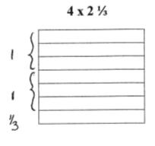

Explain John’s model and why it will work to figure out his problem
Student Work Analysis
Problem: Paint Containers Grade Level: 6

Student A
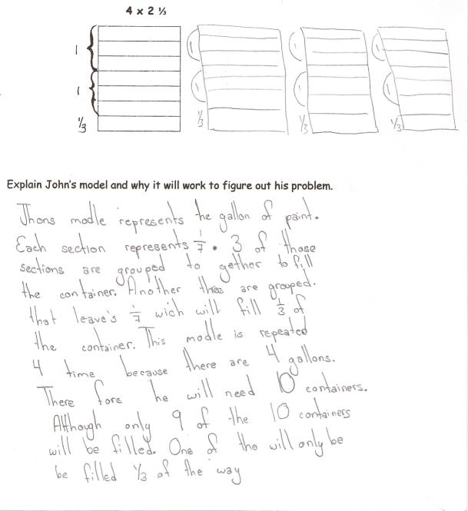

Student Work Analysis
Problem: Paint Containers Grade Level: 6

Student B
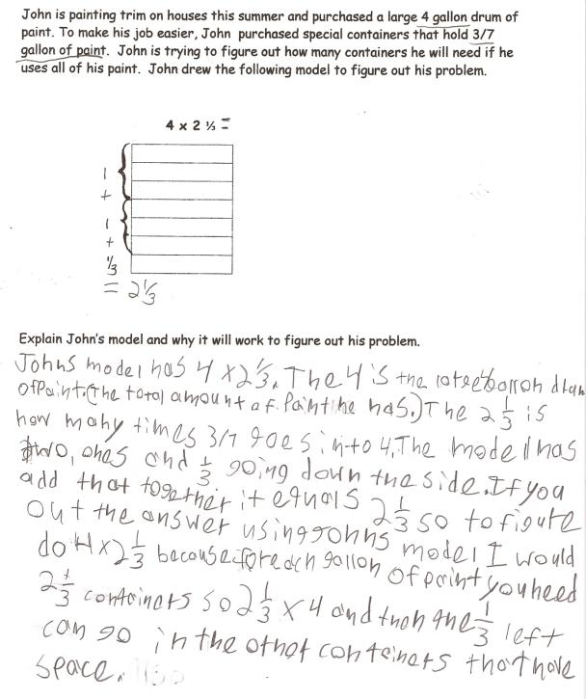
Student Work Analysis
Problem: Paint Containers Grade Level: 6

Student C
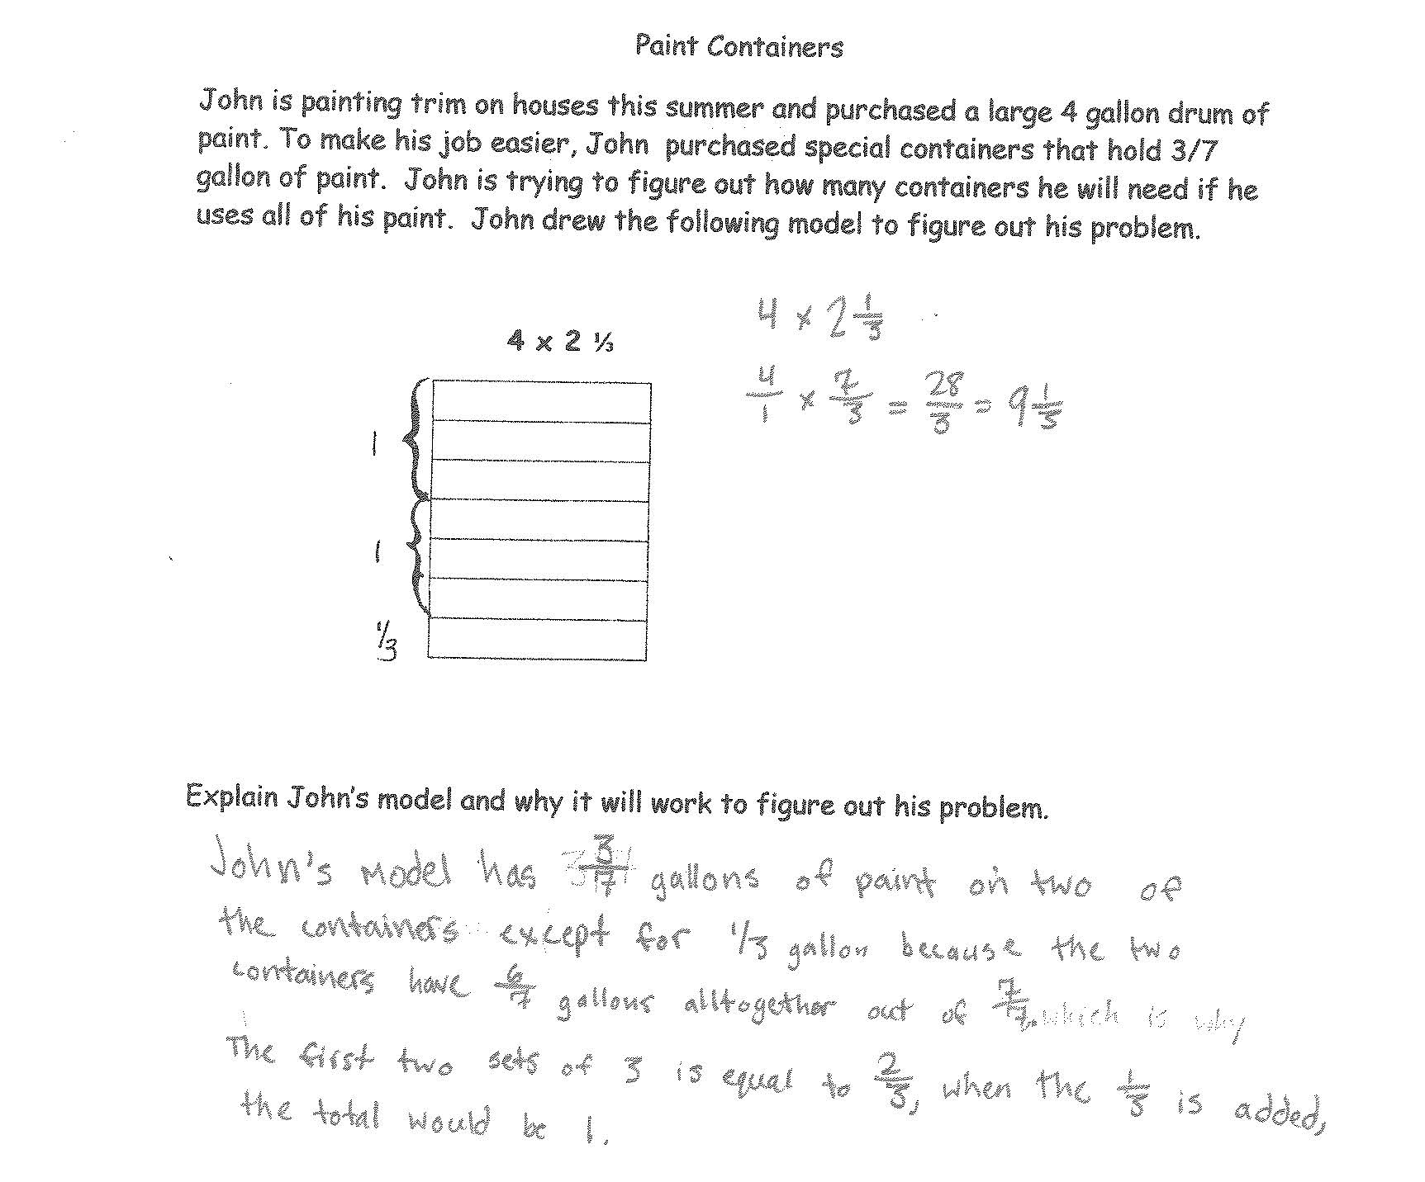

Student Work Analysis
Problem: Paint Containers Grade Level: 6

Student D
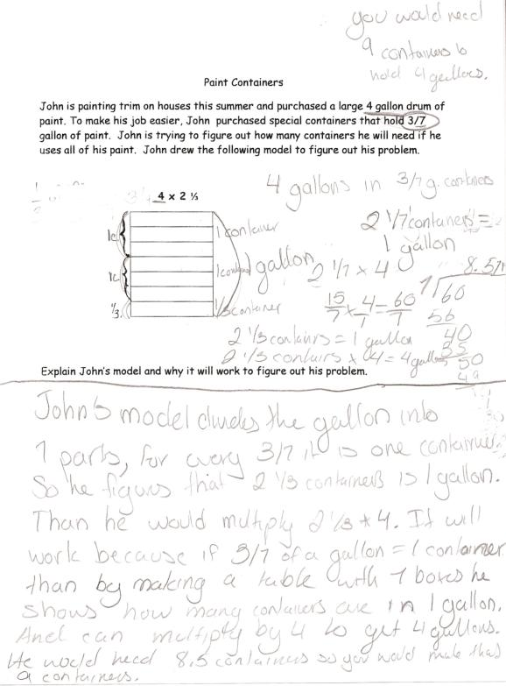
Student Work Analysis for: Paint Containers

Student | MP 1:Problem Solving  MP 6: Precision | MP 2: Reason Abstractly  MP 3: Critique Reasoning | MP 7: Look for /make use of structure | What comes next in instruction for this student?
A
B

C

D

Unpacking the Rigor
Comparing Different Versions of the Paint Containers Mathematical Task
Task | Level of Rigor
Find the quotient:
$$4÷\frac{3}{7}$$

John is painting trim on houses this summer and purchased a large 4 gallon drum of paint. To make his job easier, John purchased special containers that hold 3/7 gallon of paint. How many containers of paint will John need if he uses all of his paint?

John is painting trim on houses this summer and purchased a large 4 gallon drum of paint. To make his job easier, John purchased special containers that hold $\frac{3}{7}$ gallon of paint. John is trying to figure out how many containers he will need if he uses all of his paint. John drew the following model to figure out his problem.
Explain John’s model and why it will work to figure out his problem.

