**LASW Problem**

I baked a rectangular sheet cake for a party.

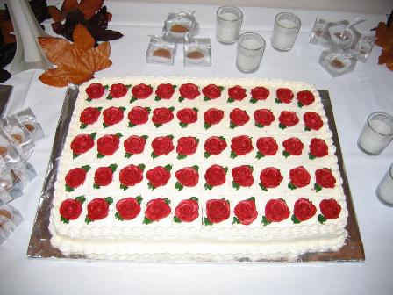

of the cake was left after the party. Draw and label how much of the cake was left.

My son came to visit and ate  of the remaining cake. Draw and label how much of the remaining cake he ate.

What portion of the whole cake did he eat?