Mathematics Learning Community

Number Sense
Session 1

Title: Getting Started with the MLC

Common Core State Standards Addressed in the LASW Problem:
6.NS.4 | Find the greatest common factor of two whole numbers less than or equal to 100 and the least common multiple of two whole numbers less than or equal to 12. Use the distributive property to express a sum of two whole numbers 1–100 with a common factor as a multiple of a sum of two whole numbers with no common factor.

Standards for Mathematical Practice Addressed in the MLC Session:
5: Use appropriate tools strategically. 7: Look for and make use of structure.

Students use a calendar to reason about a problem involving a repetitive pattern of chores done within in a given month. The structure of the pattern can be represented in various forms. To allow for thorough participation from all MLC members during this first session, this LASW math task was chosen because students, and teachers alike, can attack it from various angles. As a result, there are many different connections that can be made amongst seemingly unrelated strategies or solutions.

Standards-Based Teaching and Learning Characteristics in Mathematics Addressed:
- 5.1 Depth of content knowledge is evident throughout the presentation of the lesson.
- 5.2 Through the use of probing questions and student responses, decisions are made about what direction to take, what to emphasize, and what to extend in order to build students’ mathematical understanding.
- 5.3 Students’ prior knowledge is incorporated as new mathematical concepts are introduced.
- 5.4 Student misconceptions are anticipated /identified and addressed.

Session Agenda:
Part I: What is the MLC?
  - Welcome
  - Description of the MLC
    - Formative Task
  - Goals
  - Mathematical Theme of the MLC
  - Group Introductions (if necessary)
Part II: Setting Norms
Part III: Looking at Student Work
  - Lisa Has 3 Jobs Problem (Grade 6)
Part IV: Our Learning
Part V: Feedback and Wrap-up

Materials Needed for this Session:
- Nametags | - Chart paper and markers | - Copies of handouts
- Index cards | - Refreshments | - Highlighters

Possible Ways to Personalize this Session:
- Group introductions are optional, depending upon the make-up of your MLC.
- You may need less time to discuss and decide upon Group Norms if your group has worked together in the past.
- If time is short at the end of the session, have group members take their Exit Card “to go” and drop it off later in your mailbox.
Part I: What is the MLC?
Approximate Time: 25 minutes
Grouping: Whole Group

- Welcome the members of your group to the Mathematics Learning Community (MLC).

- Describe the MLC:
  - At this point in time, your colleagues may be wondering what the purpose of the MLC is, what it will look like, and how it will impact their own teaching. The purpose of the MLC is to provide you and the other MLC members an opportunity to work together in order to relate important mathematical content and pedagogy to classroom practice. The focus of the MLC is understanding student thinking. This is accomplished by examining key mathematical ideas through the lens of student work in a collegial setting.
  - As a facilitator, describe how important it is to use formative assessment. Just as it is important with students in the classroom, so too is it important in your work together as an MLC. It is important for you as the facilitator to learn what each of your group members knows about examining student work. Since time is a valuable commodity, you should want and need your time during the MLC sessions to be as focused and on-task as possible. To that end, you will be asking your group members to complete a student work analysis formative task on their own time and to return it to you by the next scheduled session. (Refer to pages 19 – 20 for the task).
  - It is up to you as the facilitator whether or not your group should record their actual names or record code names on the task. However, it is important to have one form of a name (real or code) used so that the pre- and the post-task can be matched up.
  - Discuss schedule of sessions (i.e., ten 2-hour sessions) and give members the schedule of meeting times, logistical information, etc.

- Goals: The work of the MLC focuses on two things: a) our own mathematical thinking and knowledge and b) our knowledge of students’ mathematical thinking and understanding. With mathematical thinking as the focus, participation in this collaborative learning community looking at student work will shape our classroom practice for the better. The more we begin to think about student understanding together, the more reflective and intentional we become in what we are doing on a daily basis. We then will really be able to pinpoint those areas where students struggle most. The MLC goals are:
  - To understand mathematical content in a deeper, more conceptual way
  - To form a collaborative learning community that focuses on student thinking
  - To reflect on our classroom practice
  - To closely examine student work in order to identify evidence of student understanding.

- Mathematical Theme for the MLC:
  - A mathematical theme involving the three C’s – Counting, Composition, and Context will tie all of the MLC content together. Student work samples that will be examined during MLC sessions will vary in grade level, but all content will be connected to each of three grade bands: K – 2, 3 – 5, and 6 – 8.
  - Mathematical Background – (Refer to research abstract on pages 10- 12).
  - Discussion questions:
    - What foundational knowledge is needed to understand these ideas?
    - What do we need to know? For example, with counting - Where do you start? Where do you stop? What do you count?
  - Chart ideas to refer to during future sessions.

- Group Introductions (if necessary)
Part II: Setting Norms
Approximate Time: 25 minutes
Grouping: Whole Group

- Brainstorm Norms: Before beginning the session, you need to discuss how you are going to work as a group. Call it "developing norms" for group interaction.
  - Offer up one example of a norm: Starting and ending on time.
  - Take suggestions/ideas from MLC members. Record brainstormed ideas on chart paper.

- Select Norms: Have members pick out three or four norms that will structure your MLC's work.
  - Record the norms on a piece of chart paper and hang the chart in a visible location during each MLC session.

Math Learning Community
Sample Norms

- Time is valuable! Start and end sessions on time.

- Question out of genuine curiosity.

- Questions should push the level of our own math understanding.

- Listen actively to one another’s thinking.

- Mistakes and errors are important! They give us a chance to re-conceptualize a problem, explore contradictions, and consider alternative strategies.

- We should spend time working as individuals and collaboratively as a team.

Part III: Looking at Student Work (LASW)
Approximate Time: 50 minutes
Grouping: Refer to protocol

- Discuss with the group that for all future sessions of the MLC, there will be opportunities to work on mathematics in two ways:
  - Math Metacognition – problems that group members will work on individually and then discuss their thinking process, strategies, and solutions as a group. (Note: There is no Math Metacognition problem for Session 1 as the time has been allotted to developing group norms).
  - Examining Student Work – math problems with student work samples. Group members will examine the problem and then analyze the student work in order to identify evidence of student understanding.

- Present the Reasons for Examining Student Work (Refer to page 8 for a handout.) to the group.
  - Present these reasons to the MLC members.
  - Remind members that the group’s focus will be looking at student work so as to better understand student thinking.
  - Explain that this part of each session will be facilitated using the protocol (see below).
  - In order to be objective, student work will be provided for the first 6 sessions. As the MLC develops over time, there will be opportunities for group members to bring in student work samples for the MLC to examine, beginning in Session 7.

- Share the MLC Protocol for Looking at Student Work (Refer to page 9 for a handout.) with the group. Explain that this will be the process that the MLC uses to explore and discuss the mathematics.

MLC Protocol for Looking at Student Work

- Read the problem and discuss what it is assessing.

- Solve the problem individually.

- Share your thinking with a partner.

- Discuss the mathematics of the problem as a whole group.

- Look at how students solved the same problem.

- Identify evidence of understanding by using guiding questions.

- Discuss evidence of student understanding as a whole group.

- Problem Introduction: The source of the problem used for this session is the stem of a multiple-choice MA DESE Released Test Item from the 2003 Grade 6 MCAS. Student work samples are from Grade 6.

Part III: Looking at Student Work (LASW), continued

Lisa has 3 Jobs Problem:
Lisa has three jobs: walking the family dog, washing the dishes, and vacuuming.
- She walks the family dog once every 3 days.
- She washes the dishes once every 4 days.
- She vacuums once every 6 days.
The calendar below shows that Lisa did all three jobs on Monday the 2nd.
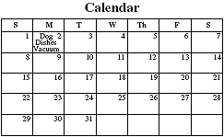
On which day will Lisa again do all three jobs on the same day?

- Follow the MLC Protocol for Looking at Student Work for this exploration. Record findings on chart paper.

- Problem Solution: Saturday, the 14th

- Problem Intent: This problem was chosen for two reasons:
  - As the first problem to be examined by the group using the MLC Protocol, we wanted to have a problem that was accessible to all group members (including both early elementary and middle school), yet was open enough to allow for multiple ways to arrive at a solution.
  - The problem raises important ideas from the Three C’s Theme:
    - How do students count or use counting to problem solve?
    - Then, the question becomes if students are simply counting, what is it that we can begin to put in place to move them forward?
    - What does this tell us about the connections that students are making or not making?

- Strategies You Might See:
  - A counting strategy: If Lisa starts on the 2nd and walks every 3 days, what number does she land on? If she’s counting in increments of 3, what numbers does she land on? For 4? For 6?
  - A more sophisticated strategy: Find the least common multiple (LCM) of 3, 4, and 6, which is 12. Since Lisa started on the 2nd day of the month, add 2 to the LCM, which results in the 14th.

- Misconceptions & Questions That May Arise:
  - Q: A student may mix up the terms ‘factor’ and ‘multiple.’ What is this telling you about his/her thinking?
  - Q: Does the student understand where to start and where to stop counting?
  - Q: Does the student make connections between common multiples and counting strategies?

Part IV: Our Learning
Approximate Time: 15 Minutes
Grouping: Whole Group

- Discussion: After the evidence of student understanding has been discussed as a whole group, you want to facilitate discussion around how the LASW process will impact what teachers do within their classrooms. Some questions to help guide discussion include:
  - What do we take away after LASW?
  - What did we learn? About student thinking? About our own knowledge?
  - How does today’s session relate to important mathematical content and pedagogy?
  - How does the student work from today’s session relate to the Three C’s Theme (counting, composition, and context)?
  - How does it impact your practice at your grade level? (Note: In order to help teachers connect this session to the mathematics within their own grade level, refer to the information below).

Making Connections Across the Grade Levels

K – 2: The problem selected for LASW can be solved using a skip counting strategy, which develops at this age level. (K.CC.3, 2.NBT.2, 2.OA.3) In addition, the use of a calendar as a tool is also developed (MA.2.MD.7a).

3 – 5: During this time, students begin to learn how to identify the classes to which a number belongs (i.e., odd, prime, etc.). In addition, they explore both factors and multiples of a given number (4.OA.4). This is the foundation for the second, more advanced strategy that can be used to solve the LASW problem.

6 – 8: The LASW problem is a Grade 6 MCAS Released Test Item and specifically addresses 6.NS.4.

- Writing a Problem or a Task: As a way to synthesize learning from today’s session, ask MLC members to come up with a math problem or task that would embody the ideas discussed today. The problem should be appropriate to use at a particular grade level. Writing these problems will help both you as the facilitator and the other group members develop a stronger sense of how these mathematical ideas show up in classrooms from grades K – 8.
  - Consider having group members work in pairs to write these problems. Be sure to have a wide variety of grade levels represented in the problems. This practice is an especially powerful means to identify vertical connections in content. If your MLC is a horizontal group, discuss how to best approach this with your group members.
  - Be sure to as MLC members to include the appropriate learning standard(s) and Standard(s) for Mathematical Practice to which the problem is written. In this way, MLC members are asked to articulate the types of content and practices with which students would be involved as a way to truly see how the work done in the MLC can have an impact on classroom practice, regardless of grade level.
  - Have MLC members record the problems on chart paper, transparencies, or the like, to present to the MLC.
  - What do you notice about the problems presented?

Part V: Feedback and Wrap-up
Approximate Time: 5 Minutes
Grouping: Individual

- Closing: Close the session with a message such as: “Hope you leave here with more questions – about student thinking, about your teaching, and ways that we as a group can help support one another.” Have MLC members keep in mind the following: Dialogue, Reflection, and Inquiry are the keys to successful learning.

- Exit Cards: Pass out exit cards for group members and ask them to provide some feedback to you as the facilitator. Select one or two questions from the list below to help them summarize their thinking about the mathematics from today’s session. Collect exit cards so that a summary can be shared at the next session.

Feedback / Exit Card Questions

- How does the mathematics that we explored connect to your own teaching?

- How do I see what we’ve done today relate to key mathematical ideas or pedagogical content knowledge?

- What idea or discussion topic did you find most interesting from today’s session. Why?

- How was this session for you as a learner?

- What ideas were highlighted for you in today’s session that you had not previously considered?

- What are you taking away from today’s session?

- Remind group to complete the formative task (see pages 19 - 23) and return it to you by the next session.

Reasons for
Examining Student Work

- Give students a grade

- Design or revise tasks

- Redirect instruction

- Deepen our own understanding of
how students think about mathematics

- Deepen our own understanding of
mathematics

MLC Protocol for
Looking at Student Work

- Read the problem and discuss what it is
assessing

- Solve the problem individually

- Share your thinking with a partner

- Discuss the mathematics of the problem as a
whole group

- Look at how students solved the same
problem

- Identify evidence of understanding by using
guiding questions

- Discuss evidence of student understanding
as a whole group

The Three C’s Theme of the MLC

Facilitator’s Notes

Counting

As adults we consider counting to be a simple mathematical task. In fact, counting is a complex task. What is the foundational knowledge base for counting?
- Knowing where to start
- Knowing where to stop
- What to count
- How to organize and sequence (keeping track)
- Which count is more
- How to represent the count as quantity
- Counting by groups
- Cardinality

These are only a few of the ideas about counting. As young children begin to count, are they in fact beginning to form an understanding of quantity or are they repeating a familiar chant? Young children might count by 2’s or 10’s but do they understand that they are counting groups? When we ask children to count the number of eyes or hands in our classroom what is our mathematical expectation for this activity? As adults we understand the complexity of a two-to-one correspondence. However, to young children this may be no more than a familiar chant. Consider the complex phrase: “one 10 is the same as 10 ones.” What can we begin to understand about the foundational knowledge that students are building from looking at students who group cubes into 10’s but go back and count each individual cube in the group by 1’s?

Another complexity for consideration would be how students understand the difference between the solution of 10 to the number sentence 80 + ___ = 90 and the fact that there are 9 numbers between 80 and 90. How do we listen intently to their thinking and look at their work as a window into their understanding of what to count?

What happens to counting when we consider operations? When we ask students to add or join quantities, are they adding or are they counting? For example, in Session 3, we look at the problem: 18 + __= 72. Students might count up from 18 to 72 or they might add 18 + 2 = 20 and continue adding 10’s and 2 more to get 72. What is it that students need to understand about counting when they consider the operation of addition? Subtraction? Multiplication or division?

Composition

The numbers 1 to 9 are composed entirely of ones. However, the numbers 27 and 127 are composed of not only ones but of units of different values. Working with units of different values layers another level of complexity onto the thinking process.
In order to combine units of different values and to name and/or rename these values, students must understand the quantitative relationship between the units. These ideas are the underlying meaning of our place value system. (Shifter, Bastable, and Russell, Building a System of Tens, 1999)

It is with these understandings that students can move from counting by ones to beginning to think about what it means to decompose number as well as to count by different size groups. Understanding how numbers in problems are related allows students to move with flexibility and fluency in our number system (Russell, 1999). In fact, some researchers believe that through computation and modeling the action in problem situations, students will learn about our place value system. (Carpenter, Fennema, Franke, 1999).

Therefore, what are the implications when students begin to compute? How does this understanding (or lack of it) influence the way that students understand the equal (=) sign? How do they understand decomposing number when they work with the distributive property of multiplication? How do they estimate without understanding the quantitative relationships between the units in our number system?

What do students understand about zero and its place in our number system as they compose and decompose number? Do students understand number composition when they tell us that 5*5 = 25, therefore 5*50 = 250 because they just added zero? Are they seeing quantitative relationships? Do they know this as (5*5)100? In lay language, zero means nothing. However, in mathematics zero has importance in our number system and modifies the meaning of other numbers. These essential understandings act as the foundational velcro on which students build an understanding of the big ideas in mathematics.

Context

Other than school, think of a time when you worked on a mathematics problem out of context? For most of us there are few instances when this has occurred. Language and situations give us a context for our problem solving.

Carpenter, Fennema and Franke (1999), reference the modeling of “actions” in problem situations as bringing meaning to operations and in helping students to represent and discuss connections between the operations in problem solving situations. For example, using the number line as a tool provides a visual context for understanding the action of moving right or left or even in dividing the line into equal groups.

Context for multiplication problems help students visualize the geometric model of multiplication as well as the decomposition of number, the distributive property and binomial multiplication. Outside of context, and the use of base 10 materials and diagrams, how can we support students in understanding decimal operations? (Chapin, Johnson, 2006). For division, context determines how a remainder is expressed and the interpretation of the quotient or the divisor as rate in d = r x t formulas. Without context and representations for the context, do our students understand the ‘invert and multiply’ rule for division of fractions? Do we?

Mathematics should make sense. Students should understand the language of mathematics. Many times, context dictates what we understand, how we understand and if we understand.

What do these concepts look like as they are developed through the grades and as we, move amongst the four operations and into fractions, decimals, and algebra? What can we learn about what students understand by thoughtful examination of their work and by listening intently to their thinking? What can we learn about ourselves and our own understanding by looking at student work?

-Dona T. Apple

References

Carpenter, T., E. Fennema, M. L. Franke, L. Levi, S.B. Empson, 1999, Children’s Mathematics:
Cognitively Guided Instruction. Heinemann: Portsmouth, NH.

Chapin, S., A. Johnson, 2006, Math Matters: Understanding the Math You Teach, Math Solutions
Publications: Sausalito, CA.

Russell, Susan Jo, 1999, Relearning To Teach Arithmetic. TERC, Dale Seymour Publications: Parsippany,
NJ.

Shifter, D., V. Bastable, S.J. Russell, Developing Mathematical Ideas, Number and Operations, Part I:
Building a System of Tens. 1999, Dale Seymour Publications: Parsippany, NJ.

Shifter, D., V. Bastable, S.J. Russell, Developing Mathematical Ideas, Number and Operations, Part II:
Making Meaning for Operations. 1999, Dale Seymour Publications: Parsippany, NJ.

LASW Problem

Lisa has three jobs: walking the family dog, washing the dishes, and vacuuming.
- She walks the family dog once every 3 days.
- She washes the dishes once every 4 days.
- She vacuums once every 6 days.
The calendar below shows that Lisa did all three jobs on Monday the 2nd.

On which day will Lisa again do all three jobs on the same day?
Problem Source: MA DESE Released Test Item, 2003 Grade 6 Mathematics MCAS
Student Work Analysis

Problem: Lisa Has 3 Jobs Grade Level: 6

Student A
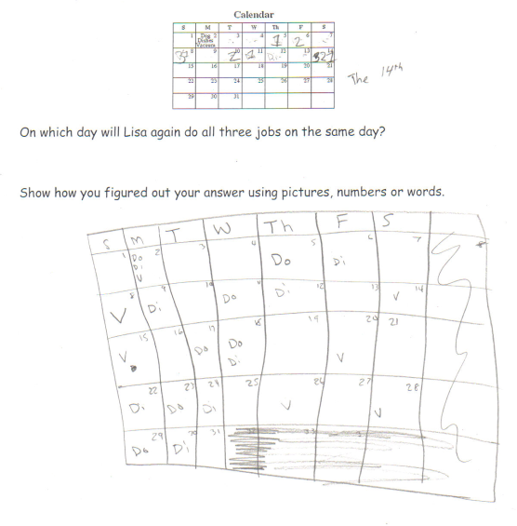

Student Work Analysis

Problem: Lisa Has 3 Jobs Grade Level: 6

Student B
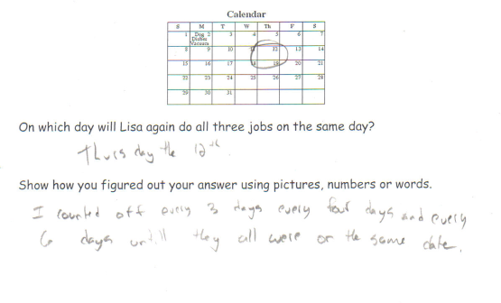

Student Work Analysis

Problem: Lisa Has 3 Jobs Grade Level: 6

Student C
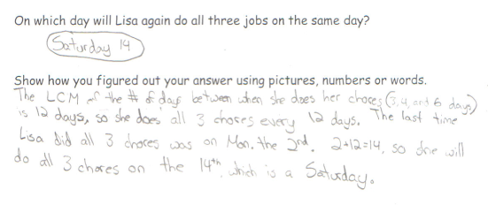
Student Work Analysis

Problem: Lisa Has 3 Jobs Grade Level: 6

Student D
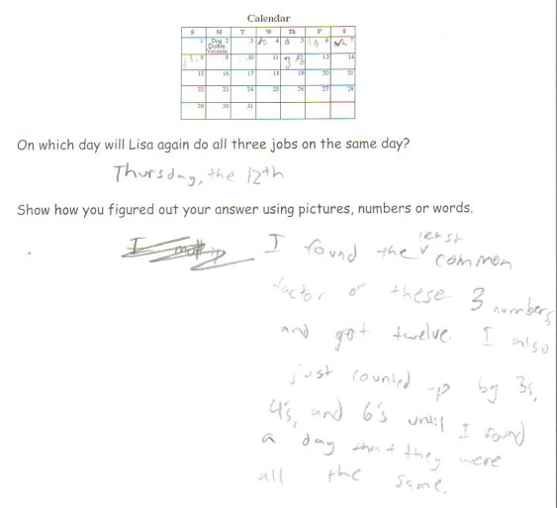

Student Work Analysis for: Lisa has 3 Jobs

Student | What strategy does the student use to arrive at a solution? | What is missing from the student’s strategy? Any misconception or flawed thinking? | What does the student understand based on the evidence? | What question would you want to ask the student to probe understanding and further mathematical thinking?
A
B

C

D

MLC Formative Task: Analyzing Student Work

We are asking you to engage in a formative task around looking at student work. The purpose for this is to give you the opportunity to share your ideas around student work and to inform our learning about you, out of genuine curiosity and also as a way to help us better facilitate our conversations during our time together in the MLC Facilitator Training sessions. In addition, we are modeling this process of formative assessment which can occur back in your own MLC.

Introduction: The problem and student work used in this task are from Grade 2.

Problem:
Write a story problem for this number sentence:
18 + _____ = 72

Your Task: Analyze the two student work samples (A & C) on page 2 and write any comments that come to mind as you examine each student’s written work. Record your comments in the space below.

Student A
Student C
Student A
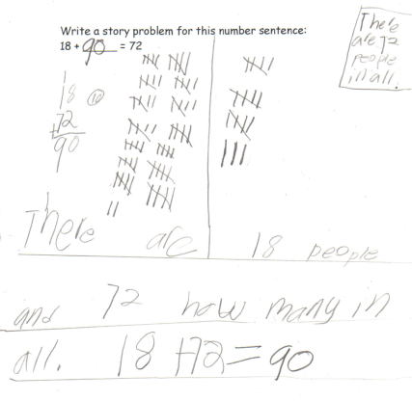

Student C
