Mathematics Learning Community

Number Sense
Session 6

Title: Multiplication Strategies

Common Core State Standards Addressed in the LASW Problem:
4.OA.3 | Solve multi-step word problems posed with whole numbers and having whole-number answers using the four operations, including problems in which remainders must be interpreted. Represent these problems using equations with a letter standing for the unknown quantity. Assess the reasonableness of answers using mental computation and estimation strategies including rounding.

Standards for Mathematical Practice Addressed in the MLC Session:
1: Make sense of problems and persevere in solving them. 6: Attend to precision.

Multiplication is the focus for this session, as mental math strategies emerge during Math Metacogntion and problem solving methods come out during the student work discussion. The LASW problem involves a multi-step word problem in which students must make sense of two sets of data, each with two units to keep track of (days, laps). As a result, students must label their work accurately in order to solve the problem correctly.

Standards-Based Teaching and Learning Characteristics in Mathematics Addressed in the MLC Session:
- 5.1 Depth of content knowledge is evident throughout the presentation of the lesson.
- 5.2 Through the use of probing questions and student responses, decisions are made about what direction to take, what to emphasize, and what to extend in order to build students’ mathematical understanding.
- 5.3 Students’ prior knowledge is incorporated as new mathematical concepts are introduced.
- 5.4 Student misconceptions are anticipated /identified and addressed.
- 5.5 Classroom strategies incorporate multiple forms of representation.

Session Agenda
Part I: Mathematical Background

Part II: Math Metacognition

Part III: Looking at Student Work
- Haley Swims Problem (Grade 4)
Part IV: Our Learning

Part V: Feedback and Wrap-up

Materials Needed for this Session:
- Nametags | - Chart paper and markers | - Copies of handouts
- Index cards | - Refreshments | - Highlighters

Possible Ways to Personalize this Session
- Surfacing group members’ ideas about multiplication may take a bit longer in this session. The ideas that you will want to be listening for will surface as you begin the conversation during Part II. If needed, adjust the times to make this longer and push for staying on task with the remainder of the session. Understanding of content is crucial so you will need the time to go deep here.
- Extend the multiplication strategies discussion to include an examination of the multiplication chart. See Part II for more details.
- If your group is interested in learning more about different multiplication word problem types, refer to Part III for an extension activity using the “Common Multiplication and Division Situations” found on Page 8.
- If time is short at the end of the session, have group members take their Exit Card “to go” and drop it off later in your mailbox.
Part I: Mathematical Background
Approximate Time: 20 minutes
Grouping: Whole Group

- Welcome members of your group to the Math Learning Community.

- Remind group of established norms.

- Today’s Content:
  - The mathematics during this session focuses on multiplication strategies.
  - What do we need to know in order to be able to multiply fluently?
  - Chart ideas to refer to during the Protocol for LASW.

- Relating Content to the Three C’s Theme:
  - How do the ways in which students learn to multiply relate to the ways in which they count?
  - Moving from counting to the other themes, how do the strategies that students use to move into multiplication fluently relate to the ways in which they compose and decompose numbers?
  - What about context for multiplication? As adults, how often do we use multiplication strategies in our daily lives? What about estimation and multiplication?

Part II: Math Metacognition
Approximate Time: 25 minutes
Grouping: Whole Group

- Present the following problem to the MLC:

29 x 4 = ?
- Solution: 116

- Problem Intent: (Note: The problem intent for all Math Metacognition problems is the same). See Session 2 for more information.

- Give a name to each strategy used. Strategies you might see are described on the next page. This part of the discussion will take a shorter time because not as many strategies will emerge as in previous sessions.

- Points for Group Discussion:
  - A tool that can be very helpful in visualizing multiplication is the area model (known also as rectangular arrays). Why are arrays helpful?
    - Again, go back to counting. Use a template of a 5 x 4 array and think about what is being counted: count by 5’s (groups of 4). Now, flip the template over and think about what is now being counted: count by 4’s (groups of 5).
    - How many columns? How many rows? What is in the middle of the rectangle?
    - Do students understand counting strategies (by 2’s, 5’s and 10’s) or are these merely familiar chants?
  - The complexity of multiplication involves the notion that the factors can represent both the number of groups and the number of objects in each group. However, the product (answer) only represents one of those quantities.
  - There is a definite connection between addition and multiplication, however multiplication should not just be thought of as repeated addition. It is important to think about what is being repeated (i.e., the number of objects in each group or the number of groups). If students only consider multiplication as repeated addition, then their understanding of this operation is fragile, especially when students multiply quantities that are no longer whole numbers. For example, if students see the multiplication problem x , how would they go about adding one-sixth seven-eighths times?
  - Higher level mathematics is easier for students who at some point commit their facts to memory. At some point, it becomes cumbersome to add repeatedly.
  - What are the facts that are easier for students to remember? (i.e., 2’s, 3’s, 5’s, 10’s) What are some of the strategies that can help students to make connections between a multiplication chart and the facts? Use 7 x 8 as an example: (5 x 8) + (2 x 8) = 56. Why does this work? Again, consider the area model and decomposition of number.
  - If time allows, use a multiplication chart to:
    - Show square roots
    - Highlight conversations in this session
  - Distributive property-Why is this important? Note: Your group does not need to spend as much time on this topic now as it will be the focus of the mathematics in the next session.

Multiplication Strategies

Counting up or down and then compensating (equivalency)

30 x 4 = 120
1 x 4 = 4
120 – 4 = 116

Halving/Doubling

29 x 2 = 58
58 + 58 = 116

Multiplying by place value

4 x 9 = 36
4 x 20 = 80
36 + 80 = 116

Breaking up one of the numbers into parts that
are easier to multiply

(29 = 25 + 4)
(25 x 4) + (4 x 4)
100 + 16 = 116

(29 = 10 + 10 + 9)
4 (10 + 10 + 9) = (4 x 10) + (4 x 10) + (4 x 9)
40 + 40 + 36 = 116

Part III: Looking at Student Work (LASW)
Approximate Time: 50 minutes
Grouping: Refer to protocol

- Complete the MLC Protocol with the group.

- Problem: The source of the problem used for this session is the stem of a multiple-choice MA DESE Released Test Item from the 2006 Grade 4 MCAS. Student work samples are from Grade 4 students.

Haley swam 22 laps each day for 18 days. Then she swam 25 laps each day for 10 days. What was the total number of laps she swam over the 28 days?

- Solution: 646 laps

- Problem Intent: This problem goes back to how students are composing and decomposing numbers, as well as how students multiply double-digit numbers.
  - Within the composition/decomposition of numbers, do students understand the distributive property? (i.e., adding on groups of things).
  - The problem presents two multiplications - how do students go about finding the combination of the two? Do they do each one individually and combine the totals or do they try to combine quantities as a result of seeing relationships between the numbers? Is that combination correct?

- Strategies you might see include decomposing and repeated addition, along with other strategies described earlier in Part II.

- A description, along with varied examples, of the different types of Multiplication Situations can be found on Page 8. For an extension of this topic, consider having your MLC complete this task:
  - Use the “Common Multiplication and Division Situations” found on page 8 to extend the thinking of this session. (NOTE: This information can be found in Table 2 of the CCSS.) Have MLC members work through the problems presented in one of the following ways:
    - Write a number sentence that models each problem. Act out each problem using manipulatives. Consider both discrete and measurement contexts. How do these problems surface ideas about multiple representations of both multiplication and division?
    - Individually cut out the word problems and try to match each one up to its problem type. Why would knowledge of these problem types be important to know and understand?

- Misconceptions/Questions that May Arise:
  - M: Students remove numbers from a problem and operate blindly on them
  - M: The use of the traditional algorithm masks number sense (i.e., 25 x 10 = 00 + 250)
  - Q: Including labels or units during the process of multiplication could make the operation more explicit for some children. How?
  - Q: How are these samples of student work similar? How are they different? Why does that matter?

Part IV: Our Learning
Approximate Time: 20 Minutes
Grouping: Whole Group

- Discussion: After evidence of student understanding has been discussed as a whole group, you want to facilitate discussion around how the LASW process will impact what teachers do within their classrooms. Some questions to help guide discussion include:
  - What do we take away after LASW?
  - What did we learn? About student thinking? About our own knowledge?
    - Refer back to chart made at the beginning of the session
  - How does today’s session relate to important mathematical content and pedagogy?
  - How does it impact my practice at my grade level? (Note: In order to help teachers connect this session to the mathematics within their own grade level refer to the information below).

Making Connections Across the Grade Levels

K – 2: Work with multiplication naturally follows from addition. As students look for more efficient ways to add, they realize they can add in groups, skip count, and the like. The concept of multiplication develops from these early strategies. (K.CC.1, 1.OA.5, 1.NBT.4, 1.NBT.5, 1.NBT.6, 2.OA.3, 2.OA.4, 2.NBT.2)

3 – 5: The LASW problem is appropriate for Grade 4 to explore and specifically addresses learning standard 4.OA.3. Multiplication as both a concept and a skill are developed during upper elementary school. Students should have varied multiplication experiences (including those where one or both factors are fractions) so that they become fluent and efficient in their thinking and computation. (3.OA.1, 3.OA.3, 3.OA.4, 3.OA.5, 3.OA.7, 3.OA.8, 3.NBT.3, 4.OA.1, 4.OA.2, 4.OA.4, 4.NBT.5. MA.4.NBT.5a, 4.NF.4 a – c, 5.NBT.5, 5.NBT.7, 5.NF.4 a – b, 5.NF.5, 5.NF.6). In addition, the concept of area and the area model are connected to multiplication (3.MD.7 a – d).

6 – 8: All 4 operations, including multiplication, learned in elementary school are revisited as students master fraction, integer, exponent, and scientific notation operations. Because these conceptual ideas are so complex, it is important that students have a solid foundation of the operations themselves. (6.NS.3, 7.NS.2a and c, 7.NS.3, 8.EE.1, 8.EE.4).

- Writing a Problem or a Task: As a way to synthesize learning from today’s session, ask MLC members to come up with a math problem or task that would embody the ideas discussed today. The problem should be appropriate to use at their grade level. Writing these problems will help both you as the facilitator and the other group members to develop a stronger sense of how these mathematical ideas show up in classrooms from grades K – 8. (Note: See Part IV in Session 1 for more details).

Part V: Feedback & Wrap-up
Approximate Time: 5 Minutes
Grouping: Individual

- Closing: Close the session with a message such as: “Hope you leave here with more questions – about student thinking, about your teaching, and ways that we as a group can help support one another.” Have group members keep in mind the following: Dialogue, Reflection, and Inquiry are the keys to successful learning.

- Exit Cards: Pass out exit cards for group members and ask them to provide some feedback to you as the facilitator. Select one or two questions from the list below to help them summarize their thinking about the mathematics from today’s session. Collect exit cards so that a summary can be shared at the next session.

Feedback / Exit Card Questions

- How does the mathematics that we explored connect to your own teaching?

- How do I see what we’ve done today relate to key mathematical ideas or pedagogical content knowledge?

- What idea or discussion topic did you find most interesting from today’s session. Why?

- How was this session for you as a learner?

- What ideas were highlighted for you in today’s session that you had not previously considered?

- What are you taking away from today’s session?

Related Student Discourse Video Clips

Math Metacognition | LASW Problem
Bridges, Segment #3: Grade 4 Assessment  Problem: Solve 27 x 4 in two ways  Children’s Mathematics: CGI, Disc 2: K  Problem: How many legs on 5 bees?  Developing Mathematical Ideas: MMO, Session 3 Video: Multiplication/Division  Problem: How many legs on three elephants? | Developing Mathematical Ideas: BST, Session 5 Video: Multiplication  Students: Thomas B., Thomas H., Jemea  Relearning to Teach Arithmetic, Session 4, Tape 1  Students: Thomas B., Thomas H.

Session References
- Bridges to Classroom Mathematics, TERC/COMAP, 1998
- Children’s Mathematics: Cognitively Guided Instruction by T. Carpenter, et. al., Heinemann/NCTM, 1999
- Developing Mathematical Ideas: “Number and Operations, Part 1: Building a System of Tens,” by D. Schifter, V. Bastable, and S. Russell, Dale Seymour Pub., 1999.
- Developing Mathematical Ideas: “Number and Operations, Part 2: Making Meaning for Operations,” by D. Schifter, V. Bastable, and S. Russell, Dale Seymour Pub., 1999.
- Relearning to Teach Arithmetic: Addition and Subtraction Guide, Dale Seymour Pub., 1999.

Common Multiplication and Division Situations (Table 2 of CCSS)
 | Unknown Product | Group Size Unknown  (“How many in each group?” Division) | Number of Groups Unknown  (“How many groups?”  Division)
 | 3 × 6 = ? | 3 × ? = 18 and 18 ÷ 3 = ? | ? × 6 = 18 and 18 ÷ 6 = ?
Equal Groups | There are 3 bags with 6 plums in each bag. How many plums are there in all?  Measurement example. You need 3 lengths of string, each 6 inches long. How much string will you need altogether? | If 18 plums are shared equally into 3 bags, then how many plums will be in each bag?  Measurement example. You have 18 inches of string, which you will cut into 3 equal pieces. How long will each piece of string be? | If 18 plums are to be packed 6 to a bag, then how many bags are needed?  Measurement example. You have 18 inches of string, which you will cut into pieces that are 6 inches long. How many pieces of string will you have?
Arrays, Area | There are 3 rows of apples with 6 apples in each row. How many apples are there?  Area example. What is the area of a 3 cm by 6 cm rectangle? | If 18 apples are arranged into 3 equal rows, how many apples will be in each row?  Area example. A rectangle has area 18 square centimeters. If one side is 3 cm long, how long is a side next to it? | If 18 apples are arranged into equal rows of 6 apples, how many rows will there be?  Area example. A rectangle has area 18 square centimeters. If one side is 6 cm long, how long is a side next to it?
Compare | A blue hat costs $6. A red hat costs 3 times as much as the blue hat. How much does the red hat cost?  Measurement example. A rubber band is 6 cm long. How long will the rubber band be when it is stretched to be 3 times as long? | A red hat costs $18 and that is 3 times as much as a blue hat costs. How much does a blue hat cost?  Measurement example. A rubber band is stretched to be 18 cm long and that is 3 times as long as it was at first. How long was the rubber band at first? | A red hat costs $18 and a blue hat costs $6. How many times as much does the red hat cost as the blue hat?  Measurement example. A rubber band was 6 cm long at first. Now it is stretched to be 18 cm long. How many times as long is the rubber band now as it was at first?
General | a × b = ? | a × ? = p and p ÷ a = ? | ? × b = p and p ÷ b = ?

Math Metacognition

29 x 4 = ?
LASW Problem

Haley swam 22 laps each day for 18 days. Then she swam 25 laps each day for 10 days. What was the total number of laps she swam over the 28 days?
Problem Source: MA DESE Released Test Item, 2006 Grade 4 Mathematics MCAS

Student Work Analysis
Problem: Haley Swims Grade Level: 4

Student A
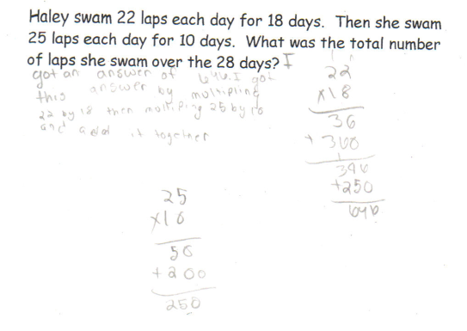

Student Work Analysis
Problem: Haley Swims Grade Level: 4

Student B
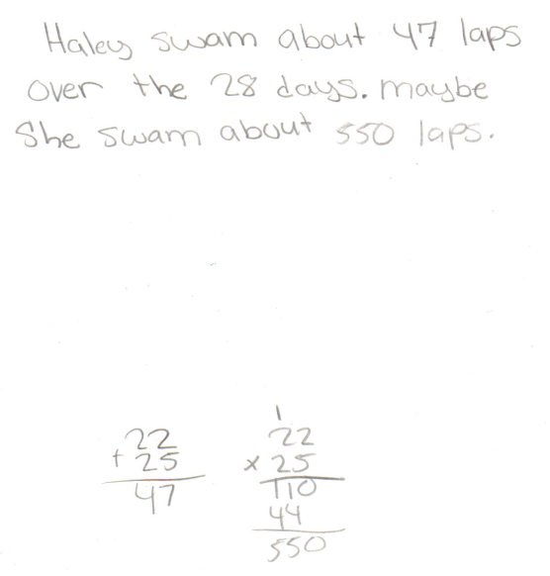

Student Work Analysis
Problem: Haley Swims Grade Level: 4

Student C
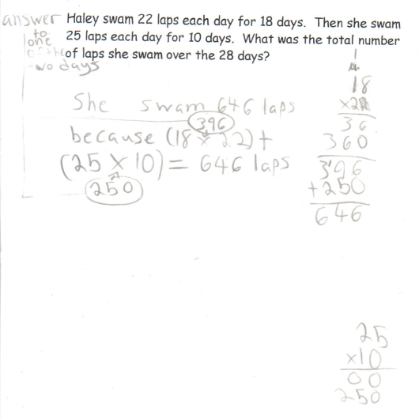

Student Work Analysis
Problem: Haley Swims Grade Level: 4

Student D
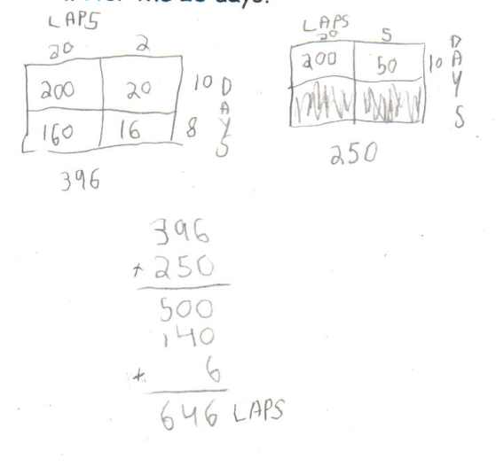

Student Work Analysis for: Haley Swims

Student | What strategy does the student use to arrive at a solution? | What is important to consider about this piece of work? | What does the student understand about the concept of multiplication based on the evidence? | What question could you ask to further probe the student’s thinking?
A
B

C

D

The first examples in each cell are examples of discrete things. These are easier for students and should be given before the measurement examples.
The language in the array examples shows the easiest form of array problems. A harder form is to use the terms rows and columns: The apples in the grocery window are in 3 rows and 6 columns. How many apples are in there? Both forms are valuable.
Area involves arrays of squares that have been pushed together so that there are no gaps or overlaps, so array problems include these especially important measurement situations.

