Mathematics Learning Community

Number Sense
Session 8

Title: Dealing with Division

Common Core State Standards Addressed in the LASW Problem:
4.NBT.6 | Find whole-number quotients and remainders with up to four-digit dividends and one-digit divisors, using strategies based on place value, the properties of operations, and/or the relationship between multiplication and division. Illustrate and explain the calculation by using equations, rectangular arrays, and/or area models.

Standards for Mathematical Practice Addressed in the MLC Session:
7: Look for and make use of structure. 8: Look for and express regularity in repeated reasoning.

The process of long division remains a mystery for so many adults and children alike. The focus of this session, found within both the Math Metacognition task and the LASW problem, is to de-mystify the operation of division through strategies that rely on number sense, place value, composition of numbers, numerical properties, as well as the relationship between division and the other operations, in particular multiplication and subtraction. MLC members look for patterns and structure within the way in which they approach a particular division problem to determine how the divisor and dividend play a role in finding the quotient. In addition, they look for ways that students make sense of different division problems and determine if the students made use of repeated reasoning as they worked.

Standards-Based Teaching and Learning Characteristics in Mathematics Addressed in the MLC Session:
- 5.1 Depth of content knowledge is evident throughout the presentation of the lesson.
- 5.2 Through the use of probing questions and student responses, decisions are made about what direction to take, what to emphasize, and what to extend in order to build students’ mathematical understanding.
- 5.3 Students’ prior knowledge is incorporated as new mathematical concepts are introduced.
- 5.4 Student misconceptions are anticipated /identified and addressed.
- 5.5 Classroom strategies incorporate multiple forms of representation.

Session Agenda:
Part I: Mathematical Background

Part II: Math Metacognition

Part III: Looking at Student Work
- Division Problems Using Student Invented Algorithms (Grade 4)

Part IV: Our Learning

Part V: Feedback and Wrap-up

Materials Needed for this Session:
- Nametags | - Chart paper and markers | - Copies of handouts
- Index cards | - Refreshments

Possible Ways to Personalize this Session
- Surfacing ideas about division may be difficult. If needed, adjust the times to make this longer and push to stay on task with the remainder of the session.
- Three student work samples are provided for Part III. However, members of your group may be interested in providing some samples of their own student work. See Page 5 in Part III for more details.
- Two Guiding Questions are provided in the Student Work Analysis Grid – the other two can be selected by you, the facilitator, or by the group as a whole. See Page 5 in Part III for additional information.
- If time is short at the end of the session, have participants take their Exit Card “to go” and drop it off later in your mailbox.

Part I: Mathematical Background
Approximate Time: 25 minutes
Grouping: Whole Group

- Welcome members of your group to the Math Learning Community. Remind group of established norms.

- Today’s Content:
  - The mathematics during this session focuses on division strategies.
  - What do we need to know in order to be able to divide fluently? Chart ideas to refer to during the Protocol for LASW.
  - What is division? What is the connection to multiplication? To subtraction? To addition?
  - There are two types of division problems – partitive and quotative. Both of these division types are important to consider, especially when division is set within a context, as most real-world computation is. (Note: Session 9 will go more in-depth into partitive and quotative division).
  - In Sessions 6 and 7, we connected number properties and multiplication to formal algebraic properties and skills. To make additional connections, group members should realize that the ways students understand division and how it relates to multiplication has implications for proportional reasoning. We will move deeper into these ideas in Sessions 9 and 10.
  - How does estimation play a role in division?
  - How do we promote efficiency? We want students to use an efficient algorithm, whether it be the traditional algorithm or not.
    - NOTE: Surfacing MLC members’ ideas about division may be difficult. There is a widely-held belief that the traditional, historically-taught algorithm is the “only” way to efficiently and accurately solve a division problem. However, as members begin to make connections to math content, student ideas as they LASW, and the research and other discussion points brought up during the MLC, they will begin to think about division situations in ways they previously may have never considered. .
    - Depending on the make-up of the group, you may want to point out that number sense is the cornerstone of elementary mathematics. Embedded in number sense is place value. The language of the traditional, historically-taught algorithm obscures place value and what is actually happening to the quantities as we divide.

- Relating Content to the Three C’s Theme:
  - How do the ways in which students learn to divide relate to the ways in which they learn to count? Connect to fair sharing: Counting or doling out as in the “one for you, one for me” is a strategy that is often employed. Young children come to us with an innate sense of what fair sharing means.
  - How do the strategies that students use to move into division relate to the ways in which they compose and decompose numbers? Composition plays a role in partial quotients and other strategies for solving division problems.
  - What about context for division? As adults how often do we use division strategies in our daily lives? Can you think of a time other than in school where division is needed out of context?

Part II: Math Metacognition
Approximate Time: 20 minutes
Grouping: Whole Group

- Problem:
182 ÷ 15 =

Make note of the first step you think about to begin this problem

- Solution: 12, R2; 12; or 12.1333…

- Problem Intent: (Note: The problem intent for all Math Metacognition problems is the same). See Session 2 for more information. With division, group members will often naturally use a strategy other than the first step in the traditional, historically-taught algorithm to enter this problem.

- Give a name to each strategy used. (See Page 4 for Division Strategies).

- Points to bring up for discussion include:
  - The area model can be a tool that is helpful for visualizing division. (Note: See Part II in Session 6 for more information on arrays and the area model). Refer back to the same template of a 5 x 4 array and think about what is being counted: count by 5’s (groups of 4). Now, flip the template over and think about what is now being counted: count by 4’s (groups of 5). What is in the middle? How many columns? How many rows?
  - Does this look familiar? Outline the top and side of the array to show the division “house.”
  - Connect the traditional long division algorithm back to subtraction by exploring how the repeated subtraction of groups of the divisor occurs.
  - Discuss the complexity of division and how it involves three different quantities – the total number of objects, the number of groups and the number of objects in each group, yet the answer (quotient) represents only one of the two latter quantities.

Division Strategies

Dealing out in groups

15 x 10 = 150
15 x _ 2 = _30
12 180

12, R 2
12
Using a ratio table (Setting up an equivalent problem)

# of 15’s | Total
2 | 30
4 | 60
8 | 120
12 | 180

Subtracting groups of the divisor

Total Remaining | Groups of 15
182
182 – 30 =152 | 2
152 – 30 = 122 | 2
122 – 30 = 92 | 2
92 – 30 = 62 | 2
62 – 30 = 32 | 2
32 – 30 = 2 | 2
Total: | 12 groups of 15, with 2 remaining

Breaking the dividend into manageable parts

=
= 10 + 2 +
= 12

Part III: Looking at Student Work (LASW)
Approximate Time: 50 minutes
Grouping: Refer to protocol

- Complete the MLC protocol with the group.

- Problems: The problems used for this session are appropriate for Grade 4.
1. 56 ÷ 3 | 2. 70 ÷ 9
3. 128 ÷ 6 | 4. 482 ÷ 5
5. 972 ÷ 2 | 6. 371 ÷ 8

- Solutions: 18 , 7 , 21 , 96 , 486, 46

- Problem Intent:
  - This problem goes back to how students are composing and decomposing numbers. These are numbers out of context.
  - What is the prior knowledge that students use to enter a division problem? How do their strategies relate to our Math Metacognition strategies? How do they relate to other algorithms (including the traditional division algorithm)?

- Strategies you might see can be found on Page 4.

- Misconceptions/Questions that May Arise:
  - Q: How do students make use of prior knowledge when problem solving?
  - Q: How does this approach help students to understand what division is? Or, in fact, for any operation?
  - Q: What are the connections between the students’ division strategies and the traditional division algorithm?

Options for Customization

- Guiding Questions: Two Guiding Questions have been provided in the Student Work Analysis Grid for this problem. As a way to customize the LASW process, you (or your group) will need to decide on the remaining two questions. You can use the two questions listed below that are specific to this problem or refer to the list of generic questions found on Page 5 in Session 7.
  - In what way(s) does the student’s method connect to the standard division algorithm?
  - How does the student’s method(s) make use of place value?

- Using A Group Member’s Student Work:
  - Prior to offering this session to your MLC, you would need to collect student work samples for the task: Division Problems Using Student-Invented Algorithms.
  - See Page 5 in Session 7 for more details on collecting student work samples. For this task, select 3 samples to discuss during the MLC session. Prior to photocopying samples, mark them as A, B, and C.

Part IV: Our Learning
Approximate Time: 20 Minutes
Grouping: Whole Group

- Discussion: After evidence of student understanding has been discussed as a whole group, you want to facilitate discussion around how the LASW process will impact what teachers do within their classrooms. Some questions to help guide discussion include:
- What do we take away after LASW?
- What did we learn? About student thinking? About our own knowledge?
  - Refer back to chart made at the beginning of the session
- How does today’s session relate to important mathematical content and pedagogy?
- How does it impact my practice at my grade level? (Note: In order to help teachers connect this session to the mathematics within their own grade level refer to the information below).

Making Connections Across the Grade Levels

K – 2: Work with division naturally follows from students’ work with counting and with subtraction, along with their real-life experience fair sharing. The concept of division develops from these early experiences (K.CC.6, K.OA.1, 1.OA.3, 1.NBT.6, 2.OA.2, 2.NBT.5, 2.NBT.8, and 2.NBT.9).

3 – 5: Division as both a concept and a skill are developed during upper elementary school. The LASW problem is appropriate for this grade band to explore and specifically addresses learning standards 4.NBT.6 (3.OA.3, 3.OA.4, 3.OA.5, 3.OA.6, 3.OA.7, 3.OA.8, 4.OA.2, 4.OA.3, 5.NBT.6, 5.NBT.7). In addition, fractions are interpreted as a division of the numerator by the denominator or as the quotient when a whole number is not evenly divisible by another whole number (5.NF.3). Fraction division (unit fraction as the dividend and whole number as the divisor, and vice versa) is also explored (5.NF.7 a – c).

6 – 8: Computation with decimals and integers, including division, is one of the key areas of number sense that is addressed during middle school. Fluency with both will make symbolic algebraic manipulation, including solving equations, much easier when students enter Algebra I. In addition, division of fractions is conceptually difficult for students to grasp, especially if they can only interpret division as fair sharing. (6.NS.1, 6.NS.2, 6.NS.3, 7.NS.2b and c, 7.NS.3, 7.EE.3). Computation with exponents and scientific notation are also explored (8.EE.1, 8.EE.3)

- Writing a Problem or a Task: As a way to synthesize learning from today’s session, ask MLC members to come up with a math problem or task that would embody the ideas discussed today. The problem should be appropriate to use at their grade level. Writing these problems will help both you as the facilitator and the other group members to develop a stronger sense of how these mathematical ideas show up in classrooms from grades K – 8. (Note: See Part IV in Session 1 for more details).
Part V: Feedback & Wrap-up
Approximate Time: 5 Minutes
Grouping: Individual

- Closing: Close the session with a message such as: “Hope you leave here with more questions – about student thinking, about your teaching, and ways that we as a group can help support one another.” Have group members keep in mind the following: Dialogue, Reflection, and Inquiry are the keys to successful learning.

- Exit Cards: Pass out exit cards for group members and ask them to provide some feedback to you as the facilitator. Select one or two questions from the list below to help them summarize their thinking about the mathematics from today’s session. Collect exit cards so that a summary can be shared during the next session.

Feedback / Exit Card Questions

- How does the mathematics that we explored connect to your own teaching?

- How do I see what we’ve done today relate to key mathematical ideas or pedagogical content knowledge?

- What idea or discussion topic did you find most interesting from today’s session. Why?

- How was this session for you as a learner?

- What ideas were highlighted for you in today’s session that you had not previously considered?

- What are you taking away from today’s session?

Related Student Discourse Video Clip – Math Metacognition Problem

Lenses on Learning, Video – Course 1
Problem: 6 kids share 14 brownies

Session Reference

- Lenses on Learning: “Course 1: Instructional Leadership in Mathematics,” by C. Grant, et. al., Dale Seymour Publications, 2003

Math Metacognition

182 ÷ 15 = ?

Make note of the first step you think about to
begin this problem.

LASW Problem

Solve each problem using a method other than the traditional division algorithm.

1. 3 | 2. 70 ÷ 9
3. 128 ÷ 6 | 4. 5
5. 972 ÷ 2 | 6. 8

Student Work Analysis
Problem: Division Problems Using Student-Invented Algorithms Grade Level: 4

Student A
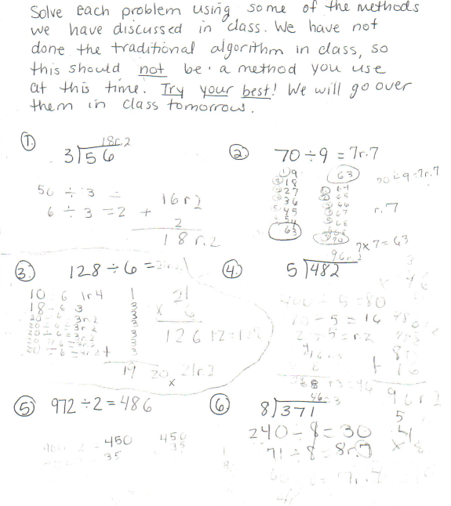

Student Work Analysis
Problem: Division Problems Using Student-Invented Algorithms Grade Level: 4

Student B
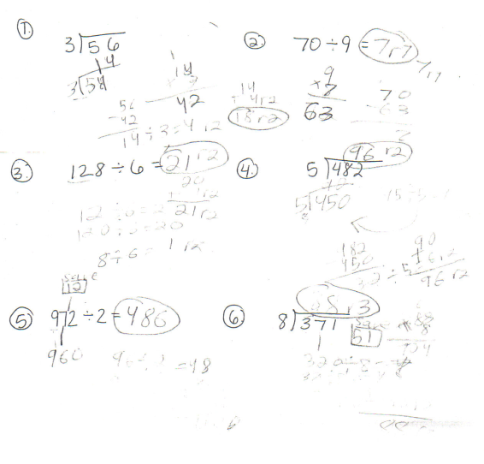

Student Work Analysis
Problem: Division Problems Using Student-Invented Algorithms Grade Level: 4

Student C
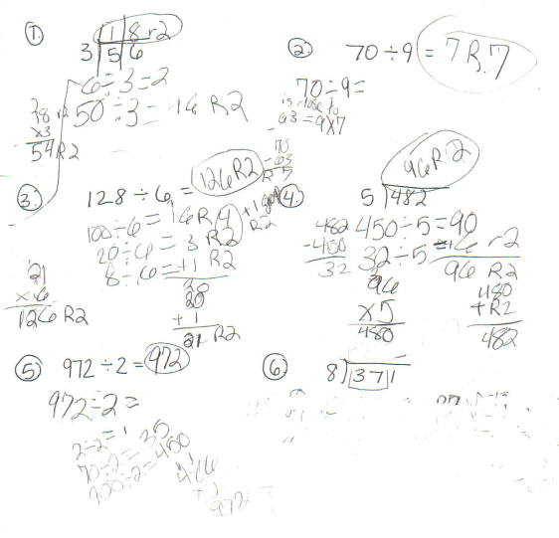

Student Work Analysis for: Division Problems Using Student-Invented Algorithms

Student | What method(s) does the student use to solve the problems? | What is the evidence that the student is relying on prior knowledge to solve the problems?
A
B

C

