Context
CSDP Progress Monitoring Rubric
December 2023

The Center for School and District Partnership (CSDP) is committed to improving educational outcomes for all students in Massachusetts, particularly those from historically underserved backgrounds (i.e., racial/ethnic minority students, students with disabilities, English learners, students who are socioeconomically disadvantaged). Both historically and contemporarily, these students have faced systematic barriers to inclusion, access, and success in K–12 schools across the country, including schools in Massachusetts. These barriers produce widespread and enduring disproportionalities in educational outcomes along the lines of race, ability, language, and socioeconomic status, and they illustrate the difficult truth that educational experiences and outcomes are inequitably distributed among the diversity of K–12 students in the United States. Acknowledging the existence of educational inequities is a necessary first step in the journey to creating educational equity in Massachusetts.
The following figure provides an overview of the key drivers of educational inequities, including sociopolitical, environmental, and cultural factors that create inequitable educational experiences, as well as academic and life outcomes for students from historically underserved groups. Some of the drivers are beyond the control of CSDP and the schools and districts we work with. However, by acknowledging the deeply rooted and complex factors that shape students’ experiences and outcomes, we hope to support our partner schools and districts in making strategic decisions to advance educational equity for the students most in need of change.
Although this rubric is designed to assess a variety of indicators of the quality of education in participating schools and districts, CSDP contends that schools and districts cannot be considered as providing high-quality educational experiences overall if these experiences are not available to all students. Many of the criteria for gauging school and district performance across indicators refer to “all students.” To understand whether schools are meeting these criteria for all students, we need to disaggregate data to learn how the experiences of students from historically marginalized groups compare to those from groups that have historically benefitted from greater privilege in educational settings. Disaggregation can happen at the student level (e.g., comparing experiences for English learners to non-English learners) or at the school or district level (e.g., comparing the quality of instructional materials in schools or districts serving larger populations of racial/ethnic minority students to materials in schools or districts serving larger populations of White students). When possible, CSDP will provide schools and districts with disaggregated data to help school and district leaders understand the extent to which existing practices and policies create high-quality educational experiences for all students and to support strategic planning to ensure equitable access and outcomes.

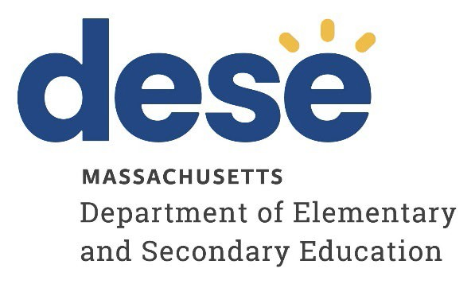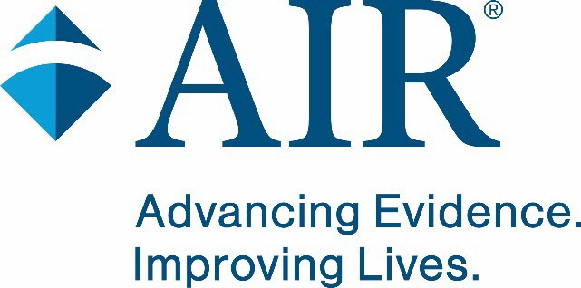

Understanding Systemic Drivers of Educational Inequities

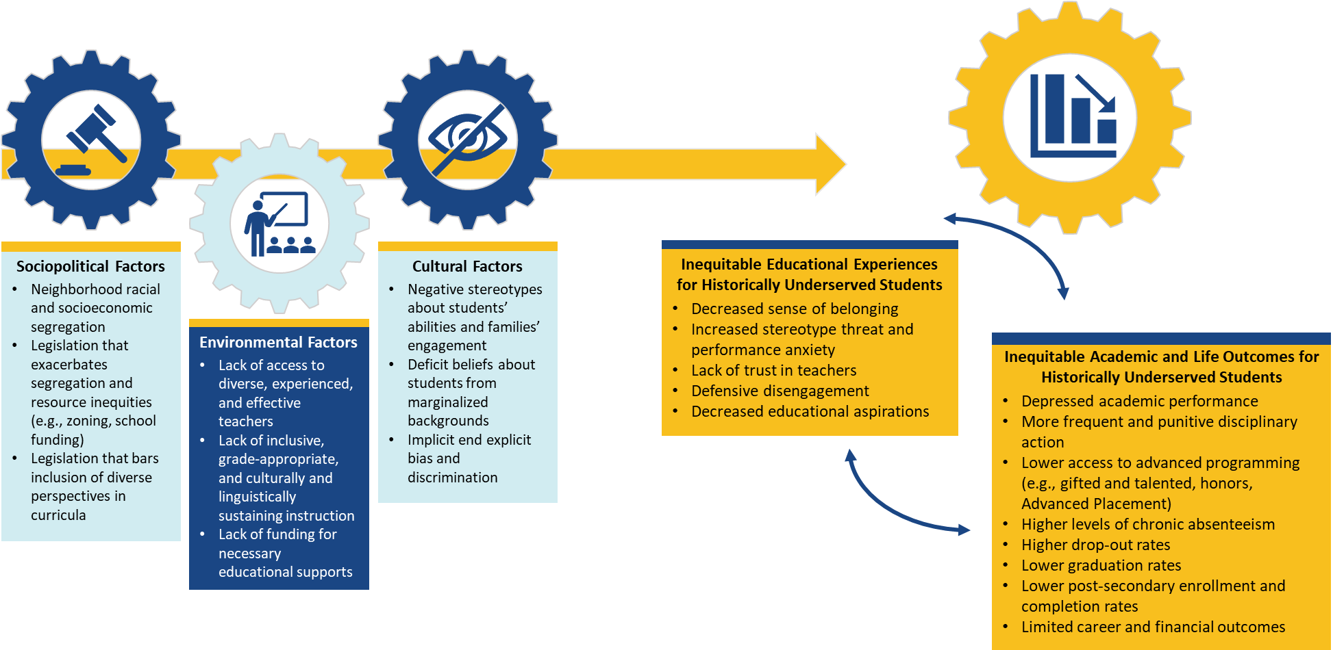

Connections to the DESE Coherence Guidebook
Recently, the Massachusetts Department of Elementary and Secondary Education (DESE) reorganized to ensure greater collaboration and coherence amongst offices within the organization. This reorganization combined the following essential offices available to support districts via the newly formed CSDP: Statewide System of Support, Kaleidoscope Collective of Learning, Educational Technology, Effective Partnerships and Impact, and Language Acquisition. This reorganization provided an opportunity to combine guidance from several recently published documents into a coherent resource for Massachusetts schools that clearly articulates a vision of deeper learning for all students. This effort resulted in the DESE Coherence Guidebook and the related Coherence Guidebook self-assessment.
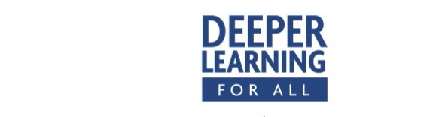
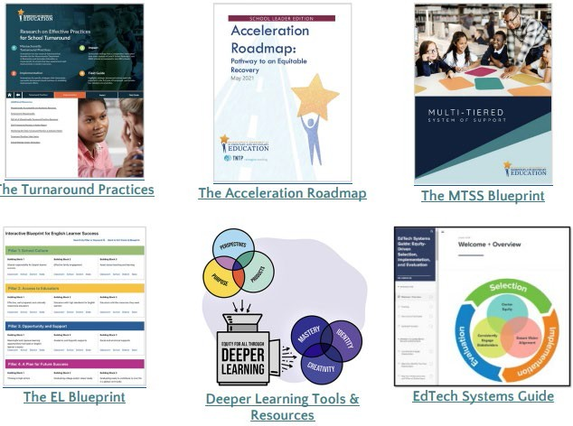
This rubric—derived from the full Coherence Guidebook—serves as a powerful tool for schools, districts, and CSDP to evaluate the alignment and effectiveness of educational systems. The rubric focuses on a subset of indicators from the Coherence Guidebook that DESE and its partners have identified as particularly important to regularly reflect on and monitor. Designed to promote clarity, collaboration, and continuous improvement, this rubric empowers teams to engage in self-assessment and guides our department in conducting comprehensive progress monitoring of the guide's various elements.

For school and district teams, this rubric offers a structured approach to assess their own systems—in relation to the subset of indicators— providing a clear framework for identifying strengths and areas in need of enhancement. The rubric encourages thoughtful reflection and data- driven decision making, enabling teams to make targeted improvements that align with the principles outlined in the Coherence Guidebook. Simultaneously, CSDP will use this rubric to assess the various components of the Coherence Guidebook across the educational landscape. By employing a standardized progress

monitoring framework, we can systematically gauge the level of coherence and alignment within our educational systems. This approach allows us to identify trends, common challenges, and exemplary practices, ultimately informing our strategic planning and support efforts. In this dual capacity, the rubric serves as a catalyst for fostering coherence, promoting excellence, and ensuring that our educational systems remain dynamic and responsive to the evolving needs of our students and stakeholders.

CDSP Progress Monitoring Rubric: Priority Indicators and Rating Continuum

The first section focuses on effective instructional practices within the context of deeper learning, which encompasses a diverse array of strategies geared toward nurturing profound student engagement and achievement. These practices, ranging from providing grade-appropriate content that is relevant, real-world, and interactive to integrating culturally and linguistically sustaining approaches, collectively contribute to the establishment of student-centered learning environments that prioritize inclusivity, engagement, and academic advancement. Within effective instructional practices, the progress monitoring system measures both high-quality instructional materials and high-quality professional learning, specifically, as indicators essential to establishing and maintaining effective instructional practices.

# | Indicator | Initial | Emerging | Established | Robust and Sustainable
Effective Instructional Practices and Resources
1a | Effective Instructional Practices | There is little to no evidence that educators implement effective instructional practices across classrooms. | Educators implement effective instructional practices in some classrooms. Implementation of practices is inconsistent. | Educators implement effective instructional practices in most classrooms. However, there are some pockets of the learning community still working to fully implement these practices.  (Classroom observation scores are in at least the middle range for specified dimensions.) | Educators implement effective instructional practices (rooted in deeper learning, universal design, culturally responsive pedagogy, linguistically supportive and trauma- informed practices) across all classrooms and for all students.  (Classroom observation scores are in the high range for specified dimensions.)
1b | High-Quality Instructional Materials (HQIM) | Materials do not meet any of the criteria for high-quality instructional materials, as described at the highest level (and also here). | HQIM are available only for some grade levels/content areas. | HQIM are available for all grade levels and core content areas but may not be implemented with fidelity across all classrooms and/or tiers. | HQIM, which include diverse people and perspectives and real-world, relevant content, are available for core content areas and implemented with fidelity across all classrooms and tiers.

# | Indicator | Initial | Emerging | Established | Robust and Sustainable
1c | High-Quality Professional Learning | Evidence-based and relevant job- embedded professional learning opportunities are not in place or are infrequent. | Educators engage in evidence- based and relevant ongoing, job-embedded professional learning opportunities, but the opportunities are not consistently implemented or do not align with the instructional vision. | Educators engage in a deliberately planned sequence of evidence-based and relevant job-embedded professional learning opportunities that are coherent with the instructional vision. However, there is limited or no evidence that instructional leaders monitor implementation of professional learning opportunities to generate evidence that the opportunities result in the use of effective instructional practices or improved student outcomes. | Educators engage in a deliberately planned sequence of evidence-based and relevant job-embedded professional learning opportunities that are coherent with the instructional vision. Instructional leaders monitor implementation of professional learning opportunities to generate evidence that the opportunities result in the use of effective instructional practices and improved student outcomes.

This section explores the organization’s commitment to a tiered support approach, designed to meet the diverse needs of our students. By establishing a structured system encompassing universal (Tier 1), targeted (Tier 2), and intensive (Tier 3) support, we ensure that each student receives precisely the support they need to be successful in our school(s), including English learners (ELs) and students with disabilities.

# | Indicator | Initial | Emerging | Established | Robust and Sustainable
SSS tudent-Specific Supports and Access
2a | Equitable Access | Students do not have equitable access to individualized support or high-quality, grade- appropriate instruction. | Some students have access to individualized support and high- quality, grade-appropriate instruction. However, this is not consistent across all grade levels and classrooms, and individualized support may require students to miss core instructional periods. | Most students have access to individualized support and high- quality, grade-appropriate instruction. However, some barriers (e.g., staffing, scheduling, curricular materials) exist. | All students have access to high-quality, grade-appropriate instruction, and individualized support that does not require students to miss core instructional periods.
2b | High Expectations | There is little to no evidence that the school makes high expectations for students a priority. | School leaders understand the importance of high expectations, but the strategies implemented to elevate this as a shared understanding and practice are minimally effective (e.g., not all staff hold high expectations for all students and/or implement practices that demonstrate high expectations). | School leaders understand the importance of high expectations and implement multiple strategies to ensure this is a shared understanding and practice throughout the school. Most staff members hold high expectations for all students and implement practices that demonstrate high expectations. | School leaders understand the importance of high expectations and implement multiple strategies to ensure this is a shared understanding and practice throughout the school. All staff members hold high expectations for all students and regularly implement practices that demonstrate high expectations.

# | Indicator | Initial | Emerging | Established | Robust and Sustainable
2c | Tiered Support Systems | There is no clearly defined framework for providing tiered support to students at the different tiers (universal, targeted, intensive). | Tiered supports are provided in some areas across academic, social-emotional, and behavioral domains but not systematically. The school is in the process of setting up structures, processes, and resources to identify and address student needs across these tiers. | The school has necessary structures, processes, and resources in place to systematically address most students’ academic, social- emotional, and behavioral needs across three tiers; however, some barriers (e.g., staffing, schedules) still exist to meeting all needs consistently and coherently. | The school ensures all student needs are systematically identified and addressed across three tiers. Tier 1 delivers universal support through high- quality instruction and proactive strategies for all students. Tier 2 offers targeted interventions to a smaller group requiring additional support. Tier 3 provides individualized and specialized support to a select subset of students with unique needs. Systems are in place and effectively implemented, with evidence of improvement.
2d | English Learners (ELs) | The school does not plan for students to receive appropriate English as a second language (ESL) services and/or ELs are generally excluded from Tier 1 core content instruction. | The school plans for students to receive appropriate ESL services and access to core content instruction, but these plans are not consistently or systematically implemented (due to staffing, scheduling, or other barriers). ELs may not have access to a tiered system of support as needed, or language needs may not be accurately identified. | The school provides supports for ELs, including ESL services, access to Tier 1 core content instruction, and access to a tiered system of support as needed. However, supports are not always aligned to students’ specific needs. | All ELs receive systematic, explicit, and sustained ESL services, access to Tier 1 core content instruction, and access to a tiered system of support, as needed.

# | Indicator | Initial | Emerging | Established | Robust and Sustainable
2e | Students With Disabilities (SWDs) | Support for SWDs is neither evidence based nor provided within the least restrictive environment. | Supports for SWDs exist but may not be consistently or systematically implemented (due to staffing, scheduling, or other barriers). Supports are evidence based but may not be provided in the least restrictive environments. | Supports for SWDs are implemented consistently to ensure SWDs can access evidence-based tiered supports. However, supports may not always be provided in the least restrictive environment. | Supports for SWDs are designed and implemented to ensure that all SWDs can access evidence- based tiered support as appropriate in the least restrictive environment, are aligned with the goals of their individualized education programs (IEPs), and are created in collaboration with the full IEP team.

This section focuses on the crucial aspects of a student’s learning environment, including two key related indicators: Safe and Supportive and Sense of Belonging. These indicators play a vital role in ensuring an environment where every learner feels secure, supported, and a sense of belonging.

# | Indicator | Initial | Emerging | Established | Robust and Sustainable
Learning Environment
3a | Safe and Supportive | Across most classrooms, the learning environment does not meet students’ physical and mental well-being needs. Student self- regulation and proactive teacher responses to students’ emotions and behaviors are rarely present. | In some classrooms, the learning environment is joyful, healthy, safe, and supportive of students’ physical and mental well-being needs. Teachers are sometimes reactive in helping students regulate their emotions and behaviors. | In most classrooms, the learning environment is joyful, healthy, safe, and supportive of students’ physical and mental well-being needs. Teachers are often proactive in helping students regulate their emotions and behaviors. The creation of expectations includes student input. | In all classrooms, the learning environment is joyful, healthy, safe, and supportive of students’ physical and mental well-being needs. Students manage and self-regulate their emotions and behaviors in classrooms following co-created expectations that allow them to feel safe physically, socially, and mentally. There are intentional school-level systems and structures in place to ensure sustainability and consistency across classrooms and school environments.

# | Indicator | Initial | Emerging | Established | Robust and Sustainable
3b | Sense of Belonging | Very few or no students experience a learning environment that is welcoming and affirming, where they feel known and valued. Most students do not demonstrate connectedness and positive relationships with peers or adults in their school and have few opportunities to express their sense of agency. | Some students experience a learning environment that is welcoming and affirming, where they feel known and valued.  Students demonstrate connectedness and positive relationships with peers in their school and have some opportunities to express their sense of agency. | Most students experience a learning environment that is welcoming and affirming, where they feel known and valued.  Most students demonstrate connectedness and positive relationships with peers and at least one adult in their school and have opportunities to express their sense of agency or self-advocate.  (Classroom observation scores are in at least the middle range for specified dimensions.) | All students experience a learning environment that is welcoming and affirming, where they feel known and valued.  Students experience connectedness and positive relationships with peers and adults in their school and have opportunities to express their sense of agency and self- advocate. There are intentional school-level systems and structures in place to ensure sustainability and consistency across classrooms and school environments.  (Classroom observation scores are in the high range for specified dimensions.)

In this section, we explore the pivotal role of data systems in ensuring schools function effectively to identify and address individual and schoolwide needs. A robust data system serves as the backbone, providing schools with the essential tools and processes needed to gather, analyze, and disseminate data, thereby guiding informed decision making focused on improvement.

# | Indicator | Initial | Emerging | Established | Robust and Sustainable
2DB ata-Driven Progress Monitoring
4a (School) | Continuous Improvement | The school does not engage in ongoing long-term or short- term goal setting and monitoring. | The school engages in ongoing long-term and/or short-term goal setting, but the goals do not align—or only partially align—with the instructional vision and with any districtwide improvement plans. The school has established some systems to monitor progress toward its goals but is not yet using those systems effectively to make adjustments. | The school engages in ongoing long-term (multiyear and annual) and short-term (quarterly and monthly) goal setting that is aligned with the instructional vision and district improvement plans. The school regularly and systematically monitors progress toward goals and makes some adjustments accordingly. | The school engages in ongoing and inclusive long- term (multiyear and annual) and short-term (quarterly and monthly) goal setting and monitoring toward realizing the instructional vision and ensuring each student is making progress, which results in adjustments to the school’s structures, programs, and resources (e.g., time, staff, schedules) throughout the year. Plans align with districtwide goals and initiatives, and monitoring systems include feedback from students, families, and community partners.

# | Indicator | Initial | Emerging | Established | Robust and Sustainable
4b (School) | Data Systems | Data may be collected, but there is no system in place for regularly using and sharing data to guide decision making. | There is a system in place for collecting data regularly, but the use of these data to guide decision making is irregular or inconsistent across staff. | School leaders support a culture of data use, and there is a system in place for collecting and using data regularly. Data are used to guide decision making at the school level but may not be used to guide decision making across all classrooms OR may not be used to improve opportunities for all students. | School leaders establish and support a culture that values the use of data in improving teaching, learning, and decision making. School leaders ensure that systems are in place for the efficient and purposeful collection, use, and sharing of data from a variety of assessments to guide decision making at school and classroom levels and to improve all students’ performance, opportunities, and outcomes.
4c (District) | Continuous Improvement | The district improvement plan does not align well with school or student needs, and district leaders do not engage in regular long- or short-term goal setting. | District and school leaders develop strategic improvement plans to improve all students’ performance, opportunities, and outcomes. However, there is no system in place to ensure alignment or responsiveness with school needs. | District and school leaders conduct annual planning to improve all students’ performance, opportunities, and outcomes. They establish, implement, and evaluate policies, procedures, systems, and budgets with a primary focus on achieving districtwide improvement goals (articulated in strategic plans), in part through equitable and effective use of resources. | District and school leaders work collaboratively and strategically, through data- driven multiyear planning, to improve all students’ performance, opportunities, and outcomes. They establish, implement, and evaluate policies, procedures, systems, and budgets with a primary focus on achieving districtwide improvement goals (articulated in strategic plans), in part through equitable and effective use of resources.

Recommended Reading on Systemic Drivers of Educational Inequities
Byrd, C. M. (2016). Does culturally relevant teaching work? An examination from student perspectives. SAGE Open, 6(3). https://doi.org/10.1177/2158244016660744
Chetty, R., Friedman, J. N., & Rockoff, J. E. (2014). Measuring the impacts of Teachers II: Teacher value-added and student outcomes in adulthood. American Economic Review, 104(9), 2633–2679. https://doi.org/10.1257/aer.104.9.2633
Dee, T., & Penner, E. (2016). The causal effects of cultural relevance: Evidence from an ethnic studies curriculum (Working Paper 21865).
National Bureau of Economic Research. https://doi.org/10.3386/w21865

Egalite, A. J., Kisida, B., & Winters, M. A. (2015). Representation in the classroom: The effect of own-race teachers on student achievement. Economics of Education Review, 45, 44–52. https://doi.org/10.1016/j.econedurev.2015.01.007
Fenwick, L. T. (2022). Jim Crow’s pink slip: The untold story of Black principal and teacher leadership (Race and Education Series).
Harvard Education Press.
Fryberg, S. A., Covarrubias, R., & Burack, J. A. (2013). Cultural models of education and academic performance for Native American and European American students. School Psychology International, 34(4), 439–452. https://doi.org/10.1177/0143034312446892
Gay, G. (2018). Culturally responsive teaching: Theory, research, and practice (Multicultural Education Series; 3rd ed.). Teachers College Press.
Gershenson, S., Hansen, M., & Lindsay, C. A. (2021). Teacher diversity and student success: Why racial representation matters in the classroom. Harvard Education Press.
Gray, D. L., McElveen, T. L., Green, B. P., & Bryant, L. H. (2020). Engaging Black and Latinx students through communal learning opportunities: A relevance intervention for middle schoolers in STEM elective classrooms. Contemporary Educational Psychology, 60, 101833. https://doi.org/10.1016/j.cedpsych.2019.101833
Ladson-Billings, G. (1994). The dreamkeepers: Successful teachers of African American children (3rd ed.). Wiley.
Ladson-Billings, G. (1995). Toward a theory of culturally relevant pedagogy. American Educational Research Journal, 32(3), 465– 491. https://doi.org/10.3102/00028312032003465

Ladson-Billings, G. (2021). Three decades of culturally relevant, responsive, & sustaining pedagogy: What lies ahead? The Educational Forum, 85(4), 351–354. https://doi.org/10.1080/00131725.2021.1957632
Lara, J., Noble, K., Pelika, S., & Coons, A. (2018). Chronic absenteeism (NEA Research Brief; NBI No. 57). National Education Association. https://eric.ed.gov/?id=ED595241
Major, B., Spencer, S., Schmader, T., Wolfe, C., & Crocker, J. (1998). Coping with negative stereotypes about intellectual performance: The role of psychological disengagement. Personality and Social Psychology Bulletin, 24(1), 34–
50. https://doi.org/10.1177/0146167298241003

Mickelson, R. A. (2015). The cumulative disadvantages of first- and second-generation segregation for middle school achievement. American Educational Research Journal, 52(4), 657–692. https://doi.org/10.3102/0002831215587933
Okonofua, J. A., Paunesku, D., & Walton, G. M. (2016). Brief intervention to encourage empathic discipline cuts suspension rates in half among adolescents. Proceedings of the National Academy of Sciences, 113(19), 5221–5226. https://doi.org/10.1073/pnas.1523698113
Phillips, L. T., Stephens, N. M., Townsend, S. S. M., & Goudeau, S. (2020). Access is not enough: Cultural mismatch persists to limit first- generation students’ opportunities for achievement throughout college. Journal of Personality and Social Psychology, 119(5), 1112–1131. https://doi.org/10.1037/pspi0000234
Steele, C. M., & Aronson, J. (1995). Stereotype threat and the intellectual test performance of African Americans. Journal of Personality and Social Psychology, 69(5), 797–811. https://doi.org/10.1037/0022-3514.69.5.797
Walton, G. M., & Cohen, G. L. (2011). A brief social-belonging intervention improves academic and health outcomes of minority students.
Science, 331(6023), 1447–1451. https://doi.org/10.1126/science.1198364

Williams, C. L., Hirschi, Q., Sublett, K. V., Hulleman, C. S., & Wilson, T. D. (2020). A brief social belonging intervention improves academic outcomes for minoritized high school students. Motivation Science, 6(4), 423–437. https://doi.org/10.1037/mot0000175

