**Overview of 2016 Turnaround Practices Evaluation and Resources**

cover page of research brief document
Research Brief

This research brief, titled “How to Succeed in School Turnaround: Strategies That Characterize Successful Turnaround Schools in Massachusetts” summarizes key findings from both parts of the technical report – the implementation study (Part 1) and the impact study (Part 2). The brief highlights those strategies described by successful schools as “essential” to the school’s turnaround efforts and ability to sustain improvements.

***E***valuation of Level 4 School Turnaround Efforts in Massachusetts

This two-part technical report summarizes findings from our implementation and impact studies of SRG schools.

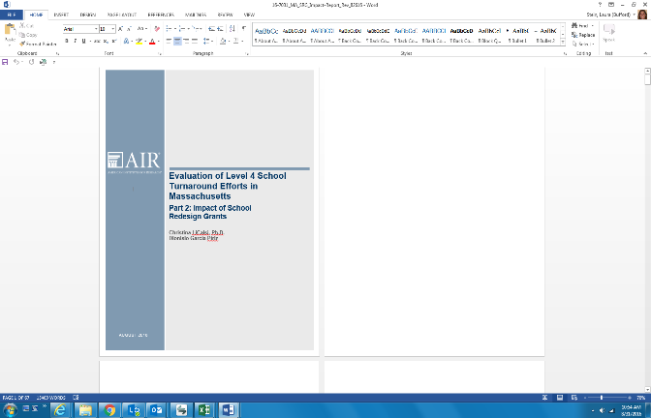

Part 1: Implementation Study, summarizes the specific strategies that characterize successful turnaround schools and keys to sustaining improvement efforts.

Part 2: Impact Study, summarizes findings from a comparative interrupted time series analysis of Level 4 SRG schools, as compared to non-SRG schools.

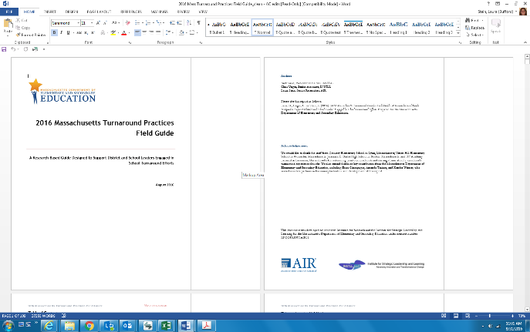2016 Massachusetts Turnaround Practices Field Guide

This guide, designed for school- and district-level practitioners, describes how successful turnaround schools implement the Massachusetts Turnaround Practices. The guide highlights strategic turnaround actions especially important in the first year of turnaround, and includes four detailed school profiles. Each profile describes how school leaders and staff implemented school-specific strategies that contributed to successful turnaround. Authentic artifacts from each school are included in the Appendix.

Turnaround Practices in Achievement Gain Schools Video Series

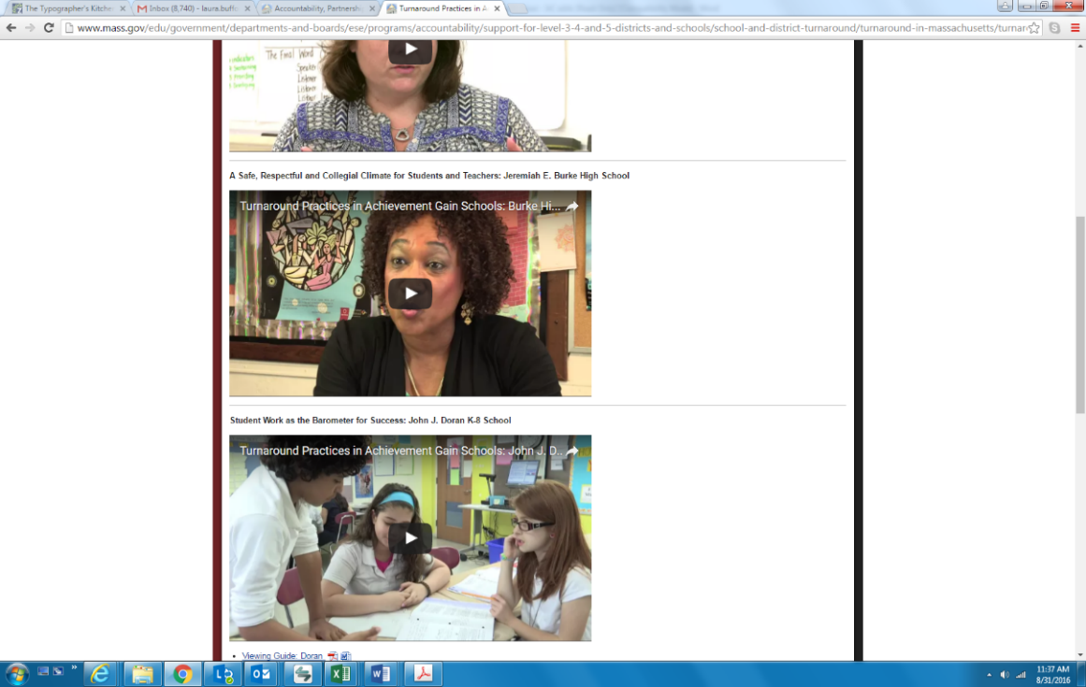ESE has developed a video series to highlight the work of achievement gain schools. In each video, school staff and leadership tell their unique story through the lens of the four key turnaround practices. Two of the four schools profiled in the field guide (Connery and Union Hill) are featured in new videos for the Achievement Gain Schools series, and a third (Burke High School) had been featured previously.