Massachusetts Department of Elementary and Secondary Education

Research on Effective Practices for School Turnaround

Massachusetts Turnaround Practices
Summarizes four key research-based practices identified by the Massachusetts Department of Elementary and Secondary Education as characteristic of schools that have experienced rapid improvements in student outcomes.

Implementation
Summarizes the specific strategies that characterize successful turnaround schools and keys to sustaining improvement efforts.

Impact
Summarizes findings from a comparative interrupted time series analysis of Level 4 School Redesign Grant (SRG) schools as compared to non-SRG schools.

Field Guide
Highlights strategic turnaround actions especially important in the first year of turnaround, and includes four detailed school profiles.

Additional Resources
Massachusetts Accountability and Assistance Resources
Turnaround in Massachusetts
Full List of Massachusetts Turnaround Practices Resources
2014 Turnaround Practices in Action Report
Monitoring Site Visits: Turnaround Practices & Indicators Rubric
Turnaround Practices Video Series
School Redesign Grants Information

1 Massachusetts Turnaround Practices

Introduction
In 2014, after four years of analyzing the practices used by Massachusetts’ Level 4 schools and exploring differences between schools that improved student achievement and ultimately exited Level 4 (achievement gain school) and schools that did not improve (non-gain schools), four turnaround practices emerged as crucial to the success of schools that exited Level 4: (1) strong individual and distributed leadership that cultivates collective responsibility among all staff; (2) the provision of targeted instructional interventions and support for all students needing additional support, and (3) ongoing systems to establish, monitor, and improve instructional quality among all teachers and classrooms. These practices reinforce each other to contribute to improvements in student achievement, and are grounded in (4) a safe, orderly and respectful learning environment for students and a collegial, collaborative, and professional culture among teachers.
These practices became the foundation of Massachusetts’ assistance services and resources for turnaround and low-performing schools and districts. The Turnaround Plan Template and Guidance documents are structured around the four turnaround practices, and the School Redesign Grant program incorporates the turnaround practices into the grant application and review process. Monitoring Site Visits, which provide feedback to schools and districts on the progress they are making in support of turnaround efforts, are similarly organized around the four turnaround practices. Massachusetts is committed to continuously looking at data to identify and disseminate best practices in turnaround to the field, and the 2016 evaluation and resources are key example of that commitment.
The following pages provide detailed examples of what each turnaround practice typically looks like in year 3, for both achievement gain and non-gain schools, as well as additional detail on what the turnaround practice means for schools moving from year 1 through year 3. This view can be used to inform or jumpstart a deeper conversation of what the practice means in a school or district and how the practice connects with other turnaround practices, as well as with district systems and policies.
For more information on accountability and assistance in Massachusetts, please visit:
http://www.doe.mass.edu/turnaround/

Turnaround Practice 1
Leadership, Shared Responsibility, and Professional Collaboration

Effective Strategies
Autonomy
Communication Culture

School-Specific Examples
Union Hill Elementary School
Establishing an improvement mind-set
Using common planning time to drive turnaround efforts

Jeremiah Burke High School
Cultivating a learner mind-set
Creating integrated teaming structures for collective inquiry
The school has established a community of practice through leadership, shared responsibility, and professional collaboration.

Using autonomy and authority to improve teaching and learning
School leaders make strategic use of staffing, scheduling, and budgeting autonomy to focus work on implementing their turnaround plan or other improvement efforts to improve the quality of teaching and learning at the school.

Teaming, shared leadership and responsibility, and collaboration
Collective, distributed leadership structures and practices are apparent throughout the school building in the form of an active, well-represented instructional leadership team and grade-level and vertical teams. Administrators and teachers are jointly committed to and have assumed shared ownership and collective responsibility for improving student achievement.

Using teams, shared leadership, and a collaborative and trusting environment to accelerate improvement
Administrators and teachers (through teacher teams or involvement in an instructional leadership team) are actively monitoring and assessing the implementation and impact of key improvement strategies, use of resources, classroom instructional practices, and nonacademic supports on student achievement.
Turnaround Practice 1 (Leadership, Shared Responsibility, and Professional Collaboration)

Detailed Examples

In Achievement Gain Schools

Year 1
- School leadership is deliberate, distributed, and focused on increasing student achievement
- An instructional- and results-oriented principal has galvanized individual and collective responsibility for the improved achievement of all students through:
- An explicit focus on continuously improving instruction that involves regular structures for collecting and analyzing data that directly informs teacher-specific instruction.
- Frequent and ongoing visits to classrooms that provide positive and useful feedback to teachers, as perceived by teachers.
- Ongoing modeling of and support for a safe, orderly, and engaging environment for teachers and students.

Year 2
- A community of practice has been developed through distributed leadership, shared responsibility, and professional collaboration
- School leaders and professional staff in achievement gain schools have assumed collective responsibility and ownership of the pursuit of greater student achievement. Strong leaders and proactive leadership teams intentionally foster collective responsibility by mobilizing structures, strategies, practices and the use of resources for the ongoing evaluation and improvement of instruction.
- Principals are actively sustaining an effective system of shared leadership and responsibility throughout the school with an articulated focus on high-quality instruction and response to student needs.
- Leaders and teachers are jointly committed to and have assumed shared ownership and collective responsibility for improving student achievement.
- The professional environment is one of mutual respect, teamwork, and accountability.

Year 3
- A strong, distributed leadership structure is actively monitoring and pursuing efforts to increase student achievement through a robust system of ongoing student assessment informing tiered interventions and the delivery of high-quality instruction throughout the building
- Sustained leadership pursues increased student achievement through the development of robust and effective systems of ongoing student assessment and tiered responses by teachers, the deployment of student-specific interventions, a focus on the improvement of classroom instruction through targeted training and teacher-specific feedback and coaching, which is actively managed and monitored throughout the building by teachers.
- School leadership is actively monitoring student achievement, student assessments, instruction, and effectiveness of tiered responses to student needs throughout the school.
- Where needed, school leadership provides targeted instructional guidance, support, and feedback to teachers.
- The school has created a culture of shared ownership improvement throughout the building for the well-being and achievement of their students.

In Non-Gain Schools

Year 3
- The school has not developed a leadership structure to collectively and strategically monitor student achievement and instruction throughout the school, proactively responding to the specific needs of students and its teachers.
- School leadership has not developed a robust system for the collection, review, and use of student data to drive tiered responses, nor has it created a system of frequent and specific teacher-feedback for the improvement of instruction throughout the building. School priorities are often not well known by the school community. A common focus on instruction has not been shared with the community.
- School leadership is not actively monitoring student data to inform the need or effectiveness of instruction and tiered interventions for students.
- School leadership has not developed or is not actively pursuing strategies to provide their teachers with frequent and constructive instructional feedback.
- The goals and priorities of the schools’ efforts for improvement are unclear to staff as is how these efforts are to contribute to students’ achievement.

Turnaround Practice 2
Intentional Practices for Improving Instruction

Effective Strategies
Instructional Foci and Expectations
Classroom Observation Feedback and Data Use

School-Specific Examples
Connery Elementary School
Using teaming structures to vertically and horizontally align instructional strategies
Union Hill Elementary School
Conducting classroom walk-throughs and instructional rounds
Calibrating and improving instructional practice
Jeremiah Burke High School
Improving instructional practice through the data inquiry cycle process
UP Leonard Middle School
Building teachers’ instructional and organizational capacity to meet the needs of all students
The school employs intentional practices for improving teacher-specific and student-responsive instruction.

Defined expectations for rigorous and consistent instructional practices
School leadership has identified a clear instructional focus and shared expectations for instructional best practices that address clearly identified, student-specific instructional needs.

Administrative observations leading to constructive, teacher-specific feedback, supports, and professional development
There is a defined and professionally valued system for monitoring and enhancing classroom-based instruction across the school and for individual teachers. The system includes frequent observations of instructional practice and the impact of instruction on student work, team-based and job-embedded professional development, and teacher-specific coaching, when needed.

Teachers and teacher teams use student data to adapt and improve instructional strategies
Teachers use and analyze a variety of student-specific data to assess the effectiveness of their instructional strategies and practices and modify instruction to meet their students’ needs as identified.
Turnaround Practice 2 (Intentional Practices for Improving Instruction)

Detailed Examples

In Achievement Gain Schools

Year 1
- Leadership has deployed a deliberate and resource-intensive focus on effective instruction throughout the school community
- Leadership has deployed teaming structures and deliberate, teacher-specific practices for pursuing effective improvement
- Pervasive and ongoing coaching is provided to individual teachers, informed by classroom observations, student assessments, and teacher need.
- There is weekly common planning time for ongoing teacher collaboration with a focus on attending to students’ specific academic needs through an ongoing analysis of data and the provision of instructional strategies.
- Administration regularly visits classrooms to provide feedback and commendations to teachers that teachers identify as helpful and of value.

Year 2
- The school is employing intentional practices for improving teacher-specific and student-responsive instruction
- School leadership, teachers, and coaches have refined their collection and use of student data to inform the evaluation and improvement of instructional practices that directly benefit student learning. Instruction-specific conversations are taking place throughout the school with the intent of improving instruction of each and every teacher.
- Professional conversations, targeted coaching, and professional development is perceived as effective and is informed and driven by data and observations around what is working (e.g., helping students to improve) and what is not.
- There is an ongoing collective review and use of student data to inform instructional strategies and use of resources, including how the school implements its tiered system of instructional support.
- Principals spend significant time in classrooms, observing teachers and providing teachers with constructive, teacher-specific feedback.

Year 3
- The school has rallied around a shared vision and set of best practices and strategies for effective instruction, and it is well-known and observed throughout the school building.
- School leadership has identified a clear instructional focus with a shared understanding of expected practices. Teachers understand expectations and the school’s observation, monitoring, and feedback systems look very closely at the implementation of these practices throughout the school, and include informal and formal feedback by administration, peers, and coaches.
- Clear instructional priorities and practices have been identified and shared across all teachers and are observed throughout the building. Instructional expectations are specific rather than general and include specific classroom strategies to improve student learning.
- Resources, including use of principal observations, coaching, common planning time, and the ongoing review of student data are used for the active improvement of instruction.
- Administration and coaches are actively monitoring instructional practices throughout the building providing informal and formal feedback.

In Non-Gain Schools

Year 3
- The school has not identified a core set of effective instructional practices targeting increased student achievement—as a result, effective instruction is not observed throughout the school building
- The school has not identified a core set of effective instructional practices for the purpose of raising student achievement. Instruction is not frequently and routinely monitored nor are teachers provided with frequent, classroom-specific recommendations for improving instruction. Instruction varies throughout the school, often falling short of multi-modal opportunities for student learning.
- Clear, strategy-specific classroom practices have not been identified and are not being monitored across all classrooms.
- Resources are not being allocated for the explicit purpose of increasing teachers’ classroom practices.
- Constructive, classroom-specific feedback is not routinely being offered throughout the school building by the principal or coaches.

Turnaround Practice 3
Student-Specific Supports and Instruction to All Students

Effective Strategies
Multitiered Systems of Support
Nonacademic Student Supports

School-Specific Examples
Connery Elementary School
Employing customized solutions so that all students receive the supports and instruction needed to succeed
UP Leonard Middle School
Using teams to diligently monitor and use student behavior data to support students
The school provides student-specific supports and interventions informed by data and the identification of student-specific needs.

Using data to identify student-specific academic and nonacademic needs
Administrators and teachers use a variety of ongoing assessments (formative, benchmark, and summative) to frequently and continually assess instructional effectiveness and to identify students’ individual academic needs (e.g., content or standard-specific academic needs) in order to provide student-specific interventions, enrichment, and supports.

Providing targeted interventions and supports to students and monitoring for effectiveness
The school employs a system (structures, practices, and use of resources) for providing targeted instructional interventions and supports to all students, including the ongoing monitoring of the impact of tiered interventions and the ability to adapt and modify the school’s structures and resources (e.g., time, staff, schedules) to provide interventions to students throughout the year.
Turnaround Practice 3 (Student-Specific Supports and Instruction to All Students)

Detailed Examples

In Achievement Gain Schools

Year 1
- The school has deployed a system of student assessments to provide student-specific tiered interventions
- The school has begun to deploy a well-orchestrated and deliberate system of continuous data collection and analysis that directly informs a continuously responsive and adaptive system of tiered instruction
- The school is engaged in the ongoing identification and placement of students throughout the school year into flexible groupings attentive to the specific skill needs of students in Tier I instruction as well as Tier II and Tier III interventions.
- The school applies Tier II and III responses that are directly attentive to the specific needs of students, not a general response to perceived needs of the larger group.
- The allocation (or reallocation) of staff, including coaches, support staff, and interventionists, to provide a continuously responsive system of tiered instruction for all students.

Year 2
- The school provides student-specific supports and interventions informed by data and student-specific needs
- After 2 years, leadership, teachers, and coaches are rigorously using a well-orchestrated system of ongoing data collection and analysis to inform a continuously responsive and adaptive system of tiered instruction attentive to students’ specific academic needs.
- The school is employing a variety of assessments to determine student’s specific academic needs and providing them with interventions in direct response to those needs.
- Students are provided with instruction and interventions in direct response to their academic needs, identified through focused analysis of student skill-specific assessments
- Leadership and teachers have the autonomy and flexibility to quickly adapt and modify classroom time, resources (e.g., people and interventionists), and interventions to directly and immediately meet student-specific needs.

Year 3
- The school has creatively allocated staff, time, and resources to effectively monitor student data and needs to inform tiered responses to student-specific needs.
- The school has added to and/or refined their use of resources and strategies to continually assess and monitor student needs to inform a variety of student-specific tiered responses dependent on student needs and inform adaptive forms of instruction.
- The school is employing a variety of frequent ongoing assessments (formative, benchmark, and summative) to regularly assess and monitor student needs and inform student-specific instruction.
- A variety of resources and responses are being employed to directly address student-specific needs dependent on those needs.
- The allocation of staff and use of resources has greatly increased the schools’ capacity to effectively respond to and monitor student needs.

In Non-Gain Schools

Year 3
- While the school may be reviewing periodic student data (eg., ANet data), the array of instruments used and frequency of analysis and use of the data is limited.
- While the school may be collecting and reviewing student data, the array of instruments and frequency of analysis is limited not allowing for a robust system of assessment that can frequently respond to student needs and inform instruction
- The array and frequency of student assessments does not allow for a frequent adoption of tiered interventions catering to the specific needs of students
- The school has not significantly expanded its human and programmatic resources to substantively respond to and address their students’ needs.
- The school has not adapted its use of resources to support the ongoing collection, analysis, and use of student assessments to identify and subsequently address student needs.

Turnaround Practice 4
School Climate and Culture

Effective Strategies
Schoolwide Student Behavior Plan
Expanded Learning Opportunities
Family Engagement

School-Specific Examples
Union Hill Elementary School
Establishing clear behavioral expectations and encouraging positive behaviors
UP Leonard Middle School
Employing a sophisticated, consistent, and student-specific system for monitoring and reinforcing behavioral expectations
Linking behavior and student support teams to provide ongoing and school-based social-emotional supports to students
The school has established a climate and culture that provide a safe, orderly and respectful environment for students and a collegial, collaborative, and professional culture among teachers that supports the school’s focus on increasing student achievement.

Shared behavioral expectations that support student learning
Administrators and teachers have clearly established and actively reinforce a set of behavioral expectations and practices that supports students’ learning and efforts to increase student achievement.

Targeted and effective social-emotional supports and expanded learning opportunities
The school has identified and established and proactively provides effective social-emotional resources and supports and expanded learning opportunities for students in need of such supports and assistance.

Establishing a collegial, respectful, and trusting environment for staff and families
A climate of respectful collegial communication, relationships, and leadership has been established by leadership, teacher leaders, and teachers, thus allowing for a positive, productive, and collective effort to increase family engagement and student achievement throughout the school.
Turnaround Practice 4 (School Climate and Culture)

Detailed Examples

In Achievement Gain Schools

Year 1
- School leadership was able to develop a much safer and more orderly and professional school environment
- School leadership instituted teacher and student behavioral expectations and practices to ensure a safe, orderly, and professional school environment throughout the school:
- There are clear and well-supported expectations for student behavior and teacher responses in the classroom (such as establishing clear procedures for arrival and dismissal and travel throughout the building)
- There are clear expectations for teachers’ professional behavior and fulfillment of responsibilities and duties.
- There are mechanisms for school-wide communication that supported turnaround activities throughout the community.

Year 2
- The school established student behavioral expectations and a positive climate of teacher professional interactions, support, and collaboration
- The school has established a community-wide set of student behavioral expectations and teacher responses, as well as a positive, professional culture of collaboration and shared efforts to increase student achievement.
- School leadership has worked with the staff to establish and reinforce student behavioral expectations, and in many cases has established a positive discipline program to support a healthy, orderly, and respectful school environment
- School leadership is highly communicative with and supportive of teachers, establishing a responsive and inclusive leadership climate, resulting in a culture of collegiality and transparent decision-making and effective communication channels.
- The school has established a mechanism for identifying and employing additional social, emotional, and/or behavioral supports for students in need of such resources.

Year 3
- School leadership established an organized community with a shared, colegial, and collective focus and school-wide array of practices to effectively pursue the schools’ improvement efforts
- The school has institutionalized an array of structures and practices to ensure a collective, collegial effort to improve student achievement, inclusive of a safe, orderly, and respectful environment that supports students’ engagement in learning.
- School structures and practices ensure healthy, collegial communication throughout the school that ensures a collective focus on overall improvement efforts to increase student achievement.
- Teachers are empowered to take leadership roles throughout the school and entrusted to make professional judgments that contribute to the eventual success of their students.

In Non-Gain Schools

Year 3
- The school has not fully established behavioral expectations and a collective, collegial set of practices that would enable the school (leaders and teachers) to deeply refine turnaround practices
- School leadership has not institutionalized a common array of practices to ensure that the school community can collectively and collegially pursue improvement efforts that result in greater student achievement, inclusive of a safe, orderly, and respectful school environment for supports.
- The school’s structures and organizational practices tend to inhibit the development of a shared, collective effort to improve instruction.
- Ongoing struggles in attending to student behavior and a lack of a fully collaborative culture limited the ability of schools to fully develop and leverage turnaround practices.

2
Implementation
As part of the Massachusetts Department of Elementary and Secondary Education’s (ESE’s) ongoing commitment to improving supports provided to all schools, and to the lowest-performing schools in particular, American Institutes for Research conducted a mixed-methods evaluation of how Level 4 schools use School Redesign Grants (SRGs) and other supports to catalyze improvement.
Nine overarching areas emerged from the evaluation as essential elements of turnaround work for improving Level 4 schools, defined as high implementers exhibiting early evidence of improvement, and already exited schools, as follows:
Strategic use of staffing and scheduling autonomy
Culture of open, two-way communication
Establishment of clear, consistent, and aligned instructional foci and expectations
Regular use of classroom observations to improve instruction
Consistent implementation of a well-defined multitiered system of support
Provision of nonacademic student supports, including social-emotional supports
Consistent implementation of a schoolwide student behavior plan
Focus on offering expanded learning opportunities
Commitment to engaging families in student learning
Struggling schools, defined as low implementers not yet showing clear evidence of improvement, often found these same areas the most challenging to address. Throughout the report, we describe wherever possible effective solutions to common challenges.
This study relied heavily on rich, existing data collected from Level 4 school stakeholders as part of ESE’s Level 4 school monitoring processes. These data included school-level ratings for turnaround practice implementation, which enabled the study team to focus exploration on schools with high and low implementation ratings specifically. In addition, survey data collected from already exited schools shed some light on why some schools have been able to sustain improvements over time, after exiting Level 4 (and often relinquishing some autonomies that come with that designation) and in many cases losing SRG funds, whereas other schools are not able to sustain the improvements they made while Level 4.
Although most schools surveyed indicated that all four turnaround practices were essential to their ability to improve student outcomes and ultimately exit Level 4 status, schools able to sustain improvements over time—referred to throughout as continuous improvement schools—reported one key difference in their overall approach from that of schools that have stalled or declined since exiting. Continuous improvement schools recognized the limited nature of time, resources, and staff willingness and strategically prioritized continued improvement efforts, whereas less successful schools tried to do it all.
This report reveals the high-yield strategies successful turnaround schools implement and acknowledges related challenges all schools face. The 2016 Massachusetts Turnaround Practices Field Guide, which serves as a companion document to this report, lays out cross-cutting themes and actions that characterize successful turnaround schools, along with real-world examples, in authentic and varied contexts, of how schools overcome common challenges and implement specific turnaround strategies.
Each school is unique, and there is no one-size-fits-all approach to turnaround. However, taken together, these documents further the important work of building a shared understanding of what it often takes to turn around a low-performing school. In sharing this information, we hope to contribute to the ability of schools to focus on strategies most likely to impact student outcomes, as evidenced by other schools facing similar challenges, and ESE can continue to refine its approach to supporting the lowest-performing schools in the state, thus laying the groundwork for all schools to succeed.
Click here for more information about Turnaround in Massachusetts.

Turnaround Practice 1
Leadership, Shared Responsibility, and Professional Collaboration

Autonomy
Staff members from nearly all improving current and exited Level 4 schools described, via either interviews or surveys, increased staffing and scheduling autonomy as being especially helpful to implementing school turnaround efforts. Most surveyed principals from exited schools also reported that strategically using autonomy and authority to focus work on implementing improvement efforts was essential to the school’s ability to exit Level 4 status.
Staffing Autonomy. Staff at most improving and exited schools indicated that school leaders have used autonomy to strategically recruit and hire new teachers and support staff. As one respondent said, “The principal has flexibility to put people in the right jobs or bring people in to give the added supports to help students that are struggling.” New principals at two improving schools, for example, added highly qualified staff to their school by recruiting staff members who had contributed to the success of the principals’ former schools. At two exited Level 4 schools, principals recruited effective teachers by offering an additional stipend. In addition to the autonomy to hire staff, Level 4 principals also have the ability to dismiss staff. Describing the principal’s staffing autonomy, one teacher said, “There was one very ineffective teacher the first couple of months, a new hire. To [the principal’s] credit, she did get rid of her” because the teacher was not contributing meaningfully to the school’s turnaround efforts.
When explaining how school leaders use their staffing autonomy, school staff described how district support factored into their school’s ability to recruit and hire highly qualified staff. Respondents from two struggling current Level 4 schools reported in interviews that they do not receive enough district support during the recruiting and hiring process. Staff said there needs to be more district attention to recruiting highly qualified teachers to fill all positions and recruiting a school principal who stays for more than a year. In contrast, staff from one improving current Level 4 school said that the district allowed their school to opt out of the traditional staffing-by-seniority system that exists in most schools, which helped school leaders effectively use their staffing autonomy. Leaders at this school were able to retain newer teachers who were already at their school and were acclimated to the school’s culture and systems even if a veteran teacher requested a position at their school.
Scheduling Autonomy. School personnel from both current and exited Level 4 schools also described the importance of a school leader’s ability to make changes to the school-day schedule. For example, some principals use their scheduling autonomies to increase instructional time for core classes and determine when snow day make-ups occur. Scheduling autonomy was exercised by two exited Level 4 schools that chose to embed common preparation time into their schedule. Furthermore, nearly all surveyed principals of exited Level 4 schools reported that the ability to control the school-day schedule for both students and staff contributed to school improvement, with the addition of teacher collaboration time being a common way that leaders chose to change staff schedules.
Challenges. Staff members from current Level 4 schools, especially struggling schools, cited budget and staffing challenges as barriers to fully utilizing their autonomies. School personnel from two struggling current Level 4 schools, for example, explained that loss of school funding and a lack of autonomy over how their budgets are allocated has led to significant cuts in staffing. In response to similar budget cuts, one improving current Level 4 school decreased time for core instruction blocks instead of reducing staff. Personnel from three struggling current Level 4 schools also described how high staff turnover rates have made it difficult to use strategically the staffing autonomy afforded. For example, one school leader planned to replace a high percentage of staff for the next school year, a stipulation of the specific turnaround model the school chose to adopt. However, in addition to the planned and intentional staffing vacancies, the school leader faced additional unexpected staffing vacancies when some staff left their positions during the school year. As a result, and further complicated by ongoing teacher talent shortages this school faced and similar schools often face, the school leader was unable to use this staffing autonomy fully and strategically; the leader simply was trying to ensure all positions were filled. Elaborating on the school’s staffing challenges, one staff member reported that one class experienced two teacher resignations during the course of the year and said, “That class has been unstable all year long, which impacts the entire culture of the building, particularly in our student behavior.”
Surveyed principals from three exited schools indicated that effectively using staffing and other autonomies has been one of their top five challenges since exiting Level 4 status. Since exiting Level 4, principals have less autonomy to remove staff who do not meet performance standards and to determine staffing roles and assignments. Although Level 4 schools have certain autonomies as part of the 2010 legislation, including certain staffing, budgeting, and scheduling autonomies, these are not guaranteed on exit. Schools may, however, seek certain continued autonomies as part of their exit assurances application process.¹
¹ Continued flexibilities available include budget authority, staffing authority, ability to increase or differentiate salaries, expanded time, increased planning, collaboration or professional development time, authority over the master schedule, and curriculum authority. These may be achieved by seeking expanded learning time or innovation school status, establishing new collective bargaining agreements, or direct Superintendent or Commissioner’s approval.

Communication Culture
When discussing school turnaround efforts, staff members from all current Level 4 schools and half of the exited Level 4 schools indicated that a two-way communication structure between school staff and school leadership is instrumental to school turnaround. In addition, when asked about the importance of an open culture of communication in school turnaround, all surveyed principals from exited schools indicated that developing a system for two-way communication was very important or essential to school improvement.
Evidence from both current and exited schools indicated the importance of an open-door policy for communication between school leaders and teachers, and inviting staff opinions through vehicles such as regular teacher surveys, newsletters, or committees. Some schools also encourage staff to use coaches and members of the school’s instructional leadership team as liaisons for their concerns. At several current Level 4 schools, staff emphasized the importance of having opportunities to communicate with school leaders and feeling that their input results in changes at the school level.
Teachers and school leaders stressed the importance of communicating instructional expectations consistently to the entire staff. Staff from most current Level 4 schools and all exited schools reported that leaders communicate expectations in many ways, including through offering professional development, reviewing lesson plans, and providing curriculum guides. Staff in several current Level 4 schools noted that instructional leaders monitor teacher understanding of expectations as part of regular classroom observations.
“Now, a lot of the things that we’re doing, it’s whole school…. We’re identifying needs together, and that’s been huge in terms of just keeping this school flowing like a real school.” —Staff Member
Challenges. Ensuring consistent understanding of expectations across the school, however, is not always simple. One principal wrote that the school needed “substantial communication on the part of the principal” to overcome schoolwide communication issues, but unfortunately “substantial communication” takes time and effective systems, which many principals and schools lack. Several staff members in current and exited Level 4 schools mentioned that administrators sometimes have difficulty communicating to all staff or that such attempts to engage all staff in the school’s turnaround efforts are ineffective. At one struggling school, respondents noted that there were limited opportunities for staff input beyond a single committee and, as such, many felt they lacked access to information, while staff at another school were unsure of the members of the instructional leadership team. Some surveyed principals also indicated that effectively communicating a schoolwide turnaround vision, including instructional expectations for all staff, was an ongoing challenge during turnaround. One exited principal explained that the staff were “demoralized by the previous administration, and so accustomed to blaming students and their families for the lack of achievement, it was extremely difficult to convey the urgency needed to complete the work. Perseverance and persistence on the part of the school leadership and teacher leaders ultimately overcame most of the negative stereotypes.”
Several staff from current and exited schools also mentioned that, despite communication efforts, they felt their input was rarely heard or acted on and described some open meetings as “artificial opportunities” where concerns and disagreements were not taken seriously by school leaders. Staff from one school explained that the school tends to use whole-staff meetings as the sole form of two-way communication; as a result, staff feel that their school leaders do not value their input and that messages and instructions from administrators are often lost or overlooked. According to one staff member, “There’s just no opportunity to really say what you feel or, if there is, it’s not responded to.” A teacher leader at one improving Level 4 school explained their more effective formal structures for two-way communication: “As the teacher leader for the department, I attend meetings and also meet with administration and relay that information back to our weekly CPT [common planning time] meetings with our department. I’ll also relate information from my peers to the administration.” Although this is a common formula at many schools, the connection that teachers feel to the ongoing improvement work at this school helps make this communication strategy effective. This overall culture of openness plays an integral part in making teacher leader communication between department or grade-level teams and administration successful.

Turnaround Practice 2
Intentional Practices for Improving Instruction

Instructional Foci and Expectations
When discussing instructional foci and expectations, staff at most improving current Level 4 schools and two exited schools described the importance of setting and communicating high expectations for staff and students. Staff at many improving and exited schools reported a focus on instructional rigor as a key aspect of their turnaround goals.
Staff from both struggling and improving Level 4 schools, along with staff from exited schools, also emphasized the importance of using data to establish instructional goals, with one person stating, “We really just sat down and spent weeks going through the data, working with the instructional leadership teams, pulling teachers together, and saying, ‘What are the priorities that exist? What’s the data that backs that up? What are the root causes?’” Staff at most improving schools describe monitoring progress toward their turnaround goals by meeting regularly to review Achievement Network (ANet) and other student data.
Staff and school leaders both discussed the importance of creating, and monitoring, clear instructional expectations that are understood by all staff. Surveyed principals from 13 exited schools indicated that establishing a clear instructional focus and shared expectations was essential to their school improvement efforts. Staff members at several improving schools specifically noted an emphasis on higher-order thinking tasks as well as regularly checking for student understanding during instruction. Staff at most current Level 4 schools and several exited schools also discussed classroom observations and walk-throughs as integral to monitoring the consistency of implementation of the instructional expectations.
Staff also described observation feedback as a method of communicating expectations, such as using classroom observation protocols that align with school goals. Other ways to ensure expectations that were commonly mentioned across both current and exited schools include the use of coaching, common planning time, lesson templates, and curriculum guides. Several improving schools also use targeted professional development to “establish expectations and common practices and language to use in the classroom” and to familiarize teachers with new curriculum maps. A couple of improving schools also rely on their district for this type of support.
Challenges. Evidence from MSVs at many Level 4 schools suggests inconsistencies at the classroom level in implementing instructional expectations, as shown by low instructional observation scores in classrooms across the schools. At times, even improving and exited schools struggled to effectively implement expectations. According to one exited school principal, “Overcoming the [issue of] consistently implementing and monitoring high expectations required the principal to spend an enormous amount of time at school and at home providing comprehensive evaluations with constructive feedback.” In several struggling schools, although staff were able to name the broader instructional goals of their school, they often struggled to “articulate the specific instructional expectations or how these practices might manifest themselves in their classrooms.” Teachers at several struggling schools and some exited schools that have struggled to maintain improvements since exiting Level 4 status discussed a lack of specific and actionable feedback as a challenge to improving instruction. One teacher remarked that she “was told to increase the rigor of her questions and was left wondering what it meant to increase rigor,” whereas others indicated that structures for lesson plan feedback are unclear. Staff at both struggling schools and some exited schools that have had difficulty maintaining improvements since exiting Level 4 status mentioned that the system for classroom observations was, at times, inconsistent, and had mixed views of the usefulness of feedback because it was not always clear how the feedback related to the instructional focus or expectations in their school.²
² MSV classroom observation scores range from 0 to 7; scores between 0 and 2.9 are in the low range, scores between 3.0 and 5.9 are in the middle range, and scores between 6.0 and 7 are in the high range.

Classroom Observation Feedback and Data Use
In conversations about school turnaround efforts, staff members from all improving Level 4 schools and most exited Level 4 schools discussed regular classroom observations as critical to their turnaround efforts.
Staff members said school leaders regularly conduct classroom observations and provide specific, actionable feedback to teachers based on these observations. In one improving current Level 4 school, teachers explained that instructional leaders target feedback to specific learning goals and relate feedback to professional development experiences, for example, “a lot of the feedback goes back to our PD [professional development] on Teach Like a Champion.” Teachers at this school went on to remark that “no matter what your rating is, there’s always feedback of what you can do to improve your practice.” Staff members in most schools said that school leaders conduct observations on a weekly basis or during monthly learning walks and deliver feedback from these observations to teachers in a timely manner in writing or through face-to-face conversations. Individual teachers reported that school administrators do informal observations or walk-throughs in their classrooms at least once a month and conduct formal observations three or four times a year. According to staff in current Level 4 schools, teachers usually receive feedback within four days of their observation and often within a day or two. When asked about the importance of classroom observations in school turnaround, surveyed principals from ten exited Level 4 schools indicated that instructional leaders conducting regular classroom observations and providing feedback to teachers was essential to school improvement.
In addition to observations conducted by school leaders, staff members from both improving and exited schools found peer observations particularly helpful in improving their instruction. Teachers in many schools had the opportunity to observe peers at their school or, in one instance, at other schools in the district. Teachers at one improving school explained peer observations within their school: “We go around as department teams and we’ll observe people within our department, we’ll observe people in other departments, we’ll see those classrooms, and then we can see what’s working. Not only are we hearing it in the peer reviews [of lesson plans], but then we’re seeing it, what’s working and what’s not.” During these teacher-initiated and -led peer observations, there is always a “focus question based on a concern that we have” that guides what the teachers look for while in the classes. Teachers said that peer observations were helpful because they could see examples of high-quality instruction and, after observing instruction of higher grade levels, prepare their students for the instruction they would receive in future years.
Instructional leaders use data collected from classroom observations to provide recommendations to individual teachers and make schoolwide decisions. In most improving schools and some exited schools, observers give teachers specific, actionable feedback to improve instruction and set up tailored supports. Surveyed principals from ten exited Level 4 schools indicated that using classroom observation data to inform instructional conversations and provision of targeted and individualized supports for teachers was essential to school improvement. To help make school-level changes in instruction, school leaders from a few current Level 4 schools reported using observation data to plan professional development and instructional leadership team activities.
According to interviewed and surveyed school-level staff, one factor that contributed to effectively conducting classroom observations in some schools was district support. Staff members from both current and exited Level 4 schools reported that district staff help improve instruction by participating in walk-throughs and classroom observations.
“Most of the time [the coach] will give me data on what she saw and then she’ll give me action steps to tweak to make it a little bit better. . . . There’s a lot of collaboration.” —Teacher
Challenges. When asked about challenges of effectively using classroom observations to improve instruction since exiting Level 4 status, multiple principals of exited schools reported that conducting classroom observations and communicating feedback to teachers was one of their most significant challenges to continued improvement. Interestingly, no principals selected this as a significant challenge to improvement while Level 4. During interviews with school personnel, participants at current struggling Level 4 schools elaborated on their challenges, both conducting classroom observations and using the observation data. A few staff members at these schools reported that no comprehensive system for classroom observations exists, so the frequency of observations and type of feedback varies among observers. Furthermore, according to staff from most struggling Level 4 schools, school leaders primarily use classroom observation data to provide recommendations and support to individual teachers, but do not often use the data to make schoolwide decisions (such as planning professional development based on observed needs) or improvements.

Turnaround Practice 3
Student-Specific Supports and Instruction to All Students

Multitiered Systems of Support
When asked about the supports available to students, staff at all improving Level 4 schools were able to give clear, detailed information about the schoolwide systems for identifying and addressing student needs.
Most improving and exited Level 4 schools had a teaming structure through which student needs were identified by regular review of student data. Student support teams at these schools meet weekly and include school administrators, guidance counselors, and department heads. At most schools, these teams discuss a small number of students at each meeting; at one school the team discusses “6–7 students” per meeting. Typically, the procedure for assigning student supports consists of teachers first identifying students they have noticed (either through observing the student in their classrooms or by reviewing data) who might need additional supports, then discussing these students at the team meeting, and finally implementing and monitoring the decided-upon interventions. Staff members at another school reported that they review the “ABCs” (attendance, behavior, and course performance) during their team meetings and document progress and interventions in a Google Doc that all teachers can access. In addition to using data to identify individual student needs, school leaders, coaches, and teachers at improving schools continually reference data to monitor the effectiveness of interventions and, if needed, adjust supports. One teacher said that “every five or six weeks we’re looking back at the data, and we talk to teachers about what they think students need.” Surveyed principals from exited Level 4 schools reported that using a variety of ongoing assessments to frequently and continually assess instructional effectiveness and identify student academic needs was essential to school improvement.
Unlike the improving schools, staff members at struggling current Level 4 schools had difficulty articulating the process for identifying and addressing student needs at their school. In interviews, teachers noted that there was often a team, but their vague descriptions of the team’s role and processes suggest that systematic procedures were not in place. This was common across all struggling Level 4 schools. Regarding the identification of student needs, one support team member at a struggling Level 4 school said, “I don’t think there’s a clear process for that.” Similarly, there did not appear to be a system for monitoring the effectiveness of interventions and adjusting supports. At struggling Level 4 schools, student support teams do not have structures or protocols in place to determine when students should enter or exit an intervention. Rather, entry and exit criteria are informal and, in some schools, determined at the classroom level. Demonstrating the specificity of criteria used in improving schools, at an exited Level 4 school, “two consecutive scores greater than 80 percent” serves as the set schoolwide expectation for transitioning students out of interventions.
Challenges. Surveyed principals from exited Level 4 schools reported that implementing a tiered system of academic supports and adjusting schoolwide academic supports was a significant challenge to both improving and exiting Level 4 status and to sustaining improvements after exit.³ One of these exited principals reported losing two intervention teachers after the end of the SRG funds and said that those who remain have schedules “full-to-the-brim just providing required SPED [special education] services. We’ve relied mostly on teachers to do Tier 2 interventions within their classrooms, but we don’t have nearly the bandwidth we need for preventative intervention or a true RTI [response to intervention] system.” Another exited principal described struggles with setting up a multitiered intervention system because of a variety of factors, including the diverse levels and needs of the students and limited staff time and training. At most struggling current Level 4 schools, evidence suggests that the creation and implementation of a tiered system of supports is hindered, at least in part, by lack of training on identifying and addressing student academic needs. According to the schools’ MSVs, teachers at these schools do not have a clear sense of how to use data to identify student learning gaps. At one school, for example, some teachers reported “looking at MCAS scores” or “using DEWS [Dropout Early Warning Systems] data” while others said, “I don’t know how they identify them.” Conversely, at many improving Level 4 schools, staff members reported that they receive trainings on identifying student academic needs. Teachers said that the professional development taught them how to use data to identify student academic needs in addition to “a lot of strategies to help kids stay on task.”
³ Exited school leaders were most likely to report implementing a tiered system of academic support and engaging family and community members as top challenges both when at Level 4 and since exiting. range. Overall, improving schools had higher average scores in all domains than struggling schools: Instructional Support domain – 4.0 in improving schools, 3.0 in struggling schools; Emotional Support domain – 5.5 in improving schools, 4.6 in struggling schools; Classroom Organization domain – 6.3 in improving schools, 5.2 in struggling schools.

Nonacademic Student Supports
In addition to significant academic needs, many Level 4 schools serve large populations of students with significant nonacademic needs, including social-emotional needs. Students’ social-emotional needs may be addressed in a multitude of ways, including through behavior management systems or structures focused on cultivating adult-student relationships in the school, as well as providing access to social services for students and families, such as mental health counseling or housing, clothing, or food assistance.
Social-Emotional Supports. According to all but one surveyed principal from exited schools, establishing a structure to deliver social-emotional supports was essential or very important to school turnaround success. In interviews, staff at improving and exited schools described having a multi-tiered system of supports for identifying and addressing nonacademic student needs, including social-emotional needs. At one exited school, teachers mentioned many school staff who make themselves available to help students, including multiple social workers and a mental health clinician. At this school, social workers are available to any student and regularly meet one-on-one with a number of students who were identified as in need of social-emotional support. In addition to supports offered by school staff, surveyed principals from 12 exited schools indicated that having an external partner or partners focused on providing students with social-emotional supports contributed to their improvement and exit from Level 4, and many of them reported that continuing these partnerships contributed to sustaining their improvement efforts after exiting Level 4 status.
None of the struggling schools have a clear process for providing students with social-emotional supports. At one struggling school, according to the school’s MSV, “There was no evidence that social-emotional or behavioral supports were actively monitored to determine whether they are meeting the needs of the school.”
Adult-Student Relationships. Staff at all improving schools and some exited schools also indicated the importance of establishing a structure for developing adult-student relationships. Schools developed a variety of methods for cultivating these relationships, including implementing advisory periods and Partners in Intervention (PIE). Staff at one school said, “Significant time is devoted to relationship building with students.” Advisory periods and programs such as PIE encourage adult-student relationships by assigning each staff member a small group of students. The staff member is expected to regularly “check in” with these students and sometimes their families. This structure allows a student to create a relationship with an adult in the school, outside of instruction. Surveyed principals from eleven exited schools indicated that developing structures for adult-student relationships was essential or very important to the success of their school turnaround. Staff at all struggling schools noted a lack of structures for developing adult-student relationships, with one staff member stating, “I don’t think there’s anything official.”
Social Support Services. Staff at many current and exited improving schools also described the importance of systems for connecting students and their families to social support services, often referred to as wraparound services. Many improving schools have systems in place to match student needs to external partners that provide services such as counseling, medical and dental support, and other social services. Many struggling schools try to provide social services to students, but do not always have staff members dedicated to this work and teachers at the schools are not necessarily always aware of how to help their students access these services. When surveyed, exited principals from 16 schools indicated that providing social support services to students and families was essential or very important to school turnaround success and that having the support of external partners for making these connections contributed to improvement. Surveyed principals from nine exited schools also indicated that continuing to partner with social support service providers contributed to sustaining improvement efforts.
“I connect with the kids and the families to see if there’s any services that they may need. I can make referrals to agencies in the community. I’m a distributor for GiftsToGive, so if they have basic needs, I can help them by ordering clothing, toys, books, shoes, coats . . . anything.” —Staff member
Challenges. Some of the surveyed principals from exited schools said that implementing processes and using student data to address nonacademic student needs and delivering social-emotional supports were some of their top challenges during turnaround; a few noted that providing social-emotional supports continued to be a challenge after exiting. Many exited principals noted that the loss of grant funds for partners focused on providing social-emotional supports specifically inhibited sustained improvement. The principal from one exited school spoke about addressing this challenge, saying, “Creating a system of support for students that includes tiered interventions for both academics and social-emotional qualities has been key in helping us to successfully continue our work. In addition, provisioning for the supports and interventions during the school day is key.”
Both improving and struggling current Level 4 schools saw the lack of a system for providing social support services, where “any strategies or solutions [for providing social support services] are just kind of left at the teacher level,” as a significant barrier to turnaround. According to survey data, two exited principals also indicated that delivering social support services was a challenge to improvement, both during and after exiting Level 4 status. In addition, surveyed principals from seven exited schools stated that the loss of grant funds for partners focused on connecting students and their families to social support services made their school’s ability to sustain improvement more difficult.

Turnaround Practice 4
School Climate and Culture

Schoolwide Student Behavior Plan
In addition to serving as one way to address some nonacademic (behavioral) needs, implementing a consistent and explicit schoolwide behavior plan is also critical to allowing staff to focus on instruction, rather than frequent behavior problems.
Staff at most improving Level 4 schools and at exited schools described clear and consistently implemented schoolwide behavior plans. All surveyed principals from exited schools indicated that having a clearly established and actively implemented set of behavioral expectations was very important or essential to their school’s turnaround success. Strategies for effective behavior management may include establishing clear guidelines for hallway conduct, hanging school behavior code posters in the hallways and classrooms, and creating a system of rewards and demerits. In contrast, none of the struggling Level 4 schools described having a consistently implemented schoolwide behavior plan. Staff at one of these schools described their schoolwide behavior plan as “a loose structure of ‘norms’ or expectations in regard to behavior, but nothing well defined.” Staff at another struggling school described their behavior plan as “in progress,” stating that while they are currently “trying to embrace more PBIS [positive behavioral interventions and supports], some more positive programs,” the urgency of other current challenges has slowed its development. Staff members noted that administrative turnover and the significant social-emotional needs of their population are factors in the delay.
How staff establish behavior norms varies greatly across schools. A few improving schools involved the entire staff in the process, using staff meeting time during the summer to develop a clear code of conduct. At one school, “teachers voted on the school’s…expectations, identifying the following as the school’s behavioral motto: Caring, Accountable, Respectful, Every day (CARE).” Several schools also embed elements of PBIS into their school’s behavior plan, the importance of which was described both by many exited schools and improving current Level 4 schools, in addition to one struggling current Level 4 school. Schools varied in their specific implementation of PBIS, with some allowing students to earn credits for the school store or other concrete rewards, while others described a system of students earning merits and demerits.
Many improving Level 4 schools conducted multiple staff trainings and other professional development focused on the behavior plan to ensure consistency. Several schools, both current and exited, clearly display behavior norms in the hallways and classrooms, and teaching staff clearly communicate their expectations to students. Classroom observation scores⁴ in the high range for behavior at the improving schools suggest that behavior plans are clearly communicated to teachers and consistently implemented across classrooms.
“You have a culture and climate in that building [the school] that is spot on; the children and the adults both know what the non-negotiables are in that building.” —Staff member
⁴ The average MSV classroom observation score for the Behavior Management dimension (part of the Classroom Organization domain) was 6.1 in the improving schools and 5.0 in the struggling schools.
Challenges. All of the struggling Level 4 schools named consistency of implementation of behavior expectations as a major challenge to improvement. One staff member remarked, “The rules have changed a lot throughout the year, of how teachers are supposed to follow up with student behavior. I think a lot of what you do as a classroom teacher is [that] you manage just within the classroom.” In addition, multiple principals from exited schools named consistency of behavior plan implementation as one of their top five challenges while designated as Level 4, and a few indicated that it is one of the top challenges with which they continue to struggle since exiting. Staff at several current Level 4 schools also mentioned the lack of a plan for students with more significant behavior needs as a challenge in this area.

Expanded Learning Opportunities
Most exited Level 4 schools and all improving current Level 4 schools provide a number of academic and nonacademic expanded learning opportunities to students, including most commonly, afterschool tutoring.
Regarding nonacademic opportunities, staff members at exited and improving current Level 4 schools named a variety of clubs, activities, and athletic programs that included, but were not limited to, Girl and Boy Scouts, theatre, and robotics club. Staff members at most exited schools also said that students were able to enroll in summer instruction. The wide range of expanded learning opportunities seen at improving current Level 4 schools contrasts sharply with the limited opportunities offered at struggling Level 4 schools.
In addition to offering a wide range of opportunities, improving schools often offer programs outside the regular school day that target the needs of a variety of students, such as students struggling academically, students with additional social-emotional needs, and students above grade level. Staff members at both improving and exited schools said that students were targeted for participation based on data, including attendance, test results, grades, and teacher observations of the student’s overall progress. Referring to how he became involved in a program, a student at one improving school said, “If it wasn’t for my teacher that recommended me, I probably wouldn’t have went into the program, and my grades probably wouldn’t be as good.” In general, struggling schools have fewer expanded learning opportunities available and were less likely to describe targeting their afterschool programming to specific student needs than improving schools.
One factor that contributed to the successful implementation of expanded learning opportunities at exited Level 4 schools was effectively engaging external partnerships. Surveyed principals from 12 exited schools reported that having external partnerships focused on curriculum and instruction, including offering academically-focused expanded learning activities, contributed to their school’s ability to improve student performance and exit Level 4 status. Staff members at exited schools named a wide variety of external partners that provided expanded learning opportunities. For example, at one school, local universities sent student volunteers to provide afterschool tutoring. At another school, a partnership with the Boston Debate League provided students with debate team experiences, including the opportunity to learn a new skill and travel to compete at other schools. Although one struggling Level 4 school has an external provider leading a tutoring program, the program is reportedly not effective.
Challenges. As noted earlier, struggling current Level 4 schools have fewer expanded learning opportunities available to students, and some are just in the planning stages of trying to engage partners to introduce more programs to their students. Participation was noted as the most common challenge related to implementing expanded learning opportunities, particularly for current Level 4 schools. For example, one current Level 4 school serves less than three dozen students with their afterschool program. To encourage student participation in their afterschool program, one exited Level 4 school provided late transportation home. Another exited school encouraged student participation by giving incoming eighth graders an orientation on the programs available to ninth- and 10th-grade students. This school also required students to attend an afterschool life skills course if they had found a job through the school’s external partnership.

Family Engagement
Staff members at improving Level 4 schools described the ways they engaged parents in planning for and collaborating in the implementation of academic and nonacademic supports.
At most schools, teachers frequently communicate with parents about student needs, such as attendance and behavior concerns. Describing how parents were engaged in improving student attendance, one staff member said they are “engaging parents in thinking about,…‘You’re allowing your child to stay home, [X number of] days. Well, those days, equal these many hours’… Showing the families, ‘Your child is at risk based on the data. This is the number of days.’ Really getting the parents more involved with helping them, supporting them, and bringing [their kids] to school.” Teachers communicate about student progress and setbacks through phone calls, e-mails, letters, informal conversations, and parent conferences. Staff said that school leadership have made frequent, documented communication with parents an expectation. Staff at many schools reported that offering communication materials in multiple languages also helps them engage family members.
Staff at both improving and struggling schools reported having a parent liaison at the school who is responsible for planning family events and outreach to parents. This role includes learning the background and needs of the families, locating and coordinating translation services as needed for school documents, and making contact with families through phone calls or other communication. One improving school lost its parent coordinator role and reported that this posed a challenge for the staff as the responsibility of coordinating family events became an additional task for other staff members. Parents of students in current Level 4 schools also have the opportunity to provide feedback on schoolwide supports or events through parent teacher organizations or other teaming structures. For their school’s decision-making team, one school leader said that at least one parent member “will come and bring any issues that [parents] may be concerned about or suggestions that they may have and speak for the parents all around.”
Many improving schools were proactive about communicating with parents. Teachers at these schools routinely reached out through phone calls and home visits to build a relationship, giving parents positive information about their children and breaking down negative associations some of the parents previously had held about the school. At one improving Level 4 school, teachers now use phone calls and home visits to build a positive connection to the school: “A lot of these parents have not had good experiences with schools, whether it was when they were little or family members. We’re trying to get them to feel that this is an open door. Come on in. We’d love to talk to you.” In another school, teachers recalled contacting parents “at the beginning of the year to introduce ourselves and create a connection, get the parent on your side, create a relationship at the beginning of the school year,” so that there is a relationship in place that teachers can “refer back to as the school year goes on.” A different improving school has been creating opportunities for parents “to come in to share their cultures with us, [and] doing a little work around cultural diversity.” These strategies engage parents in meaningful one-on-one relationships with the teachers and invite parents to contribute to the school community.
Challenges. Although all schools had some common supports in planning family events, evidence suggests that struggling Level 4 schools have difficulty overcoming challenges. To start, social events for families do not occur regularly and staff members reported that family engagement events are often sporadic and informal. Furthermore, staff from struggling schools described especially low attendance at family events that are scheduled. Staff members at one school described parent turnout as “dismal.” Other staff members at this school attributed ineffective family engagement to having few family activities and a lack of communication with parents because of low response rates for parent contact information.
Recognizing that family engagement can be a challenge for many schools, to overcome similar barriers, one exited school principal reported that the school started doing community walks and home visits to develop better relationships with families. To involve parents in providing academic supports to students, another school made their open house more focused on sharing academic skills and materials with family members.
“I think some parents, a handful, have been reached out to, but I don’t really see us, I don’t know if the parents really feel welcomed here. I don’t think our community feels welcomed here.” —Staff Member describing barriers to effective parent engagement
“Our school has restructured our open house model to engage our parents in their child’s learning. Teachers share classroom data on two to three specific skills and then model and share activity materials with parents that they can do to help support the skill presented.” —Principal

Sustaining Improvement
All but one exited school, both those continuing to show improvement and those that have stalled or even declined in some ways, indicated that since exiting Level 4, they have tried to sustain all of the turnaround strategies implemented before exit.
However, when asked which strategies have been most critical to their efforts to sustain improvement over time, responses from the eight schools continuing to show improvement (continuous improvement schools) differed from the five schools struggling to maintain improvement. In general, schools continuing to show improvement identified a few specific turnaround strategies that especially impacted their ability to sustain improvement efforts since exiting Level 4. In contrast, responses from two of the five schools struggling to maintain improvement indicated that all turnaround strategies were of equal importance to maintain after exiting Level 4, which suggests a lack of prioritization that may impede continued improvement. According to one principal from a school struggling to maintain improvement after exiting Level 4: “They [the turnaround strategies] were all significant to the overall improvement of the school.”
Specific strategies prioritized by schools continuing to show improvement included:
- Use of autonomy, particularly with regard to school-day and school-year scheduling, to maintain consistent instructional expectations. Half of the eight continuous improvement schools, for example, mentioned the importance of using time during the school day for collaboration and professional development, anchored in shared instructional expectations, whereas only one of the five stalled or declining schools explicitly mentioned the importance of building in time for collaboration or professional development. The notion of building in time during the school day is important to note, given some of these schools lost extended-day options once exiting Level 4 status.
- Use of a tiered system of academic and nonacademic supports to efficiently and effectively identify and address student needs. Nearly all continuous improvement schools identified a functional tiered system of supports as critical to the school’s ability to sustain continuous improvement since exiting Level 4, whereas only one of the five stalled or declining schools mentioned the importance of a tiered system of supports on the school’s ability to sustain improvement efforts
Challenges. Establishing a tiered system of supports was a top challenge cited by surveyed principals from stalled or declining schools in terms of improving when in Level 4 and the most commonly cited challenge to sustaining improvement efforts across time. In contrast, only two principals from continuous improvement schools identified establishing a tiered system of supports as a top challenge.
In addition to challenges related to establishing effective tiered systems of supports, principals from stalled or declining schools identified other challenges to improvement, both while in Level 4 status and since exiting, which differed from those identified by principals from continuous improvement schools. Principals from two stalled or declining schools identified effectively using classroom data to improve instruction, providing adequate time for teachers to collaborate and use data, and offering training on how to identify student needs as top challenges to improving while in Level 4, whereas no principals from continuous improvement schools identified these areas as key challenges. Surveyed principals from two stalled or declining exited schools also said their reduced autonomy with regard to establishing budget priorities based on school needs has inhibited improvement since exiting Level 4, whereas no surveyed principals from improving schools said reduced budget autonomy had inhibited improvement.
“Implementing a tiered system of supports was a challenge considering the large number of students, the limited amount of staff, limited training on behalf of the staff, the amount of time that testing interfered with instruction… also, the lack of trained subs to take the place of professional teachers going for training sessions.” –Principal

3
Impact

Introduction
As part of the Massachusetts Department of Elementary and Secondary Education’s (ESE’s) ongoing commitment to improving supports provided to all schools, and to the lowest performing schools in particular, American Institutes for Research (AIR) conducted a mixed-methods evaluation of how Level 4 schools use School Redesign Grants (SRGs) and other supports to catalyze improvement, and how SRGs specifically affect student achievement. This report summarizes findings from our impact analysis of how SRG receipt affects student achievement. A separate report (Part 1: Implementation Study) describing how Level 4 schools implement key turnaround practices, and which specific strategies characterize schools able to improve student outcomes, also was prepared.
The current impact study expands upon findings from a previous study of the effect of SRGs on schools in Commissioner’s Districts (the 10 largest districts in the state). That study, using comparative interrupted time series (CITS) analysis, focused only on SRG schools within Commissioner’s Districts from Cohorts I, II, and III, and found that students in SRG schools performed better on the English language arts (ELA) and mathematics sections of the Massachusetts Comprehensive Assessment System (MCAS) compared with students in comparison non-SRG schools.⁵ The study found that SRG receipt also was associated with a decrease in the achievement gap on both the ELA and mathematics sections between English language learner (ELL) and non-ELL students in SRG schools compared with the change in the achievement gap between students in the comparison non-SRG schools.
This report summarizes results from a study that analyzed the effect of SRGs on all Level 4 SRG recipient schools throughout the state, comprising Cohorts I through V. Using a CITS design, AIR researchers examined whether, when compared with non-SRG schools and taking into account trends over time, students in SRG schools experienced better academic outcomes.

Methodology section of the Impact Report
http://www.doe.mass.edu/turnaround/howitworks/impact-study.pdf
⁵ The effects were statistically significant after the first, second, and third years of SRG implementation on both the ELA and mathematics sections. The full report is located here: http://www.air.org/sites/default/files/downloads/report/15-2687_SRG_Impact-Report_ed_FINAL.pdf

Methods
AIR used a CITS design to measure the effect of SRG receipt on student outcomes, namely student achievement. The basic principle of CITS is that the SRG effect can be detected by comparing changes over time in the outcomes of SRG schools with changes in the outcomes in a comparison group during the same time period. This approach draws on information from both the treatment and comparison schools to estimate what performance in SRG schools would have been if the program had not been implemented. The deviation from this prediction is the estimated treatment effect of SRG receipt.
The sample for this study included all students in Cohorts I through V of the SRG schools (excluding any Level 3 SRG schools), plus students within the same grade span in comparison schools. Comparison schools were those in the same districts as the SRG schools, but that either never received an SRG or had not received it by the time period being evaluated. We used multilevel regression models to account for nesting of students within years and schools, and any changes in the given indicator across time that were not caused by the intervention itself. In addition, we controlled for student-level covariates (e.g., race, gender, special education status, free or reduced-price lunch [FRPL] status, and ELL status) and school-level factors (e.g., year, district, and whether the school served students in elementary/middle school grades or high school grades). We also allowed for pretreatment differences in outcome trends for students in SRG and comparison schools. In addition, subgroup analyses were conducted to evaluate effects by student grade (elementary, middle and high school grades), by district (only for large districts), by special student populations (ELL, FRPL, and special education status), and by SRG cohort.

Findings
Figure 5. ELA Achievement Score Effect Sizes by Years After First SRG Receipt
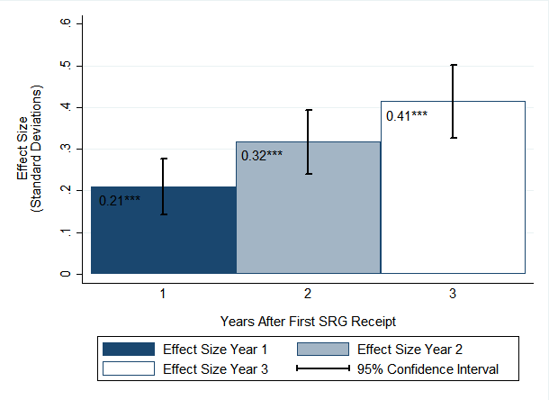
* p < .01, ** p < .005, *** p < .001
Figure 6. Mathematics Achievement Score Effect Sizes by Years After First SRG Receipt
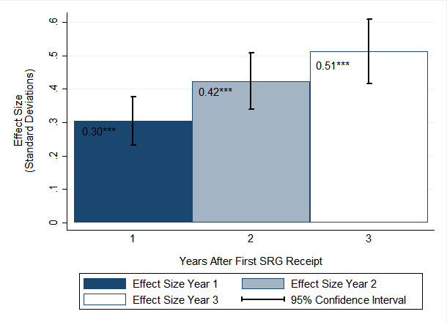
* p < .01, ** p < .005, *** p < .001
The impact study found the following:
- When considering prior achievement trends, students in the SRG schools performed better on the ELA and mathematics sections of the Massachusetts statewide student assessment compared with students in comparison schools.⁶ The effects were statistically significant after the first, second, and third years of SRG implementation on both the ELA and mathematics assessments.
- Positive effects of SRG on achievement were found for elementary school students in Grades 3–5 and middle school students in Grades 6–8 across all 3 years after implementation on both the ELA and mathematics sections. For high school students in Grade 10, positive effects were found across all 3 years for mathematics, but not for ELA.⁷
- Positive effects on both the ELA and mathematics sections were found in all 3 years of program implementation in Boston and Springfield as well as for all remaining districts combined.
- SRG receipt was associated with a decrease in the achievement gap on both the ELA and mathematics sections between ELL and non-ELL students and between students who did and did not have FRPL status in SRG schools, as compared with the change in the achievement gap between students in the comparison schools. These effects were found in all 3 years of program implementation. For students with special education status compared to those without, results indicate a decrease in the achievement gap in the second and third years after implementation for ELA, and only in the second year for mathematics.
- Subgroup analysis by cohort also found positive and statistically significant impacts one, two, and three years later for all cohorts contributing to the analysis in both ELA and mathematics. The one-year impact in ELA for Cohort III is the only exception, being positive but insignificant.

Conclusion
The results from this evaluation suggest that the disbursement of federal Title I School Improvement Grants in the process designed by ESE (as SRGs) have consistently positive effects on student academic achievement. Moreover, these results are generally robust across districts, grade levels, and cohorts of grant recipients, and they are particularly strong for students who are ELLs or have FRPL status.
⁶ The Massachusetts Comprehensive Assessment System (MCAS) examination was used for the years 2007–14, and both MCAS and the Partnership for Assessment of Readiness for College and Careers (PARCC) were used in 2015. Prior to the 2014–15 school year, the primary measure of achievement used to standardize was MCAS student raw scores. Because some schools took PARCC in 2015, PARCC and MCAS theta scores were used to standardize instead to be able to combine and compare results from both assessments in that year.
⁷ Impact estimates found for Grade 10 students in English language arts were positive in magnitude but not statistically significant, which may be explained by the smaller sample size.

Overall

III. Findings
This section describes the overall and subgroup analyses for each subject, first including descriptive analyses of the outcomes, and then results of the CITS analyses.

Descriptive Analysis
Figures 1 through 4 show the mean standardized state scores for ELA and mathematics proficiency by grade and time period for SRG and never-SRG schools in the sample. Vertical lines indicate SRG time receipt for each cohort.
Between 2007 and 2015, mean ELA and mathematics standardized scores remained relatively flat for elementary and middle schools that never received an SRG within districts where at least one school received an SRG (see Figures 1 and 2). These never-SRG-funded schools performed approximately one half of a standard deviation lower, on average, compared with the mean performance of all schools in the state, and this performance remained stable over the 9-year period observed. Schools receiving SRGs performed worse during this period, particularly in the years prior to receiving SRGs where they scored between .75 and 1.25 standard deviations below the state mean for most measures. All five cohorts of SRG schools serving Grades 3–8, however, show steady score gains since SRG receipt, substantially narrowing the gap between them and never-SRG schools by 2015. For instance, at the time Cohort I schools received their SRGs in 2010–11, the gap between these schools and the never-funded-SRG schools was approximately .75 and .50 standard deviations in ELA and mathematics, respectively. This gap had shrunk to approximately .25 in both subjects by 2014–15. This pattern can be observed across SRG cohorts, with the caveat that Cohorts IV and V show a pattern of declines prior to the SRG receipt, whereas the pretrend is more stable for the other cohorts.
Tenth-grade scores show a similar pattern for never-SRG schools—a relatively flat trend and scoring approximately one half of a standard deviation below the state’s mean performance (see Figures 3 and 4). As for SRG schools, they show an overall pattern of declines in mean scores prior to SRG receipt, but with steady gains afterward. Cohort II is the exception, having overall gains after first SRG receipt, but with a slight decline in ELA scores during the first year of SRG receipt. Across cohorts, the gap in scores between SRG and never-SRG schools consistently narrows after receiving the grant compared to pretrend years close to SRG receipt.⁸
⁸ Cohort I was removed from Figures 3 and 4 given that none of the SRG schools in that cohort consistently served students in Grade 10 over the period of analysis (2007–15). Harbor and Dearborn high schools are the only schools with student scores in Grade 10, but starting from 2013–14 and 2014–15, respectively.
Figure 1. Mean Standardized ELA Score for Schools Serving Grades 3–8 by School Year and First SRG Receipt
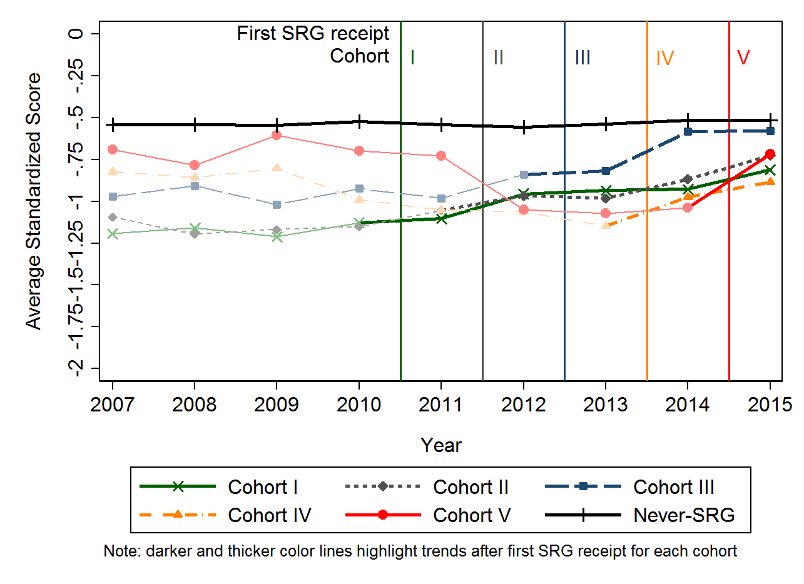
Figure 2. Mean Standardized Mathematics Score for Schools Serving Grades 3–8 by School Year and First SRG Receipt
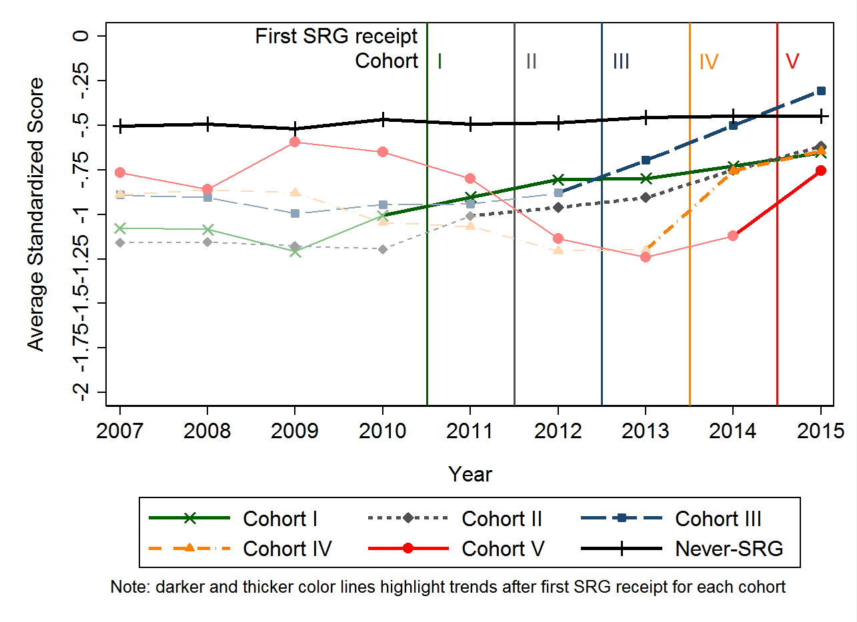
Figure 3. Mean Standardized ELA Score for Schools Serving Grade 10 by School Year and First SRG Receipt
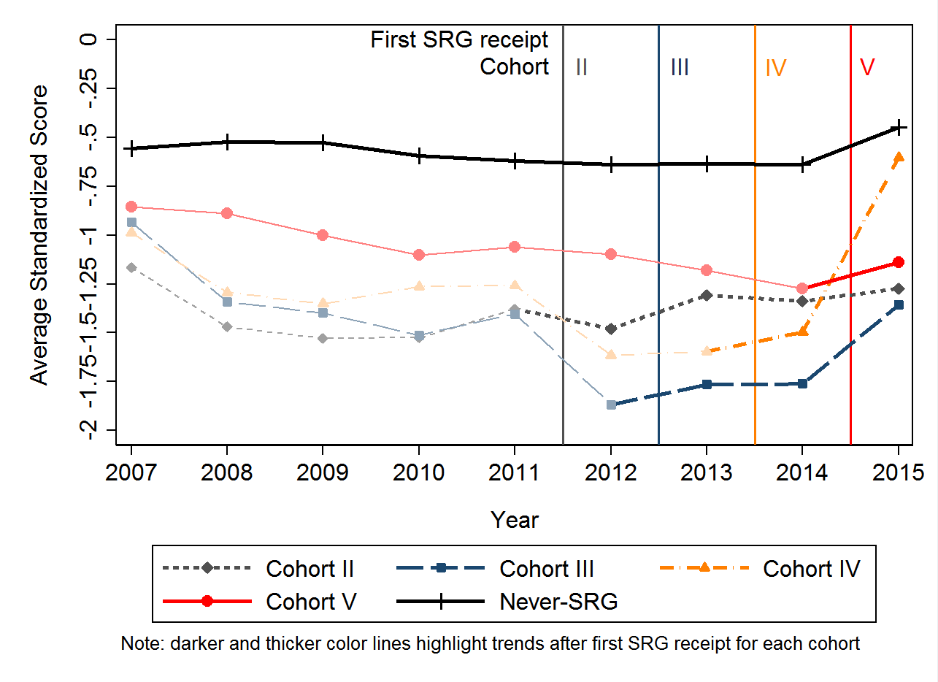
Figure 4. Mean Standardized Mathematics Score for Schools Serving Grade 10 by School Year and First SRG Receipt
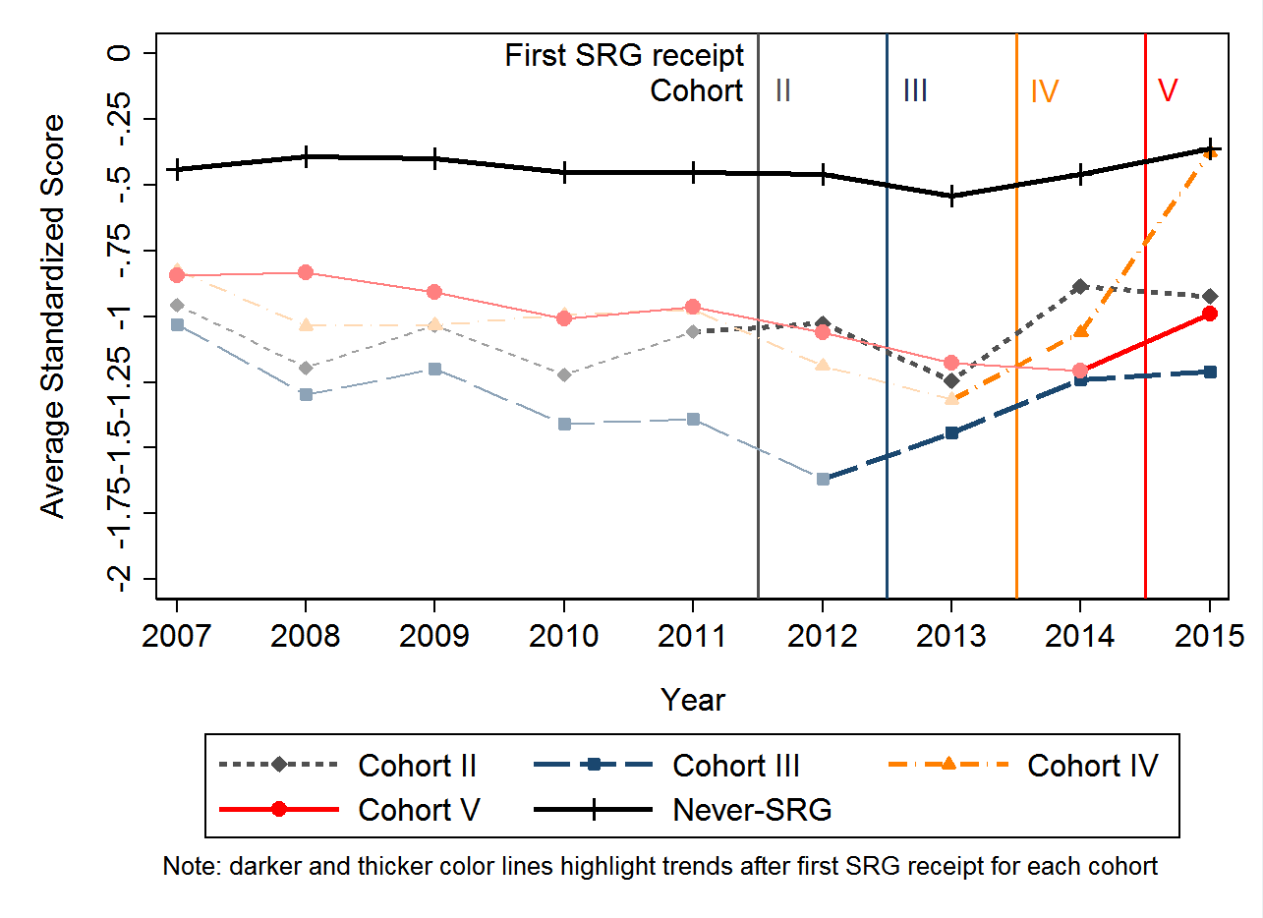

By District
Figure 6. Mathematics Achievement Score Effect Sizes by Years After First SRG Receipt
* p < .01, ** p < .005, *** p < .001

Subgroup Analyses
Subgroup analyses were conducted based on district, student grade level, special student population classification, and cohort. The findings are summarized in the following subsections.
District. The district subgroup analyses find a statistically significant positive impact of receiving an SRG one, two, and three years later for all three district subgroups: Boston, Springfield, and all other districts, in both ELA and mathematics (Figures 7 and 8).⁹ This finding suggests that results from the overall analysis are not driven by one specific district. (Tables C1, C2, and C3 in Appendix C show full results.)
⁹ Districts were divided into these three groups because Boston and Springfield each accounted for approximately one third of the total number of SRG schools, while the final third consisted of a small number of schools from the remaining districts that did not allow for individual district analyses.
Figure 7. ELA Achievement Score Effect Sizes by District and Years After First SRG Receipt
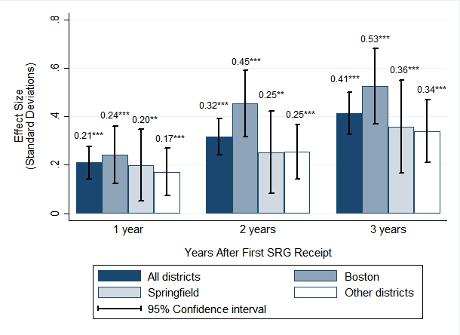
* p < .01, ** p < .005, *** p < .001
Figure 8. Mathematics Achievement Score Effect Sizes by District and Years After First SRG Receipt
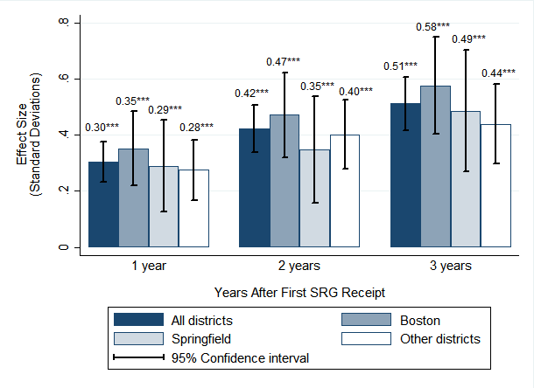
* p < .01, ** p < .005, *** p < .001

By Grade
Subgroup analyses by grade range found a statistically significant positive impact of being in a school that received an SRG one, two, and three years after SRG receipt in both ELA and mathematics for students in Grades 3–5 and for students in Grades 6–8. The magnitude and statistical significance are larger for the elementary grades, especially for the one-year estimates. For students in Grade
10, one-year through three-year impacts are positive and significant in mathematics, but not in ELA. See Figures 9 and 10. It should be noted, however, that because of the much smaller number of high school students observed in SRG schools, it is more difficult to capture a statistically significant effect. (Tables D1 through D3 in Appendix D show the full results.)

Special Student Population Classification
The special student population analyses identified two robust statistical differences in the changes in achievement gaps between the SRG and comparison schools (see Table E1 in Appendix E). First, the achievement gap between ELL and non-ELL students decreased on both the ELA and mathematics assessments relative to the achievement gap between similar students in the comparison schools; these results were significant one, two, and three years after program implementation (Figures 11 and 12). Second, the ELA and mathematics achievement gap between students who received FRPL and those who did not similarly decreased relative to the achievement gap between these groups of students in the comparison schools one, two, and three years later (Figures 13 and 14). There were no statistically significant changes in the special education/non-special education achievement gap in SRG schools as compared with comparison schools in year 1, but were significant for both outcomes in year 2 and only for ELA in year 3 (Figures 15 and 16).
Figure 9. ELA Achievement Score Effect Sizes by Grade Range and Years After First SRG Receipt
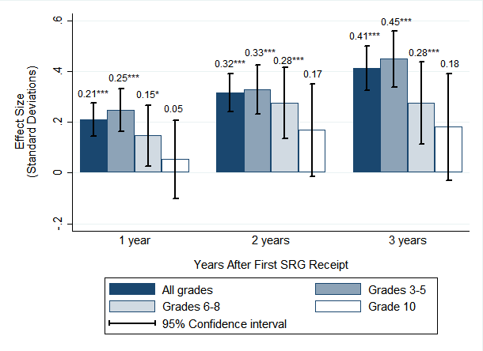
* p < .01, ** p < .005, *** p < .001
Figure 10. Mathematics Achievement Score Effect Sizes by Grade Range and Years After First SRG Receipt
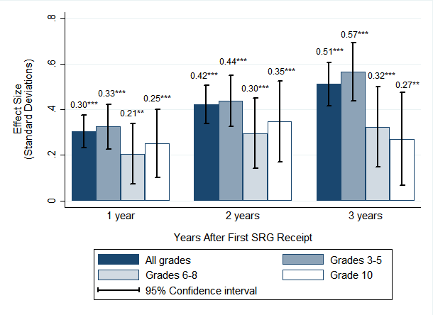
* p < .01, ** p < .005, *** p < .001

By Subgroup
English Language Learner
Figure 11. ELA Achievement Score Effect Sizes by English Language Learner (ELL) Status and Years After First SRG Receipt
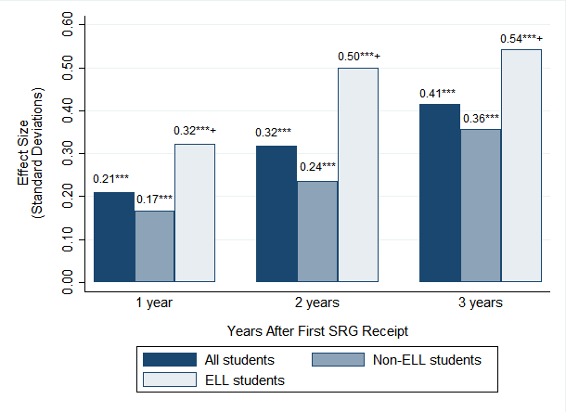
* p < .01, ** p < .005, *** p < .001; + significance refers to the subgroup difference (subgroup – nonsubgroup)
Figure 12. Mathematics Achievement Score Effect Sizes by English Language Learner (ELL) Status and Years After First SRG Receipt
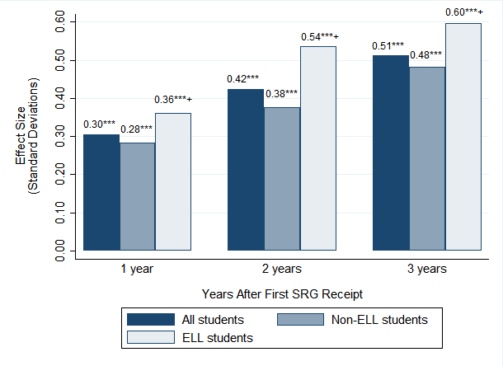
* p < .01, ** p < .005, *** p < .001; + significance refers to the subgroup difference (subgroup – nonsubgroup)

By Subgroup
Free Or Reduced-Price Lunch
Figure 13. ELA Achievement Score Effect Sizes by Free or Reduced-Price Lunch (FRPL) Status and Years After First SRG Receipt
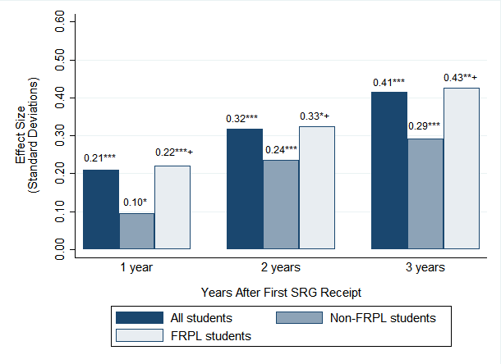
* p < .01, ** p < .005, *** p < .001; + significance refers to the subgroup difference (subgroup – nonsubgroup)
Figure 14. Mathematics Achievement Score Effect Sizes by Free or Reduced-Price Lunch (FRPL) Status and Years After First SRG Receipt
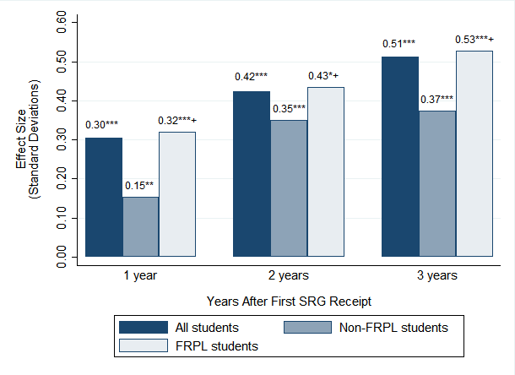
* p < .01, ** p < .005, *** p < .001; + significance refers to the subgroup difference (subgroup – nonsubgroup)

By Subgroup
Special Education
Figure 15. ELA Achievement Score Effect Sizes by Special Education Status and Years After First SRG Receipt
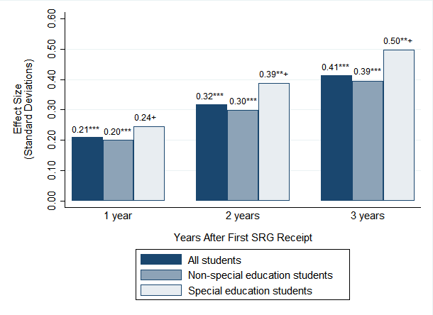
* p < .01, ** p < .005, *** p < .001; + significance refers to the subgroup difference (subgroup – nonsubgroup)
Figure 16. Mathematics Achievement Score Effect Sizes by Free or Reduced-Price Lunch (FRPL) Status and Years After First SRG Receipt
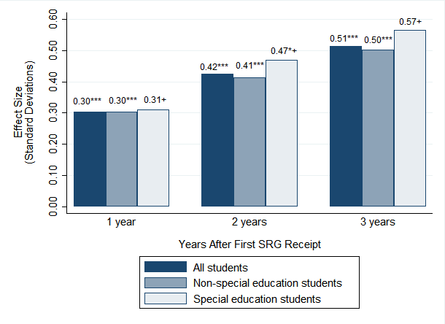
* p < .01, ** p < .005, *** p < .001; + significance refers to the subgroup difference (subgroup – nonsubgroup)

By Cohort
Subgroup analysis by cohort also shows positive and statistically significant impacts one, two, and three years later for all cohorts in both ELA and mathematics (Figures 17 and 18). The 1-year impact in ELA for Cohort III is the only exception, being positive but insignificant. Impact estimates consistently increase over time for all cohorts. This finding suggests that the results from the overall analysis are not driven by any given cohort. (See Tables F1 and F2 in Appendix F for the full results.)
Figure 17. ELA Achievement Score Effect Sizes by Cohort and Years After First SRG Receipt
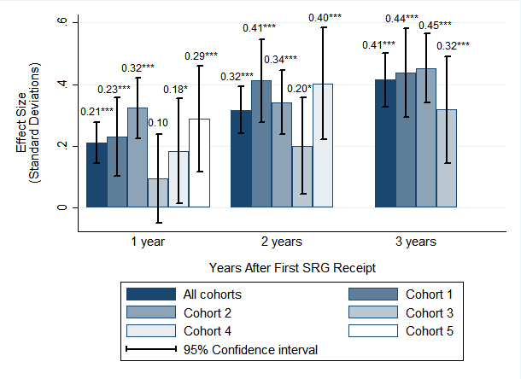
* p < .01, ** p < .005, *** p < .001
Figure 18. Mathematics Achievement Score Effect Sizes by Cohort and Years After First SRG Receipt
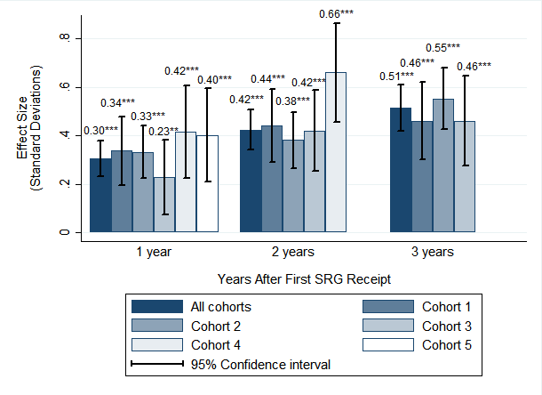
* p < .01, ** p < .005, *** p < .001

4 Field Guide

Introduction
Since 2010, the Massachusetts Department of Elementary and Secondary Education (ESE) has classified schools into Levels 1 through 5, based on absolute achievement, student growth, and improvement trends as measured on standardized state assessments. Level 1 represents schools in need of the least support—those that have met their gap-closing goals—and Level 5 represents the lowest performing schools, in need of the most support (and, in fact, have been placed under state receivership). ESE’s District and School Assistance Centers and Office of District and School Turnaround, in particular, provide ongoing targeted support to Level 3, 4, and 5 districts and schools. In addition, for the past several years, ESE has committed substantial resources to developing research-based tools specifically designed to support continuous school improvement in the state’s lowest performing schools and districts (see Appendix A). This guide adds to the state’s existing catalog of tools and resources available to schools and districts either embarking on or in the midst of turnaround.
The 2016 Massachusetts Turnaround Practices Field Guide builds upon the 2014 Turnaround Practices in Action report, which documented four interconnected practices used in Level 4 schools (priority schools in the lowest 5%) that increased student achievement and exited Level 4 status, and the 2016 Evaluation of Level 4 School Turnaround Efforts in Massachusetts, which illustrated specific practices that are characteristic of improving and exited schools.
For more information on accountability and assistance in Massachusetts, please visit: http://www.doe.mass.edu/accountability/

Cross-Practice Themes
- Turnaround Leaders
- Improvement Mindset
- Alignment
Although the turnaround practices offer a useful structure for organizing the key activities and strategies that successful turnaround schools often implement, our ongoing analysis of how schools engage in successful and sustainable turnaround highlighted three themes that cut across the four practices. These themes tend to characterize successful turnaround schools. Although findings from the 2014 Turnaround Practices in Action report suggest that district actions and systems of support impact a school’s ability to achieve successful turnaround as well, these themes focus at the school level.
The cross-practices themes exemplify the overarching culture of successful turnaround schools and may provide another useful lens for thinking about what successful turnaround requires, beyond implementing discrete structures, policies, and practices.
Cross-Practice Themes

Turnaround Leaders

Theme 1: Turnaround Leaders who have a sense of urgency, expertise, and relational leadership skills
Leadership in successful turnaround schools is characterized by certain attributes, features, and actions that, according to the research on leadership and school improvement (Hallinger & Heck, 2010; Seashore Louis, Leithwood, Wahlstrom, & Anderson, 2010), appear to be particularly important in turnaround schools working to dramatically improve student achievement. What is equally important for those engaged in turnaround is to consider these attributes as crucial ingredients for a successful turnaround effort, and to ensure that such leadership attributes are in place and are actively supported by district and state policies.

Core Turnaround Leadership Attributes
- Sense of urgency: The new principal (and, often, a new leadership team) comes fresh to the school, willing and eager to take on the challenge of turnaround. The principal and leadership team have a strong sense of urgency to change the lives of students in the school and are willing to “do whatever it takes” to improve. The principal has a mantra of high expectations and no excuses and communicates this clearly and consistently to staff, ensuring that all teachers believe that they can directly impact their students’ achievement regardless of the students’ circumstances.
- Expertise: The principal and leadership team come to the school with a strong understanding and knowledge of what an effective school looks and feels like, organizationally and instructionally, and a proven track record of success in similar situations. They have expertise in educational best practice, especially regarding what rigorous instruction looks like and requires, and they know that a major part of the work involves infusing this knowledge among and across the entire school community. Building off their understanding of educational best practices, the principal and leadership set a few key non-negotiables and expectations for instructional practices and student behavior. The principal and administration are in classrooms daily, providing feedback to teachers in terms of non-negotiable instructional expectations. Giving and receiving feedback is valued by all instructional staff and part of what it means to be a professional.
- Relational: The principal has a deep understanding of leadership as relational and involving the building of trusting and collegial relationships across the school community. The principal understands that a key piece of the work is to build an organization in which leaders and teachers “like to work together,” where there is shared ownership of students, and where teachers are empowered to learn from one another as colleagues. This is accomplished by providing teachers with the skill, time, and trust to bring their own issues, or problems of practice, to the surface and work through these issues collectively.

Improvement mindset

Theme 2: Improvement mind-set that permeates all behaviors, decisions, discourse, and actions
Successful turnaround schools are characterized by an “improvement mind-set.” This is a schoolwide culture in which leaders and teachers work closely with one another to actively identify and address specific problems of practice. (Different schools use different terminology, e.g., learning mindset, and may define the broad concept slightly differently.) Successful turnaround schools integrate this improvement mind-set into the core functions of teaching, such as developing and modifying lesson plans, providing rigorous core and tiered instruction, and using data to provide students with targeted interventions. When schools identify and then address a problem of practice, it is imperative that they have and maintain an improvement mind-set, so that teachers work collectively to improve their individual and joint efforts to improve instruction and practice. This way, they learn from each other through the process, rather than trying to improve in isolation from one another, with classroom doors closed.
Approaching problems of practice with an improvement mind-set happens when leaders and teachers identify key issues or challenges that are influencing their ability to improve student learning (e.g., schedules and staffing challenges, students having trouble with open-response questions, academic vocabulary, or evidence-based argumentation, and lack of instructional alignment) and then work collectively (in grade-level teams, in vertical teams, or across the entire school community) to solve this problem. Some school leaders use an adaptive leadership model, which the original theorists define as a “the practice of mobilizing people to tackle tough challenges and thrive” (Heifetz, 2009, p. 14).
Cultivating and then using an improvement mind-set is not, however, something that happens overnight or that can be left to chance. Cultivating an improvement mind-set requires a leader with turnaround leadership attributes, such as expertise, relational trust, and a sense of urgency, as well as a commitment to setting high expectations for teachers and creating the conditions in which teachers are willing and eager to work together to solve a common problem, are trusting enough to acknowledge that they may not individually have the answers to every challenge, and take ownership for the success of all students. It is also important that school leaders develop multiple teaming structures—a matrix of grade-level teams, vertical teams, and student support teams—and support teachers in using these structures effectively. Developing a system of high-functioning teaming structures and communication channels often accelerates problem diagnosis; the development, implementation, and testing of new practices; and the sharing and spread of practices that work.
“There’s too much for one person to do, there’s too much for two people to do. We had to go at it from a team approach from the very beginning. The way I understand the adaptive model is that, presenting issues come in, you vet out and decide what’s the most important thing that is pressing upon the success of the organization. Then you, as a team, come up with solutions and ideas to try to resolve those issues, and you try it out. If it works and it’s a positive contribution to the outcomes and the goals, then you institutionalize the effort across the school or across different grades.” —Union Hill Principal

Alignment

Theme 3. Highly consistent, aligned, and rigorous instructional practices
Successful turnaround schools have developed tightly aligned and consistent curricula, expectations, instructional strategies, and assessment tools. What is potentially new about this theme is the extent of the alignment and consistency and the ways in which teachers (often with the support of administrative leaders) are working together to develop vertically and horizontally aligned instruction and instructional strategies, which have clear implications for schools engaged in accelerated improvement and turnaround.
What do consistency and alignment mean in practice? Although the degree of consistency varies from one school to the next, successful turnaround schools are places in which teachers in each grade level have developed common units and lesson plans and are teaching the same lesson to their students within the same week, if not the same day. Within each lesson, teachers have developed and are using similar prompts, note-taking techniques, and common strategies to support students in accessing the content of the lesson. Across grades, teachers have analyzed the standards and not only know precisely what students need to know and be able to do from one grade level to the next, but also intentionally use standards-aligned key words, phrases, and essential questions, taught and reinforced in earlier grades, to support students. Each lesson, within and across grades, is similarly structured (e.g., entry work, activators, exit tickets), and behavioral expectations are the same, across the entire school. Rigorous instruction, aligned to the Massachusetts Curriculum Frameworks is, by definition, consistent and aligned across content and grade levels. Students then know exactly what to expect in each class and can employ the same tools to access information. According to leaders and teachers in exited Level 4 schools, consistency in instructional strategies, language, and general classroom management removes barriers to learning for English language learners (ELLs) and high-need students, in particular, who may struggle with academic language.
To an outside observer, the work in such schools may appear highly routinized and prescriptive. However, teachers collectively have a great deal of autonomy, and the work is often perceived as more “owned” and more valuing of teacher expertise, because teachers have developed common lessons, routines, and instructional strategies collaboratively rather than individually. Often, grade-level, team-developed strategies are rolled up to the school after testing, reflection, and evidence of impact. Tight alignment and consistency of instructional practices reduce instructional variability across the school, making it easier to develop, implement, and test new instructional strategies, and to then scale up effective strategies across the entire school. These schools are effective learning organizations with the infrastructure and know-how to quickly and effectively implement proven instructional and organizational improvements.

Sustained and Stable Staffing
Sustained staffing is another essential aspect of a successful turnaround effort, contributing to teachers’ willingness to work intensively and deeply on core problems of practice and to fully implement a consistent and aligned system of instruction and assessments. It is particularly important for ensuring that the school is not hindered by policies that might lead to unintended shifts in staff that would, in turn, undermine efforts to develop and maintain highly consistent and aligned.

Strategic Turnaround Actions:
The First 100 Days
Through multiple interviews and focus groups with school administrators, instructional coaches, teachers, and external partners, some initial steps and strategic actions emerged as important processes in starting to turn a school around.¹⁰
What schools did in the initial 100 days of turnaround and the remainder of Year 1 and beyond is important to understand and consider. How schools used resources and employed certain strategies prior to and during the first year is presented here as a set of strategic actions taken by leaders, often in response to a myriad of needs and challenges facing the school. These actions are not a step-by-step recipe for success; however, it does seem that there is a flow to the work and certain issues that must be addressed for any turnaround school seeking to pursue similar immediate and sustained gains.
First, the district must get the right leaders and teachers in the building.
Then, school leadership and teachers must prioritize and tackle the following key actions: (1) establish teacher agency and ownership by recalibrating the mind-sets of teachers through, for example, targeted professional development and professional learning communities; (2) establish collaborative teaming structures to improve instruction; (3) ensure a safe and secure environment for students; and (4) provide leadership and collegial support to teachers. These actions—all in the service of improving instruction—occur simultaneously, in an ebb and flow that is context- and school-specific. But whereas the order and intensity of effort in each of these actions may be school-specific, what is clear is that schools must attend to these issues to move forward successfully.
Moving forward, schools that take these actions put in place the conditions for a successful Year 1 and ongoing work, through collaborative teaming, targeted professional development, and collective work on key problems of practice.
The following pages provide succinct overviews of each strategic turnaround action, including evidence from the schools profiled.
¹⁰ As a reminder, the observations and strategic actions presented in this section stem from detailed conversations with four schools and a review of current and past monitoring site visits. These actions are presented as a guide rather than a recipe for success.

Six Strategic Actions

Get the right teachers and leaders in building
The start of any turnaround work requires hiring a principal who can determine what needs to be done and who has been successful in leading a school with a similar population of students. Cross-practice theme 1 describes a turnaround leader as a person with:
- a strong sense of urgency to do what it takes to improve the lives of students in the school;
- an exceptionally strong understanding and knowledge of what an effective school looks and feels like, organizationally and instructionally;
- a deep understanding of high-quality, rigorous instruction;
- a deep understanding of relational leadership that builds trusting and collegial relationships across the school community; and
- an ability to continually reflect and adjust practice as needed.
Second to the hiring of a proven principal who possesses turnaround leadership attributes is ensuring that the principal has the autonomy to build a leadership team (often including colleagues with whom he or she previously worked and who share a common vision) and to select and hire staff willing to engage in the hard work of turnaround. Screening and hiring might involve the new principal interviewing all potential returning staff and asking hard questions to assess the degree to which the teachers in the school believe that their students can achieve, and also the degree to which they want to take on the challenge of working in a turnaround school.
Developing a strong administrative team and a core group of teachers provides an initial reservoir of capacity and expertise. These core staff can model effective practices, provide guidance to teachers on their instruction in the classroom, and lead and model effective use of common planning time.
Third, districts must ensure that principals are able to keep the teachers who have both the skill and will to do the work, and that teachers are secure in their positions and not faced with the uncertainty of being discharged from the school – teachers who want to work together should be able to continue to do so.
“She [the principal] came in and completely tried to change [the school], and it worked successfully…during that turnaround process, everyone re-interviewed with the leadership, and you decided whether or not you wanted to be here because it was going to be a lot of extra work and extra time.” —Union Hill Elementary School Profile
Six Strategic Actions

Establish teacher agency, ownership, and urgency: Start building the community immediately
Once the leadership and teachers are hired for the opening of the school year, it is important to immediately start building a community of practitioners who will be able to overcome challenges and work together productively. To do so, the principal and leadership team start the year by providing a formal opportunity—a summer retreat, for example—for community building, reinforcing teachers’ collective agency, and focused work on developing curriculum and instruction (and other issues, as the work progresses).
The initial summer retreat may be 2 or even 3 weeks, focused on specific planning for the coming year (e.g., identifying an instructional focus, developing behavioral expectations) and on building community. A summer retreat held away from the school grounds provides an environment that supports relationship building, where plenty of time is given for small groups to work together outside (e.g., at the beach, at a retreat setting) as they plan for the upcoming year. In the process, staff get to know one another and begin to build a sense of community.
Part of summer planning also involves considering ways to change the physical look and feel of the school prior to the school year, or other “quick wins.” Giving the school a face-lift by cleaning and painting hallways and classrooms, developing “model” classrooms, and ensuring that students and parents are welcomed on the first day (and going forward), for example, are equally important actions that can instantly cultivate support both from and with the school community.
“Nobody had worked together. And we, the school district, decided that the two Level 4 schools, if we wanted to start some professional development and organize a new plan for the building, it would be nice to have an outdoor event with everybody to meet. That’s what we did. We had some professional development inside. We had some group work outside. We had lunches. We wrote our school pledge for the building. We came up with thoughts on how we would run classes with interventionists coming in. We worked on schedules. We planned our first year out during that week.” —Connery Elementary School Profile
Six Strategic Actions

Establish collaborative teaming structures to improve instruction
Crucial to initiating and maintaining momentum is establishing collaborative teaming structures both to improve instruction and to build collective responsibility and capacity across the school. Specifically, this entails establishing vertical and horizontal teams and sharing practices and expectations across teams, as well as linking grade-level and vertical teams with the school’s overall leadership team. More generally, leadership “builds a collective learning organization” by establishing a schedule, structure, and strategic use of resources that allow for the ongoing collaborative teaming necessary to ensure a schoolwide focus on curriculum, instruction, and assessment. A robust teaming structure, coupled with instructional supports and frequent classroom visits, is the mechanism through which instructional strategies are quickly implemented, shared, evaluated, and calibrated.
Although developing highly effective and efficient teams (e.g., teams that use data, improve instruction, target supports) often takes multiple years to develop and refine, there are a few early actions that can help a school become expert collaborators, implementers, and learners.
- Establish a vertical and horizontal teaming structure. In elementary and middle schools, this may involve daily, grade-level common planning time, whereas high schools may use a combination of content- and grade-level team structures.
- Set clear expectations for how the team time is used, including expected outcomes from each meeting. Ensure that key specialist staff (e.g., coaches, ELL and Special Education staff, guidance counselors) participate in relevant teams, establish norms for collaboration, and provide teachers with training on teaming practices and facilitation.
- Initially, leadership and/or coaches may play a more prominent role in teachers’ team meetings, but over time the team meetings must become teacher-driven and teacher-owned, to the extent that administrators rarely take the lead in any grade-level or vertical team meetings, including instructional leadership team meetings.
- Organize and staff leadership teams so that they are informed by the participation of their members in all other meetings, and information regarding any needs or challenges can move freely between the leadership team and the other teams.
Six Strategic Actions

Ensure a safe and secure learning environment
At the beginning of the school year, it is likely that school climate and student behavior in particular will be the very first challenge that needs to be addressed so that teachers can teach and students can learn. It is crucial to begin the school year with a clear set of behavioral expectations that both students and educators understand and follow consistently.
To ensure that the hard work of the summer, including planned instructional interventions, is not derailed during the first year, leadership must recognize that student behavior may require immediate attention, especially in Year 1. Leadership must prioritize setting clear behavioral expectations, applying consistent consequences, implementing strategies to build and maintain positive adult-student relationships, and providing students with rewards and additional supports to help them regulate their own behavior.
Prior to the first year:
- Develop a system to clearly communicate behavioral expectations (among students and between teachers and students) and to address situations when these expectations are not followed.
- Be diligent about setting expectations and deliberate in ensuring that responses and supports are consistent throughout the school, across all staff and all classrooms.
- Provide all staff with adequate initial training on how to implement a student behavior system and ongoing and targeted support for implementation throughout the year.
- Consider whether consistent implementation of the behavior system will require any staffing or structural changes, and hire or reallocate staff as needed. Use data to monitor implementation.
“We did begin to build strategies and ideas of how to handle disruptive behaviors in a whole, schoolwide way, so rather than having emergencies only here, we were able to not have emergencies all day long, so the teachers were able to have control within the classroom.”
—Union Hill Elementary School Profile
Six Strategic Actions

Provide leadership and collegial support
Turnaround is hard work. It is not just about implementing a set of practices in a predetermined manner, or implementing a research-based practice with fidelity. Turnaround involves individuals and teams of professional educators attending to daily challenges that, if left unaddressed, would undermine their ability to fully meet the academic and social-emotional needs of all students. The reality of turnaround is that some initiatives, no matter how well planned, may not be successful. Recognizing the difficulty of this work and being resilient in the face of challenges is a common characteristic of exited Level 4 schools and the schools profiled in this guide.
Leaders of successful turnaround schools know that the work is hard, and that it is part of their job to provide staff (teachers and leaders alike) with positive support and continual encouragement. Without positive reinforcement, some teachers may not be able to weather the constant pressure and workload. Effective turnaround leadership involves listening to colleagues, actively providing support, and posing suggestions and offering feedback to improve instruction. It requires distribution of leadership, mainly because there is so much to do that the work could not be accomplished by a single leader, administrative team, or two or three eager teachers.
The leaders of the schools profiled in the 2016 Massachusetts Turnaround Practices Field Guide each had a keen awareness of the importance of relationships and the relational trust among leaders and teachers, and in providing support to teachers as professionals with the expertise to identify issues (e.g., problems of practice) and to develop solutions, when given the time and skills to do so.
“Everyone at this school has an ownership to the process. You’re not afraid to say, “Oh, let’s do this and see what kind of improvements we will bring,” because you know that if it makes sense, she’s not going to tell anybody, “You can’t do that because it was not my idea,” so let’s go with it and see what it takes. That’s the type of mentality that every staff member has in this organization.”
—Burke High School Profile
Six Strategic Actions

Sustain and maintain turnaround efforts long-term
The first 100 days of turnaround may look different from school to school, but schools that establish effective methods of working together are well-positioned to move forward to quickly improve core instruction and raise student achievement. In the first year, intensive training for teachers on priority practices (e.g., teaming practices, core instruction, and student behavioral systems), coupled with frequent classroom visits and feedback by administrators, sets the stage for ongoing, focused work on improving and providing rigorous, high-quality core instruction.
Moving forward, specific problems of practice are identified, addressed, and solved by teacher teams, building teachers’ capacity to continue to look at their evolving needs. Establishing an agreed-upon problem of practice sets clear expectations for improving core instructional practices. The problem of practice then becomes the content—the what and the how—that is discussed within and across grades, as teachers assess the impact of various. In the first 100 days, work to identify some of the long-term problems of practice that will take years of applied work to solve. What distinguishes this work from traditional continuous improvement is the intensity of the efforts and number of problems of practice that must be addressed simultaneously; for example, there may be far more frequent team meetings needed, and changes to strategies may need to take place more often and more quickly.
Much of the work that is done early will be continued (and built on) throughout the turnaround effort, and a focus on establishing these ongoing strategies can help set the stage for long-term gains. Ongoing strategies for successful turnaround include the following:
- Using multiple data sources to collectively identify a problem of practice. Ongoing analysis of data and observations, reflection, and assessments continue to help identify problems of practice. Becoming skilled and efficient in this approach early in the turnaround process will yield dividends for years to come.
- Training up through aligned and intensive professional development. With the identification of a problem of practice, a summer institute or retreat allows for extensive professional development and the crafting of shared expectations in pursuit of that focus across the school. Starting this process quickly—but methodically, with an eye to the future— helps to ensure valuable effort and resources are not wasted.
- Designing, examining, and improving core and targeted instruction. As the school year unfolds, grade-level team meetings, vertical team meetings, and content area team meetings, along with targeted training during the school year for key staff, focus on how to address the problem of practice, by incorporating new strategies or practices into planning and co-constructing solutions.
- Using collaborative teaming structures to accelerate improvement. Throughout the school year, leadership and teacher teams use inquiry cycles or a version of the plan-do-check-act (PDCA) process to quickly assess how well the strategies are working.
- Leadership to support, monitor, and reinforce the joint effort. Leadership uses ongoing classroom observations, review of student work, and formative assessments to constantly monitor and assess progress in the identified priority area.

School Profiles
The following profiles explore how four schools that exited Level 4 status implemented certain practices and strategies that contributed to successful turnaround. The profiles provide a context-specific description of how particular strategies were implemented and how they contributed to increased student achievement in each school. The specific strategies profiled here are characteristic of successful turnaround schools described in the 2016 Evaluation of Level 4 School Turnaround Efforts in Massachusetts report.
Appendices are referenced throughout the individual school profiles. These appendices can be accessed from: http://www.doe.mass.edu/turnaround/howitworks/turnaround-practices-field-guide.pdf

School Profiles:

Connery Elementary School

Introduction

Strategy: Using instructionally focused teams to provide aligned core and tiered instruction to all students
When Dr. Mary Dill came on board as the new principal of the Connery School in 2010, she told current staff that there was going to be a collective effort to significantly increase student achievement, and that the school would be much different than it had been in the past. She kept a few core staff members, but hired many outside teachers willing to join in the work and embrace the challenge. The principal focused first on establishing and enforcing consistent behavior and learning expectations, in a school in which students were used to limited consequences, and her team established high expectations for family involvement. Then the leadership team tackled the significant work necessary to improve instruction.
Connery Elementary School’s leadership team developed streamlined and tightly focused teaming processes built around grade-level, vertical, and instructionally focused leadership teams throughout the school. A team of two curriculum instructional teachers, a math specialist, and an English as a Second Language (ESL) specialist work with grade-level teams (meeting daily) and with content-specific vertical teams (meeting weekly). The team focuses on the development, review, and assessment of curriculum and instruction throughout the year, ensuring consistency and efficacy of instruction across content areas and grade levels. Vertical and horizontal alignment of curriculum and instruction and ongoing use of assessments and tiered interventions (individually and in groups) in the classroom, along with targeted professional development, has brought significant academic gains.
In talking to the staff, it is clear that everyone at Connery feels that they are part of the process of planning, assessing, refining, and improving their instruction—at the classroom level and throughout the school.
For the Connery Elementary School video profile, go to: Turnaround Practices in Achievement Gain Schools Video Series
School Profiles:
Connery Elementary School

Profiled Turnaround Practices

Using teaming structures to vertically and horizontally align instructional strategies
The teaming structures at Connery Elementary are tightly integrated and mutually supportive; they include a leadership team, an instructional support team, and grade-level and vertical teams.
Connery’s leadership team meets weekly to review progress across the school’s other teams, address any issues or challenges identified through team meetings or classroom visits, and monitor the professional development activities of the school. The school has a program specialist who serves as a manager, helping to facilitate meetings and provide instructional guidance and feedback through classroom visits.
The instructional support team is the instructional “glue” of the school, attending most of the grade-level team meetings to assist with lesson and unit planning, ensuring that instructional supports are keyed to specific units and activities. Beyond the typical role this type of team would typically play (e.g., providing ideas and resources to instructors), Connery’s instructional support team members serve as the first line of instructional assistance, which most schools would consider their tier 2 supports. For example, when students are identified as needing additional support, the team’s curriculum instructional teachers and math specialist are the ones providing assistance, either working with small groups or individual students.
The instructional support team relies on data from teachers’ frequent, “quick check” assessments and end-of-lesson assessments (“summarizers”) to monitor student progress. The team’s curriculum instructional teachers or math specialist can use the data to provide additional instructional guidance to teachers so that students master the targeted lesson objectives.
“We have a “quick check” assessment. You can already flag some kids that need help right there, so they might do some independent work. As you’re seeing the kids struggling, the special education or ESL or curriculum support person might pull certain kids… If they’re still struggling after the summarizer, there’s an opportunity the next day.” —Teacher
School Profiles:
Connery Elementary School
Profiled Turnaround Practices
Grade-level teams meet daily to co-plan lessons and units, review curriculum, and assess student outcomes and needs. Each grade-level team includes grade-level teachers, a curriculum instructional teacher, a math specialist from the instructional support team, a special education teacher, and an English as a second language teacher.
The vertical teams meet weekly to plan, review curriculum and instruction, and assess outcomes and needs within content areas across multiple grades. These teams provide a mechanism for developing common instructional practices and language, and for ensuring that common instructional practices are consistently used and implemented across the grades. Teachers and specialists review data together and use these to adjust instruction. They also work together to make sure that lessons for different grades use similar instructional tools, such as concept maps, and contain consistent academic vocabulary so that students can build on their existing knowledge as they progress through the grades. The vertical teams become a central clearinghouse for developing and calibrating common language, instructional strategies, and assessments that can be used throughout the school.
The Connery system of ongoing daily and weekly interactions across all staff ensures aligned curriculum and instruction from grades K–5. Teachers use similar instructional strategies, prompts, and vocabulary within and across grades. The team structures also ensure that a focus on improvement is being pursued throughout the school; the entire school community pursues practices that better promote their students’ ability to achieve, and that mirror and reinforce the efforts of the school’s other teachers and leaders.

Example in Practice

Unit Lesson Planning
Several years ago it became apparent that filling out the district unit planner was taking teachers a great deal of time and was sometimes overwhelming. A school leader proposed a more practical unit planning tool that would enable teachers to hone in on the objectives, activities, and assessments of a unit and that could then inform grade-level and vertical team planning.
Now all of the grade-level teams and the vertical team use this planning tool (see Appendix C1 for an example). The tool includes quick checks, independent practice, and a summarizer. The quick checks are short, formative assessments; the “summarizer” is a simple, end-of-class assessment handed in to the teacher that lets the teacher know how the class is doing and which students might need additional

Employing customized solutions so that all students receive the supports and instruction needed to succeed
The collaborative teaming structures at Connery Elementary help the school continue to improve and better meet the needs of all students. The efforts put in by the teams have resulted in a body of carefully fine-tuned instructional practices the staff can draw on to ensure that all students are given the opportunity to achieve.
Using formative assessments for immediate response to student needs. Early on in Connery’s turnaround efforts, the school struggled to find ways to identify student needs and respond effectively. For example, the school found that its periodic assessments did not always allow for the responsive in-class assistance that they felt was needed to support all students on a daily basis.
The school’s new awareness of this gap in its assessment approach coincided with a district professional development offering on the use of formative assessments. Instead of simply requiring that teachers attend the district professional development, Connery’s leaders asked the teachers whether it would be useful to make formative assessments the focus for the year. Once the full teaching staff bought in to this year-long commitment, the school participated in the district training.
One of the practices demonstrated during this professional development was using quick assessments during class to identify whether or not students understand the content. To implement this strategy, teachers started using a new iPad-based tool that allowed them to easily identify each day whether a student needed additional guidance or instruction on the day’s material. As the school’s program specialist described it, the tool allowed staff to ask students a question “halfway through a lesson.” The specialist explained, “Doing the formative assessments on a daily basis [identifies] a different kid every day.… That immediacy is very helpful:—‘Look, we have these problems; we can fix this right now.’” The tool has allowed teachers to “check in” with students and then immediately use small-group or individually targeted assistance to meet the students’ instructional needs.
“We were teaching and we were checking in at 2-, 4-, [and] 6-week intervals. By the time we got to that checkpoint, we’re realizing that they missed something 5 weeks ago, and because of that, [the problems] just snowballed.” —Teacher
Decoding standards-based lesson objectives. As is common practice in many schools, early in their turnaround effort, Connery Elementary teachers were required to post their standard-based objectives on the board and review them with students at the beginning of each lesson. The teachers began to realize that these objectives needed to be explained to students—especially English learners—in more student-friendly terms. To address this challenge, fifth-grade teachers at Connery piloted a strategy focused on ways to make the “decoding” of objectives more user-friendly. For example, consider the following objective:
Students will be able to make inferences about the sequence of events of the Jr. Iditarod race by identifying words that signal chronology. (RI5.5)
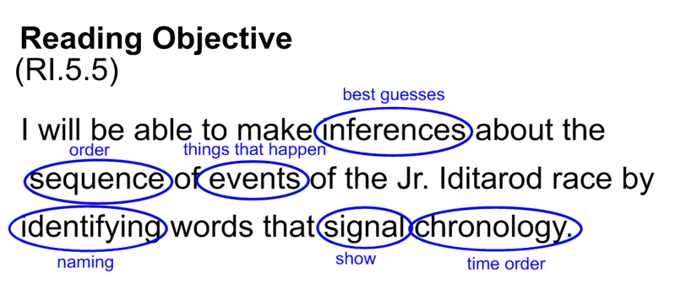
Fifth-graders may not know or understand some of these key terms, and thus may not understand the objective at all. The teacher would ask the students whether there were any words they did not understand, and then ask the class to try to define that term in their own words. In this case, the class decided, for example, that inferences were akin to “best guesses,” sequence meant “order,” events meant “things that happen,” and chronology was “time order.”
After the fifth-grade team’s experimentation with the strategy, other grade-level teams began to use it, and eventually the school community decided to formally adopt this practice schoolwide. Now every student, regardless of grade level or classroom, is familiar with this practice, and teachers can be certain that all students understand what the learning objectives mean.
Example in Practice

Using Vertical and Grade-Level Teams to Align Instructional Strategies and Language
Facilitated by the math specialist, the vertical team examined how students are exposed to base 10 numbers at the earlier grades and how they are taught to perform addition/subtraction and multiplication/division with base 10 numbers in the later grades (see Appendix C2). Starting with the specific strategies that teachers in early grades used with students to work with base 10 numbers and number operations, the team highlighted key concepts and vocabulary being used, so that teachers of later grades could reinforce and build on this learning.
This example illustrates how the conclusions of the vertical team are reported back to each grade-level team, who then use the information to ensure that all teachers within each grade use the same approach when teaching the same material.
Through these vertical and grade-level alignment efforts, the entire school can ensure that student learning—vocabulary, skill development, and content knowledge—is built coherently year by year, regardless of which teacher a student has in each grade. This overall approach to all instructional content has been particularly useful in providing supports to students in the later grades who are struggling.
“When you get into the classroom, it’s not just, “All right, boys and girls, let’s read this objective out loud.”… Now the kids are forced to really dig deep and own when they’re learning for that day and for that unit. It gives them a deeper understanding throughout the lesson and throughout the week and the month that “I own this objective. I really know what I’m learning, what I need to learn.”… They like looking at those big words and saying, “I know what that means, I understand that, I can explain that to my friend.” As the kids come up through the grades, they know in September, “All right, boys and girls, we’re going to code our objectives.”” —Program Specialist
School Profiles:
Connery Elementary School

Profiled Turnaround Practices
Today at Connery Elementary, the standards-based objectives are posted at the beginning of each lesson, coded by students, and then used and referred to during the lesson. Over time, students become familiar with the practice, and become fluent in using that practice in the classroom.
Several other practices have been investigated and eventually adapted or developed to serve the staff and students in the school. Examples include common and schoolwide use of academic language, higher order thinking in the classroom, concept maps for developing and presenting units, and success criteria for students (see Appendix C3: Connery at a Glance for a comprehensive list of teaming structures and interventions).
“We focused on not just creating worthwhile formative assessments, but where to strategically place them with the unit so we could use them to readjust practice or adjust practice.” —Teacher

Example in Practice

Using formative assessments for immediate instructional responses to students’ needs
- Each student has a QR (Quick Response) card that can represent a different answer to a question provided by the teacher.
- After posing a question, the teacher quickly scans the room as each child holds up his or her answer card, and the teacher immediately identifies students who are correctly or incorrectly responding to the question.
- Depending on how the students respond:
- The teacher might decide to review the material with all students once again, with full knowledge of the various ways his or her students answered.
- Or the specialist can work with only those students who were identified as needing further assistance, as preplanned during grade-level meeting and as specified in the lesson plan.
School Profiles:
Connery Elementary School

Discussion
Connery leaders established multiple purposeful teaming structures designed to improve instruction by creating consistency across grade levels and content areas. The teams meet regularly to provide staff structured opportunities to share knowledge and reflect on promising instructional practices. Each year, leaders and teachers develop a coordinated plan for using unit planning, grade-level, and vertical team meetings to implement and refine new strategies and supports. These collaborative structures help the school continuously improve achievement schoolwide.
Based on the problems of practice Connery Elementary School identified and addressed, and the lessons the school community took away from those challenges, consider these discussion questions about your own experience:
- To what extent do staff in your school share a common understanding of expectations for instruction? To what extent do those expectations vary across the school? How would you describe the impact of any variation you notice?
- What ideas from Connery’s experience can you apply to improve the consistency of expectations?
- What systems or structures, e.g., regular vertical team meetings, are already in place at your school to ensure consistent alignment of instruction across grade levels and content areas?
- Based on what you learned from the Connery profile, what specific steps could staff (school leaders, teachers, and other staff) take to improve consistency in instruction across grade levels and content areas?
“It’s really deciding as a school, “What’s going to help us get better? What’s going to help us improve learning?”” —Program Specialist
School Profiles:

Union Hill Elementary School

Introduction

Strategy: Using an adaptive leadership model to create a high-performing school
When Marie Morse came on board as the new principal of Union Hill Elementary, she interviewed the staff and observed what was happening throughout the school. It became clear that there were too many issues for any one person to address—it would take a team approach. The principal quickly recruited staff she already knew and respected, including an assistant principal, an instructional coach, and a lead teacher, urging them to transfer their knowledge, skills, and experience to a low-performing school that needed them. Together, these staff would be jointly responsible for modeling the mind-set, beliefs, and practices needed to make a significant impact in the school.
The Union Hill Elementary School principal and leadership team engaged teachers in addressing high-priority issues. The principal describes this as “adaptive leadership”; the school’s leaders have used this approach in implementing new evidence-based practices, such as daily common planning time, frequent professional development focused on specific problems of practice, and classroom walk-throughs focused on instruction and behavior. As the school has rolled out these practices, teachers have been given meaningful roles in identifying challenges as they appear, and in deciding how to address those challenges.
For the Union Hill Elementary School video profile, go to: Turnaround Practices in Achievement Gain Schools Video Series
School Profiles:
Union Hill Elementary School

Profiled Turnaround Practices

Establishing an improvement mind-set¹¹
Prior to the beginning of the first year of turnaround, the principal interviewed all of the staff. She emphasized that the work would be difficult, and asked teachers for their take on their students’ capacity to achieve. These interviews revealed a pervasive “deficit model” attitude toward the school’s students; getting rid of this mentality and instilling a “can do” culture became a top priority.
The principal used a 3-week summer institute before Year 1 to set the stage for the first year. She used the time to develop her relationship with the staff and their relationships with each other, and to establish a collective mind-set that every student could, and would, achieve at high standards. One activity was a book study of Quiet Strength, by former NFL coach Tony Dungy. Some teachers questioned the importance of a “football book,” but staff later cited the exercise as a critical first step. Conversations about the theme of the book—that an organization with a “can do” and “no excuses” attitude can overcome adversity—coupled with the intentional relationship-building among teachers and between administrators and teachers, laid the groundwork for the staff to work together and persevere through a difficult first year. (Subsequent summer institutes continued to motivate staff and emphasize improved instruction; see Appendix D1 for a sample document from the 2015 institute).
According to the principal, staff members were “good, caring, loving teachers who wanted to make a difference” who had not had access to the needed “tools and ideas and ways to teach the kids that we have in front of us today.” From the vantage point of the teachers, the empathy and support the principal displayed at the institute and throughout Year 1 were critical—she “listened” to the teachers and understood their needs, resulting in a tailored approach that staff could rally behind.
¹¹ See page 45 for a general definition of improvement mind-set. Individual schools may develop their own nuanced working definition, or may use a different term for a similar concept.
“She came in and she listened to [us]. That was her first step. She didn’t come in with all these changes….By listening... she [found out] what needed to be changed…. Providing support for her teachers led to success for the kids.” —Teacher
School Profiles:
Union Hill Elementary School
Profiled Turnaround Practices

Establishing clear behavioral expectations and encouraging positive behaviors
The school leaders sought to address behavioral challenges immediately and create an environment where teachers could teach and students could learn. The school implemented a color-coded system with three levels—dependent, almost there, and independent—that lets students earn points for specific positive behaviors. Through building relationships with students, increasing trust between teachers and students, and getting students to believe in their own ability to succeed, the system was intended to reinforce positive behaviors and discourage disruptive ones.
To help teachers adapt to this new system, the principal provided professional development on “what disruptive behaviors mean, and what lies beneath,” and how to give feedback to students about their behavior. The school leaders also encouraged regular communication with parents about student behavior, both positive and negative. Students were sent home with behavioral notices to remind parents of the school’s student learning and behavioral expectations and to reiterate that positive behavior leads to privileges and misbehavior has consistent consequences. With a system in place that the staff understood and could help enforce, behavioral challenges began to subside, allowing the focus to turn to improving instruction.
“If you were a ‘dependent,’ that means that our trust level was at the point where you had to depend on me and I had to depend on you in order to get through the day. ‘Independent’ means I can step away from you a little bit more. I trust that you can make good decisions and so I can back away. And then there were certain privileges that they could get with each of those levels.” —Teacher
School Profiles:
Union Hill Elementary School
Profiled Turnaround Practices

Using common planning time to drive turnaround efforts
Establishing formal, daily common planning time was one of the first structural changes made by the principal and leadership team. This time was fundamental in supporting the teachers in planning instruction, aligning teaching strategies with other staff, and providing tiered instruction and student-specific supports. To make the time useful, the leadership team initially provided significant oversight and structure; many teachers had never had this time built in to their schedule, and had little knowledge of how to use it.
The eventual goal was for the teachers to take ownership of this time together. To this end, norms and teaming practices were established and modeled, both during the common planning time and through professional development. Teachers gradually took ownership of the time as their comfort level increased and as they became more adept at using the time as a resource.
Common planning time became the primary vehicle for improving instruction. Because the school’s targeted professional development was a major focus, with significant amounts of time set aside for it, it did not need to be explicitly integrated into the common planning time. This allowed the planning time to focus on other important topics. There were three major uses of the planning time:
- Engaging in specific planning, such as joint lesson planning and developing and aligning curriculum and instructional strategies
- Analyzing data and formally assessing student work (see Appendix D2) to gauge the effectiveness of strategies and adjust instruction as needed
- Sharing instructional strategies, including information gathered by team members during instructional rounds
The precise role the common planning time played in the turnaround effort is illustrated in the following examples of practice. As one teacher saw it, the planning time “is one of the [most], if not the most important” practices the school implemented, allowing time every day for teachers to discuss “those students in front of you and in the class next door to you” and compare notes on “what worked and what didn’t, and what their day looks like, and what everyone’s day looks like.”

Example in Practice

Common Planning Time
- Grade-level teams meet daily at 7:40 a.m. for 45 minutes.
- Teams are trained in teaming practices, common norms, and standard protocols.
- Teachers set the agenda, aligned with relevant grade-level issues and schoolwide instructional priorities.
- Teams focus on a specific category of practice on the same day each week (e.g., “Looking at Students’ Work Wednesdays”; “Tech Thursdays”).
School Profiles:
Union Hill Elementary School
Profiled Turnaround Practices

Conducting classroom walk-throughs and instructional rounds
Union Hill’s leaders—the principal, assistant principal, lead teacher, and instructional coach—started visiting classrooms daily. The principal and assistant principal visited seven to nine classrooms each day, using a Walk-Through and Teacher Reflection Form (Appendix D3) to provide teachers feedback and individualized, targeted support.¹² During the challenging first year, feedback was intentionally positive:
As the leaders developed rapport with teachers, and as the school’s environment improved, they could then be more specific about their expectations.
In the first two years, the school was inundated with new approaches and systems. To address the problem of practice this presented—the challenge of implementing multiple programs simultaneously—only certain grades or groups of teachers would pilot each new program for two to three weeks. Other teachers would participate in focused instructional rounds, modeled after the “grand rounds” used in the medical profession, to observe the strategy. These rounds allowed teachers to see a strategy and ask questions before implementing it in their own classroom; the discussion of what teachers had observed often took place during the common planning time.
The rounds also gave the school a chance to work through any challenges with the pilot teachers, rather than having the entire school struggle. According to the principal, “It brought together all kinds of ideas for you, and gave you a way to start with implementing that program, because we had so many [programs] at one time, you couldn’t possibly get through all of them.” The rounds allowed the school to scale up programs that worked and to discontinue those that did not work, without undergoing a whole year of trial and error.
Eventually, instructional rounds became a general-use tool—not just for new program implementation. The rounds let teachers regularly experience how others teach, and let teachers build capacity in practices of their own choosing.
¹² The statewide model system for educator evaluation also hinges on regular constructive feedback from evaluators, coupled with opportunities to reflect on and improve practice.
“One week would be vocabulary, and three or four people would be set up where you would actually go around into their class and watch them teach the vocabulary. Or maybe we would implement Making Meaning or another program, Go Math, and you would go around and watch three or four teachers teaching Go Math.” —Teacher

Calibrating and improving instructional practice
For Union Hill, establishing trust, cultivating teacher agency, and instituting key structures like common planning time and instructional rounds provided the foundation for intensive work toward improving instruction and meeting the needs of all students. One example of this focus on improved instruction is the professional development on writing instruction that was provided in Year 1, and the series of events that followed it.
After the professional development had taken place, school leaders noticed the student work posted in classrooms and hallways—displayed because it received high marks on the scoring rubric—was of inconsistent quality, both in terms of student writing and in the feedback provided by the teacher. As the lead teacher recalled, “When we entered the building and we saw the writing that was on display, it was a little alarming to us.” To address the lack of consistency in scoring and feedback they were seeing, the leadership team sought age-appropriate examples of good writing from peers at other schools.
Then the school leaders set up multiple opportunities for teachers to review their students’ writing and compare it to these examples from other schools. In a series of three after-school faculty meetings, teachers first reviewed and scored their own students’ writing (frequently giving a score of 3 or 4 out of 4). Then the teachers reviewed the exemplars. This was followed by discussion of the differences in content and ratings, and what these meant for the teachers’ own expectations of student work. In the context of the provided benchmarks, teachers were able to see ways their students’ writing could be improved. (See Appendix D4 for an example of guidance that was provided to the teachers in one of these meetings.)
The meetings also led to continuing discussions about instructional strategies the teachers could use to help their students write better, and teachers visited one another’s classrooms to observe how their peers employed the practices identified. The ultimate outcomes were changed instructional strategies, better feedback, and improved student writing.
In addition to this writing-instruction example, Year 1 professional development also focused on organizing and running centers, use of assessments, and raising student reading and writing achievement. In subsequent years, teachers themselves began to create professional development activities for the school, and the annual summer institute and monthly staff meetings evolved into opportunities for teachers to learn from and with one another. The teacher-centered, practice-based work helped drive the school’s continued improvement efforts.
“They took those exemplars back into their classrooms, and they projected those on those walls to those kids. They showed them exactly what was being scored a 3 or 4 and what we as a school were doing. They said to their kids, “We will not turn in a 1 or a 2. We will be scoring 3s and 4s.””—Lead Teacher

Discussion
The principal’s guiding belief is that all students can learn. On top of this foundation, the principal’s development of the school community and her use of teams to mobilize and assist all of the teachers in the building were important factors in Union Hill’s successful turnaround. She has also ensured that staff are equipped with the tools and supports necessary to facilitate learning. Extensive use of specific strategies such as classroom observations and instructional rounds have also helped ensure continuous opportunities for improvement. As a direct result of these efforts, Union Hill Elementary School now provides a supportive and effective learning environment for all students.
Based on the problems of practice Union Hill identified and addressed, and the lessons the school took away from those challenges, consider these discussion questions about your own experience:
- To what extent has your school implemented a culture of high expectations for all students? What are some obvious signs, particularly for students and families, that this culture exists? What more might be done to extend this culture of high expectations?
- What systems or structures (e.g., common planning time, peer-based classroom observations, etc.) are already in place at your school to support continuous individual and collective improvement? And how do those systems or structures function to support that? What more might be done to encourage continuous individual and collective improvement?
- Based on what you learned from the Union Hill profile, are there any new programs or strategies your school could pilot in a few classrooms, and use as a learning opportunity for all staff, instead of rolling out all at once to the whole school?
- Union Hill used student writing samples and scores from other schools to calibrate teacher expectations. What specific problems of practice could your school investigate by calibrating with other schools?
School Profiles:

UP Leonard Middle School

Introduction

Strategy: Creating a safe learning environment and meeting students’ social-emotional needs in order to create a foundation for providing rigorous instruction to all students.
In 2012, the James F. Leonard School was in need of a significant turnaround. The school climate was not conducive to student learning, with students often acting out, leading to more management of student behavior than teaching and learning. Students’ needs were not being met, either academically or with respect to social and emotional learning. When the school’s district came under state receivership, the school gained the autonomy to make significant changes. In fall 2012, the James F. Leonard Middle School was closed, and restarted as UP Academy Leonard, with a new principal and staff, and operated by Unlocking Potential, a proven school turnaround operator. Having had the opportunity to observe the school in 2011–12, the incoming principal identified three interrelated issues—significant behavioral issues, a lack of effective instruction, and students’ social-emotional needs—that needed to be immediately addressed. The first priority was to get a handle on student behavior—what the principal and staff called “the ground floor” of the needed changes.
Early in the turnaround process, the UP Academy Leonard principal used her budget autonomy to build a school-based team composed of a school psychologist, a social worker, and a liaison between UP Academy and Lawrence Public Schools responsible for ensuring compliance with special education laws. Under the leadership of Principal Komal Bhasin, the school also developed an integrated system for setting, monitoring, and reinforcing consistent behavioral expectations, and linked this system to an in-house approach to meeting the social and emotional needs of students. The school’s staff and leaders all understand that behavior is a form of communication, and is important to learning, and the school depends on data related to schoolwide behavior and learning expectations to identify and provide targeted supports to high-risk students.
“We focus a lot on joy… celebrating the work that we do together. The easiest way to turn around the culture of the room is to get kids feeling positive, feeling invested, feeling excited about what they’re doing. I think recognizing the work that they do is part of what builds that.” —Principal
School Profiles:
UP Leonard Middle School

Profiled Turnaround Practices

Employing a sophisticated, consistent, and student-specific system for monitoring and reinforcing behavioral expectations
The first priority was to ensure that the entire staff used a consistent set of common behavioral expectations for all students, across all classrooms (see Appendix F1 for the school’s Behavioral Intervention Plan Overview). The school took pains to make sure that every teacher responded the very same way to the same student behavior. Consistency was, and is, considered essential.
UP Academy Leonard’s students are expected to be attentive and engaged in the classroom: eyes forward, actively listening, responding to questions, doing one’s work, and collaborating with peers constructively when asked. In the classroom and throughout the building, staff actively monitor and reinforce these expectations and address issues through a variety of rewards, responses and supports as necessary. At the beginning of each school year, new and existing students participate in a multiday orientation, where they review student behavioral expectations (see Appendix F2) to ensure that all students and teachers understand what is expected. All new teachers receive training on specific techniques, hand signals, and ways of speaking with students. During the school year, the principal and administrators visit classes every day to observe and provide support to teachers on their execution of the academic and behavior-oriented routines and responses, focusing on consistency within and across grades.
UP Leonard’s system awards “merits” to reinforce positive behavior, and uses “demerits” to signify to students when behavioral expectations are not being met. The school grants merits (through a system called “Pride Points”) for positive behaviors such as following classroom norms and helping other students. The emphasis is on reinforcing the positive behaviors, and on “nurturing joy” in the building. The school aims to award three times as many merits as demerits; ending up with more demerits than merits over the course of a day or a week is unusual.
Each Friday afternoon, students throughout the school participate in a “reward activity,” which may involve an activity such as dodgeball, basketball, or a dance competition. Each student begins the week with 90 “pride points,” and if by the end of the week the student has at least 70 points, he or she can participate in the reward activity. In addition, there are monthly “Joy” events, which can range from academic events (such as a spelling bee) to parent-engagement activities (for example, a family block party). These activities are intended to boost student investment in the school (see Appendix F3 for the school’s “Joy Calendar”).
What happens if a student is not following expectations? The teacher simply tells the student that he or she has a demerit for the specific behavior. This statement is carefully delivered in a manner that is not disrespectful or unkind, and without a raised voice. The teacher and the student take note of the demerit and quickly return to the lesson content, without taking up much instructional time or emotional space. This is a very important tenet of the system—provide demerits and feedback without additional fanfare while being as neutral as possible. In the majority of cases, the classroom lesson simply carries on. Over time, the behavior system feels more natural to students and becomes simply part of the way the school operates.

Examples in Practice

General Behavior and Learning Expectations
- Eyes on the teacher
- Responding when asked
- College posture
- Positive interactions with peers
- Engaged in the lesson

Setting and Maintaining
Behavioral Expectations
There is a family handbook that has it all written out, but in class you are sitting up straight; you are tracking or looking at the person who’s speaking. Those are [the same] for every classroom for every teacher in every setting; we see our students who really struggled with behavior in their last school feeling pretty empowered by those. I think for sixth graders there’s a month-long adjustment period, but once those kids master those rules, they have a lot of control over what happens because it makes the school environment more predictable.
School Profiles:
UP Leonard Middle School

Profiled Turnaround Practices

Using teams to diligently monitor and use student behavior data to support students
UP Academy Leonard goes beyond just expecting fidelity across classrooms. Staff actively monitor the assigning of merits and demerits to identify issues at either the staff or the student level. Every Monday, grade-level team leaders meet to review the numbers and kinds of merits and demerits given across teachers and students throughout the week, through an online data dashboard. The dashboard allows the team to review whether an atypical number or ratio of merits or demerits is being given by a particular teacher, or in a particular class, or to a particular student. Cohort leaders can then investigate any of these cases. This system ensures that there is consistency in how behavior is being monitored and reinforced throughout the school, across all teachers and classrooms, and it is also a way to identify whether a particular student may be in need of additional support.
Providing tiered and targeted responses to students’ behavioral needs. Upon a review of student needs in a cohort meeting, the team may decide to move forward with student-specific interventions, using a tiered approach. In keeping with the focus on positive reinforcement and rewards, a Tier 2 response includes a clearly articulated set of expectations regarding how the student can accumulate merits day to day (see Appendix F4). In some cases, the team might decide that a more nuanced approach might be necessary to ensure that a student remains engaged in the classroom and does not act out negatively. In these cases, the team, with assistance from one or more members of the in-house student support team, may develop a more detailed plan to help the student, with specific guidance on how the student can adjust his or her responses and behavior and how the teachers can more directly assist the student when certain behaviors are occurring.
The Deans of Students: Maintaining consequences while building relationships. Along with the classroom-specific responses, students may be referred to one of UP Academy Leonard’s two Deans of Students. The Deans of Students focus on supporting student behavior and providing behavioral assistance throughout the school. Directing a student to the Dean’s office is done in a respectful manner to avoid escalating the misbehavior of the student.
In the Dean of Students’ office, the student is given a reflection packet, which asks the student to reflect on what he or she did and how he or she could have responded more appropriately. The Dean of Students reviews and discusses the completed packet with the student. Then the Dean of Students and the student make a plan regarding what the student could do next time to better reflect the expectations of the school. After this conversation, the student returns to class. According to one of the Deans of Students, this “processing” is “really powerful,” and is “something that they didn’t get in their last school” that helps “teach them in the moment.”
In this way, the student is afforded the opportunity to reflect upon and review his or her behavior with the Dean of Students outside the classroom environment. At the same time, the Dean of Students is able to build a personal relationship with the student and to better help the student with his or her behavior in the future.
Upon return to the classroom, the student gives the teacher a written apology and resumes work. The teacher is to formally “check in” with the student within the next 24 hours to (1) acknowledge the behavior and (2) check in about the behavior and expectations moving forward. This is an opportunity for the student and teacher to acknowledge what happened and to ensure that the student is able to continue in a positive manner in class; it helps the teacher build a relationship with the student that is focused on providing continued support and assistance.

Building teachers’ instructional and organizational capacity to meet the needs of all students
UP Academy Leonard’s initial efforts to establish a safe and secure learning environment for students and teachers laid the foundation for teachers to provide ongoing rigorous and high-quality instruction to students. Once again leveraging the school’s autonomy, the school staff developed a customized approach to building teachers’ instructional capacity, described as a professional “pathway” for teachers.
The pathway uses locally identified and vetted research-based resources (e.g., practices, materials, examples, research synthesis, school-based materials) located on a dedicated web portal and organized in different categories (or components), as determined by the school. The pathway begins with ensuring that teachers have mastered the fundamentals of the school’s system for monitoring and reinforcing student behavior. Once a teacher has mastered behavior (based on outcomes and tracked by the principal and teachers), the principal and the school’s two instructional coaches provide training to ensure that each teacher is using high-quality instructional materials with students. Each subsequent component of the pathway focuses on specific aspects of high-quality and rigorous instruction (e.g., differentiated instruction, checking for understanding, effective use of time) that collectively define what high-quality and rigorous instruction means at UP Academy Leonard.
Having two dedicated instructional coaches is, in the words of the principal, a “game changer.” The instructional coaches’ only job all day is to support teachers. At a minimum, each teacher is observed once every two weeks, for 40 minutes, followed promptly by a debriefing. The coaches also play a key role in supporting lesson planning, through their participation in weekly teacher-led unit planning meetings to develop instructional lessons and units. (The lessons are informed by UP Academy’s use of the Unlocking Potential suite of benchmark assessments.) The coaches attend weekly department-specific professional development meetings, to reinforce instructional expectations and vertical alignment of instructional strategies, and also attend weekly schoolwide professional development that focuses on common instructional practices and issues, such as tiered interventions or inclusion. The instructional coaches play a prominent role in all of these meetings, working closely with teachers and building teachers’ instructional and organizational capacity to meet the needs of all students.

Linking behavior and student support teams to provide ongoing and school-based social-emotional supports to students
To give every student the opportunity to be successful, UP Leonard established a full-time student support team—composed of a school psychologist, social worker, and liaison between the school and the district—that meets together regularly and works hand in hand with teachers and leaders to ensure that nonacademic needs are met.
As a full-time, school-based team, the student support team can provide a great deal of individual and collective support to students identified as needing additional non-academic support, and work closely with teachers, deans, and with the principal. Although many schools have guidance and in-house supports for students, what distinguishes UP Leonard is the real-time support that they are able to provide to all students. The behavioral management system provides detailed student-level data that allow the student support team to work closely with deans and cohort teams in real time to develop and implement student-specific interventions and tiered supports.
In addition to overseeing special education compliance, the special education specialist works across grade levels and content areas to identify accommodations, and works closely with the school’s Response to Intervention (RTI) team to develop interventions and assist with the tiered system of supports. The social worker works with students and families and assists in developing interventions. In addition to providing traditional evaluations, the school psychologist provides a significant amount of counseling and crisis management, and works regularly with teachers as well as the RTI team.
The homework club—a simple yet powerful example of an integrated approach. The student support team also creates opportunities to work with and develop supportive relationships with students. One example is the “homework club,” designed as an alternative to detention. Student support team members assist these students with their homework and use the time to informally monitor the students’ behaviors and engagement in school as a whole. In addition, of the students assigned to the homework club, the support team identifies those who would benefit from additional support in a one-to-one or small-group setting. Staff collect and review data to assess the degree to which the homework club is having a positive impact: school leaders track whether students in the homework club experience a decrease in demerits, as well as whether homework is turned in more often and whether grades have improved. Some students now choose to stay after school and go to homework club, either because they recognize that they need the help, want the help, or perhaps because they find the homework club to be a safe and supportive after school environment.
“Last year [a student came to our school from a large urban city], really disengaged. Very low skills.
A lot of emotional regulation issues sort of mixed in with that.… The biggest thing that has helped him improve is relationships. If he didn’t have the relationships he has with myself, with Emily, and with José, and his teachers, I don’t think we’d be seeing the success that we’re seeing now. He’s staying in class. He’s getting homework done. He’s asking for extra help, which he never did last year.… [Realizing] that he has this own team behind him is what has really pushed him to want to be successful.” —Support Team Leader
School Profiles:
UP Leonard Middle School

Discussion
UP Leonard’s system for monitoring and reinforcing behavioral expectations—and its particular emphasis on providing positive reinforcements and a sense of “joy” in the school—showcases one way a school can quickly and effectively create a climate that is safe, orderly, and respectful. Furthermore, UP Leonard provides an example of how a school community can support positive student behavior and work together to respond to the social-emotional needs of its students. The safe environment and the social-emotional supports allow teachers to focus on rigorous instruction, and allow students to focus on learning.
Reflecting on the lessons provided by UP Leonard Academy’s journey, ask yourself the following discussion questions about your own school:
- What staffing changes or additions, if any, would help your school be able to more fully address students’ academic and non-academic needs, including social-emotional needs?
- What systems and structures are already in place at your school to support a safe and respectful learning environment?
- What tools and training have teachers been provided?
- What supports have students been provided?
- How is behavior data used to make decisions about additional teacher training and/or student supports needed?
- Based on what you learned from the UP Leonard Academy profile, what other specific steps could your school take to create and maintain a safe and respectful learning environment conducive to teaching and learning?
- What more could teachers and students in your school achieve in teaching and learning through a safer and more respectful learning environment?

School Profiles: Jeremiah Burke High School

Introduction

Strategy: Empowering teachers to engage in teacher-driven, collective inquiry
The first few years of Burke High School’s turnaround effort were not unlike those of other schools. With a new principal on board, an increased sense of urgency, and heighted scrutiny from both the district and the state, the school experienced significant staff turnover (more than 50% of the staff), and opened up its doors to outside observation and inspection. The initial turnaround plan called for an immediate move to block scheduling; the school’s leaders delayed the change so that teachers could first be trained on how to take advantage of the 80-minute blocks, and so that the school leaders could take the time to build in the teaming structures necessary to leverage the new format. Once the new schedule was in place, the school focused on developing a collective learning organization.
Jeremiah E. Burke High School’s approach is based on the belief that real change requires an organization in which all members are always involved in the learning process and moving toward a common goal. To accomplish this, the school has, under the leadership of Principal Lindsa McIntyre, developed integrated teaming structures and has cultivated an environment of psychological safety in which all staff feel comfortable taking risks. Over time, through continual refinement and with support from external partners, staff at Burke have become empowered to engage in collective, deliberate inquiry focused on developing and improving instructional practice and student learning. The principal has also prioritized creating culturally relevant learning experiences and a psychologically safe environment for students, described in more detail as part of the Burke High School video profile. Taken together, these efforts have resulted in increased student achievement and sustainable improvement structures within the school community.
For the Burke High School video profile, go to: Turnaround Practices in Achievement Gain Schools Video Series
School Profiles: Jeremiah Burke High School

Profiled Turnaround Practices

Cultivating a learner mind-set¹³
Burke’s leaders believe that the foundation for improving teaching and learning lies in providing opportunities for teachers and staff to have open, two-way conversations in which they can speak freely. Having teachers engage in authentic, deliberate inquiry focused on real problems of practice related to teaching and learning is the essence of what Burke calls a “learner mind-set.”
Creating a “safe space” for teachers, cultivating what school staff refer to as psychological safety, was paramount for facilitating conversations and reflection that could lead to change in practice. Psychological safety allows teachers to openly acknowledge when they are having difficulty, and to ask for help without worry of judgment or recourse, so that staff can problem-solve together.
Creating psychological safety and a culture of collective inquiry were important for the school to move forward, but this did not happen overnight. There were several processes that contributed to Burke’s now well-established learner mind-set:
- Leaders continuously modeled behaviors (e.g., listening, asking open-ended questions, granting teachers autonomy to identify and solve problems, developing effective teaming structures) that reflected a belief in the power of cultivating a learner mind-set.
- Teachers received extensive training on teaming practices, and received training on common language and questioning strategies from an outside consultant. Teachers were given enough exposure to the concepts that teaming practices are now institutionalized, and are used widely across all teams.
- Burke High School held annual summer retreats to build relationships and community, in addition to setting goals and focus areas for the coming year.
The accountability pressures that came with being identified as a Level 4 school influenced the school’s staff in two ways: First, staff who may not have shared the vision of the school’s leaders left, and over time a staff with shared beliefs about students’ potential filled the roster, which set the stage for integrated teaming structures comprised of like-minded and committed staff. Second, the district and state visits and walk-throughs required that teachers open their doors to visitors, readying teachers for peer-based observations and instructional rounds.
¹³ See page 45 for general definition of improvement mind-set. Burke uses the term “learner mind-set” to refer to a similar concept.
“I think in the heart of that psychological safety is creating spaces for people to be open, honest, transparent, and [to] struggle and grapple without being evaluated.” —Principal
School Profiles: Jeremiah Burke High School
Profiled Turnaround Practices

Creating integrated teaming structures for collective inquiry
Multiple types of teams in the building meet regularly, with the goal of improving instruction and outcomes for students and ensuring that students’ social-emotional needs are met. The teams have different functions, but are highly integrated across team types, which promotes consistent, multi-directional communication among staff and teams, and between leaders and teachers. Although many high schools have similar teams, the way Burke overcame common high school scheduling challenges and the way these different types of teams work together to address schoolwide and content-specific problems of practice distinguishes Burke from other schools.
Data inquiry cycles. Much of the work of the school’s teams is structured around a “data inquiry cycle.” Developed in partnership with a local university, the data inquiry cycle gives the school’s vertical content area teams a formal, time-bound, data-based process for improving teaching and learning. In a typical cycle, teachers analyze student learning data related to a specific instructional focus and examine their current instructional practice. They generate hypotheses for how their instructional practice impacts student learning, develop strategies for improving practice or implementing appropriate interventions, and then implement these strategies. They gather evidence about changes in student learning and teacher practice and then modify instructional practices accordingly. Weekly data inquiry cycle meetings provide a formal and facilitated time for content area teams to meet; teams can then use their common planning time during the week to work on implementing the strategies introduced in those meetings (e.g., by developing shared units and lessons, or refining shared instructional strategies to be tested).
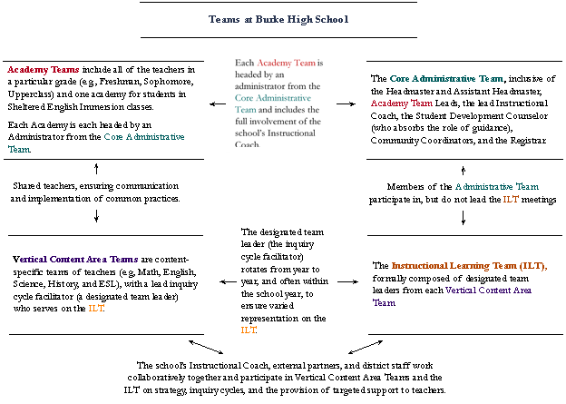
Vertical content area teams are composed of teachers who teach the same subjects in different grades. In addition to participating in a weekly data inquiry cycle meeting, team members meet together in daily common planning time for 65 minutes. Depending on the content area, teams often use this common planning time to accomplish the following:
- Review upcoming units and lessons and discuss how teachers could enhance them with specific instructional strategies drawn from professional development
- Consider teachers’ observations or student work to share and debrief
- Review videos of one another’s practices, as predetermined by the team
The work of vertical content area teams is not performed in isolation. For instance, each vertical content area team has a designated team leader who facilitates common planning time and data inquiry cycle meetings, and represents the team on the schoolwide instructional learning team discussed below. These team leaders share information from the vertical content area teams to the entire school and back, thus ensuring consistency and the spread of best practices. With this feedback and input, the team leader ensures clear, thorough communication between the vertical content area team and the instructional learning team and other school teams.
The instructional learning team, composed of these vertical content area team leaders and school administrators, meets twice a month after school to review the work of the school in relationship to the vertical content area teams’ data inquiry cycle processes. The instructional learning team reviews data, discusses progress made in data inquiry cycle groups, and considers issues related to resources and ongoing professional development. As a result, the work of the entire school is closely coordinated, and the resources and professional development that are needed to support the efforts of the school are kept up to date and relevant. According to one staff member, the vertical content team leaders, through their role on the instructional learning team, are “calibrating what’s going on across the school.”
The academy teams (freshman, sophomore, upper class, and sheltered English immersion [SEI]) are cross-content area teams that include all teachers and the school’s social worker, instructional coach, student engagement counselor, and community coordinator. Each academy has its own Early Warning Indicator (EWI) data review meeting once a week; these meetings are the basis for identifying the academic and social-emotional support that students need. Academy team meetings are used to address day-to-day issues, but they are also a means of learning and problem-solving within grade levels, reinforcing strategies developed through vertical content area teams.
Collective teacher inquiry focused on improved instructional practices. Burke High School has spent multiple years refining its use of teams, setting expectations for multi-directional communication, and cultivating trusting relationships and ways of working together. Through this hard work, Burke has become a learning organization in which formal opportunities for sharing, observing, and collective discussion of teacher practice are expected and welcomed by teachers, and have become defining features of what it means to be an educator at Burke High School.
Burke’s teachers can identify specific practices or strategies that they want to improve upon, implement these in their own classrooms, collect data on the results, and then share and reflect with others during vertical content area team meetings. Sometimes this means revisiting the results from a formative or summative assessment after having employed a particular strategy or activity, or discussing observations of students responding to an activity and identifying how well the strategy worked. Other times, members of vertical content area teams might examine and share their teaching by showing a video of themselves using a particular strategy or practice. In addition, the instructional learning team organizes opportunities for teachers to participate in instructional rounds, in which they observe one another using a specific practice in the classroom.

Improving instructional practice through the data inquiry cycle process
Burke’s team-driven processes permeate everything the school does. One example that illustrates this well is how the school approached teaching its students higher order reasoning skills. A few years into the school’s turnaround implementation, Burke’s vertical content area teams were becoming more sophisticated in how they shared information through the instructional learning team and in their use of the data inquiry cycle process. Since data from the ILT showed that several vertical content area teams were grappling with similar issues related to students’ capacity to use logical arguments in their writing and thinking, the entire Burke community engaged in a series of instructional rounds, and reviewed student work and data in their vertical content area teams. This exploration made it clear that a schoolwide focus on higher order reasoning, across all content areas, would be useful; students were not consistently creating effective problem statements or using evidence to support their arguments. In the summer retreat leading up to the following school year, the Burke community came back together to examine its data from the previous year regarding this focus on reasoning skills.
The issue was framed as a problem of practice that became the focus of the work for the coming year:
Problem of practice: Teachers do not give students at different levels of readiness (including English learners and students with disabilities) the appropriate supports to engage in reasoning in equitable ways.
Accessing external expertise to provide practice-based professional development. Recognizing that external expertise would be needed, Burke obtained a coach through its partnership with a local debate league. This coach supported the vertical content area teams, worked with individual classroom teachers, and provided professional development on strategies to improve students’ evidence-based argumentation. Burke also relied heavily upon a district instructional coach to support the data inquiry cycle process and serve on the instructional learning team. The coach from the debate league, the district, and an instructional coach at the school all worked together to support teachers in fine-tuning instruction related to the problem of practice.
“We started off just building the methodology around what a collective [learning] organization should look like and how we should situate ourselves within that, so that we can embed supports for one another.” —Principal
Instructional rounds to measure progress. To assess progress in addressing the problem of practice, the school organized a set of instructional rounds, looking for specific evidence of practices that supported students’ use of evidence-based argumentation. Substitutes and teacher coverage were used throughout the day so that multiple teachers could spend an entire period in a classroom. At the end of the instructional rounds, the instructional learning team engaged the entire school community in a formal debriefing structure to share observations and discuss the findings made by all throughout the rounds.
“The next item of work was to engage students in real discourse…. How will they engage with the content? Ask them questions, questions, and questions. That’s where “evidence-based argumentation” came from.” —Principal
What happened as result of the instructional rounds? These instructional rounds resulted in teachers and leaders reflecting on the role of how teachers scaffold support for students. Targeted support for teachers related to scaffolding was still needed.
Additional problems of practice were investigated by Burke, using the same team-based approach, formal data inquiry cycle process, and instructional rounds:
- What structural supports are in place to support effective engagement of all learners?
- What tasks are students engaged with, and how do these tasks allow students to demonstrate and develop their reasoning skills?
- Is there equitable student voice and participation, and how is this attained?
- In what ways are academic and behavioral expectations being communicated?
- What opportunities do students have to demonstrate their reasoning?
“The rounds made clear that opportunities [for students to practice and receive feedback on evidence-based argumentation] are there, but the proper supports are not always in place.” —Principal
School Profiles: Jeremiah Burke High School

Discussion
Burke’s experience illustrates how collaborative, teacher-led mechanisms can be used to focus on a particular problem of practice. In the specific case discussed in this profile, the school community used all of its resources in an attempt to improve students’ ability to draw from evidence to construct and present evidence-based arguments. The work of the teams, the ongoing practice-based professional development, the coaching support, and the use of instructional rounds and other sources of classroom data were largely designed and implemented by the staff members themselves. In addition to the specific supports each strategy provides, they all work together to help reinforce the collective learning environment that is central to Burke’s turnaround process.
With this example in mind, ask yourself the following questions about your own school and its specific context:
- “What specific strategies do school leaders already use (e.g., collective inquiry cycles) to cultivate a learner mind-set” among staff? What else could school leaders do to cultivate a learner mind-set among staff?
- To what extent is your school’s current schedule conducive to frequent and effective teaming? How, if at all, could the schedule be changed to better accommodate frequent and effective teaming?
- What systems and structures (e.g., instructional rounds, data inquiry cycles) are already in place at your school to support collaboration specifically focused on improving instruction?
- Burke used an external partner to support the school’s data inquiry cycle process. In what ways, if any, could your school use an external partner to help improve existing strategies or implement new strategies?
Thank you to all the principals, teachers, and students who made this research possible. Your time and participation is valuable in helping the field learn about effective practices in school turnaround.
For a list of additional resources, see page 1 of this document.
Massachusetts Department of Elementary and Secondary Education

