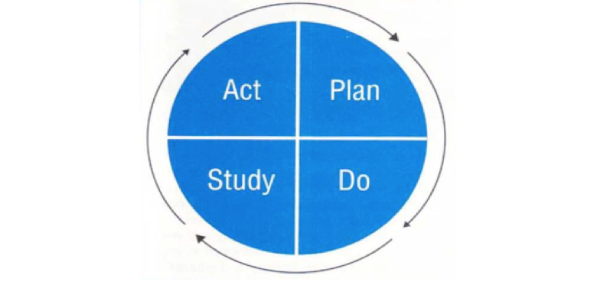
Pre-Work for ILT members
Review the benchmarks, strategies, and actions from your turnaround plan.
Highlight: green: completed or achieved
yellow: partially completed or achieved
red: did not complete or achieve

Study: Reflecting Back on Current Implementation of Turnaround Plan
(copy table for each turnaround practice)

Use the completed highlights from your turnaround plan to identify the successes and challenges related to strategies from your Turnaround Plan

Turnaround Practice # 1. Leadership, Shared Responsibility, and Professional Collaboration
Preferred State (copy/paste from original plan)
What were you aiming for?
Theory of Action (copy/paste from original plan)
Current State. Briefly share what you accomplished in this last year of implementation and where you encountered challenges. Make sure your response incorporates specific evidence and data that would help all stakeholders (including DESE) understand how you came to those conclusions. Data to consider: most recent MSV/TSV findings, classroom and co-planning visit data, PLC goals and agendas, ILT self-assessment and agendas, peer observation data, common achievement and growth assessment data, ACCESS data (when released), disciplinary data, attendance data, and any other school based-data.
Accomplishments | Evidence
Challenges | Evidence

Act: Planning Forward

What did you learn from your successes? (Recognize and communicate with staff)

What did you learn from your challenges? (Recognize and communicate with staff)

From your learning, what aspects of your turnaround plan will your school continue to leverage/implement next year?

From your learning, what modifications or changes to your turnaround plan do you expect to make for next year?

Plan: Revise Benchmarks to reflect progress made or not realized during implementation
and modifications/changes to your plan.

Benchmarks for Current School Year (copy/paste from plan) | Revised Benchmarks for Next School Year
New Strategies for Next School Year | Additional Benchmarks for Next School Year

Plan: District Systems of Support and Assistance
Turnaround Practices research highlights the positive benefits that accrue to turnaround schools (and other schools in their districts) when the district takes proactive roles to support them. These roles have included: developing new ways of working with schools (e.g., taking an active role in monitoring Turnaround plan implementation and outcomes), customizing supports based on a school’s specific needs, and putting systems in place to expand Turnaround Practices to other schools in district.

Please share an example of a district system that is positively impacting the implementation of your school’s turnaround plan.
Please share an example of a district system that has yet to fully impact your school’s turnaround work, and the ways in which district and school leaders are working together to resolve it.
Identify current autonomies gained in the current year that you found beneficial to the implementation of the Turnaround Plan that should remain in place.
Identify any additional autonomies needed and the impact on student achievement and Turnaround Plan implementation these autonomies would have.

Plan: Identify PD, Autonomies, Resources, Meetings needed for implementation of revised plan for next year

 | Professional Development | Resources | Meeting Times/  Structures Needed
Turnaround Practice 1
Strategy

Turnaround Practice 2
Strategy

Turnaround Practice 3
Strategy

Turnaround Practice 4
Strategy

