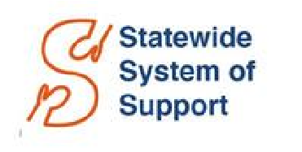

STATEWIDE SYSTEM OF SUPPORT (SSoS)
Month | Activity | Timeline**
July | SSoS Reviews District Submissions
August | SSoS Provides Feedback on District Submissions  OPTIONAL Webinar – Overview of SSoS-District Partnership | August 23
September | SSoS Launches Support Toward District Instructional Priorities Associate Commissioner Visits
October | SSoS Caseload Shifts, pending Fall Accountability Results  Associate Commissioner Visits  Underperforming School Visits****  Annual School Site Visits***
November | Associate Commissioner Visits  Underperforming School Visits****  Annual School Site Visits***
December | Associate Commissioner Visits  Underperforming School Visits****  SSoS Mid-Year Progress Monitoring  Annual School Site Visits***
January | School Improvement Plan Renewal (Underperforming schools only)  SSoS Mid-Year Progress Monitoring Associate Commissioner Visits  Underperforming School Visits****  Annual School Site Visits*** | January 31
February | SSoS Mid-Year Progress Monitoring  Underperforming School Visits****  Associate Commissioner Visits  Annual School Site Visits***
March | District Submission Guidance Released  District Experience Survey Released  Associate Commissioner Visits  Underperforming School Visits****  Annual School Site Visits***  Prioritization Institute I | March 1  March 1
April | Student Opportunity Act Progress Reports Due  Underperforming School Visits****  Annual School Site Visits***  OPTIONAL Webinar – Overview of District Submission guidance | April 1  April 3
May | Prioritization Institute II  Underperforming School Visits****  Annual School Site Visits***  SSoS End-of-Year Progress Monitoring
June | District Submission Due for SY2024-25  School Improvement Plans Due (Underperforming schools only) SSoS End-of-Year Progress Monitoring | June 30  June 30
** This calendar will be updated and shared throughout the year to reflect exact dates, updates where applicable.
***Annual school site visits (formerly known as MSVs and TSVs) are conducted by American Institutes for Research (AIR)
****Underperforming school visits are conducted by Komal Bhasin, Chief Schools Officer, on behalf of Commissioner Jeff Riley. SSoS staff do not participate in such visits, but are available for visit debriefs, where scheduling permits.

