Module 4: Overview of Communication Standards and
ACTFL Proficiency
This module provides an overview of the ACTFL Proficiency Guidelines, discusses how they connect to the Framework, and introduces the Communication Standards, explaining how they progress as proficiency increases.
ACTFL Proficiency Guidelines and the Framework
The Massachusetts World Languages Curriculum Framework embraces the ACTFL Proficiency Guidelines in its vision, guiding principles, practices, and content standards. The ACTFL Proficiency Guidelines are asset-based descriptions of what individuals can do with language in real-world situations in a spontaneous and non-rehearsed context for speaking, writing, listening, and reading (which can be applied to viewing and signing). They identify five major levels of proficiency: Novice, Intermediate, Advanced, Superior, and Distinguished. The first three levels are further divided into Low, Mid, and High sublevels. The levels of the Standards in the Massachusetts World Languages Curriculum Framework correspond to the levels of the ACTFL Proficiency Guidelines.
Overview of Communication Standards
The Communication Standards describe how students use language to express themselves and the four C’s of Cultures, Comparisons, Connections, and Communities. The Framework organizes the different skills involved in communication into the four modes of Interpersonal, Presentational, Interpretive, and Intercultural Communication. These modes comprise the Communication Practices in Domain 1. The Communication Standards support meaningful and authentic interactions in the language that enable students to access information and engage in the local and global community.
Progression of Communication Standards
Students develop and/or advance their skills in the communicative modes at each level of proficiency and show progression across the following linguistic components:
- Function: the simplest expression of the standard, describing what students can do with the language
- Context: the topics and settings in which students can use the language to accomplish a function
- Text Type: the length and complexity of the language students produce or understand to accomplish a function
- Supports: what students may need to accomplish the function
- Comprehensibility: the degree of success a student experiences in communicating a message
As proficiency increases, students can perform a greater variety of Functions; operate in a broader variety of Contexts; understand and produce more complex Texts; need decreasing Support; and are easier to understand.
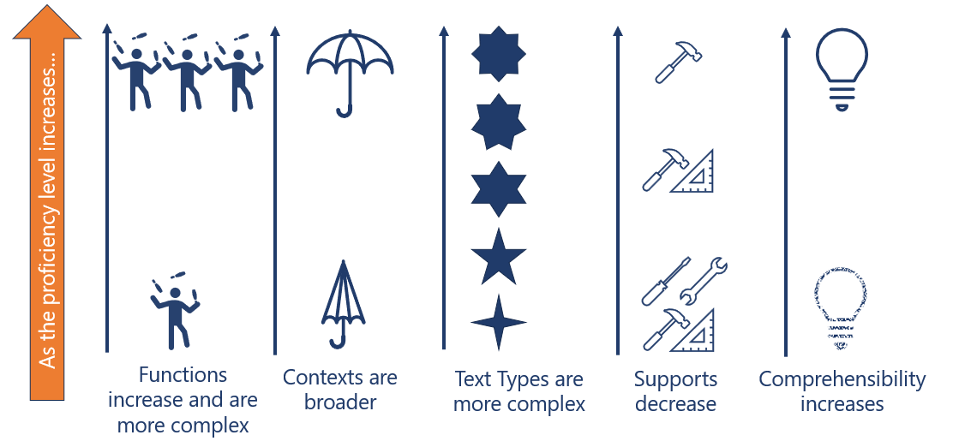
Two Lenses: Proficiency and Equity
Proficiency and equity serve as the foundation of the Communication Standards. The Standards are organized by proficiency level according to the ACTFL Proficiency Guidelines, and they are addressed using Core Practices that align with proficiency-based approaches to language teaching. In terms of equity, the Communication Standards center and affirm student diversity; focus on what students can do rather than what they cannot do; emphasize the importance of meaningful communication rather than the mechanics of language; develop students’ social and emotional competence; and provide opportunities for students to demonstrate Mastery, Creativity, and Identity through Deeper Learning.

Additional Resources
ACTFL Core Practices • ACTFL Proficiency Guidelines • CARLA Step-by-Step Guide to Creating Integrated Performance Assessments • MaFLA Programming • Massachusetts World Languages Linguistic Components Summary • Massachusetts World Languages Quick Reference Guides

