WL Proficiency Academy Presenter Biographies

Foundations Strand, Rebecca Blouwolff
- 2020 ACTFL National Language Teacher of the Year
- Frequent presenter at ACTFL, NECTFL, MAFLA Proficiency Academy, and other MAFLA conferences
- French teacher at Wellesley Middle School since 1998
- Master’s degree from Harvard Graduate School of Education in Teacher Leadership
- Certified French teacher
- National Board Certified French teacher

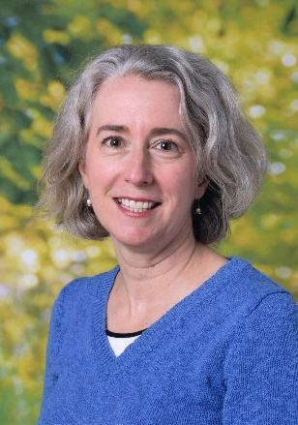
Rebecca Blouwolff has taught French at Wellesley Middle School in MA since 1998, but fell in love with teaching middle schoolers while serving as a Fulbright teaching scholar at a collège in Saint-Omer, France. Novice students inspire her to create engaging, age-appropriate lessons focused on global awareness. Together with her husband, she speaks non-native French at home to her own two children. She earned a B.A. magna cum laude in American Civilization and Judaic Studies at Brown University, and an M.Ed. in Teacher Leadership at the Harvard Graduate School of Education. She is a National Board Certified Teacher, 2019 MaFLA and NECTFL Teacher of the Year, and 2020 ACTFL Language Teacher of Year.

Implementation Strand, Catherine Ritz

- Clinical Associate Professor and Director of World Language Education and Curriculum & Teaching, Boston University Wheelock College of Education & Human Development
- Certified French & Spanish teacher
- National Board Certified French teacher
- Master’s degree from New York University in Foreign Language Education; Master’s degree from Harvard University in Foreign Language Literature & Culture; EdD in Curriculum & Instruction from Texas A&M University
A former French & Spanish teacher and world language 6-12 department leader, Catherine Ritz is now a Clinical Associate Professor and director of the World Language Education and Curriculum & Teaching programs at Boston University's Wheelock College of Education & Human Development. She teaches courses on world language pedagogy, research, and learning design, as well as courses on curriculum and teaching across content areas. Catherine founded the MAFLA Proficiency Academy in 2015, and is dedicated to supporting school districts in transitioning to teaching for proficiency. She consults with schools on world language pedagogy and curriculum development, and is also the author of two books, including the popular, "Proficiency-Based Instruction: Input & Interaction in World Language Education”.

