Directory Administration Guide
Automated Process for Adding a New User

There is a new feature in DA when adding a NEW user with one or more security roles. We have added an automated process which, once the user is added successfully, will send the new user an email containing the information needed to setup a new password and login.

This feature does not apply to existing users that you are simply adding new roles or functions to. Also, this new feature does not apply to users who are added with only a function and no security roles.

The process to adding a user has not changed. You simply follow these steps and click, add.

Enter the following information for the new user:

First Name
Last Name
Email address
Enter phone number
Select No on ‘Link to MEPID’ (unless they are a teacher, then select Yes)
Click add.

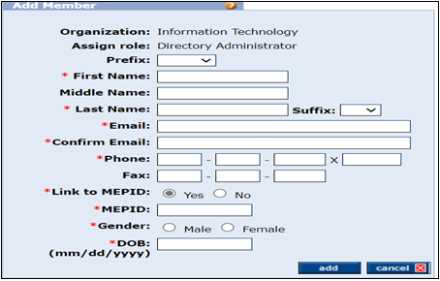

There will be a success message at the top letting you know the user has been added. The message will contain the new username with information confirming an email has been sent.

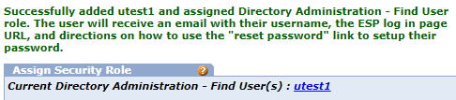

Below is an example of the email. The email contains their new username and instructions on how to reset their password. Once they have received their temporary password, the user will then set their permanent password to login to the portal.

