# Organization Manager User Guide

Table of Contents

Organization Manager User Guide 1

User Roles 1

Packet Statuses 1

Email Notifications 1

Starting a Packet 2

## User Roles

Roles are attached to a District. Not an individual school

1. **Change Org Coordinator**: Able to start a new packet and create and update forms. Not able to submit packet.
2. **Change Org Approver**: Able to start a new packet, create/update forms, and submit forms. Must also be the Superintendent/Head of Org for the District.

## Packet Statuses

1. **In Progress**: Has not yet been submitted to DESE for approval. In this status, required fields may be blank and all users will have the ability to remove a form. All required fields must be completed prior to submission to DESE.
2. **Pending Review**: Packet has been submitted to DESE for review. All forms will now be Read Only and users are no longer able to add or remove forms to or from the packet. All users will have the ability to enter a note.
3. **Accepted**: DESE Admin has reviewed and accepted the forms. All forms remain Read Only and users are not able to add or remove forms to or from the packet. All users will have the ability to enter a note.
4. **Completed**: The updates have been made in Directory Administration and are live on Profiles. Packet is complete and no further updates to the forms can be made.
5. **No Action**: No action will be taken. When in this status, it is possible for DESE Admin to return the packet to ‘In Progress’ for further updates if needed.

## Email Notifications

Emails will be sent for the following actions:

1. Packet submission to DESE – triggers an email to be sent DESE Admins
2. Status change for a packet – triggers an email to be sent to all District Coordinators and Approvers associated with the District
3. DESE Admin enters a note – triggers an email to be sent to all District Coordinators and Approvers associated with the District
4. District User enters a note - triggers an email to be sent DESE Admins

## Starting a Packet

1. Select District
2. Select Create New Request

District drop down for request


1. Select ‘New Request’ from dashboard (Note: it will default to current year. Year can be modified in next step)

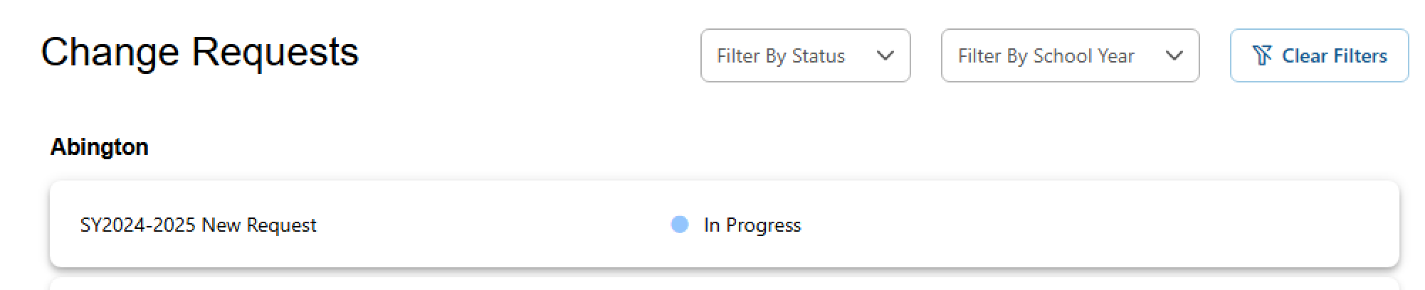

1. Select desired school year from dropdown list. Packets may not be started for past years. Window closes for the school year June 30th of the second listed year.
2. Select Edit button to rename the packet.

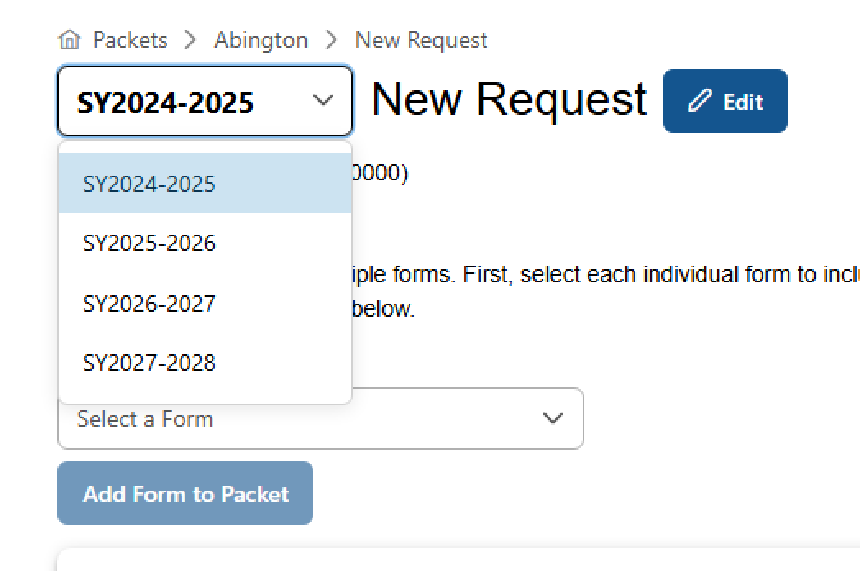

1. Select a Form to add from the dropdown. Multiples of each form may be added. Upon selecting a form that form will open for editing. Forms in packets in the ‘In Progress’ status are allowed to be saved with incomplete required fields. For the Approver to be able to Submit the form to DESE, all required fields must be completed.

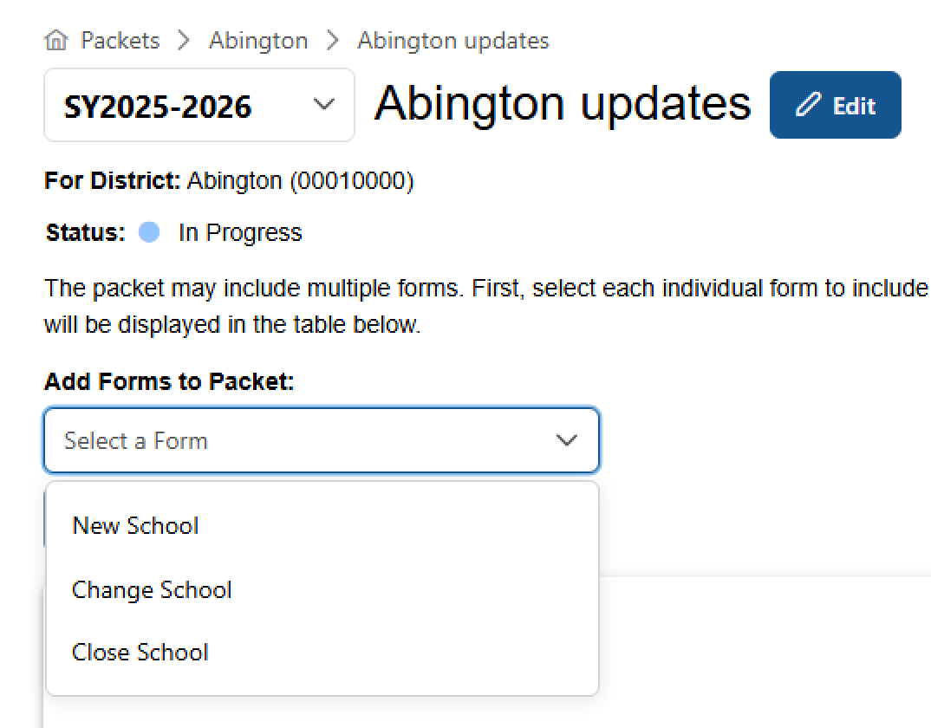

1. Once packet is complete, please ask your Superintendent to login to review the pending forms and submit the packet once approved.

