New Bedford Public Schools
Accelerated Improvement Plan

Summary
In 2011, New Bedford Public Schools was named a Level 4 district by the Massachusetts Department of Elementary and Secondary Education. This past school year has seen tremendous positive change. Last year the district concentrated intensely on developing and supporting principals to improve our schools. Principals were provided with training and worked with their teachers on two main areas: growing teachers’ repertoire of strategies to engage students and using data to understand specific student strengths and needs.

Our schools now have leaders who are actively working with teachers to improve their practice and guiding teams to look at evidence of what students have learned. These two advances are the first steps in creating a constant cycle of improvement. They provide a strong foundation for increasing student progress that is more than intermittent but sustainable in all schools and all classrooms during the 2014-15 SY. This school year, the district will continue to develop principals’ abilities by providing training at twice-monthly Principals’ Meetings and will offer different levels of support to principals based on their school’s context and their individual needs.

Additionally, the district will help teachers to become more skillful. The district will establish a common definition of excellent teaching, the New Bedford Instructional Framework, which will be accompanied by a resource bank of high-leverage strategies and tools for teachers to use in their classrooms. Teacher trainings will focus on two important pieces of the Instructional Framework:

- Unit- and lesson-planning based on the updated curriculum, which will help ensure teachers are teaching grade-level material to students.
- Teachers’ ability to meet each student’s specific needs by using multiple strategies and styles of teaching in the classroom.

These focus areas for teacher development build on last year, when teachers learned new approaches to engage students in their learning. This year, they will strive to plan more rigorous lessons. With better planning, teachers can engage their classes in a way that challenges each student to work at a higher level than before, while taking specific student needs and learning styles into account.

To make these changes sustainable, the district leadership will also invest in strengthening its partnership with the New Bedford community at large, including employees, families, and community members. The Superintendent plans to use regular meetings of the following groups to engage a wider array of stakeholders during the decision- making process:

- Teacher Advisory Group
- Guiding Coalition Team (which includes a variety of district employees and representative principals)
- Superintendent Forum Series (open to the public)

Structure of the AIP

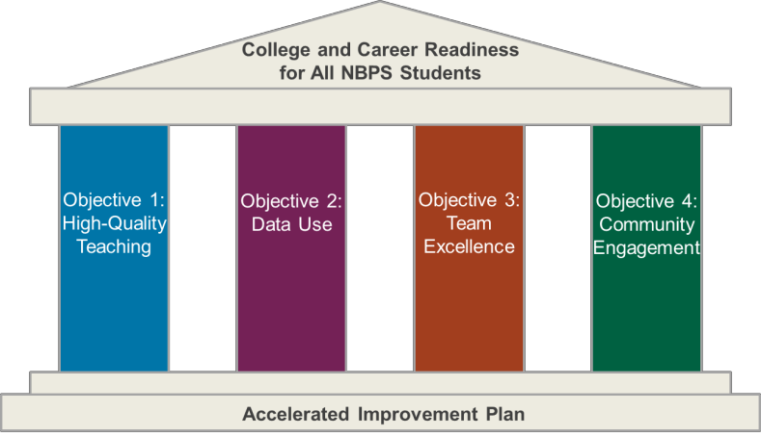

Introduction to the Instructional Framework
One of the most significant parts of the AIP this year is the introduction of the New Bedford Instructional Framework, which has two pieces. The first piece (shown below) is an outline of the components of excellent teaching. The second piece is a resource bank that will provide teachers and principals with research-based, high- leverage tools and strategies to help improve teachers’ skills related to each of the five components.

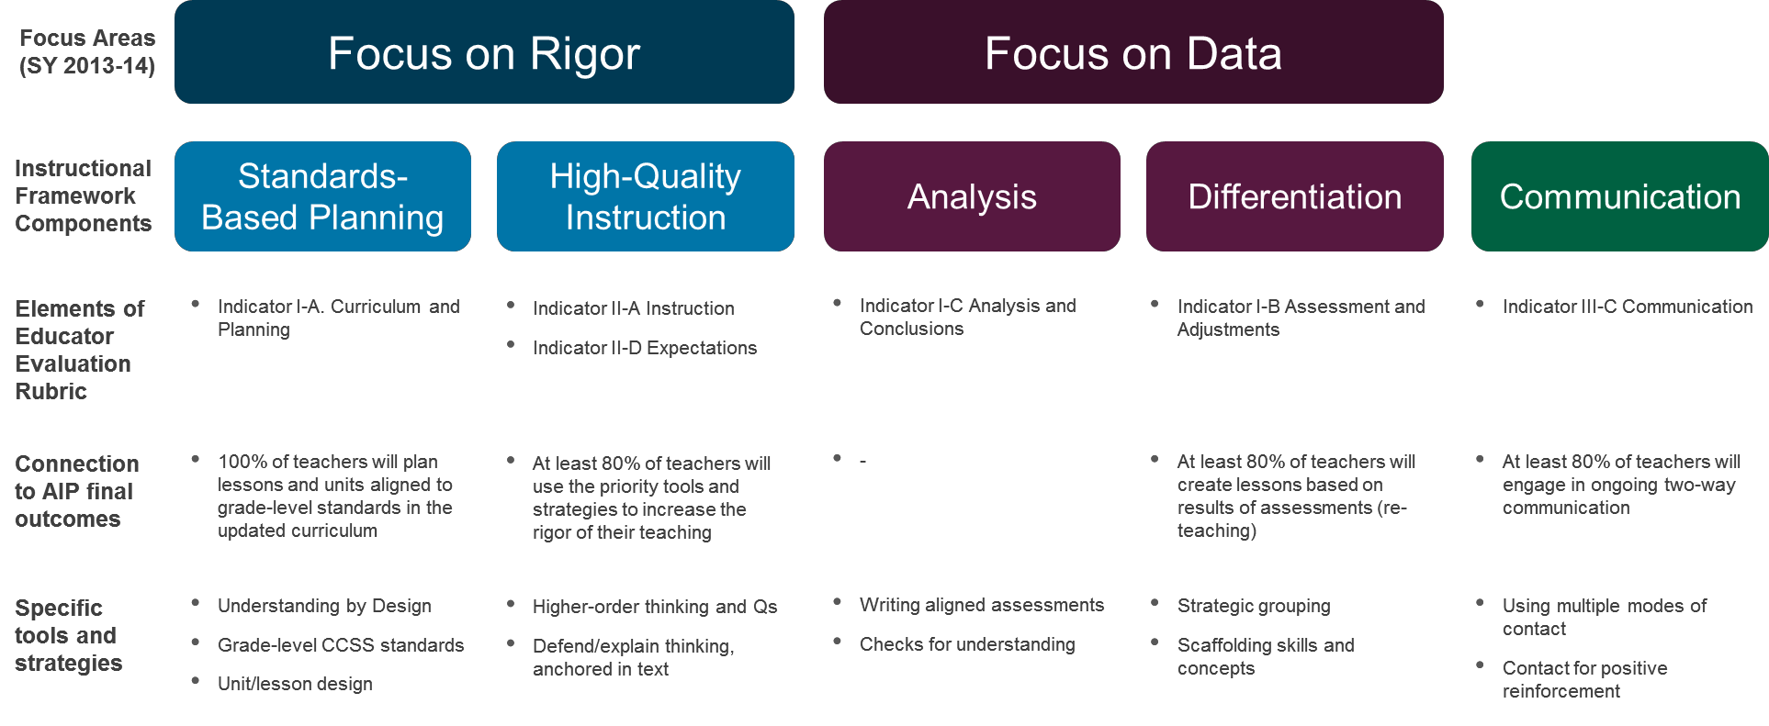

The content included in the Framework is not new; rather, it is a more focused view of the Massachusetts Educator Evaluation Rubric. It will provide teachers, school leaders, and district leaders an opportunity to structure and focus their discourse around improving instructional practice, which will lead to increased student outcomes. Principals will be formally introduced to the Instructional Framework in early September, and the professional development days for teachers in October and January will be aligned to it.

The Instructional Framework is not…
The Instructional Framework is…

- A focused selection of indicators from the educator evaluation rubric
- A way to identify individual teacher’s areas of strength and opportunity
- A common language and foundation to break down excellent teaching into specific skills
- A database of proven, high-leverage strategies to improve each component of instruction

× A set of new expectations for teachers
× A checklist of necessary pieces of a lesson
× A replacement for the educator evaluation rubric
× A laundry list of resources and aspects of an effective lesson
× A cure-all for improving instruction in the district

Table of Contents

Summary 1
Introduction to the Instructional Framework 2
Glossary of Terms and Acronyms 4
District History and Context 5
Objectives and Final Outcomes 7
Ownership of the Accelerated Improvement Plan 10
Accountability for Improvement in Outcomes 11
Progress Monitoring During the School Year 12
Objective 1: Overview 15
Strategic Initiative 1.1 16
Strategic Initiative 1.2 17
Strategic Initiative 1.3 18
Objective 2: Overview 20
Strategic Initiative 2.1 21
Strategic Initiative 2.2 22
Objective 3: Overview 23
Strategic Initiative 3.1 24
Strategic Initiative 3.2 25
Objective 4: Overview 26
Strategic Initiative 4.1 27
Strategic Initiative 4.2 28
Appendix A: Initiative Road Maps and Activities 29

Glossary of Terms and Acronyms

AIP – Accelerated Improvement Plan

Aspen 2X: The new student information system that the district will be using to manage student data. BOY/MOY/EOY – Beginning of Year/Middle of Year/End of Year
CAO – Chief Academic Officer

CCSS – Common Core State Standards: New research-based, high-quality academic standards that have been adopted by states across the country to help prepare students for success after high school.
CFA – Common Formative Assessments: Tests that are administered to students to monitor their progress and check their understanding of specific content.
DESE – Massachusetts Department of Elementary and Secondary Education

DIBELS – Dynamic Indicators of Basic Early Literacy Skills: A test provided to students, typically in elementary school, to measure their progress in learning literacy skills.
ELL – English Language Learner
Galileo: The software system that the district uses to administer BOY, MOY, and EOY tests for students. Instructional Framework: The Instructional Framework covers the key aspects of effective teaching in
New Bedford, including planning, instruction, data and parent communication. The framework describes what exemplary teaching looks like for each component, and includes resources and examples to help teachers improve.

MCAS – Massachusetts Comprehensive Assessment System: The state standardized tests that New Bedford students took through SY 2013-14.

NBHS/NBPS – New Bedford High School/New Bedford Public Schools

PARCC – Partnership for Assessment of Readiness for College and Careers: New standardized tests aligned with CCSS that New Bedford students will take starting in SY 2014-15 in lieu of MCAS in some grades and subjects.
PD – Professional Development: This is a term that can be used to describe any training for teachers, principals, or other district employees to help them improve their skills.
SEI – Sheltered English Immersion: This is a strategy to provide specific services to help ELL students. SY – School Year
TAG – Teacher Advisory Group

TCT – Teacher Collaboration Team: Groups of teachers that focus on using data to improve instructional practice.
TLS – Teaching and Learning Specialist: This is a school-level position that provides coaching to teachers to improve their instructional practice.

District History and Context

In 2011, New Bedford Public Schools was named a Level 4 district by the Massachusetts Department of Elementary and Secondary Education (ESE). In a District Review, ESE identified a number of areas for improvement for the district, including:

- Limited principal oversight and accountability
- Lack of leadership and capacity at the central office to support an improving educational system
- Little evidence of characteristics of effective teaching
- Limited use of formative assessment data to inform instruction
- Limited efforts to improve the quality of teachers’ instruction
- High dropout, retention, suspension, and absence rates, especially at the high school

As the district lacked systems and structures to address these areas when it was named Level 4, the New Bedford Public Schools (NBPS) used the first two years of turnaround work to build a foundation for continuous improvement. Once that foundation was set, the SY 13-14 AIP focused on change at the school level, leveraging and developing principals as change agents. The SY 14-15 AIP seeks to drive change in classrooms, through:

− Updated curriculum
− Instructional Framework
− Continuing support of principal capacity around improving teacher practice
− Improved data systems

The summary below highlights key initiatives from the past three years and outlines specific additions to this year’s District Accelerated Improvement Plan (AIP).

WHAT WE HAVE ACHIEVED

Year 1 (2011-2012): Laying the Groundwork

New Bedford Public Schools made progress on building structures across the district to support broader reform. At the beginning of the 2011-2012 school year, the district lacked structures for convening school-based administrators; had no “dipstick” for assessing the quality of instruction district-wide; and lacked the school-based structures necessary for data-driven instruction to occur, such as school-based data teams. NBPS made significant progress towards establishing these organizational elements. Key accomplishments included:

- Established data teams in all schools
- Developed a District Learning Walk process aligned to the AIP
- Established monthly Principals’ Reports
- Created monthly feeder pattern meetings

Year 2 (2012-2013): Strengthening District Systems and Structures

In the second year, the district implemented an Accelerated Improvement Plan with tighter focus. The district’s plan emphasized the “through-lines” of instructional leadership and practice, from the district’s central office down to the classroom level. In addition to continuing the accomplishments above, highlights include:

- Completed curriculum maps based on pre-CCSS standards
- Implemented a new educator evaluation system
- Launched a K-2 literacy initiative to strengthen the reading block
- Revised the District Learning Walk protocol and continued district and school learning walks to determine quality of classroom instruction
- Leveraged bi-weekly Principals’ Meetings to discuss instruction
- Appointed teaching and learning specialists (TLSs)

Year 3 (2013-2014): Building the “Instructional Core”

This past school year, the district implemented an Accelerated Improvement Plan with a focus on the importance of rigorous classroom instruction. Building on the same four strategic objectives from previous years, the 2013-2014 Accelerated Improvement Plan focused on increasing the rigor of classroom instruction in reading, math, and science for all students. Highlights from this past year include:

  - Defining a district-wide vision for rigorous instruction, and creating a “rigor rubric” to help principals, teachers, and other leaders use common language to discuss excellent instruction
  - Redefining the principal job in terms of instructional leadership, providing coaching and professional development to principals to increase their ability to help teachers improve
  - Restructuring the middle school schedules to incorporate more core class and intervention time
  - Providing targeted, intensive supports to the middle schools, including coaching for principals
  - Providing professional development, which was managed by principals, at bi-weekly Principals’ Meetings to increase their capacity as instructional leaders
  - Recruiting and cultivating a talented central office team for 2014-15 SY
  - Embedding the use of data to drive decision-making with the district-level district data team and school- level teacher collaboration teams

WHAT WE WILL ACHIEVE

Year 4 (2014-2015): Scaling Success

Last school year the district gained some traction in embedding a focus on rigorous instruction and built a foundation of capacity in its leaders. These efforts created pockets of growth, and the goal for SY 2014-15 is to expand this growth throughout the district by providing high-quality, core instruction in every classroom, built upon a foundation of rigorous curriculum that is sustainable and leads to definitive student achievement results.

Theory of Action
The district’s theory of action created an articulated, coherent strategy for the district beginning in SY 2013-14 and continuing this year. The strategic initiatives included in the AIP focus on the core elements outlined in the district’s theory of action that will bring about systemic change and improvement.

IF the NBPS focuses on and persists in expecting, developing, supervising, and evaluating educators’ capacity to deliver rigorous and engaging instruction that is:
- Aligned to state standards,
- monitored so student progress in attaining those standards reaches to a level of proficiency,
- adjusted and differentiated so that all students will be supported and stretched to make progress
- and evidence of student learning is demonstrated every day in every classroom in every school
THEN student achievement will significantly increase in each New Bedford school and in the New Bedford Public Schools as a district.

Objectives and Final Outcomes
The Accelerated Improvement Plan defines four objectives for the district, along with supporting initiatives, as illustrated in the figure below. For each objective, the district has set targets for a number of final outcomes. These are the measures of tangible improvement that will occur during this year of accelerated improvement.

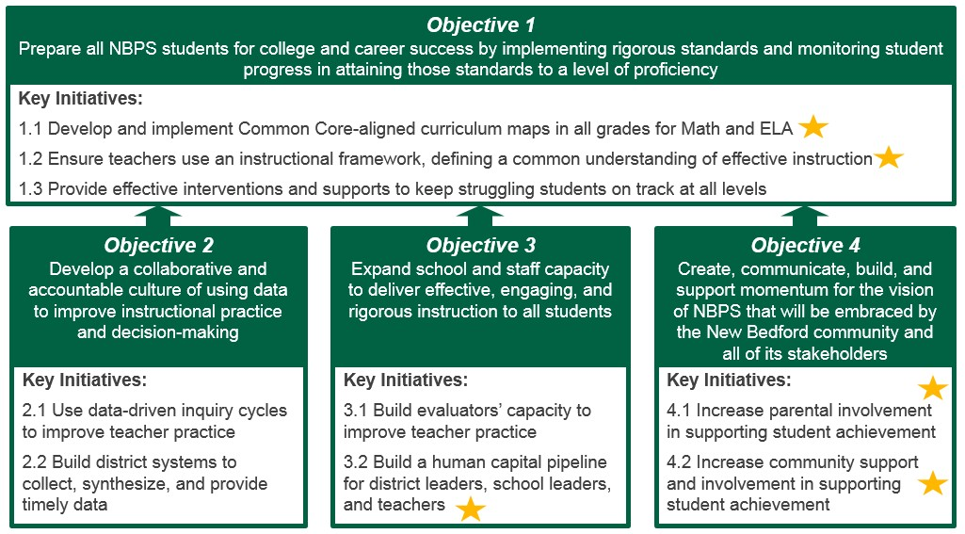

Objective 1: Prepare all NBPS students for college and career success by implementing rigorous standards and monitoring student progress in attaining those standards to a level of proficiency

District and School Improvement Plan Final Outcomes
  - By EOY principals can demonstrate that 100% of teachers, who teach reading/ELA or Math, consistently use the updated curricula in their classrooms.
    - Measured through: co-planning and pre-observation meetings, observations, meetings with principals, lesson plans, TCT meetings, and other evidence.

  - At least once per term, CFAs aligned to CCSS curriculum for Math and ELA will be administered.

  - By EOY principals can demonstrate that at least 80% of teachers at all levels of performance in their building use the priority tools and strategies in the Instructional Framework to increase the rigor of their instruction.
    - Measured through: observations, principal meetings with teachers, lesson plan reviews, TCT meetings, samples of feedback to teachers at varying performance levels, and other evidence.

  - By EOY the district will realize at least a 40% reduction in students not proficient or advanced in ELA and Math for grades K-5.
    - Measured through: DIBELS, MCAS, and PARCC test results.

  - By EOY the district will realize at least a 40% reduction in students not proficient or advanced in ELA, Math, and Science in grades 6-12.
    - Measured through: DIBELS, MCAS, and PARCC test results.

  - By EOY the district will see at least 10% of students in the “Warning” category move into “Needs Improvement” and at least 10% of students in the “Proficient” category move into “Advanced” in Math and ELA.
    - Measured through: MCAS and PARCC test results.

  - At least 90% of students remain enrolled in school from 8th through 10th grade, based on an analysis of 3-year cohort data.

Objective 2: Develop a collaborative and accountable culture of using data to improve instructional practice and decision-making

District and School Improvement Plan Final Outcomes
  - By EOY principals can demonstrate that at least 80% of teachers can design and implement lessons tailored to meet student needs based on analyzing the results of standards-based assessments.
    - Measured through: administrators’ assessment of lesson plans, classroom observations, TCT minutes, and other evidence.

  - By EOY the district will have a centralized data system for student data and district-wide processes for accessing and analyzing the data collected.

  - By EOY the Data and Assessment Manager can demonstrate that 100% of principals and central office leaders and at least 80% of teachers will demonstrate the ability to access data in the centralized data system, including at least one person at each school.
    - Measured through: evidence included in teachers’ education evaluation portfolios.

Objective 3: Expand district, school, and educator capacity to develop, deliver, and supervise effective instruction to all students

District and School Improvement Plan Final Outcomes
  - By EOY at least 80% of evaluators provide consistent growth-producing feedback to teachers.
    - Measured through: co-observations with Superintendent, CAO, and/or principal coaches; review of written feedback to teachers; and other evidence provided in the evaluator's portfolio.

  - By EOY each evaluator will be able to provide evidence that they helped at least two high- priority teachers improve their practice, leading to gains in student learning.

  - By EOY at least 10 teachers and 5 other building leaders have been identified as “high- potential” and have entered a leadership development track, including additional professional development and opportunities.

Objective 4: Create, communicate, build, and support momentum for the vision of NBPS that will be embraced by the New Bedford community and all of its stakeholders.

District and School Improvement Plan Final Outcomes
  - By EOY sign-in records show that at least 60% of students had a parent or guardian participating in or attending a school-sponsored event in the 2014-15 SY.

  - By EOY at least 80% of teachers can provide evidence of ongoing, sustained two-way communication with the families of at least 5 struggling students.

  - By EOY at least 70% of community members responding to a survey agree that the district proactively communicates plans for critical district activities to keep the community informed and include community input when possible.

HOW WE WILL GET THERE
The 2014-2015 Accelerated Improvement Plan builds on the successes of the previous three years, and includes some new areas of focus. NBPS will continue to refine the systems and structures it has established, but will also focus on several areas of work for greater impact:

- Establishing a common language of rigor and resources to improve core instruction (Objective 1): The district identified increasing the rigor of instruction as one of its main focuses in SY 13-
  - This year, the district will build upon the work from last year, providing teachers and school leaders with focused professional development and resources around rigorous instruction, including:
    - A district-wide Instructional Framework focused on four critical teaching skills:
      - Standards-based planning and assessment
      - High-quality instructional strategies
      - Analysis of assessment results
      - Differentiation approaches
    - Updated CCSS-aligned curriculum
    - A resource bank to facilitate district-wide sharing of best practices
    - Continuing the bi-monthly Principal Meetings with a focus on rigorous instruction for at least 50% of the time allotted

- Bolstering supports for struggling students (Objective 1): The district has identified opportunities to provide greater quantity and quality of interventions for all struggling students, including English Language Learners and students with disabilities. The middle schools modified their schedules to carve out more time to provide general education interventions in SY 14-15. Other strategies to identify and increase the effectiveness of interventions include:

  - Integrating professional development on content, teaching strategies and accommodations for both general education and special education teachers
  - Creating a protocol to guide the identification process to ensure that students are being prescribed appropriate supports from general education, special education, and ELL staff
  - Training staff members to conduct effective ELL screenings
  - Working with 2-4 elementary schools to redesign their schedules for more general education intervention time as the middle schools did in SY 13-14
- Developing district data systems to provide timely, meaningful data (Objective 2): The second focus of the district in SY 13-14 was around the development of systems to use data to drive decision- making. This year, the district will support the Teacher Collaboration Teams at each school by creating a district-wide data system to provide more accurate and timely data from common formative assessments.

- Creating systems to develop internal talent (Objective 3): The district will continue its work to increase the capacity of principals to serve as effective instructional leaders through professional development at bi-monthly Principals’ Meetings and support from the new Office of Instruction. Additionally, the district will create a formalized leadership development track to identify school-level leaders, including teachers, and provide them with greater professional opportunities and development. The district will also introduce principal Zone Leaders to sit on the district’s Guiding Coalition Team to ensure school-based leaders have a voice in district decisions.

- Engaging parents as partners (Objective 4): Teachers and principals will engage families as partners in their child’s education, identifying venues to reach unengaged parents and collaborating with engaged parents to support their child. The district will develop proactive communication plans for critical district activities to keep the community informed and include community input when possible.

Ownership of the Accelerated Improvement Plan
To ensure that principals and teachers can easily identify the final outcomes, strategic initiatives, and road maps for which they are accountable, the document uses specific district language and connects short-term outcomes to the goal-setting process in the educator evaluation cycle. For example:

- Schools will be expected to use the AIP final outcomes as the final outcomes in their individual School Improvement Plans
- Educators will be expected to set student learning goals and professional practice goals that are aligned with the short-term outcomes in the AIP
- District leaders will provide differentiated support to principals as they develop and implement their School Improvement Plans based on the accountability level of the school, student outcomes from the previous year, the principals’ performance on a beginning-of-year rigor assessment
This year, the district is leveraging the AIP process to move toward “Transitional Implementation,” as outlined by DESE in the Level 4 district exit criteria. The AIP was developed with significant contributions from central office staff, principals, and teachers. The Superintendent met with principals and representatives from the district’s Teacher Advisory Group to receive their input on the AIP. Additionally, the strategic initiative leaders, consisting of principals and central office staff, contributed to the planning and development of the AIP by generating the road maps that outline the specific activities necessary to implement the plan (see Appendix A).

The diagram below shows the relationship between the major elements of the Accelerated Improvement Plan. These through-lines to school-level and educator-level work will help ensure that the district maintains a laser-like focus on the district’s four strategic objectives.

The Chief Academic Officer will oversee and manage the progress for all strategic initiatives. Each strategic initiative is assigned to district owners who will work with the CAO to oversee the day-to-day operations of the initiative and report on the planning and progress.

Ownership of the AIP
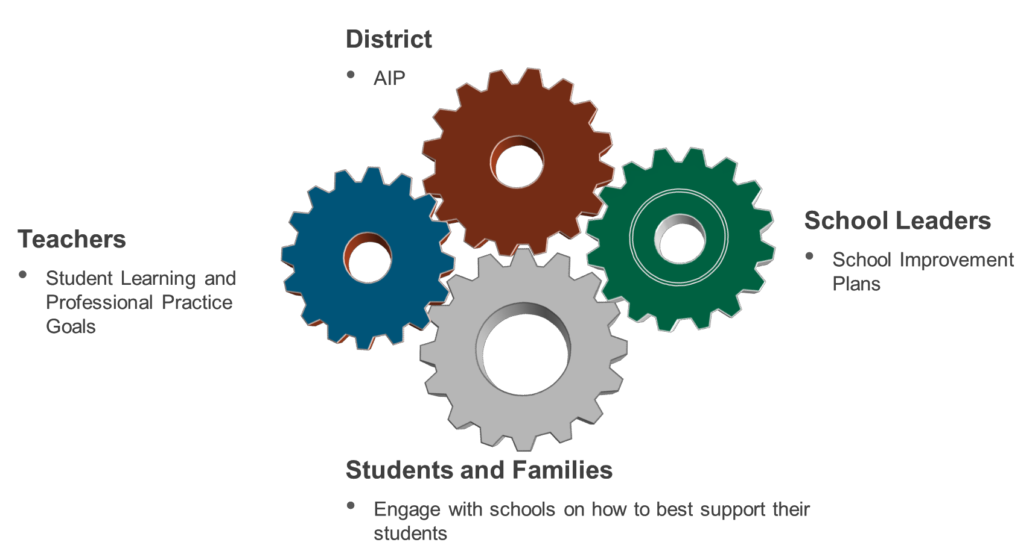

Accountability for Improvement in Outcomes

Accountability for Student Improvement

The AIP contains targets for improvement in student outcomes, and all teachers, principals, and district leaders share the responsibility for ensuring that students reach these final outcomes. Principals are accountable for the learning outcomes of students in their building, and the Superintendent is accountable for the district overall.

- By EOY the district will realize at least a 40% reduction in students not proficient or advanced in ELA and Math for grades K-5.
- By EOY the district will realize at least a 40% reduction in students not proficient or advanced in ELA, Math, and Science in grades 6-12.
- By EOY the district will see at least 10% of students in the “Warning” category move into “Needs Improvement” and at least 10% of students in the “Proficient” category move into “Advanced” in Math and ELA.
- At least 90% of students remain enrolled in school from 8th through 10th grade, based on an analysis of 3- year cohort data.

Accountability for Principal Improvement

The AIP contains specific targets for principal capacity-building. Each principal is responsible for their own growth and capacity, as well as collaboration with other principals. The Superintendent and CAO are responsible for conducting school learning walks and inter-rater reliability checks to determine principal capacity on key measures, and providing feedback and access to resources to help principals improve.

- By EOY at least 80% of evaluators provide consistent growth-producing feedback to teachers.
- By EOY each evaluator will be able to provide evidence that they helped at least two high-priority teachers improve their practice, leading to gains in student learning.

Accountability for Teacher Improvement

The AIP contains specific areas for teacher improvement. Each teacher is responsible for their own improvement in practice, as well as collaborating with other teachers to help them improve. Principals are responsible for coaching, providing feedback, leading professional development, and providing relevant materials to help teachers improve. Principals are ultimately accountable for the skill level and success of teachers in their building.

- By EOY principals can demonstrate that 100% of teachers, who teach reading/ELA or Math, consistently use the updated curricula in their classrooms.
- By EOY principals can demonstrate that at least 80% of teachers at all levels of performance in their building use the priority tools and strategies in the Instructional Framework to increase the rigor of their instruction.
- By EOY principals can demonstrate that at least 80% of teachers can design and implement lessons tailored to meet student needs based on analyzing the results of standards-based assessments.
- By EOY at least 80% of teachers can provide evidence of ongoing, sustained two-way communication with the families of at least 5 struggling students.

Accountability for District Activities

For the AIP final outcomes that describe important district-level actions, the roadmaps provided in this document name the owner for specific initiatives. Those owners are responsible for managing and completing the activities according to the timeline, and the Superintendent and CAO will monitor progress through quarterly AIP check-in meetings.

Progress Monitoring During the School Year

Tracking Student Progress

The five main methods the district will employ to monitor student learning this year are DIBELS tests, Galileo Benchmark assessments, common formative assessments, teacher-written assessments, and examinations of student work artifacts. DIBELS, Galileo assessments, and CFAs are organized at the district-level, while teacher- written assessments and examinations of student work artifacts are more variable across schools and classrooms.

The district will implement the Galileo tests and CFAs as follows:

- District Data Team identifies priority standards by analyzing student answers from previous tests
- Galileo and/or DIBELS tests assess students on priority standards
- Principals and teachers use the Galileo results to adjust instruction, emphasizing and re-teaching the standards on which students struggled
- CFAs are created to retest students on standards with which they previously struggled

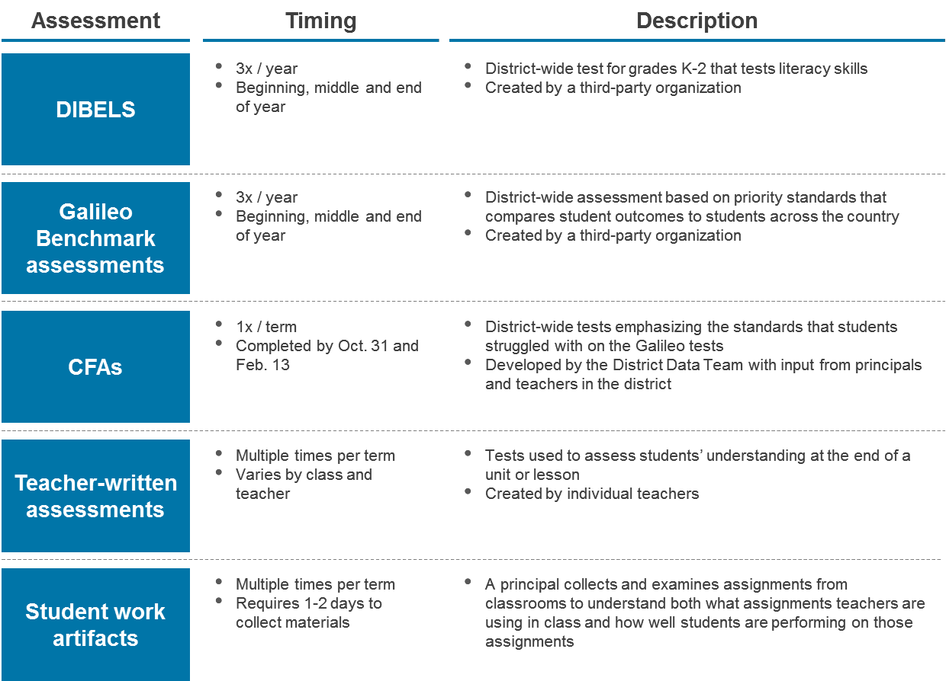

Tracking School Progress

The district has created a system to monitor the progress of individual schools and to support school leaders as they implement the AIP. Each principal will be matched with a liaison from the Office of Instruction to support them throughout the year and ensure that each school is on track to experience significant student growth. The liaison’s support will focus on supporting principals in their efforts to improve teacher practice in the five areas outlined in the Instructional Framework.

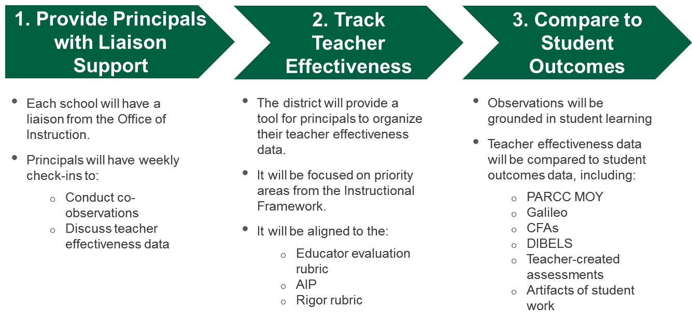

Tracking District Progress

The Chief Academic Officer will oversee the AIP work in the district this year, using four main methods to monitor progress. Below is a description of the different processes that will be used to track progress on both student outcomes and AIP activities from the district-level.

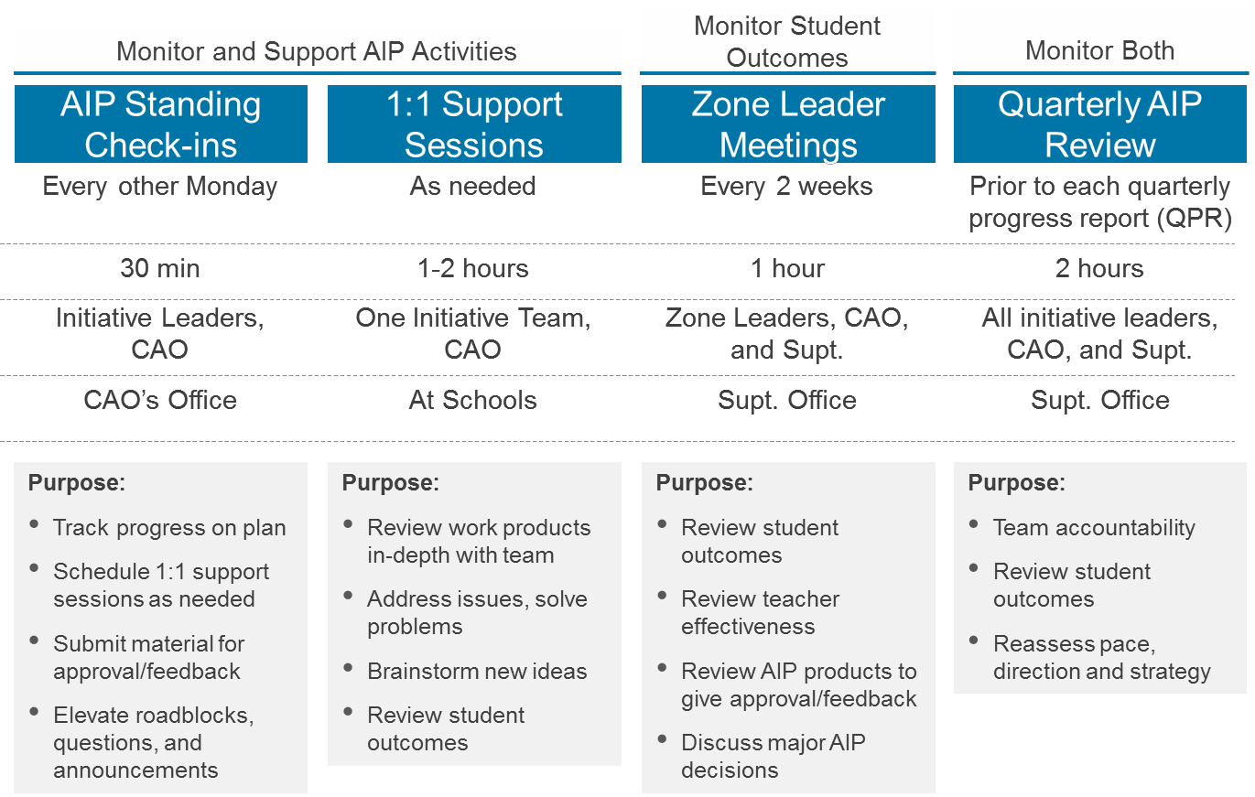

Objective 1: Overview

Objective 1: Provide students with high-quality teaching in every classroom.

GOALS FOR THE DISTRICT

WHAT THIS MEANS FOR STUDENTS

District and School Improvement Plan Goals

- New Bedford teachers will use an updated curriculum that will prepare students for success after high school graduation.

- Once per term, teachers will administer common formative assessments to track students’ progress in English/Language Arts and Math.
District and School Improvement Plan Goals

a) The district will establish a common definition of excellent teaching, accompanied by a variety of resources and trainings so that teachers are equipped to provide high-quality instruction to all students.
District and School Improvement Plan Goals

- At least experience a 40% reduction in students not proficient or advanced in ELA and Math for grades K-5.

- At least experience a 40% reduction in students not proficient or advanced in ELA, Math, and Science in grades 6-12.

- At least 10% of students who are in the lowest performance level will move up one level and at least 10% of students rated as proficient will move into the highest performance level.

- At least 90% of NBHS students will remain in school from 8th grade through at least 10th grade.

Strategic Initiative 1.1
Students will have access to current, relevant and challenging content meeting the same standards as the top districts in Massachusetts when they enter a New Bedford classroom.

Each student will have an opportunity to show their progress once per term on a test, which will allow teachers to provide more customized support to students tailored to that student’s specific needs.
Strategic Initiative 1.2
Teachers will have access to principal coaching and an online toolkit, with the training, materials and example lessons they need to teach New Bedford students the challenging content in the updated curriculum.

Initiatives marked by a star indicate that they are new for SY 14-15.
Strategic Initiative 1.3
The district will do better at providing the right supports to each student. There will be more accurate identification of students with disabilities or English language learning needs. Students without special needs will be able to receive extra support if they are struggling in their classes to fill learning gaps and accelerate growth. Teachers will use multiple activities during a lesson matched to the needs of students and provide enrichment to students who are ready for new material.

WHAT WE WILL ACHIEVE

District and School Improvement Plan Final Outcomes 1.1
Implement updated CCSS-aligned curriculum maps in all grades for ELA and math.

- By EOY principals can demonstrate that 100% of teachers, who teach reading/ELA or Math, consistently use the updated curricula in their classrooms.

- At least once per term, CFAs aligned to CCSS curriculum for math and ELA will be administered.

Why are these Final Outcomes critical to achieve?
While last year’s focus on rigorous instruction led to noticeable improvements in teacher practice, the impact on student learning was not as great as hoped. Analysis of teacher assessments and practice showed that even when classrooms were highly engaging and teachers used rigorous techniques, lessons were not consistently designed with mastery of grade-level standards in mind. Especially with the upcoming transition to PARCC assessments, robust CCSS-aligned curriculum maps will be critical to ensure teachers understand the standards they must help students master.

How does this Strategic Initiative build on the district’s previous work?
The district’s work in SY 13-14 focused on creating structures that will support the implementation of a strong, CCSS-aligned curriculum. Examples of this include:
  - Middle School Schedules and the Elementary Literacy Blocks: The modifications to the elementary and middle school schedules to support more general education interventions will benefit from a strong curriculum. Teachers now have more time to provide differentiated instruction in ELA and math to the neediest students, which will be strengthened significantly by a district-wide curriculum with high standards.
  - District- and School-Level Data Use2: The development of the district data team and teacher collaboration teams will support this initiative. These teams will be able to make more meaningful comparisons across schools and classrooms when they are confident that the same curriculum is used district-wide, which will lead to more effective recommendations for improving practices.
  - Professional Development on Rigor: The district added school-level Teaching and Learning Specialists (TLSs) to provide coaching and support to teachers on instructional practice and continues to provide training for principals to help increase their capacity to be instructional leaders in their schools (see Strategic Initiative 3.1).

Short-Term Outcomes 1.1
- By Sept 30 the math curriculum maps for grades K-8 will be updated and provided to schools.

- By Oct 31 a progress monitoring plan with pacing guidelines and a common formative assessment schedule built around the math curriculum maps for grades K-8 will be completed.
- ELA curriculum maps for grades K-5 will be developed and sent via email to schools and posted on the NBPS website by October 30.
- ELA units of study for middle school ELA curriculum will be updated and posted on the NBPS website by November 30.

2 “Emerging and Sustaining Practices for School Turnaround.” April 2013. Massachusetts Department of Elementary and Secondary Education.

District and School Improvement Plan Final Outcomes 1.2
Ensure teachers use the Instructional Framework defining a common understanding of effective instruction.

a) By EOY principals can demonstrate that at least 80% of teachers at all levels of performance in their building use the priority tools and strategies in the Instructional Framework to increase the rigor of their instruction.

Why is this Final Outcome critical to achieve?
Improving instructional practice requires a process and culture of continuous improvement that is embedded in every level of the district. The Instructional Framework has two parts: a high-level outline of the components of an effective instructional approach and a resource bank to support teachers and principals as they implement the concepts in the framework. Creating a common language and framework to discuss which instructional approaches lead to the most student learning is a critical step toward the necessary shift in culture and practice. Further, creating a resource bank to supplement the framework that teachers and school leaders from across the district can leverage to share tools and strategies will catalyze the spread of best practices in classrooms.
Additionally, while the district is pursuing a plan that would increase the time allotted for professional development (to four hours per month of TCT time and two hours per month of after-school sessions) a large piece of the district’s approach to developing teacher practice is embedded in daily work. Thus, providing high- quality resources for instructional leaders to use when coaching teachers is critically important in the district’s efforts to increase the rigor of instruction.

How does this Strategic Initiative build on the district’s previous work?
In SY 13-14, the district developed goals and processes that focused on certain pieces of the instructional cycle, such as mini-observations for principals and TCT meetings for teachers using data. This resulted in disparate efforts to improve instructional practice, with some efforts making gains, but without an explicit connection between the initiatives. For SY 14-15, the district plans to develop a comprehensive Instructional Framework that will explicitly integrate all aspects of improving instruction, including pedagogy, the use of data, and instructional leadership. The Instructional Framework will be aligned with the rigor rubric that the district developed last year and with the Massachusetts Educator Evaluation tool.

Short-Term Outcomes 1.2
- Instructional Framework is completed and adopted by district leadership before the district-wide professional development day in October.

- Before the district-wide professional development day in January, 100% of teachers have been accurately evaluated based on the Instructional Framework and evaluators have communicated 1-2 focus areas for growth with each teacher.

- At least 90% of teachers attend a session during the district-wide professional development day in January that is targeted toward their focus area of growth from the Instructional Framework as identified by principal observations.

17

District and School Improvement Plan Final Outcomes 1.3
Provide appropriate supports for all students in all grades.

- By EOY the district will realize at least a 40% reduction in students not proficient or advanced in ELA and Math for grades K-5.

- By EOY the district will realize at least a 40% reduction in students not proficient or advanced in ELA, Math, and Science for grades 6-12.

- By EOY the district will see at least 10% of students in the “Warning” category move into “Needs Improvement” and at least 10% of students in the “Proficient” category move into “Advanced.”

- At least 90% of students remain enrolled in school from 8th through 10th grade, based on an analysis of 3-year cohort data.

Why are these Final Outcomes critical to achieve?
Accurately identifying student need and providing appropriate supports is a critical priority for the district. In SY 2012-13, just 10% of New Bedford students with disabilities and 4% of ELL students were rated “Proficient” on the ELA MCAS. Less than 1% of students with disabilities and ELL students were rated “Advanced.”3 Students need to start on a path to success early, but the district also needs to provide appropriate supports to keep students on track. The district is making a concerted effort this year to improve screening of ELL students and identification of special needs, so that students needing specialized supports will get them earlier and students who have struggled in class will receive effective interventions. The district currently over-identifies students with special needs and vastly under-identifies ELL students, and fixing these two processes will help more students receive the right interventions at the right time.
In addition to improving identification, the district must also prepare all teachers to meet the needs of students, since nearly all teachers will have ELL students or students with special needs in their classes. The district will also build on the current magnet program to ensure that more students receive high-quality enrichment and extension opportunities.

How does this Strategic Initiative build on the district’s previous work?
The district’s work in SY 13-14 focused on similar Final Outcomes and the district leadership believes these are the correct measures of progress. The district made progress toward these goals, but unfortunately did not achieve them in SY 13-14. The district has made strides in an effort to use a more effective approach to accomplishing the Final Outcomes, which include:
  - Middle School Schedules and the High School Redesign: The modifications to the high school and middle school schedules to support more general education interventions will provide teachers with more time to provide differentiated instruction to their neediest students. An increased focus on high-rigor general education interventions will help schools make significant gains with struggling students.

3 2013 Report Card: New Bedford. Department of Elementary and Secondary Education. Link here.

18

Short-Term Outcomes 1.3
- At BOY the professional development sessions for the new Reading Street program will be integrated so that both general education and special education teachers receive the same training.

- The district will decrease by at least 70% the number of students labeled not proficient on the standards included in the math and ELA October CFA compared to BOY Galileo results. (CFA #1 testing window: 10/6- 10/24)

- The district will decrease by at least 70% the number of students labeled not proficient on the standards included in the math and ELA February CFA compared to MOY Galileo results. (CFA #2 testing window: 2/2- 2/13)

- By MOY the district will decrease by at least 20% the number of students not proficient on DIBELS in grades K- 2, compared to BOY DIBELS data.

- By Dec 1 the district will finalize a guide for special education facilitators to support them in accurately identifying student needs, whether they originate from a lack of content knowledge, a need for ELL services, non-academic needs, or a disability.

- By end of December, all students identified for ELL screening have been screened.

- By EOY, at least two new schools will have developed plans for implementing intervention time for struggling students in their schedule for the following school year.

- NBHS will decrease by at least 50% the number of students who are not promoted from 9th grade to 10th grade compared to June 2014.

SYSTEMS/STRUCTURES/STAKEHOLDERS TO SUPPORT OBJECTIVE 1:

  - Office of Instruction
  - Common formative assessments
  - School learning walks
  - Teacher Collaboration Teams (TCTs)
  - Special education identification process and ELL student screening
  - Educator evaluation ratings for teachers and evidence collection
  - Teacher Advisory Group
  - Guiding Coalition Team

The systems and structures found in Objectives 2 and 3 are aligned with this initiative. Please refer to the initiatives in Objectives 2 and 3 for additional activities and action steps related to the use of data and expanding capacity for engaging instruction, both of which need to happen to accomplish Objective 1.

Objective 2: Overview

Objective 2: Use data to gain a better understanding of each student’s specific needs.

GOALS FOR THE DISTRICT

WHAT THIS MEANS FOR STUDENTS

District and School Improvement Plan Goals
a) Teachers in New Bedford will create meaningful tests to check for understanding and use the results to identify where individual students are strong and where they might need more support.
Strategic Initiative 2.1
Teachers will use results from more frequent, but shorter tests to customize their teaching to the needs of students in their class.

District and School Improvement Plan Goals
a) The district will provide teachers, principals, and district leaders with an updated, modern system for collecting and organizing student data.

b) By the end of the school year, all principals and the vast majority of teachers will have easy access to data that will help them improve their practice.
Strategic Initiative 2.2
The district believes in the power of data to help teachers provide higher-quality services to students, so it is investing in more effective systems to collect and organize data. This means that students will receive more individualized instruction from their teachers and that student data will be more secure than in the past.

WHAT WE WILL ACHIEVE

District and School Improvement Plan Final Outcomes 2.1
Implement the data cycle at the school level to improve instruction.

a) By EOY at least 80% of teachers can design and implement lessons tailored to meet student needs based on analyzing the results of standards-based assessments.

Why is this Final Outcome critical to achieve?
Knowing whether or not students are making steady progress toward clear learning targets is essential for staying on track for success. If teachers know where each student is in his or her learning trajectory, they will be able to adjust instruction and provide specific interventions, thereby greatly increasing the likelihood that all students will reach the identified learning goals. Research has shown that teachers can improve their own practice through collaboration with their peers, so the teacher collaboration teams are an opportunity for teachers to engage in data analysis and share strategies to improve their own instruction.

How does this Strategic Initiative build on the district’s previous work?
The district’s work in SY 13-14 focused on building the teams and structures necessary for using data to inform decision-making on a district- and school-level. This included the formation of the district data team and teacher collaboration teams. Now that the district has developed capacity and processes around the use of data, a focus for SY 14-15 will be on improving teacher practice based on the recommendations of teacher collaboration teams and to create a strong marriage between TCTs and instructional practices in classrooms.

Short-Term Outcomes 2.1

- By Oct 30 100% of school-based instructional leaders will have assessed 100% of their teachers’ capacity to design and/or adapt standards-based assessments.

- By MOY at least 80% of principals will demonstrate evidence of modeling data use and providing growth- producing feedback to teachers on data use, as measured by evidence presented during their mid-year evaluations, conversations with the Superintendent and other district leaders, observations with peers and district leaders, etc.

- By MOY at least 80% of teachers will design and/or adapt and administer standards-based assessments to identify student needs and monitor students’ progress towards their learning goals, as measured by district and school leaders.

District and School Improvement Plan Final Outcomes 2.2
Implement district-level data systems to support school-level data cycles.

- By EOY the district will have a centralized data system for student achievement and district-wide processes for accessing and analyzing the data collected.
- By EOY the Data and Assessment Manager can demonstrate that 100% of principals and central office leaders and at least 80% of teachers will demonstrate the ability to access data in the centralized data system, including at least one person at each school.

Why is this Final Outcome critical to achieve?
A prerequisite to the effective use of data is having technological and procedural systems in place so that all levels of the organization can access accurate, relevant, and timely data. New Bedford Public Schools has very low-quality data systems in the district, which require labor-intensive and inefficient processes to access data. These systems cause significant lag time between when assessments are administered and when the data is ready to analyze. Without having access to data in a timely manner, it is difficult for teacher collaboration teams to leverage data to improve instructional practice. Upgrading and improving the systems for accessing data will strengthen and facilitate more effective use of data across the district.

How does this Strategic Initiative build on the district’s previous work?
The district has made gains in its work developing structures around the use of data, establishing structures and protocols for TCTs and the District Data Team. Now that the district has developed capacity and procedures, a focus for SY 14-15 will be on improving the technical and departmental systems in place to collect, synthesize, and provide data for district- and school-level needs. Improving and integrating the district’s data systems will help make the jobs of the District Data Team and the Teacher Collaboration Teams much more effective, efficient, and impactful.

Short-Term Outcomes 2.2

- By end of March 100% of data currently available will be uploaded and accessible in Aspen X2.

- By EOY 100% of teachers at 2-3 pilot schools will demonstrate the ability to produce reports and analyze data in the centralized data system, as measured by evidence included in teachers’ education evaluation portfolios.

SYSTEMS/STRUCTURES/STAKEHOLDERS TO SUPPORT OBJECTIVE 2:
  - Office of Instruction
  - Common formative assessments
  - District data team (DDT), and teacher collaboration teams (TCTs)
  - Instructional Framework

Objective 3: Overview

Objective 3: Develop the district’s employees to ensure that there will always be highly- skilled faculty and staff in NBPS.

GOALS FOR THE DISTRICT

WHAT THIS MEANS FOR STUDENTS

District and School Improvement Plan Goals
- The vast majority of school leaders will be effective in helping teachers improve their practice.

- School leaders will specifically focus on helping at least two teachers in their building significantly improve their practice, both to help the teacher and as a learning experience for the school leader.
Strategic Initiative 3.1
Students will attend a school where all adults are focused on providing high-quality teaching to students, including the administrators.

District and School Improvement Plan Goals
a) The district will identify high-potential teachers and school leaders and provide them with additional support to help them grow into future principals and other leadership positions.

Strategic Initiative 3.2
Students and families can be confident that New Bedford will continually develop its own people to ensure that there are highly-skilled teachers and school leaders across the district for years to come.

WHAT WE WILL ACHIEVE

District and School Improvement Plan Final Outcomes 3.1
Develop evaluators’ capacity to improve teacher practice.

- By EOY at least 80% of evaluators provide consistent and constructive feedback to teachers.

- By EOY each evaluator will be able to provide evidence that they identified at least two high-priority teachers, and helped these teachers improve their practice, leading to gains in student learning.

Why are these Final Outcomes critical to achieve?
A major component of the district’s theory of action is that teachers in the district will deliver rigorous instruction, which will lead to student gains. Principals and other school leaders, such as Teaching and Learning Specialists (TLSs), need to support teachers in these pursuits. Specifically, school leaders need to provide strong instructional leadership and growth-producing feedback to create a culture of continuous improvement around instructional practice. Additionally, teachers throughout the district must take ownership for improving their own practice, recognizing their own need to improve, and seeking out professional development and collaboration opportunities.

How does this Strategic Initiative build on the district’s previous work?
The district’s work in SY 13-14 focused on establishing a common language and understanding of rigor with principals, who are the key factors in driving change in their schools. In the upcoming year, the district plans to focus on teacher understanding and ownership of rigor in the classroom. Principals are key figures in communicating with teachers about rigor and supporting them as they strive to increase the rigor of their instruction.

Short-Term Outcomes 3.1

- By the end of October all evaluators will identify at least two high-priority teachers in their schools on which the evaluators will place a particular focus for improvement.

- By February 15 all evaluators will be able to provide evidence of focused instructional coaching with at least the two teachers that were identified as high-priority in their building as measured by observations by Superintendent, CAO, or coaches; review of written feedback to teachers; and other evidence.

- By June 15 all zone groups will participate in a minimum of six school learning walks to include classroom visits.

District and School Improvement Plan Final Outcomes 3.2
Develop a leadership pipeline to develop high-potential leaders in the district.

a) By EOY at least 10 teachers and 5 other building leaders have been identified as “high-potential” and have entered a leadership development track, including additional professional development and opportunities.

Why is this Final Outcome critical to achieve?
An excellent district requires excellent leaders and teachers. Creating a formalized system to identify high- potential staff members and cultivate their talents will allow the district to develop its own talent at every level of the organization. This will allow the district to both develop its own talent as well as attract high-capacity external candidates. Increasing the level of talent across the district will help drive and sustain the impactful changes outlined in this and previous AIPs.

How does this Strategic Initiative build on the district’s previous work?
Strategic Initiative 3.1 seeks to create a foundation of highly-skilled individuals that can implement the work of the district for years to come. A challenge that the district encountered in SY 13-14 was the discrepancy between the tremendous amount of work needed to turn the district around and the capacity and skill level of the district talent pool, especially in the central office. Instituting a human capital pipeline will allow the district to develop its own people, creating a self-sustaining cycle of growth in New Bedford.

Short-Term Outcomes 3.2
- By Dec 1 the following will be defined:
  - Objectives, design, and structure of the leadership development track
  - Potential “stretch” assignments for participants
  - Selection criteria to identify program participants

- By Feb 1 participants in the leadership track will be selected.

- By April 1 the first meeting of the first leadership track cohort will take place.

SYSTEMS/STRUCTURES/STAKEHOLDERS TO SUPPORT OBJECTIVE 3:

- Office of Instruction
- Office of Human Capital Services
- Teaching and Learning Specialists
- Instructional Framework
- Teacher Advisory Group
- Guiding Coalition Team

Objective 4: Overview

Objective 4: Engage the community to help NBPS students succeed in school and beyond.
The overarching intent of Objective 4 is to create and enact a vision for education for New Bedford Public School that is embraced by staff, students, families, and the broader community to prepare students for success after high school. In order to achieve this vision, we need to engage families in understanding and shaping their child’s learning experiences as well as to be advocates for rigorous academic instruction throughout their school careers.
The strategic initiatives in Objective 4 for 2013-14 were aimed at establishing a foundation which paved the way for increasingly substantive family involvement over time.
The two strategic initiatives in Objective 4 for 2014-15 seek to transition from one-way communication to sustained, two-way engagement between New Bedford Public Schools and its students’ families in Initiative 4.1 and the broader community in Initiative 4.2. The goal is to provide the families and the community at large with the ability and knowledge to support the learning of New Bedford students outside of the school day.

GOALS FOR THE DISTRICT

WHAT THIS MEANS FOR STUDENTS

District and School Improvement Plan Goals
- Teachers will proactively communicate with the families and guardians of struggling students.

- Families of NBPS students will take a proactive approach to communicating with schools on how to best support their students.

Strategic Initiative 4.1
Students will see their family working in coordination with their teachers, so that families can provide more learning support at home and teachers can get to know the particular needs and strengths of each student from the student’s family.

District and School Improvement Plan Goals
- The district will use a transparent process and engage the community at appropriate times when making decisions about the future of NBPS.

- The community will be proactive about engaging the district in the decision- making process.

Strategic Initiative 4.2
Families of students will be more informed about upcoming changes to their schools and will have the opportunity to provide input for important decisions when possible.

WHAT WE WILL ACHIEVE

District and School Improvement Plan Final Outcomes 4.1
Increase school outreach to families.

- By EOY at least 80% of teachers can provide evidence of ongoing, sustained two-way communication with the families of at least 5 struggling students.
- By EOY sign-in records show that at least 60% of students had a parent or guardian participating in or attending a school-sponsored event in the 2014-15 SY.

Why are these Final Outcomes critical to achieve?
Every student’s education is a partnership between school and family. Families should feel like valuable members of the school learning community and feel equipped with tools and strategies to support their child’s achievement. Additionally, ensuring effective on-going communication between schools and families contributes to building trusting relationships, which can help bolster student success. Especially for ELL students, whose parents might have different cultural expectations about involvement in school, the district will make a concerted effort to engage parents and teach them how to support their students.

How does this Strategic Initiative build on the district’s previous work?
The district’s work in SY 13-14 focused on creating a welcoming environment in schools and communicating this effort with the families of students and the broader community. Last year’s work was a necessary step in building a relationship with the community, and the district hopes to leverage last year’s work to encourage the families of students to actively participate in school-related activities.

Short-Term Outcomes 4.1
- By Oct. 1, the district will pilot a new conferences model at selected schools and gather feedback.

- By Jan. 1, identify venues and channels to reach parents in each community and create a calendar of touchpoints for the remainder of the year.

District and School Improvement Plan Final Outcomes 4.2
Increase district outreach to the community.

a) By EOY at least 70% of community members responding to a survey agree that the district proactively communicates plans for critical district activities to keep the community informed and include community input when possible.

Why is this Final Outcome critical to achieve?
There are many individuals, families, and organizations that have a stake in the success of New Bedford Public Schools. Communicating with these stakeholders to generate support for the district’s AIP is critical to implementing the aggressive efforts that the district has planned for the near future. Building relationships with key community stakeholders is also integral in sustaining community support for the district in the long-term. Effective communication to the New Bedford community will help minimize the resistance to the changes outlined in this document, which will allow for accelerated improvement in student outcomes and district performance. Additionally, many of these stakeholders have resources that could be invested to supplement and support certain district initiatives, but these resources have been leveraged inconsistently by NBPS in the past.

How does this Strategic Initiative build on the district’s previous work?
The district’s community stakeholder outreach in SY 13-14 focused on building a supportive relationship with the School Committee and the Mayor’s office. These efforts proved highly successful, as the district and city leaders approved a budget with no reductions for the first time in recent history. The district looks to build upon this support from key stakeholders in the local government and to transition outreach efforts to the families of New Bedford students, local organizations and taxpayers about the district’s AIP.

Short-Term Outcomes 4.2
- By Nov 1, the district will create communication calendar for the 4-5 critical areas identified.

- By Nov. 1, the district will determine if a partner is needed to organize the survey, and select a partner if so.

SYSTEMS/STRUCTURES/STAKEHOLDERS TO SUPPORT OBJECTIVE 4:

- School Improvement Plans
- Parent-teacher conferences
- Educator evaluation ratings for teachers and evidence collection
- Principal, school based administrator, and central office administrator educator evaluation ratings
- Superintendent Forum Series

Appendix A: Initiative Road Maps and Activities

Objective 1: Prepare all NBPS students for college and career success by implementing rigorous standards and monitoring student progress in attaining those standards to a level of proficiency
Initiative 1.1: Develop and implement CCSS-aligned curriculum maps
Team Leader(s): Beth Doherty (Math) and Lisa Dion (ELA)
Team Members: Representatives from the Teacher Advisory Group

Final Outcomes:
- By EOY principals can demonstrate that 100% of teachers, who teach reading/ELA or Math, consistently use the new curricula in their classrooms.
  - Measured through: observations, meetings with principals, lesson plans, TCT meetings, and other evidence.

- At least once per term, CFAs aligned to CCSS curriculum for math and ELA will be administered.

Short-Term Outcomes:
- By Sept 30 the math curriculum maps for grades K-8 will be updated and provided to schools.

- By Oct 31 a progress monitoring plan with pacing guidelines and a common formative assessment schedule built around the math curriculum maps for grades K-8 will be completed.

- ELA Curriculum Maps for Elementary School (K-5) developed and sent via email to schools and posted on the NBPS website by October 30.

- ELA units of study for middle school ELA curriculum will be reviewed. Updated and posted on the NBPS website by November 30, 2014.

Roadmap
Activity Aug Sep Oct Nov Dec Jan Feb Mar Apr May

Math

Finalize math curriculum maps for grades K-8.

- Research and compile CCSS-aligned resources to include in curriculum maps.
- Draft curriculum maps based on feedback from grade-level teacher teams.
- Send the final curriculum maps to schools and post them on the NBPS website upon approval from the CAO.

Develop curriculum maps for the district’s Envision Math pilot at Parker Elementary.
- Draft a new curriculum map that aligns the Envision Math K-5 curriculum.
- Solicit feedback on Envision Math curriculum maps from Parker Elementary staff.
- Send the final Envision Math curriculum maps to schools upon approval from the CAO.
Sept. 30: Math curriculum maps for grades K-8 will be updated and provided to schools.

Implement a progress monitoring plan with pacing guidelines for the updated K-8 math curriculum maps and CFAs.
- Meet with school leaders to identify one point person for math curriculum at each elementary and middle school.

Activity Aug Sep Oct Nov Dec Jan Feb Mar Apr May
- Meet with school leaders, grade level teams, and point people for math curriculum to determine unit pacing guidelines for the new curriculum maps.
- Outline the common formative assessment schedule.

- Draft a progress monitoring plan combining pacing guidelines and the CFA schedules for grades K-8.

- Finalize progress monitoring plan upon approval of grade level teams and the CAO.
- Organize monthly check-ins with point people for math curriculum to support them as they implement the progress monitoring plan at their schools.

Develop systems for providing professional development on math instruction in grades K-8.
- Three NBPS staff are selected and trained to be facilitators of EDC trainings for staff in grades 6-8.
- Meet with training facilitators to determine the goals, schedules, and roles for the sessions.
- Provide ten EDC trainings to staff from grades 6-8.
- Identify specific look-fors from the training and communicate them to school leaders for use during observations.
- Meet with the point people for math curriculum from each school to draft a new system for providing professional development on math instruction.
- Present the draft plan to district leaders for feedback.
- Finalize plan for math professional development.
- Implement a pilot of the new plan for professional development by extending the content from the EDC trainings to staff in grades K-5.
- Revise the new professional development plan based on lessons learned from the K-5 pilot before full implementation in SY 15-16.
- Develop a tentative 1-2 year schedule for math professional development.

Update math curriculum, curriculum maps, and units of study for grades 9-12.
- Content instructional leader reviews the current curriculum and researches successful approaches in other turnaround districts.
- Draft new curriculum with support from the Office of Instruction.
- Meet with CAO to finalize new curriculum.
- Content instructional leader works with teacher PLCs to develop curriculum maps and units of study.
- Content instructional leader and administrators train teachers on best practices for using the new curriculum maps and units of study during PLC time.

Implement a progress monitoring plan for math in grades 9-12.
- Content instructional leaders draft pacing guidelines and CFAs for updated curricula.

Oct. 31: Math progress monitoring plans for grades K-8 will be updated and provided to schools.

Activity Aug Sep Oct Nov Dec Jan Feb Mar Apr May
- Work with a sampling of teacher PLCs to refine pacing guidelines and CFA content.
- Meet with CAO to finalize pacing guidelines and CFAs.
- Implement CFAs based on pacing guidelines.

English and Language Arts

Develop curriculum maps that are aligned to the new Reading Street curriculum in grades K-5.
- Distribute Reading Street materials to elementary schools.
- Review the new Reading Street curriculum and materials.
- Update K-5 curriculum maps to align with Reading Street and CCSS standards.
- Meet with a sampling of principals and TCTs to receive their input on the updated curriculum maps.
- Meet with principals and CAO to finalize updated curriculum maps.
- Principals use TCT time to train teachers on updated curriculum maps and materials.

Update ELA units of study for grades 6-8.
- Meet with principals to review the current units of study.
- Draft new units of study based on recommendations from principals.
- Meet with principals and CAO to finalize units of study.
- Principals use TCT time to train teachers on updated units of study.

Implement a progress monitoring plan with pacing guidelines for the updated K-8 ELA curriculum maps and CFAs.
- Meet with principals to draft pacing guidelines for each grade based on updated curriculum maps or units of study.
- Draft CFAs based on the updated curriculum maps for grades K-5 and units of study for grades 6-8.
- Meet with principals and CAO to finalize CFAs and pacing guidelines.
- Principals work with TCTs to implement new curriculum maps and pacing guidelines.
- Administer CFAs based on the pacing guidelines. Update ELA curriculum, curriculum maps, and units of study for grades 9-12.
- Content instructional leader reviews the current curriculum with support from DESE.
- Draft new curriculum with support from DESE and Office of Instruction.
- Meet with CAO to finalize new curriculum.
- Content instructional leader works with teacher PLCs to develop curriculum maps and units of study
- Content instructional leader and administrators train teachers on best practices for using the new curriculum maps and units of study during PLC time.

Activity
Aug
Sep
Oct
Nov
Dec
Jan
Feb
Mar
Apr
May
Implement a progress monitoring plan for ELA in grades 9-12.
- Content instructional leaders draft pacing guidelines and CFAs for updated curricula.
- Work with a sampling of teacher PLCs to refine pacing guidelines and CFA content.
- Meet with CAO to finalize pacing guidelines and CFAs.
- Implement CFAs based on pacing guidelines.

Objective 1: Prepare all NBPS students for college and career success by implementing rigorous standards and monitoring student progress in attaining those standards to a level of proficiency
Initiative 1.2: Teachers use the Instructional Framework to guide instruction
Team Leader(s): Andrea Curtis and Peg Mongiello

Team Members:
Representatives from the Teacher Advisory Group

Final Outcomes:
- By EOY principals can demonstrate that at least 80% of teachers in their building use the tools and strategies in the Instructional Framework to improve their practice.
  - Measured through: observations, meetings with principals, lesson plans, TCT meetings, and other evidence.

Short-Term Outcomes:
- Instructional Framework is completed and adopted by district leadership before the district-wide professional development day in October.

- Before the district-wide professional development day in January, 100% of teachers have been accurately evaluated based on the Instructional Framework and evaluators have communicated 1-2 focus areas for growth with each teacher.

- At least 90% of teachers attend a session during the district-wide professional development day in January that is targeted toward their focus area of growth from the Instructional Framework as identified by principal observations.

Roadmap
Activity Aug Sep Oct Nov Dec Jan Feb Mar Apr May

Develop content of the Instructional Framework.
- Draft a preliminary framework showing the connections between the three aspects of the rigor rubric: standards-based unit design, well-planned lessons and high expectations.
- Determine and document what proficiency should look like for each aspect of the framework.
- Review the preliminary framework with the CAO and teachers, and incorporate input.
- Present the preliminary framework to principals at Aug. 18-20 meetings for feedback, and preview how the framework will be developed and used.

- Select evidence-based strategies or methods that teachers should use for each aspect of the framework.

- Compile and organize videos, guides, references and other materials that teachers should use to develop their practice.
- Compile and organize real examples illustrating proficient or exemplary unit design, lesson plans or engaging students with high expectations.
- Create a page on the website where all tools, strategies, and examples can be accessed.
- Create a finalized binder for the 2014-15 Instructional Framework.

Introduce the content of the framework to all levels of the district.
- Create an overview PD session explaining what the framework is and how instructional leaders should use it with teachers.
Oct. 31: Instructional Framework is completed and adopted.

Activity Aug Sep Oct Nov Dec Jan Feb Mar Apr May

- Deliver the overview PD session to principals.
- Coordinate with all principals to ensure they introduce the framework to their staff (e.g. in faculty meetings, start of year training, etc.)
- Create 2-3 PD sessions to introduce the key aspects of the framework to teachers.
- For each of the teacher PD sessions, create a “train the trainer” session for principals, TLSs or strong teachers.
- Engage principals to develop a plan for delivering training on October PD day, e.g. will schools combine? How will teachers be grouped? Who will

deliver the trainings?
- Hold a “train the trainer” workshop for the trainers of the October PD sessions.
- Implement PD sessions on October PD day, including exit tickets or other method to assess teacher learning.

Provide ongoing training and monitoring for teachers, linked to the framework.
- Coordinate with data initiative teams to develop an approach to integrate the framework into TCTs.
- Work with Team 3.1 (Principal capacity) to develop a tool to track teacher capabilities on the framework.
- Principals observe each teacher at least once between October and January to assess capabilities on the framework.
- Collect a list from each principal detailing the capabilities observed for each teacher.
- Develop a plan for January PD day, grouping teachers by capabilities.
- Coordinate with Team 3.1 to help principals provide ongoing differentiated support to each teacher, focusing on 1-2 primary areas for improvement.
- TCTs use the Instructional Framework as a guide for discussion about how instructional practice influences student outcomes and how to improve instruction based on findings in student data.
- Principals work with teaching and learning specialists and other evaluators at their school to conduct observations and coaching aligned to the Instructional Framework.
Oct: District-wide professional development day introduces teachers to framework.

Jan: District-wide professional development day provides differentiated training to teachers.

Objective 1: Prepare all NBPS students for college and career success by implementing rigorous standards and monitoring student progress in attaining those standards to a level of proficiency
Initiative 1.3: Provide appropriate supports to struggling students
Team Leader(s): Ashley Hebert
Team Heather Larkin, Sonia Walmsley, representatives from the Teacher Advisory Group, Special
Members: Education Facilitators
Final Outcomes:
- By EOY the district will realize at least a 40% reduction in students not proficient or advanced in ELA and Math for grades K-5.
  - Measured through: MCAS, PARCC, and DIBELS test results.

- By EOY the district will realize at least a 40% reduction in students not proficient or advanced in ELA, Math, and Science in grades 6-12.
  - Measured through: MCAS and PARCC test results.

- By EOY the district will see at least 10% of students in the “Warning” category move into “Needs Improvement” and at least 10% of students in the “Proficient” category move into “Advanced.”
  - Measured through: MCAS and PARCC test results.

- At least 90% of students remain enrolled in school from 8th through 10th grade, based on an analysis of 3-year cohort data.
Short-Term Outcomes:
- At BOY the professional development sessions for the new Reading Street program will be integrated so that both general education and special education teachers receive the same training.

- The district will decrease by at least 70% the number of students labeled not proficient on the standards included in the math and ELA October CFA compared to BOY Galileo results. (CFA #1 testing window: 10/6-10/24)

- The district will decrease by at least 70% the number of students labeled not proficient on the standards included in the math and ELA February CFA compared to MOY Galileo results. (CFA #2 testing window: 2/2-2/13)

- By MOY the district will decrease by at least 20% the number of students not proficient on DIBELS in grades K-2, compared to BOY DIBELS data.

- By Dec 1 the district will finalize a guide for special education facilitators to support them in accurately identifying student needs, whether they originate from a lack of content knowledge, a need for ELL services, non-academic needs, or a disability.

- By end of December, all students identified for ELL screening have been screened.

- By EOY, at least two new schools will have developed plans for implementing intervention time for struggling students in their schedule for the following school year.

- NBHS will decrease by at least 50% the number of students who are not promoted from 9th grade to 10th grade compared to June 2014.
Roadmap
Activity | Aug | Sep | Oct | Nov | Dec | Jan | Feb | Mar | Apr | May
Develop special education structures to ensure that students are receiving the appropriate services and supports.
- Review the official procedures used currently in the district for special education referrals.

Activity Aug Sep Oct Nov Dec Jan Feb Mar Apr May
- Conduct PD for all special education facilitators on the official procedures for referrals, emphasizing their role in correctly determining eligibility.
- Conduct interviews, observations and review sample IEPs to determine how facilitators implement the referral process with fidelity, and areas for PD.
- Use data on new referrals and identification rate to assess consistency across different facilitators.
- Write a summary of findings.
- Determine required changes to policy and additional training needs to ensure that facilitators are effective at identifying students with disabilities.
- Monitor the identification rate of specific special education facilitators as a check to ensure that they are implementing the referral procedure with fidelity and equity across the district.

- Engage a work group of special ed, general ed and ELL teachers to create a process to identify student need when there is overlap between ELL, SPED and academic struggles.

- Create a district rubric and process guide to create greater equity across the district when determining student needs (both academic and non-academic).

Conduct screenings to identify ELL students, align resources and programs to students.
- Send home language surveys out to the families of all New Bedford students.
- Identify students to screen for ELL services based on the home language and MCAS data.
- Train teachers to conduct screening and assessments to determine if students need ELL services.
- Screen students who are likely to need ELL services based on the home language survey and student performance data.
- Develop procedures to screen potential ELL students for implementation next year, leveraging the greater number of teachers that can conduct the screening.
- Draft preliminary ELL staffing and programming for SY 15-16 based on updated student need.
- Determine costs for staffing and transportation.
- Determine recommended changes in student assignment to schools to ensure services are available.
- Communicate with parents about recommended changes in school assignments.

Train teachers on key strategies for ELL students, and train principals to monitor use.
- Develop PD for teachers on five strategies:
  - Prompt ELL students to talk more in class and be more engaged
  - Integrate ELL students into groups for classroom activities
  - Seat ELL students in front
  - Include a language objective in addition to the mastery objective for each lesson
  - Pre-teaching key vocabulary terms
Dec 1: The district will finalize a guide for special education facilitators to support them in accurately identifying student needs.

Dec 31: All students identified for ELL screening have been screened.

Activity Aug Sep Oct Nov Dec Jan Feb Mar Apr May
- Create list of “look-fors” that principals can use when observing classrooms with ELL students.
- Train principals on “look-fors.”
- Conduct PD for teachers on October district PD day.
- Conduct SEI endorsement courses for 450 teachers and administrators.
- Develop procedures and systems to include ACCESS in the list of data that teachers, TCTs, and the DDT analyze for SY 15-16.

Develop content and resources that support teachers providing general ed interventions.
- Assess which schools currently have dedicated intervention time built into schedules.
- Work with Team 2.1 to develop resources for teaching interventions, focused on:
  - Using data to determine standards to re-teach
  - Planning a lesson starting from a standard
  - Multiple strategies for effective instruction and differentiation
- Upload tools and resources to resource bank.
- Work with Team 2.1 to create PD for TLSs on accessing resources for effective interventions.
- Leverage TLSs to support effective general education interventions in the schools that already have the structures in place.
- Identify 2-4 schools that want to add intervention time to their schedule, and work with them to develop a plan for next year. Provide training on:
  - Leveraging school schedules to allocate sufficient time for interventions

  - Creating intervention groups that are based on student data

  - Creating processes to enter and exit students based on performance throughout the school year

Develop content and resources to support teachers in challenging accelerated learners in core classes.
- Conduct focus groups with teachers about challenges when differentiating instruction for accelerated learners.
- Develop and compile resources for teachers to use when differentiating instruction for accelerated learners.
- Include these resources in the Instructional Framework.
- Conduct a training on strategies to differentiate instruction for accelerated learners in a general education classroom at a Principals’ Meeting.

Ensure that PD is integrated for all teachers: general ed, ELL, SPED.
- Organize Reading Street PD to include general education, special education, and ELL teachers together.
EOY: At least two new schools will have developed plans for implementing intervention time for struggling students in their schedule for the following school year.

BOY: Professional development sessions for the new Reading Street program will be integrated so that both general education and special education teachers receive the same training.

Activity
Aug
Sep
Oct
Nov
Dec
Jan
Feb
Mar
Apr
May
- Organize October PD day to integrate general education, special education, and ELL teachers for key topics.
- Develop materials for resource bank on effective accommodations for students with special needs, both academic and non-academic.
- Organize January PD day to integrate general education, special education, and ELL teachers for key topics.

Objective 2: Develop a collaborative and accountable culture of using data to improve instructional practice and decision-making
Initiative 2.1: Increase data-driven decision-making
Team Leader(s): Lisa Yates and Karen Treadup

Team Members:

Content Instructional Leaders from NBHS, representatives from the Teacher Advisory Group

Final Outcomes:
- By EOY at least 80% of teachers can design and implement lesson plans tailored to meet student needs based on analyzing the results of standards-based assessments.
  - Measured through: administrators’ assessment of lesson plans, classroom observations, TCT minutes, and other evidence.

Short-Term Outcomes:
- By Oct 30 100% of school-based instructional leaders will have assessed 100% of their teachers’ capacity to design and/or adapt standards-based assessments.

- By MOY at least 80% of principals will demonstrate evidence of modeling data use and providing growth-producing feedback to teachers on data use, as measured by evidence presented during their mid-year evaluations, conversations with the Superintendent and other district leaders, observations with peers and district leaders, etc.

- By MOY at least 80% of teachers will design and/or adapt and administer standards-based assessments to identify student needs and monitor students’ progress towards their learning goals, as measured by district and school leaders.

Roadmap
Activity Aug Sep Oct Nov Dec Jan Feb Mar Apr May

Agree on expectations around data use for teachers and school-based instructional leaders
- Identify ~3 focus areas within the data cycle for administrators and teachers to focus on over the course of the year (e.g., focus area 1: designing and adapting standards-based assessments)
- Seek input from the Superintendent, CAO, teachers, etc. on these focus areas
- Finalize focus areas

Communicate these expectations and focus areas to teachers and instructional leaders
- Create user-friendly material (e.g., 2-3 slides, newsletter) for principals to use to communicate expectations and focus areas to their staff
- Share and discuss expectations and focus areas at a Principals’ Meeting near the beginning of the year.
- Identify and communicate the key components of effective TCTs to principals and staff, enabling teams to move away from mere compliance to a deeper understanding and change in classroom practice

- At October professional development day, principals communicate expectations to their staff (e.g., in faculty meetings, TCT meetings, training, newsletter, etc.)

- In all communications, replace the phrase “re-teach plans” with the phrase “lesson” to message that re- teach plans are just one of many forms of lesson plans
Oct.: 100% of principals and teachers are aware of district-wide expectations for data use.

Activity Aug Sep Oct Nov Dec Jan Feb Mar Apr May

Develop and share resources to support teachers in effective data use
- Create materials for an online resource bank for teachers including exemplars and samples of lesson plans and item analysis, potential forms to use, rubrics for TCT observations and re-teach plans, etc.
- Develop and share a calendar of recommended actions for TCTs (e.g., topics, data analysis, etc.) throughout the year aligned with the district assessment calendar
- Share the resource bank with school-based instructional leaders and teachers

Build school-based instructional leadership capacity to support and monitor teachers
- Work with Team 3.1 (Principal Capacity) to develop a tool to track teacher capabilities on using data to drive instruction
- Provide professional development for principals at a Principals’ Meeting on the first focus area
(designing and/or adapting standards-based assessments)
- For all focus areas, principals share PD materials with school-based instructional leaders (e.g., APs, TLSs) who also support and monitor teachers

- School-based instructional leaders assess the capacity of teachers on the first focus area.
- Create a principals’ toolkit based on material from the teacher resource bank for principals to use to support and coach teachers
- Calibrate for inter-rater reliability via joint observations or discussions with principals and CAO
- Provide professional development for principals at a Principals’ Meeting on the second focus area
- School-based instructional leaders assess the capacity of their teachers on the second focus area
- Provide professional development for principals at a Principals’ Meeting on third focus area
- School-based instructional leaders assess the capacity of their teachers on the third focus area
- Provide ongoing professional development for principals on how to model data use and provide growth-producing feedback
- Establish opportunities for principal collaboration (e.g., through feeder groups, informal walk- throughs, Principals’ Meetings)
- School-based instructional leaders support teachers in developing their skills in each focus area
- The focus areas are TBD.

Jan. 30: 100% of principals have assessed 100% of their teachers’ capacity in focus area 2.*
Oct. 30: 100% of school-based
instructional leaders have assessed 100% of their teachers’ capacity in focus area 1.*

March 30: 100% of principals have assessed 100% of their teachers’ capacity in focus area 3.*

Objective 2: Develop a collaborative and accountable culture of using data to improve instructional practice and decision-making
Initiative 2.2: Build district systems around data
Team Leader(s): Data and Assessment Manager

Team Members:
District Data Team

Final Outcomes:
- By EOY the district will have a centralized data system for student achievement and district-wide processes for accessing and analyzing the data collected.

- By EOY the Data and Assessment Manager can demonstrate that 100% of principals and central office leaders and at least 80% of teachers will demonstrate the ability to access data in the centralized data system, including at least one person at each school.
  - Measured through: evidence included in teachers’ education evaluation portfolios.

Short-Term Outcomes:

  - By end of March 100% of data currently available will be uploaded and accessible in Aspen X2.

  - By EOY 100% of teachers at 2-3 pilot schools will demonstrate the ability to produce reports and analyze data in the centralized data system, as measured by evidence included in teachers’ education evaluation portfolios.

Roadmap
Activity Aug Sep Oct Nov Dec Jan Feb Mar Apr May

Establish a vision for how school-based

instructional leaders and teachers will use a centralized data system.

- Determine what teachers should know and be able to do using the district data system by September 2015
- Seek input from the Superintendent, CAO, teachers
- Communicate the vision to principals
- Create user-friendly material (e.g., 2-3 slides, newsletter) for principals to use to share the vision with their staff

Set up a centralized data system using Aspen X2.
- Develop an assessment calendar for state and district level assessments and share with school-based staff
- Identify what data will be included in the data system, e.g., student demographics, grades, contact information, attendance data, transportation data, state and district test results, common formative assessments, etc.
- Identify which data can be collected and uploaded this school year and what will be added to the system in SY15-16 (e.g., CFAs)
- Determine what data needs to be uploaded from other systems (e.g., iPass) and what needs to be collected
- Collect and upload the data.
- Spot check data as it is collected and uploaded into Aspen X2 to check for data quality and accuracy
- Select and set up test scanning machines to allow teachers to scan assessments easily
- Link the test scanning machine system to Aspen X2
Oct 30: 100% of
principals will be aware of the goals for the centralized data system.

Feb. 28: Data to be collected in SY14-15 is uploaded into Aspen X2.

Activity Aug Sep Oct Nov Dec Jan Feb Mar Apr May

Pilot the system.
- Identify 2-3 schools in which to pilot the data system
- Develop 2-3 PD sessions for teachers on how to access and use Aspen X2 to be piloted in SY14-15 and rolled out district-wide in SY15-16
- Develop 2-3 PD sessions for teachers on how to analyze district and school-level data in Aspen X2 to be piloted in SY14-15 and rolled out district-wide in

SY15-16
- Pilot trainings in 2-3 schools and revise as necessary to ensure material is user-friendly and effective
- Solicit feedback from pilot schools on how to make the data system more accessible, easier to use, and more informative for teachers’ practice
- Communicate the expectation to principals and central office leaders that 100% of staff will access the system by end of the year
- Create material for principals to communicate this expectation to all their teachers
- Teachers include evidence of having accessed the data system in their portfolios of evidence
- Coordinate and align efforts with Team 2.1 Analyze district-, school-, and classroom-level data.
- Create guidance for school-based instructional leaders and teachers on the most useful reports for assessing student progress in Galileo and DIBELs for use this year and in Aspen X2 for use next year
- Draft key questions for school-based instructional leaders and teachers to answer in looking at data results
- Share guidance and key questions in the online resource bank for teachers and at a Principals’ Meeting
- Analyze district-level and school-level data to identify trends and progress by subgroup, grade, school, etc.
- Create user-friendly reports summarizing the district’s progress to share with key stakeholders (e.g., School Committee) as needed
March 30: At least 90% of teachers in pilot schools will have attended trainings.

Dec 30: Resources for teachers created and uploaded into online resource bank.

Objective 3: Expand district, school, and educator capacity to develop, deliver, and supervise effective instruction to all students
Initiative 3.1: Develop evaluators’ capacity to improve teacher practice
Team Leader(s): Paula Bailey and Tammy Morgan

Team Members:
Final Outcomes:
Representatives from the Teacher Advisory Group

- By EOY at least 80% of evaluators provide consistent and constructive feedback to teachers.

  - Measured through: observations with Superintendent, CAO, and/or principal coaches; review of written feedback to teachers; and other evidence provided in the evaluator's portfolio.

- By EOY each evaluator will be able to provide evidence that they identified at least two high-priority teachers, and helped these teachers improve their practice, leading to gains in student learning.

Short-Term Outcomes:

  - By the end of October all evaluators will identify at least two high-priority teachers in their schools on which the evaluators will place a particular focus for improvement.

  - By February 15 all evaluators will be able to provide evidence of focused instructional coaching with at least the two teachers that were identified as high-priority in their building as measured by observations by Superintendent, CAO, or coaches; review of written feedback to teachers; and other evidence.

  - By June 15 all zone groups will participate in a minimum of six school learning walks to include classroom visits.

Roadmap
Activity Aug Sep Oct Nov Dec Jan Feb Mar Apr May

Develop and administer rigor assessments for evaluators.
- Draft the BOY rigor assessment for evaluators, including identifying videos of classroom lessons and writing questions based on the videos.
- Review rigor assessment with CAO to finalize content.
- Document an exemplar response for each question on the BOY rigor assessment.
- Administer the rigor assessment to all evaluators.
- A district team grades the BOY rigor assessment, with DMC support.
- Identify exemplar responses during grading to use as models with zone groups.
- Develop content for the MOY rigor assessment.
- Administer the MOY rigor assessment to all evaluators who took the BOY rigor assessment.
- A district team grades the MOY rigor assessment, with DMC support.

Activity Aug Sep Oct Nov Dec Jan Feb Mar Apr May

Create and implement the zone group structure for evaluators.
- Identify group protocols, supports that the district will provide, and the content focus of each zone group.
- Identify support person and principal leader for each of the zone groups.
- Develop structure and protocols for the zone leader PLC to support principals as they lead their peers.
- Determine how high-priority teachers might participate zone groups before or after zone group learning walks.
- Finalize supports for each zone group and zone leader.
- Zone groups develop communication plans to invite identified teachers to participate in the zone group at appropriate times throughout the year.
- Zone groups and zone group leader PLC meet throughout the year using the defined protocols, including a monthly meeting that rotates between schools within each group.

Develop a formalized coaching model for administrators to use when developing teachers.
- Research coaching models that have proven to be effective in other districts, especially turnaround districts. Present findings to zone leaders to get input.
- Present recommendations to CAO to finalize coaching model for the district.
- Communicate to zone leaders about their role in piloting the new coaching model.
- Work with zone leaders to define how the coaching model will be used.
- Zone leaders implement the new coaching model and document successful strategies.
- Identify the relationship between the coaching model and the Instructional Framework from Initiative 1.2 and communicate this with all evaluators.
- Zone groups compile the successful strategies and tools from SY 14-15 into a resource guide for other evaluators in the future.

Objective 3: Expand district, school, and educator capacity to develop, deliver, and supervise effective instruction to all students

Initiative 3.2: Human capital system and pipeline
Team Leader(s): Heather Emsley

Team Members:
Akilah Alleyne

Final Outcomes:
a) By EOY at least 10 teachers and 5 other building leaders have been identified as “high-potential” and have entered a leadership development track, including additional professional development and opportunities.

Short-Term Outcomes:
- By Dec 1 the following will be defined:
  - Objectives, design, and structure of the leadership development track
  - Potential “stretch” assignments for participants
  - Selection criteria to identify program participants

- By Feb 1 participants in the leadership track will be selected.

- By April 1 the first meeting of the first leadership track cohort will take place.

Roadmap
Activity Aug Sep Oct Nov Dec Jan Feb Mar Apr May

Develop the content and structures for the leadership development track.
- Research effective practices for leadership

development in other districts.
- Research effective compensation structures for leadership development tracks in other districts.
- Identify district-level projects that could serve as “stretch” opportunities for participants.
- Draft program schedule and structure addressing supplemental skill-building sessions and a “stretch” assignment.
- Define compensation for participants to be approved by district leadership.
- Develop a process to select participants.
- Develop a structured review process for participants after they complete their stretch assignments.
- Develop the content for the skill-building sessions and identify individuals to lead each session.

Implement the leadership development program.
- Select program participants.
- Pair program participants with an in-district mentor.
- Convene monthly skill-building sessions.
- Participants work on their stretch assignments through the summer.
Dec. 1: Stretch assignments for the program will be identified.

Dec. 1: The selection process for participants will be defined.

Feb. 1: Program participants selected.

Objective 4: Create, communicate, build, and support momentum for a shared vision of NBPS that will be embraced by the New Bedford community and all of its stakeholders
Initiative 4.1: Increase school outreach to families
Team Leader(s): Sonia Walmsley

Team Representatives from the Teacher Advisory Group
Members:
Final Outcomes:
- By EOY at least 80% of teachers can provide evidence of ongoing, sustained two-way communication with the families of at least 5 struggling students.

- By EOY sign-in records show that at least 60% of students had a parent or guardian participating in or attending a school-sponsored event in the 2014-15 SY.
Short-Term Outcomes:
- By Oct. 1, the district will pilot a new conferences model at selected schools and gather feedback.

- By Jan. 1, identify venues and channels to reach parents in each community and create a calendar of touchpoints for the remainder of the year.

Roadmap
Activity Aug Sep Oct Nov Dec Jan Feb Mar Apr May
Help teachers be more effective with parent- teacher conference time to support ELL and other struggling students.
- Hold a focus group with parents from ELL communities to ask what expectations, needs, fears and questions they have about conferences.
- Create a video for parents to show at beginning-of- year open houses.
- Work with teachers and parents to design a best- practice model for parent-teacher conferences.
- Create video training for teachers explaining key best practices and expectation to stay in two-way communication with parents of 5 students. |  |  |  | 1: Pilot new conferences model at selected schools and gather feedback.
- Introduce new model to principals for feedback.
- Email all teachers asking them to watch the training videos and use the practices at conferences.
- Observe conferences at select schools.
- Gather feedback from principals about conferences.
- Meet with parents and teachers to gather feedback.
- Incorporate feedback and update training materials for next conferences.
- Implement updated training.
Meet parents where they are and equip them with more tools to support their students.
- Hold focus group with families (run by Parent Support Specialists) to determine cultural events, centers and media in New Bedford for key communities, e.g. Spanish-speaking, Portuguese- speaking, and African-American.

Activity Aug Sep Oct Nov Dec Jan Feb Mar Apr May

- Use results of focus groups to create outreach calendar of touchpoints for each community (e.g. radio ad, visit to church, etc.) including at least 3 for each community.
- Identify main messages to each community, providing skills and knowledge parents need to help

their students (e.g. come to school events, have a quiet space for homework, ask your child what they learned, read with your child, etc.)
- Determine which teachers can lead each event.
- Develop materials for each touchpoint.
- Track visits and attendance/response for each touchpoint.
- Use touchpoints to direct families to the Family Welcome Center, as appropriate.
- Document lessons learned for next year. Collect more thorough and current contact information for parents.
- Work with IT and Data Manager to create a way to record all relevant forms of contact information in the SIS.
- Develop a form for families to fill in relevant contact info, and a way to indicate preferred contact method.
- Make the form available on paper, web and email.
- Contact families via notes home, email, all-call and other channels to ask them to fill out contact info.
- Coordinate with principals to enlist help of teachers to collect and update all family contact info.
- Identify students who still lack family contact info in SIS, and work with teachers to collect missing info.
- Develop a training video for teachers on accessing contact info and approaches to reach parents.

Jan. 1: Identify venues and channels to reach parents in each community.

Objective 4: Create, communicate, build, and support momentum for a shared vision of NBPS that will be embraced by the New Bedford community and all of its stakeholders
Initiative 4.2: Increase district outreach to the community
Team Leader(s): Sonia Walmsley and Patrick Murphy

Team District Wraparound Manager, Chris Horan
Members:
Final Outcomes:
a) By EOY at least 70% of community members responding to a survey agree that the district proactively communicates plans for critical district activities to keep the community informed and include community input when possible.

Short-Term Outcomes:
- By Nov 1, the district will create communication calendar for the 4-5 critical areas identified.

- By Nov. 1, the district will determine if a partner is needed to organize the survey, and select a partner if so.
Roadmap
Activity Aug Sep Oct Nov Dec Jan Feb Mar Apr May
Develop a proactive communication calendar to engage community for key events during the school year.
- Select 4-5 critical events for community input and communication. Tentative list:
  - Budget (incl. staffing and program changes)
  - School level changes
  - MCAS results
  - NBHS, Parker, and Hayden-McFadden updates
  - Realigning school resources and capital improvements
- Review list with Superintendent.
- For each event, create a calendar with known relevant dates.
- For each event, determine stakeholders and the information and input they should have.
- For each event, create a calendar detailing pro-active communication and opportunities for stakeholders to give input (when possible).
- Share communication calendar with NBPS staff leading each event or process, and ask for input and feedback. Revise as needed.
- Support NBPS leaders to create communication materials and ensure follow-through of stakeholder engagement events.
Conduct community engagement survey.
- Determine whether an external partner is needed to administer the survey, and if so, select and engage a partner.
- Review results of last year’s survey.
- Identify specific survey questions that should be kept conceptually similar to allow year-to-year comparisons.

Nov. 1: Create
communication calendar
for the 4-5 critical areas.

Nov. 1: Determine if a
organize the survey, and
select a partner if so.

Activity
Aug
Sep
Oct
Nov
Dec
Jan
Feb
Mar
Apr
May
- Revise survey questions to reflect current goals and needs.
- Determine what demographic info should be requested on the survey (e.g. school child attends, race/ethnicity, languages spoken, etc.)
- Set goals for survey response rate, including goals for relevant sub-groups.
- Review survey with Superintendent and leaders of key events identified above (for community engagement), and incorporate input.
- Develop a publicity strategy for the survey, with specific strategies to reach targeted sub-groups.
- Implement and launch the survey.
- Compile survey results into final report, and share back with community.

