

Lawrence Public Schools
DISTRICT PLAN FOR SCHOOL INTERVENTION (DPSI)
REVIEW

July 2009

Massachusetts Department of Elementary and Secondary Education
75 Pleasant Street, Malden, MA 02148-4906
Phone 781-338-3000 TTY: N.E.T. Relay 800-439-2370
www.doe.mass.edu



This document was prepared on behalf of the
Center for School and District Accountability of the
Massachusetts Department of Elementary and Secondary Education
Mitchell D. Chester, Ed.D
Commissioner

Board of Elementary and Secondary Education Members
Ms. Maura Banta, Chair, Melrose
Ms. Harneen Chernow, Jamaica Plain
Mr. Gerald Chertavian, Cambridge
Mr. Michael D’Ortenzio, Jr., Chair, Student Advisory Council, Wellesley
Dr. Thomas E. Fortmann, Lexington
Ms. Beverly Holmes, Springfield
Dr. Jeff Howard, Reading
Ms. Ruth Kaplan, Brookline
Dr. Dana Mohler-Faria, Bridgewater
Mr. Paul Reville, Secretary of Education, Worcester
Dr. Sandra L. Stotsky, Brookline
Mitchell D. Chester, Ed.D., Commissioner
and Secretary to the Board

The Massachusetts Department of Elementary and Secondary Education, an affirmative action employer, is committed
to ensuring that all of its programs and facilities are accessible to all members of the public.
We do not discriminate on the basis of age, color, disability, national origin, race, religion, sex or sexual orientation.
Inquiries regarding the Department’s compliance with Title IX and other civil rights laws may be directed to the
Human Resources Director, 75 Pleasant St., Malden, MA 02148 781-338-6105.

© 2009 Massachusetts Department of Elementary and Secondary Education
Permission is hereby granted to copy any or all parts of this document for non-commercial educational purposes.
Please credit the “Massachusetts Department of Elementary and Secondary Education.”

This document printed on recycled paper

Massachusetts Department of Elementary and Secondary Education
75 Pleasant Street, Malden, MA 02148-4906
Phone 781-338-3000 TTY: N.E.T. Relay 800-439-2370
www.doe.mass.edu



Overview of the District Plan for School Intervention (DPSI) Review

The purpose of the eight DPSI reviews is to assess district efforts to support school intervention, including strategic decisions made to support ongoing school improvement. These reviews also seek to assess the impact of support given by the Massachusetts Department of Elementary and Secondary Education (ESE) for improvement efforts. DPSI reviews also carry out requirements for state audits of districts.
The review is designed around the District Plan for School Intervention (DPSI) approved by the Board of Elementary and Secondary Education in June 2008 for each of the urban school districts being reviewed. The DPSI, which serves as the guiding document to support and hold accountable Commonwealth Priority Schools (CPSs), is unique to each district and its schools. The DPSI serves as the foundation for the review, ensuring that each district’s unique priorities, current improvement strategies, and key decisions are central to the review. In addition, the review considers other key documents, processes, and initiatives that have been central to the development and implementation of district intervention strategies and Department support efforts in recent years. These include, for example, the District Leadership Report on the Essential Conditions, the State Review Panel report, and the Memorandum of Understanding (MOU) between the district and the state.
The review places a team of contracted Department consultants in the district and its schools to collect and analyze evidence about district efforts to support school intervention, the evolution and current status of school intervention and improvement strategies, and the impact of Department efforts to support the district. This evidence includes documentation provided by the district and by the Department, interviews with Department staff, and focus groups and interviews at the central office level, as well as visits to Commonwealth Priority Schools. In some districts, reviews also include visits to schools in restructuring. While on site at schools, the review team reviews school documents, conducts focus groups, and visits classrooms.
The review places a value on engaging the district in understanding its own performance.
_________________
The DPSI review to the Lawrence Public Schools was conducted from June 1-9, 2009 and included visits to the following seven district schools: Guilmette Elementary School (1-4), South Lawrence East Elementary School (1-4), John K. Tarbox Elementary School (1-5), Emily G. Wetherbee School (K-8), Arlington Middle School (5-8), Guilmette Middle School (5-8), and South Lawrence East Middle School (5-8). Further information about the review and the schedule can be found in Appendix B; information about the members of the review team can be found in Appendix A.

Lawrence Public Schools

District Profile
The Lawrence Public Schools (LPS) is currently under the leadership of an acting superintendent who also serves as assistant superintendent for operations and support services. At the time of the review, the superintendent, who is serving his ninth year in this role, was on a short leave and expected to return shortly. Most of the core members of the district leadership team have served in their current positions for five to ten years; many of them have worked within LPS for 25 to 30 years. In the Commonwealth Priority Schools included in this DPSI review, 80 percent of the school principals have been in their positions fewer than five years.
In the 2008-2009 school year, LPS enrolled more than 12,221 students. Student enrollment has remained stable over the past four years. Enrollment of students in the seven Commonwealth Priority Schools included in this DPSI review has shown a slight decline, while their percentage of limited English proficient (LEP) students has grown substantially since the 2003-2004 school year, from 13.9 percent in that year to a high so far of 24.8 percent in 2007-2008—more than a percentage point higher than the district’s percentage and nearly 20 percentage points higher than the state’s average LEP enrollment in 2007-2008. Large numbers of students move in and out of LPS during the K-12 years. The average number of non-stable students (in the district fewer than or equal to three consecutive years) in grades 3-8 is 23 percent. In the tenth grade, 37 percent of the students have been in the district three years or less. Student demographic and subgroup information for the 2008-2009 school year is provided in the following table.
Table 1: LPS Student Enrollment by Race/Ethnicity & Selected Populations 2008-2009
Enrollment by Race/Ethnicity | Percent of Total | Selected Populations | Percent of Total
African American | 1.9% | First Language not English | 80.7%
Asian | 2.6% | Limited English Proficient | 22.8%
Hispanic or Latino | 89.1% | From low-income families | 87.1%
Native American | 0.1% | Special Education | 18.6%
White | 6.3% | Free-lunch | 77.7%
Native Hawaiian/Pacific Islander | 0.0% | Reduced-price lunch | 9.4%
Multi-Race, Non-Hispanic | 0.1% | N/A | N/A

The district’s students are enrolled in 26 schools: 3 Early Childhood Centers (configurations are Pre-K - K or K only); 10 elementary schools (configurations vary from grades K-4/5 to 1-4, K-8 or 1-8); 5 middle schools (configurations include grades 5-8 and 6-8); 6 small, stand-alone thematic high schools; one High School Learning Center; and one K-12 special education school.
Over the past four years, with the goal of creating smaller learning environments, LPS has made significant changes to the school configuration of several of the Commonwealth Priority Schools included in this review. In 2005-2006, both the Arlington School and the South Lawrence East School were split into an elementary and a middle school—two separate enrollment centers. In 2007-2008, the Guilmette School was reconstituted into an elementary and a middle school. These elementary and middle schools each have their own principal and faculty. Tarbox Elementary School serves students in grades 1-5. The Wetherbee School serves a K-8 student population.

Student Performance
Since 2003, LPS has not made Adequate Yearly Progress (AYP) in the aggregate or for subgroups in English language arts (ELA). The district currently has a No Child Left Behind (NCLB) status of Corrective Action in the aggregate in ELA. The district made AYP in mathematics in the aggregate in 2007 and 2008; however, it did not make AYP for subgroups. The district currently has a mathematics NCLB status of Corrective Action for subgroups.
Table 2: LPS Adequate Yearly Progress History
N/A | N/A | 2003 | 2004 | 2005 | 2006 | 2007 | 2008 | NCLB Accountability Status
ELA | Aggregate | No | No | No | No | No | No | Corrective Action
ELA | All Subgroups | No | No | No | No | No | No | Corrective Action
Math | Aggregate | No | No | No | No | Yes | Yes | Corrective Action - Subgroups
Math | All Subgroups | No | No | No | No | No | No | Corrective Action - Subgroups
In 2008, one of the elementary schools included in the DPSI review—the Wetherbee School—made AYP in ELA in the aggregate but not for subgroups. Three of the four elementary schools included in the DPSI review—the Guilmette Elementary School, South Lawrence East Elementary School, and Tarbox Elementary School—made AYP in mathematics in 2008 for both the aggregate and subgroups. None of the middle schools included in the review made AYP in either ELA or mathematics in the aggregate or for subgroups.
Table 3: 2008 District and School AYP Status
District/School | Enroll | ELA Status 08 | ELA CPI 08 | ELA CPI Chg  07-08 | ELA AYP  Agg | ELA AYP Sub | Math Status 08 | Math CPI 08 | Math CPI Chg 07-08 | Math AYP Agg | Math AYP Sub
Lawrence | 12,301 | CA-A | 68.2 | 0.6 | No | No | CA-S | 56.0 | 3.9 | Yes | No
Guilmette ES | 507 | None | 59.2 | -2.7 | No | No | None | 72.8 | 11.2 | Yes | Yes
S. Lawrence East ES | 521 | II2-A | 70.3 | -0.7 | No | No | None | 78.9 | 5.9 | Yes | Yes
Tarbox ES | 274 | RST1-A | 61.8 | 3.2 | No | No | None | 58.3 | 7.9 | Yes | Yes
Wetherbee K-8 | 584 | RST1-S | 75.3 | 2.2 | Yes | No | RST2-A | 68.1 | 0.8 | No | No
Arlington MS | 486 | II1-A | 61.7 | 0.7 | No | No | RST2-A | 39.4 | 1.1 | No | No
Guilmette MS | 513 | None | 66.9 | -0.6 | No | No | RST1-A | 48.7 | 3.1 | No | No
S. Lawrence East MS | 532 | CA-A | 67.8 | -0.2 | No | No | RST2-A | 44.3 | -2.9 | No | No
Note: A or Agg = Aggregate; CA = Corrective Action; CPI = Composite Performance Index; II1 = Identified for Improvement year 1; II2 = Identified for Improvement year 2; RST1 = Restructuring year 1; RST2 = Restructuring year 2; S or Sub = Subgroup

The district’s composite performance index (CPI) in ELA has shown slight growth over the past three years (2.6 points from 2006 to 2008). Across MCAS administrations (2006 to 2008), both the Wetherbee and South Lawrence East Elementary Schools outperformed the district in ELA. The Tarbox Elementary School has shown incremental growth each year, but performance is below the district across years. Guilmette Elementary School has fluctuated in ELA; its CPI is below the district’s. Arlington Middle School has performed below the district, and South Lawrence East Middle School has a CPI comparable to the district across years; performance at both schools has remained flat. The Guilmette Middle School CPI was slightly below the district’s in its first year as a separate enrollment center.
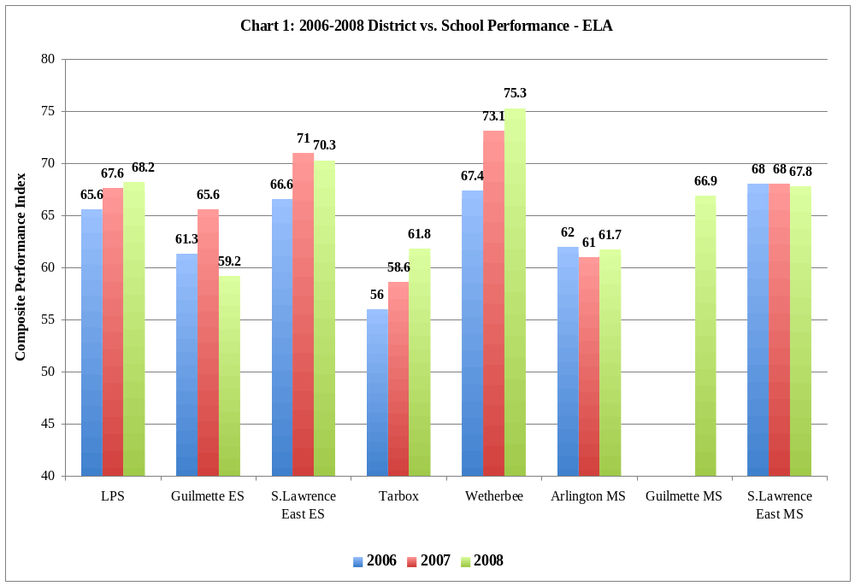

In mathematics, the district has increased its CPI each year, with a total increase of 10 points from 2006 to 2008. All four of the elementary schools (including the K-8 Wetherbee School) in this DPSI review showed marked improvement in mathematics CPI from 2006-2008, including gains of 13.7 points (Tarbox Elementary School), 14.1 points (South Lawrence East Elementary School), 16.5 points (Wetherbee School) and 32.3 points (Guilmette Elementary School). Each of these schools also outperformed the district in mathematics in 2008. The mathematics CPI at both Arlington Middle School and South Lawrence East Middle School has remained relatively flat across years; neither school has outperformed the district. The Guilmette Middle School became a separate middle school in 2007-2008; its performance that year was lower than the district’s. It is also noteworthy that the significant gain seen in performance at Guilmette Elementary School may be, in part, a result of the departure of middle school students who were previously accounted for under this enrollment center.

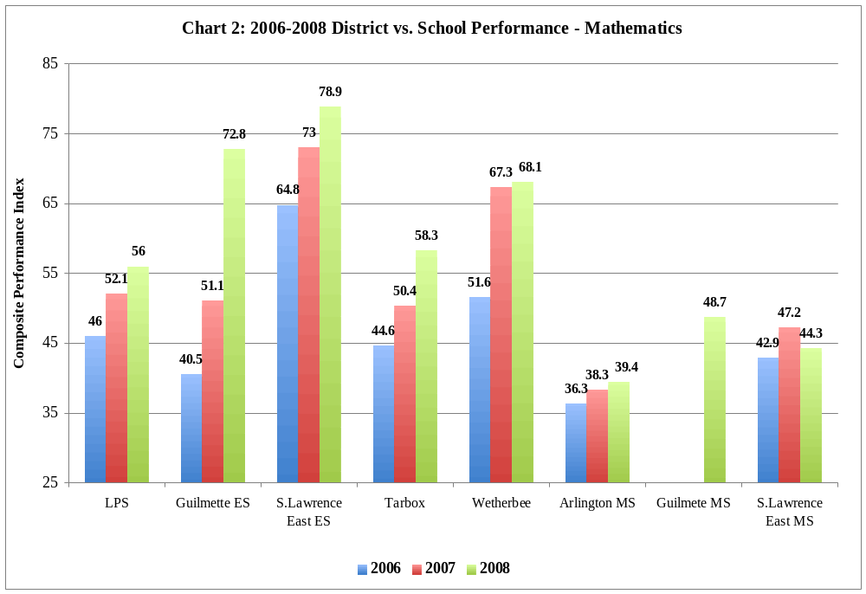

The four elementary Commonwealth Priority Schools included in the DPSI review showed significant CPI increases in ELA for the English language learner (ELL) subgroup over four test administrations from 2005-2008, particularly at the South Lawrence East Elementary School. Gains were considerably more modest at the three middle schools—that is, less than the 9-point gain in the district from 2005-2008. At four out of the seven schools included in the DPSI review, the CPI growth for the special education subgroup was lower during this same time period. At the Tarbox Elementary School, the CPI for special education students declined by 14.6 points. At the Arlington Middle School, the CPI for special education students declined by 22.5 points. This compares to a gain in CPI of 6.2 points for the special education subgroup in the district during this period.



Similarly, across the MCAS administrations from 2005 to 2008, the CPI in mathematics for the ELL subgroup has grown significantly, ranging from a point increase of 9.3 (Arlington Middle School) to as much as 44.6 (Guilmette Elementary School). Gains at the elementary schools were stronger than gains at the middle schools. The district showed a 10-point gain during this time period. CPI gains in mathematics for the special education subgroup were variable. In two of the seven schools in the DPSI review, the rate of growth within the ELL subgroup was significantly stronger than the rate of growth within the special education subgroup. At three of the schools—South Lawrence East Elementary School, Guilmette Middle School and South Lawrence East Middle School—the growth rate was comparable between the two subgroups. At two schools—Tarbox Elementary School and Arlington Middle School—the CPI for special education students declined significantly from 2005 to 2008. This compares to a gain in CPI during this time period of 9.9 points for the special education subgroup in the district.

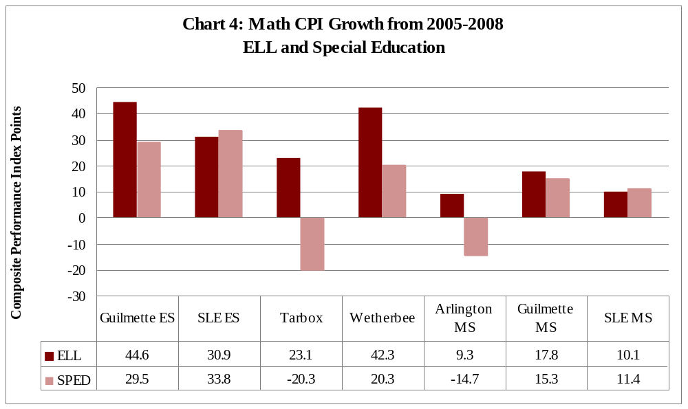

Key Question 1: What capacity to support school intervention efforts has the district demonstrated to date? To what extent have these efforts impacted student achievement?
There has been considerable stability in leadership at the district level in the Lawrence Public Schools (LPS). A core curriculum has been in place at most of the Commonwealth Priority Schools (CPS) for more than five years. The district has taken clear steps to develop and support leadership at the school level. Professional development and the ongoing monitoring of instruction take place in a similar manner across Commonwealth Priority Schools through the use of full-time coaches, focused lesson plans, classroom walkthroughs, formal observations and evaluation, and use of outside consultants.
Collaborative planning time is provided to teachers, although the degree of structure to meetings varies across schools. Certain District Plan for School Intervention (DPSI) initiatives are more evident at the four elementary schools than at the three middle schools. The district has made considerable gains in achievement with its ELL population. The plan for promoting the achievement of its special education subgroup is underdeveloped.
Each school’s Comprehensive Education Plan (CEP) is in alignment with the district’s DPSI and was developed in accordance with Seven Essential Elements for School Transformation.
The LPS DPSI highlights several key strategies for school improvement: strengthening instructional leadership for change through monitoring teaching and learning; structuring teacher collaborative planning; increasing student engagement; refining literacy and mathematics instruction; and closing the achievement gap for ELL and special education students. In order to actualize these strategies, the Commonwealth Priority Schools included in this DPSI review were required to develop CEPs that focus on certain aspects of the DPSI. A review of the CEPs and reports from school administrators and teachers indicated that each school developed goals in alignment with the DPSI and has implemented practices in support of those goals.
For example, at both the Tarbox and the Guilmette Elementary Schools, classroom visits showed teachers addressing their schools’ goal of increasing student engagement through implementing lessons promoting higher-order thinking, based on Bloom’s Taxonomy. At the Arlington Middle School, teachers reported having restructured their team time for grade-level rather than vertical teams to better structure collaborative planning. All seven Commonwealth Priority Schools provide increased literacy instructional time and the elementary schools provide increased mathematics learning time. At the elementary schools, students receive two to three hours of literacy-related instruction and one-and-a-half hours of mathematics instruction daily. At the middle schools, students receive at least two hours of reading/writing instruction and one hour of mathematics each day. All schools are implementing the Success For All (SFA) school reform model for literacy, with the exception of South Lawrence East Elementary School, which has used the Tufts University Learn to Read by Reading literacy model since 2000.
All Commonwealth Priority Schools used a planning format in developing their CEP that required them to consider each of seven elements for school transformation—leadership and school culture; coherent curriculum; instructional practices; assessment and accountability; professional learning; student support services; and family and community engagement. Each school identified its areas of strength and weakness, as well as next steps within each element. The CEPs were all developed in a collaborative manner. Some schools formed committees, with each committee tackling one of the seven elements. Some schools formed a leadership team that consisted of administrators, coaches, teacher representatives, and student support staff.
There are structures to develop and sustain instructional leadership capacity within the district and the Commonwealth Priority Schools.
All central office leaders, as well as principals and assistant principals in the Commonwealth Priority Schools, completed National Institute for School Leadership (NISL) training. Principals reported that they found the focus on mathematics instruction and formative assessment work with students to be most beneficial. District leaders reported that they saw that the training had an immediate impact on mathematics conversations at the school level (e.g., administrators working with teacher teams on aligning components of the mathematics triangle of standards, performance tasks, and activities). District leaders also described the experience as having crystallized a common language between principals and assistant principals and promoted a higher degree of collaboration, sharing of practices, and problem-solving among administrators. The Institute chose to videotape Lawrence classrooms and interviews with administrators and teachers to add to their collection of training modules. The principals of five out of the seven Commonwealth Priority Schools are furthering their leadership education by using the NISL credits they earned toward the completion of a doctoral program through NOVA Southeastern University. In addition to supporting the leadership training of current school administrators, the district has supported the participation of two cohorts of teachers (15 to 25 per group) in the Leadership Enhancement program at the University of Massachusetts at Lowell, promoting a practice of growing leadership from within the district. Furthermore, where Commonwealth Priority Schools have created leadership teams, the district has supported these efforts by paying stipends to teachers who stay after school to fulfill this responsibility.
Interviews with principals and district leaders indicated that the district makes a point of training principals in initiatives first so that they are in a position to lead staff members during the implementation of the initiative. The South Lawrence East Middle School principal, for example, attended a three-day training in SFA before introducing the program into the school two years ago. All principals, assistant principals, and coaches were trained in the use of the Department’s learning walk tool and then they, in turn, trained teachers in their respective schools. In focus groups district leaders, principals, and teachers reported that the use of learning walks has promoted a common understanding of effective instructional strategies and enabled principals and coaches to provide greater leadership by giving specific feedback to teachers regarding their teaching strengths and weaknesses. In addition, at some schools, teacher leadership in improving instructional practices is being developed through including teachers in the learning walks. For instance, at Arlington Middle School, each teacher participated in a minimum of three learning walks in 2008-2009.
The district further develops leadership capacity of principals through the use of principal peer performance reviews (PPPR), conducted mid-year. District leaders reported that these reviews promote a structured discussion between a principal and central office leaders about school performance indicators, student achievement, and progress toward meeting CEP goals and objectives. A review of letters summarizing these reviews from district leaders to principals showed written feedback with recommendations for next steps (e.g., “Identify 2-3 strategies from the Department learning walk protocol to focus your walkthroughs the remainder of the school year. Make sure they are connected to your school priorities and include your teachers and members from central office.”). Summative evaluations are written for principals at the end of the year. The district has also encouraged and supported the participation of middle school Commonwealth Priority School principals in Department-sponsored professional development. Topics for the professional development have included leadership in mathematics and strengthening the outcomes of teacher common planning time.
Not only has the district established structures to build leadership capacity in the district, but these structures have increased confidence in leadership at the school level. A survey conducted of Commonwealth Priority School teachers in 2009 indicated that a very high percentage of teachers hold confidence in the leadership of the principals in their schools. Ninety-six percent of the teacher respondents responded, “The principal has the vision, skills, and knowledge to guide school improvement.” Ninety-eight percent said that “My principal communicates expectations about teaching and learning clearly to the teaching staff.” Eighty-three percent felt that “The school administration and faculty are able to create an environment in our school in which teachers and students can focus on teaching and learning.”
Coaches are assigned to each school and serve a critical role in strengthening classroom practices through providing school-based professional development and ongoing support to teachers.
All of the Commonwealth Priority Schools included in the DPSI review have full-time coaches in their schools. The elementary schools have the equivalent of one SFA facilitator, one reading coach, one writing coach and one mathematics/science coach. The middle schools have a smaller number of coaches and variability in the focus of the coaches. For instance, Arlington Middle School has three coaches: one SFA facilitator, one mathematics coach and one writing coach. The other two middle schools each have two coaches: one for SFA and the other for mathematics. In focus groups, coaches and teachers reported that coaches serve similar professional development functions across schools. Using observation tools (e.g., Department learning walk tool, Sheltered Instruction Observation Protocol (SIOP), SFA tool), they conduct walkthroughs and give feedback to teachers; they also model lessons in classes, participate in co-teaching lessons, and plan and implement training sessions within the school.
In focus groups, coaches and teachers described the use of resident classrooms to model effective practices in each school. The coaches identify and encourage teachers to serve as peer leaders in demonstrating a particular teaching strategy while other teachers come in to observe the class. This practice has been in place in some schools for as long as seven years. Teachers in focus groups reported feeling increasingly more comfortable having peers come into their classes to observe. In some schools the coaches, as well, maintain resident classrooms. At the South Lawrence East Elementary School, literacy and mathematics coaches teach a daily learning lab for students in grades 3 and 4. Teachers are able to come and observe best practices and debrief with the coach afterward.
Coaches also play a critical role in weekly collaborative planning meetings with teacher grade-level teams. In focus groups, teachers and coaches reported that coaches attend—and often lead—at least one meeting per week. They assist teachers in analyzing and discussing implications of data, developing weekly lesson plans, and planning interventions for at-risk students. The district provides the opportunity for coaches to meet with district leaders once a month for their own professional development.
Both school administrators and teachers perceive the coaches as playing a key role in serving as models and resources in their respective content areas. Coaches are also helping to empower teachers to take on instructional leadership roles through practices such as resident classroom.
Instruction is monitored in a variety of ways in the district. The frequency of such monitoring and the amount of feedback given to teachers varies from school to school.
All Commonwealth Priority School administrators, coaches, and teachers reported using the learning walk protocol, or variations of the tool, in their schools. The frequency with which the learning walk is conducted varies across schools. At one school, for example, the learning walk generally takes place twice a month and several of the walks have included teachers. At another school, the administrators and coaches visit classrooms at least twice a week, using the SFA or SIOP-adapted learning walk tool. At another school, there were three learning walks scheduled during the year involving three teams with visits to approximately 15 classrooms each time. In a survey of Commonwealth Priority School teachers in 2009, 83 percent of teacher respondents indicated that, in addition to the formal evaluation process, school administrators observe instruction in classrooms three or more times per year. Across schools, leadership, coaches, and teachers reported that administrators and coaches frequently participate in the learning walks. In some schools, teachers or grade-level teams have conducted walkthroughs together.
While walkthroughs occur in all schools, the amount of feedback teachers receive from principals, assistant principals, and coaches varies across Commonwealth Priority Schools. Teachers in some schools regularly receive feedback after classroom walkthroughs are conducted. In other schools, feedback is not routinely provided. Teachers in focus groups at several schools included in the DPSI review reported that the principal consistently provides meaningful written feedback, often within 24 hours after a visit. Teachers in focus groups at other schools reported that feedback is not consistently given to teachers after visits. On the 2009 Commonwealth Priority Schools teacher survey, 98 percent of the teachers indicated that the feedback they receive from school administrators after they observe a classroom is “somewhat useful” or “very useful.” Teachers also receive feedback as part of implementation visits from outside consultants who conduct classroom visits and follow-up meetings with administrators and teachers (e.g., SFA, Tufts University). A review of sample reports showed that feedback includes key observations and recommended next steps at both the classroom and school levels.
There is also variability in the monitoring of lesson plans. All teachers in the Commonwealth Priority Schools write weekly lesson plans. At some schools, such as the Guilmette Elementary School, the principal reviews all plans weekly and provides teachers with written feedback and suggestions. At other schools, the plans are turned in to the principal but he or she does not regularly provide feedback.
Many of the schools have tailored the learning walk tool to focus on the implementation of specific programs or strategies. For example, at the Wetherbee School and the Guilmette Middle School, coaches have crafted the learning walk tool to focus on different strategies related to programs such as Reading First, SFA, or SIOP. The walkthrough protocol used at the South Lawrence East Elementary School is tailored to each grade level and to content areas such as mathematics or literacy. When principals or coaches visit classrooms, they sometimes target their observations on programmatic elements or strategies.
Teachers indicated that principal and coach feedback after walkthroughs is appreciated and worthwhile. The foundations have been established for increasing feedback in the district to continue to improve teaching and student learning. The frequency of classroom visits and the amount of feedback after visits vary across schools.
There are structures for teachers to collaborate regularly at the school level. This time is generally used for discussion related to improving instruction. There is variability in how collaborative meeting time is organized to focus on improving instructional practices.
District leaders and principals, coaches, and teachers across schools in the DPSI review reported that there has been an increasing shift in the district from teachers working individually to teacher team collaboration. Furthermore, many teachers reported moving away from using collaborative time for business or logistical conversations to focusing more consistently on data analysis and instruction. One of the Commonwealth Priority Schools principals stated, “Being a Commonwealth Priority School has really driven our focus to make common planning time more productive.” Across all Commonwealth Priority Schools, grade-level teacher teams meet at least twice a week for the equivalent of two hours— time allocated in addition to the 150 minutes of contractual personal planning time. Some teacher teams choose to meet daily. In addition to the collaborative planning meetings, the district provides half-day release time once a month. Twice a year, this time is used for job-alike meetings across schools in which teachers within grade levels or specialty areas collaborate around issues of common interest and need.
Teachers and coaches in focus groups reported that collaborative planning time is used to conduct a range of discussions and activities related to improving instruction. The types of activities included discussing and/or developing weekly lesson plans; reviewing student performance data; identifying needed interventions for students; and looking at student work (using a rubric to score and analyze written responses to writing prompts). Grade-level teams reported having the flexibility to choose a particular topic for discussion. At Guilmette Middle School, for instance, each grade-level team conducted a book study group focused on improving strategies for giving effective feedback on student work.
Protocols and agendas for structuring the collaborative planning time are not standardized across Commonwealth Priority Schools. Some schools create very specific agendas for their meetings. At the South Lawrence East Middle School, for example, the agenda for one of the weekly meetings is devoted to SFA planning with the coach, whereas the second day is focused on either mathematics/science or humanities. At the South Lawrence East Elementary School, each grade-level team has its own focus agenda, according to which certain topics are discussed every week (e.g., standards-based instructional planning through refining units of study). At other schools, an agenda is sometimes brought into the meeting, but at other times the focus of discussion is decided once teachers convene. In some schools, the meeting minutes are routinely sent to the principal. In other schools, minutes are kept in a binder.
Administrators, coaches, and teachers across Commonwealth Priority Schools reported that membership at teacher team meetings always includes administrators and coaches for one to two of the sessions. There is variability across schools in the inclusion of the special education teachers. At some schools, the special education teacher consistently joins the grade-level team teachers. At other schools, this does not happen because the special education teacher is scheduled to provide services to students during the meeting time.
While team meetings are built into each school’s schedule, at some schools this collaborative planning time is held sacred. At other schools, individualized education plan (IEP) review meetings often get scheduled during this time, interfering with the teachers’ ability to focus on instructional improvement. At the South Lawrence East Middle School, for example, where there are 40 special education students in one grade, many common planning meetings become IEP meetings because there is difficulty finding alternative times when teachers can attend.
The variability in the use of specific agendas to focus discussion and the challenges of using the scheduled time for teacher collaboration only may have influenced teacher respondents on the 2009 survey of Commonwealth Priority School teachers. Only 64 percent of teachers responding to the survey said that they participate in meetings with their colleagues to have professional discussions about teaching and learning, and with a frequency of at least twice a week. While the district has supported the scheduling of regular collaborative meetings, the ability to focus on improving instructional practice during these times is influenced by disruptions to meeting times and inconsistent use of discussion agendas.
The district provides meaningful professional development related to its improvement initiatives.
In focus groups, teachers across Commonwealth Priority Schools reported that there is a tremendous amount of helpful professional development (PD) available within the district. There is a combination of school-based and district-sponsored PD. Each school provides the majority of its professional development during half-day release time once a month. The agendas are sent to district leaders, who make a point of attending sessions at different schools. District leaders also come to individual schools to provide workshops. The work of the full-time coaches in the Commonwealth Priority Schools provides ongoing embedded PD for teachers. During 2008-2009, 50 literacy-related resident classrooms were made available in different schools for teacher visits. The walkthroughs that involve teachers have influenced instruction. One teacher stated, for example, “During a walkthrough, I learned a lot from the grade five teachers. They write learning objectives for students that focus on how students will know they’ve mastered concepts or skills. For example, ‘I will know I have learned this when I can…’ That’s powerful. I never thought of it like that.”
The district provides professional development opportunities during the school year and summer. SIOP training is provided to all staff annually. A review of the 2008-2009 PD calendar indicated that mathematics-related training is provided throughout the year. Teachers are paid to attend a weeklong reading and/or mathematics academy held in the summer, with priority given to Commonwealth Priority School teachers. In addition, a writing institute has been held annually in June for the past five years. Throughout the year, workshops are held for new and beginning teachers. The district relies heavily on the use of a “turn-key” strategy for training in which the staff member who has been trained then becomes the trainer of others (e.g., the Department trained principals in the use of the learning walks tool and principals trained teachers in their school).
Lawrence Public Schools also maintains affiliations with outside organizations that support the work of Commonwealth Priority Schools. LPS has a partnership with Boston University and the University of Massachusetts at Lowell through the Focus on Mathematics project, designed to improve student achievement by providing mathematics teachers with content knowledge and skills. The South Lawrence East Elementary School is affiliated with the literacy program of the Center for Applied Child Development at Tufts University. When the grant money that originally supported this affiliation ended, the district continued to support this work, covering the $20,000 cost.
Student engagement and the use of higher-order thinking skills vary across schools and are more evident in the elementary schools than in the middle schools.
One of the goals and cross-cutting issues articulated in the Lawrence Public Schools’ DPSI is that students respond actively and interactively with content, participate in collaborative learning activities, and engage with questioning that promotes higher-order thinking and reasoning. The DPSI review team conducted 84 classroom visits across seven schools while on site in Lawrence. A high level of student engagement and higher-order thinking was observed in more classrooms at the elementary schools than at the middle schools. Pacing the lesson to ensure all students were actively engaged was observed in 73 to 91 percent of classrooms at three out of the four elementary schools. At the three middle schools, this was observed in only 22 to 55 percent of classrooms. The frequency of questions requiring students to engage in higher-level thinking (e.g., application, analysis, synthesis, and evaluation) varied across elementary schools. There was solid evidence of this practice in two elementary schools (64 and 73 percent)—first grade students, for example, used a Venn Diagram to compare and contrast schooling in the USA and schooling in China—while the other two had lower rates (20 and 33 percent). There was also less evidence in the classrooms at all three middle schools of higher-order thinking skills being practiced (11 to 36 percent).
Similarly, in 64 and 100 percent of the classes within two of the elementary schools, students were observed to be inquiring, exploring, or problem solving together, in pairs or small groups. In a third grade class, for example, students were estimating their heights, measuring one another, and comparing data. Such collaborative paired or small group work was observed in 10 and 44 percent of the other two elementary schools, and in 11 to 55 percent of the middle school classrooms.
The district uses curricular materials designed to encourage peer interactions and group problem solving. For instance, in ELA, six out of the seven Commonwealth Priority Schools use the SFA literacy program that requires team talk, literature circles, and group discussion and problem solving. In mathematics, the TERC Investigations and Connected Mathematics Project curricula both encourage peer sharing and problem solving. However, whether lessons required student collaborative work and higher-order thinking skills varied considerably from school to school. Overall, there was less evidence of a focus on student engagement and higher-order thinking in middle school classrooms visited during this DPSI review.
Summative data is used to track student progress, group students for instruction, and evaluate the impact of certain programs. The use of formative assessments is not widespread.
Lawrence Public Schools uses a considerable amount of summative data throughout all its Commonwealth Priority Schools. The position of one of the district leaders (director of assessment and accountability) is specifically devoted to managing and evaluating data and making data accessible to all school administrators and teachers in the district. Each fall, the district provides schools with a data profile sheet for every student that includes three years of student information, such as enrollment history and achievement data. Measures of Academic Progress (MAP) assessments are used three times per year in grades 2-10. School administrators and teachers interviewed during the review reported using this data to group students for SFA, Literature Circles, or Read 180 and System 44 technology interventions. SFA summative testing is conducted three times per year. Principals, coaches, and teachers in focus groups reported giving mock MCAS tests during the year—some as frequently as monthly. Reports from teacher focus groups were that data is not consistently used to make content instructional decisions at the grade level, but is routinely used by individual teachers in assessing the needs of students in their classes.
Data walls showing results of MCAS and MAP existed in all Commonwealth Priority Schools, most of them geared toward use by principals, teachers, and coaches in monitoring the progress of students. At some schools, the data walls were exceptionally detailed. At Guilmette Elementary School, for example, an entire conference room was filled with assessment results by grade and class used to track student performance, along with a description of specific interventions and strategies being provided and information as to whether the student was enrolled in after-school support programs. At some schools, there were data walls intended for review by students. For instance, at Wetherbee Elementary School students track their progress on mock MCAS tests and are provided rewards for improving performance and demonstrating proficiency in content areas.
An in-house program evaluator conducts assessments on the effect on student achievement as a result of newly initiated programs within the district. For instance, an end-of-year report was generated in 2008 on the effectiveness of the Read 180 program with students in five out of the seven Commonwealth Priority Schools (as well as students in several other district schools). The report noted the fidelity with which various schools had used the technology program and looked at growth in the MCAS and MAP performance of students who had been assigned to the program.
The use of formative assessments in the Commonwealth Priority Schools included in the DPSI review is not as widespread. The Dynamic Indicators of Basic Literacy Skills (DIBELS) is the one formative assessment consistently used by teachers at each of the CPS elementary schools; it is used three times per year to assess developing pre-reading and reading skills. The SFA program is used at six of the seven Commonwealth Priority Schools and includes weekly comprehension and vocabulary testing. LPS has recently introduced the use of the Criterion Online Writing Evaluation program for grades 4-12—a web-based application that provides immediate feedback on students’ writing skills. A process of looking at student writing and collaboratively scoring writing samples based on rubrics has begun at some of the elementary and middle schools. Some schools have begun to develop common assessments. At other schools, teachers reported that they plan to develop common assessments in the future. At South Lawrence East Middle School, for example, teachers in focus groups reported that they had developed ELA benchmarks and administered common assessments one time this year, with plans to develop similar mathematics benchmarks during the summer.
The use of assessment information at the classroom level to understand student learning and modify instruction is also varied. In 44 percent of the classrooms visited during the DPSI review (N=37), there was solid evidence of use of on-the-spot assessments. At Wetherbee Elementary School, for example, a mathematics teacher was observed using exit slips before the end of class, providing an opportunity for students to demonstrate learning based on the lesson. At Guilmette Middle School, the teachers include a daily assessment (e.g., exit cards) in their plan books. In 38 percent of the classes (N=32), there was solid evidence of the use of formative written feedback to students. For instance, at Tarbox Elementary School, student papers on the wall held post-its with teacher comments, such as “Excellent adjectives! Next step: Make sure proper nouns are capitalized.”
The district has made significant strides in using summative data to monitor student learning. There is currently a lack of frequent and consistent use of formative assessments throughout the district. In some focus groups, teachers expressed their uncertainty about the difference between formative versus summative types of assessments. District leaders reported awareness of the necessity for more day-to-day formative assessments in the Commonwealth Priority Schools in order to continue to improve teaching and learning.
Sheltered English immersion instructional strategies to support English language development are evident across the district’s Commonwealth Priority Schools, with varying degrees of implementation across classrooms.
In all seven Commonwealth Priority Schools included in the DPSI review, ELL students have made gains in achievement in ELA and mathematics over four test administrations from 2005 to 2008. Gains at the elementary level have been particularly noteworthy. The district mandates training in sheltered English immersion strategies for all administrators and teachers. New teachers participate in training the summer before school begins. One teacher stated that the training in SIOP three years ago had been the professional development that has had the biggest impact on changing instructional practice. In addition, at least 50 teachers in the district have been trained in the use of MELA-O assessments.
Classroom visits during the DPSI review showed that sheltered English immersion strategies are particularly evident in many elementary classrooms. At Tarbox Elementary School, for example, many teachers were observed using visuals (e.g., puppets, pictures, cards, role-playing, extensive labeling) as well as speaking clearly/slowly and restating. In addition, common phrases were posted on walls in the stairwells. There was evidence at Wetherbee School and Guilmette and Tarbox Elementary Schools that teachers use a planning template requiring them to incorporate SIOP strategies into their lessons. The district has invested in the UnitedStreaming video collection to enable teachers to further incorporate visual teaching into their lessons. There was more evidence of the use of SIOP strategies in the elementary classes than in the middle school classes, and there was a lack of consistency in the use of these strategies across all classrooms.
The district has given particular attention to equipping teachers with knowledge and instructional strategies for promoting the achievement of ELL students. These efforts have been most successful at the elementary level, where the achievement of ELL students grew significantly from 2005 in both ELA and mathematics. SIOP strategies are actively in use in many elementary classrooms. The progress of ELL students has been more modest at the middle school level—stronger in mathematics than in ELA. There was less evidence of the use of SIOP strategies in the middle school classrooms.
The district does not currently have a specific improvement plan for raising the achievement of special education students.
Growth in achievement for special education students from 2005 to 2008 has been evident in four of the seven Commonwealth Priority Schools in ELA, and in five out of the seven schools in mathematics. In one school, however, the growth in CPI for special education students in ELA has been less than half that for ELL students; in a different school, the same has been true in mathematics. Two schools demonstrate significant decreases in performance in both subjects for the special education subgroup during this time period. In the Commonwealth Priority Schools overall, the rate of growth in achievement for the special education subgroup has been lower than that for ELL students.
In focus groups, district leaders, principals, coaches, and teachers reported that professional development on effective instructional techniques for teaching special education students has generally been left to the discretion of individual schools. There have been district Response to Intervention trainings on specific programs and interventions such as Fast ForWord, READ 180, and the Family Support Team (FST). Other than these trainings, and occasional PD in the use of differentiated instruction, professional development on effective instructional techniques for teaching special education students has not been a focus of the district. The district has depended on the embedded professional development that takes place when the special education teacher meets with grade-level teams or individual teachers to discuss the needs of special education students. However, this practice is inconsistent. In many schools, due to scheduling conflicts, the special education teacher cannot consistently attend grade-level meetings. There has also been very limited PD for special education teachers other than opportunities to meet together during job-alike sessions.
The provision of services for special education students varies throughout the Commonwealth Priority Schools. At some of the schools, services are generally provided through “push-in,” in which special education staff members teach students in the general education classroom. At other schools, students receive mathematics instruction in substantially separate learning environments. Teachers and support staff in focus groups reported that paraprofessionals assigned to support special education students often get pulled to substitute in classes, interrupting the regular flow of services to students in the general education classroom.
In focus groups, teachers reported the use of a mock MCAS test several times during the year as being an effective way to assist special education students because they obtain practice in taking the test with their IEP accommodations in place. Also, the district provided an extra special education teacher to the South Lawrence East Middle School in 2008-2009 because 32 percent of the students in one grade received services through IEPs.
The kind of focused professional development established for improving the performance of ELL students has not been established for improving the performance of special education students in the Commonwealth Priority Schools. In focus groups, district leaders stated that they intend to focus on special education next year, however, specific plans have not yet been developed.
Key Question 2: To what extent has the work of the Department impacted and supported the district in implementing improvement initiatives?
The work of the Department has had a positive impact on the district’s implementation of improvement initiatives. In particular, the grants that have supported professional development in literacy and mathematics and the introduction of the learning walk protocol have greatly influenced instructional practices and the monitoring of instruction. District leaders have noted a shift in the role of the Department from being primarily focused on accountability and compliance to being more assistance-oriented.
The district is using Department resources effectively to build teacher and administrator capacity for advancing instructional improvement.
In focus groups, both district leaders and principals spoke positively about the impact of the Department’s provision of training and monies to support the Commonwealth Priority Schools in advancing instructional improvement. All principals and assistant principals have completed the NISL training. The more experienced principals reported feeling that certain topics were repetitive of what the district had already offered them, and recommended that training be better customized for the participating districts (e.g., for LPS, more focus on ELL and special education). However, certain topics—leadership in mathematics and providing students with feedback—were universally felt to be valuable. District leaders reported that NISL training has had a critical impact on teachers seeing increased leadership from principals.
The Department provided training on the use of the learning walks tool for all district leaders and Commonwealth Priority School principals. The tool is being used regularly in all Commonwealth Priority Schools. In focus groups, coaches and middle school principals spoke about the value of the Department’s training and assistance with respect to using exercises and protocols to develop professional learning communities in the schools. In focus groups, district leaders, principals, coaches, and teachers identified ways in which the Department has supported Commonwealth Priority Schools in the areas of mathematics and literacy. The activities, programs, and funding found to be most critical in improving instruction included: middle school principal team focus on leadership in mathematics, Carnegie Bridge to Algebra and Carnegie Cognitive Tutor software, reading and mathematics academies, Reading First and Silber grants, and the $10,000 provided for each Commonwealth Priority School to hire consultants and specialists (e.g., bringing back Andrew Chen for further professional development in mathematics). Furthermore, the provision of additional technology has allowed Commonwealth Priority Schools to give assistance with content and skills to students who need additional interventions (e.g., FASTT Math to develop student automaticity in mathematics facts).
District personnel report the existence of a supportive, positive, and collaborative relationship with the Department.
District-level and school-based leaders uniformly reported having a very positive working relationship with the Department. They noted that the Department has moved from taking a more evaluative stance to partnering with the district to help support school improvement. District leaders reported feeling that there has been very collaborative work with ESE representatives at the Commonwealth Priority Schools (e.g., with the liaison who oversees Reading First schools and the mathematics learning community liaison). District leaders asserted that liaisons from the Department help them “push at our thinking” about next steps in the improvement process. The district has particularly appreciated the Department’s ability and willingness to share with it promising practices in communities with similar demographics and needs, as well as the Department’s help in networking with other districts.

Recommendations
The recommendations provided in this report were developed by the review team. Recommendations reflect the areas that the review team determined should be priorities for the district in its future improvement efforts and are not intended to address every area requiring improvement. These recommendations are for the district to consider in future improvement efforts and for the Department to consider in determining support for improvement.
Improve the rigor of instruction through increasing students’ engagement in problem solving and use of higher-order thinking (HOT) skills.
- Focus learning walk walkthroughs and resident classrooms more specifically on a narrow range of instructional strategies to promote increased student engagement and use of higher order thinking skills.
- Provide additional professional development on high quality small-group student problem solving and HOT.
- Some schools are using HOT strategies more effectively; consider investigating how this capacity has been built in these schools and apply these methods to other schools.
Develop common assessments at the district level for use by teachers to benchmark student growth more regularly throughout the school year.
- Including teacher representatives in the district-level work of creating assessments will help to build teacher capacity and create ownership of the process.
- This might include professional development for teachers in how to use the common assessments and how to design/adapt lessons to address student needs based on the results of assessments.
Strengthen implementation of instructional strategies that specifically support the learning of ELL students at the middle school level.
- Use Sheltered Instruction Observation Protocol (SIOP) lesson planning template or incorporate specific structured immersion strategies into weekly lesson plans.
- Monitor instruction for use of SIOP strategies through targeted walkthroughs and review of lesson plans.
Develop a clear improvement plan for increasing the achievement of special education students.
- Include strategies for promoting the academic achievement of special education students in an improvement plan. Once implemented, monitor the effectiveness of these strategies for special education students to ensure that they are having the intended impact.
- Review the components of professional development and the school-based practices that resulted in the effective use of SIOP. Incorporate those elements into the plan for special education.
- Create opportunities for consistent weekly planning time between grade level teachers and special educators.

Appendix A: DPSI Review Team Members

The review of the Lawrence Public Schools was conducted from June 1-9, 2009, by a team of educators from SchoolWorks, LLC on behalf of the Massachusetts Department of Elementary and Secondary Education.
Susan Carlson, Consultant, SchoolWorks
Patricia O’Leary, Consultant, SchoolWorks
Dr. Muriel Leonard, Consultant, SchoolWorks
Ledyard McFadden, Chairman, SchoolWorks
Dr. Fred Wetzel, Consultant, SchoolWorks
Pat Williams, Consultant, SchoolWorks

Appendix B: DPSI Review Activities and Schedule

DPSI Review Activities
The following activities were conducted as part of the DPSI review of the Lawrence Public Schools.
- The DPSI review team conducted interviews and focus groups with the following representatives from the Massachusetts Department of Elementary and Secondary Education: manager of and staff from the Urban and Commissioner’s Districts unit; manager of the Educator Leadership unit; staff from the Math, Science, Technology & Engineering unit; and staff from the Literacy unit.
- The DPSI review team conducted interviews and focus groups with the following representatives from the Lawrence Public Schools central office administration: acting superintendent/assistant superintendent for operations and support services; assistant superintendent for curriculum and instruction; director of assessment and accountability; director of human resources; coordinator of curriculum and instructional measurement; coordinator of reading and English language arts; supervisor of instructional technology; supervisor of Reading First; district principal for mathematics; district facilitator of mathematics; supervisor of early childhood, Pre-K-3; coordinator of special learning services; director of ELL programs.
- The DPSI review team conducted 84 classroom visits within different grade levels and subjects across the following Lawrence Public School Commonwealth Priority Schools: Guilmette Elementary School (1-4); South Lawrence East Elementary School (1-4); John K. Tarbox Elementary School (1-5); Emily G. Wetherbee School (K-8); Arlington Middle School (5-8); Guilmette Middle School (5-8); South Lawrence East Middle School (5-8).
  - During school visits, the DPSI review team conducted interviews with the following personnel: school principals; assistant principals; teachers; instructional coaches; support staff; specialists; students.
    - The DPSI review team reviewed the following documents provided by the Department:
- The Lawrence Public Schools DPSI
- The Memorandum of Understanding (MOU) between the Lawrence Public Schools and the Department
- The District Leadership Report on the Essential Conditions
  - The DPSI review team reviewed the following documents at the district and school levels (provided by the district or schools):
- District and school Comprehensive Educational Plans 2008-2010
- Professional development calendars
- Lawrence Public Schools District Plan for School Intervention PowerPoint presentation, June 1, 2009
- Individual school reports on student enrollment and accountability data
- DESE Teacher Survey Results for Commonwealth Priority Schools, May 2009
- The Lawrence Educator, Winter 2009
- Agendas for CPT meetings
- District Priorities for ESE Assistance to Commonwealth Priority Schools FY2009

DPSI Review Schedule
The following is the schedule for the onsite portion of the DPSI review of the Lawrence Public Schools, conducted from
June 1-9, 2009.
Monday | Tuesday | Wednesday | Thursday | Friday
June 1  DPSI review team meeting  Initial district meeting and interviews | June 2  Site visit to  Arlington  Middle School Day 1  Site visit to Tarbox Elementary School | June 3  Site visit to Arlington Middle School  Day 2  Site visit to Wetherbee Elementary School | June 4  Site visit to Guilmette Elementary School  Site visit to Guilmette Middle School | June 5  DPSI review  team meeting  Interviews and focus groups with central office administration
June 8  Site visit to South Lawrence East Elementary School  Site visit to South Lawrence East Middle School | June 9  DPSI review team meeting  Final meeting and interviews with district | N/A | N/A | N/A

See Mass. Gen. Laws c. 15, § 55A, as amended by St. 2008, c. 311, § 3, effective August 14, 2008.
With respect to Commonwealth Priority Schools and schools in restructuring, see 603 CMR 2.00, available at Laws and Regulations.
The Seven Essential Elements for School Transformation were developed by the superintendent in 2000 and described by a member of the district leadership in “The Seven Essentials of School Transformation: An Extreme Makeover for Schooling” in The Lawrence Educator, the district’s new quarterly magazine, in spring 2008.

