# Massachusetts District Reviews

Research on effective school and district leadership highlights the importance of a concerted districtwide focus on aligning systems, policies, and practices in service of improving student outcomes and experiences. This focus is demonstrated by clear standards for performance and goals for improvement, coupled with an ongoing cyclical process for measuring progress.

Therefore, in alignment with state statute (M.G.L. Ch. 15 S 55A), the Office of District Reviews and Monitoring (ODRM) at the Massachusetts Department of Elementary and Secondary Education (DESE) partners with an outside contractor to conduct in-depth reviews of school districts across the Commonwealth. These reviews identify strengths, areas for growth, and recommendations that district leaders can leverage to catalyze systemic improvements.

A select number of districts are reviewed each year and are assigned either a *comprehensive* or *targeted* review. Both review types are grounded in the *District Standards and Indicators*, the foundational document guiding all data collection and reporting for district reviews.

The district review process culminates in a detailed report on each district that is shared with district leaders and published to DESE’s website. District leaders are encouraged to use the information collected in the review to guide strategic planning, inform resource allocation, and determine focus areas.

Contents

Massachusetts District Reviews 1

Preview of DESE’s *District Standards and Indicators* 3

The District Review Process 4

Phase 1: Preparation 4

Phase 2: Onsite 6

Phase 3: Drafting and Publication 7

Phase 4: Post-Review 8

Contact 8

Appendix A. Document Collection and Submission 9

Document Uploads 9

Uploading Files to SharePoint 9

Having Difficulty? 11

Educator Evaluation Files 11

Questionnaires 12

Appendix B. Instructional Observations and CLASS Information 13

Appendix C. Key Stakeholders for Interviews and Focus Groups 14

## Preview of DESE’s *District Standards and Indicators*

The [*District Standards and Indicators*](https://view.officeapps.live.com/op/view.aspx?src=https%3A%2F%2Fwww.doe.mass.edu%2Faccountability%2Fdistrict-review%2Fdistrict-standards-indicators.docx&wdOrigin=BROWSELINK) is DESE’s definition of effective district systems, policies, and practice. Furthermore, the document is the basis for the comprehensive district review. The *District Standards and Indicators* was based on research and on input from Massachusetts school-, district-, and state-level stakeholders, with a particular focus on equity and practices that can help advance equitable outcomes for historically underserved student groups.

The six standards include Leadership and Governance, Curriculum and Instruction, Assessment, Human Resources and Professional Development, Student Support, and Financial and Asset Management. Within each standard, there are three to four indicators and corresponding “look-fors” that increase in granularity and further describe what effective systems, policies, and practices can look like.

The six standards and their corresponding indicators are displayed below:

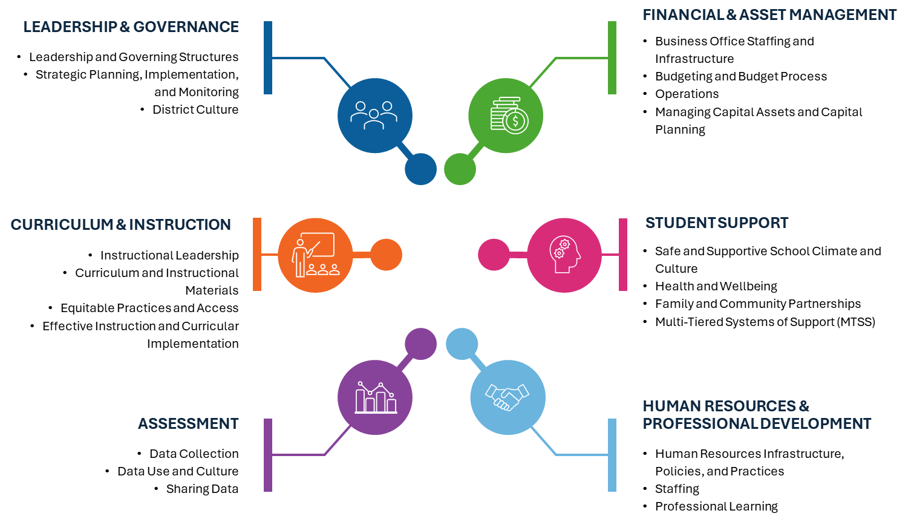

It is highly recommended that district leaders review the *District Standards and Indicators* in its entirety, as this document informs every aspect of data collection for district reviews. Your district’s finalized report will be structured around the six standards and their corresponding indicators.

DESE strongly recommends that superintendents and district review liaisons read through the *District Standards and Indicators* prior to their district’s onsite week.

## **Th**e District Review Process

The four phases of the district review process are as follows:

### Phase 1: Preparation

The preparation phase includes all the tasks a district must complete to be well-prepared for the onsite portion of the review. Because this phase is typically the most labor-intensive for districts, the following checklist is designed to clearly display and organize each of the tasks required and their approximate timelines.

| Item | Description | Timeline/Due Date | Completed? |
| --- | --- | --- | --- |
| Liaison Selection | Select a liaison for the review. This person is responsible for facilitating the review through its completion. Typically, districts will appoint **a central office administrator to this role.**  Submit the liaison’s name, role, and contact information to [Robert.J.Havdala@mass.gov](mailto:Robert.J.Havdala@mass.gov). | Due by: March 30th |  |
| Orientation | ODRM will host two 90-minute orientation sessions in which DESE will discuss the review process, introduce the *District Standards and Indicators*, and answer districts’ questions.  Each district must send at least one representative (the liaison and/or superintendent) to one of the orientation sessions. | 2025-26 orientation sessions are scheduled for the following dates/times:  June 10th: 10:30am-12pm  August 5th: 10am-11:30am |  |
| Document Collection | Districts must submit several documents as part of the district review process. Please see Appendix A for details on the required documents and submission directions. | All documents should be submitted 2 weeks prior to the district’s onsite week. |  |
| Master Schedule Development | Districts will receive survey to determine their preferred onsite review week. Scheduling decisions will take into consideration MCAS testing schedules and other constraints. | The scheduling survey will be sent out in the week of August 5th, after the August orientation. |  |
| Introductory Calls | District review partner will reach out to each district to schedule a brief introductory meeting with the district review liaison. This is an opportunity for the district review partner to answer questions about the review process and to support the district with its document collection and scheduling responsibilities. | District review partner will begin scheduling these meetings once the master schedule is set. Typically, this will take place in September and/or October. |  |
| Onsite Scheduling | Ahead of each district’s onsite, the review team leader will work with the district liaison to build a detailed schedule for all onsite classroom observations, interviews, and focus groups. | This process can start with the introduction call (above) and should be finalized two weeks in advance of the onsite. |  |

### Phase 2: Onsite

The onsite phase of the district review will last one week **and will take place between the months of October and April**. Typically, reviewers will be physically present in each district for three to five days during the onsite. In the week following the onsite, stakeholders may be contacted on a limited basis to provide additional information, clarification, and/or documentation.

The onsite consists of three components:

**Interviews and focus groups** are core elements of the district review process. While onsite in the district, the review team will conduct in-person interviews and focus groups with an array of stakeholders. Most of these discussions will be held in person, however, the review team will arrange virtual interviews and focus groups when necessary. Appendix C provides detailed information regarding which stakeholders will participate and directions for selecting focus group participants.

**Classroom observations** are conducted in all district reviews. Certified observers will conduct classroom observations using the Classroom Assessment Scoring System (CLASS) observation tool. Observations will be conducted at each grade level and across multiple subjects. Observations are typically scheduled at the same time as the on-site stakeholder interviews and focus groups. Appendix B provides additional information on the CLASS protocol.

**Exit calls** typically take place 1-2 weeks after the onsite visit. These are short (approximately 15-30 minute) calls facilitated by ODRM staff, the review team, and the district liaison. During the call, ODRM and the review team will summarize the visit, share preliminary themes and observations, and preview next steps in the process.

### Phase 3: Drafting and Publication

Once the onsite is complete, the review team will begin synthesizing data collected through the documents, questionnaires, interviews and focus groups, and classroom observations. Once a near-final draft report is developed, the district will have an opportunity to review findings and provide factual corrections prior to its publication on DESE’s website.

|  |  |  |  |  |
| --- | --- | --- | --- | --- |
| **Findings Call** |  | **Factual Corrections** |  | **Publication** |
| * Approximately 3-6 months after onsite * ODRM, with the support of the review team, will review the findings of the near-final draft report, introduce the factual correction process, and preview opportunities for ongoing monitoring and support. |  | * This is the district’s opportunity to review the report ahead of publication, identify factual errors, and communicate these to ODRM so they can be corrected. * Please reference the Factual Correction Guidance when completing this step. * Factual corrections are due back to ODRM via email 2 weeks after the findings call. |  | * Once factual corrections are received and any necessary adjustments are made, the final report will be emailed to the district liaison and superintendent and published on [DESE’s website](https://www.doe.mass.edu/accountability/district-review/default.html). |

### Phase 4: Post-Review

Once the review is published on DESE’s website, the district assumes the responsibility of reviewing, disseminating, and acting upon the findings. ODRM provides optional resources and follow-up opportunities to support this work.

### Contact

Robert Havdala

Office of District Reviews and Monitoring

Massachusetts Department of Elementary and Secondary Education

[Robert.J.Havdala@mass.gov](mailto:Robert.J.Havdala@mass.gov)

## **Appendix A. Document Collection and Submission**

Document review is a critical piece of the district review process. The onsite team will use the submitted documents, in combination with focus group and interview responses and classroom observations to triangulate findings in the final report. Additionally, completing an in-depth review of district documents allows the team an opportunity to familiarize themselves with district systems, policies, and practices so that they may identify key stakeholders and tailor their interview and focus group scheduling and protocols accordingly.

There are three core components of the document submission process. These include:

1. Document Uploads
2. Educator Evaluation Files
3. Questionnaires

Detailed instructions for each of these components are below:

### Document Uploads

As part of the review, districts are expected to submit documents related to each of the six standards outlined in the [*District Standards and Indicators*](https://view.officeapps.live.com/op/view.aspx?src=https%3A%2F%2Fwww.doe.mass.edu%2Faccountability%2Fdistrict-review%2Fdistrict-standards-indicators.docx&wdOrigin=BROWSELINK), as well as general documents to facilitate classroom observations (e.g. school maps and class schedules).

The full list of required documents is available as an Excel spreadsheet. Districts can fulfill document requirements by uploading files to SharePoint (see instructions below) or, in many cases, sharing internet links to district websites. Please note that districts are not required nor expected to create new documents where they do not already exist. The only exceptions to this are the **Curriculum Table**, the **Assessment Inventory**, and the [**Self-Assessment**](https://view.officeapps.live.com/op/view.aspx?src=https%3A%2F%2Fwww.doe.mass.edu%2Faccountability%2Fdistrict-review%2Fdistrict-selfassessment.docx&wdOrigin=BROWSELINK).

All districts are required to create and submit the Curriculum Table, which lists the various curriculum and instructional materials used across each grade and subject area in the district alongside their ratings on [CURATE](https://www.doe.mass.edu/instruction/curate/reports.html) and [EdReports](https://www.edreports.org/), as well as the Assessment Inventory, which lists the various assessments across each grade and subject area. Completing the Self-Assessment is optional, but highly recommended, as it gives districts an opportunity to evaluate themselves against the indicators and look-fors outlined in the *District Standards and Indicators.*

Once the district liaison has gathered and/or completed all the requested documents, they should upload the documents to the district review partner’s SharePoint site. Directions for uploading are as follows:

#### Uploading Files to SharePoint

1. Provide your review team with email addresses for one or more district representatives who will be responsible for providing documents for the district review and thus need access to SharePoint. Note: Only authorized individuals will have access to the SharePoint.
2. You will receive an email sharing a folder with you. (This email may go to your Spam or Junk folder, so please check those folders if you are expecting the invitation.) Click on the folder icon or the Open button to open a folder.

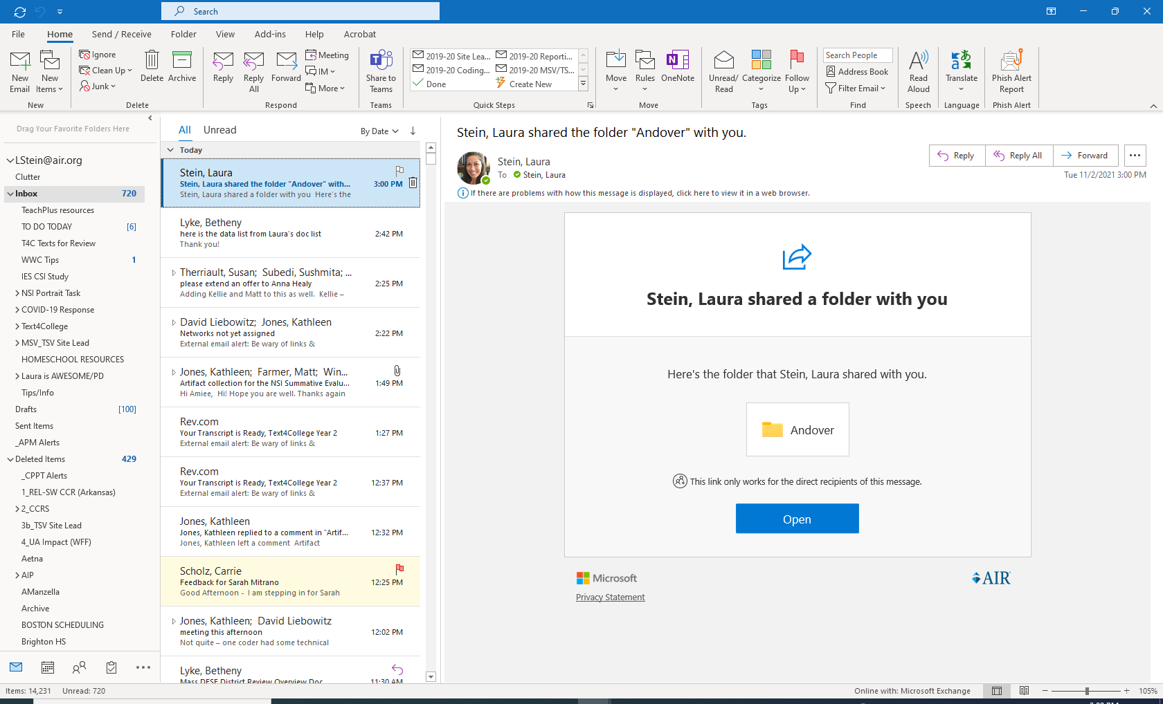

1. Note: You may need to create a Microsoft account to access the site. You may have difficulty accessing the site if you use a Microsoft account that already is linked to another organization. If you have any difficulty connecting to the folder, please contact your district lead.
2. You should then receive a prompt for two-factor authentication. Click Next.
3. Select your preferred method of contact (text, call, or mobile app) for two-factor authentication.

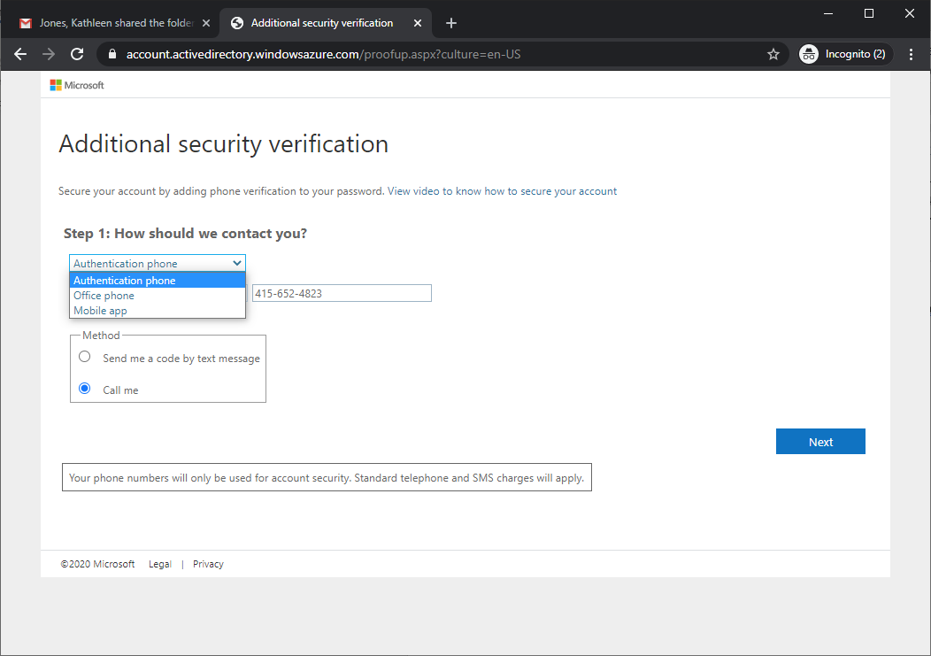

Click Next and enter in the code as prompted.

1. Click Done, and you will be taken directly to the folder for your district (only authorized users from your district and the onsite team will have access to this folder).
2. On the SharePoint site, click upload and select the file or files you want to upload. Folder permissions ensure that personnel from each district can only view their own district’s documents. Please be sure that all documents are titled in such a way that the content of the document is clear.

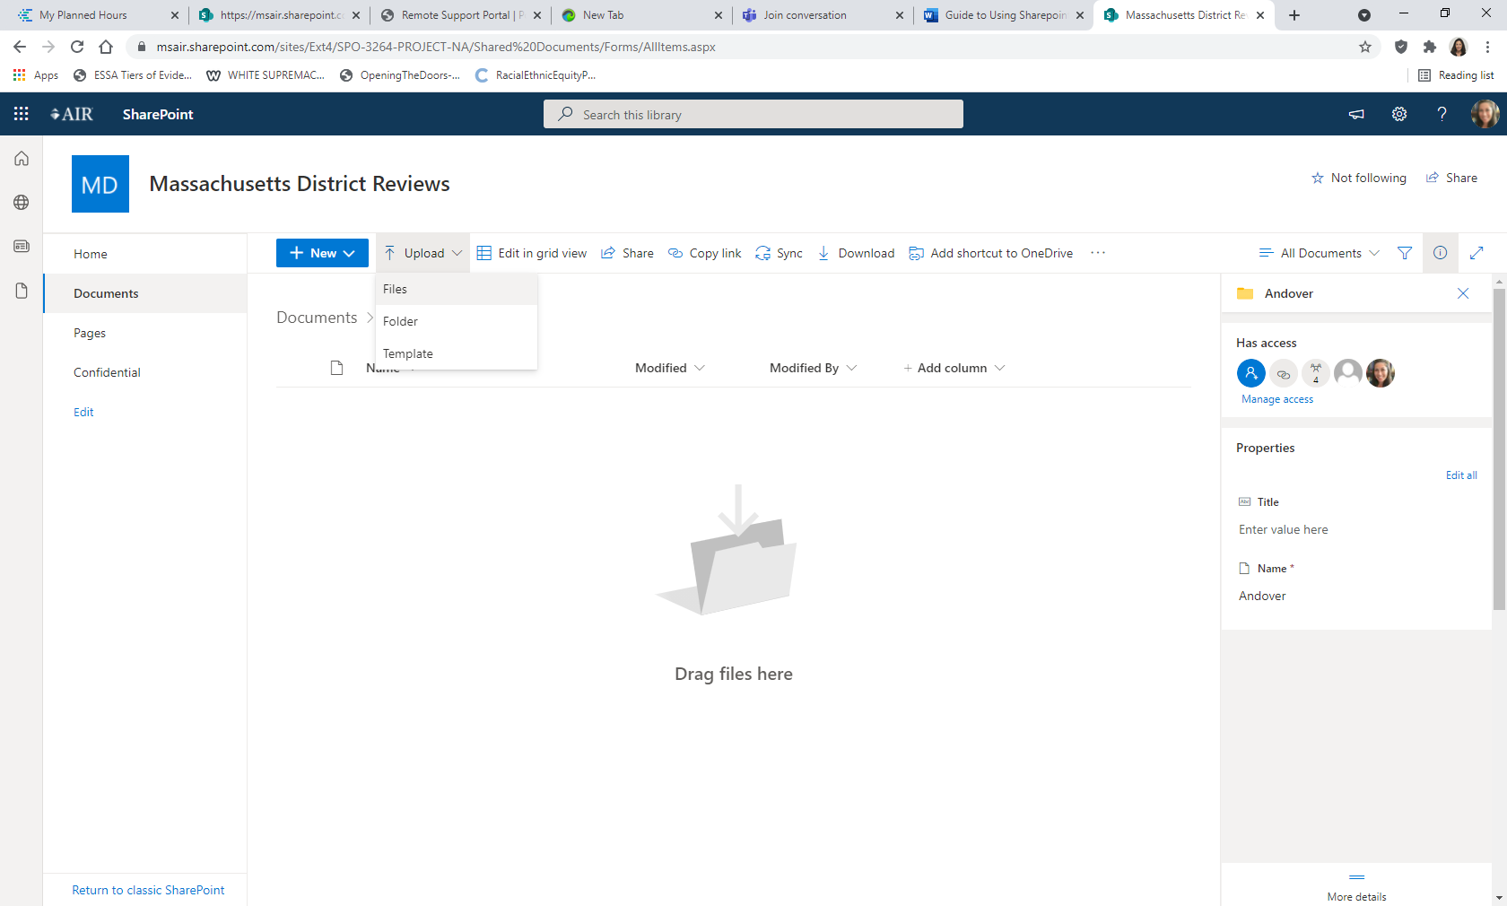

If the documents are already stored in a folder or directory structure, you may upload the complete structure.

#### Having Difficulty?

If you are signed into a SharePoint, OneDrive, or Microsoft account with an email address that differs from the email address that received the SharePoint Online invitation, please sign out of the account before clicking on the SharePoint Online folder link in the email from AIR.

If you have any questions about the document collection process or using the SharePoint, please contact your district lead.

### Educator Evaluation Files

Because a district’s systems for continually building educator effectiveness are critical to improving student achievement, the review includes a careful analysis of educator evaluations, following the guidelines below.[1]

1. Based on the number of teachers working in the district, the site-visit team identifies a group of teachers who were scheduled to receive a summative evaluation in the previous school year and asks to see the following documents for each of them:
   * + Teacher self-assessment
     + Educator Plan, including professional practice and student learning goals
     + Announced or unannounced observation reports
     + Formative assessment or evaluations
     + Summative evaluations
2. In addition, the site-visit team will ask to see the following documents for each currently serving administrator, including the superintendent:
   * + Self-assessment
     + Educator Plan, including professional practice and student learning goals
     + Observation or school visit reports or documentation
     + Formative assessment or evaluations
     + Summative evaluations (also called administrator evaluations) for administrators who were evaluated during the previous school year

Initially, districts will need to provide AIR with a list of staff who should have been evaluated in the previous school year. Then, in order to provide the documents required:

1. If records are stored electronically, the district should provide electronic access for the assigned members of the site-visit team. Alternatively, the district may download the select staff members’ documents and submit them electronically.
2. If paper documents are stored, hard copies should be provided or scanned and submitted electronically.

The site-visit team recognizes that in many districts, only about half the teachers and half the administrators are being evaluated each year, in accordance with the educator evaluator requirements.

### Questionnaires

In addition to the documents and files listed above, districts are required to complete two types of questionnaires. The **district liaison questionnaire**, completed by the district’s designated liaison, and **school leader questionnaire**, completed by each school’s principal, confirm general information about administrative, curriculum, and support services and technology infrastructure. Questionnaires will be completed through an online survey and links will be sent to the district liaison once the master schedule for reviews is set.

## Appendix B. Instructional Observations and CLASS Information

Site review team members who observe the classrooms all receive training on the CLASS protocol in a two-day session and pass a rigorous certification exam to ensure that they can accurately rate the dimensions.

Table E1. CLASS K–3 Domains and Dimensions

|  |  |  |
| --- | --- | --- |
| **Emotional Support** | **Classroom Organization** | **Instructional Support** |
| * Positive Climate * Negative Climate * Teacher Sensitivity * Regard for Student Perspectives | * Behavior Management * Productivity * Instructional Learning Formats | * Concept Development * Quality of Feedback * Language Modeling |

Table E2. CLASS Upper Elementary Domains and Dimensions

Student Engagement

|  |  |  |
| --- | --- | --- |
| **Emotional Support** | **Classroom Organization** | **Instructional Support** |
| * Positive Climate * Teacher Sensitivity * Regard for Student Perspectives | * Behavior Management * Productivity * Negative Climate | * Instructional Learning Formats * Content Understanding * Analysis and Inquiry * Quality of Feedback * Instructional Dialogue |

Table E3. CLASS Secondary Domains and Dimensions

Student Engagement

|  |  |  |
| --- | --- | --- |
| **Emotional Support** | **Classroom Organization** | **Instructional Support** |
| * Positive Climate * Teacher Sensitivity * Regard for Student Perspectives | * Behavior Management * Productivity * Negative Climate | * Instructional Learning Formats * Content Understanding * Analysis and Inquiry * Quality of Feedback * Instructional Dialogue |

When conducting a visit to a classroom, the observer rates each dimension on a scale of 1 to 7. The ratings of all classrooms visited in a school will be aggregated for each domain and dimension in the district review report. Names of teachers whose classrooms are observed are not recorded and will not be reported.

## Appendix C. Key Stakeholders for Interviews and Focus Groups

Guided by the *District Standards and Indicators*, interview (I) and focus group (FG) questions will be customized for specific stakeholders. Interviews and focus groups will take approximately 45-90 minutes. Stakeholders participating may include the following:

|  |  |  |
| --- | --- | --- |
| Stakeholder(s) | Type | Participant Details |
| Superintendent | Interview | * + - Individual interview |
| District leaders | Interviews | * + - Individuals who lead each standard area will be asked to participate in interviews |
| School leaders | Focus group(s) | * + - One focus group[2]     - All principals in the district |
| School-Level Instructional staff | Focus groups | * + - Multiple focus groups     - General education, special education, and English learner teachers     - Interventionists (if applicable)     - One Physical Education and/or Health teacher     - One teacher who has served as a mentor in the district |
| School committee members | Focus group | * + - 3+ members, but less than quorum |
| Town Manager (or equivalent) | Interview | * + - Individual interview |
| Teachers’ association leadership | Focus group | * + - 1-5 leaders, depending on leadership size/structure |
| Family members | Focus groups | * + - 1-2 focus groups with 3–5 families each     - Translation services will be provided as needed |
| Students (middle and high school) | Focus groups | * + - 2 focus groups     - 6–8 students each[3] |

1. The review of evaluations as part of the district review process is mandatory for each district receiving a Comprehensive District Review and is allowable under state regulations ([603 CMR 35.10 (2)](https://www.doe.mass.edu/lawsregs/603cmr35.html)). Both DESE and district review partner staff understand the sensitive nature of this information and are committed to ensuring its confidentiality in the development of the district review report.
2. This may be broken into two focus groups if there are more than six schools in the district.
3. Permission forms for each student must be signed by a family member and submitted to the onsite team staff before student groups occur. The district lead will provide these blank forms to the district liaison.