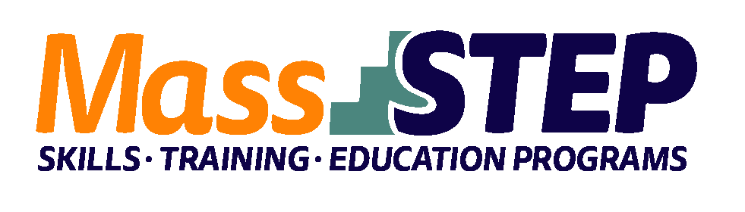

Adult Education Provider: | Brockton Adult Learning Center
Type of Organization: | Local Educational Agency
Workforce Training Provider: | Health and Homecare of New England
Employer Partners: | AdviniaCare Baypointe, Right at Home
 | St. Joseph’s Manor, West Acres
Level: | SPL 5+
Credentials: | Home Health Aide, Alzheimer’s Rehabilitation, CPR and nurse assistant training
Occupational Cluster: | Healthcare
Occupation: | Nursing Assistant
Program Description: | Students receive 96 hours of contextualized ESOL instruction including civics education. Workforce preparation is also provided in collaboration with the MassHIRE Career Center. The workforce partner provides an additional 96 hours of training including home health aide, nursing assistant, Alzheimer’s and CPR. Students complete a 28-hour supervised clinical practicum with one of our employer partners. We offer this program twice a year, September and January for 17 weeks. 10 students are accepted for each semester.

Weekly Schedule
Weeks 1 – 14
 | Monday | Tuesday | Wednesday | Thursday
9:00 AM – 12:00 PM | Workforce Training | ESOL/Civics | Workforce Training | ESOL/Civics

Week 15
 | Monday | Tuesday | Wednesday | Thursday
7:00 AM – 2:00 PM | Clinical | Clinical | Clinical | Clinical

Week 16 – 17
 | Monday | Tuesday | Wednesday | Thursday
9:00 AM – 12:00 PM | Exam prep and job readiness | Exam prep and job readiness | Exam prep and job readiness | Exam prep and job readiness

Contact: Patricia Hembrough, patriciahembrough@bpsma.org, 508-580-7475

Website: https://www.bpsma.org/schools/adult-learning-center

