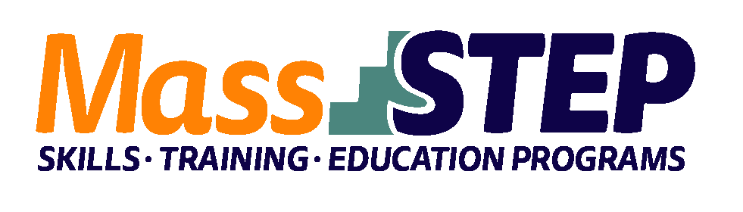

Adult Education Provider: | Cambridge Community Learning Center
Type of Organization: | Community-Based Organization
Workforce Training Provider: | Laboure College of Healthcare
Employer Partners: | Beth Israel Lahey Health, Neville Center, Mass General Hospital
Level: | SPLs 4-6
Credentials: | Certified Nursing Assistant; Home Health Aide, CPR/AED, Alzheimer’s/Dementia Certificates
Occupational Cluster: | Healthcare
Occupation: | Certified Nursing Assistants and Home Health Aides
Program Description: | The Careers in Healthcare Training Program prepares ESOL learners to pass the Massachusetts licensure exam for Certified Nursing Assistants and for success on the job as CNAs and Home Health Aides. The program design is based on research and provides contextualized and concurrent ESOL/Civics education, workforce preparation activities, and workforce training to improve participants’ reading, writing, math, and English proficiency using healthcare-contextualized curricula and occupationally relevant instructional materials together with guidance and support for career planning specific to the career pathway. The program supports its graduates to get jobs.

Weekly Schedule

Weeks 1 – 10 | Monday | Tuesday | Wednesday | Thursday | Friday
5:00 PM – 7:15 PM | ESOL | Online Coursework: ReadyCNA | ESOL |  | Online Coursework: ReadyCNA
7:30 PM – 9:00 PM | Workforce Prep /Job Readiness |  | Math
4:30 PM – 9:30 PM |  |  |  | CNA Workforce Skills Training

Weeks 11 – 16 | Monday | Tuesday | Wednesday | Thursday | Friday
4:30 PM – 9:30 PM | Clinical | Clinical | Clinical | Clinical | Clinical

Contact: Yan Zheng, yzheng@cambridgema.gov, 617-349-6363

Website:
Community Learning Center - DHSP - City of Cambridge, Massachusetts (cambridgema.gov)

