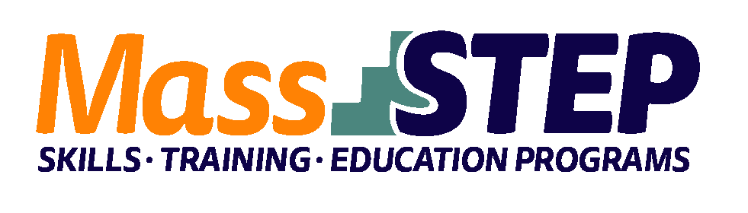

Adult Education Provider: | Hampden County Sheriff’s Office
Type of Organization: | Correctional Institution
Workforce Training Provider: | Holyoke Community College (HCC)
Employer Partners: | MGM Springfield, Log Cabin Restaurant/Banquet facility
Level: | GLE 8+
Credentials: | ServSafe for Managers, ServSafe Allergen, Certified Kitchen Cook, Customer Service Gold: Making Connections
Occupational Cluster: | Food Preparation and Serving Occupations
Occupation: | Cooks and Food Preparation Workers
Program Description: | The 15 week program includes five weeks at the facility and ten weeks at the HCC MGM Culinary Arts Institute (CAI). HCSO provides contextualized math, ELA, and digital literacy instruction. Workforce Training topics include ServSafe prep, Food Service Operations, Knife Skills, and Product Knowledge for Food Preparers. HCC speakers discuss admission and financial aid. Workshops include diversity training and work readiness. MGM conducts practice interviews and provides feedback. Students complete a computer-based Food Truck Project to present at graduation.

Weekly Schedule

Saturday | 8:00 AM – 10:00 AM | 10:00 AM – 12:00 PM | 12:30 PM – 3:30 PM
Week 1 | Math for Chefs | Reading/Vocab ServSafe | MAPT testing
Week 2 |  |  | Entrepreneurship workshop
Weeks 3 – 5 |  |  | ServSafe Test Prep
Week 6 | ServSafe Review ServSafe Allergen Training | ServSafe for Managers/testing | AHLEI Certified Kitchen Cook Preparation/testing
Week 7 | Fundamentals of Food Service Operations | Knife Skills 1 & 2 | Diversity in the Workplace workshop
Week 8-9 |  |  | Cooking Methods
Week 10 |  |  | AHLEI Customer Service Gold
Week 11 |  |  | DL for Food Truck Project
Week 12 | Speakers: AISS, employment partners  (MGM, local restaurants); HCC Admissions & TCC | Dining Room Etiquette/ Customer First Service | Work Readiness
Week 13 | Product Knowledge for Food Preparers |  | Preparation for and individual recorded Interviews with MGM
Week 14 | Product Knowledge for Food Preparers |  | MGM part II; HR Individual feedback on recorded interview
Week 15 | Food Prep for graduation |  | Graduation/awards/ Food Truck Projects

Weeks 2 – 13 | Monday | Tuesday | Wednesday | Thursday
3:30 PM – 5:30 PM | Contextualized HSE Math  Food Truck Project | Contextualized ELA HSE Prep  Book group (Cooked by Jeff Henderson) | Science and Social Studies HSE Prep  Digital Literacy | Contextualized HSE Math  Food Truck Project

Contact: Susanne Campagna, susanne.campagna@sdh.state.ma.us, 413-730-6811

Website: https://hcsoma.org

