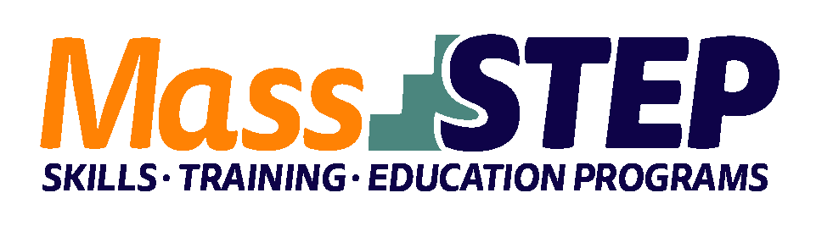

Adult Education Provider: | Jamaica Plain Community Centers Adult Learning Program (JPCC/ALP)
Type of Organization: | Community-Based Organization
Workforce Training Provider: | JPCC/ALP
Employer Partners: | Rogerson House and Lahey Clinic
Level: SPL 4 | SPL 4
Credentials: | CNA Certification and CPR Certification
Occupational Cluster: | Healthcare
Occupation: | Nursing Assistants
Program Description: | The CNA (Certified Nursing Assistant Certification for English Language Learners) is a 14 - week, program where learners are actively pursuing CNA and CPR credentials while improving their English language proficiency. The program includes English language instruction, basic mathematics, and clinical/healthcare site instruction.

Weekly Schedule
 | Monday | Tuesday | Wednesday | Thursday | Friday
9:00 AM – 12:00 PM | Contextualized ESOL | CNA Clinical  (Group 1) | Contextualized ESOL | CNA Clinical  (Group 2) | Contextualized ESOL
12:00 PM – 1:00 PM |  |  | Contextualized Math
1:00 PM – 4:00 PM |  | CNA Clinical  (Group 1) |  | CNA Clinical  (Group 2)

Contact: Joyce Henderson, jehenderson.jpcc@gmail.com, (617) 635-5201

Website: https://www.jpccc.org/

