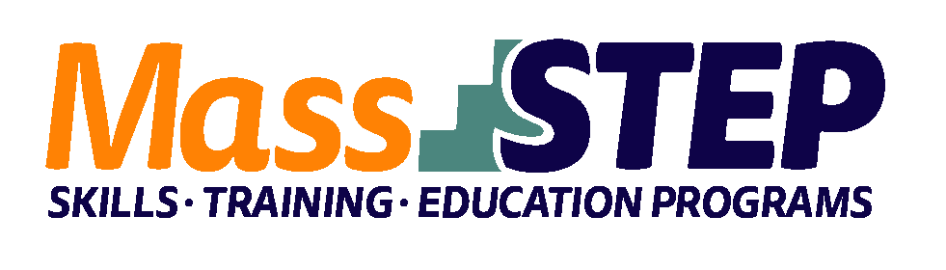
Adult Education Provider: | North Adams Public Schools – Northern Berkshire Adult Education
Type of Organization: | Local Education Agency
Workforce Training Provider: | McCann Technical High School
Employer Partners: | Meze, Williams College
Level: | GLE 8+
Credentials: | ServSafe for Managers, ServSafe Allergen, Certified Kitchen Cook
Occupational Group: | Food Preparation and Serving Occupations
Occupation: | Chefs and Head Cooks, Cooks, and Food Preparation Workers
Program Description: | A 16-week Culinary Arts Program based at McCann. Earning the credentials and engaging students in all aspects of kitchen life, the program will prepare students for the reality of the workforce. Students will also craft cover letters and a resumes and receive interview practice with feedback. Building connections with industry partners such as Williams College and Mezze will also serve to support employment at the program’s completion. Students receive instruction and practice on everything from comprehensive breakfast delicacies to customer service to poultry preparation.

Weekly Schedule

 | Tuesday | Wednesday | Thursday
4:00 PM – 8:00 PM |  | Hiset STEM and Humanities  Workforce Development
4:30 PM – 7:30 PM | Culinary Arts |  | Culinary Arts

Contact: Annie Pecor, apecor@napsk12.org, (413) 412-1118

Website: https://www.napsk12.org/page/adult-education

