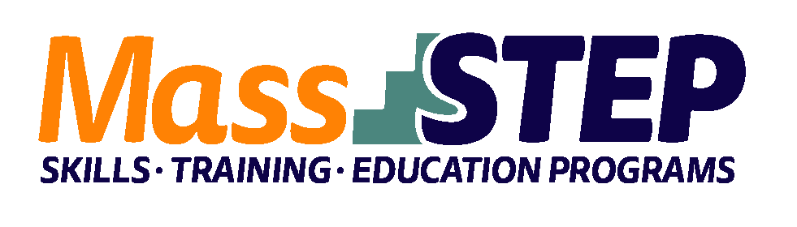

Adult Education Provider:
Type of Organization:

Workforce Training Provider:
Employer Partners:

Level

Credentials:
Occupational Cluster:
Occupation:

Program Description:

North Shore Community Action Programs

Community-Based Organization

Essex North Shore Agricultural and Technical School

Brooksby Village (Erickson Senior Living), Jeffrey & Susan Brudnick Center for Living, Beverly Hospital, Brightview Senior Living,
MassHire North Shore

SPL 4

Certified Nurse’s Aide, CPR/First Aide, and Dementia

Healthcare

Nursing Assistant

The program provides ESOL support throughout the program, including the test preparation, career advising, and job placement assistance stages. The CNA training is provided by an experienced registered nurse instructor. It includes the following: licensed CNA training, CPR/First Aid training and dementia care training as well as an intensive practice week at a local nursing home.

Weekly Schedule

Weeks 1 – 3 | Tuesday | Wednesday | Thursday
4:00 PM – 7:00 PM | Contextualized ESOL | Contextualized ESOL | Contextualized ESOL

Weeks 4 – 9 | Tuesday | Wednesday | Thursday | Saturday
9:00 AM – 3:00 PM |  |  |  | CNA Skills Training
4:00 PM – 6:00 PM | CNA Skills Training | Contextualized ESOL | CNA Skills Training
6:00 PM – 7:00 PM | CNA Skills Training with ESOL Support |  | Contextualized ESOL

Week 10 | Monday | Tuesday | Wednesday | Thursday | Friday
9:00 AM – 4:00 PM | Clinical Externship | Clinical Externship | Clinical Externship | Clinical Externship | Clinical Externship

Weeks 11 – 14 | Tuesday | Wednesday | Thursday
4:00 PM – 7:00 PM | Test Preparation, Career Readiness & Civics Education | Test Preparation, Career Readiness & Civics Education | Test Preparation, Career Readiness & Civics Education

Contacts:
Alex Cabrera, acabrera@nscap.org, 978-595-3507, Jessica Cardin, jcardin@nscap.org, Marcelle Abi-Esber, mabi-esber@nscap.org

Website:
https://www.nscap.org/

