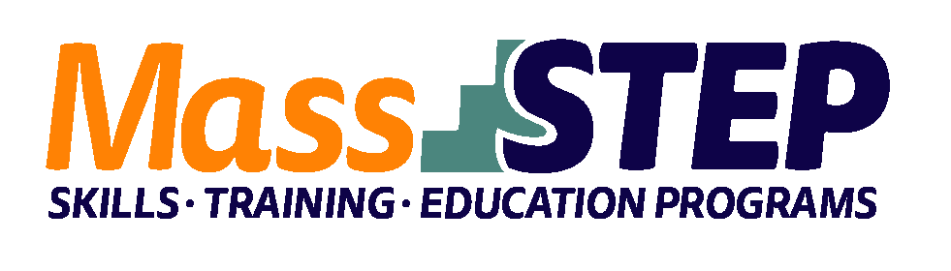
Adult Education Provider: | North Shore Community College (NSCC) Adult Learning Center
Type of Organization: | Community College
Workforce Training Provider: | NSCC Division of Corporate and Professional Education
Employer Partners: | Mass General Brigham, GraVoc, Tokio Marine Insurance, and NSCC Information Systems Department
Level: | GLE: 8+ in Reading; GLE: 6+ in Math
Credentials: | CyberSAFE, Serve Desk, OSHA 10, and CompTIA IT Fundamentals
Occupational Cluster: | Computer and Information Technology
Occupation: | IT Support Specialist
Program Description: | This 20-week program combines IT instruction with workplace readiness skills, HiSET and/or ACCUPLACER preparation. The IT instruction includes CyberSafe, OSHA 10, CompTIA IT Fundamentals, and Service Desk & Support Analyst. Employer partners participate in mock interviews, provide internship opportunities, and host company site visits.

Weekly Schedule

Weeks 1 – 20 | Tuesday | Wednesday | Thursday
9:00 AM – 12:00 PM | IT Class | IT Class | IT Class
12:30 PM – 2:00 PM | Academic and  Workplace Readiness Skills | Academic and  Workplace Readiness Skills | Academic and  Workplace Readiness Skills

Contacts: Stephanie Moriarty, smoriart01@northshore.edu, 978-236-1242 or
Stacy Randell-Shaheen, srandell@northshore.edu, 978-236-1227

Website: https://www.northshore.edu/adult-learning/ and
https://www.northshore.edu/adult-learning/massstep.html

