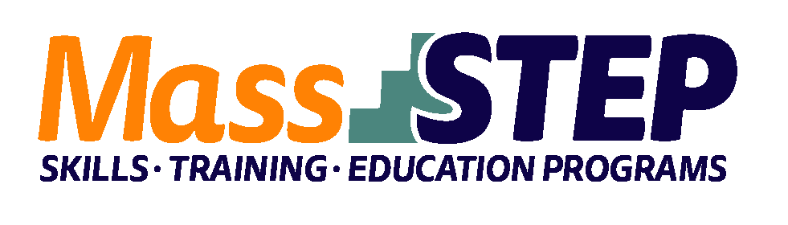
Adult Education Provider: | Quincy Community Action Programs
Type of Organization: | Community-Based Organization
Workforce Training Provider: | Quincy College
Employer Partner(s): | Beth Israel Lahey Health
Level: | SPL 5+
Credential: | CompTIA+
Occupational Group: | Computer and Information Technology
Occupation: | Computer Support Specialists
Program Description: | QCAP and Quincy College co-host the Information Technology Fundamentals+ (ITF+) Program, which provides Adult Education students with an opportunity to transition into college and obtain the CompTIA Fundamentals+ credential. In this 16-week program, students attend advanced-level, contextualized Adult Education classes concurrently with college-level classes in Operating Systems and Customer Service. This integrated curriculum helps students take their first steps towards post-secondary education and meaningful careers in the IT field.

Weekly Schedule

 | Monday | Tuesday | Wednesday | Thursday | Friday
9:00 AM – 12:00 PM | Quincy College: Introduction to Computers | Quincy College: Operating Systems | QCAP: Adult Education for IT | Quincy College: Operating Systems | Tutoring and Self-Study
12:00 PM – 3:00 PM | QCAP: Adult Education for IT | QCAP: Adult Education for IT | Quincy College: Introduction to Computers | QCAP: Adult Education for IT

Contact: Sam Bernstein, sbernstein@qcap.org, 617-657-5355

Website: https://www.qcap.org/our-programs/adult-education-workforce-development/

