

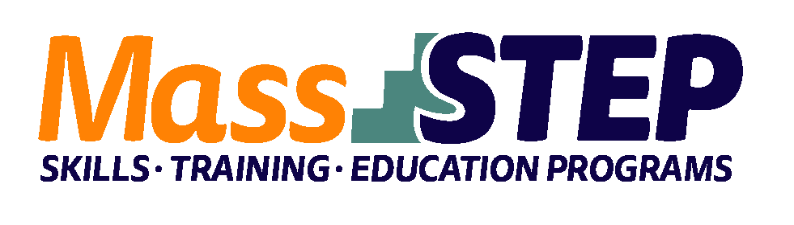

|  |  |
| --- | --- |
| Adult Education Provider: | Quinsigamond Community College (QCC) |
|  |  |
| Type of Organization: | Community College |
|  |  |
| Workforce Training Provider: | QCC Center for Workforce Development & Continuing Education |
|  |  |
| Employer Partners: | The Overlook |
|  |  |
| Level: | ESOL SPL 3 |
|  |  |
| Credentials: | Certified Nursing Assistant |
|  |  |
| Occupational Cluster: | [Healthcare](https://www.bls.gov/ooh/healthcare/home.htm) |
|  |  |
| Occupation: | [Nurse Assistants](https://www.bls.gov/ooh/healthcare/nursing-assistants.htm) |
|  |  |
| Program Description: | The curriculum for this 16-week program covers basic patient care, medical terminology, nutrition, patient care procedures, communication skills, basic anatomy, safety, and assisting with therapies. The program also covers caring for patients living in their own homes or residential facilities. |

**Weekly Schedule**



|  |  |  |  |  |  |
| --- | --- | --- | --- | --- | --- |
|  | **Monday** | **Tuesday** | **Wednesday** | **Thursday** | **Friday** |
| 9:00 AM – 2:00 PM | ESOL Instruction | ESOL Instruction | ESOL Instruction | Nurse Assistant Instruction | Nurse Assistant Instruction |

**Contact:** Kate O’Connor, kaoconnor@qcc.mass.edu

**Website:** [*https://www.qcc.edu/learn-qcc/advance-your-career*](https://www.qcc.edu/learn-qcc/advance-your-career)