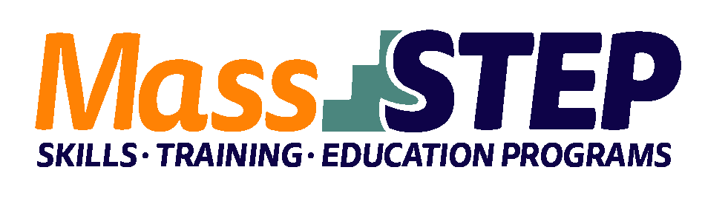

Adult Education Provider: | Randolph Community Partnership, Inc.
Type of Organization: | Community-Based Organization
Workforce Training Provider: | QARI/Wutabon
Employer Partners: | Kam Man
Level: | SPL 4+
Credentials: | OSHA 10, TIPS, ServSafe
Occupational Group | Food Preparation and Serving Occupations
Occupation: | Food Preparation Workers
Program Description: | This training program is designed to prepare students with basic skills, relevant occupational skills, and essential workplace skills to enter the food service and hospitality industries. The curriculum combines language development and workforce preparation training to provide ESOL students with a current SPL of 4 or higher the skills needed to obtain an entry-level position with an employer partner. The skills taught will also help prepare students to move into higher-wage jobs at a faster pace. The workforce preparation classes will help students navigate the American workplace and learn about the specifics of roles and responsibilities within food service occupations. Students will engage in work-related classroom readings, problem-solving activities, and role-playing opportunities to prepare them for the real-world situations they will encounter in the workplace.

Weekly Schedule

Week 1 | Monday | Tuesday | Wednesday | Thursday
9:30 AM – 11:45 AM | Orientation & ACA Support | ServSafe | Kitchen Basics/Knife Skills | ServSafe
12:00 PM – 2:15 PM | ESOL/Civics | Math |  | Math

Weeks 2 – 4 | Monday | Tuesday | Wednesday | Thursday
9:30 AM – 11:45 AM | ESOL/Civics  & ACA Support | ServSafe | Kitchen Basics/Knife Skills | ServSafe
12:00 PM – 2:15 PM |  | Math |  | Math

Week 5 | Monday | Tuesday | Wednesday | Thursday
9:30 AM – 2:30 PM | OSHA-10 | OSHA-10 | Kitchen Basics/Knife Skills | ServSafe
 |  |  |  | Math

Weeks 6 – 8 | Monday | Tuesday | Wednesday | Thursday
9:30 AM – 11:45 AM | ESOL/Civics  & ACA Supports | ServSafe | Kitchen Basics/Knife Skills | ServSafe
12:00 PM – 2:15 PM |  | Math |  | Math

Week 9 | Monday | Tuesday | Wednesday | Thursday
9:30 AM – 11:45 AM | ESOL/Civics  & ACA Support | ServSafe | On-site training and skills practice | ACA Support
12:00 PM – 2:15 PM |  | TIPS

Week 10 | Monday | Tuesday | Wednesday | Thursday
9:30 AM – 11:45 AM | ESOL/Civics  & ACA Support | On-site training and skills practice | On-site training and skills practice | Graduation
12:00 pm – 2:15 pm

Contact: Susan Hearn, susanh@rcpinc.org, 781-961-8888

Website: www.rcpinc.org

