

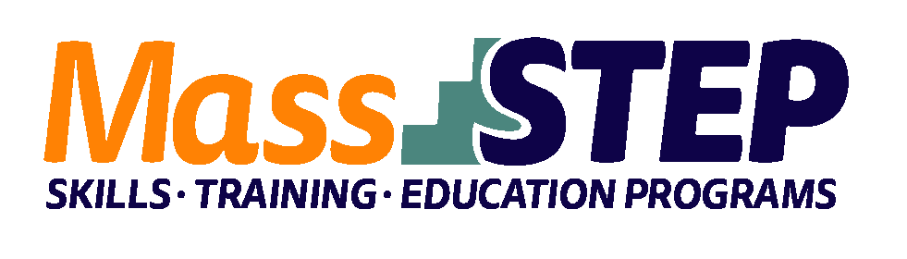

Adult Education Provider:

Type of Organization:

Workforce Training Provider:

Employer Partner(s):

Level:

Credential(s):

Occupational Group:

Occupation:

Program Description:

UMass Dartmouth Workers’ Education Program (WEP)

Four-Year College

Coastal Career Academy

Brandon Woods New Bedford and Our Lady's Haven Diocesan Health Facility

5+

Certified Nursing Assistant, Home Health Aide

[Healthcare](https://www.bls.gov/ooh/healthcare/home.htm)

[Nursing Assistants](https://www.bls.gov/ooh/healthcare/nursing-assistants.htm)

UMass Dartmouth WEP offers an ESOL CNA training program. Upon completion, students will be qualified to take the Massachusetts State Nurse Aide test leading to job placement. 1199SEIU will assist with outreach and recruitment amongst PCAs. The Greater New Bedford Workforce Development Board (WDB), Greater New Bedford Career Center, and other partners will work with UMass Dartmouth WEP to market the program to WDB member organizations, area employers, and Career Center customers.

**Weekly Schedule**

|  |  |  |  |  |  |
| --- | --- | --- | --- | --- | --- |
|  | **Monday** | **Tuesday** | **Wednesday** | **Thursday** | **Friday** |
| 9:00 AM – 2:30 PM | ESOL/  CNA Training | ESOL/  CNA Training | ESOL/  CNA Training | ESOL/  CNA Training | ESOL/  CNA Training |

**Contact:** Eva dos Santos, PhD, [edossantos@umassd.edu](mailto:edossantos@umassd.edu), 508-910-9004