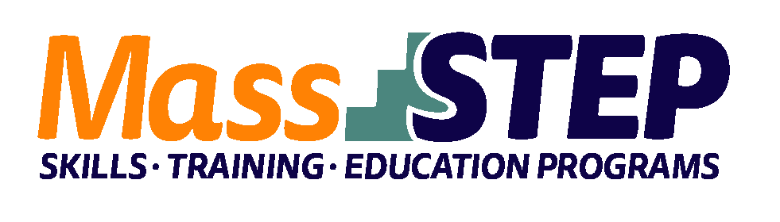

Adult Education Provider: | YMCA of Greater Boston International Learning Center Woburn
Type of Organization: | Community-Based Organization
Workforce Training Provider: | Aspire Training and Development LLC
Employer Partners: | Eviva Trattoria, Mooo, Winchester Hospital
Level: | SPL 3+
Credentials: | Servsafe Food Handler Certification, MA Allergen Training Certification, Choke Saver Certification
Occupational Cluster: | Food Preparations and Serving Occupations
Occupation: | Cooks and Food Preparation Workers
Program Description: | The culinary arts program is an integrated adult ESOL and workforce training program that provides students with culinary arts training, contextualized ESOL instruction, and workforce preparation. Students received wrap-around services including social-emotional support and career services, as well as resume, cover letter, interview and job placement assistance. The curriculum consists of the following elements: hands-on culinary arts employment training, contextualized ESOL and civics instruction, contextualized mathematics instruction, and career management instruction. Digital literacy instruction is embedded throughout the curriculum.

Weekly Schedule

Weeks 1 – 9 | Monday | Tuesday | Wednesday | Thursday | Friday
9:00 AM – 11:00 AM | Contextualized ESOL | Culinary Arts Training | Culinary Arts Training | Culinary Arts Training | Culinary Arts Training
11:00 AM – 12:00 PM | Career Management
12:30 PM – 1:00 PM | Contextualized ESOL | Certifications | Certifications | Certifications | Certifications

Contact: Kelly Harrington, kharrington@ymcaboston.org, 617-819-1527

Website: https://ymcaboston.org/

