Adult and Community Learning Services (ACLS)

Fiscal Year 2020 Program Quality Review Summative Report

July 2019 – June 2020

July 19, 2020

Massachusetts Department of Elementary and Secondary Education
75 Pleasant Street, Malden, MA 02148-4906
Telephone: (781)-338-300, TTY: N.E.T. Replay 800-439-2370
Fax: (781)-338-3394
www.doe.mass.edu
Contents
INTRODUCTION 3
EXECUTIVE SUMMARY 4
Purpose and Audience 4
Analysis, Data Sources and Report Organization 4
Summary of Findings 5
INDICATOR 3: CAREER PATHWAY COLLABORATIONS 8
Indicator 3 Synopsis 8
Indicator 3 Data Analysis 9
INDICATOR 4: CURRICULUM AND INSTRUCTION 11
Indicator 4 Synopsis 12
Indicator 4 Data Analysis 12
INDICATOR 7: ORGANIZATIONAL SUPPORT 20
Indicator 7 Synopsis 21
Indicator 7 Data Analysis 21
INDICATOR 8: EDUCATIONAL LEADERSHIP 23
Indicator 8 Synopsis 24
Indicator 8 Data Analysis 24
RECOMMENDATIONS 27
APPENDIX A-Fiscal Year 2020 Program Quality Reviews 28
APPENDIX B-Fiscal Year 2020 Ratings 29
REFERENCES 30

INTRODUCTION

In 2017, the Massachusetts Department of Elementary and Secondary Education (DESE), through the Office of Adult and Community Learning Services (ACLS), set out to improve its adult education program monitoring and site visit protocols with the intention of bringing into greater alignment the state adult education performance standards with the new federal performance measures outlined in the Workforce Investment and Opportunity Act (WIOA) of 2014.

In order to achieve the outcomes required by WIOA, ACLS implemented a new theory of action focused on quality. The theory of action states in part that if ACLS aligns the Indicators of Program Quality (IPQ) with WIOA, aligns key documents with the IPQ (policy manual, open and competitive bid process), provides programs quality feedback (Program Quality Reviews), and delivers high quality professional development (PD), then students will make greater educational progress and be better prepared to access college and careers as required by the WIOA performance measures (Measurable Skill Gain).

To this end, ACLS created the Program Quality Team (PQ Team) whose charge was to redesign the former monitoring process and then conduct Program Quality Reviews (PQR) of all Community Adult Learning Centers (CALC) and Correctional Institutions (CI) who receive funding as part of the Fiscal Year 2019-2022 cycle.

In addition to reviewing literature on how to conduct effective reviews, the PQ Team also looked at adult education monitoring protocols from other states (Florida, New Mexico, Illinois, and Colorado). Further, the PQ Team consulted other units within DESE, even to the extent of shadowing other teams on their monitoring visits.

The purpose of the revised Program Quality Review (PQR) is to assess program quality against four Indicators of Program Quality:

- Indicator of Program Quality 3-Career Pathways Collaborations
- Indicator of Program Quality 4-Curriculum and Instruction
- Indicator of Program Quality 7-Organizational Capacity
- Indicator of Program Quality 8-Educational Leadership

This process is intended to be formative and to assist programs in gaining an understanding of their quality measured against standard benchmarks and, where applicable, acknowledge promising practices. PQR were first instituted in FY2019, when 25 programs were reviewed. (The FY19 Program Quality Summative Report can be downloaded from: (See the FY19 Program Quality Summative Report).

ACLS uses a set of four ratings and Indicator-specific rubrics to determine the quality of programs at a given point in time. Program Quality Reviews use multiple sources of evidence including interviews, program-developed materials, program data, curriculum, lesson plans and classroom observations.

Review Teams are comprised of members of the Program Quality Team and often include additional ACLS program specialists, ACLS leadership, and/or ACLS Program Quality Review consultants (selected through a Request for Response process). A local MassHire workforce development board representative is also invited to participate in a review.

All Review Team members and ACLS consultants have extensive background knowledge in one or more of the following areas: educational leadership, teaching, curriculum development, adult education research, adult English language learners, digital literacy, and adult education program evaluation. Further, all Review Team members received in-depth training on the protocol, including but not limited to interview facilitation, evaluation rubrics, classroom observations, collection of evidence, calibration, and report writing.

With the goal of establishing validity and reliability for the collected evidence, Review Teams used the following rubric to determine ratings:

Limited Evidence | Developing | Proficient | Exemplary
The program demonstrates little to no evidence; significant concerns are noted. | The program demonstrates inconsistent evidence; moderate concerns are noted. | The program demonstrates consistent evidence; minor concerns are noted. | The program demonstrates consistent evidence; potential exemplar.

While PQR are intended to be comprehensive and collect evidence from multiple sources (e.g., students, teachers, program leadership, advisors, document review, and classroom observations), ACLS acknowledges that they reflect a program’s performance at a particular point in time.

EXECUTIVE SUMMARY

Purpose and Audience
The purpose of this report is to highlight promising practices collected in Fiscal Year 2020 that could be replicated in CALC and CI adult education programs funded in Massachusetts. The intended audience for this report is Massachusetts adult education program leaders, Massachusetts professional development providers, Massachusetts policy makers, and other stakeholders striving to improve and sustain high quality adult education services.

Analysis, Data Sources and Report Organization
In Fiscal Year 2020, ACLS conducted a total of 20 Program Quality Reviews (for a list of these programs, see Appendix A). This end-of-year-report provides a summary of these programs’ ratings and highlights promising practices.

The primary data sources for this report were the 20 PQR reports. Rating percentages were calculated by dividing the number of programs that received the same rating by 20, the number of total sites visited in Fiscal Year 2020.

The report is organized by the four Indicators of Program Quality that were reviewed. For each Indicator the following are provided: a table summarizing the percentage of programs receiving ratings of Limited Evidence, Developing, Proficient, and Exemplary; a synopsis intended to summarize the main findings; a data analysis section; and a section on promising practices and areas for improvement.

Each Indicator is rated at the Indicator level. Additionally, Indicator 4-Curriculum and Instruction is also rated at the standard level. The rating process for Indicator 4 provides programs and ACLS with specific information about programs’ performance against each of the standards, as well as general, big picture information about programs’ performance against the overall Indicator.

Appendix A provides a list of the CALC and CI programs that received a PQR in Fiscal Year 2020 and, Appendix B is a detailed chart of these programs’ ratings in each of the four Indicators of Program Quality. In order to preserve confidentiality of specific program ratings, any correlation between Appendix A and Appendix B has been eliminated.

Summary of Findings
This summary addresses the overall ratings, areas of overall strength, and areas for improvement.
Figure 1 below shows the combined Indicator level ratings of the 20 programs reviewed in Fiscal Year 2020.

Figure 1
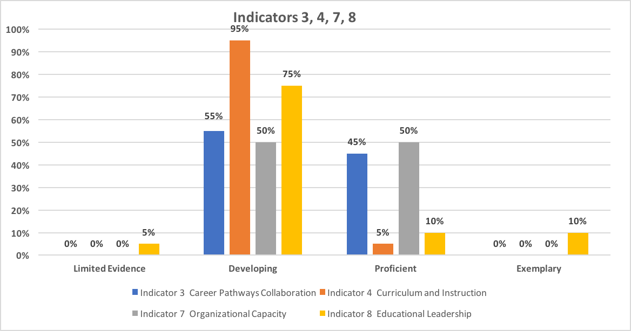

Figure 2 below shows the combined standard level ratings of Indicator 4-Curriculum and Instruction for the 20 programs reviewed in FY2020.

Figure 2
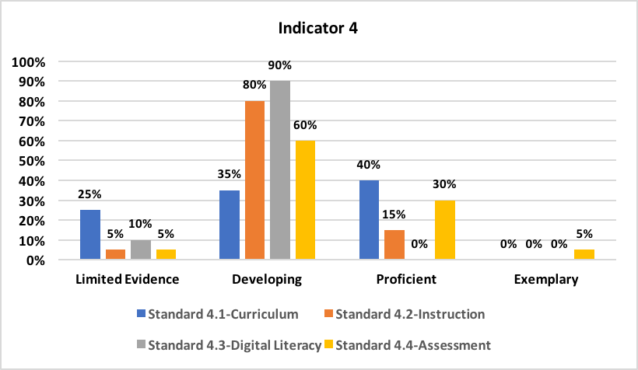

Figure 3 below shows the combined ratings for the four key instructional practices (scaffolding, differentiated instruction, checking for understanding, and student engagement) of Indicator 4.2-Instruction. ACLS observed a total of 156 classes at the 20 programs visited in Fiscal Year 2020.

Figure 3
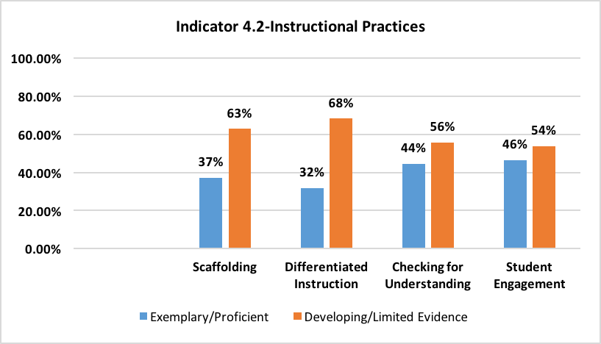

Overall Strengths
Overall, there was one primary area of strength for the programs evaluated in Fiscal Year 2020: Indicator 7-Organizational Support.

Regarding Indicator 7, 50 percent of programs received a rating of Proficient, while the remaining programs were rated Developing. In general, programs reviewed in Fiscal Year 2020 have safe, clean and accessible sites, quality working conditions, and access to quality resources, including technology. In many multisite programs, however, there were discrepancies in the quality of space and resources across sites.

Access to computers and the Internet was evident in the majority of programs. For example, 12 of the 20 programs had up-to-date computer labs with high speed connection or mobile carts with Chromebooks for individual class use, LED projectors, and instructional software aligned to the College and Career Readiness Standards for Adult Education. Teachers and students in the other programs had less consistent access to technology.

Three programs were highly rated in Fiscal Year 2020, receiving Proficient or Exemplary ratings in most of the four Indicators. While each program was unique in its strengths and needs, all three had the following systems in place that contributed to their success:

- A focus on supporting students in setting and meeting education and career goals embedded into the program’s culture.
- Demonstrated and consistent support by the larger organization of which the program is a part.
- Strong educational leadership leading to a vision for the program that is shared by staff, students, and stakeholders.
- Strategic use of data to inform programmatic decisions.

Overall Areas for Improvement
Three primary areas for improvement were identified: Indicator 4.2-Instruction, Indicator 4.3-Digital Literacy, and Indicator 8.4-Continuous Improvement Process.

Seventeen of 20 programs received a rating below Proficient in Indicator 4.2: Instruction. Overall, the observed classroom instruction showed only partial evidence of the four high-quality instructional look-fors−student engagement, checking for understanding, differentiated instruction, and scaffolding−with differentiated instruction and scaffolding having the highest percentages of Developing or Limited Evidence ratings−68 percent and 63 percent respectively, followed by checking for understanding with 56 percent and student engagement with 54 percent.

With regard to Indicator 4.3: Digital Literacy, all 20 programs were rated below Proficient. Review Teams found that the majority of sites provided staff and students with sufficient access to up-to-date technology and there was some evidence that technological skills were being taught and that digital literacy was being incorporated to some degree in classes. However, in nearly all programs, such practices were irregular and not a consistent aspect of instruction. Students in only 20 percent of programs used technology consistently, 15 percent of programs incorporated widespread digital literacy instruction, and 10 percent of programs integrated digital literacy activities into all classes.

For Indicator 8.4-Continuous Improvement, 35 percent of programs had a clear continuous improvement process in place and provided opportunities for input from program staff and students, and in 30 percent of reviewed programs there was a fully developed continuous improvement plan.

Overall, six of the 20 programs reviewed in Fiscal Year 20 received ratings of Developing or Limited Evidence across all Indicators, and seven programs were rated Proficient in one area.

INDICATOR 3: CAREER PATHWAY COLLABORATIONS

The program supports career pathways outlined in Massachusetts’ state plan for a seamless system of education and workforce services aligned with regional employment needs identified in the Local Plan.

Review Teams analyzed interview responses, Local Plan Packages, local Memoranda of Understanding (MOU), and classroom instruction and curriculum materials to determine each program’s overall rating for Indicator 3. In particular, ACLS looked for specific evidence regarding the two standards of this Indicator:

- The program collaborates with local education and workforce systems to jointly advance students, including students who are shared customers, to their next step with regard to education, training, and employment leading to family sustaining wages.
- The program’s collaborations result in increased options for students in postsecondary education, training, and employment aligned with the regional employment needs identified in the Local Plan.

Figure 4 below shows the overall ratings on Indicator 3-Career Pathway Collaborations for the programs reviewed in Fiscal Year 2020.

Figure 4
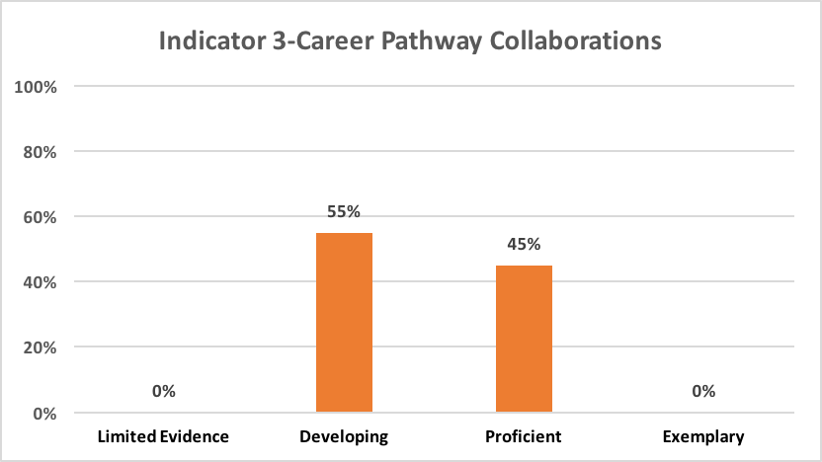

Indicator 3 Synopsis
Programs have in general established collaborations with local education and workforce partners that are aligned to the needs identified in the local plan. However, Review Teams found inconsistent evidence that those partnerships helped to accelerate students with regard to their next steps after leaving the program. Additionally, there was evidence that some programs have a system for the identification and referral of shared customers, but less indication that all staff are fully apprised of collaborations and process.

Indicator 3 Data Analysis
Eighty-five percent of programs have collaborations with local workforce and education partners aligned with the priority industries identified in the Local Plan Package, and the other 15 percent of programs were in the process of developing partnership when being reviewed. Notably, 65 percent of programs demonstrated ways in which the program’s collaborations have resulted in increased options for students in postsecondary education, training, and employment, although not all of these options were aligned with the regional employment needs identified in the local plan.

Review Teams found that at least some adult education staff at 10 of the 20 programs appeared to be aware of the program’s WIOA collaborations, although teachers in particular were aware of their role in these collaborations in only five of the 10 programs. In one multisite program, the staff in one site had strong knowledge of partnerships, while staff in the other sites demonstrated little understanding of collaborations. In 13 programs, students were able to identify local opportunities for further education and employment, although in four of these programs that had multiple sites, students’ knowledge varied by site.

Teachers in five of the 20 programs effectively and systematically include student career pathways into their instruction. Additionally, teachers in three other programs embed students’ career pathways into their instruction; however, these appeared to be individual efforts and not a coordinated and systematized approach.

Seven of the 20 programs showed evidence of established systems for shared customers, and an additional three programs showed progress in this area. Other programs emphasized wraparound services that, while essential, were not necessarily education- or career-focused. Two programs specifically noted that the specific employment needs of their adult education students were not always aligned or represented in the local plan.

Overall, 45 percent of programs were rated Proficient in Career Pathways Collaborations, while the other 55 percent were rated as Developing.

Career Pathways Collaborations: Overall Promising Practices

- The program collaborates with local education and workforce partners to jointly advance students, including shared customers, to next steps including education, training, and employment. The program has well-established relationships with several local colleges. College Readiness Advisors (CRAs) embedded at these programs to support student transitions to their education and training programs.
- The program has been proactive in working with core partners in the MassHire region. For example, the program initiated a meeting with the MassHire Career Center because referrals of shared customers were not processing seamlessly. In response to this meeting, the local workforce board created a portal to make it easier for the program and the career center to share customer information.
- Through collaborations, a high percentage of students have been placed in jobs with a family sustaining wage and/or enrolled in higher education and training programs.
- Overall, there was strong evidence that program leadership and the advisor have strong connections with local partners and a process in place to consistently integrate career planning into the program.
- As a result of the partnership with the local MassHire Career Center, opportunities for students have increased in postsecondary education, training, and employment aligned to the regional employment needs identified in the local plan.
- Teachers stated that the College and Career Readiness Standards for Adult Education (CCRSAE) are incorporated into curricula and lesson plans. They detailed ways in which they personalized examples and role plays in instruction to connect with students’ jobs and experiences. Teachers identified the leadership and advisors as the program’s primary connections with the workforce system and career trainings.
- The program has made a commitment and built capacity to adapt to WIOA requirements, such as with their recent curriculum adaptations, and expanded connections made with local MassHire Centers and other partnerships.
- The program’s strong connection to other workforce development efforts within the agency has provided students with numerous pathway options that reflect the employment needs and high demand sectors in the local plan.
- The Review Team found evidence of elements of a cohesive system, such as documented referrals, a sense of shared customers, and follow-up procedures. The Review Team also found evidence that program leadership effectively communicates to staff an understanding of the workforce system and how the program fits into it.

Career Pathway Collaborations: Overall Areas for Improvement

More than half of the programs reviewed in Fiscal Year 2020 do not have a systematic approach to increasing options for students in postsecondary education, training and employment leading to family sustaining wages:

- During interviews, neither teachers nor advisors shared a common understanding of their role in collaborating with partners from local education and workforce systems.
- As a whole, the program lacks a well-developed process to identify and share students’ career pathways, connect these with classroom curriculum and instruction, or methods to ensure teachers understand and are supported in carrying out their role and responsibilities.
- The program has plans to further the advancement of their partnership with MassHire. Among the priorities for this on-going work is the development of a shared process for the identification and referral of shared customers across core partner agencies. According to the program, development of this process has been slow partly because of the transition in leadership staff at MassHire during the previous fiscal year.
- It is unknown how successful the program has been concerning students’ transition to the workforce because the Review Team heard little evidence of systematic and documented follow-up on students once they leave the program.
- Collaborations with core partners are in the developmental stages; however, the program is moving in the right direction. Staff understanding of shared customers and core partners seems to be uneven.
- Elements that would be indicative of a cohesive system were not observed, such as documented referrals, a sense of students as shared customers with other core partners, follow-up procedures, and evaluation of the effectiveness of the region’s workforce development partnerships.
- Although the advisor spoke of student referrals to partner programs taking place, few students appear to be actively pursuing next steps toward a career pathway.
- Program leadership, teachers, and advisors all struggled to describe how local collaborations have helped advance their students along their career pathways. While the program's relationship with partners is perceived as beneficial, the program did not share a formalized process or a clearly documented system for the identification, referral, or tracking of shared customers.
- During interviews, most students could articulate their education and career options, but most could not articulate specific ways the program has helped them pursue these options. When asked how they learn about education and training opportunities, most students replied “internet”.
- There were few indications of staff knowledge of or connection with career pathways identified in the local plan or of students’ career goals.
- There was no evidence of a formal, documented process for the identification or referral of shared partners within the workforce system.

INDICATOR 4: CURRICULUM AND INSTRUCTION

The program delivers high quality standards-based instruction that meets the academic needs of all students.

Review Teams analyzed interview responses, classroom instruction, lesson plans, and curricular materials to determine each program’s ratings for Indicator 4. ACLS looked for evidence in the four standards of this Indicator:

- Curriculum and instruction are aligned to the College and Career Readiness Standards for Adult Education (CCRSAE) and the Massachusetts English Language Proficiency States (MA ELPS).
- Instruction is based on research and evidence-based practices and high expectations for all students.
- Digital literacy enhances curriculum and instruction.
- Formative and summative assessments are used to evaluate and modify instruction.

As per the ACLS Fiscal Year 2020 Program Quality Review and Site Visit Protocol, Indicator 4 is rated at both Indicator level and standard level. Figure 5 below shows the Indicator 4 standard rating percentages for the programs reviewed in Fiscal Year 2020.

Figure 5

Indicator 4 Synopsis
Nineteen of the 20 programs received an overall rating of Developing for Indicator 4-Curriculum and Instruction, while one program was rated Proficient. In 60 percent of the reviewed programs, curriculum and scope and sequence were incomplete or not fully aligned with the College and Career Readiness Standards for Adult Education (CCRSAE), the former ESOL Frameworks, or the Massachusetts English Language Proficiency Standards (MA ELPS). In general, Review Teams found little evidence that research-based instructional strategies (scaffolding, differentiated instruction, checking for understanding, student engagement) are used consistently in classrooms. Overall, most programs had access to at least some up-to-date technology, but students were not consistently provided with adequate opportunities to strengthen their digital literacy. There is evidence that formative and summative assessments effectively supported instruction in 35 percent of programs.

Indicator 4 Data Analysis
The majority of the programs reviewed submitted curriculum scope and sequences/curriculum units, and eight of the 20 programs were rated Proficient in Standard 4.1-Curriculum Aligned to Standards. Seventy-five percent of the programs submitted curriculum scope and sequences/curriculum units that were mostly or partially aligned to the CCRSAE, the former ESOL Frameworks, and/or the MA ELPS (depending on services offered by each program). However, 25 percent of programs visited in Fiscal Year 2020 provided either no scope and sequence materials or minimal documents that demonstrated Limited Evidence of having developed curricula, and these were not aligned to required standards. In 50 percent of the programs reviewed, staff articulated how the curriculum was implemented in the classroom instruction and the underlying research on which scope and sequence materials were based.

The ratings for Standard 4.2-Instruction was informed by evidence collected from staff and student interview responses, class observations, and curriculum document review. Fifteen percent of the programs reviewed in Fiscal Year 2020 received a rating of Proficient for Standard 4.2, 80 percent were rated Developing, and five percent were rated Limited Evidence. In examining the specific instructional look-fors—scaffolding, differentiated instruction, checking for understanding, and student engagement—Review Teams found wide variation among practices and between programs. Classroom observations showed that Exemplary and Proficient practices exceeded those rated Developing and Limited Evidence in six of the 20 reviewed programs with regard to scaffolding. Reviewers found higher rated examples of differentiated instruction were more prevalent than those rated Developing and Limited Evidence in only three programs. In checking for understanding, instruction in nine programs was rated Exemplary and Proficient more often than the lower ratings. Student engagement was the strongest look-for noted, with 12 programs receiving more higher level than lower level ratings.

Regarding Standard 4.3-Digital Literacy, ACLS defines digital literacy as the skills associated with using technology to enable users to find, evaluate, organize, create, and communicate information. The majority of sites reviewed in Fiscal Year 2020 provided staff and students with sufficient access to up-to-date technology. However, 90 percent of programs received a rating of Developing and the other 10 percent were rated Limited Evidence for this standard because technology was not used in a systematic way to build digital literacy skills and enhance learning. Students in all classes had the opportunity to use technology regularly in only four of the 20 reviewed programs and used computers/tablets occasionally in another 12 programs. Technological literacy was consistently taught in three programs and to some classes or students in 12 other programs. Digital literacy activities were at least partially integrated into curriculum and instruction in 12 of the reviewed programs, although digital literacy was a routine element of instruction in only two programs.

Based on classroom observations, interview responses, and a review of submitted curricular material, Review Teams found that five percent of programs demonstrated effective use of formative and summative assessments to a level that warranted a rating of Exemplary and 30 percent of programs were rated Proficient in Indicator 4.4-Assessment. Sixty percent of programs received a rating of Developing for this standard, while five percent were rated as having provided Limited Evidence of effective assessments in the classroom instruction and/or curricular materials, as well as limited use of assessment results to modify instruction, identify student learning needs, and determine appropriate student interventions.

Standard 4.1-Curriculum Aligned to Standards

Curriculum: Overall Promising Practices

- An analysis of the program’s curriculum policy and textbook excerpts reveals that its curriculum materials are appropriately aligned with College and Career Readiness Standards for Adult Education (CCRSAE) and Massachusetts English Language Proficiency Standards (MA ELPS).
- Teachers meet monthly in content area groups to ensure that their curriculum is appropriately aligned to the College and Career Readiness Standards of Adult Education (CCRSAE).
- The introduction to the English Language Arts (ELA) scope and sequence provides a clear explanation for the intention of the curriculum and its purpose, and the expectations of teachers for using the curriculum and in what ways (e.g., create lesson plans for each unit; use assessments to measure student growth).
- A Curriculum Guide, a fifty-plus page document developed by the director and teachers, serves as a starting point, continual reference document, and aide for curriculum development at the program.
- The program leadership stated that teachers submit lesson plans for the program director to review, and teachers related how they use the scope and sequences to inform their lesson planning.
- All curricula are contextualized to life skills.
- Program staff spend time reevaluating the curriculum to identify any gaps in focus or rigor, sometimes with help from SABES.
- The introductions to each scope and sequence provide a clear explanation for the intention of the curriculum and its purpose, and the expectations of teachers for using the curriculum and in what ways.

Curriculum: Overall Areas for Improvement

- There is no scope and sequence, and the curricular materials contain no overall standards or specific indicators for which to mark student achievement.
- A review of the curriculum materials provided to the Review Team shows several important components are underdeveloped or missing, including a scope and sequence for each level.
- The program submitted a sample scope and sequence for one level only.
- The Review Team noted that most focal standards were not aligned with the grade level equivalents of the classes in which they were addressed in the scope and sequence documents, unit plans, and lesson plans submitted. For the most part, the standards were directed at supporting students of lower GLE levels than the class levels.
- While ESOL and ELA scope and sequence documents were aligned with each other in both format and focus, the math scope and sequence documents were substantially incomplete.
- Unit plans did not include formative assessment activities to determine if a student has mastered material nor digital literacy activities that improve digital literacy skills to enable students to find, evaluate, organize, create, and communicate information.
- In the scope and sequence document, there is a section entitled “CCRS” with reading, writing, science and social studies standards extrapolated from the CCRSAE. However, it is unclear which levels are covering which identified anchors of the CCRSAE.
- Analysis of the program’s submitted curricular documents revealed that the curriculum is not yet clearly aligned to the CCRSAE or the MA ELPS (or the former ESOL Frameworks).
- Most units and standards are derived from commercial programs and only some benchmarks refer to CCRSAE standards. In addition, the standards and benchmarks appear randomly assigned to the different levels.

Standard 4.2-Instruction

Instruction: Overall Promising Practices

- Teachers demonstrated their understanding and application of backwards design, scaffolding, and differentiation, and provided clear examples of these practices.
- Teachers reported integrating formative assessment to determine how well students understand key concepts and what should be retaught and affirmed the importance of the end-of-term summative assessment in verifying student progress and readiness for the next level.
- Program leadership and staff were able to articulate what research and evidence-based practices grounded their work as instructors, specifically Stephen Krashen’s Theory of Second Language Acquisition and the educational theories of Paulo Freire.
- The Review Team found evidence of productive struggle within classes.
- Program leadership provided in-house training on differentiated instruction, and the Review Team found evidence of Proficient differentiated instruction in the majority of classes.
- Teachers made the instructional materials relevant to their students.

Scaffolding

- Teachers posed questions, asked for clarification, and provided cues before moving on, and finally, teachers provided clear guidelines, scaffolding, and modeling.
- Students were engaged in sustained interaction in small groups to complete carefully designed academic tasks.
- Teachers provided effective modeling and a gradual release of responsibility from teacher to students for the lesson and its outcomes, which prepared students to work independently with rigorous, grade-level-appropriate material.
- The lesson plan included extensions for students who finished the activity early, utilization of two levels of reading material, use of manipulatives such as flash cards, and various ways for students to participate (draw, speak, write).
- Teachers connected the day’s lesson to prior learning and offered supplemental information to extend learning for higher level students.

Differentiated Instruction

- Observers noted a well-structured activity using multiple means of expression: unison repetition, individual practice with a partner, and whole group practice.
- A differentiated activity in one classroom had some students writing original sentences, other students copying sentences from the board onto their handout, and the remaining students speaking to their neighbor – each working with career-focused vocabulary.
- The teacher designed the lesson to meet students' varied educational needs by providing them with personalized materials and allowing them to work at their own pace.
- Teachers grouped students deliberately; tiered activities to meet students’ diverse needs; and, provided opportunities that allowed students to struggle productively, regardless of their level.
- There were extensions in the lesson plan for students who finished the activity early. utilization of two levels of reading material, use of manipulatives such as flash cards, and various ways for students to participate (e.g., draw, speak, write).

Checking for Understanding

- Students received immediate feedback during all stages of the lesson observed, and multiple responses, rather than a single correct answer, were acceptable.
- The teacher followed up student work on the board to ask students how they got to their answer and communicated to students the expectation that they have to defend their answers even if they are struggling with language abilities.
- Students were asked effective questions, provided with immediate and appropriate feedback, and redirected as needed.
- One teacher provided immediate feedback throughout the lesson, and students could compare their responses to those of other students and learn from their mistakes.
- All students explained and defended their work with peers and reflected on their own and their partners’ reasoning, while the teacher circulated through the room and collected and graded activities completed by learner pairs.
- Teachers asked both literal and inferential follow-up questions.

Student Engagement

- Instructors utilized “cold calls” to include all students and additionally had students move around the room.
- Teachers paced the lessons very effectively and purposely to ensure students were actively engaged, and lesson materials appeared to be relevant and engaging to the adult learners.
- Instruction included open-ended questioning, problem-solving, high-interest materials and interactive activities.
- Teachers built conversations and discussion topics from students’ own experiences.
- Teachers actively encouraged participation from all students and paired and small group classroom activities had students involved in the lesson.
- The teacher designed pair or group work to maximize engagement and allowed students enough wait time to answer questions thoughtfully and provide evidence.

Instruction: Overall Areas for Improvement

- The leadership team provided few indications that evidence-based practices are embedded into instruction.
- While program leaders and teachers acknowledged the unique challenges in educating their population of students, they did not address any underlying research or solutions that would help drive high expectations for instructing these adult learners.
- Most teachers could not articulate how their teaching was grounded in research-based practices.
- It was unclear to the Review Team how teachers know when students have mastered rigorous material.
- Program staff had difficultly identifying evidence and research-based instructional practices during interviews.
- Teachers stated high expectations for their students, but Review Team observations identified inconsistent supports to help all students meet these expectations.
- The Review Team saw little evidence of an awareness of the importance of staying current with relevant educational research to inform instructional practice.
- It was unclear what research supported math and ESOL instruction as no examples were given during interviews.

Scaffolding

- There was no evidence of scaffolding, and students worked individually on worksheets.
- Teachers used vocabulary that was too advanced for their students, instructional guidelines were not clear, and all students did not understand expectations of group work.
- The teacher explained steps without modeling or allowing students to rehearse.
- Directions for an activity were not modeled, and students appeared confused when asked to complete the activity.
- The teacher provided modeling but did not allow students to work independently on what was being modeled.
- Teachers did most of the talking, and some of the information teachers wrote on boards contained spelling errors.
- Students remained in whole class instruction, even when the workbook suggested having students work in pairs.

Differentiated Instruction

- There was no indication that groups were formed based on student needs, and all groups completed the same tasks and materials, while teachers moved among groups.
- Students appeared to be paired with other students that were sitting next to them during pair work, rather than intentionally paired based on ability.
- Instruction was not varied in process or content.
- The use of common worksheets did not encourage critical thinking or differentiation.
- Materials were not differentiated, and students worked independently.
- Some students were working one-on-one with the instructor, while the rest of the class waited for direction.
- There was a reliance on book-based, teacher-led, whole-class instruction.

Checking for Understanding

- The teacher posed most questions to the full group and moved on after a single response from any student.
- The teacher seemed focused on getting through the lesson within a limited period of time rather than allowing students time for productive struggle.
- Teachers posed few questions of students or overcorrected their responses.
- Questions appeared to be asked of the whole class without connecting to each student’s understanding, therefore it was unclear if each student had mastered the material before moving on to the next activity.
- A single student delivered nearly all the responses in the whole-group portion of the class.
- Teacher correction of students’ incorrect responses to workbook exercises appeared more evaluative than intended to encourage reflection or understanding.

Student Engagement

- Instruction was teacher-centered, offering students few opportunities to participate.
- Observers found little wait-time to allow students to think about what to say, pacing that was very fast, and students that were allowed to continue talking over other students.
- The materials were not engaging to adult learners, the teacher employed round-robin reading, and few students actively participated when offered the opportunity.
- Teachers tended to provide students with answers to the questions they posed, not allowing enough time for students to respond or struggle to find the correct answer.
- Students tended to work independently with limited peer interaction, and classroom lessons and materials did not appear interesting to some students who were noticeably less engaged in the lesson.
- Most students had no active role for much of the observation time, students did not appear attentive (e.g., doodling), and the teachers were not checking in on student engagement.

Standard 4.3-Digital Literacy

Digital Literacy: Overall Promising Practices

- In some programs, technology is used to complete an array of assignments designed to build students’ digital literacy skills and enhance learning. For example:
  - Students are taught how to search and use the Internet for accessing information and doing everyday tasks (shopping, looking up phone or address information related to local businesses).
  - Teachers and program leaders described accessing programs like NorthStar and Learning Upgrade and using Google Docs and Slides for organizing their writing and making classroom presentations.
  - In class, students engage in online research, complete online job applications, and work in Google Docs, receiving immediate feedback.
  - One teacher described students designing their own TED Talk using Prezi, and the advisor described students researching employment opportunities using MASSCIS.
  - Teachers and program leaders reported having their students use Google Classroom and Microsoft Office tools to do research, write papers, construct household budgets, and make classroom presentations.
- Programs help students increase access to technology and digital literacy skills. For example:
  - The program is a host site for Tech Goes Home, where students attend six weeks of training and are eligible for a Chromebook at a reduced cost.
  - The program offered a computer boot camp for students who have limited computer skills.
  - The program offers occasional and optional Friday workshops on such topics as social media and basic computer skills.
  - Teachers and students use the Remind app to ensure students come to class. All adult education students get email addresses and online resources, such as Blackboard.
  - The program addresses digital literacy in its continuous improvement process.
  - The program uses the NorthStar digital literacy assessment to determine students’ baseline knowledge with the goal of incorporating digital literacy and consistent technology use more fully into classes in the coming year.

Digital Literacy: Overall Areas for Improvement

- Despite being well-equipped with up-to-date computers, many programs do not have a systematic approach to ensuring technology is consistently used to build all students’ digital literacy skills and to enhance learning; teachers incorporate into instruction randomly and infrequently.
- In some programs, students have only limited access to computers or Internet. For example:
  - Students were vocal regarding the sub-standard, and at times non-functional, wi-fi and the lack of digital literacy integration.
  - Students who were interviewed reported that they never use computers in class.
  - One of the lessons observed during the review was focused on conducting research on the computer. However, students did not have access to computers in order to immediately apply the research skills being taught.
  - Overall, the program has technological resources, although only enough sets of Chromebooks/iPads for classes to have access to approximately 10 percent of the time.
- Technology is not used for the purpose of developing students’ digital literacy skills or to enhance learning. For example:
- It appeared to the Review Team that there is an uneven application of digital literacy when comparing what is referenced in the scope and sequence documents and classroom instruction.
- Teachers reported encouraging students to use additional websites (e.g., Khan Academy, mathisfun.com, softschools.com) independently, but did not mention using them in class.
- The Review Team did not observe or hear any evidence that classroom curriculum and instruction is being used to build students' digital literacy skills that enable users to find, evaluate, organize, create and communicate information.
- Technology use in the program is better described as computer assisted instruction than digital literacy.
- One evening teacher reported that only two students know how to use a computer but did not indicate any intention of building those skills.

Standard 4.4-Assessment

Assessment: Overall Promising Practices

- Programs have a systematic approach to assessment. For example:
- The program director stated she expected to see formative assessments in every class, for every day, and has instructed her teachers to use the formative assessment data to adapt their instruction accordingly.
- Students reported that each student meets with their instructor and/or the director at least three times each year to discuss progress and/or the results of NRS assessments.
- Teachers reported that they monitor students as they are working independently, record students who are struggling, analyze exit tickets, evaluate standards-based products, and use rubrics and checklists to provide students with explicit feedback.
- Teachers recounted using exit tickets to determine when to revisit material, when skills have been mastered, and when to increase rigor.
- Teachers use assessment data to determine who is ready to move on, within the class or to the next level, and who is not.
- Leadership provides teachers with report cards on all students which include students’ education levels, disclosed disabilities and available accommodations, length of time in the program, and assessment results.
- Advisors regularly analyze students’ MAPT scores, review results with instructors, and, together, generate ideas of how to modify instruction.
- When a student takes an initial placement test and scores high enough to be eligible for a HiSet class, the program then has the student test in their strongest area on the HiSet exam. This practice demystifies the test, and the student is able to see in real time how they scored on the test.

Assessment: Overall Areas for Improvement

- Formative and summative assessment is limited in scope, is not systematic and only occasionally relies on the analysis of results to inform and modify instruction. For example:
- There was little evidence presented to suggest that a formal process exists for administering student assessments.
- Teacher use of formative and summative assessment is uneven.
- It was unclear whether teachers use any data to inform or differentiate instruction.
- Assessment activities were not evident in scope and sequence documents and individual lesson plans.
- It did not appear that all teachers share an understanding of the role of formative assessment in the classroom or an understanding of when individual students should advance to the next level.
- The program utilizes summative assessments in a consistent manner, but the use of formative assessments is inconsistent, and there is minimal evidence to suggest that formative assessments clearly inform or modify instruction.
- Assessments are not being used consistently by program leaders, teachers, or advisors to evaluate the overall quality and effectiveness of instruction and to modify it accordingly.
- Some teachers were not familiar with the difference between formative and summative assessment.
- Teachers acknowledged widespread learning disabilities among students but presented no evidence that they incorporate formative assessments to identify students’ strengths and needs, which would lead to effective differentiation.

INDICATOR 7: ORGANIZATIONAL SUPPORT

The agency/institution (e.g., Community Based Organization, Local Education Agency, Community College, and Correctional Institution) actively builds and supports the capacity of the program and maintains quality working conditions to ensure its success.

Review Teams analyzed interview responses, the program’s physical space, and submitted job descriptions to determine each site’s overall rating for Indicator 7. ACLS looked for evidence in the five standards of this Indicators:

- The program operates at a site that meets all city, state, and federal accessibility and safety requirements.
- The program provides regionally competitive salaries, benefits, and opportunities for full-time employment. In addition, the program compensates all job responsibilities including paid prep time for teachers.
- The program provides career growth opportunities and rewards experience, education, and/or licensure.
- The program has organizational leadership that established minimum qualifications and maintains high standards for program leadership. The agency/institution provides in-depth training and on-going support to staff in leadership roles, including acting or interim staff.
- The program has classrooms that are suitable for adults and is conducive to learning, dedicated advising space that is private and secure, and up to date technology that is readily available for all staff and students.

Figure 6 below shows the rating percentages for Indicator 7-Organizalational Capacity for the 20 programs reviewed in Fiscal Year 2020.

Figure 6
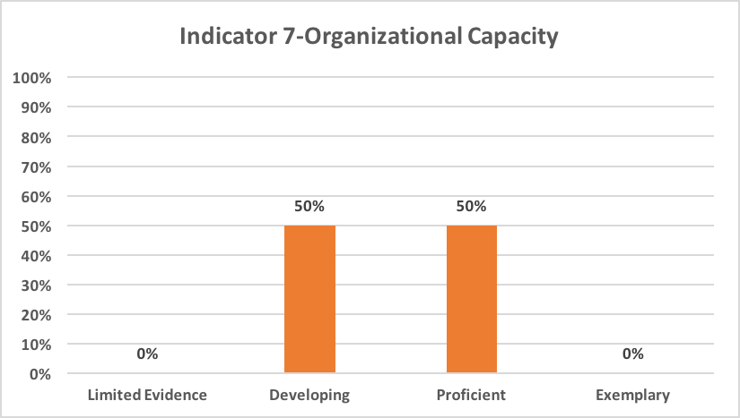

Indicator 7 Synopsis
Indicator 7 illustrates that half of the programs rated Proficient and the other half rated Developing. Although most programs provided clean and adequate facilities, the quality of spaces and resources for some rated Developing varied across multiple sites within the program. Other programs showed limited on-going educational support for the adult education program leadership from the parent agency/institution.

Indicator 7 Data Analysis
The majority of the 20 programs visited in Fiscal Year 2020 appeared to be safe and accessible with classrooms that were clean, appropriate for adult learners, and conducive to learning. Quality resources were available in most programs. However, in many multi-site programs, there were considerable disparities in physical facilities, including classroom and advising space, instructional resources, and up-to-date technology across sites. Program leaders in all 20 reviewed programs have the required qualifications to serve as educational leaders per ACLS policies.

Regarding quality working conditions, all of the programs reviewed in Fiscal Year 2020 compensate staff for all professional development activities, meetings, and lesson preparation at a salary rate that meets or exceeds the minimum stipulated by ACLS policies. In 70 percent of the programs, adult education leaders receive ongoing support from their parent agency or institution relating to their role specifically as a leader of an educational program.

Organizational Capacity: Overall Promising Practices

- There is little staff turnover, and the program provides experienced mentor teachers who support newer teachers; both mentors and mentees are paid for their work together. The program has a clear teacher development process: many staff enter the program as volunteers who work with small groups using lessons that the program provides. They can progress to become paid substitutes and eventually teachers. Some teachers with requisite experience are available to write curriculum as needed or take on teaching additional classes as they are created. There are, then, sufficient opportunities for career advancement, within the parameters of part-time employment.
- Staff members spoke to the clarity of job expectations, the sharing and experience of professional development opportunities during staff meetings, and regular feedback and evaluation from the director as being among the positive features of the program.
- The program’s staff evaluates leadership annually, and the leaders act on the feedback.
- Formal procedures have been put in place for the safety of staff and students, including making walkie-talkies available to teachers and making emergency materials available in each classroom, and securing doorways.
- Professional development time is paid and is tiered to reflect the additional needs of newer teachers: all staff receive 12-14 paid hours per year, while new and inexperienced staff have up to 10 additional hours for PD.
- All teachers are part time but receive paid holidays and medical and dental insurance. Sick and personal time are available to staff who work over 1,000 hours.
- Program leaders have been responsive to safety concerns raised by staff and students. In one case, doors can now be locked from the inside, whereas previously doors could only be secured after they were opened which concerned staff in the event of an active shooter.
- If students need ADA accommodations, the ADA coordinator would initially meet with the student and then refer based on the need (e.g. tutoring, hearing, vision). Accommodations are discussed during orientation with students.
- Through its Human Resources Department, the agency supports the program director with management training on topics such as cultural differences and dealing with difficult people.
- Incentives are offered, such as bonuses to staff obtaining positive evaluations and maintaining strong attendance.

Organizational Capacity: Overall Areas for Improvement

- In some programs, space and resources are insufficient. For example:
  - Classroom space is difficult to find. Staff also mentioned that it is sometimes difficult to find dedicated rooms for private meetings, forcing them at times to meet in the cafeteria.
  - Advisors do not have access to a dedicated, confidential space for sensitive conversations.
  - The program operates at a site that does has limited ADA accessibility. The building does not have an elevator or ramp to allow entry to individuals with mobility issues.
  - Access to technology is limited, and the technology is not up to date.
- In multisite programs, there are often inequitable resources across sites. For example:
  - One program site takes place in a modern, well-equipped facility shared with another program that has up to date (although largely unused) technology and ensures the confidentiality needed to conduct instructional, advising, and assessment activities. Another site has a single office shared by the program coordinator and advisor located in one suite, and it has two overly crowded classrooms two-doors down on the same block.
  - There appears to be a recognition that facilities at the main site are considered superior to offsite locations where teachers have fewer resources, and access to technology is not equitable. As an example, private space for confidential meetings with students or testing is not available at all program locations.
- Staff and students are not fully informed about emergency and safety plans. For example:
  - Not all staff and students could provide details regarding what to do in the event of an emergency (e.g. no fire drill practice).
  - Staff and students are not clear on the procedures to follow during a fire or other type of emergency, and the Review Team could find no evidence of emergency procedures posted in visible areas for staff and students to read.
  - Most students reported no information regarding safety procedures had been shared and few reported participating in fire drills at any point in time.
- Some adult education programs are not fully supported by their parent agencies. For example:
  - Program staff and students reported to the Review Team that the program does not have a cleaning service, and that they themselves have been asked clean on occasion. Other offices and programs in the agency appear to be part of a regular cleaning service.
  - In-house professional development, agency and program staff meetings, and cross-site staff collaborations were inconsistently scheduled and at times loosely coordinated.
  - Classroom assignments favor the scheduling of other programs in the organization prior to the scheduling of ABE and ESOL classes, often resulting in classrooms that are not located in the main sections of campus or are in buildings that are difficult to identify.
  - The director reports to the board, but there was little evidence of training or other support provided by the board.

INDICATOR 8: EDUCATIONAL LEADERSHIP

The program’s leadership ensures that the vision for academic success is shared by staff and students and that the program engages in a continuous improvement planning process with the goal of improving student outcomes.

The Review Team analyzed interview responses, teacher evaluations, professional development plans, and continuous improvement plans to determine each program’s overall rating for Indicator 8. ACLS looked for evidence in the four standards of this Indicator:

- Program leadership provides on-going supervision for all staff which includes regular supervision meetings, and an annual evaluation. Teachers receive regular classroom observations with written feedback and follow up that leads to improved teaching practice and student outcomes.
- Program leadership makes informed decisions for providing professional development to staff based on student outcome data and program needs.
- Program leadership collects and analyzes a variety of program and regional data to inform decisions about program planning and evaluation.
- Program leadership ensures the program’s continuous improvement planning process involves all stakeholders, including students, and incorporates their feedback, reflections, and recommendations for improvement.

Figure 7 below shows the Indicator 8-Educational Leadership rating percentages for the 20 programs reviewed during Fiscal Year 2020.

Figure 7
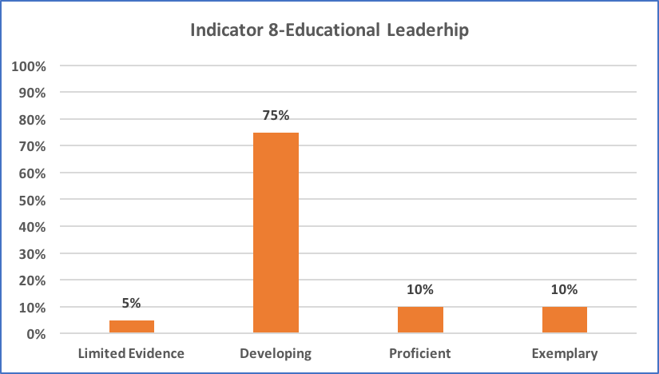

Indicator 8 Synopsis
The majority of programs were rated Developing, with two programs rated Exemplary, two rated Proficient, and one rated Limited Evidence. Although most program leaders provide regular supervision and evaluation to staff, there is limited evidence that this process led to improved teaching practices and/or student outcomes. More than half of the programs visited use a variety of data to inform planning and evaluation decisions. However, the majority of programs did not appear to have a continuous improvement planning process that includes staff and student input or a shared vision for the program’s direction.

Indicator 8 Data Analysis
Although 80 percent of program leaders provided regular supervision and evaluation to staff, only six programs demonstrated evidence that supervision consistently led to improved teaching practices. Further, while many staff attended professional development activities, staff professional development goals at only 35 percent of the programs seemed to be specifically aligned with the program’s continuous improvement goals; in four other programs (20 percent), there was evidence of partial alignment between professional development and program goals.

Six programs provided evidence of a clear process in place for gathering staff and student feedback for program improvement and for documenting continuous improvement goals in the form of a continuous improvement plan. Approximately 65 percent of programs collect, analyze, and effectively use a variety of program and regional data to inform planning and evaluation decisions.

Further, seven programs appeared to have effective systems in place to ensure a vision for academic success that is shared by staff and students.

Educational Leadership: Overall Promising Practices

- Program leadership, advisors and teachers described how continuous improvement was an ongoing, collaborative process. During staff meetings, all staff members participate by talking about their goals and plans for how to achieve them.
- All staff in the program participate in PD, which is based on recommendations from program leadership, as well as each staff member’s individual needs. Staff spoke about the program director “constantly” referring them to PD opportunities.
- Advisors use orientation to collect data by giving each student a “barriers assessment.” The advisors then ask students to write three possible solutions for each barrier. Since time management has been one of the barriers they have seen often from the assessment, advisors developed a time management plan that has helped ensure that students come to class on-time.
- The program gave many examples of how they use data to inform programmatic decisions. The program has a monthly survey in place to gather data from students. One of the ways the program responded to the survey was to create summer classes.
- As the educational leader for the program, the director provides regular feedback and evaluation to her staff. Instructors discussed formal and informal observations, regular evaluation procedures, and regular availability for teaching support. They also provided specific examples of how feedback had improved their teaching.
- There is a concerted effort made, through conversations, surveys, and meetings, to hear the voices of all stakeholders when decisions are being made. Leadership also does a needs analysis via questionnaire for businesses in the area. The full focus of both leadership and staff on shared continuous improvement enabled them to put in place a process which officially and regularly gives students opportunities to provide program feedback.
- Leaders formally observe newer teachers once or twice a year (every other year for longer term staff), using an observation rubric. Before observations or walkthroughs, teachers have the opportunity to request that an observer focus on a specific aspect of the class. Observers follow up with meetings and then written feedback. Teachers provided several clear examples of how recommendations after observations had strengthened their instruction.
- In addition to data from LACES, the program leadership collects, analyzes, and uses program and demographic data to inform planning, instructional, and student support decisions. For example, when an increasing number of Arabic-speaking students enrolled, the program hired additional Arabic-speaking advisors.
- Teachers mentioned they have regular meetings with students to share data with them regarding their progress in class. Program leadership has strategies in place to gather feedback and recommendations from students and staff in support of continuous improvement.
- The program director works with the staff to set two professional goals per year, one of which must match the program’s goals

Educational Leadership: Overall Areas for Improvement

- In many programs, evaluation does not support teachers in strengthening instruction. For example:
  - Neither the observation nor performance reviews shared with the Review Team include professional goals or plans to improve teaching practice.
  - Some staff indicated that they have not ever been evaluated, don’t receive any written classroom observation feedback, or have not been evaluated in a long time.
  - The Review Team found little evidence from interviews and classroom observations that feedback has led to improved teaching and advising practices. Further, it is unclear whether there is a process for following up on the feedback from classroom observations.
- While professional development is available to staff in all programs, the training that staff undertakes is not necessarily connected to program goals. For example:
  - While teachers reported having participated in trainings, decisions appeared to be connected to staff preference alone and not directly linked to identified programmatic needs.
  - Overall, the Review Team found little evidence that the program currently has a systematic approach to professional development, to build either the program’s or individual teachers’ capacity, or even that most staff are engaged in PD activities.
  - While PD is encouraged, and staff does participate, the process for determining PD based on specific program needs and/or student outcome data was neither clear nor consistently applied.
  - There was limited evidence that determining or encouraging professional development based on an analysis of program data, student outcomes, or educator performance evaluation is ever applied.
- In the majority of programs reviewed in Fiscal Year 20, there is no vision for the program that is shared by leadership, staff, students, and community stakeholders. For example:
  - Most staff and program leaders were able to articulate worthwhile goals appropriate to program needs, such as providing students with more support and advising, increasing the number of students passing the HiSET, and further improving English language skill development. However, these goals varied considerably from one staff member to the next, and no one was able to explain any formal role they had in providing feedback or describing a formal process for determining these program improvement goals.
  - The vision and goals of the program’s continuous improvement process is not clear to all staff and students. According to program leadership, the improvement process is focused on resolving attendance issues, dealing with student trauma, and incorporating rigor in the classroom. However, in other interviews, the Review Team heard about different goals.
  - Some staff are aware of the director’s priority areas, but there was minimal evidence that this awareness has resulted in forwarding movement toward implementing these priorities in a uniform and timely basis.
- Programs do not have a process for continuous improvement or a documented improvement plan, thus impacting staff understanding of the overall program goals. For example:
  - The program does not appear to have a clear continuous improvement planning process that involves all stakeholders and incorporates their feedback and recommendations for improvement. Program leaders, teachers, and advisors could not articulate the overall program goals, instead providing a variety of individual goals for the year.
  - Program staff provided uneven responses regarding the program’s continuous improvement process. Most staff were able to cite individual goals pertaining to their roles, but there did not appear to be one common goal that all staff were working towards.
  - There was limited evidence of strategies to gather feedback and recommendations from staff and students to inform continuous improvement. The process by which staff work collaboratively to review data, identify program strengths and needs, and plan together for continuous program improvement was vague.
  - While some staff said that they were not aware of any program goals, other staff identified similar goals for the program.

RECOMMENDATIONS
Programs are encouraged to use the promising practices and areas for improvement listed in this report as a guide for reflection and continuous improvement. Program directors can contact their ACLS program specialist and/or SABES to discuss strategies for addressing those Indicators in need of improvement.

APPENDIX A-Fiscal Year 2020 Program Quality Reviews

- Action for Boston Community Development (ABCD), Inc.
- Berkshire County Sheriff’s Office
- Boston Chinatown Neighborhood Center, Quincy
- Boston Housing Authority, Charlestown Adult Education Program
- Bristol Community College—Fall River Adult Education Program
- Bristol Community College—Taunton Adult Education Program
- Bunker Hill Community College—Metro North
- Catholic Charities South
- College Bound Dorchester, Inc.
- Framingham Public Schools
- Hampden County Sheriff’s Department
- International Institute of New England-Boston Adult Education Program
- Martha’s Vineyard Adult Learning Program
- North Shore Community College
- Northern Essex Community College
- Notre Dame Education Center—Lawrence
- Quincy Community Action Programs, Inc
- Quinsigamond Community College
- Training Resources of America, Inc.—Worcester
- Webster Public Schools – ABE Linkages

APPENDIX B-Fiscal Year 2020 Ratings

Note: In order to preserve confidentiality of specific program ratings, there is no correlation between Appendix A and Appendix B.

Program | Indicator 3 | Indicator 4 | Indicator 4.1 | Indicator 4.2 | Indicator 4.3 | Indicator 4.4 | Indicator 7 | Indicator 8
Program AA | D | D | LE | D | D | D | D | D
Program AB | D | D | D | LE | D | D | D | D
Program AC | P | D | P | D | D | D | P | D
Program AD | D | D | LE | D | D | D | D | D
Program AE | D | D | P | P | D | D | P | D
Program AF | D | D | LE | LE | D | D | D | D
Program AG | P | D | LE | D | D | P | D | D
Program AH | P | D | D | D | D | D | D | D
Program AI | P | D | P | D | D | E | D | E
Program AJ | D | D | D | D | LE | D | D | D
Program AK | D | D | D | D | D | D | P | D
Program AL | P | D | D | P | D | P | P | P
Program AM | P | D | P | D | D | D | P | D
Program AN | D | D | P | D | D | P | P | D
Program AO | P | D | P | D | D | D | P | P
Program AP | P | D | D | D | D | P | P | D
Program AQ | P | D | P | D | D | P | D | D
Program AR | D | P | P | P | D | P | P | E
Program AS | D | D | D | P | LE | LE | P | LE
Program AT | D | D | P | D | D | D | P | D

REFERENCES

ClarusGroup (June 2015), Conducting Effective Accountability Visits-Guidance Document

Massachusetts Adult and Community Learning Services, Massachusetts Department of Elementary and Secondary Education (2019), Fiscal Years 2019-2022 Program Quality Review and Site Visit Protocol, retrieved from http://www.doe.mass.edu/acls/pqrsv/

Massachusetts Adult and Community Learning Services, Massachusetts Department of Elementary and Secondary Education (2019), Fiscal Year 2019 Program Quality Review Summative Report. retrieved from http://www.doe.mass.edu/acls/pqrsv/

Massachusetts Adult and Community Learning Services, Massachusetts Department of Elementary and Secondary Education (2019), ACLS Policies for Adult Learning Centers and Correctional Institutions, retrieved from http://www.doe.mass.edu/acls/abeprogram/

Massachusetts Department of Elementary and Secondary Education (2016), Learning Walkthrough Implementation Guide, retrieved from http://www.doe.mass.edu/educators/title-iia/ImplementationGuide2016.pdf

Massachusetts Department of Elementary and Secondary Education (July 2014), Turnaround Practices in Action, A Three-Year Analysis of School and District Practices, Systems, Policies, and Use of Resources Contributing to Successful Turnaround Efforts in Massachusetts’ Level 4 Schools, , retrieved from http://www.doe.mass.edu/turnaround/howitworks/reports.html

Massachusetts Department of Elementary and Secondary Education (November 2016), 2016 Massachusetts Turnaround Practices Field Guide, A Research-Based Guide Designed to Support District Leaders Engaged in School Turnaround Efforts, retrieved from http://www.doe.mass.edu/turnaround/howitworks/reports.html

Massachusetts Department of Elementary and Secondary Education, District and School Turnaround Protocol (2018-2019), retrieved from http://www.doe.mass.edu/turnaround/

Massachusetts Department of Elementary and Secondary Education, Office of Charter School and School Redesign Site Visit Protocol (2017), retrieved from http://www.doe.mass.edu/charter/

Merriam, Sharan B. and Simpson, Edwin L, A Guide to Research for Educators and Trainers of Adults, second edition, Krieger Publishing Company, 1995.

Southern Regional Education Board (Spring 2009), Technical Assistance Site Visits, Atlanta, retrieved from https://www.sreb.org/post/technical-assistance-visit

A shared customer is a student who is enrolled in more than one core partner program at any time during a fiscal year (i.e., a student who is co-enrolled and a student who is sequentially enrolled). Examples of shared customers who enroll in more than one core partner program include but are not limited to: ABE/ESOL students enrolled by OSCC and receiving career center services leading to employment , ABE/ESOL students ages 16-24 and enrolled in Title I out-of-school youth programs, ABE/ESOL students and recipients of Department of Transitional Assistance (DTA) and/or Massachusetts Rehabilitation Commission (MRC) services, ABE/ESOL students who exit ABE services and then enroll in a training program funded by a core partner.
The Massachusetts ESOL Frameworks have been replaced with the Massachusetts English Language Proficiency Standards (MA ELPS) in April, 2019. The MA ELPS integrate standards from the MA ESOL Frameworks (2005), the CCRSAE, and the English Language Proficiency Standards for Adult Education (2016).

