Massachusetts Department of

Elementary and Secondary Education

75 Pleasant Street, Malden, Massachusetts 02148-4906 Telephone: (781) 338-3000 TTY: N.E.T. Relay 1-800-439-2370

Jeffrey C. Riley
Commissioner

Adult and Community Learning Services

To: Program Directors, Adult Education Teachers, Adult Education Test Administrators

From: Wyvonne Stevens-Carter, Adult Education State Director
Date: November 4, 2020
Re: ACLS Special Mailing: Assessment

Assessment Reminders
- MAPT-CCR can be taken on a cell phone device
ACLS and UMass CEA understand the need for flexibility and are therefore allowing students to take the MAPT-CCR on their smart phone if:
a) no other devices are available for students taking the MAPT-CCR, and
b) students are receiving instruction and completing class work/homework on their smartphone.

In those limited circumstances programs can have students take the test on the smartphone that students have access to. The smartphone must have an internet browser installed and be capable of maintaining a videoconferencing link with the test administrator (e.g., Zoom, FaceTime, Google Meet).

- Only tests administered in FY20 can be moved forward in FY21
Tests that were moved forward from FY2019 into FY2020 cannot be further moved forward into FY2021. Tests administered in FY2020 and moved forward in FY2021 can be used as pre-tests in FY2021 only until December 31, 2020.

- Pre-tests with scores Completed ESL Level 6 are Invalid
Pre-tests with scores resulting in an entry level of “Completed ESL Level 6” are not valid. Students at this level cannot be considered participants, nor can they be reported. Programs are reminded to:
- review the ACLS Assessment Policies
- administer a new test for students whose tests at ESL level 6 were moved forward, and/or
- administer a different test for students who were pre-tested this year and scored at ESL level 6.

Assessment Clarification
Instructional hours for tests moved forward in FY2021
ACLS has learned that the LACES dashboard functions differently than we expected. When tests are moved forward from the previous fiscal year, the dashboard student alert identifies students for eligible for posting based on the total instructional hours since the original test date, including hours from the previous year. For example, if a program moves forward a student’s assessment administered January 15, 2020 and records 63 hours of attendance for the student between the test date and end June, the LACES dashboard will show that the student is eligible for a post-test after only two hours of instruction in FY21. This is not the intent of the Massachusetts posttest policy.
In Massachusetts, the state assessment policy requires that students be post-tested after they have accumulated 65 instructional hours (for CALC) or 40 hours (for AECI) since the date of the pre-test administered in the current fiscal year.
Students whose tests were moved forward from the previous fiscal year must have at least 65 hours (40 for AECI) of instruction in the current year before being eligible for post-tests.
The easiest way to identify students who are eligible for a post-test as defined by ACLS policy is through the dashboard student alerts. Click on the number of students eligible for post-testing.

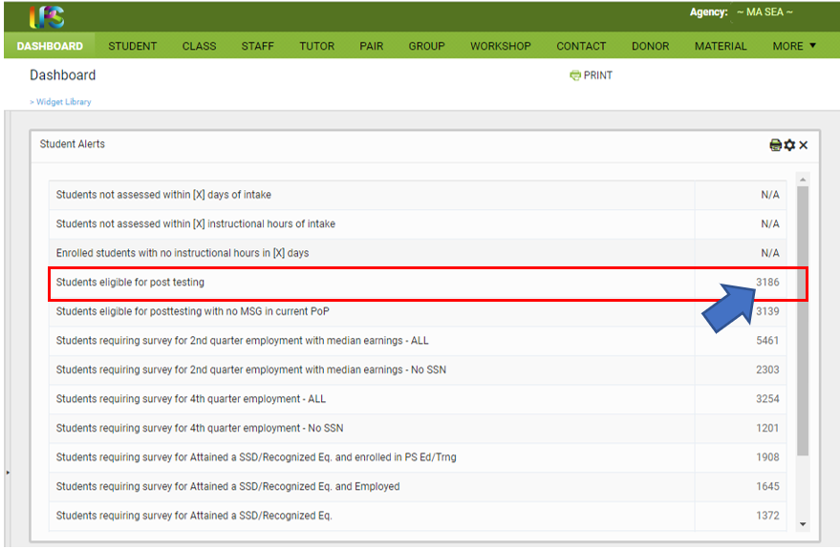

Then filter by current fiscal year instructional hours (40 for AECI and 65 for CALCs) to determine which students are eligible for a post test.

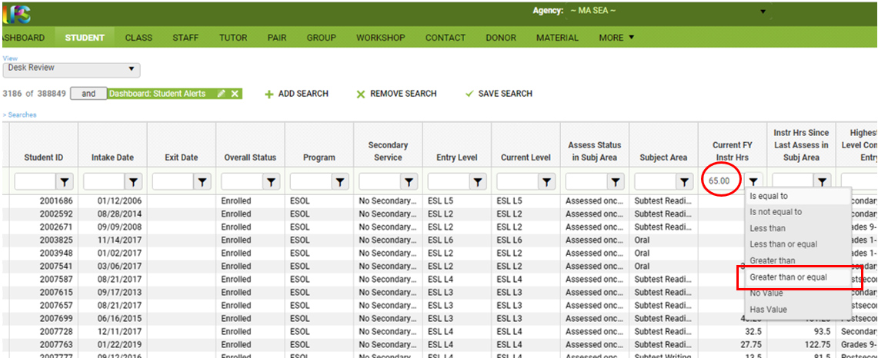

Assessment Policy Exception
Policy Exception for BEST Plus 2.0 and CLAS-E Writing Scoring Recertification in FY2021
In FY2021, because of ongoing challenges associated with the COVID-19 pandemic, annual recertification for BEST Plus 2.0 and CLAS-E Writing scoring will be modified in February-March 2021 as follows:
UMass CEA staff will email program directors the names and emails of currently certified BEST Plus test administrators and CLAS-E Writing scorers. Directors will then respond to the email confirming which test administrators and scorers are current. This will ensure that CEA’s records are up-to-date and ensure that the outreach to administrators and scorers is successful.
For FY2021, currently certified test administrators and scorers must complete the following by March 31, 2021 to maintain their certification status and continue as an administrator/scorer in FY22:
- FY21 CLAS-E Writing Scoring Recertification Activities
By February 1, 2021, all practitioners who are eligible for recertification will receive a link to the following materials:
- a video refresher of the CLAS-E Writing Scoring rubrics
- survey to attest to successful completion of recertification activities

By March 31, 2021, practitioners must:
- watch the video refresher of the CLAS-E Writing Scoring rubrics
- complete an attestation that they watched the video
- update their contact information using the link from the CEA

Completion of the two steps listed above will serve as the CLAS-E Writing Scoring recertification activities for FY21
.
- FY21 BEST Plus 2.0 Recertification Activities
By February 1, 2021, all practitioners who are eligible for recertification will receive a link to the following materials:
- A video refresher of the BEST Plus 2.0 rubric and scoring considerations
- survey to attest to successful completion of recertification activities

By March 31, 2021, practitioners must:
- watch the video refresher of the BEST Plus 2.0 rubric and scoring considerations
- complete an attestation that they watched the video
- update their contact information using the link from the CEA

Completion of the two steps listed above will serve as the BEST Plus 2.0 recertification activities for FY21.

Programs may choose to watch the videos as a group professional development activity over videoconferencing or allow individual practitioners to watch the video(s) they need independently.

This table summarizes all the Covid-19 related assessment policy updates for FY2021. ACLS is in the process of updating the assessment policy manual to reflect all these changes.

# | Old Policy | New Policy | Effective since
1 | Moving Assessments Forward  Any assessment administered after April 30 may be moved forward into the next fiscal year and used as a pre-test until December 31 of that calendar year. For example, a student's test administered on May 2, 2018 (FY 2018) can be moved forward and used as a pre-test into the next fiscal year starting July 1, 2018 (FY 2019) until December 31, 2018. If the student leaves before June 30 and returns after December 31, the student must be pre-tested again. | Moving Assessments Forward  Any assessment administered in FY 2020 may be moved forward in FY 2021 and used as a pre-test until December 31, 2020. If a student has two previous assessments, the most recent assessment may be moved forward. For example, a student's test administered in September 2019 (FY 2020) can be moved forward and used as a pre-test into the next fiscal year from July 1, 2020 (FY 2021) until December 31, 2020. If the student has an assessment administered in October 2019 and another assessment administered in January 2020, only the January 2020 assessment can be moved forward. | May 20, 2020
 | NRS Test Administration: in person only  - BEST Plus 2.0, TABE CLAS E Reading, TABE CLAS E Writing, MAPT-CCR, TABE 11/12, TABE Literacy | NRS Test Administration: remotely and in person physically distant  - BEST Plus 2.0, TABE CLAS E Reading, TABE CLAS E Writing, MAPT-CCR, TABE 11/12-remotely or in person physically distant  - TABE Literacy-in person physically distant only | July 1, 2020
 | Number of hours before pre-test  All students must be pre-tested within the first 18 hours of attendance,  but students can be pre-tested prior to enrollment (with the exception of  MAPT-CCR). Exception to the 18 attendance hour pre-testing policy:  Due to the time-consuming re-testing requirements of the CLAS-E Reading  and the CLAS-E Writing assessments, programs using these two  assessments can administer these pre-tests after students have  reached 18 attendance hours. | Number of hours before pre-test  The policy that students must be pre-tested within the first 18 hours of contact/instruction is being relaxed for FY2021 only. In FY2021, students must be pretested within the first 30 hours of instruction. | July 1, 2020
 | MAPT-CCR tests on cell phone devices  MAPT-CCR tests can be taken on laptops, desktops, tablets only. | MAPT-CCR tests on cell phone devices  MAPT-CCR tests can be taken on a cell phone as well.  It is strongly recommended that students take the MAPT-CCR on a desktop, laptop, or tablet, but if a) there are no other options for devices for students to take the MAPT-CCR, and b) students are receiving instruction and completing class work/homework on their smartphone, then, in those limited circumstances programs can have students take the test on the smartphone that students have access to. The smartphone must have an internet browser installed and be capable of maintaining a videoconferencing link with the test administrator (e.g., Zoom, FaceTime, Google Meet). | August 17, 2020
 | BEST Plus 2.0 and CLAS E Writing Annual Recertification Requirements  - Review rubrics (both test)  - Review previous year recertification test (CLAS E Writing  - Watch video refresher (BEST Plus 2.0)  - Pass a recertification test with a certain score | BEST Plus 2.0 and CLAS E Writing Annual Recertification-Temporary Policy Change due to COVID-19  - watch the video refresher of the CLAS-E Writing Scoring and/or BEST Plus 2.0 rubrics  - complete an attestation that practitioners watched the video and update their contact information using the survey link from the CEA | November, 2020

For assessment policy questions, please contact Dana Varzan-Parker, assessment policy coordinator, at dana.varzan-parker@mass.gov.

For BEST Plus 2.0 and CLAS E Writing recertification questions, please contact April Zenisky or Jennifer Lewis at aclstesthelp@umass.edu .

